Addendum No. 2

RFP 25-13 YC Sports Field, Synthetic Turf Replacement Project
Date: 11/12/2025

Date: January 26, 2016

Clarifications:

- Question: Please consider including the language of “Project Assessment” in the line 1 of the Bid Form so that it aligns with the scope of work for the Architectural Firm?

Answer: The updated bid form is in exhibit A on this Addendum No. 2.
- Question: Please consider adding an add service under line 10 of the bid form to separately bid the cost of adding a civil engineering firm to the project to do all of the documents necessary to provide drainage, subgrade and base for the new turf, only if it was needed for the project based on the outcome of the drainage testing that is required as part of the project.
Answer: The updated bid form is in exhibit A on this Addendum No. 2.

- Question: For Appendix “F”: Proposal Signature Form, are we allowed to submit a copy/scanning of the notary?
Answer: Yes for the electronic digital copy of the proposal. The hard copy original document needs to have an original notary stamp and signature.
- Question: In the RFP, Appendix “G” References is blank. Is there supposed to be a form attached?

Answer: No, the Architectural Firm is to provide the needed references per Appendix B, “Statement of Qualifications”, question no. 24 with all required and scored support information per:

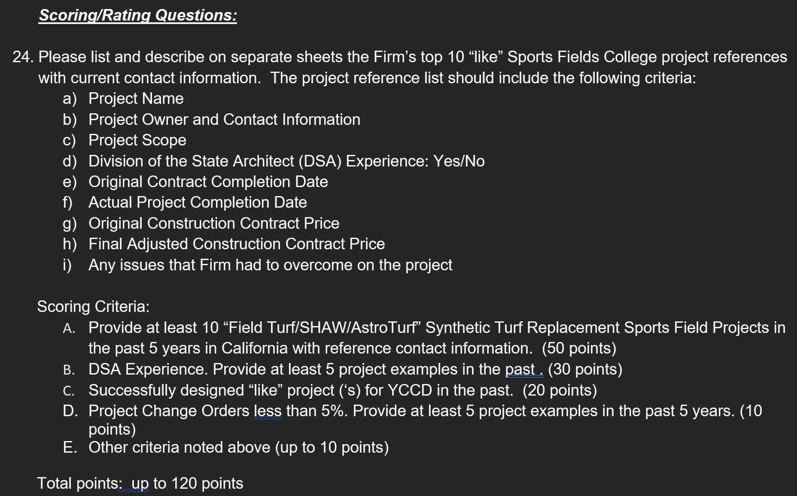

- Question: I received the RFP for the Yuba college design services and I just wanted to make sure if this RFP was geared towards the architects and not for the turf companies to submit. Can you kindly clarify the intent?

Answer: Yes, RFP 25-13 is soliciting proposals from Architectural Firms for design services and is NOT for synthetic turf manufacturers to provide proposals. Proposals from Synthetic Turf Manufacturers will be published later in the process after the design is approved by DSA. Thank you.

Exhibit A: Updated (RFP Appendix A) Bid Form:

No. | Description | Cost
1 | On Campus Project Assessment, Site Conditions Investigation, Testing of Existing Conditions. | $
2 | Topographical Survey of the field and access pathway. | $
3 | 50% Construction Documents | $
4 | 90% Construction Documents | $
5 | DSA Submission and support, DSA Fees paid by District directly to DSA. | $
6 | Contract Administration for the base bid Soccer Fields project (not the additive alternates) | $
7 | Cost Estimate generated by a local qualified cost estimating Firm that uses actual recent costs of other similar projects to help generate a cost estimate for this project. If a Firm has the capability and expertise to provide an accurate estimate +/- 10 percent, using the actual local similar project costs, then this is also acceptable. Submit credentials and project examples, and references of the cost estimating Firm with the proposal. | $
8 | Reimbursable Expenses: 6 sets of each: 50% CD review, 90% CD review, and 100% DSA approved CD drawings and specifications. | $
9 | Other Reimbursable Expenses: Architect to Define/Explain  Note: No hotel or travel costs | $
10 | Sub-Total of Base Bid Proposal Costs: | $
11 | Additive Alternate No. 1: Civil engineering services added to the Architectural Firms scope to the project to complete all of the documents necessary to provide drainage, subgrade and base for the new turf, only if it was needed for the project based on the outcome of the drainage testing that is required as part of the project. | $
12 | Additive Alternate No. 2: (by Architectural Design Firm) | $
13 | Deductive Alternate No. 1: (by Architectural Design Firm) | $
14 | Other: | $
15 | Total Costs: | $

Provide hourly rates for each design professional title.
Provide schedule of values.
Prevailing wages apply to this project.

List all First Tier Sub-Design Firms.

Please round off numbers to the nearest dollar.

A preliminary overall start-to-finish project schedule is required with the proposal.

The End.

