Request for Proposal
Yuba Community College District

Yuba College Campus
Architectural / Design Services
Yuba College Sports Complex Field Synthetic Turf Replacement
No. RFP 25-13

Issue Date: October 24, 2025
Proposals Due: November 18, 2025, 1pm Sharp

Proposals Due Date: November 18, 2022, 2:00 PM Sharp, Yuba College Location Delivered To:

Yuba Community College District, District Offices
Attn.: David Willis
District Director of Facilities Planning, Maintenance & Operations
RFP No. 25-13 Yuba College, Sports Complex Field Synthetic Turf Replacement
Address: Sutter County Campus, Second Floor, District Offices, Attention: David Willis, 3301 East Onstott Road, Yuba City, California 95991

Proposal Delivery at Second Floor
Yuba Community College District
Sutter County Campus
District Offices
3301 East Onstott Road (second floor)
Yuba City, California, 95991

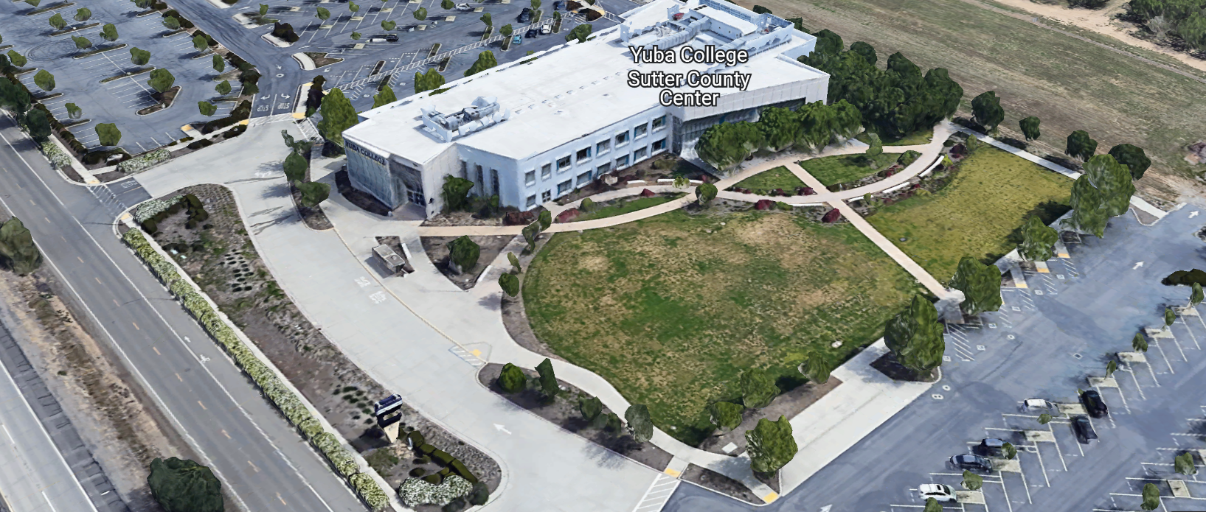
West Building Entrance
TABLE OF CONTENTS

1.0 INTRODUCTION
1.1 District Information
1.2 Yuba Community College District Background
1.3 Purpose of the Request
1.4 Applicable Codes
2.0 Scope of Work
2.1 Project Schedule
2.2 District Staff Contacts during Proposal Process
3.0 Proposal Format Organization
3.1 Proposal Delivery, Contents, and Format
4.0 Selection of “Firm”
5.0 Basis of Award
6.0 Non-Discrimination
7.0 Response to Request for Proposal (RFP)
8.0 Requests for Information (RFI)
9.0 Proposal Schedule
10.0 Evaluation of Proposals Form
11.0 District Parking
12.0 RFP Proposals
13.0 Award of Contract/Proposal
14.0 Reservation of Rights
15.0 Bid Bond Requirements (not applicable)
16.0 Performance Bond, Payment Bond Requirements (not applicable)
17.0 Liquidated Damages (not applicable)

Proposal Required Items:

Appendix A, Proposal Bid Form
Appendix B, Statement of Qualifications
Appendix C, Acknowledgement of Addenda Form
Appendix D, Non-Collusion Affidavit Form
Appendix E, YCCD Professional Services Agreement, PSA (Can be provided by Successful Firm, not required on proposal due date)
Appendix F, Signature Proposal Form
Appendix G, Architectural/Design Firm References
Appendix H, Preliminary Schedule, List of first tier Sub-Design Firms, Architectural/Design License, other credentials.

Informational Items:
Appendix I: YCCD Academic Calendars
Appendix J: Map of Yuba College Campus
Appendix K: Historical Yuba College Sports Complex Field Drawings
Appendix L: New Proposed Synthetic Sports Turf System

1. INTRODUCTION

  - District Information:

The District consists of two colleges, Woodland Community College and Yuba College, with campuses located at five different locations: Yuba College in Marysville, CA; Sutter County Campus in Yuba City, CA; Woodland Community College in Woodland, CA; Colusa County Center in Williams, CA; and Lake County Campus in Clearlake, CA.

  - Yuba Community College District

The Yuba Community College District (YCCD) was founded in 1927 and spans eight counties (Yuba, Sutter, Colusa, Yolo, Lake, Butte, Glenn and Placer) and nearly 4,200 square miles of territory in rural, north-central California. It has colleges in Marysville and Woodland, a Woodland Community College Campus in Clearlake, an educational center in Williams, a Yuba College, and a Sutter County Campus in Yuba City.

  - Purpose of Request

The Yuba Community College District seeks Proposals and Statements of Qualification from Licensed Architectural/Design Firms to provide design services, DSA submission, and contract administration through construction.
Yuba College Campus Address: 2088 North Beale Road, Marysville, California 95901.

  - Applicable Codes
All work shall meet all State of California Building Codes, and Federal codes, and local ordinances.
The design of the Sports Complex Field Turf Replacement project shall meet the requirements of the Bay Valley Conference.
- Scope of Work

The Yuba Community College District is accepting proposals for “RFP 25-13 Architectural/Design Services, YC Sports Complex Field Turf Replacement Project”.

The District intends to design the new replacement Football/Soccer Field

The scope of the “Sports Complex Field Turf Replacement Project” will include the following:
- Campus Site Research and Investigation of Existing Utilities and Site Conditions
- Development of design document that support the synthetic turf replacement
- DSA Access submittal requirements that include all required minimum ADA accessibility required improvements to meet current codes along that accessibility access pathway from the field to the nearest restrooms, restrooms, and the nearest minimal accessible parking.
- Destructive testing of the existing field drainage system to determine existing field drainage performance.
- Retain any required sub-consultants or testing firms to assist as needed in opening two locations to allow for permeable stone base and collector trench system field permeability tests using ASTM F2898-11 “Standard Test Method for Permeability of Synthetic Turf Sports Field Base Stone and Surface system by Non-Confined Area Flood Test Method”. This will determine the infiltration capacity of the field. Prepare a report of the results of the testing and outline the findings and options regarding next steps in the design scope process. Develop all required details and design to support the chosen drainage solution.
- Provide a comprehensive review and design solution to address any restroom deficiencies, any required signage, Parking lot adjustments, ramps, pathways, etc.. as required by DSA.
- Provide a new topographical survey to determine existing slopes and required site improvements along the accessibility pathway. A placeholder value will be included in the Bid Form to cover potential accessibility pathway improvements.
  - Work with the District to develop a project schedule.
- Project Architectural/Design Services Scope Development Meetings and Services Summary to include at a minimum the following:
  - 1. Project Assessment, Site Investigation, and Information Gathering and Review
    - Kickoff Meeting with the District/College Representatives
      - Review project, budget, timeline, and any parameters and deliverables.
    - Topographical Survey
    - Download and review available existing drawings from the College/District
    - Prepare Electronic Base
    - Complete Access Compliance Survey
    - Site Analysis: Conduct ASTM F2898-11 Testing. Repair after testing.
    - Develop Initial Design Concepts
    - Develop rough order magnitude cost estimate
    - Meeting with College/District stakeholders to review conceptual drawings
    - Setup DSA forms, start review process
    - Project Administration as required by DSA
    - Include 3 Planning online meetings in addition to the kick-off meeting noted.
  - 2. 50% Construction Document Package
    - Drawings and Specifications
      - Cover sheet
      - Existing conditions, as-built, survey plan
      - Accessibility plan
      - Demolition plan
      - Grading plan
      - Drainage/utilities plan
      - Layout plan
      - Material and Details reference plan
      - Construction details plan
      - Technical specifications (MS Word format).
      - Coordinate with the District to provide General Conditions and Division One specifications.
    - Cost Estimate of all probable costs at 50% CD and at 90% CD.
    - DSA Submittal Preparation and Coordination
    - Submit to DSA through Blue Beam software to begin the review process.
    - Participate in a 50% CD Review Meeting with the District. Provide agenda and meeting minutes.
    - Project Administration as needed.
  - 3. Construction Document Package-DSA Submittal
    - Prepare 90% CD DSA Submittal Package
    - Meet with the College / District to review the 90% CD Package
    - Update Drawings and specifications as needed.
    - Submit a DSA online fee cost estimate to the District. District to process a check payment for all DSA review fees.
    - Attend a meeting with DSA to review the 100% CD submittal package.
    - Support all DSA review and backcheck processes.
    - Provide fully stamped and approved CD package documents to the District.
    - Provide estimate of probable costs at 90% CD. Cost estimate shall be comprehensive and line itemized including contingencies, based on actual recent regional projects.
    - Provide Project Administration as required.
  - 4. Bidding Assistance
    - Assist the District in creating an RFP document for Sourcewell Field Turf USA Procurement
    - Attend an in-person pre-proposal meeting at the campus
    - Answer questions during the bidding process.
    - Evaluate all contractors field turf proposals for materials performance and quality assurance standards of performance.
    - Participate in the evaluation of Contractors for pre-qualification.
    - Participate in the review of Contractors’ proposals.

  - 5. Construction Administration and Project Closeout
    - Attend 1 Pre-Construction Meeting
    - Attend 8 On Campus Project Construction Meetings, provide observation reports with photos.
    - Attend and participate in up to 8 On-Line Construction Meetings
    - Process and coordinate submittals, shop drawings, RFI responses, ASI’s, and DSA CCD’s as required.
    - Reviewing orders, verify scope is a warranted change.
    - Review monthly contractor progress payments.
    - At substantial completion, visit site, generate corrective punch list, track to completion.
    - Provide stringline observations.
    - Generate synthetic turf installation punch list
    - Develop final punch list, distribute, and track to completion.
    - Review all contractor warranties, guarantees, and M & O manual information for completeness and compliance with specifications and drawings.
    - Close out the project, organize the electronic files, plans, and construction binder.
    - Close out the project with DSA by ensuring all forms are uploaded to the DSA project folders. Track and coordinate as needed.
  - 6. Architectural/Design Services
    - Provide all required Architectural/Design services to meet all Division of the State Architect requirements
      - Accessibility Survey, Assessment, and code review to identify what improvements are required.
      - Design drawings and specifications to address required access requirements required by DSA.
      - DSA submission and processing requirements.
      - Generate and provide the topography survey as required.
      - All required civil, structural, mechanical engineering to provide a comprehensive design service for the synthetic field replacement.
  - 7. Other Included Services
    - Subsurface and utility investigation and validations
    - Field Gmax testing if needed.
    - Utilities relocation design and documentation to meet the requirements of this project in replacing the synthetic field.
    - Include colored field renderings showing the new field and features once designed.

  - 7. District Responsibilities
    - Provide vectored pixel graphics if used on the field.
    - Provide project budgetary constraints
    - Provide project schedule constraints
    - Provide which sports will be using the field. The field will likely support football, soccer, and some track sports. Design Firm to engineer and provide all required field layout and markings to meet designated sports use requirements.
    - Provide available as-built drawings of the existing field, utilities, etc..
    - District to provide the Geotechnical Reports/Survey.
    - CEQA environmental review, study, and documentation.
    - Commissioning agent services through a contracted third party.
    - Quality Assurance Inspections by a third party.

The District does not historically have accurate as-built drawings for underground utilities and projects in general.

The District will be generating three (3) Requests for Proposals (RFP’s), one for each Turf Manufacturer to bid on the design of the project using the SOURCEWELL COOP or State Chancellors Office CollegeBuys program contracts pricing:

- Field Turf USA
- SHAW
- AstroTurf
The Design and Technical Specifications for the Turf System will inform each of the RFP’s.

2.1 Preliminary Project schedule
Proposals Due: November 18, 2025
College/District Design Proposals Review: November 19, 2025
Board Approval: December 18, 2025
Approximate Award Date: January 16, 2025
Project Start-Up/Site Investigation/Analysis: January 26, 2025
50% Construction Documents: March 20, 2026
College/District Review of 50% Construction Documents: April 3, 2026
90% Construction Documents: April 24, 2026
College/District Review of 90% Construction Documents: May 8, 2026
100% CD DSA Submittal: May 14, 2026
YCCD Board Approval of 100% CD Package: June 11, 2026
DSA Review Complete: August 14, 2026
DSA Backcheck Complete: August 28, 2026
Contractor Bids Received: October 13, 2026
College/District Review of Contractor Bids: November 3, 2026
Board Approval: December 17, 2026
Award of Contractor: January 15, 2027
Note: Construction period subject to scope determination whether or not subsurface drainage rock and drainage piping needs to be removed, replaced, or modified. This will be known after testing and design work is completed. It is possible that the construction schedule may be extended if the subsurface drainage systems require improvements.
Substantial Completion: May 2027
100% Project Construction Completion: June 2027
Project Close-Out Process: June 2027
College Move-In/Use of the Field: June 2027
If possible, the District would like to shorten the above overall schedule.
Note: These are target dates which can be changed by the Architectural/Design Firm to provide a preliminary schedule for this RFP. Architectural Firms that can expedite the design schedule should indicate this on their preliminary schedule with their proposal.
Provide a preliminary realistic project schedule with the proposal with dates for activities as noted above. Please do not submit a schedule that your Firm cannot meet.

2.2 District Staff Contacts during the Proposal process:
Firms interested in submitting a Proposal are directed not to make personal contact with the Board of Trustees, District staff, or members of the evaluation committee. Any contact shall constitute grounds for disqualification from consideration.
Single Point of Contact during the Proposal Preparation Process:
David L. Willis
District Director of Maintenance, Operations, and Planning
Sutter Center, YCCD District Offices, room 217
3301 East Onstott Road
Yuba City, California, 95991
Cell Phone: 916-747-4262
Email: dwillis@yccd.edu

3.0 Proposal Format Organization
The Firm is requested to use the following proposal format:
3.1. Proposal Delivery, Contents, and Format:
Proposals should provide straightforward, concise information that satisfies the requirements noted in this RFP. Expensive binding, color displays, and the like are discouraged. Emphasis should be placed on brevity, conformity to the Districts instructions, selection criteria of this RFP, and completeness and clarity of content. Each Respondent’s proposal should clearly and accurately demonstrate specialized knowledge and experience required for consideration.
In a sealed box or envelope (clearly marked “), submit the following:
- One (1) flash memory stick containing the complete proposal and supporting documentation;
- One (1) original signed hard copy in paper form of the proposal, which consists of a Proposal Letter and responses to the proposal requirements of this RFP.

There is no page limit.

Firms must comply with the provisions of these instructions for completion and submission of the Proposal. The failure of a Firm to comply with the Proposal Instructions and Requirements will likely result (at the sole discretion of the District) in rejection of the Proposal for non-responsiveness.
Proposal Section | Format
- Cover Letter | PDF
- Table of Contents | PDF
Appendices (See Table of Contents for each one) Submit a response to each Appendix that requires Firm information. Please submit responses to Appendices A, B, C, D, E, F, G, and H. Appendices I, J, K, and L are informational only. | PDF

Proposal General Information Contents:

The information requested will help the District determine if the Firm is a “Responsible Proposer”.

Cover Letter

The Proposal shall include a Cover Letter on Respondent’s official business letterhead, which shall be signed by an individual authorized to legally bind Respondent. The Cover Letter shall also identify the name, telephone number, and email of a person who may be contacted during the Proposal evaluation process.

Table of Contents

Provide a Table of Contents that outlines in sequential order the major sections and sub-sections of the Proposal. Use tabs to allow information to be more easily located.

4.0 Selection of “Firm” Services Provider

The process of “Firm” selection is based upon the complete responsiveness of the RFP and the criteria as outlined in the RFP.

The District Project Evaluation Team will read the written proposals. The District Evaluation Team will discuss the proposals and verify that the “Basis of Award” information below, the Statement of Qualifications, and information submitted in response to the RFP are complete and responsive.

Process Summary:

- Evaluation of the Statement of Qualifications, and prequalification of Firms
- Proposal Review
- Interview with Firm—if determined to be required by the District.
- Selection of most qualified, cost-effective comprehensive proposal which includes all needed and requested services as described in this RFP.

The District reserves the right to reject any or all submittals, to amend the RFP process, and to discontinue or re-open the process at any time. The District reserves the right to request clarifications to RFP responses and to negotiate the terms of the agreement.

5.0 Basis of Award

This project will be awarded based on the following criteria:

- “Best Value” Proposal as Defined by the District:
  - Statement of Qualifications Evaluation, Interview, resulting in Prequalification.
  - Proposal Review, Complete and Comprehensive, and Lowest Total Cost.
  - Experience designing Sports Turf Fields with the manufacturers listed in this RFP.
  - Ability to provide all required services in an expedited comprehensive manner to complete the work asap and accelerate (move up) the DSA submission date.

- Other Factors Considered in the above process:
  - Project Team, Credentials, Time Commitment
  - Proper State of California Architects License in good standing
  - Information provided as requested in the RFP.
  - All Addendums are acknowledged.
  - Architectural/Design Firm’s exceptions or exclusions.
  - Architectural/Design Firm with historical good performance on YCCD projects regarding minimal number and cost of change orders, maintaining project schedules and completing the work promptly, and overall quality of work.
  - Architectural/Design Firm’s ability to meet schedule requirements. Time is of the essence. Provide an abbreviated schedule for services if realistically possible. The District does require complete and thorough construction documents to reduce the risk of change orders by the contractor.
  - Architectural/Design Firm has demonstrated past project references of “like” projects
  - Architectural/Design Firm’s references are all good with respect to schedule, cost, and quality.
  - No other factors such as litigation, licenses not in good standing, bankruptcy, or other similar criteria.

The one or two of the best qualified and lowest total cost responsive proposer’s may be requested to participate in a ZOOM interview process with the District Project Proposal Evaluation Team. The Architectural Professional Services lowest cost proposer may not be awarded the project due to other “Best Value” considerations and criteria as defined in this RFP. Firms must first be qualified by the District, at it’s discretion and per Appendix B, “Statement of Qualifications” and possibly a scoring interview before the proposal will be considered.

6.0 Non-Discrimination

The District does not discriminate with regard to race, color, gender, national origin, disability, or any other protected or other classification in the awarding of contracts/agreements. The District welcomes all Qualified Firms to participate in the project Request for Qualification/Proposal process.
The District encourages firms that are women or minority owned, emerging small businesses, veteran owned firms, disabled person owned firms, and all other qualified firms to participate in the proposal process.
The District encourages the submission of proposals from all Firms that can meet the stated requirements set for this RFP.
7.0 Responses to RFP:
Sealed responses to this RFP must be clearly marked "RFP NO. 25-13 Architectural Services, Yuba College Sports Complex Field Synthetic Turf Replacement Project”.

Responses shall be mailed to or hand-delivered to the following address:

Yuba Community College District, District Offices
Attn.: David Willis
District Director of Facilities Planning, Maintenance & Operations

Envelope/Box Marked:
"RFP NO. 25-13 Architectural Services, Yuba College, Sports Complex Field, Synthetic Turf Replacement Project”.
.

Address: Sutter Center, District Offices, Second Floor, Room 217, Yuba City, California, 95991

Note: Completely seal your proposals in envelope/box and make sure it gets date/time stamped when delivering proposal. Firms are each 100% responsible to make sure proposals that are mailed using a carrier such as UPS, FED Ex, etc…are received and date/time stamped by District personnel prior to the proposal due date/time. No proposals will be considered if they are late, even if it is only 5 minutes late. Please make sure your proposals are delivered and received promptly prior to the due date/time. There will be a public proposal opening at the due date/time.

Do NOT email your proposals. Emailed proposals that are not sent per the above guidance requirements will not be considered.

8.0 Requests for Information (RFI)

Requests for Information concerning the RFP must be in writing and may be submitted via email no later than the date shown below. Please direct all questions to David Willis, email: dwillis@yccd.edu.

Following the RFI deadline, all questions and answers will be summarized and posted on the District's website: https://www.yccd.edu/central-services/purchasing/ , then, click on the “Requests for Proposals / Quotes” tab on the right hand side of this web page. It is anticipated that responses to inquires received by the required time and date will be provided within 5 business days and posted on the District website or responded to per the dates listed in the RFP for addendum publishing. Should more time be needed by the District to answer I respond to RFI’s, this information will also be posted on the above website.

- Include the following in the subject matter field on emails when requesting information: “RFP 25-13”, RFI.

9.0 Proposal Schedule:

Important Dates and Times:

October 24, 2025: Release of Request for Proposal

All Pre-Bid Meetings Are Optional.

November 6, 2025: 1:00PM to 3:00PM Optional On-Campus Pre-bid Meeting. Location, Building 1400 Maintenance Building conference room (east side of the campus)

November 11, 2025: 1:00PM to 3:00PM Optional On-Campus Pre-bid Meeting. Location, Building 1400 Maintenance Building conference room (east side of the campus)

If you are not able to meet at the Optional On Campus dates and times indicated above but would like to walk the project on campus, please contact Bryan Epp, phone: 530-740-1722 or email: bepp@yccd.edu to schedule another date and time to tour the campus project sports field.

November 12, 2025: 12:00PM Noon, All questions and requests for information must be submitted to David Willis at: dwillis@yccd.edu.

November 12, 2025: Addendum Issued if needed.

November 18, 2025: Proposals due at 2:00 PM SHARP, Yuba Community College District, District Offices Location: Sutter Center, District Offices, Second Floor, Room 217, Attention: David Willis, 3301 East Onstott Road, Yuba City, Ca., 95991. There will be a public bid opening on this RFP in room 211 at the Sutter Center Building.

All bid documents will be posted on this website link: https://www.yccd.edu/district-services/requests-proposals-quotes/

I understand that this is an accelerated bid schedule. This is however a pretty simple project scope and should be fairly easy to bid, especially if your Firm has experience with these types of projects.

10.0 Evaluation of Proposals Form

Firm: .

Proposals of Qualified Firms will be evaluated by a District Facilities Management Team, based on a number of factors which are described below:

Evaluation Criteria:

- Firm/Project Team Qualifications, Roles, Experience, Project Examples,
Time Commitment, DSA Experience, References: 35 Points

- Fee Proposal: 35 Points
- Previous successful work for the District 20 Points
- “Other Factors” Described in the RFP: 10 Points
.
.
Total Score: /100 Points

Comments:

Evaluator Name (Print): . Evaluator Signature: .
Date: . Recommendation to Interview: Yes/No: .

The Top 1 to 3 Best Qualified Firms with the Most Advantageous “Best Value” Proposal for the District will be interviewed. The interview will have a 50-point value with questions developed after reviewing the proposals.

The District may negotiate terms with the most qualified Firm that provides the most advantageous proposal for the District. The lowest cost proposer may not be awarded the project, at the full discretion of the District.
The Top 1 or 2 Best Qualified Firms with the Most Advantageous Proposal for the District may be interviewed by the District, at the District’s discretion. The interview will have a 50-point value with questions developed after reviewing the proposals.

The District may negotiate terms with the most qualified Firm that provides the most advantageous proposal for the District. The lowest cost proposer may not be awarded the project, at the full discretion of the District.

11.0 District Parking: Not Applicable

12.0 RFP Proposals

Proposals received after the deadline date and time will not be opened. Each responder shall submit one (1) signed original written paper copy, in separate binders. Provide one electronic format copy of the proposal using electronic media such as a flash drive. (No CD formatted Disks). Email proposals to David Willis, email: dwillis@yccd.edu by the proposal due date and time. The emailed proposal does not relieve the requirement to get the hard copy original signed copy of the proposal to the District by the due date and time as noted in this RFP.

All materials submitted in response to the RFP shall be on 8-1/2"x11" paper, preferably in
Portrait orientation. All submitted materials must be bound in either a three-ring binder or spiral bound notebook. Content shall be tabbed and numbered per the items included in the Submittal Requirements. All Proposals will be reviewed and evaluated by a District Selection Committee. The District at its sole discretion may interview finalists or select a firm or firms to perform work based solely on the evaluation of the Proposal. There is no page limit.

All Proposals become the sole property of the District and the content will be held confidential until the selection of the Firm or Firm’s is made and the project is awarded.

13.0 Award of Contract (refer to section 5)

A. The District will award these services based on “Best Value” as defined by the District. Only pre-qualified Firms will have their proposals considered.

B. The District reserves the right to enter into an Agreement without further discussion of the proposal submitted based on the initial offers received.

C. The District reserves the right to reject any or all proposals or any part of the proposal and to waive informalities and minor irregularities in the proposals received.

D. The RFP, its addendums, any follow-up clarifying information, and the proposal of the selected Firm will become part of any contract initiated by the District.

E. A formal contract shall be signed by the successful proposer and Yuba Community College District to perform this service.

F. The District reserves the right to enter into discussions with any one or all of the Responders after Proposals have been initially reviewed. Such responses shall be subject to all provisions, terms and conditions as set forth in the RFP, unless otherwise modified.

G. The District intends to award to a single RFP Responder.

H. BONDS: There are no bid bond, payment bond, or performance bond requirements on this Architectural/Design Services RFP.

I. Failure to acknowledge all of the addendums, provide the items listed in the RFP, may render the proposal unresponsive at the discretion of the District. Items listed in the RFP become part of the contract unless the Architect provides an exception in the proposal. Architectural/Design Firm exceptions, depending on the magnitude, may render the proposal unresponsive, at the discretion of the District.

J. The District reserves the right to request clarification of proposal content during the review and evaluation process.

K. The District reserves the right to negotiate the terms of the agreement to align with budgetary constraints.

14.0 Reservation of Rights

The District reserves the right to:

- Reject any or all submittals at its sole discretions.
- Cancel the Request for Proposal (RFP), without cause.
- Modify any requirements contained within the RFP and request a revised submission from all Providers.
- Establish other evaluation criteria determined to be in the best interest of the District.
- Contract with any of the firms responding to the RFP based solely upon its judgment of the qualifications and capabilities of the firm.
- Clarify the content of any proposal to verify that the requirements of the RFP are included.
- Waive “minor” proposal inconsistencies that do not change the scope of work as outlined in the RFP.
- Disqualify a Firm after reviewing the proposal and finding concerning performance information in references, inadequate or incomplete proposal information which renders the proposal unresponsive, and historically poor project performance at the District/Colleges (as solely defined by the District).

This RFP does not commit the District to award or negotiate a contract. The District will not be responsible for any expenses incurred by any firm in preparing and submitting a proposal or response to this RFP or in completing any of the work specified.

15. Bid Bond Requirements (Not applicable)

16. Performance and Payment Bond Requirements (Not applicable)
17. Liquidated Damages (Not applicable)
Appendix A: Proposal Base Bid Form:

No. | Description | Cost
1 | On Campus Site Conditions Investigation, Testing of Existing Conditions | $
2 | Topographical Survey of the field and access pathway.
3 | 50% Construction Documents | $
4 | 90% Construction Documents | $
5 | DSA Submission and support, DSA Fees paid by District directly to DSA. | $
6 | Contract Administration for the base bid Soccer Fields project (not the additive alternates) | $
7 | Cost Estimate generated by a local qualified cost estimating Firm that uses actual recent costs of other similar projects to help generate a cost estimate for this project. If a Firm has the capability and expertise to provide an accurate estimate +/- 10 percent, using the actual local similar project costs, then this is also acceptable. Submit credentials and project examples, and references of the cost estimating Firm with the proposal. | $
8 | Reimbursable Expenses: 6 sets of each: 50% CD review, 90% CD review, and 100% DSA approved CD drawings and specifications. | $
9 | Other Reimbursable Expenses: Architect to Define/Explain  Note: No hotel or travel costs | $
10 | Additive Alternate: (by Architectural Design Firm) | $
11 | Deductive Alternate: (by Architectural Design Firm) | $
12 | Other: | $
13 | Total Costs: | $

Provide hourly rates for each design professional title.
Provide schedule of values.
Prevailing wages apply to this project.

List all First Tier Sub-Design Firms.

Please round off numbers to the nearest dollar.

A preliminary overall start to finish project schedule is required with the proposal.

Appendix B: Statement of Qualifications
The Firm shall furnish the following information. Failure to comply with this requirement will render the submittal informal and may cause its rejection. Additional sheets may be attached if necessary.
Basic Firm Informational Items 1 through 16:

- Firm Name:___________________________________________________________________

- Primary Address: ______________________________________________________________

- Firm’s Contact Person and Title:___________________________________________________

- Telephone: ___________ Facsimile: ____________________

- Email Address: ___________________

- License No.: ______________________________ Class: __________________________

Responsible Managing Employee/Officer:___________________________________________

- Names and titles of two officers of the Firm:

NAME TITLE

8. Specific type of Ownership (Check one)

Individual
Partnership
Corporation; If a corporation, state the following:

State of incorporation:
Date of incorporation: President/CEO:
Joint Venture
Other (Specify)

- Taxpayer Identification No.: _______________________

- List annual gross income for last three (3) years:
Year: _______________ $_____________________
Year: _______________ $_____________________
Year: _______________ $_____________________

- Number of years Firm has been in business:
If less than 5 years, please describe:

- Number of years Firm has conducted business under the present name:__________
- Has the Firm ever been licensed under a different name or different license number? . If Yes, give name(s) and license number(s) and dates or operation under that name(s) and license number(s) (attach separate sheets if necessary):___________________________________________ _________________________________________________________ _________________________________________________________
- Number of years’ experience in California Community College, University or educational facility projects .

- Do you now or have you ever had any direct or indirect business, financial or other connection with any official, employee or consultant of the District? ___. If Yes, please elaborate:
_________________________________________________________

- Has the Firm ever completed any work at the Yuba Community College District? If Yes, please elaborate:

Potentially Disqualifying Questions 17 through 23 Firm’s refusal to answer or omission of response to any of Questions 17 through 23 may result in disqualification of Firm.:

- Does the Firm possess a valid and currently in good standing California Architects’ license? If Yes provide the license number(s). Yes/No______________________________________________________

- Has the Firm been defaulted or terminated (other than for convenience) by any California school district, community college district or other California public agency on any project within the past 5 years? Yes/No

If yes, identify agency and details:

- Has the Firm or any of its owners, officers, or partners, ever been convicted of a crime, or found guilty in a criminal action, involving fraud, theft, making any false claim or material representation to a public agency, or involving any federal, state, or local law, rule, or regulation related to Architectural/Design Services or Construction? Yes/No_____

If yes, explain, identify the agency, and provide case name and number.

- Has the Firm been assessed liquidated damages for any project in the past five years? Yes/No If so, identify owner and details:

- Has the Firm ever failed to complete a project in the past five years? Yes/No: If so, give owner and details:

- Is the Firm currently or has the Firm been in a state of “Bankruptcy” in the past five years? Yes/No:
If yes, please explain.

- Please describe the Firm’s commitment to maintaining the rigorous design schedule. How will the Firm recover the schedule if it slips due to weather or illness impacts, or the Firm gets busy with other projects? Please describe specific actions the Firm will take to maintain the Project design schedule.

Scoring/Rating Questions:

- Please list and describe on separate sheets the Firm’s top 10 “like” Sports Fields College project references with current contact information. The project reference list should include the following criteria:
  - Project Name
  - Project Owner and Contact Information
  - Project Scope
  - Division of the State Architect (DSA) Experience: Yes/No
  - Original Contract Completion Date
  - Actual Project Completion Date
  - Original Construction Contract Price
  - Final Adjusted Construction Contract Price
  - Any issues that Firm had to overcome on the project

Scoring Criteria:
  - Provide at least 10 “Field Turf/SHAW/AstroTurf” Synthetic Turf Replacement Sports Field Projects in the past 5 years in California with reference contact information. (50 points)
  - DSA Experience. Provide at least 5 project examples in the past . (30 points)
  - Successfully designed “like” project (‘s) for YCCD in the past. (20 points)
  - Project Change Orders less than 5%. Provide at least 5 project examples in the past 5 years. (10 points)
  - Other criteria noted above (up to 10 points)

Total points: up to 120 points

- How many years has your Firm been in business in California as an Architectural/Design Firm under your present business name and license number? __________
(less than 5 years = 0 points; 5-7 years = 3 points; 8+ years = 10 points.)

- In the last 10 years, how many legal proceedings (filed in court or arbitrations) has your Firm initiated against an owner, regardless of outcome? _______
(0 = 10 points; 1 = 5 points; 2+ = 0 points.)

- In the last 10 years, how many legal proceedings (filed in court or arbitrations) has an owner initiated against your Firm, regardless of outcome? _______
(0 = 10 points; 1 = 5 points; 2+ = 0 points.)

- Has your Firm been denied an award of public works contract based on a public agency’s finding that your Firm was not a responsible Proposer within the last 10 years? ______
(No = 5 points; Yes = 0 points.)

- Please describe the Capability/Capacity of your Firm. Please provide a comprehensive list of projects that the Architectural/Design Firm has in process and reasoning/justification regarding how the Firm has capacity to perform the required services on this project.

(Up to 20 points.)

- Please list and describe the Firms Team Members that will be working on the project, roles, percent of time commitment, and provide support information of their experience working on “like” projects and credentials. Has this team worked together before? Provide examples.

(Up to 40 points.)

Qualification Criteria:
Questions 1 through 16 are general base level information that is required for pre-qualification.
Questions 17 through 23 are possible disqualifying questions that would render the Firm “not qualified” as determined by the District.
Questions 24 through 30 are rating questions that are scored and more deeply evaluated. Not scoring the minimum threshold value will render the Firm “not qualified”.
  - There are a total of 215 points possible.
  - The District can disqualify a Firm (at it’s sole discretion) if the Firm does not meet the requirements of Questions 17 through 23.
  - Each Firm must score at least 175 points.
  - Once a Firm meets the 175 point threshold, the top 2 Firms will be interviewed if the District evaluation team determines the need. Interviews score 50 points.
  - The Project Proposal Form will also be considered regarding the fully responsiveness of the proposal and “best value” for the District. 100 points.
  - The associated Proposal will be evaluated by the District. The best qualified Firm with the most cost effective and fully responsive proposal will be selected by the District.

The undersigned is duly authorized to execute this Statement of Qualifications under penalty of perjury on behalf of the above-identified Firm. The undersigned warrants and represents that he/she has personal knowledge of each of the responses to this Statement of Qualifications and/or that he/she has conducted all necessary and appropriate inquiries to determine the truth, completeness, and accuracy of responses to this Statement of Qualifications. The undersigned declares and certifies that the responses to this Statement of Qualifications are complete and accurate; there are no omissions of material fact or information that render any response to be false or misleading and there are no misstatements of fact in any of the responses. The above-identified Firm acknowledges and agrees that if the District determines that any response herein is false or misleading or contains misstatements of fact so as to be false or misleading, the District may find the Firm is not qualified and the District can reject the proposal for non-responsiveness or non-responsibility.

Executed this___ day of __________________ 20__ at_____________________________.
(City and State)
I declare under penalty of perjury under California law that the foregoing is true and correct.

By: ____________________________________________
(Signature of Firm’s Authorized Officer or Representative)
____________________________________________
(Typed or Printed Name)
Title: ___________________________________________

Appendix C: Acknowledgement of Addenda Form

The undersigned acknowledges receipt of the following addenda from the District pursuant to the Request for Proposal:
Acknowledgement: Yes or Not Applicable
Addendum No. 1: .
Addendum No. 2: .
Addendum No. 3: .
Addendum No. 4: .
Addendum No. 5: .

Firms are required to acknowledge all addenda’s within the submitted proposal at the time of submission.

Appendix D: Non-Collusion Affidavit Form

STATE OF CALIFORNIA, COUNTY OF I, being first duly sworn, deposes and says that I am the of , the party submitting the foregoing proposal (“the Proposal”). In connection with the foregoing Proposal, the undersigned declares, states and certifies that:
- The Proposal is not made in the interest of, or on behalf of, any undisclosed person, partnership, company, association, organization or corporation.
- The Proposal is genuine and not collusive or a sham.
- The Firm has not directly or indirectly induced or solicited another Firm to put in a false or sham proposal, and has not directly or indirectly colluded, conspired, connived, or agreed with any other Firm or anyone else to put in a sham proposal, or to refrain from bidding.
- The Firm has not in any manner, directly or indirectly, sought by agreement, communication, or conference with anyone to fix the proposal price, or that of any other Firm, or to fix any overhead, profit or cost element of the proposal price or that of any other Firm, or to secure any advantage against the public body awarding the contract of anyone interested in the proposed contract.
- All statements contained in the Proposal and related documents are true.
- The Firm has not, directly or indirectly, submitted the proposal price or any breakdown thereof, or the contents there of, or divulged information or data relative thereto, or paid, and will not pay any fee to any person, corporation, partnership, company, association, organization, proposal depository, or to any member or agent thereof to effectuate a collusive or sham proposal.
Executed on this date: , 2025/2026, at:

(City, County, and State)
I declare under penalty of perjury under the laws of the State of California that the foregoing is true and correct.
Signature Printed Name .
Address: .
Area Code & Phone Number: .
Note: In addition to other bid documents, bidders on public works projects are required by Public Contract Code section 7106 to submit a certification form that they have not colluded with another proposer.

Appendix E: YCCD Professional Services Agreement
Link:
https://goyccd-my.sharepoint.com/:w:/g/personal/w0398409_yccd_edu/ERbySD9LcYVIrfyOJdkcvQ4BbA3z9n_hPhUowlL2XJLUHA?e=hGeURd

This agreement is optional at the time of the proposal submission.
The successful Firm will be required to provide this agreement within 7 days after requested by the District.

Appendix “F” Proposal Signature Form
The undersigned acknowledges the following:
- Having become familiar with the specifications and requirements of the Request for Proposal, hereby offers to provide all services in accordance with the proposal set forth herein, including all referenced material and attachments.
- By submitting a signed proposal in response to this solicitation, the Firm acknowledges that they completely understand the scope of the needed services and that the proposed services as described in the proposal will meet or exceed the needs of the District.
- Late proposals will not be accepted (even if they are only 5 minutes late).
- The District reserves the right to reject any and all proposals and that this proposal shall remain open and not be withdrawn for a minimum of 90 days.
- Cancellation Clause: The District may, without cause, terminate the contract(s) or a project under the contract(s) by giving written notice of such termination to the awarded firm. In the event of such termination the District shall reimburse the firm for services performed and reasonable expenses actually incurred by the firm in relation to the terminated project prior to the firm’s receipt of such notice of termination. The cost of proposal generation, associated travel, copies, postage, etc.., will not be reimbursed and is considered a typical and normal part of the bid process and is not reimbursed for any of the proposers.
- If the prospective Firm is a corporation, the undersigned hereby represents and warrants that the corporation is duly incorporated and is in good standing in the state of California , and that, , is authorized to act for and bind the corporation.

Entity Type (Select One):

Sole Owner: Partnership: .

Corporation: .

Other; Please specify;

- Regular monthly progress payments are made using NET 30 as a basis for payment, with Net 30 time starting after receipt of the invoice with all required support documentation, and once this information is reviewed and approved by the District.

Invoices must be emailed to the following with all support documentation:
Accounts Payable: accountspayable@yccd.edu
Rachel Harvey: rharvey@yccd.edu
It is critical that invoices have all required support documentation including an updated schedule of values with 5% retainage for construction projects, updated project schedule, description of completed work, and any other information that will help to justify and support the progress payment request.

Signature_____________________________ Date: _______________________
Position: _____________________________
Print name____________________________ Title________________________

Notary Required On This Project
Notary Stamp:

Appendix “G” References (see “Statement of Qualifications)

Appendix H: Preliminary Schedule, List of first tier Sub-Design Firms, Architect License, Engineering Licenses, other credentials

Appendix I: YCCD Academic Calendar
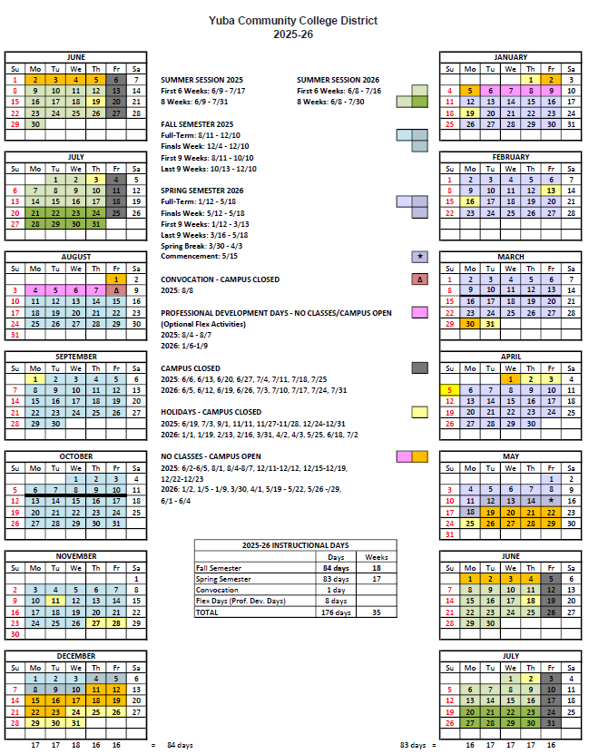

Appendix J: Map of Yuba College Campus
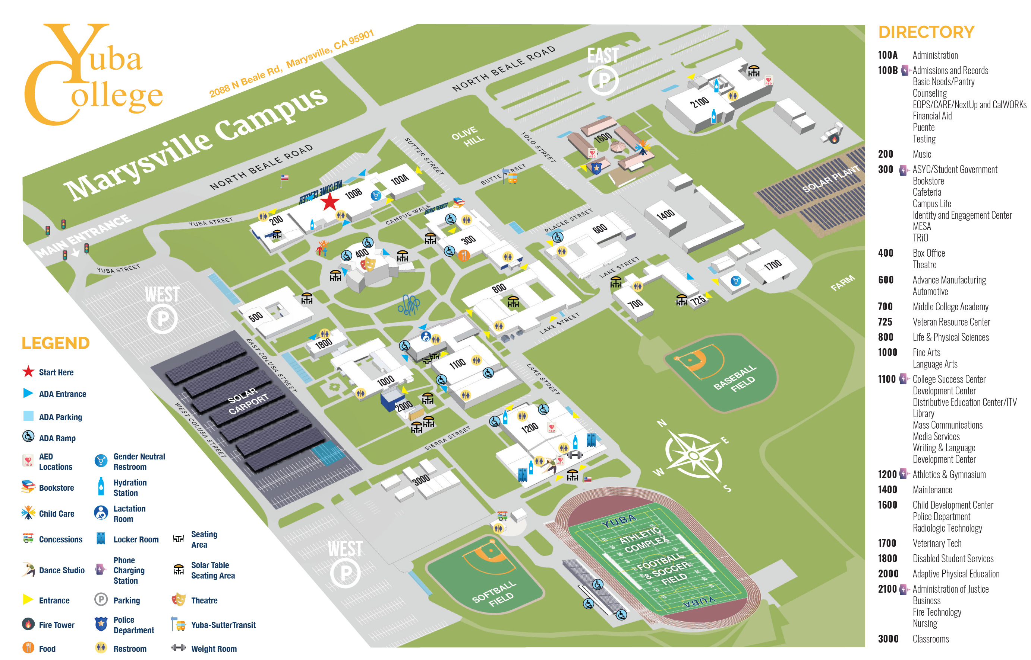

Appendix K: Historical Existing Yuba College Football/Soccer Field Information as a reference.

https://goyccd-my.sharepoint.com/:f:/g/personal/w0398409_yccd_edu/Egzscu6B3OZBvTVhkltYNbIB8KbNcjdZCoqPr2LvX6kTaA?e=MweHFo

.
The existing synthetic field is a SHAW (manufacturer) sports field.

Appendix L: New Proposed Synthetic Sports Field Manufacturers:
The design of this project will allow the District to pursue proposals with SOURCEWELL Contract COOP Pricing from the following Turf Manufacturers:
      - Field Turf USA
      - SHAW
      - AstroTurf
The following information is offered as the basis of design for the project and is an example using Field Turf USA specifications:
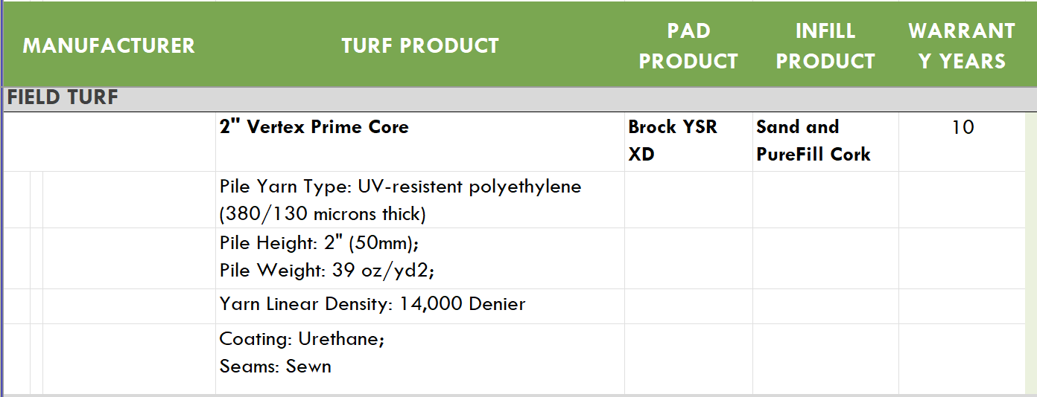
FieldTurf https://goyccd-my.sharepoint.com/:f:/g/personal/w0398409_yccd_edu/EuNcr1SSUOlHncXWxQt8i3cBdvQcuJ_1Za4LBWHzguM-tA?e=swPFn4USA
Reference sports field specification that may be used for the design documents for the new sports field turf:

SECTION 32 18 13

SYNTHETIC TURF PLAYING FIELD

PART 1 GENERAL

1.01 SCOPE OF WORK

- It shall be the responsibility of the successful turf contractor to provide all labor, materials, equipment and tools necessary for the complete installation of a synthetic grass material, as called out in the RFP and this specification section.

  - JOB CONDITIONS

- Contractor shall be responsible for reviewing the base and ensuring it conforms to the project requirements prior to placement of the synthetic turf.

- Playing field subgrade preparation shall be completed and accepted by the District’s Representative prior to commencement of Work under this Section.

1.03 REFERENCES

- ASTM Standard Test Methods:
1. D1335 - Standard Test Method for Tuft Bind of Pile Yarn Floor Coverings
2. D1577 - Standard Test Method for Linear Density of Textile Fiber
3. D2859 - Standard Test Method for Ignition Characteristics of Finished Textile Floor Covering
4. D4491 - Standard Test Methods for Water Permeability of Geotextiles by Permittivity
5. D5034 - Standard Test Method of Breaking Strength and Elongation of Textile Fabrics (Grab Test)
6. D5848 - Standard Test Method for Mass Per Unit Area of Pile Yarn Floor Covering
7. F355 - Standard Test Method for Shock-Absorbing Properties of Playing Surfaces.
8. F1015 - Standard Test Method for Relative Abrasiveness of Synthetic Turf Playing Surfaces
9. F1936 - Standard Test Method for Shock-Absorbing Properties of North American Sports Complex Field Playing Systems as Measured in the Field

- Current NCAA soccer rules and local Bay Valley Soccer League rules as applicable.

  - SUBMITTALS

- The turf manufacturer shall submit a project specific letter on the company letterhead certifying that the products of this section meet or exceed all specified requirements, and state that the installer has complied with the qualifications above and is certified by the manufacturer to install this type of synthetic turf.

- Submit Drawings for:
- Seaming plan.
- Installation details; edge detail, utility box detail, etc.
- Field Layout and Striping Plan (including field colors), including field line layouts (including colors), etc.
- The Turf Manufacturer shall submit color samples for approval for all color and/or logo work, including final electronic versions of artwork.

C. Certified copies of independent (third-party) laboratory reports on ASTM tests as follows:
1. Pile Height, Face Width & Total Fabric Weight, ASTM D5848
2. Primary & Secondary Backing Weights, ASTM D5848
3. Tuft Bind, ASTM D1335
4. Grab Tear Strength, ASTM D5034
5. Water Permeability, ASTM D1551
6. Flame Resistance, ASTM F1551
7. Tuft Yarn Tensile Strength and Elongation, ASTM D2256

D. One 12” square of the proposed product fibers, including one for each fiber color.

E. Submit a copy of the 10-year (minimum), prepaid, non-prorated, third-party insured warranty and insurance policy information.

F. PFAS Certification as called out in the RFP document.

PART 2 MATERIALS

2.01 INFILL SYNTHETIC TURF

- Shall be the following (50mm minimum tall PE fibers, extruded with both monofilament and slit film) preapproved product:
- FieldTurf Vertex Core, with infill rates of Cork (1.1 lbs) and Sand (4.5 lbs). Contact is Andrew Rowley, Reginal Vice President, Ph. No. (707) 586-8873.
- The preapproved products shall meet the following criteria at a minimum:
N/A Pile Yard type UV-Resistant Polyethylene
N/A Yarn Structure Dual Fiber (Ridged Monofilament
and Fibrillated Slit-Film)
ASTM D1577 Fiber Denier min. 14,000 (mono) / 5,000 (slit)
ASTM D3218 Tape Thickness (in microns) > 380 (mono) / > 130 (slit)
ASTM D2256 Yarn Breaking Strength min. 21 lbs
ASTM D5823 Pile Height min. 2.0” (50mm)
ASTM D5793 Stitch Gauge 3/4”
ASTM D5848 Pile Weight min. 39 oz/square yard
ASTM D5848 Total Backing Weight min. 21 oz/square yard
ASTM D5848 Total Weight (without infill) min. 60 oz/square yard
ASTM D1335 Tuft Bind (Without Infill) min. 8 lbs
ASTM D5034 Grab Tear (Width) min. 200 lbs/force
ASTM D5034 Grab Tear (Length) min. 200 lbs/force
ASTM D4491 Carpet Permeability >40 inches/hour
ASTM F355A Impact Attenuation (Gmax) <160
Infill Material Depth 1.25 inches (min.)

2.02 TURF PRODUCT REQUIREMENTS

- Sand shall be rounded silica sand and dust free. Coarse jagged sand will not be accepted. Sand shall have the following gradation:
Sieves (US Mesh Size) | % Retained
16 | 0
25 | 10-30
30 | 30-50
35 | 15-35
40 | 5-15
50 | <5
70 | <1

- The carpet shall be delivered in 15-foot wide rolls. The perimeter white and yellow lines can be tufted into the individual sideline rolls. The rolls shall be of sufficient length to extend from sideline to sideline. Head seams, between the sidelines, will not be acceptable.
- All field of play lines shall be inlaid or tufted. The sport’s field lines shall be conforming to USA Soccer and local little league requirements, or as noted in the RFP document.

- Thread for sewing seams of turf shall be as recommended by the Synthetic Turf Manufacturer.

- Glue for inlaying lines and markings shall be as recommended by the synthetic turf manufacturer. Seams between turf panels must be sewn. Inlaid markings may not be installed by means of cutting through the fabric and adhering the colored turf to a separate reinforcing tape or cloth. Rather, inlaid markings (that cannot be tufted into the fabric), shall be installed by means of shearing out the existing fiber and laying in a new piece of colored fabric into a bed of suitable “hot melt” adhesive placed directly on the original turf backing material. Systems that cut through the turf fabric for inlaid lines are not acceptable due to the fact that such a procedure shall weaken the structural integrity of the turf fabric backing.

2.03 MANUFACTURED POROUS CLOSED CELL COMPOSITE BASE AND SHOCK PAD MATERIAL

A. New pad shall be min. 1 inch thickness, and shall be one of the following brand / product (contact info is above):
a. Brock Power BaseYSRXD

2.04 PERMEABLE GEOTEXTILE FILTER FABRIC

- Geotextile Filter Fabric: Mirafi 140 N, or accepted equal, conforming to the following minimum specifications, unless otherwise recommended by the Geotechnical Engineer:
Property | Test Method | Typical Values
Grab Strength | ASTM D4632 | 80 lb.
Puncture Strength | ASTM D4833 | 25 lb.
Burst Strength | ASTM D3786 | 130 lb.
Trapezoid Tear | ASTM D4533 | 25 lb.
Permeability | ASTM D4491 | 0.1 cm/sec
Apparent Opening Size | ASTM D4751 | #50 Sieve size
Permittivity | ASTM D4491

2.05 SYNTHETIC TURF MAINTENANCE EQUIPMENT (GROOMER AND SWEEPER)

- Contractor shall supply one field groomer and one sweeper. Sweeper to have a debris collection attachment that shall pick up ¼" diameter (and larger) material, but leave infill material (i.e. sand and rubber). The groomer shall have plastic brushes and metal tines that are adjustable.

- Acceptable grooming product is Synthetic Turf Groomer w/ height adjustable front and rear multi-V brushes, central rotating tines, drag tines, and wheels.

- The field sweeper shall be LitterKat Synthetic Turf Sweeper by Greens Groomer with sports field magnet, or acceptable equivalent product.

PART 3 EXECUTION

  - GEOTEXTILE AND SHOCK/ DRAIN PAD PRODUCT INSTALLATION

- Contractor shall review field base and ensure planarity is acceptable. Once the planarity of the permeable rock base has been reviewed and accepted by the District and Verde Design, the Contractor shall install the geotextile material and shock pad product per the Contract Drawings and in strict compliance with the manufacturer installation instructions. Contractor to exercise extreme care in order to avoid disturbing the permeable crushed rock base.

- Contractor to take measures to ensure that the pad product is not exposed to the outdoor elements longer than the manufacturer’s recommendations. Any product that exceeds this time duration shall be removed from the project site immediately and not used on the project.

- All sections of the pad material shall be interlocked and/or connected to adjacent pieces of the pad material in strict conformance with the manufacturer’s written recommendations.
3.02 INSTALLING THE SYNTHETIC TURF SYSTEM PRODUCTS

A. Upon review and acceptance of the installed rock base by others, the Turf Contractor shall initiate the installation of all products shall be performed in full compliance with the reviewed and accepted product submittal.

B. Only trained technicians, skilled in the installation of athletic caliber synthetic turf systems working under the direct supervision of the approved installer/manufacturer supervisors, shall undertake any cutting, sewing, gluing, shearing, topdressing or brushing operations.

- The turf contractor shall strictly adhere to the installation procedures outlined in this section. Any variance from these requirements must be submitted to and accepted in writing, by the manufacturer’s onsite representative, and submitted to the District, verifying that the changes do not, in any way, affect the warranty.

- The surface must be perfectly clean as turf installation commences and shall be maintained in that condition throughout the process.

- The turf manufacturer and installation subcontractor shall inspect and accept the field base, and provide documentation to that effect, prior to the installation of the synthetic grass system. The surface must be perfectly clean as installation commences and shall be maintained in that condition throughout the process.

- The carpet rolls are to be installed directly over the properly installed manufactured shock pad material. No equipment with loads greater than 35 pounds per square inch (35 psi) shall be allowed on the field. As required, Contractor is responsible for altering operations in order to adhere to this requirement. Contractor and synthetic turf installer shall strictly adhere to the written instructions provided by the shock pad manufacturer for installing turf on top of their product. Contractor shall always make sure that those vehicles driving on the shock pad product are equipped with pneumatic (air-filled) tires, preferably turf tires. These tires are designed to spread loads and minimize damage to surface. Foam Filled or solid tires as well as tires with aggressive lug patterns should not be used on the shock pad, without synthetic turf installed. If possible, use of an A-frame for unrolling of the synthetic turf is strongly recommended. Extreme care should be taken to avoid disturbing the base, both in regard to compaction and planarity.

- Any cutouts in the synthetic turf shall be per plans. Coordinate all cutouts in turf with the District’s Representative before cutting turf for utility boxes or other structures.

- The full width rolls shall be laid out across the width of the field. Utilizing standard state of the art sewing procedures each roll shall be attached to the next. When all of the rolls of the playing surface have been installed, the sideline areas shall be installed at right angles to the playing field turf. GLUING OF ROLLS SHALL NOT BE ACCEPTABLE.

- The synthetic turf field shall utilize sewn seams. Minimum gluing will only be permitted to repair problem areas, corner completions, and to cut in any logos or inlaid lines as required by the specifications. Seams between turf panels must be sewn. Inlaid markings may not be installed by means of cutting through the fabric and adhering the colored turf to a separate reinforcing tape or cloth. Rather, inlaid markings (that cannot be tufted into the fabric), shall be installed by means of shearing out the existing fiber and laying in a new piece of colored fabric into a bed of suitable “hot melt” adhesive placed directly on the original turf backing material. Systems that cut through the turf fabric for inlaid lines are not acceptable due to the fact that such a procedure shall weaken the structural integrity of the turf fabric backing. All seams shall be sewn using double bagger stitches and polyester thread or adhered using seaming tape and high grade adhesive (per the manufacturer’s standard procedures). Seams shall be flat, tight, and permanent with no separation or fraying.

- Connections of the existing perimeter synthetic turf edges shall be completed by a manufacturer-approved adhesive or by industrial staples (min. depth embedment is one inch (1”) at maximum 2 inch (2”) on center staple spacing, whichever is appropriate.

- Infill materials shall be applied in thin lifts. The turf shall be brushed as the mixture is applied. The infill material shall be installed to a depth as specified in this section. The mix shall be uniform and even in thickness to assure proper playing characteristics.

- The infill materials shall be installed to fill the voids between the fibers and allow the fibers to remain vertical and non-directional. The infill shall be placed so that there is a void of ¾” to the top of the fibers.

- At near Substantial Completion of the synthetic turf fields, the turf contractor shall test for shock absorbency. The turf contractor and/or manufacturer shall pay for an independent testing laboratory accredited for such tests (who shall be pre-approved by the District). All testing and analysis of findings shall be completed by qualified persons utilizing correct techniques. The laboratory shall provide the necessary testing data to the District that verifies the finished field meets or exceeds the required shock attenuation. The G-max range shall be between 70 and 160 for the life of the warranty, as determined by the ASTM F355A and F1936 test procedures. Any test results that do not meet the requirements of this specification or if any one test value is greater than ten percent (10%) greater in variance as specified in 3.03-G, then the Contractor’s field installer shall address the failed test area, be required to retest the entire field as stated above, and conform to these requirements prior to the issuance of the Certificate of Substantial Completion.

3.03 MAINTENANCE & WARRANTY

A. The Turf Company shall provide the following prior to Final Acceptance and the District filing the Project Notice of Completion:
- The Turf Company shall provide the written warranty for the project per the minimum requirements identified in this specification section. Submit Manufacturer Warranty and ensure that forms have been completed in District's name and registered with Manufacturer and Insurance Carrier. Submit information confirming that the third party insurance policy, non-cancelable and pre-paid, is in effect covering this installation, and underwritten by a Best “A” Rated Insurance Carrier. Insurance carrier must confirm that the policy is in force and premiums paid.
- Three (3) copies of Maintenance Manuals, which will include all necessary instructions for the proper care and preventive maintenance of the turf system, including painting and markings.
- Project Record Documents: Record actual locations of seams and other pertinent information.
- Upon completion of the field installation, the Turf Company shall have a supervisory personnel provide a minimum one hour field training seminar per field with the District on how to care for the field. At a minimum, seminar shall include a demonstration of how to care for the field with the provided groomer / sweeper address use of the sweeper and groomer, review the entire provided maintenance manual (including the proper procedure for removal of gum and other debris) and answer any questions.
- Supply a field groomer and/or sweeper as specified.

- Turf Company shall be responsible for the testing of the G-max levels of the installed synthetic turf at the completion of the installation, as well at the completion of years two, four, six, and six months prior to the completion of year eight. If any of these tests do not fall within the G-max range as specified in this specification section, the Turf Company will be required to modify the field composition to the sole satisfaction of the District so that it falls within the target G-max range. All costs associated with such work shall be borne solely by the Turf Company and/or installer. Any failed test shall be retested to verify that the field meets the specifications. All testing shall be paid by the Manufacturer and/or installer. All testing shall be completed by an independent testing laboratory accredited for such tests, and shall be pre-approved by the District. All testing and analysis of findings shall be completed by qualified persons utilizing the required techniques outlined in the ASTM F355 test standard.

- Alternate: Turf contractor shall provide one maintenance service visit per year for the first three years of the 10 year warranty, then semi-annual visits for the remaining seven years of the warranty period as part of this proposal. Each maintenance service visit shall include the following:
- One (1) SMG Sportchamp grooming session including:
- A general sweeping to remove foreign objects such as dirt, leaves, bird droppings, gum and other debris that may collect on the field surface.
- A deep groom, sweep and rejuvenation to de-compact infill and in an effort to maintain appropriate G-Max levels, as well as clean the infill from deleterious matter contaminating the infill material. All accumulated debris and contaminating material shall be off-hauled and disposed of in a legal manner by the Turf Company.
- Minor repairs (sewing/adhesive failures, inlay separation, and general workmanship) as needed shall be completed by the Turf Company for items found relating to the synthetic surface.
- Overall analysis and inspection of the field and its applicable systems, including fiber wear analysis, ultraviolet degradation, infill depth and consistency, infill migration, field edging attachments, sewn and glued seams, line verification and field inserts (inlays).
- High wear areas (specifically the soccer penalty kick areas) are to be replaced up to four times (or every two years), at the discretion and request of the District.

End of Specification Section

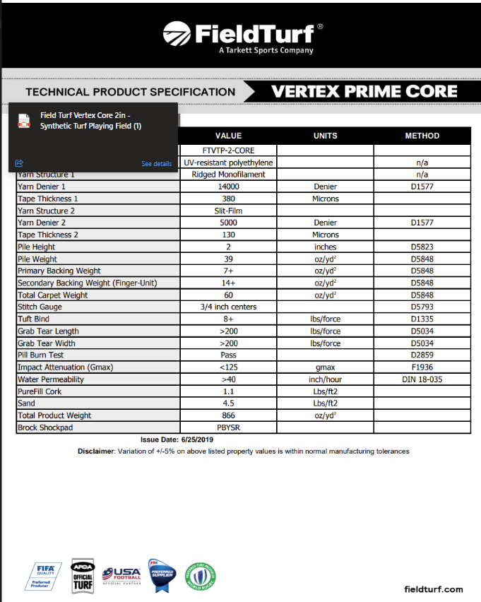
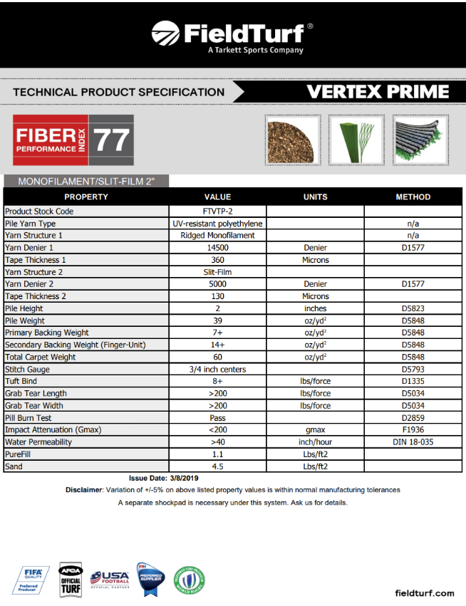
The District/College may elect to change the above specifications as part of the planning and designing process.

The District will likely generate three RFP’s for the three turf manufacturers listed above. The Architects proposal will include providing turf technical specifications, construction drawings and construction specifications for each manufacturer to inform the bidding of the field turf and other associated work.

The End.

