Addendum No. 1

RFP 25-11 YCCD Solar Systems, Maintenance, Repair and Operation
Date: 08/29/2025

Date: January 26, 2016

Clarifications:

- Question: Re: vegetation abatement, would the District be comfortable with a proposal that includes mowing, but leaves spraying on a T&M basis as needed?
Answer: No. Please provide a fixed price for the multiple vegetation spraying applications each year. Include all areas within the fenced boundaries of the solar field.
- Question: Re: pest mitigation, can the District please clarify what pests we should be addressing? Rodents at the ground mounts? Other?
Answer: Yes, certainly rodents at the ground mounted systems. Also mitigate the hornet nests in equipment or near wiring or that would impact the tracking systems. Mitigate bird and other pests nests if present.
- Question: What areas exactly should be mowed?
Answer: Include all areas within the fenced boundary of the solar field. At Sutter, this includes the storm water catch basin. Include the perimeter areas that extend to the fencing. At Woodland Community College, this includes the area to the west of the solar PV arrays to the fence. At Yuba College, this includes all of the areas within the fenced areas where the PV arrays are located and where the inverters are located.

- Question: Request for clarification on the specific systems to be included and excluded from this RFP response.

Answer: All of the systems in the following table are included in this RFP scope of work. Provide an additive alternate to provide the needed maintenance for the Tesla Battery Storage Systems at Woodland Community College and at Yuba College.

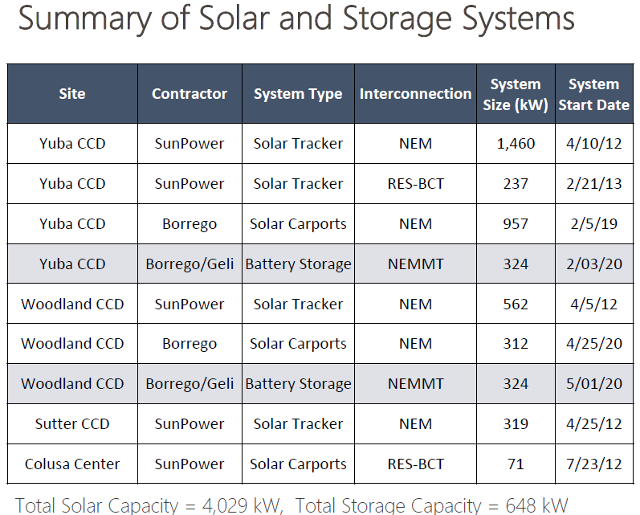

- Question: Can the District please clarify whether the maintenance of the battery energy storage systems installed at Woodland Community College (Phase II) and Yuba Community College (Phase II) should be included in our RFP response?
Answer: Yes, please provide an additive alternate proposal to provide the required maintenance services for the Tesla Lithium Battery Storage Systems. The base bid of the maintenance, repairs, and operations services shall not include the proposal for the Tesla Lithium Battery Storage System. The District may aware all of the Maintenance, Repairs, and Operations services and Additive Alternate for the Tesla Energy Storage Systems or may elect to split this up and award the Maintenance, Repairs, and Operations services to one Firm and the required maintenance of the Tesla Lithium Battery Storage System to another Firm. Provide certification and experience information of the Firm in maintaining Tesla Lithium Battery Storage Systems with the proposal.
Link to Tesla Lithium Battery Storage Systems information:
https://goyccd-my.sharepoint.com/:f:/g/personal/w0398409_yccd_edu/EmPs85NhyVNBvabZSBK4IcYBxlTXyDhtvP1e_oUbZdQ8Dg?e=18rqaO

- Question: The RFP Document and Appendix A appear to differ in their proposal delivery method requirements. Can the District please clarify whether the requirement is to email or mail in the proposal?
Answer: Yes, please deliver one hard copy of the proposal that is signed and notarized to my office by the due date and time. Also, please provide a flash drive with your proposal on it with the hard copy. Please also email David Willis at dwillis@yccd.edu a copy of the proposal.

- Question: The RFP Document and Appendix A appear to differ in their requirements for pricing in as-needed corrective maintenance. The RFP Document appears to suggest that corrective maintenance costs will be structured under a separate contract, assumed to be a Time & Materials based agreement. The Appendix (Exhibit B) specifies a requirement to include all corrective maintenance costs in the scope and fees of this proposal. Can you please clarify which direction we should take in preparing this proposal?
Answer: The repairs / corrective maintenance items that are identified need to each be submitted to the District as a lump sum fixed cost work order for review and approval on a case-by-case basis. Do not include general repairs costs in the proposal. Please refer to the updated Bid Form Spreadsheet shared in the answer to question number 11 below.

- Question: The scope in Appendix A states that “All parts and labor shall be included in Service Firm’s costs, except for the following originalequipment manufacturer items: Modules, Inverters, Tracking system drive motors, Structural steel”. Would the District consider allowing for proposals to be provided on a Time and Materials basis at a committed hourly rate for labor and fixed markup for materials?

Answer: Please see question number 7. Work orders will be submitted with fixed price costs and a full description of what is being repaired. If however, the repair is not easily determined, then, in these cases, it may be required that a T&M proposal work order be provided. The District would like as many things to be fixed price quotes for repairs as is reasonably possible.

- Question: Our service agreement proposals do not include costs for repair work. All repair work is quoted separately at T&M rates, as needed. No repair budget is included in the service agreement; it covers preventative maintenance only. Will this arrangement be acceptable for the contract?

Answer: Refer to question number 8.

- Question: Is this RFP being conducted under the Foundation of California Community Colleges process, or is it independent of that program?
Answer: It is independent of the Foundation of California Community Colleges processes and program. If there is however an agreement in place through the College Buys program, you may choose to reference it in your proposal with the associated pricing information and support documentation. The Base Bid and Additive Alternate scope and costs need to be included in your proposal.
- Question: Please clarify the expected scope of work for pest control. We have only observed a stinging insect issue at Woodland and are unsure of the broader pest control needs. Since we do not provide in-house pest control, we would subcontract this work to licensed professionals, and we need a defined scope in order to include accurate service pricing.
Answer: Provide quarterly inspections and removal of all hornet nests, bird nests, mice nests, and anything that a pest may have built that would interfere with or compromise any of the operations of the systems. This service applies also to all PV arrays, wiring harnesses, tracking equipment and control cabinets, monitoring equipment and cabinets, and inverters and all other associated equipment and wiring. Refer to the updated Bid Form in this shared folder, under 1. Annual Maintenance Services (Excluding Washing and Vegetation Management), number 6 in the description of services.
Link:
https://goyccd-my.sharepoint.com/:f:/g/personal/w0398409_yccd_edu/Eq71UK5QXvNFgFb2i8PUetoBzQkYBMOc4Of2MtUAAZzxFw?e=ajurVC

- Question: Will the District provide historical maintenance records (e.g., panel washing frequency, vegetation growth cycles, and repair history) to help us develop the annual service schedule?
Answer: No. Please follow the instructions regarding frequency on the Bid Form. Reference question no. 11 link to the updated Bid Form.
- Question: Are there specific requirements for vegetation management, including herbicide use, native plant protection, or seasonal mowing schedules? If herbicides are required, is a campus permit necessary for application?
Answer: The District is not specifying the specific herbicide to be used to control vegetation. The Contractor shall submit the proposed chemicals to be used and acquire any required permits, and utilize certified licensed applicators. There are no known native plant protection requirements. The application of the spraying must closely follow after the mowing is completed at each location.
- Question: What is the mowing and spraying frequency?

Answer: Mow all solar fields within the fenced areas three times per year in late April, June, and September. Spray for weeds in all areas that are mowed within 2 weeks after mowing services are completed.

- Question: Are there campus access restrictions or blackout periods beyond the normal operating hours, such as events or activities we should plan around?
Answer: Yes, please refer to the academic calendar in the shared folder below. Please also do not clean carport mounted solar panels Monday through Thursday when classes are in session. The services provider shall block off the carport areas to be cleaned the day before with barricades, barricade tape, and signs to keep people from parking below the carport structures. Do not plan to conduct these services on commencement (graduation) ceremony day in May. Fridays are best when planning to complete carport PV array cleaning. The cleaning and mowing of the ground mounted systems can be done anytime but should be coordinated at least 7 days in advance with the College.
Link to 2025/2026 Academic Calendar:
https://goyccd-my.sharepoint.com/:b:/g/personal/w0398409_yccd_edu/EdhTW1xidzRKnkh75Jm1tpcBSQAUCAJMrp2wrWu3IG4VJw?e=md3qWr

- Question: Additionally, it is uncommon for my Firm to provide bid bonds for projects other than new solar construction. Could you please confirm whether this is a firm requirement for the solar maintenance service agreement, or if it may have been language carried over from a construction agreement that does not apply to existing system maintenance?
Answer: The bid bond is required only for the pro-rated proposal from November 1, 2025 through June 30, 2026 amount. Performance and Payment Bonds are not required for this RFP. Repairs that do exceed $25,000 do require a Performance and a Payment Bond. These repairs will be awarded on a case-by-case basis.

- Question: If I have questions after the RFI process, what should I do?

Answer: List any exclusions or exceptions or clarifications to the services provided in the proposal. Proposals that have an excessive number of exclusions or exceptions may be rendered unresponsive by the District.

- Question: Once the District has qualified the firms and evaluated the proposals what agreement shall be used to award the contract?
Answer: The District will utilize it’s Agreement for Services (AFS) to award the contract. Please review the agreement.
https://goyccd-my.sharepoint.com/:f:/g/personal/w0398409_yccd_edu/EhWt0wOhOZREvH2pu13N72wBzQA6f79Hr9NXFNyMERqJfg?e=1YCjid
This agreement is optional at the time of the proposal submission.
The successful Firm will be required to provide this agreement within 7 days after it is requested by the District. The CAFS can be red-lined to remove items that do not apply to the specific services provided. Firms are encouraged to submit their respective certificate of insurance and w-9 forms with the proposals to speed up the award process. Firms are also required to submit the CUPCCAA forms per section 18 of the RFP.
- Comment: The District has awarded a Firm to conduct a thorough technical inspection of the solar systems throughout the District and to make recommendations for repairs. Some of the Solar systems in the District are Off-Line and the District would like to restore functional operations at the earliest possible date and time. It is hopeful that the solar systems will all be functioning normally by November 1, 2025. RFP 25-11 scope of repairs will be limited to repairs that are needed from that point forward as components fail or need repair/replacement.

- Please also ensure that your proposal includes prevailing wages, list of subcontractors and service providers with references for the subcontractors and service providers, DIR registration numbers for subcontractors and service providers, contractor licenses, and credentials for service technicians, service managers, and other service team members that will be supporting the work of the RFP service agreement.

- Please also provide any recommendations that you are aware of that the District should consider regarding our existing solar systems and battery energy storage systems.

- The last day for RFI’s is September 11, 2025.

The End.

