

Request for Proposal
Yuba Community College District

ADA Accessibility Transitional Plan Update
Architectural Services

No. RFP 25-12

Issue Date: August 15, 2025
Proposals Due: September 22, 2025

RFP Due Date: September 22, 2025, 1:30 PM Sharp, Yuba College Location Delivered To:

Yuba Community College District, District Offices
Attn.: David Willis
District Director of Facilities Planning, Maintenance & Operations
RFP No. 25-12vYCCD ADA Accessibility Transitional Plan Update, Architectural Services
Address: Sutter County Campus, Second Floor, District Offices, Attention: David Willis, 3301 East Onstott Road, Yuba City, California 95991

Proposal Delivery at Second Floor
Yuba Community College District
Sutter County Campus
District Offices
3301 East Onstott Road (second floor)
Yuba City, California, 95991

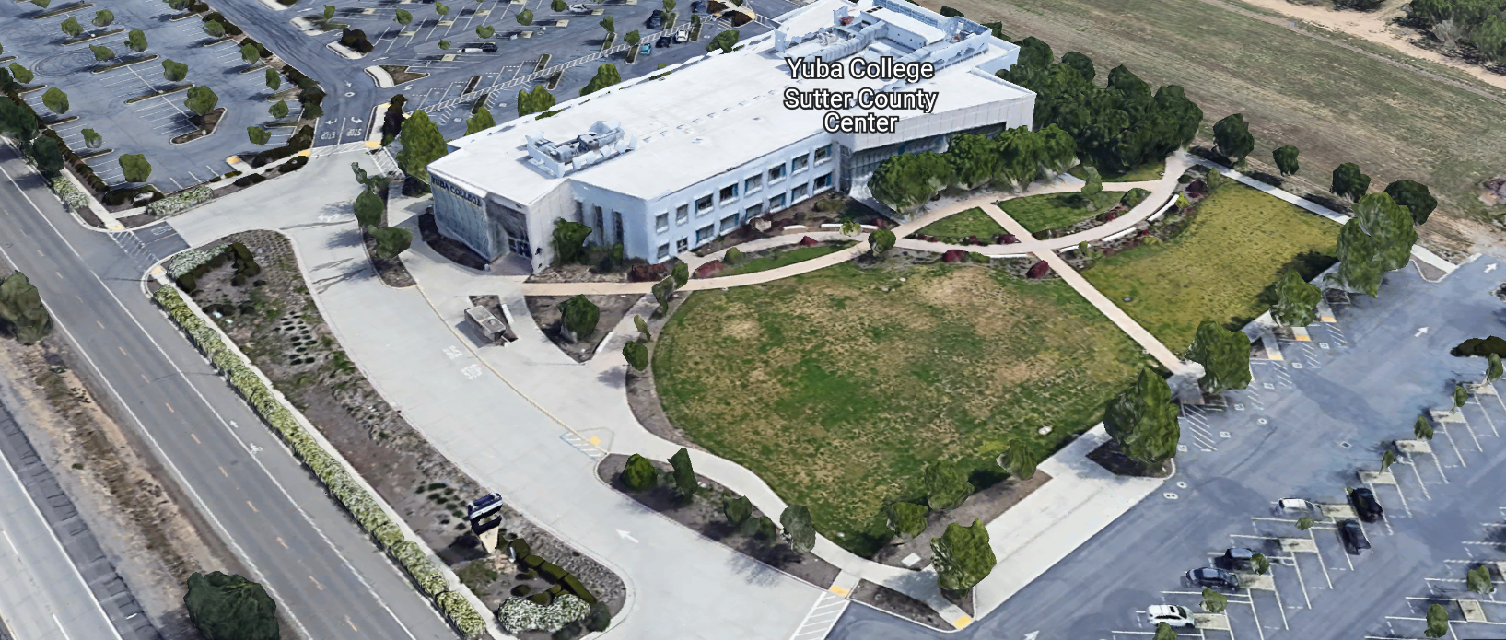
West Building Entrance
TABLE OF CONTENTS

1.0 INTRODUCTION
1.1 District Information
1.2 Yuba Community College District Background
1.3 Purpose of the Request for Proposal (RFP)
1.4 Applicable Codes
1.5 Prevailing Wages (Only if required by the Department of Industrial Relations)
2.0 ADA Accessibility Transitional Plan Projects Summary
2.1 YCCD College Locations
2.2 District Staff Contacts during Proposal Process
2.3 Fiscal Stability
2.4 Preliminary Schedule
3.0 Proposal Format Organization
3.1 Proposal Delivery, Contents, and Format
4.0 Selection of “Firm”
5.0 Basis of Award
6.0 Non-Discrimination
7.0 Response to Request for Proposal (RFP)
8.0 Requests for Information (RFI)
9.0 Proposal Schedule
10.0 Evaluation of Proposals Form
11.0 District Parking- No Fees
12.0 RFP Proposals
13.0 Award of Contract/Proposal
14.0 Reservation of Rights
15.0 Bid Bond Requirements (not applicable)
16.0 Performance Bond, Payment Bond Requirements (not applicable)
17.0 Liquidated Damages
18.0 Protest Procedure

Proposal Required Items:

Appendix A, Proposal Bid Form
Appendix B, Statement of Qualifications
Appendix C, Acknowledgement of Addenda Form
Appendix D, Non-Collusion Affidavit Form
Appendix E, YCCD Professional Services Agreement, PSA (Can be provided by Successful Firm, not required on proposal due date)
Appendix F, Signature Proposal Form
Appendix G, Architectural Firm References (At least 10 Recent Up to Date References Required)
Appendix H, ADA Accessibility Plan Approach, Preliminary Schedule, List of sub-consultants and Cost Estimating Firms and credentials/experience in the region, Architectural License, Engineering Licenses, CASp credentials, other credentials.

Informational Items:
Appendix I: YCCD Academic Calendars
Appendix J: Map of Yuba College Campus and Woodland Community College Campus.
Appendix K: Background Project Information

1. INTRODUCTION

  - District Information:

The District consists of two colleges, Woodland Community College and Yuba College, with campuses located at five different locations: Yuba College in Marysville, CA; Sutter County Campus in Yuba City, CA; Woodland Community College in Woodland, CA; Colusa County Center in Williams, CA; and Lake County Campus in Clearlake, CA.

  - Yuba Community College District

The Yuba Community College District (YCCD) was founded in 1927 and spans eight counties (Yuba, Sutter, Colusa, Yolo, Lake, Butte, Glenn and Placer) and nearly 4,200 square miles of territory in rural, north-central California. It has colleges in Marysville and Woodland, a College campus in Clearlake, an educational center in Williams, and a College campus in Yuba City.

  - Purpose of Request

The purpose of this Request for Qualifications and Request for Proposals is to solicit proposals from qualified firms to generate updated “Accessible Transitional Plans” for the following:
- Woodland Community College Campus, including:
  - Lake County Campus
  - Colusa County Center
- Yuba College Campus, Including:
  - Sutter County Center

The District requests the submission of Request for Qualifications (RFQ)/ Request for Proposal (RFP) from qualified firms, partnerships, corporations, associations, or professional organizations to provide Architectural/Engineering (A/E) services to the District for, but not limited to, those types of projects described in this RFQ and associated documents.
The District reserves the right to cancel or to amend this RFQ/RFP by issuance of addenda.

  - Applicable Codes
All Accessibility Transitional Plan Updates shall meet all State of California Building Codes, and Federal codes, and local ordinances. All ADA Title II, SB 1186, AB 1186, Title 24, Ed Code 17309, and other associated codes and regulations apply. It is the Districts intentions to support and plan additional accessibility improvements as resources are made available. Having fully accessible, safe, healthy, and welcoming high quality learning environments for all students is a core value for the District. The following list of codes applies but is not all inclusive:
- ADA Standards California Building Code
- UFAS
- ANSI
- Section 504 of the Rehabilitation Act
- Outdoor developed and recreational standards
- National Playground Safety Institute (NPSI) standards
- PROWAG – Federal Public Rights-of-way Guidelines
- Federal Highway Administration’s Manual on Uniform Traffic Control Devices (MUTCD)

  - Prevailing Wages (only if required by the Department of Industrial Relations):
It is the understanding of the District, that Architectural services are exempt from prevailing wage requirements in California. If this is not the case, include all required prevailing wages in your proposal. If required, the District will generate a project number with the Department of Industrial Relations and provide it so that the Firm can upload all certified payroll as required. Certified payroll records, if required by DIR will be required for the full scope of this work to the District with the Final progress payment application.
The purpose of this Request for Qualifications and Request for Proposals is to solicit proposals from qualified firms to generate updated “Accessible Transitional Plans” for the following:
- Woodland Community College Campus, including:
  - Lake County Campus
  - Colusa County Center
- Yuba College Campus, Including:
  - Sutter County Center

The District requests the submission of Request for Qualifications (RFQ)/ Request for Proposal (RFP) from qualified firms, partnerships, corporations, associations, or professional organizations to provide Architectural/Engineering (A/E) services to the District for, but not limited to, those types of projects described in this RFQ and associated documents.
The District reserves the right to cancel or to amend this RFQ/RFP by issuance of addenda hereto.

2.0 ADA Accessibility Transitional Plan Projects Summary
Yuba Community College District is committed to complying with the tenets of Title II of the Americans with Disabilities Act (ADA), Section 504 of the Rehabilitation Act, and other applicable Federal and State regulations and statutes to provide public programs, services, and activities to persons with disabilities. YCCD is a resource challenged District that is committed to making prioritized phased-in improvements to address needs, and ensure the best possible accessible and safe spaces and campus’s possible.
The Firm shall prioritize the ADA Transitional Plan items based on the impact to access accommodation severity and frequency of potential need, and importance of safety, security, or other regulatory criteria, and best practices in higher education College and University campus facilities. The prioritization and cost information on each item will be considered when planning future facilities improvements. Include photos, written description and reasoning for the item, and reference to regulatory requirements.
Yuba Community College District is requesting “Firms” with CASp Certified Inspectors that are fully knowledgeable of applicable codes and regulations to provide a “Statement of Qualifications” and a proposal to conduct an ADA Title II Self Evaluation and Update to the 2009 Accessibility Transitional Plans for each College and campus location. All requirements of Section 504 of the Rehabilitation act of 1973 shall be incorporated into the study and updates. An Executive Summary of the findings, combined with a summary of work completed by the District since 2009. The revised and updated Accessibility Transitional Plans shall prioritize the needed upgrades by severity, impact to students and staff, and list estimated costs with associated pictures. Consideration shall be made regarding access to campus sites, programs, services, activities, and events by individuals with disabilities in order to determine if any discriminatory or potentially discriminatory practices, policies, or procedures exist as required by the ADA or Section 504.
The Architectural Firm will need to include a cost estimate for each project by a local Certified and Qualified Cost Estimating Firm of each of the items in the Updated Accessibility Transitional Plan. If the Architecture Firm has the ability to provide a rough order budgetary cost estimate for each item based on a database of relevant recent projects in the region, then this approach may be used to provide cost estimates for the projects. Provide cost estimator credentials with the proposal. Cost Estimates through a local/regional certified cost estimating Firm shall be provided for all items identified in the 100% ADA Accessibility Transitional Plan and sub-totaled by building and by College Campus location, and by College. Cost estimates shall include all normally required contingencies. Cost estimates shall be based on either recent project work or RS Means locally adjusted cost data where actual project costs are not available.

2.1 YCCD College Locations
Woodland Community College Campus
2300 E. Gibson Road, Woodland, CA. 95776
Colusa County Center
99 Ella Street, Williams, CA 95987
Lake County Campus
15880 Dam Road Extension, Clear Lake, CA 95422
YUBA College Campus
2088 North Beale Road, Marysville, California, 95901
Sutter County Campus
3301 E. Onstott Road, Yuba City, California 95991
2.2 District Staff Contacts during the Proposal process:
Firms interested in submitting a Proposal are directed not to make personal contact with the Board of Trustees, District staff, or members of the evaluation committee. Any contact shall constitute grounds for disqualification from consideration.
Single Point of Contact during the Proposal Preparation Process:
Yuba Community College District
Yuba College, Sutter County Campus
District Offices, Second Floor, Room 217, Attention: David L. Willis
3301 East Onstott Road
Yuba City, California, 95991
Cell Phone: 916-747-4262
Email: dwillis@yccd.edu

On-site coordination, first contact person (Yuba College, Sutter Campus Locations):
Bryan Epp
Assistant Director of Maintenance, Operations
2088 North Beale Road
Marysville, California, 95901
Cell Phone: 530-701-9202
Email: bepp@yccd.edu

On-site coordination, first contact person (Woodland Community College, Lake County Campus, Colusa County Center Locations):
Brian Splaine
Assistant Director of Maintenance, Operations
2300 East Gibson Road
Woodland, California, 95776
Cell Phone: 530-812-5866
Email: bsplaine@yccd.edu

Preliminary Scheduled Meetings Plan:

Planning Phase:

- On Campus Pre-Planning Online Meeting (1 hour)
- On Campus Investigations of Existing Campus Conditions:
  - List number and duration of these meetings for each campus location in your proposal to ensure that all existing conditions are addressed. The District does not have accurate as-built drawings of the existing buildings.
- 50% Plan Review Meeting with the District (2 hours)
- 75% Plan Review Meeting with the District (2 hours)
- 95% Plan Review Meeting with the District (2 hours)
- 100% Accessibility Transitional Plan Presentation to the District Board Facilities Committee (1 hour)
- Four (4) other meetings of up to 2 hours long to review the ADA Accessibility Transitional Plans with College Leadership at each College and/or with the Chancellors Cabinet.

2.3. Fiscal Stability: The Firm should provide evidence of Corporate/Firm stability including:

1. A current report from any commercial credit rating service such as Dun and
Bradstreet or Experian; or
2. A letter from a financial institution stating a current line of credit; and
3. Latest audited financial statement and/or annual report that has been certified by a CPA.

2.4 Preliminary Schedule
Approximate Award Date: October 24, 2025
All On Campus Investigations of Existing Conditions Completed: February 13, 2026
50% Plan Review: June 30, 2026
75% Plan Review: August 28, 2026
95% Plan Review: September 25, 2026
College Reviews with Comments for Consideration: October 23, 2026
100% Plan Completion: November 10, 2026
Note: These are initial target dates. The draft schedule will need to be provided with the proposal and will be subject to review and approval by the District/College.

3.0 Proposal Format Organization
The Firm is requested to use the following proposal format:
3.1. Proposal Delivery, Contents, and Format:
Proposals should provide straightforward, concise information that satisfies the requirements noted in this RFP. Expensive binding, color displays, and the like are discouraged. Emphasis should be placed on brevity, conformity to the Districts instructions, selection criteria of this RFP, and completeness and clarity of content. Each Respondent’s proposal should clearly and accurately demonstrate specialized knowledge and experience required for consideration.
In a sealed box or envelope (clearly marked “), submit the following:
- One (1) flash memory stick containing the complete proposal and supporting documentation;
- One (1) original signed hard copy in paper form of the proposal, which consists of a Proposal Letter and responses to the proposal requirements of this RFP.
- Please also email the proposal to David Willis, email: dwillis@yccd.edu by the due date and time.

There is no page limit.

Firms must comply with the provisions of these instructions for completion and submission of the Proposal. The failure of a Firm to comply with the Proposal Instructions and Requirements will likely result (at the sole discretion of the District) in rejection of the Proposal for non-responsiveness.
Proposal Section | Format
- Cover Letter | PDF
- Table of Contents | PDF
Appendices (See Table of Contents for each one) Submit a response to each Appendix that requires Firm information. Please submit responses to Appendices A, B, C, D, E, F, G, and H. Appendices I, J, and K are informational only. | PDF

Proposal General Information Contents:

The information requested will help the District determine if the Firm is a “Responsible Proposer”.

Cover Letter

The Proposal shall include a Cover Letter on Respondent’s official business letterhead, which shall be signed by an individual authorized to legally bind Respondent. The Cover Letter shall also identify the name, telephone number, and email of a person who may be contacted during the Proposal evaluation process.

Table of Contents

Provide a Table of Contents that outlines in sequential order the major sections and sub-sections of the Proposal. Use tabs to allow information to be more easily located.

4.0 Selection of “Firm” Services Provider

The process of “Firm” selection is based upon the complete responsiveness of the RFP and the criteria as outlined in the RFP.

The District Project Evaluation Team will read the written proposals. The District Evaluation Team will discuss the proposals and verify that the “Basis of Award” information below, the Statement of Qualifications, and information submitted in response to the RFP are complete and responsive.

Process Summary:

- Evaluation of the Statement of Qualifications, and prequalification of Firms
(Note: If a Firm is not pre-qualified, their proposal will not be considered)
- Review Proposal
- Interview with Firm—if determined to be required by the District.
- References Check. Firms must have good references in meeting schedules, provide complete design packages that minimize change orders to less than 10%, and have positive references regarding services provided.
- Selection of most qualified, cost-effective comprehensive proposal which includes all needed and requested services as described in this RFP.

The District reserves the right to reject any or all proposals, to amend the RFP process, and to discontinue or re-open the process at any time. The District reserves the right to request clarifications to RFP responses and to negotiate the terms of the agreement. The District reserves the right to waive any minor issues, typo’s, etc., with the proposals.

5.0 Basis of Award

These services will be awarded based on “Best Value” with regard to the following criteria:

- Lowest Total Cost Responsive Qualified Proposer
- Statement of Qualifications Evaluation, Interview, resulting in Prequalification.
- Proposal Review, Complete and Comprehensive, and Lowest Total Cost.
- Reference Checks
- Fiscal Accounting Statements of the Firm.
- Other Factors Considered in the above process:
  - Project Team, Credentials, Time Commitment
  - Proper State of California Architects License in good standing
  - Information provided as requested in the RFP.
  - All Addendums are acknowledged.
  - Architectural Firm’s exceptions or exclusions.
- Architectural Firm with historical good performance on YCCD projects regarding minimal number and cost of change orders, maintaining project schedules and completing the work promptly, and overall quality of work.
  - Architectural Firm’s ability to meet the District’s schedule requirements.
  - Architectural Firm has demonstrated past project references of “like” projects and/or services.
  - Architectural Firm’s references are all very good with respect to schedule, cost, and quality of services.
  - Architectural Firms thorough due diligence in doing on campus site investigations of existing conditions and including the District’s requests in the scope of work.
  - Architectural Firm’s inclusion of District standards regarding equipment brands and manufacturer’s exclusively and not allowing “equals” in the project specifications.
  - No other factors such as litigation, licenses not in good standing, bankruptcy, or other similar criteria.

The one or two of the best qualified and lowest total cost responsive proposer’s that are providing “Best Value” to the District may be requested to participate in a ZOOM interview process with the District Project Proposal Evaluation Team. If an interview process is determined to be needed, the District will provide questions and clarification requests regarding scope of work and other matters. The interviews will be scored and become part of the overall “Best Value” determination process. The District Evaluation Team will solely determine which Firm and proposal provides “Best Value” to the District. The District Evaluation Team evaluation analysis will use the criteria in the RFP and will remain confidential information.

6.0 Non-Discrimination

The District does not discriminate with regard to race, color, gender, national origin, disability, or any other protected or other classification in the awarding of contracts/agreements. The District welcomes all Qualified Firms to participate in the project Request for Qualification/Proposal process.
The District encourages firms that are women or minority owned, emerging small businesses, veteran owned firms, disabled person owned firms, and all other qualified firms to participate in the proposal process.
The District encourages the submission of proposals from all Firms that can meet the stated requirements set for this RFP.
7.0 Responses to RFP:
Sealed responses to this RFP must be clearly marked "RFP No. 25-12 “YCCD ADA Accessibility Transitional Plan Update -Architectural Services”.

Responses shall be mailed to or hand-delivered to the following address:

Yuba Community College District, District Offices
Attn.: David Willis
District Director of Facilities Planning, Maintenance & Operations

Envelope/Box Marked:
"RFP No. 25-12, YCCD ADA Accessibility Transitional Plan Update -Architectural Services”.

Address: Sutter Center, District Offices, Second Floor, Room 217, Yuba City, California, 95991

Note: Completely seal your proposals in envelope/box and make sure it gets date/time stamped when delivering proposal. Firms are each 100% responsible to make sure proposals that are mailed using a carrier such as UPS, FED Ex, etc…are received and date/time stamped by District personnel prior to the proposal due date/time. No proposals will be considered if they are late, even if it is only 5 minutes late. Please make sure your proposals are delivered and received promptly prior to the due date/time. There will be a public proposal opening at the due date/time.

Do NOT email your proposals. Emailed proposals that are not sent per the above guidance requirements will not be considered.

8.0 Requests for Information (RFI)

Requests for Information concerning the RFP must be in writing and may be submitted via email no later than the date shown below. Please direct all questions to David Willis, email: dwillis@yccd.edu.

Following the RFI deadline, all questions and answers will be summarized and posted on the District's website: https://www.yccd.edu/district-services/requests-proposals-quotes/ , as part of an issued Addendum to the RFP.

- Include the following in the subject matter field on emails when requesting information: “RFP 25-12”, RFI.

9.0 Proposal Schedule:

Important Dates and Times:

August 15, 2025: Release of Request for Proposal at 1:00PM

August 26, 2025: 11:30 AM Optional ZOOM Pre-Bid Meeting:

Join Zoom Meeting

https://yccd-edu.zoom.us/j/89693186484

Meeting ID: 896 9318 6484

One tap mobile
+16694449171,,89693186484# US

August 28, 2025: 2:30PM to 3:30:PM Optional On-Campus Pre-Bid Meeting in Building 1400, Maintenance Conference Room, then tour campus. Yuba College, 2088 North Beale Road, Marysville, Ca., 95901.

There are no mandatory pre-bid meetings.
If you need to visit the campus during an alternative time/date, please coordinate with Bryan Epp at 530-740-1722 or bepp@yccd.edu If you are meeting at another time/date, you must sign and fill out a login sheet to have the meeting count for your Mandatory meeting as noted above.
September 5, 2025: 2:00pm to 3:00PM Optional On-Campus Pre-Bid Meeting, Building 100, Room 113, then tour campus. Woodland Community College Campus, 2300 East Onstott Road, Woodland, California 95776.
If you need to visit the Woodland Community College campus at times other than listed above, please contact Brian Splaine at bsplaine@yccd.edu.

Since the Lake County Campus and the Colusa County Center are small in size, there is not a scheduled optional on campus meeting at these locations. You are however welcome to visit these locations by coordinating with Brian Splaine.

September 10, 2025: 5:00 PM, All questions and requests for information must be submitted to David Willis at: dwillis@yccd.edu.

September 12, 2025: 5:00 PM, Addendum Issued if needed.

September 22, 2025: Proposals due at 1:30 PM SHARP, Yuba Community College District, District Offices Location: Sutter Center, District Offices, Second Floor, Room 217, Attention: David Willis, 3301 East Onstott Road, Yuba City, Ca., 95991. There will be a public bid opening on this RFP in room 211 at the Sutter Center Building.

All procurement documents are posted at this link: https://www.yccd.edu/district-services/requests-proposals-quotes/

10.0 Evaluation of Proposals Form

Firm: .

Proposals will be evaluated and include a careful review of the proposals and the ability of the firm to perform cost effective solutions as described in this request, including reference checks of the firm doing the work. This RFQ will be evaluated by a District Facilities Evaluation Team and awarded based on a number of factors which are described below:

Evaluation Criteria:

- Firm Statement of Qualifications: 25 Points
- Fee Proposal: 30 Points
- Architect’s Team Qualifications (CASp Certified Inspectors) 20 Points
- “Like” Accessibility Plan References: 15 Points
- Division of the State Architect (DSA) Experience: 10 Points
Total Score: /100 Points

Comments:

Evaluator Name (Print): . Evaluator Signature: .
Date: . Recommendation to Award Yes/No:
The District may negotiate terms with the most qualified Firm that provides the “Best Value” and most advantageous proposal for the District. The lowest cost proposer may not be awarded the project, at the full discretion of the District.

The Top 1 or 2 Best Qualified Firms may be interviewed by the District, at the District’s discretion. The interview will have a 100-point value with questions developed after reviewing the proposals.

District Team evaluation processes will utilize the criteria of this RFP and remain confidential.

11.0 District Parking: No Fees

12.0 RFP Proposals

Proposals received after the deadline date and time will not be opened. Each responder shall submit one (1) signed original written paper copy, in separate binders. Provide one electronic format copy of the proposal using electronic media such as a flash drive. (No CD formatted Disks).

All materials submitted in response to the RFP shall be on 8-1/2"x11" paper, preferably in
Portrait orientation. All submitted materials must be bound in either a three-ring binder or spiral bound notebook. Content shall be tabbed and numbered per the items included in the Submittal Requirements. All Proposals will be reviewed and evaluated by a District Selection Committee. The District at its sole discretion may interview finalists or select a firm or firms to perform work based solely on the evaluation of the Proposal. There is no page limit.

All Firm Proposals become the sole property of the District and the content will be held as confidential.

13.0 Award of Contract

- The Contract will be awarded based on a “Best Value” approach that includes the factors and criteria in section 5 of this RFP.

- The District reserves the right to enter into an Agreement without further discussion of the proposal submitted based on the initial offers received.

C. The District reserves the right to reject any or all proposals or any part of the proposal and to waive informalities and minor irregularities in the proposals received.

D. The RFP, its addendums, any follow-up clarifying information, and the proposal of the selected Firm will become part of any contract initiated by the District.

E. A formal contract shall be signed by the successful proposer and Yuba Community College District to perform this service.

F. If the Firm red-lines the Professional Services Agreement of the District and if the Firm and the District are not able to resolve the modifications to the PSA, then, the Firm will not be awarded the services as described in this RFP. The District will then, consider other proposals submitted by other qualified Firms.

G. The District reserves the right to enter into discussions with any one or all of the Responders after Proposals have been initially reviewed. Such responses shall be subject to all provisions, terms and conditions as set forth in the RFP, unless otherwise modified.

H. The District intends to award to a single RFP Responder.

I. BONDS: There are no bid bond, payment bond, or performance bond requirements on this Architectural Design Services RFP.

J. Failure to acknowledge all of the addendums, provide the items listed in the RFP, may render the proposal unresponsive at the discretion of the District. Items listed in the RFP become part of the contract unless the Architect provides an exception in the proposal. Architectural Firm exceptions, depending on the magnitude, may render the proposal unresponsive, at the discretion of the District.

K. The District reserves the right to request clarification of proposal content during the review and evaluation process.

L. The District reserves the right to negotiate the terms of the agreement to align with budgetary constraints.

M. The District reserves the right to not award to Firms that have not performed well by either meeting the District’s schedule requirements, not providing quality work, or not following through with comprehensive services as awarded, or submitting change orders for services that should have already been included in the contracted services scope of work, or if errors and omissions of the work exceed 3% of the contracted amount.

N. The District reserves the sole right to determine which Firms are qualified and which Firms are not qualified based on information provided in the proposal in response to the RFP. The District’s evaluation information is confidential and not subject to public information requests.

14.0 Reservation of Rights

The District reserves the right to:

- Reject any or all submittals at its sole discretions.
- Cancel the Request for Proposal (RFP), without cause.
- Modify any requirements contained within the RFP and request a revised submission from all Providers.
- Establish other evaluation criteria determined to be in the best interest of the District.
- Contract with any of the firms responding to the RFP based solely upon its judgment of the qualifications and capabilities of the firm.
- Clarify the content of any proposal to verify that the requirements of the RFP are included.
- Waive “minor” proposal inconsistencies that do not change the scope of work as outlined in the RFP.
- Disqualify a Firm after reviewing the proposal and finding concerning performance information in references, inadequate or incomplete proposal information which renders the proposal unresponsive, and historically poor project performance at the District/Colleges (as solely defined by the District).

This RFP does not commit the District to award or negotiate a contract. The District will not be responsible for any expenses incurred by any firm in preparing and submitting a proposal or response to this RFP or in completing any of the work specified.

15. Bid Bond Requirements (Not applicable)

16. Performance and Payment Bond Requirements (Not applicable)
17. Liquidated Damages (Apply to Late Completion of the Updated YCCD ADA Accessibility Transitional Plan Documents Package)
The Updated ADA Accessibility Transitional Plan must be 100% completed to the full satisfaction of the District no later than January 16, 2027. Liquidated damages after this date will be $200/ calendar day until the full and completed YCCD ADA Accessibility Transitional Plan is submitted to the District, to the satisfaction of the District.
Liquidated damages will be assessed against the total awarded fee amount for the project, reducing the total awarded fee amount that the Firm can invoice and be paid.
The District reserves the right to extend the above liquidated damages dates if unexpected unforeseen conditions warrant an extension at the full discretion of the District.

18. Protest Procedure
All Firms that have submitted a proposal will be provided an informational notice (email) with examples of supportive evidence that supports the District’s determination of not being pre-qualified/or awarded the project regarding the “Request for Proposal”. This notice will be issued as soon as the District Evaluation Team has completed it’s assessments.
Firms that wish to protest the decision of the District regarding whether to prequalify / award the Firm must submit a written notice with supportive information to the District “Point of Contact” noted in the “Request for Proposal” within three (3) working days of the initial written notice from the District.
YCCD RFP Point of Contact: David L. Willis, email: dwillis@yccd.edu, District Director of Facilities Planning, Maintenance and Operations.
The District Point of Contact person identified in the “Request for Proposal” will then review the evidence submitted by the Firm with the District’s Vice Chancellor of Administrative Services. The District will respond to the protesting Firm in writing within three (3) business days regarding it’s review of the additionally submitted information and decision. The District’s decision regarding this matter is then final. The information regarding this review process is deemed confidential.
Appendix A: Proposal Base Bid Form:

No. | Description | Cost
1 | On Campus Site Conditions Investigation of Existing Conditions | $
2 | 50% ADA Transitional Plan | $
3 | 75% ADA Transitional Plan | $
4 | 95% ADA Transitional Plan | $
5 | 100% ADA Transitional Plan | $
6 | Cost Estimates through a local/regional certified cost estimating Firm shall be provided for all items identified in the 100% ADA Transitional Plan and sub-totaled by building and by College Campus location, and by College. Cost estimates shall include all normally required contingencies. Cost estimates shall be based on either recent project work or RS Means locally adjusted cost data where actual project costs are not available. | $
7 | Reimbursable Expenses: Architect to Define/Explain  Note: No hotel or travel costs  Hard Copies of the ADA Transitional Plan for Each College:  - Yuba College, Sutter County Center (Bound together) 15 Colored Copies  - Woodland Community College, Lake County Campus, Colusa County Center (Bound together) 15 Colored Copies | $
8 | Other: | $
9 | Total Costs: | $

Provide hourly rates for each design professional title.
Provide schedule of values.
List all First Tier Sub-Design and Cost Estimating Firms.

Please round off numbers to the nearest dollar.

A preliminary overall start to finish project schedule is required with the proposal. Please allow plenty of time to complete the work.

Please list all District requirements to support the Design and Planning process.

Note: The District does not have accurate existing conditions as-built drawings. The District will share what is existing. The Architectural Firm may need to scan existing hard copy drawings that are in archives at building 1400. All scanning costs are to be included in this proposal. Please share all scans with the District.

The District has a Net 30 day invoice payment policy.

It is the responsibility of the Architect Firm Team to plan and submit it’s progress payments during the entire project schedule from start to finish to cover it’s expenses and to align with the overall project needs for support. Progress payment invoices are due monthly, the first week of each month for the previous month. Please use a standard Architectural Form such as the AIA G702 form when submitting progress payments.

Add Services change orders will not be considered unless the scope of the project changes and the District agrees with the reasoning of the Add Services request.

Appendix B: Statement of Qualifications (Important)
The Firm shall furnish the following information. Failure to comply with this requirement will render the submittal informal and may cause its rejection. Additional sheets may be attached if necessary.
Basic Firm Informational Items 1 through 16:

- Firm Name:___________________________________________________________________

- Primary Address: ______________________________________________________________

- Firm’s Contact Person and Title:___________________________________________________

- Telephone: ___________ Facsimile: ____________________

- Email Address: ___________________

- License No.: ______________________________ Class: __________________________

Responsible Managing Employee/Officer:___________________________________________

- Names and titles of two officers of the Firm:

NAME TITLE

8. Specific type of Ownership (Check one)

Individual
Partnership
Corporation; If a corporation, state the following:

State of incorporation:
Date of incorporation: President/CEO:
Joint Venture
Other (Specify)

- Taxpayer Identification No.: _______________________

- List annual gross income for last three (3) years:
Year: _______________ $_____________________
Year: _______________ $_____________________
Year: _______________ $_____________________

- Number of years Firm has been in business:
If less than 5 years, please describe:

- Number of years Firm has conducted business under the present name:__________
- Has the Firm ever been licensed under a different name or different license number? . If Yes, give name(s) and license number(s) and dates or operation under that name(s) and license number(s) (attach separate sheets if necessary):___________________________________________ _________________________________________________________ _________________________________________________________
- Number of years’ experience in California Community College, University or educational facility projects .

- Do you now or have you ever had any direct or indirect business, financial or other connection with any official, employee or consultant of the District? ___. If Yes, please elaborate:
_________________________________________________________

- Has the Firm ever completed any work at the Yuba Community College District? If Yes, please elaborate:

Potentially Disqualifying Questions 17 through 23 Firm’s refusal to answer or omission of response to any of Questions 17 through 23 may result in disqualification of Firm.:

- Does the Firm possess a valid and currently in good standing California Architects’ license? If Yes provide the license number(s). Yes/No______________________________________________________

- Has the Firm been defaulted or terminated (other than for convenience) by any California school district, community college district or other California public agency on any project within the past 5 years? Yes/No

If yes, identify agency and details:

- Has the Firm or any of its owners, officers, or partners, ever been convicted of a crime, or found guilty in a criminal action, involving fraud, theft, making any false claim or material representation to a public agency, or involving any federal, state, or local law, rule, or regulation related to Architectural Services or Construction? Yes/No_____

If yes, explain, identify the agency, and provide case name and number.

- Has the Firm been assessed liquidated damages for any project in the past five years? Yes/No If so, identify owner and details:

- Has the Firm ever failed to complete a project in the past five years? Yes/No: If so, give owner and details:

- Is the Firm currently or has the Firm been in a state of “Bankruptcy” in the past five years? Yes/No:
If yes, please explain.

- Please describe the Firm’s commitment to maintaining a construction schedule. How will the Firm recover the schedule if it slips? Please describe specific actions the Firm will take to maintain the schedule.

Scoring/Rating Questions:

- Please list and describe on separate sheets the Firm’s top (at least 10 if possible) 10 “like” ADA Transitional Plans that have been either developed or updated Colleges or Universities in California during the past 15 years. (List as many ADA Transitional Plans as possible) The project reference list should include the following criteria:
  - College or University Contact Information
  - Scope of Services
  - Division of the State Architect (DSA) Experience: Yes/No
  - Original Contract Completion Date
  - Actual Project Completion Date
  - Original Contract Price
  - Final Adjusted Contract Price or Change Orders Total Cost
  - Any issues that Firm had to overcome.

Scoring Criteria:
  - “Like” type ADA Transitional Plans (100 points)
  - DSA Experience (20 points)
  - Project Change Orders less than 5% (up to 20 points)
  - Schedule Maintained on various ADA Transitional Plans (up to 20 points)

Total points: up to 160 points

- How many years has your Firm been in business in California as an Architectural Firm under your present business name and license number? __________
(less than 5 years = 0 points; 5-7 years = 5 points; 8+ years = 20 points.)

- In the last 10 years, how many legal proceedings (filed in court or arbitrations) has your Firm initiated against an owner, regardless of outcome? _______
(0 = 20 points; 1 = 5 points; 2+ = 0 points.)

- In the last 10 years, how many legal proceedings (filed in court or arbitrations) has an owner initiated against your Firm, regardless of outcome? _______
(0 = 20 points; 1 = 5 points; 2+ = 0 points.)

- Has your Firm been denied an award of public works contract based on a public agency’s finding that your Firm was not a responsible Proposer within the last 10 years? ______
(No = 10 points; Yes = 0 points.)

- Please describe the Capability/Capacity of your Firm. Please provide a comprehensive list of projects and other work that the Architectural Firm has in process and reasoning/justification regarding how the Firm and the assigned Staff has capacity to perform the required services on this updating of the District (two colleges) ADA Transitional Plans:

(Up to 30 points.)

- Please list and describe the Firms Team Members that will be working on the ADA Transitional Plan, roles, percent of time commitment, and provide support information of their experience working on “like” ADA Transitional Plans and credentials. Has this team worked together before? Provide examples.

(Up to 60 points.)

Qualification Criteria:
Questions 1 through 16 are general base level information that is required for pre-qualification.
Questions 17 through 23 are possible disqualifying questions that would render the Firm “not qualified” as determined by the District.
Questions 24 through 30 are rating questions that are scored and more deeply evaluated. Not scoring the minimum threshold value will render the Firm “not qualified”.
  - There are a total of 320 points possible.
  - The District can disqualify a Firm (at it’s sole discretion) if the Firm does not meet the requirements of Questions 17 through 23.
  - Each Firm must score at least 250 points.
  - Step 1: Pre-qualification includes the following:
    - Statement of Qualifications Analysis and Total Score
  - Step 2: Once Firms are Pre-Qualified, Proposals will be evaluated.
  - Step 3: The top 2 or 3 Firms based on their qualification and proposal evaluations will be interviewed if the District evaluation team determines the need. Interviews score 100 points. The interview scores will be compared with each interviewed Firm to determine the 1, 2, and 3 ranking.
  - Step 4: References will be checked on the top 1 to 3 Firms by the District Director of Facilities.
  - Step 5: Base on the results of steps 1 to 4, the Firms will be ranked and a recommendation will be made to the Board of Trustees with “Best Value” criteria determining the Firm and proposal that maximizes value/benefit to the District.

The undersigned is duly authorized to execute this Statement of Qualifications under penalty of perjury on behalf of the above-identified Firm. The undersigned warrants and represents that he/she has personal knowledge of each of the responses to this Statement of Qualifications and/or that he/she has conducted all necessary and appropriate inquiries to determine the truth, completeness, and accuracy of responses to this Statement of Qualifications. The undersigned declares and certifies that the responses to this Statement of Qualifications are complete and accurate; there are no omissions of material fact or information that render any response to be false or misleading and there are no misstatements of fact in any of the responses. The above-identified Firm acknowledges and agrees that if the District determines that any response herein is false or misleading or contains misstatements of fact so as to be false or misleading, the District may find the Firm is not qualified and the District can reject the proposal for non-responsiveness or non-responsibility.

Executed this___ day of __________________ 20__ at_____________________________.
(City and State)
I declare under penalty of perjury under California law that the foregoing is true and correct.

By: ____________________________________________
(Signature of Firm’s Authorized Officer or Representative)
____________________________________________
(Typed or Printed Name)
Title: ___________________________________________

Appendix C: Acknowledgement of Addenda Form

The undersigned acknowledges receipt of the following addenda from the District pursuant to the Request for Proposal:
Acknowledgement: Yes or Not Applicable
Addendum No. 1: .
Addendum No. 2: .
Addendum No. 3: .
Addendum No. 4: .
Addendum No. 5: .

Firms are required to acknowledge all addenda’s within the submitted proposal at the time of submission.

Appendix D: Non-Collusion Affidavit Form

STATE OF CALIFORNIA, COUNTY OF I, being first duly sworn, deposes and says that I am the of , the party submitting the foregoing proposal (“the Proposal”). In connection with the foregoing Proposal, the undersigned declares, states and certifies that:
- The Proposal is not made in the interest of, or on behalf of, any undisclosed person, partnership, company, association, organization or corporation.
- The Proposal is genuine and not collusive or a sham.
- The Firm has not directly or indirectly induced or solicited another Firm to put in a false or sham proposal, and has not directly or indirectly colluded, conspired, connived, or agreed with any other Firm or anyone else to put in a sham proposal, or to refrain from bidding.
- The Firm has not in any manner, directly or indirectly, sought by agreement, communication, or conference with anyone to fix the proposal price, or that of any other Firm, or to fix any overhead, profit or cost element of the proposal price or that of any other Firm, or to secure any advantage against the public body awarding the contract of anyone interested in the proposed contract.
- All statements contained in the Proposal and related documents are true.
- The Firm has not, directly or indirectly, submitted the proposal price or any breakdown thereof, or the contents there of, or divulged information or data relative thereto, or paid, and will not pay any fee to any person, corporation, partnership, company, association, organization, proposal depository, or to any member or agent thereof to effectuate a collusive or sham proposal.
Executed on this date: , 2025/2026, at:

(City, County, and State)
I declare under penalty of perjury under the laws of the State of California that the foregoing is true and correct.
Signature Printed Name .
Address: .
Area Code & Phone Number: .
Note: In addition to other bid documents, bidders on public works projects are required by Public Contract Code section 7106 to submit a certification form that they have not colluded with another proposer.

Appendix E: YCCD Professional Services Agreement
Link:
https://goyccd-my.sharepoint.com/:w:/g/personal/w0398409_yccd_edu/EahHxSZdkRlGmDWbUKTSkUsBZ6s78gMo47TAJ7Stb0Y_kQ?e=PTPiot
This agreement is not required and is optional at the time of the proposal submission.
The successful Firm will be required to provide this agreement within 7 days after requested by the District.

Appendix “F” Proposal Signature Form
The undersigned acknowledges the following:
- Having become familiar with the specifications and requirements of the Request for Proposal, hereby offers to provide all services in accordance with the proposal set forth herein, including all referenced material and attachments.
- By submitting a signed proposal in response to this solicitation, the Firm acknowledges that they completely understand the scope of the needed services and that the proposed services as described in the proposal will meet or exceed the needs of the District.
- Late proposals will not be accepted (even if they are only 5 minutes late).
- The District reserves the right to reject any and all proposals and that this proposal shall remain open and not be withdrawn for a minimum of 90 days.
- Cancellation Clause: The District may, without cause, terminate the contract(s) or a project under the contract(s) by giving written notice of such termination to the awarded firm. In the event of such termination the District shall reimburse the firm for services performed and reasonable expenses actually incurred by the firm in relation to the terminated project prior to the firm’s receipt of such notice of termination. The cost of proposal generation, associated travel, copies, postage, etc.., will not be reimbursed and is considered a typical and normal part of the bid process and is not reimbursed for any of the proposers.
- If the prospective Firm is a corporation, the undersigned hereby represents and warrants that the corporation is duly incorporated and is in good standing in the state of California , and that, , is authorized to act for and bind the corporation.

Entity Type (Select One):

Sole Owner: Partnership: .

Corporation: .

Other; Please specify;

- Regular monthly progress payments are made using NET 30 as a basis for payment, with Net 30 time starting after receipt of the invoice with all required support documentation, and once this information is reviewed and approved by the District.

Invoices must be emailed to the following with all support documentation:
Accounts Payable email: accountspayable@yccd.edu ;
Rachel Harvey; email; rharvey@yccd.edu
David Willis, email: dwillis@yccd.edu
It is critical that invoices have all required support documentation including an updated schedule of values with 5% retainage for construction projects, updated project schedule, description of completed work, and any other information that will help to justify and support the progress payment request.

Signature_____________________________ Date: _______________________
Position: _____________________________
Print name____________________________ Title________________________

Notary Required On This Project
Notary Stamp:

Appendix “G” References

(Refer to the Statement of Qualifications, Question No. 24, provide at least 10 references.)

Appendix H: ADA Accessibility Plan Development Approach, Preliminary Schedule, List of first tier Sub-Design Firms and Cost Estimating Firms, Architectural License, CASp credentials, Project Management Experience, Required Meetings and Milestones, District and College Responsibilities to Support this work, other items as you feel would be appropriate.

Appendix I: YCCD Academic Calendar

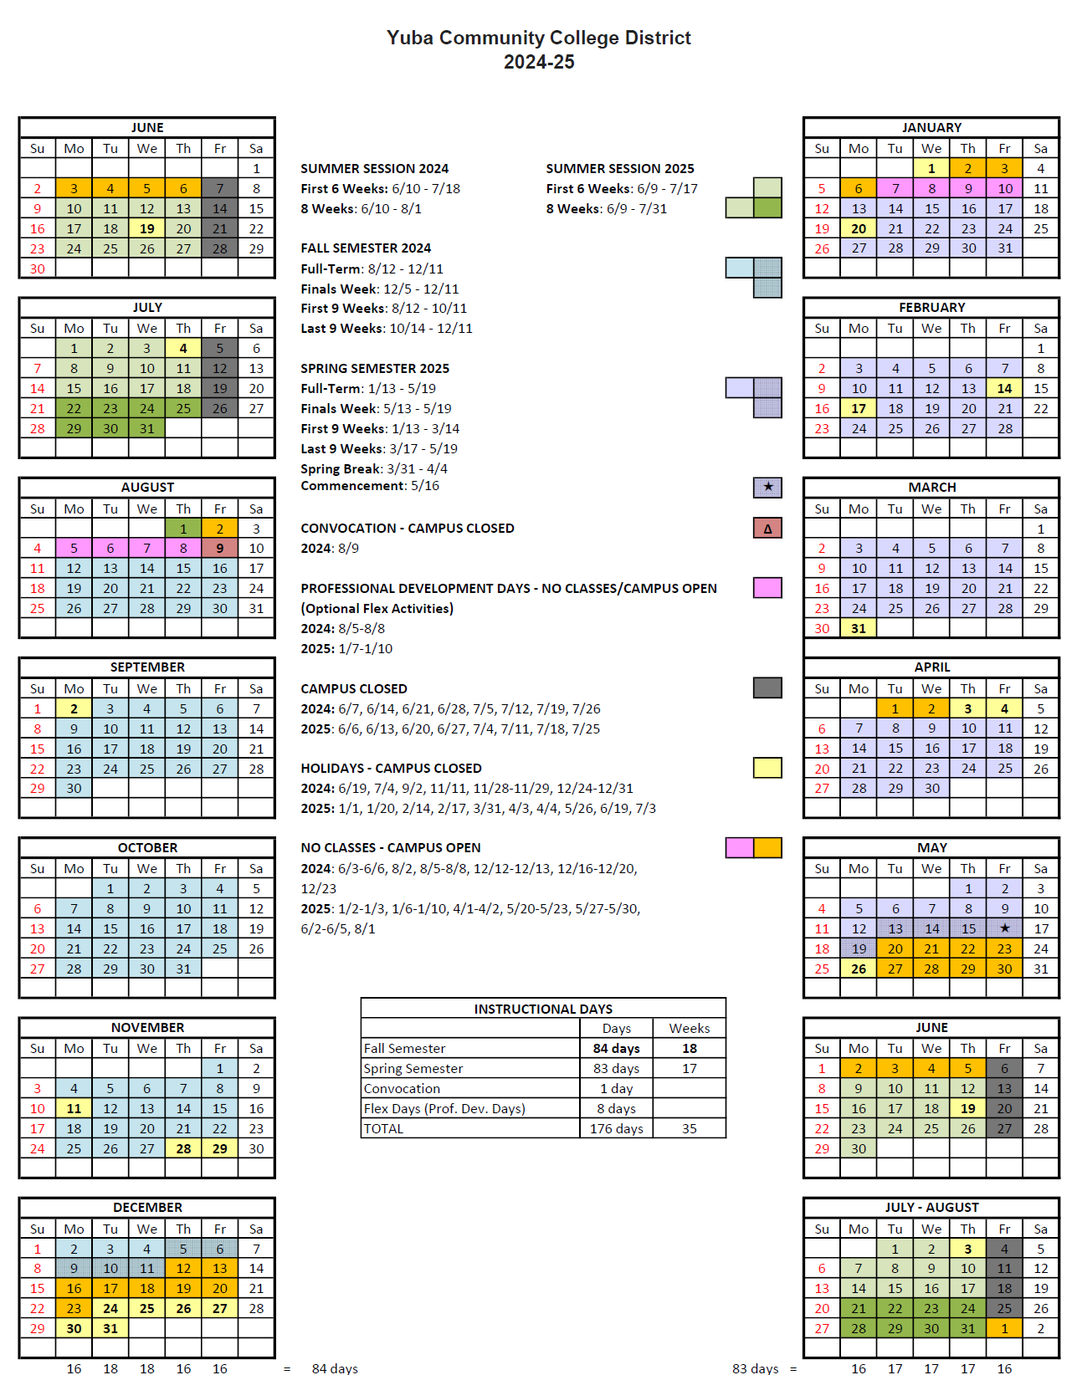

Appendix J: Map of Yuba College, Woodland Community College Campus’s
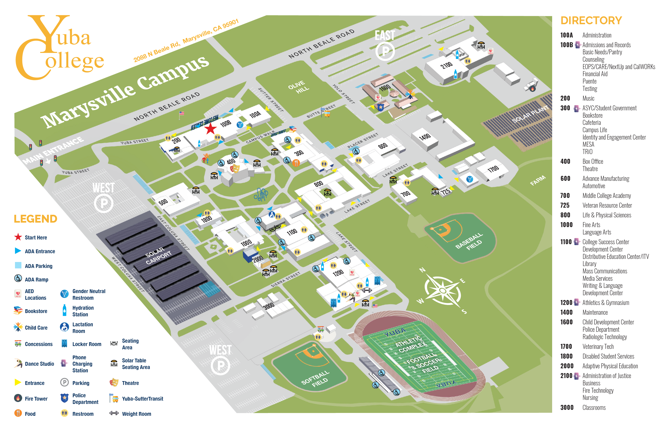

Map of Sutter County Campus (Yuba College):
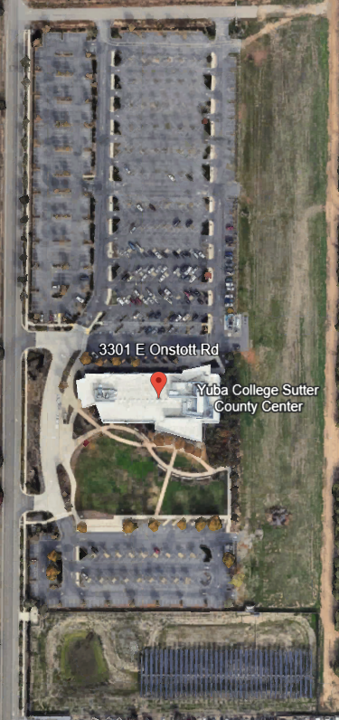

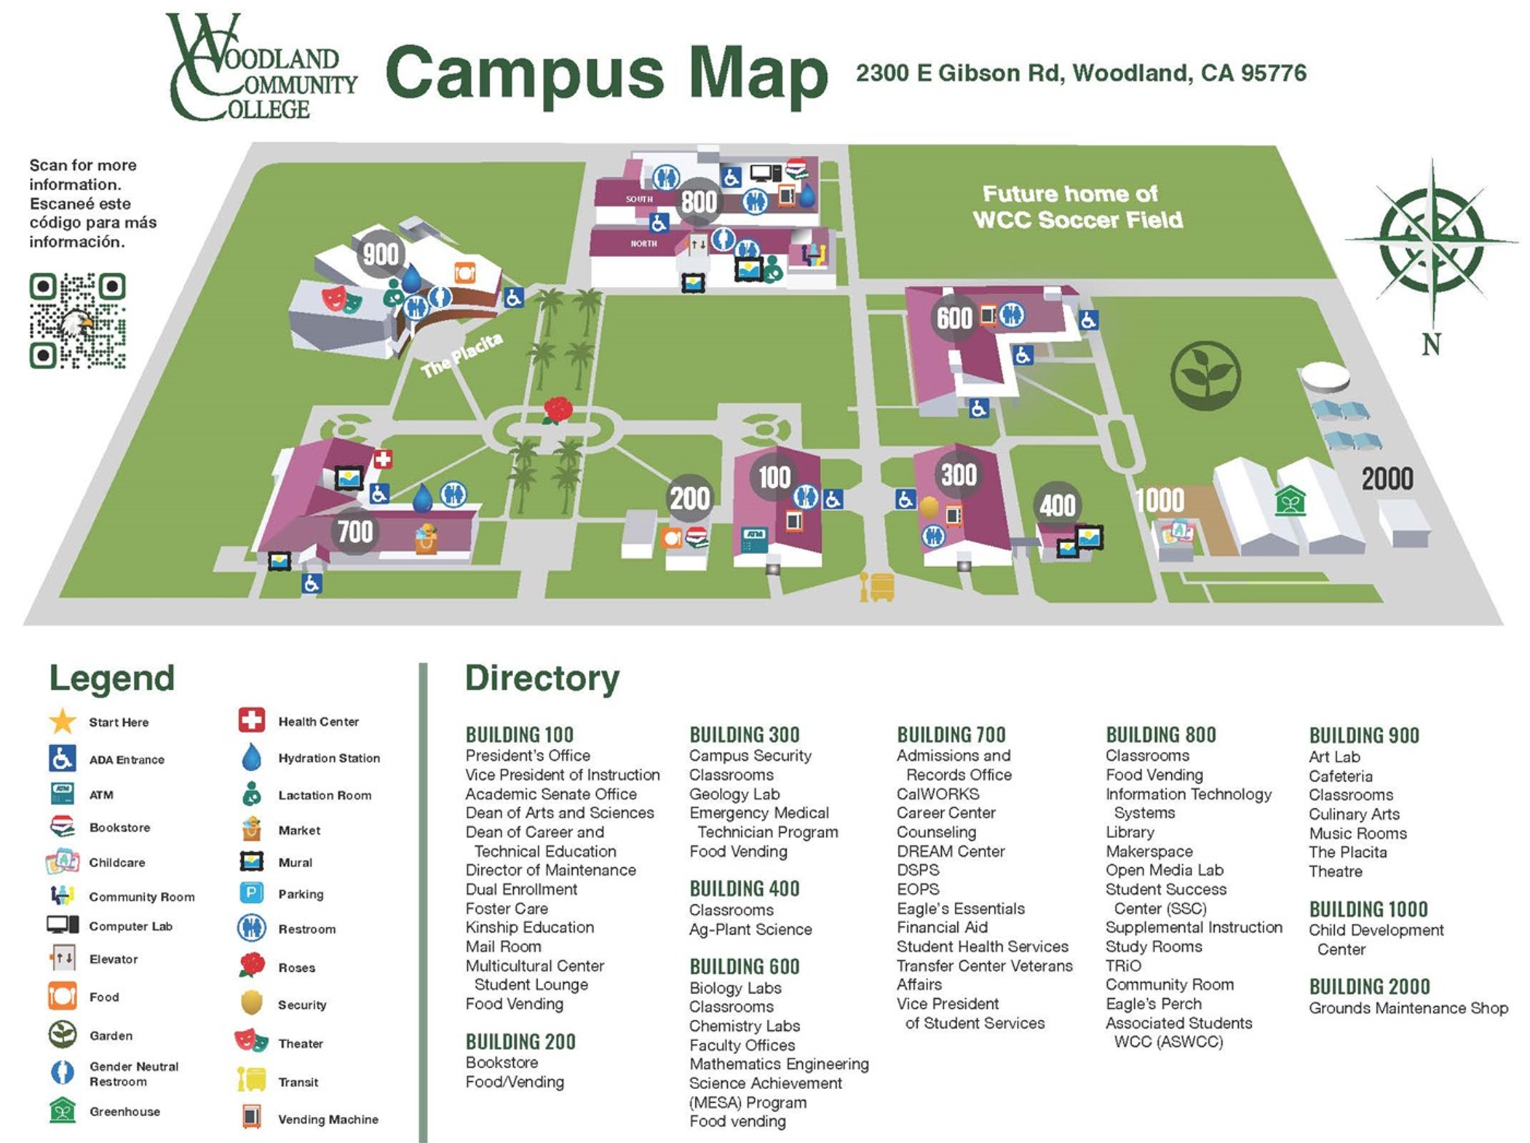

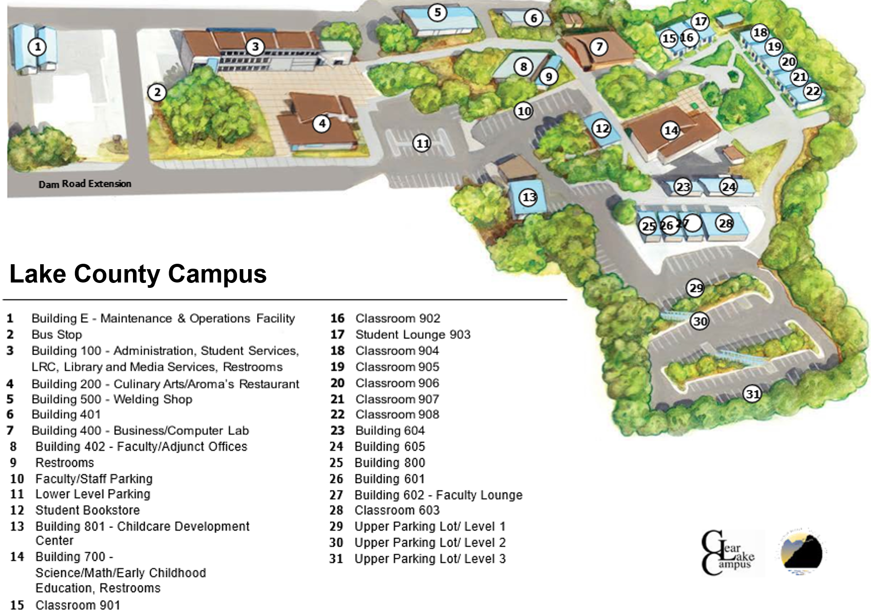

Map of the Colusa County Center: 99 Ella Rd, Williams, Ca.

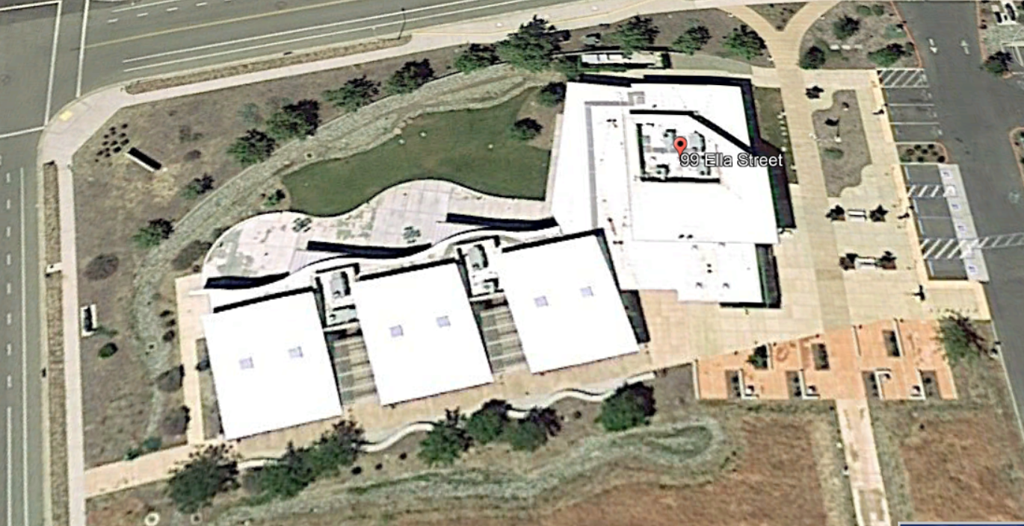

Appendix K: Background Information (Buildings Drawings and Historical ADA Accessibility Transitional Plans)

District (both Colleges) Building Drawings

Yuba College Link:
https://goyccd-my.sharepoint.com/:f:/g/personal/w0398409_yccd_edu/Eu1hc86W-QBKhVEc2Nudj7MBuWihXDbUBSEXdID1aBX24A?e=ai2b3O
Sutter County Campus Drawings Link:
https://goyccd-my.sharepoint.com/:f:/g/personal/w0398409_yccd_edu/Ek5ujEy-sDhPmo5VzrT2w80Bi_HstH2KjXdOrAx-ZUcIYg?e=6UEm96
Woodland Community College, (Includes Lake County Campus and Colusa County Center) Link:
https://goyccd-my.sharepoint.com/:f:/g/personal/w0398409_yccd_edu/EsReCsPH2dFPkLu0NasGvOIBwPMYZHMtOvap2AGbvH2kjA?e=mdSOd7
Lake County Campus Buildings 100, 200, and 700:’
https://goyccd-my.sharepoint.com/:f:/g/personal/w0398409_yccd_edu/ErQdbi_5xrxEl7Nfc_U4xgEBiFGYYNZaEquDURj-3SZxOA?e=GrAckZ

2009 ADA Accessibility Transitional Plans
Yuba College Link:
https://goyccd-my.sharepoint.com/:b:/g/personal/w0398409_yccd_edu/EeVXSh8H_t5OuoDGtKML4DgB3r9loowSplW4jRiRz9AfUw?e=bRCnTk

Woodland Community College Link:
https://goyccd-my.sharepoint.com/:b:/g/personal/w0398409_yccd_edu/EVzFFdgFgGhArB5Dsz3NkR8Bzd4qi63srCwZRVD4P7isqw?e=xIuFe4

The End.

