Request for Proposal
Yuba Community College District

Woodland Community College Campus
Building 900, Theater Rigging Changes and Adjustments
No. RFP 25-10

Issue Date: August 6, 2025
Proposal Due: September 23, 2025

Proposal Due Date: September 23, 2025, 1:00 PM Sharp, Yuba College Location Delivered To:

Yuba Community College District, District Offices
Attn.: David Willis
District Director of Facilities Planning, Maintenance & Operations
RFP No. 25-10 Woodland Community College, Building 900, Theater Rigging Changes and Adjustments
Address: Sutter County Campus, Second Floor, District Offices, Attention: David Willis, 3301 East Onstott Road, Yuba City, California 95991

Proposal Delivery at Second Floor
Yuba Community College District
Sutter County Campus
District Offices
3301 East Onstott Road (second floor)
Yuba City, California, 95991

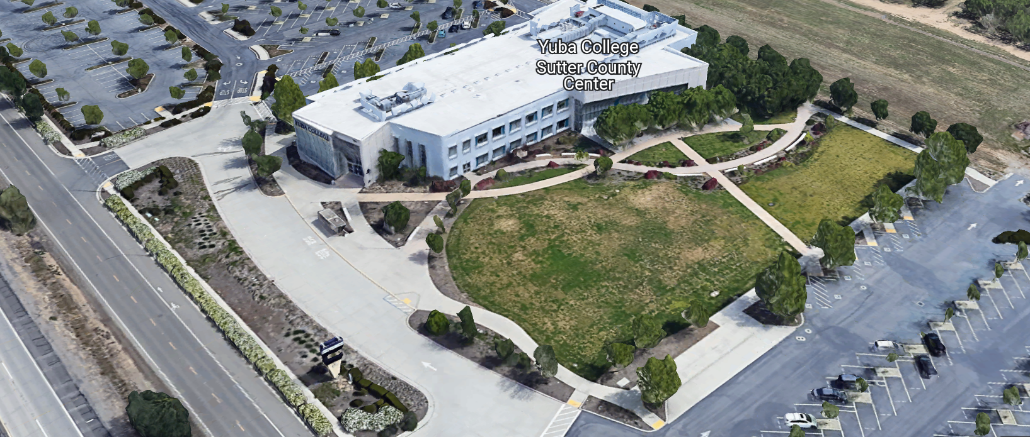

TABLE OF CONTENTS

1.0 INTRODUCTION
1.1 District Information
1.2 Yuba Community College District Background
1.3 Purpose of the Request
1.4 Applicable Codes
2.0 Scope of Work
2.1 Project Schedule
2.2 District Staff Contacts during Proposal Process
2.3 Project Safety Requirements
2.4 Demolition
3.0 Proposal Format Organization
3.1 Proposal Delivery, Contents, and Format
4.0 Selection of “Firm”
5.0 Basis of Award
6.0 Non-Discrimination
7.0 Response to Request for Proposal (RFP)
8.0 Requests for Information (RFI)
9.0 Proposal Schedule
10.0 District Parking
11.0 RFP Proposals
12.0 Award of Contract/Proposal
13.0 Reservation of Rights
14.0 Bid Bond Requirements
15.0 Performance Bond, Payment Bond Requirements
16.0 Liquidated Damages
17.0 Contractor and Subcontractors Information
18.0 CUPCCAA: Contractor Requirement

Contractor Proposal Required Items:

Appendix A, Bid Form
Appendix B, Statement of Qualifications
Appendix C, Contractor References
Appendix D, Contractors Project Approach, Project Team Members and Credentials, Preliminary Schedule, Stage Lift Equipment Proposed for this project.
Note: A Bid Bond, Performance and Payment Bond, are required.

Informational Items:
Appendix E: YCCD Academic Calendars
Appendix F: Map of Woodland Community College Campus
Appendix G: Pictures of the Theater rigging.
Appendix H: Design Drawings for the Theater rigging changes and adjustments

1. INTRODUCTION

  - District Information:

The District consists of two colleges, Woodland Community College and Yuba College, with campuses located at five different locations: Yuba College in Marysville, CA; Sutter County Center in Yuba City, CA; Woodland Community College in Woodland, CA; Colusa County Center in Williams, CA; and Lake County Campus in Clearlake, CA.

  - Yuba Community College District

The Yuba Community College District (YCCD) was founded in 1927 and spans eight counties (Yuba, Sutter, Colusa, Yolo, Lake, Butte, Glenn and Placer) and nearly 4,200 square miles of territory in rural, north-central California. It has colleges in Marysville and Woodland, an educational center in Clearlake, an educational center in Williams, an small Sutter Campus in Yuba City.

  - Purpose of Request

The Yuba Community College District seeks proposals from qualified Contractors make needed changes to the 900-theater rigging and to relocate the theater backstage white curtain as noted on the design drawings.
Woodland Community College Campus Address: 2300 East Gibson Road, Woodland, Ca. 95776

  - Applicable Codes
All work shall meet all State of California Building Codes, and Federal codes, and local ordinances.
All projects at the District/College are prevailing wage projects.
- Scope of Work (includes but is not limited to the following items)
- Inspect and investigate all existing rigging at the building 900 Theater stage and compare existing conditions to the design drawings produced by JSFA Architecture. Submit any needed Requests for Information to David Willis at dwillis@yccd.edu
- Install curtain track and associated hangers.
- Verify smooth curtain operations without catching or hanging up on extensions.
- Relocate rigging pulley mechanisms at floor level as noted on drawings.
- Move the main drape downstage approximately 8” back to provide a 3’-0” clearance to the back wall.
- Refer to all notes on the drawings.
- The intention is that after this work is completed, the curtains can be moved out of the way and the orchestra shell sections can be set-up without clearance impacts or conflicts.
- Verify proper operation of the orchestra shells and curtains. The College staff will assist with moving the curtains and the orchestra shells for this operational verification.
- The contractor shall use equipment on the stage that will not damage the stage. Place ¾” to 1” thick plywood on the stage for all areas that lifts will be operating to protect the stage floor from damage.
- Refer to the drawings for all scope of work items.
General Comments:

The Contractor shall apply and follow all Cal-OSHA regulations. All required PPE shall be in good condition and used when needed to protect employees.
The District encourages a positive and open communication strategy that includes a sense of partnership and mutual success on its projects.
The Contractor mark-ups for profit and overhead for change orders is 10%. Subcontractor mark-ups are limited to 10%.
Stage personnel lift weight limitations: Example lifts that were used in construction of the Theater.
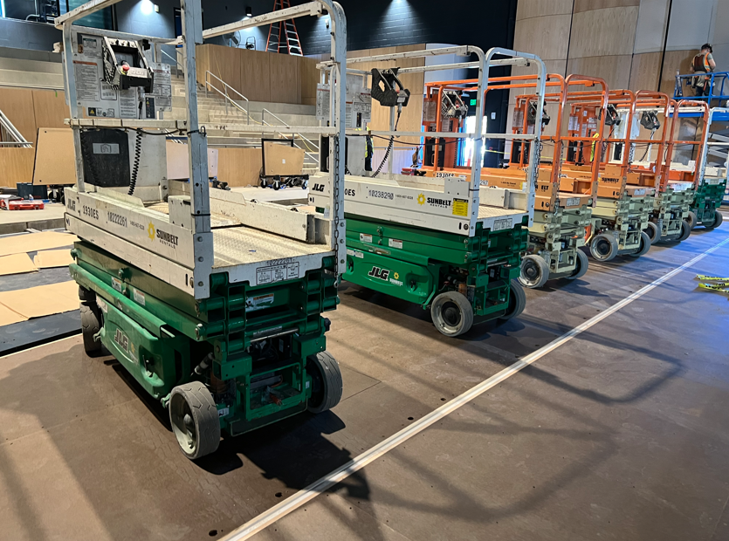
Use appropriately sized lifts. Do not use ladders on top of lifts to get additional height access. Operators of the lifts need to wear harnesses and be connected to the top of the lift. Use safety cones and barricade tape and barricades or delineators to keep others from walking near the lifts. Electric lifts shall be used. Do not use propane lifts.
The contractor shall place ¾” to 1” thick plywood on the existing stage floor before using the lifts.
Since this is a pretty small project all of the work can probably be done in 2 to 3 days.
2.1 Preliminary Proposed Project Schedule (Contractor to provide schedule with proposal)
Approximate Award Date: October 10, 2025

Rigging Submittals to District: October 24, 2025
Construction Phase: November 10-14, 2025

100% Completion: November 14, 2025

This is a prevailing wage project. The Contractor is required to upload all certified payroll information to the Department of Industrial (DIR) Relations web site. YCCD will provide a DIR project number. The District will require a copy of all certified payroll records prior to the making the final payment to the contractor.
2.2 District Staff Contacts during the Proposal process:
Firms interested in submitting a Proposal are directed not to make personal contact with the Board of Trustees, District staff, or members of the evaluation committee. Any contact shall constitute grounds for disqualification from consideration.
Single Point of Contact during the Proposal Preparation Process:
David L. Willis
District Director of Maintenance, Operations, and Planning
YCCD District Offices, Sutter Center, (Second Floor)
3301 East Onstott Road
Yuba City, California, 95991
Cell Phone: 916-747-4262
Email: dwillis@yccd.edu

On-site coordination, first contact person access and immediate contact person during construction OR if additional site visits are needed during the bidding process.
Brian Splaine
Assistant Director of Maintenance, Operations
Woodland Community College
2300 East Gibson Road, Woodland, California 95776
Phone: 530-740-1722
Email: bepp@yccd.edu

No changes can be made to the project scope without authorization in writing by David Willis.

2.3 Project Safety and Security Requirements
Safety is a top priority for the District. All California OSHA requirements apply.
The area of the project shall be blocked off with barricade tape, signs, and cones.
Protection of College property shall be taken. Contractor is 100% responsible for any damage to College property and facilities.
2.4 Demolition
The contractor may dispose of any waste associated with this project, which should be very minimal, in the College waste dumpster. Debris and waste shall be processed in accordance with all State and Federal codes, laws, and ordinances.
3.0 Proposal Format Organization: Not applicable for this project.
3.1. Proposal Delivery, Contents, and Format: Not applicable for this project.

4.0 Selection of “Firm” Services Provider: Not applicable for this project

5.0 Basis of Award

This project will be awarded based on the following criteria:

- Lowest Total Cost Responsive Qualified Bidder
  - Lowest Total Cost
  - Contractor Capability to do the work
  - Qualified Contractor (per Appendix B, Statement of Qualifications)
    - District determined “Qualified Contractors” based on the information provided in the “Statement of Qualifications” information provided by the Contractor.
    - Proper State of California Contractor License in good standing
    - Information provided as requested in the RFP and Specifications.
    - All Addendums are acknowledged.
    - Contractor listed any exceptions or exclusions.
    - At least five (5) project references of similar projects completed in the past seven (7) years with contact information, scope of work, initial awarded cost, change orders cost, pictures if possible.

6.0 Non-Discrimination
The District does not discriminate with regard to race, color, gender, national origin, disability, or any other protected or other classification in the awarding of contracts/agreements. The District welcomes all Qualified Firms to participate in the project Request for Qualification/Proposal process.
The District encourages firms that are women or minority owned, emerging small businesses, veteran owned firms, disabled person owned firms, and all other qualified firms to participate in the proposal process.
The District encourages the submission of proposals from all Firms that can meet the stated requirements set for this RFP.
7.0 Responses to RFP
Simply just email your proposals to David Willis at dwillis@yccd.edu before 1pm on September 23, 2025.
8.0 Requests for Information (RFI)

Requests for Information concerning the RFP must be in writing and may be submitted via email no later than the date shown below. Please direct all questions to David Willis, email: dwillis@yccd.edu.

- Include the following in the subject matter field on emails when requesting information: “RFP 25-10”, RFI.

9.0 Proposal Schedule:

Important Dates and Times:

August 6, 2025: Release of Request for Proposal

August 19, 2025: 10:00AM to 11:00AM Optional Pre-Bid ZOOM Meeting

Join Zoom Meeting:

https://yccd-edu.zoom.us/j/84828277918

Meeting ID: 848 2827 7918

Dial by your location
• +1 669 444 9171 US

August 21, 2025: 9:30AM to 11:00AM Optional On Campus Pre-Bid Meeting

Address: Woodland Community College, Building 900, Theater; 2300 East Gibson Road, Woodland, Ca. 95776

OR

If you cannot make it, please contact Brian Splaine at email: bsplaine@yccd.edu to schedule another time to meet and walk through the Theater stage rigging.

September 11, 2025: 5:00 PM, All questions and requests for information must be submitted to David Willis at: dwillis@yccd.edu.

September 12, 2025: 5:00 PM, Addendum Issued if needed.

September 23, 2025: Proposals due at 1:00 PM SHARP, Simply just email your proposals to David Willis at dwillis@yccd.edu before 1pm on September 23, 2025.

Note: All procurement documents associated with this procurement will be posted at this web page link: https://www.yccd.edu/district-services/requests-proposals-quotes/

10.0 District Parking: (Fees Not Applicable)

11.0 RFP Proposals

Proposals received after the deadline will not be considered. Simply, email your proposal to David Willis at dwillis@yccd.edu by the due date and time.

12.0 Award of Contract
- The Contract will be awarded to the lowest total cost, most responsive responsible District qualified Firm, whose proposal, conforming to the request for proposal and associated addendums, will be most advantageous to the District.

H. BONDS:
1. Bid Bond: Not required for this project
2. Peroformance and Payment Bonds: Required only if the value is greater than $25,000.

13.0 Reservation of Rights

The District reserves the right to:

- Reject any or all submittals at its sole discretions.
- Cancel the Request for Proposal (RFP), without cause.
- Disqualify a Contractor after reviewing the proposal and finding concerning performance information in references, inadequate or incomplete proposal information, inadequate or information that is provided by the Contractor as part of the Statement of Qualifications process, and historically poor project performance at the District/Colleges (as solely defined by the District).

This RFP does not commit the District to award or negotiate a contract. The District will not be responsible for any expenses incurred by any firm in preparing and submitting a proposal or response to this RFP or in completing any of the work specified.

14.0 Bid Bond Requirements: Not applicable for this project
15.0 Performance and Payment Bond Requirements: Only required if the value is greater than $25,000.
16.0 Liquidated Damages: (Not Applicable)
17.0 Contractor and Subcontractors Information:
No. | Name of Firm | Contractor License Number/Expiration Date | Department Of Industrial Relations Registration Number/Expiration Date
1
2

18. CUPCCAA: Contractors Requirement
Yuba Community College District is an authorized CUPCCAA District in California.
Link to YCCD Contractor CUPCCAA Application Form:
https://www.yccd.edu/district-services/fiscal-services/purchasing-2/cupccaa/
Contractors bidding on projects must also request to be added to the YCCD CUPCCAA contractors list by filling out the application form and submitting it to the District.
Information regarding CUPCCAA Links:
https://www.sco.ca.gov/ard_cuccac.html
https://www.sco.ca.gov/Files-ARD-Local/frequently_asked_questions_faq_-_uniform_public_construction_cost_accounting_act.pdf
All YCCD projects are CUPCCAA projects. All contractors bidding projects need to submit the YCCD application form if not already on the list. To verify if your Firm is on the list, please contact Rachel Harvey at rharvey@yccd.edu
Prevailing wages apply to all construction projects at YCCD.

Appendix A: Contractor Proposal
Use whatever format you prefer.

Prevailing wages apply to this project.

Please round off numbers to the nearest dollar.

A preliminary overall start-to-finish project schedule is required with the proposal. Use whatever format you prefer.

Please list any exceptions or exclusions.

Appendix B: Statement of Qualifications (Applies to the Contractor for this Project)
The Contractor shall furnish the following information. Failure to comply with this requirement will render the submittal informal and may cause its rejection. Additional sheets may be attached if necessary.
Basic Firm Informational Items 1 through 10:

- Firm Name:___________________________________________________________________

- Primary Address: ______________________________________________________________

- Firm’s Contact Person and Title:___________________________________________________

- Telephone: ___________ Email Address: ___________________

- License No.: ______________________________ Class: __________________________

Responsible Managing Employee/Officer:_________________________________________

- DIR Registration No.:________________________ Expiration Date:___________________

- Names and titles of two officers of the Firm:

NAME TITLE

___________________________________ _______________________________________

___________________________________ _______________________________________
- Number of years Firm has been in business:
If less than 5 years, please describe:

- Number of years Firm has conducted business under the present name:__________

- Has the Firm ever been licensed under a different name or different license number? If yes, please describe: .

Potentially Disqualifying Questions 11 through 13 (District may immediately disqualify Firm if its answer Questions 11 to 13 is Yes. Firm’s refusal to answer or omission of response to any of Questions 11 through 13 may result in disqualification of Firm.):

- Has the Firm been in litigation (whether in court or arbitration) with any California school district, community college district, or other California public agency on an issue pertaining to any contract during the past five years? Yes/No:

If yes, explain, identify the agency, and provide case name and number.

- Has the Firm ever failed to complete a project in the past five years? Yes/No: If so, give owner and details:

- Is the Firm currently or has the Firm been in a state of “Bankruptcy” in the past five years? Yes/No:
If yes, please explain.

Rating Questions 14 through 17:

- Please list and describe on separate sheets the Firm’s top 5 Theater rigging projects most recent (within the past 7 years) references with current contact information. The project reference list should include the following criteria:
  - Project Name
  - Project Owner and Contact Information
  - Project Scope of Work
  - Original Contract Completion Date
  - Original Contract Awarded Amount
  - Any issues that Firm had to overcome on the project

Scoring Criteria:
  - Multiple Projects with Similar Scope of Work (25 points)
  - At least two (2) Projects Completed at a school or public entity in California (10 points)

Total points for Question 20: up to 35 points

- List your Firm’s Workers’ Compensation Experience Modification Rate (EMR) for the three most recent years. Your EMR should be issued to your Firm by your workers’ compensation insurance carrier.

Year _______ EMR _______

Year _______ EMR _______

Year _______ EMR _______

(EMR numbers under 1.0 = 10 points; 1.0 to 1.24 = 5 points; 1.25 to 1.49 = 1 point; 1.50+ = 0 points.)
- In the last 10 years, how many legal proceedings (filed in court or arbitrations) has an owner initiated against your Firm, regardless of outcome? _______
(0 = 10 points; 1 = 5 points; 2+ = 0 points.)

- Please describe the Capability/Capacity of your Firm. Please provide a comprehensive list of projects that the Contractor has in process and reasoning/justification regarding how the Contractor has capacity to perform the required construction services on this project.

(Up to 10 points.)

Qualification Criteria:
Questions 1 through 10 are general base level information that is required for pre-qualification.
Questions 11 through 13 are possible disqualifying questions that would render the Firm “not qualified” as determined by the District.
Questions 14 through 17 are rating questions that are scored and more deeply evaluated. Not scoring the minimum threshold value will render the Firm “not qualified”.
  - The District can disqualify a Firm (at it’s sole discretion) if the Firm does not meet the requirements of Questions 11 through 13.
  - There are a total of 65 points possible for questions 14 through 17.
  - To be determined as a qualified Firm, each Firm must score at least 45 points.

Firms will be notified if they are determined meet minimum qualification criteria.

The undersigned is duly authorized to execute this Statement of Qualifications under penalty of perjury on behalf of the above-identified Firm. The undersigned warrants and represents that he/she has personal knowledge of each of the responses to this Statement of Qualifications and/or that he/she has conducted all necessary and appropriate inquiries to determine the truth, completeness, and accuracy of responses to this Statement of Qualifications. The undersigned declares and certifies that the responses to this Statement of Qualifications are complete and accurate; there are no omissions of material fact or information that render any response to be false or misleading and there are no misstatements of fact in any of the responses. The above-identified Firm acknowledges and agrees that if the District determines that any response herein is false or misleading or contains misstatements of fact so as to be false or misleading, the District may find the Firm is not qualified and the District can reject the proposal for non-responsiveness or non-responsibility.

Executed this___ day of __________________ 20__ at_____________________________.
(City and State)
I declare under penalty of perjury under California law that the foregoing is true and correct.

By: ____________________________________________
(Signature of Firm’s Authorized Officer or Representative)

____________________________________________
(Typed or Printed Name)

Title: ___________________________________________

General qualification process and comments:
- Firms with historically poor performance on projects at Yuba Community College District will be disqualified from consideration.
- Firms that are “disqualified” by the District will not be considered for future project work.

- Proposals from other Contractors will remain confidential.

- Contractors “Statement of Qualifications” process evaluation by the District Evaluation team will remain confidential.

- The District is not required to interview Contractors as part of the evaluation and qualification process.

Appendix C: Contractor References Form (Example Template)
No. | Project Name/Description | Awarded $$ | Change Orders $$ | Original Completion Date | Final Completion Date | Contact Information: Name, Firm, Phone Number, Email, role on project reference.
1
2
3
4
5
6
7
8
9
10

Please provide 10 project references.
You may of course use the Firm’s established reference template.

Appendix D: Contractors Project Approach, Project Team Members and Credentials.

This is a pretty small project.
Please share credentials of the foreman or other team members that would be assigned to this project.
It is important to have experienced Superintendents/Foreman, trades with expertise to do a good job and in meeting the journeyperson to apprenticeship ratios per the Department of Industrial Relations, and to be able to complete the work on schedule with good quality work.
It is expected that all equipment operators will be fully trained and experienced.
Please share personnel lift information that is planned to be used on the floor of the stage. Please include the weight of the equipment and the approach that will be used to protect the stage surface and floor from damage.
Verify no exceptions or exclusions to the project scope of work.
Please verify approach to project safety. Contractor employees shall wear hard hats, safety vests and appropriate PPE per CAL OSHA requirements. Safety is a priority for the District/College.
Please verify that operational clearance performance with moving back the curtains and then placing the orchestra shell components in place to allow both the stage curtains and the orchestra shell to be in place at the same time. College maintenance and operations staff will move the orchestra shell into place. The curtains shall not catch on the extension locations but shall slide smoothly across the connection and extension sections.

Appendix E: YCCD Academic Calendar
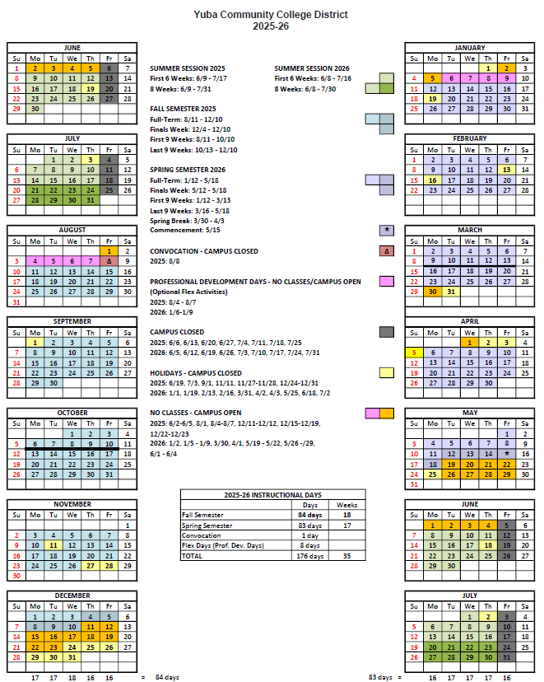

Appendix F: Map of Woodland Community College
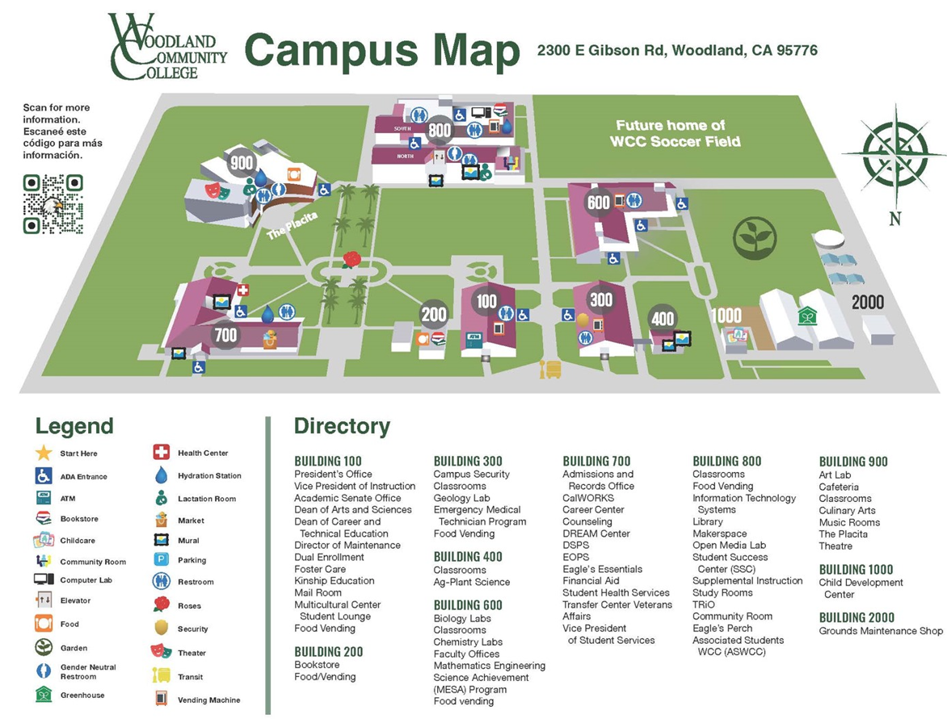

Appendix G: Pictures of the Theater Stage Rigging and Area

Link:
Theahttps://goyccd-my.sharepoint.com/:f:/g/personal/w0398409_yccd_edu/EqKu3Q9yC2lKlmcsjkyBBOgBLfZdStN2Iolzcyym1NncfA?e=sx1Dbwter Rigging & Orchestra Shell Pictures

Appendix H: Theater Stage Rigging Changes and Adjustments Drawings

Link:
Designhttps://goyccd-my.sharepoint.com/:f:/g/personal/w0398409_yccd_edu/Eg3m3odsCZ9GkZHliiX1_xkB4AwX_wpKUaqpi8W17oo0AA?e=LPOr7g Drawings

The End.

