Tuesday, July 1, 2025, re-released July 8, 2025

District: Yuba Community College District
District Offices
3301 E Onstott Rd
Yuba City, CA 95991
Contact: David Willis, Dir. Facilities Planning, Maintenance & Operations

Job Location: Yuba Community College
Building 600 (south side)
2088 N Beale Rd
Marysville, CA 95901

Clarifications:

- Question: Is it the contractor’s responsibility to hire an engineer to design the foundation for the new tank?

Answer: Yes, this is a turn-key, fixed price, formal bid process that requires the contractor to hire a design engineer to design the foundation of the new tank to meet all current state of California code requirements including seismic.

- Question: It looks like the existing tank has a compressed air pipe that extends into the adjacent building to maintain the air blanket in the tank. Is it okay to abandon this piping, remove it, and then provide a new tank with an independent air compressor system, with audible and light flashing alarm for low pressure and/or if the compressor is not running, and include the needed electrical service from the adjacent building or from existing services to power the new air compressor system?

Answer: Yes, abandon and demo the existing compressed air piping, provide a new tank with an independent air compressor system, with audible and light flashing alarm for low pressure and/or if the compressor is not running, and include the needed electrical service from the adjacent building or from existing services at the tank to power the new air compressor system

- Clarification: The original design and fabrication was done by Hansen Tank at: "sam@hansentank.com" sam@hansentank.com. It is understood that there are not any original design calculations or drawings of the tank or the tank supports.

- Clarification: The District does not have any existing drawings showing the existing irrigation system piping and devices, wells, pumps, tanks. The District does have some drawings showing the underground fire piping loop that was added to the campus per this link:

https://goyccd-my.sharepoint.com/:f:/g/personal/w0398409_yccd_edu/Es_LrCuRwDJGlinq9r2PI2cBxP2BL67NcDMuKHdmF8P7-g?e=PYQTcQ

- Clarification: All Bid documents are posted at this link: https://www.yccd.edu/district-services/requests-proposals-quotes/

- Question: The District is starting a new fiscal year July 1, 2025. The District is planning to get the existing paint tested for lead but due to the fiscal year ending and starting, this testing will not be done until later in July. The District is aware that the outside top coat of paint on the tank does not contain lead. The first coatings that were made in the 1960 era likely does include lead in the paint. Does the contractor need to include the lead paint abatement of the existing paint in their proposal?

Answer: Yes. The Contractor needs to include removing the existing paint and containing and cleaning it up using all required EPA and California code required mitigation means and methods. The disposal needs to include providing the District with all proper documentation. The Bid Form will be updated to add a line item for this cost.

- Question: What are the required new tank testing pressure requirements?

Answer: The new irrigation tank shall be rated for 150 psi working pressure. The testing for the tank shall include all ANSI / Cal-OSHA pressure testing requirements.

- Question: Does this tank need cathodic protection?

Answer: Yes, per NFPA 25.

- Question: What coating should be used inside and on the exterior of the tank?

Answer: Prepare and Apply Sherwin Williams “SHERPLATE 600” epoxy coating per the manufacturer requirements with at least three coats on the inside surface and two coats on the outside surface. Documentation of the coatings being applied such as pictures and verification of the coatings shall be provided to the District. The Safety Data Sheets, Product Data Sheets, and Environmental Sheets are attached to this Addendum.

- Question: Does there need to be a concrete pad around the tank?

Answer: Yes, the existing tank and concrete supports need to be removed. Then, the sub-grade needs to be prepared and the new supports need to be installed. Any underground piping work needs to be completed. Then, the sub-grade needs to be prepared with at least 6” of compacted road base placed all around and under the tank. The new concrete pad needs to be at least 3,000 psi with a lightly broomed finish and level and true. The Concrete pad needs to be flush with the existing asphalt elevation at the parking lot and continue under the tank and past the tank by 2 feet minimum on both ends and the south side of the tank. The concrete will then extend to the building on the north side of the tank, covering the entire gap between the tank and the building. Construction joints shall be spaced no greater than 6 feet apart in both directions. The placement of the new tank shall support (if possible) and maintain the existing number of parking stalls as shown below:

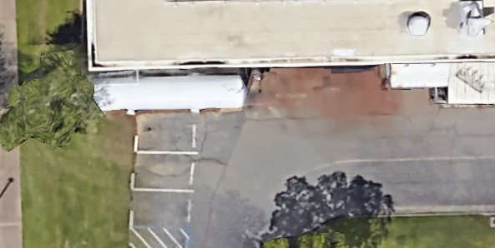

- Question: Should the Contractor provide an Additive Alternate to “MAP” all the irrigation piping and devices and system components on a drawing and provide it in at least PDF format? Is GPS tracking and locating required on the “MAP”?

- Answer: The District will consider Contractor provided Additive Alternates to “MAP” all the irrigation piping and devices and system components on a drawing and provide it in at least PDF format. It is preferred if GPS tracking and locating is provided on the “MAP”. A line item will be provided on the Bid Form for this alternate.

- Question: Does the Contractor need to remove the green box with piping inside?

Answer: Yes, the Contractor needs to remove the green box, provide piping underground connections, add isolation valves, remove the backflow device.

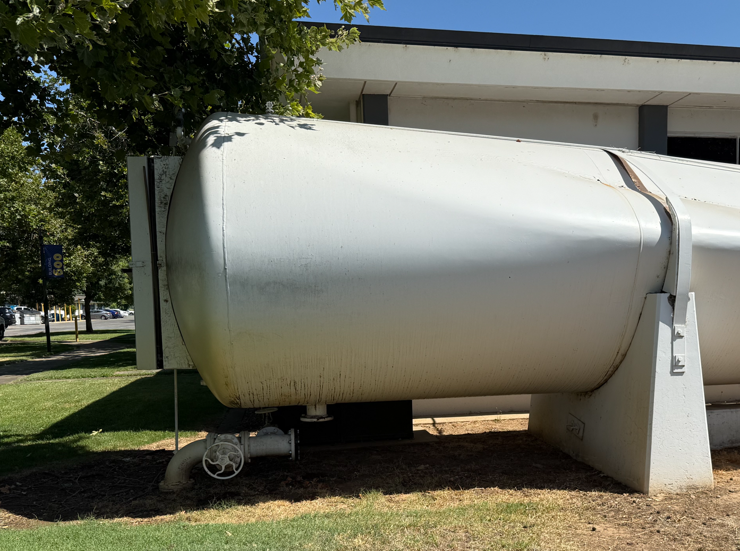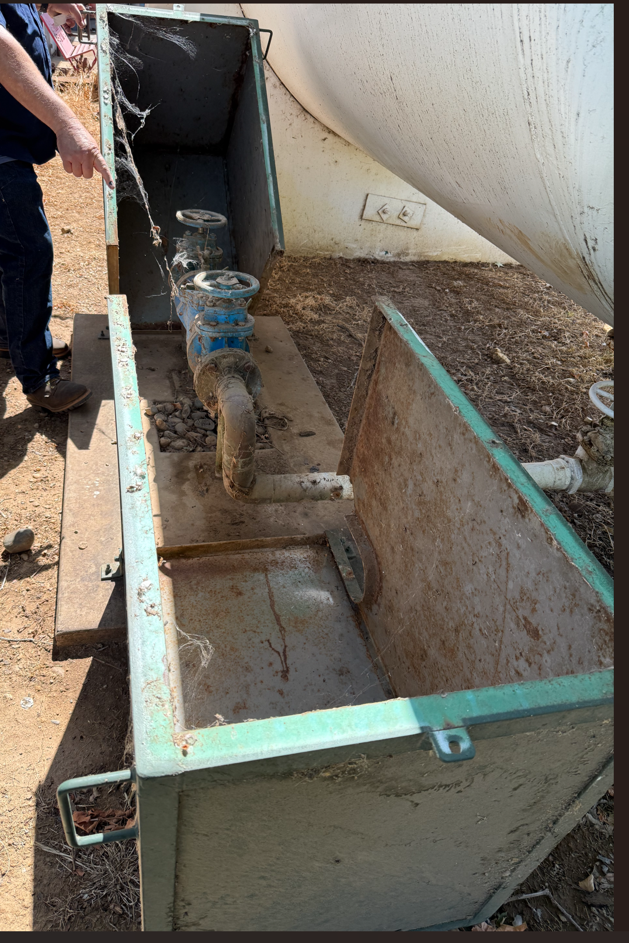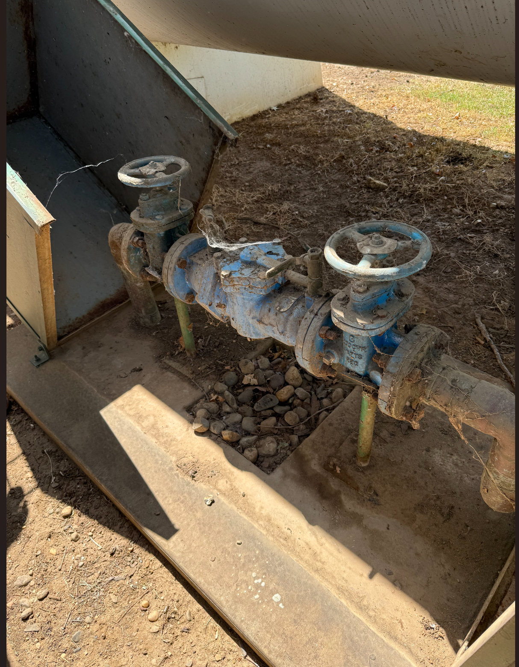

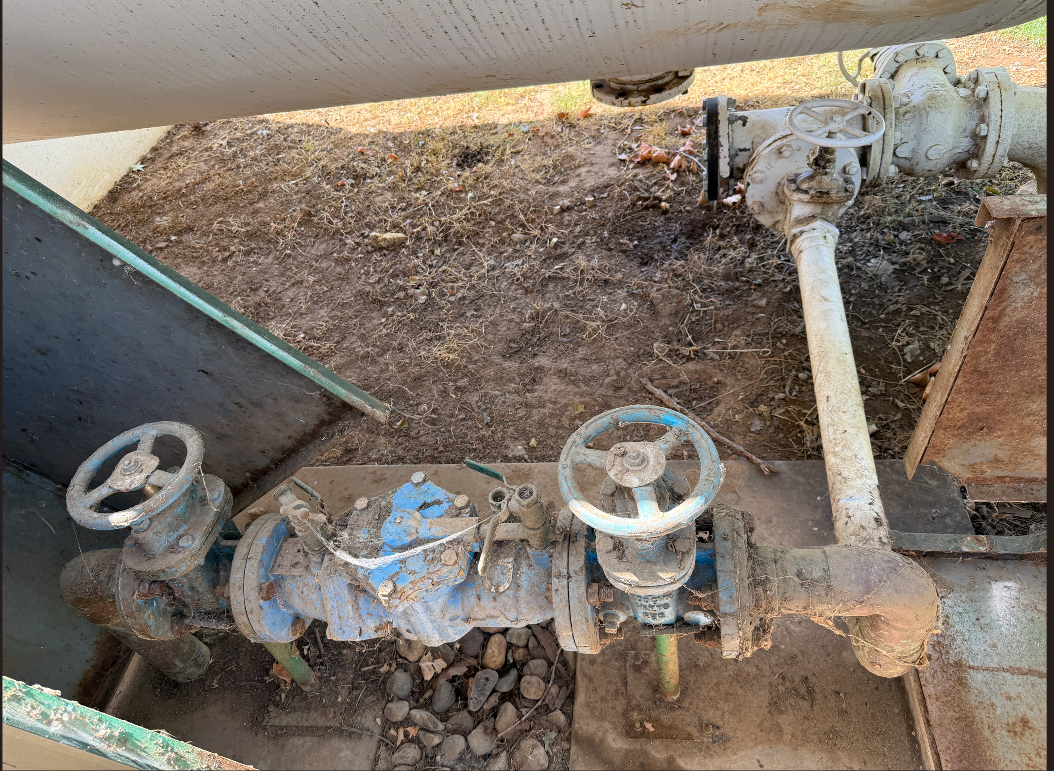

- Question: Should the Contractor relocate also the green irrigation box to outside the new concrete pad area?

Answer: Yes, the irrigation control box shall be relocated outside the new concrete pad area.

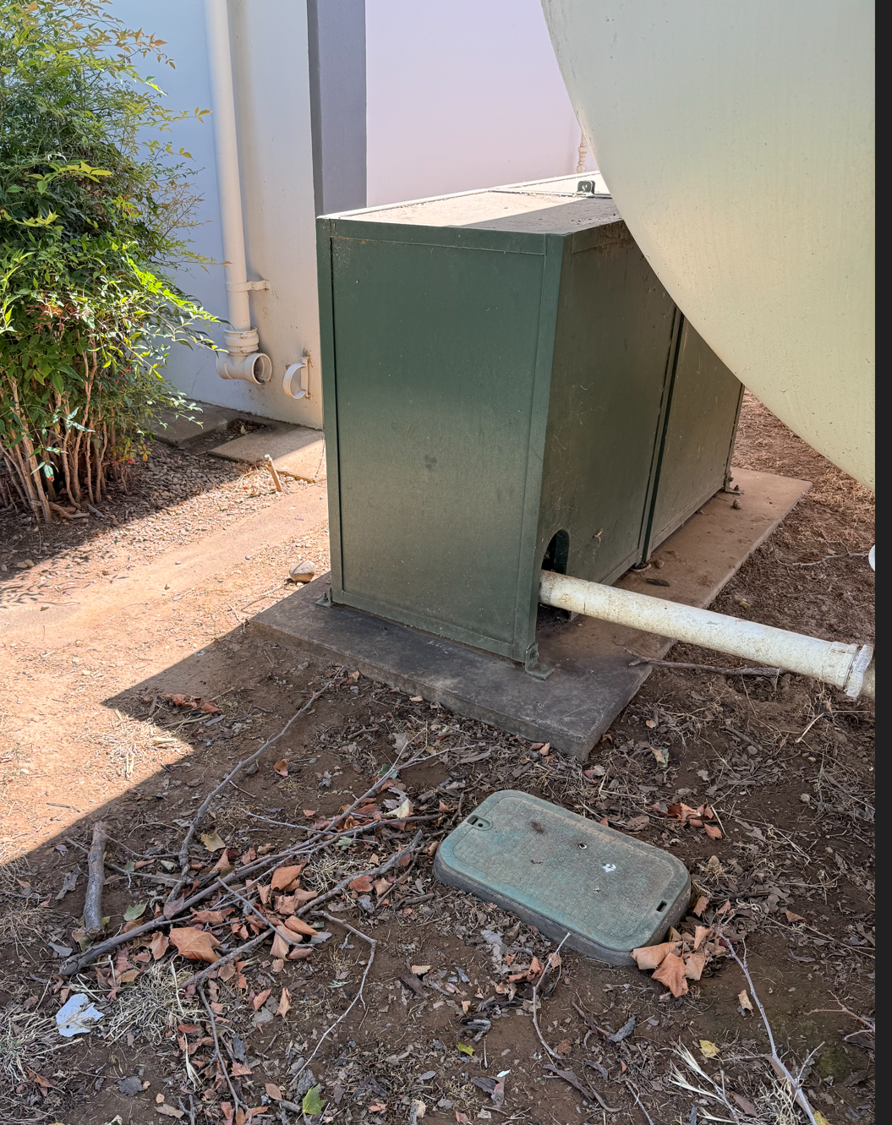

- Question: Should the Contractor provide an access hatch and a ventilation hatch on the tank so that a person can enter the tank and make repairs while the ventilation hatch provides space for a ventilation hose to be installed in the tank to remove the vapors when recoating the tank?

- Answer: Yes, the Contractor shall provide an access hatch and a ventilation hatch on the tank so that a person can enter the tank and make repairs while the ventilation hatch provides space for a ventilation hose to be installed in the tank to remove the vapors when recoating the tank. The size of the hatch shall be standard sizes for access into the tank. The access hatches need to be lockable and secured from tampering and from unauthorized access.

- Question: Is there a minimum thickness for the steel of the tank?

Answer: No, the manufacturer of the tank shall have the tank engineered with calculations to provide and meet all required performance criteria of the tank as described in the RFP, addendum, and per industry standards for the tank rating and use.

- Question: What criteria and specification shall the Contractor use for gauges?

Answer: All gauges shall be minimum 2” diameter high quality calibrated gauges constructed of stainless steel and with “unbreakable glass” or at least tamper resistant glass to provide accurate psi pressure readings.

- Question: Does the existing alarm and monitoring system need to be retained for the new tank?

Answer: No. Dispose of the existing alarm and monitoring system.

- Question: Can the existing parking stalls area be used as a staging area during construction?

Answer: Yes, maintain the roadway to have at least one lane of traffic pathway at all times. If additional staging areas are needed, they will need to be south of the roadway. The project boundary needs to be properly maintained with unauthorized access signs posted. Any open holes or pits in the ground need to be covered after each work shift. A storage container may be needed by the contractor to secure tools, materials, and other items from theft and vandalism.

- Question: What is the purpose of this tank? Normally a hydropneumatic tank like this is used to optimize pump cycling timing but the RFP seems to refer to is as more of a storage structure. Also, the reference to optional air over water seems to conflict with typical operations. A designer needs to have a very clear understanding of the purpose and intended use of this tank.

Answer: This tank is used as an expansion/pressure buffer tank in the campus irrigation system that is fed by up to two well pumps. All contractors are welcome to visit the campus.

- Question: What are the pumping conditions so that we select operating pressures for the tank that match?

Answer: The well pumps are designed and cycle to provide 80 psi working pressure. The tank is required to be at least rated for 150 psi working pressure.

- Question: What is the pumping timing so that we select a tank size that optimizes pump cycling?

Answer: The pumps randomly cycle to maintain pressure when the system is irrigating. The cycling timing will depend on the number of zones that are programmed, and which zones are watering at any given time.

- Question: Alternatively, if the tank is only for irrigation water storage, there are probably much better and cheaper arrangements that could be used.

Answer: The Contractor is welcome to provide deductive alternates for the tank replacement project.

- Question: How is the water distribution system arranged? This tank is located very close to the building and possibly foot traffic. It may be possible to find a more aesthetically pleasing and safer location for the tank. A typical hydropneumatics tank can be located anywhere in the distribution system and still do it’s job reliably. Depending on the intended use of this tank a relocation may be possible and desirable.

Answer: I’m sure you are correct. The contractor may provide an alternate. The base bid proposal needs to include all of the items required in the RFP and Addendums. The present location is on the back side of the campus and does not get a lot of visibility.

- Question: It appears that the existing tank had some local alarms. What alarm conditions are desired? Are there any campus-wide systems that could be accessed to put alarm notifications on a wider notification system rather than just rely on the local light and siren?

Answer: Please see item number 19 above. Yes there is a possibility of tying the alarms into a monitored control system if the new alarm system has the capability for this alternative.

- Question: Does this tank have an accompanying air compressor? I see a blue metal box in the photos that could be a compressor. Typically, a hydropneumatic tank is accompanied by an air compressor to maintain the proper volume of air over water. Is the compressor functional or does it require replacement to match the new intended lifespan of the facility?

Answer: Please refer to item number 2 above.

- Question: Can this project be bid as a design-bid-build project?

Answer: No. Please follow the design-build tank replacement guidance as described in this RFP and addendum.

Exhibit A: Revised Bid Form:

No. | Description | Cost
1 | Site Investigation and Inspection of Existing Conditions and System | $
2 | Tank Design | $
3 | Tank Fabrication | $
4 | Mobilization, Demolition, Disposal of Existing Tank, and Construction | $
5 | Unforeseen Conditions and Contingencies: | $10,000.00
6 | Remove the existing interior and exterior paint, contain it, clean it up using all required EPA and California code required mitigation means and methods. | $
7 | Other: | $
8 | Sub-Total Costs: | $
9 | Additive Alternate No. 1:  “MAP” all the irrigation piping and devices and system components on a drawing and provide it in at least PDF format. It is preferred if GPS tracking and locating is provided on the “MAP”. | $
10 | Additive Alternate No. 2: (by contractor) | $
11 | Total Costs: | $

Provide schedule of values.
Prevailing wages apply to this project.

Provide a list of employee classifications and labor rates for the Yuba College prevailing wage location.

This is a Department of Industrial Relations (DIR) project. The District will provide a DIR number for this project. The Contractor/Firm will be required to upload prevailing wage certified payroll records of the fabrication of the tank and the construction work. A copy of the certified payroll records for the project is required before the final payment is made.

If there is a required percentage of the tank that must be paid up front before fabrication, indicate this in the proposal.

List all First Tier Sub-Design Firms and Sub-Contractors.

Please round off numbers to the nearest dollar.

A preliminary overall start-to-finish project schedule is required with the proposal.

Please list any exceptions or exclusions.

Please include a preliminary schedule for the design, fabrication, and construction.

Exhibit B: Coating Documents:

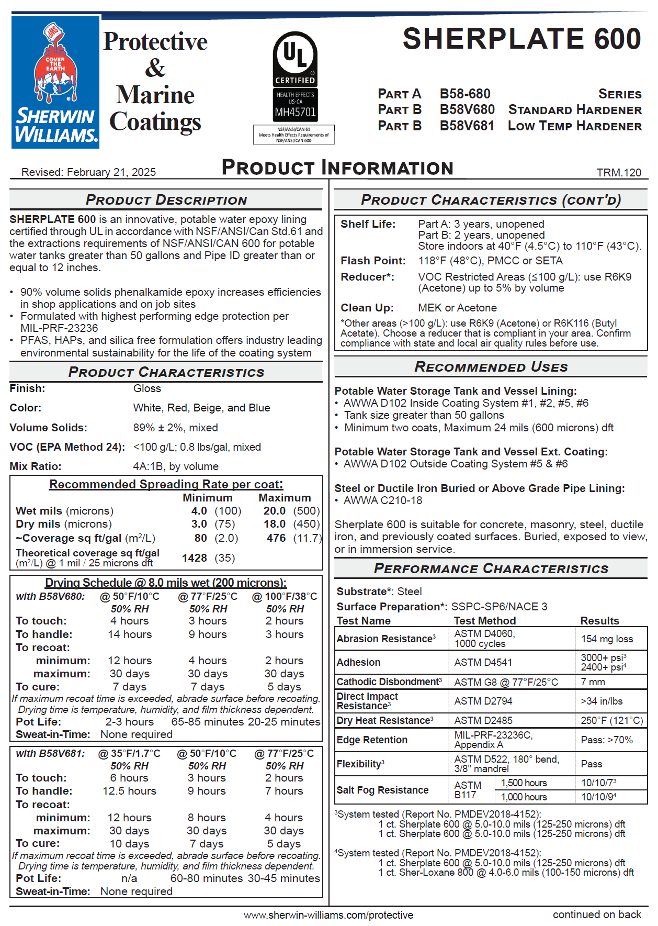

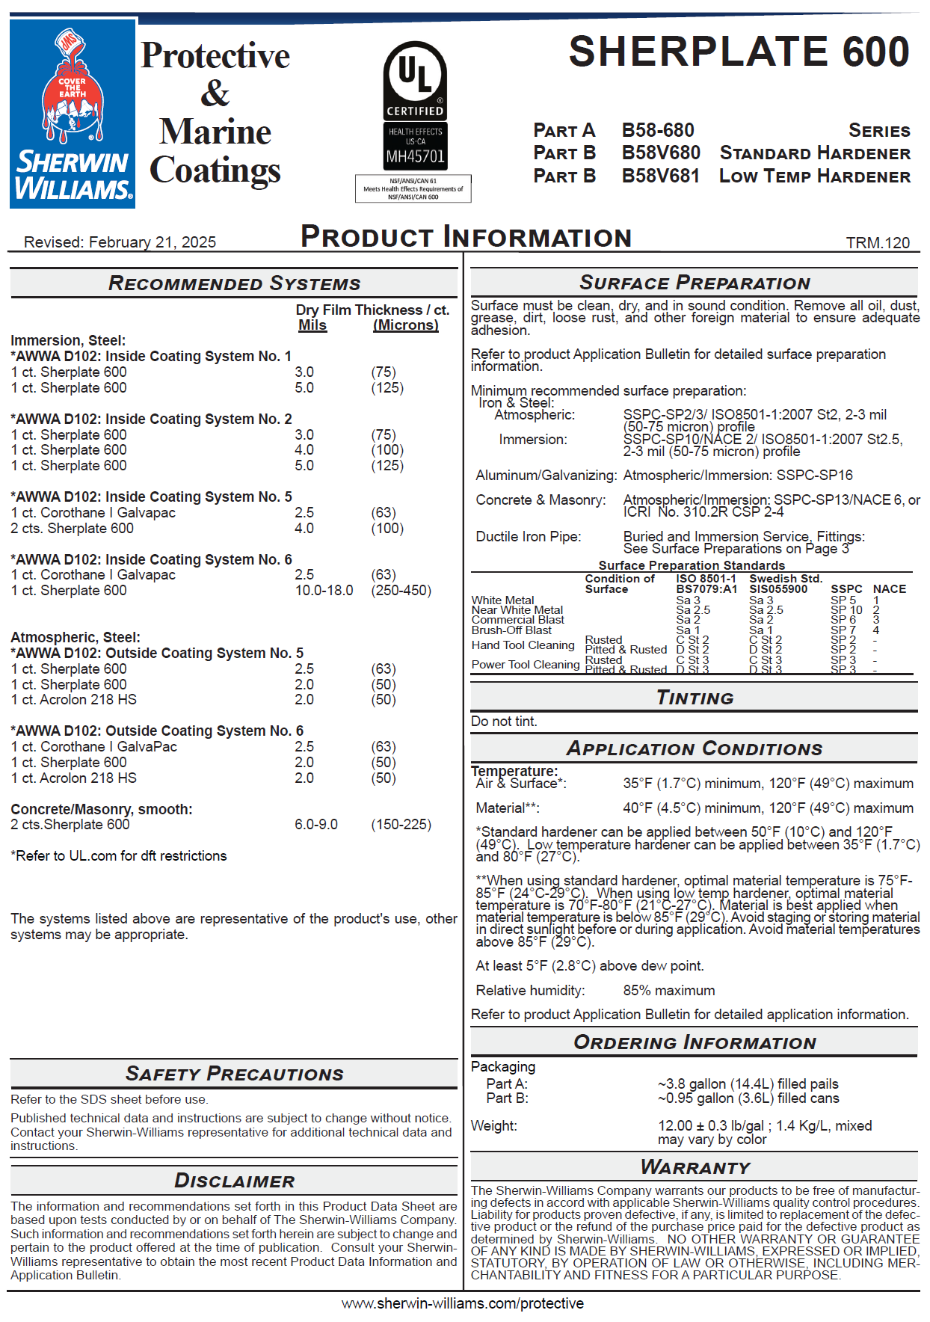

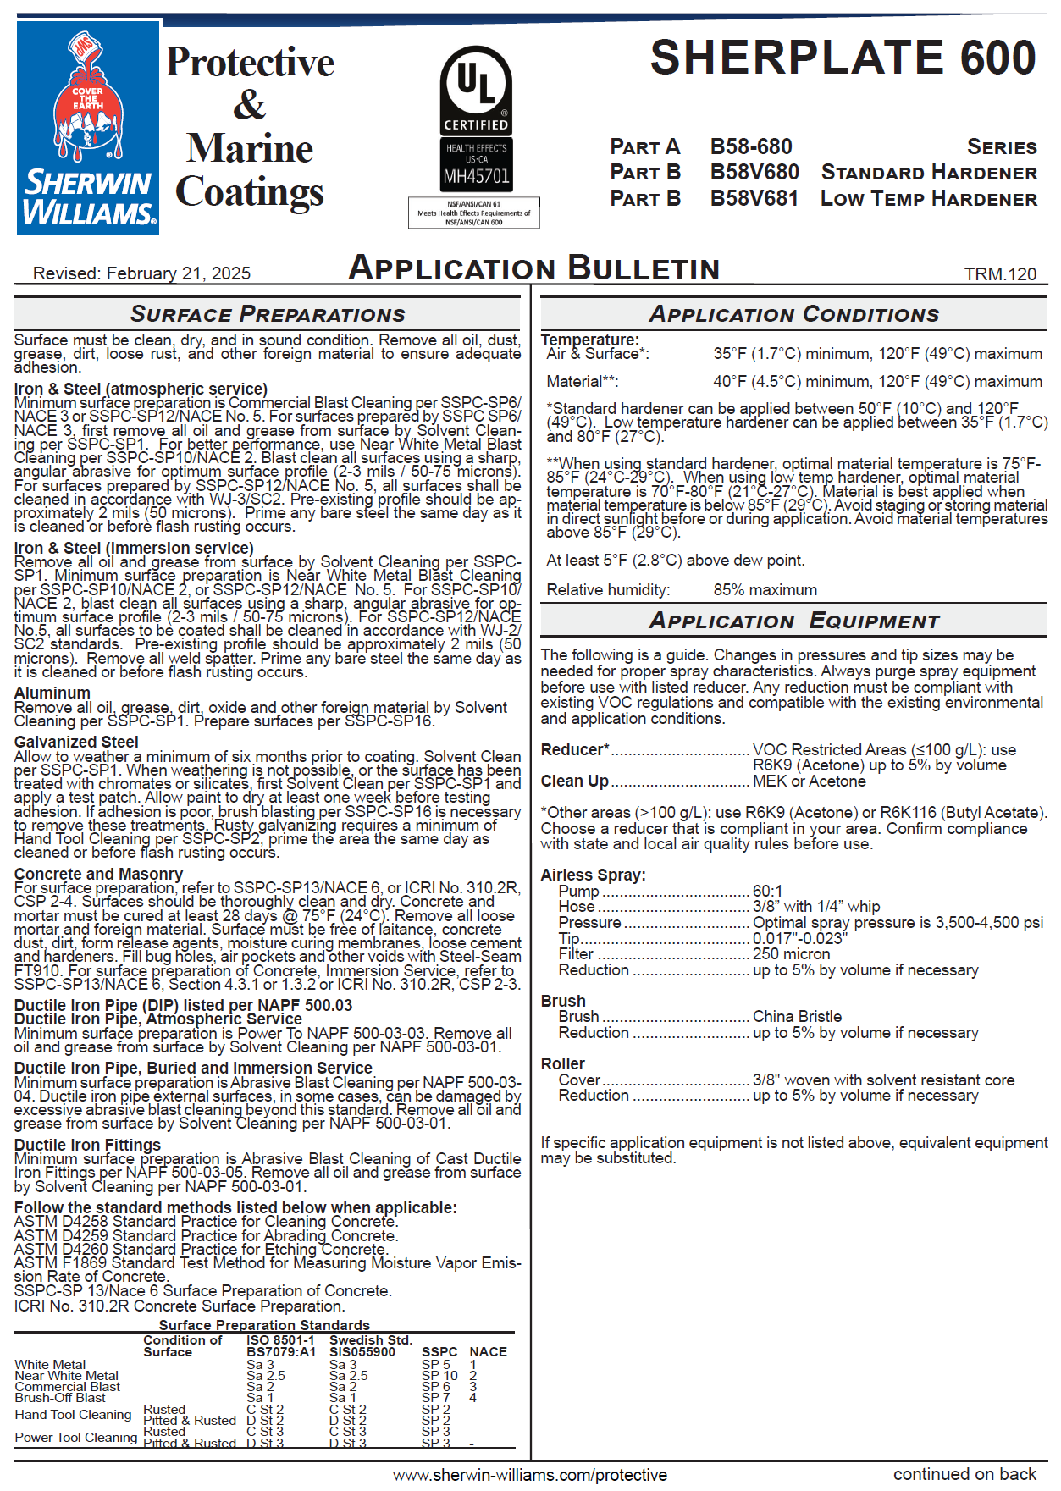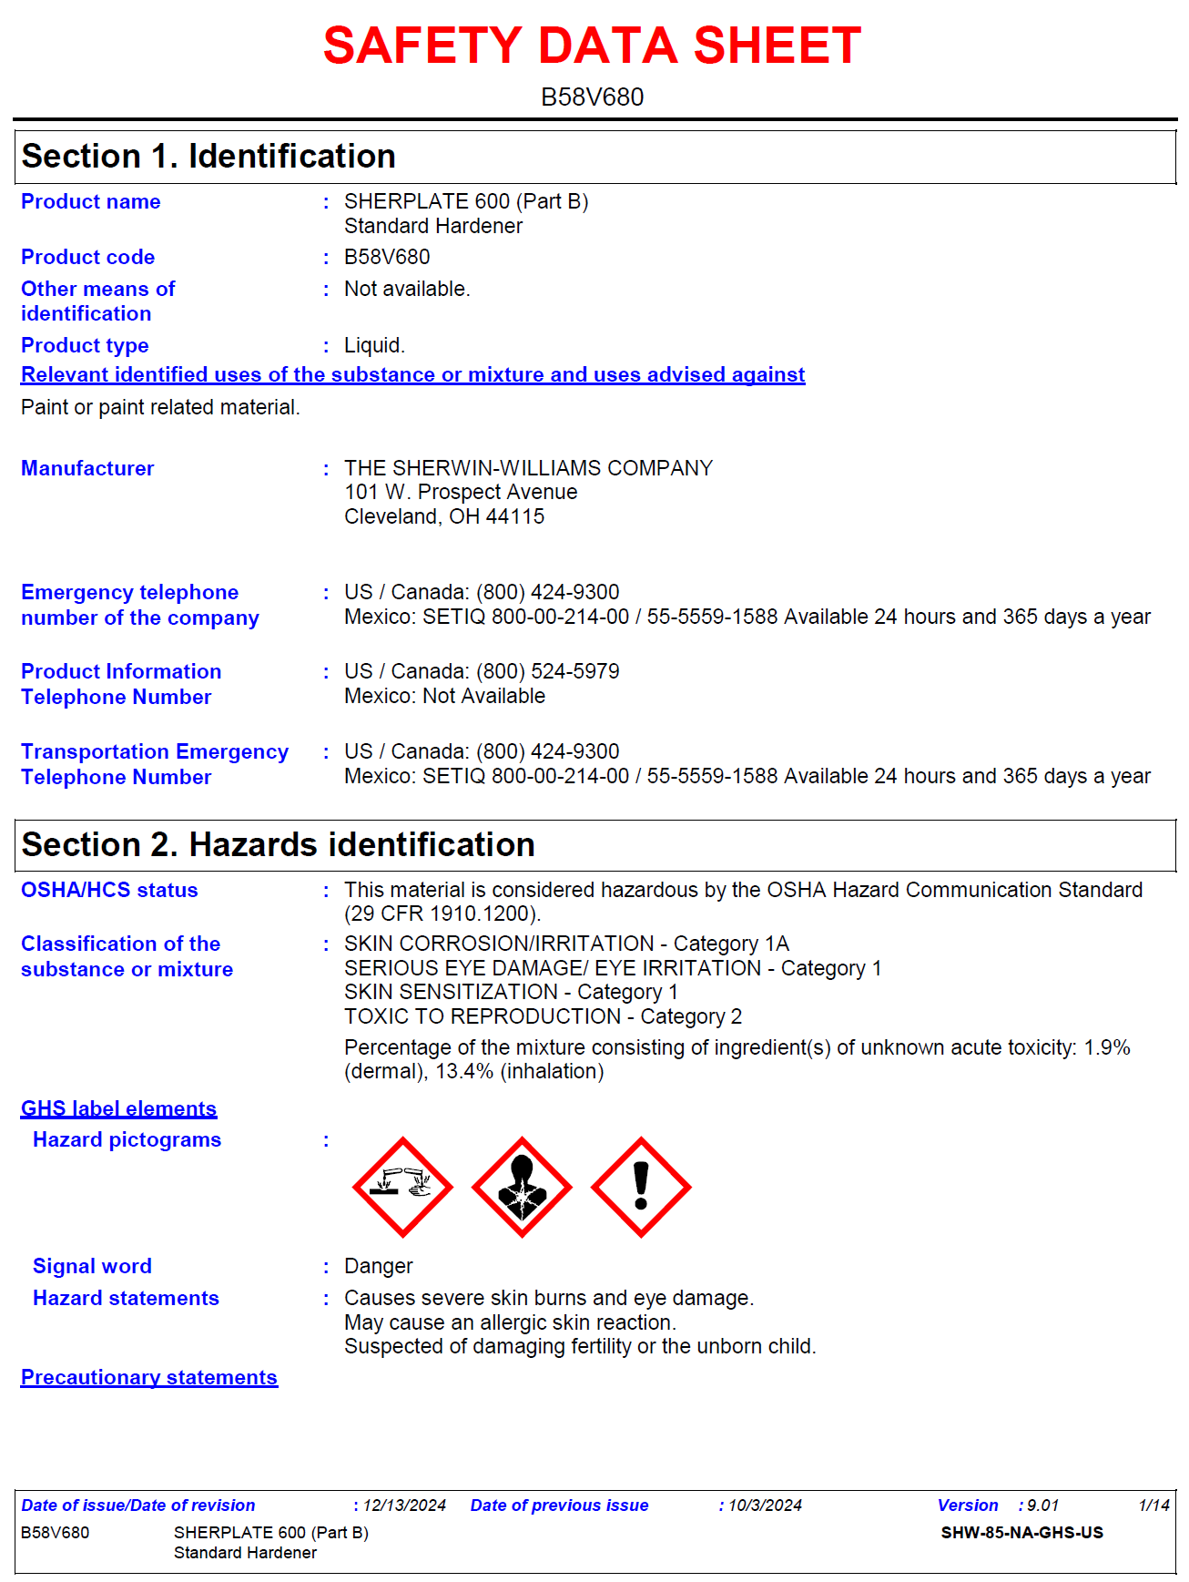

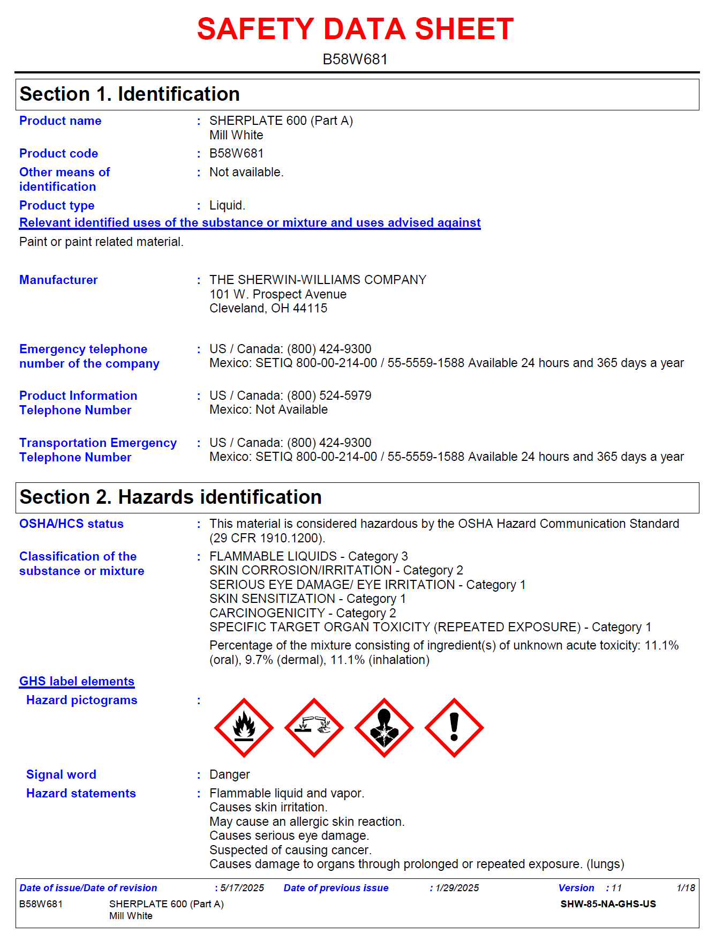

End of Addendum No.1

