Request for Proposal
Yuba Community College District

Yuba College Campus
Grounds Irrigation Tank Replacement
No. RFP 25-08

Issue Date: June 2, 2025
Proposal Due: July 15, 2025, 1pm Sharp

Proposal Due Date: July 15, 2025, 1:00 PM Sharp, Yuba College Location Delivered To:

Yuba Community College District, District Offices
Attn.: David Willis
District Director of Facilities Planning, Maintenance & Operations
RFP No. 25-08 Yuba College, Grounds Irrigation Tank Replacement
Address: Sutter County Campus, Second Floor, District Offices, Attention: David Willis, 3301 East Onstott Road, Yuba City, California 95991

Proposal Delivery at Second Floor
Yuba Community College District
Sutter County Campus
District Offices
3301 East Onstott Road (second floor)
Yuba City, California, 95991

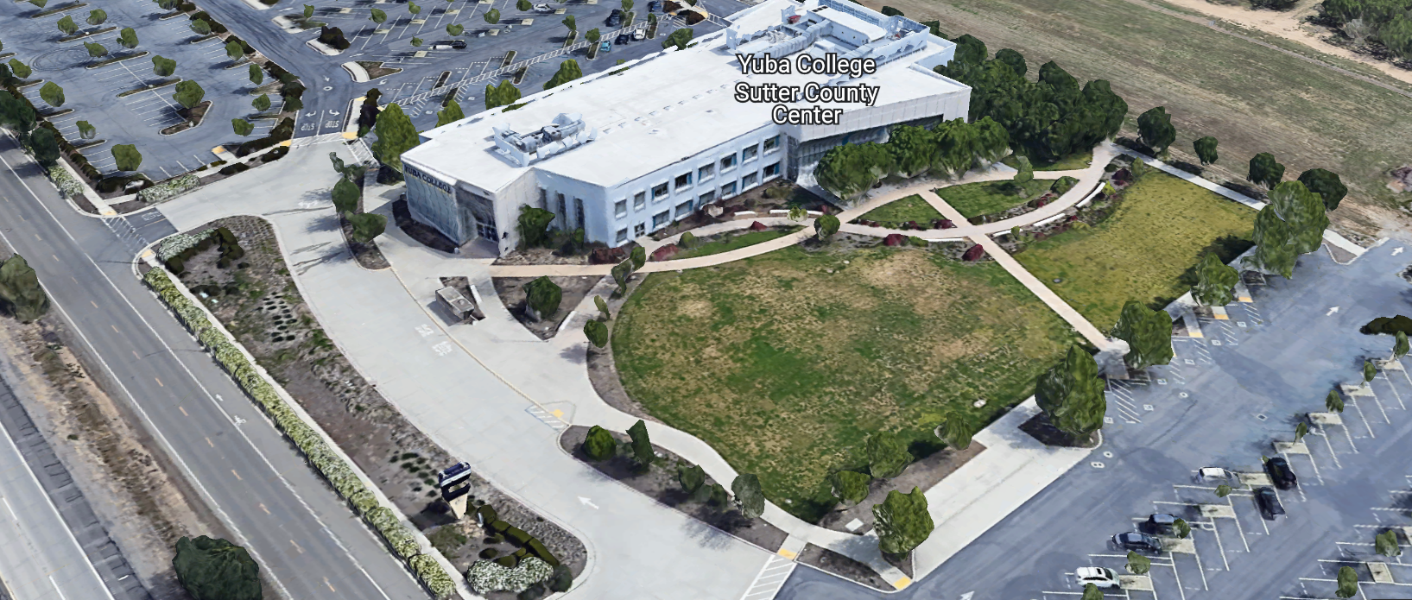
West Building Entrance
TABLE OF CONTENTS

1.0 INTRODUCTION
1.1 District Information
1.2 Yuba Community College District Background
1.3 Purpose of the Request
1.4 Applicable Codes
2.0 Scope of Work
2.1 Project Schedule
2.2 District Staff Contacts during Proposal Process
2.3 Project Safety Requirements
2.4 Demolition
3.0 Proposal Format Organization
3.1 Proposal Delivery, Contents, and Format
4.0 Selection of “Firm”
5.0 Basis of Award
6.0 Non-Discrimination
7.0 Response to Request for Proposal (RFP)
8.0 Requests for Information (RFI)
9.0 Proposal Schedule
10.0 District Parking
11.0 RFP Proposals
12.0 Award of Contract/Proposal
13.0 Reservation of Rights
14.0 Bid Bond Requirements
15.0 Performance Bond, Payment Bond Requirements
16.0 Liquidated Damages
17.0 Contractor and Subcontractors Information:

Contractor Proposal Required Items:

Appendix A, Bid Form
Appendix B, Statement of Qualifications
Appendix C, Contractor References
Appendix D, Contractors Project Approach, Project Team Members and Credentials, Preliminary Schedule
Note: A Bid Bond, Performance and Payment Bond, are required.

Informational Items:
Appendix E: YCCD Academic Calendars
Appendix F: Map of Yuba College Campus
Appendix G: Pictures of the failed irrigation tank
Appendix H: Irrigation System Piping Sketches for the Campus System

1. INTRODUCTION

  - District Information:

The District consists of two colleges, Woodland Community College and Yuba College, with campuses located at five different locations: Yuba College in Marysville, CA; Sutter County Center in Yuba City, CA; Woodland Community College in Woodland, CA; Colusa County Center in Williams, CA; and Lake County Campus in Clearlake, CA.

  - Yuba Community College District

The Yuba Community College District (YCCD) was founded in 1927 and spans eight counties (Yuba, Sutter, Colusa, Yolo, Lake, Butte, Glenn and Placer) and nearly 4,200 square miles of territory in rural, north-central California. It has colleges in Marysville and Woodland, an educational center in Clearlake, an educational center in Williams, an small Sutter Campus in Yuba City.

  - Purpose of Request

The Yuba Community College District seeks proposals from qualified Contractors to remove the existing failed irrigation tank, fabricate a new tank, modify or replace the tank supports and existing piping connections and install a new fabricated irrigation tank.
Yuba College Campus Address: 2088 North Beale Road, Yuba City, California 95901

  - Applicable Codes
All work shall meet all State of California Building Codes, and Federal codes, and local ordinances.
All projects at the District/College are prevailing wage projects.
- Scope of Work
- Inspect and investigate all existing campus site conditions of the tank, supports, piping, and general irrigation system.
- Design a new replacement tank with gauges, valves, pressure relief valves, coatings to protect the tank from corrosion for the next 20 years, drain piping and valves, seismic supports that are architecturally attractive yet functional to match the existing tank capacity.
- The existing tank, supports and associated fittings shall be properly disposed of by the contractor. If the existing concrete saddles and footings and supports can be re-used and meet seismic requirements in California, then, they can be re-used and not removed and disposed of. There are not any archived drawings or design documents for this tank and footing supports.
- The New tank shall be properly pressure rated and stamped to meet all standard industry standards.
- An access inspection port shall be provided to allow a person to enter the tank, conduct periodic inspections and to provide any internal maintenance to the tank.
- The tank shall be completely functional for the application.
- The new tank shall not leak.
- The new tank shall be level and true when installed.
- The walls of the tank, welding, and fabrication and testing records shall be provided to the District.
- It is difficult to read the existing nameplate on the tank since it has been painted over several times. Here’s what I see when I read it:
  - Roy E. Hanson Jr. Mfg.
  - Los Angeles, California
  - Max. W.P. 75 psi.
    - The new tank maximum working pressure shall be rated at least 120 psi. The existing irrigation pumps run at 80 psi working pressure.
  - Net Gallons
  - Gross Water Gallons 15,000
    - The new tank shall have at least 15,000 gallons capacity.
  - Serial No. 28907
  - Shell Thickness: 270 FL 75009
  - Head Thickness: 350 FL 75008
  - Year Built 1961 For H2O
  - 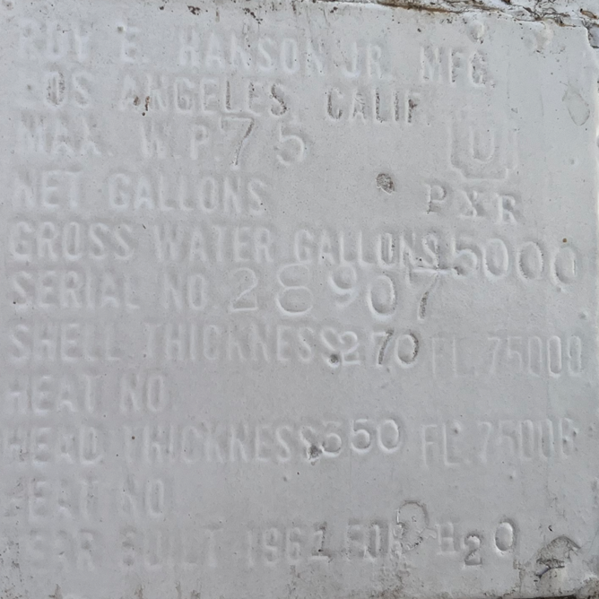
- The tank orientation shall be bid as horizontal for the purpose of the RFP. Alternates regarding size and orientation and features are certainly welcome during the bidding process.
- Tank coatings that will minimize maintenance of the steel tank over time are welcome. The color of the new tank needs to be white.
- If design provisions can be made to protect the tank against the system drawing slight negative pressure due to the College Fire Academy drawing down water to fill fire trucks, or some other large water use, etc.. then that is preferred to reduce the risk of the tank collapsing again. If a compressed air blanket on the top of the tank is the solution, it should be monitored and verified. There needs to be backflow check valves or anti-siphon provisions so the tank does not draw down into a negative pressure condition.
- Over pressure protection shall also be provided for the tank with a pressure relief valve.
- All tank design work shall meet all State of California code and regulatory compliance requirements.
- All required signs and a steel nameplate shall be on the tank.
- The tank shall have at least three 4” diameter concrete filled steel bollards that extend into the ground at least 3 feet and 4 feet above the ground, painted with primer and 2 coats of yellow epoxy enamel paint to protect the tank from impacts.
- The new tank shall be ANSI Certified with Documentation, Stamped, Tested.
- There shall not be any sharp edges. All surfaces must be prepared and properly cleaned prior to coatings.
- The Tank, Coatings, Design shall be submitted to the District for review and approval prior to fabrication as shop drawings and calculations. All coatings, gauges, valves, and features of the tank must be included in the shop drawings submittal to the District.
General Comments:

The Contractor/Tank Designer/Firm shall visit the Yuba College failed irrigation tank prior to submitting the proposal.

The Contractor personnel must provide temporary restroom facilities.

Underground utilities locating shall be done by a third part utilities locating Firm that specializes in finding and locating existing utilities to the depths of this work.
The Contractor shall apply and follow all Cal-OSHA regulations. All required PPE shall be in good condition and used when needed to protect employees.
The District encourages a positive and open communication strategy that includes a sense of partnership and mutual success on its projects.
The Contractor mark-ups for profit and overhead for change orders is 10%. Subcontractor mark-ups are limited to 10%.
2.1 Preliminary Proposed Project Schedule (Contractor to provide schedule with proposal)
Approximate Award Date: August 28, 2025

Tank Design: September 2, 2025 to October 6, 2025

Tanks design submittals and reviews will be done with the District/College during the process.

Tank Fabrication: October 13, 2025 to February 13, 2026
Construction Phase: March 2, 2026 to April 17, 2026.

100% Completion: April 24, 2026

If the tank can be replaced sooner than the above schedule, please describe this in your proposal and include a modified project schedule that allows the tank to be replaced as soon as reasonably possible.
This is a maintenance project and not, at this time, determined to be a Division of the State Architect (DSA) project.
All seismic supports for the tank shall meet California requirements, stamped engineer calculations shall be provided to the District.
Please note all College Holidays. Unless otherwise mutually agreed to, the Contractor shall not work on College/District holidays.
The contractor may work whatever hours are needed Monday through Friday. Normal working hours are 7:00am to 5:00pm but can be adjusted to meet whatever the Contractor needs.
This is a prevailing wage project. The Contractor is required to upload all certified payroll information to the Department of Industrial (DIR) Relations web site. YCCD will provide a DIR project number. The District will require a copy of all certified payroll records prior to the release of the 5% retainage and final payment to the contractor.
2.2 District Staff Contacts during the Proposal process:
Firms interested in submitting a Proposal are directed not to make personal contact with the Board of Trustees, District staff, or members of the evaluation committee. Any contact shall constitute grounds for disqualification from consideration.
Single Point of Contact during the Proposal Preparation Process:
David L. Willis
District Director of Maintenance, Operations, and Planning
YCCD District Offices, Sutter Center, (Second Floor)
3301 East Onstott Road
Yuba City, California, 95991
Cell Phone: 916-747-4262
Email: dwillis@yccd.edu

On-site coordination, first contact person access and immediate contact person during construction OR if additional site visits are needed during the bidding process.
Bryan Epp
Assistant Director of Maintenance, Operations
2088 North Beale Road
Phone: 530-740-1722
Email: bepp@yccd.edu

No changes can be made to the project scope without authorization in writing by David Willis.

2.3 Project Safety and Security Requirements
Safety is a top priority for the District. All California OSHA requirements apply. Industry best practices apply. Contractor employees shall wear shirts with sleeves, a hard hat, eye protection, hearing protection as needed, gloves, substantial leather footwear, long pants, a reflective safety vest, and take all needed precautions to complete the work in a safe manner. Safety shall not be compromised at all during the work.
Enhanced fall protection precautions shall be taken.
During windy conditions, precautions shall be taken to ensure the safety of staff and to properly secure materials and debris. The Contractor shall also take precautions during windy days if there are any risks of material being carried by the wind and deposited on vehicles or other surfaces.
The area of the project shall be fenced off with the orange flexible construction fencing and signs to keep students and staff out of the area during construction.
Protection of College property shall be taken. Contractor is 100% responsible for any damage to College property and facilities.
These campuses have a moderate risk of theft. It is the sole responsibility of the Contractor to receive and secure all materials, equipment, tools, monument signs, and other items associated with this work.
The Firm shall coordinate with the College to minimize any impacts to class schedules or roadway traffic. The access roadway shall be kept open at all times as much as possible. Tank delivery and crane setting of the tank will need to be done when least impactful to the College.
2.4 Demolition
The contractor shall provide a debris waste manifest for all items removed from the campus. Debris and waste shall be processed in accordance with all State and Federal codes, laws, and ordinances.
3.0 Proposal Format Organization
The Firm is requested to use the following proposal format:
3.1. Proposal Delivery, Contents, and Format:
Proposals should provide straightforward, concise information that satisfies the requirements noted in this RFP. Expensive binding, color displays, and the like are discouraged. Emphasis should be placed on brevity, conformity to the Districts instructions, selection criteria of this RFP, and completeness and clarity of content. Each Respondent’s proposal should clearly and accurately demonstrate specialized knowledge and experience required for consideration.
In a sealed box or envelope (clearly marked “), submit the following:
- One (1) flash memory stick containing the complete proposal and supporting documentation; You may also in addition to the flash drive, email your proposal to: dwillis@yccd.edu.
- One (1) original proposal in paper form, which consists of a Proposal Letter and responses to the proposal requirements of this RFP.

There is no page limit.

Firms must comply with the provisions of these instructions for completion and submission of the Proposal. The failure of a Firm to comply with the Proposal Instructions and Requirements will likely result (at the sole discretion of the District) in rejection of the Proposal for non-responsiveness.
Proposal Section | Format
- Cover Letter | PDF
- Table of Contents | PDF
Appendices (See Table of Contents for each one) Submit a response to each Appendix that requires Contractor information. Please submit responses to Appendices A, B, C, D. Appendices E, F, are informational only. | PDF

Proposal General Information Contents:

Information provided by the Contractor will help the District determine if the Firm is a “Responsible Bidder”.

Cover Letter

The Proposal shall include a Cover Letter on Respondent’s official business letterhead, which shall be signed by an individual authorized to legally bind Respondent. The Cover Letter shall also identify the name, telephone number, and email of a person who may be contacted during the Proposal evaluation process.

Table of Contents

Provide a Table of Contents that outlines in sequential order the major sections and sub-sections of the Proposal. Use tabs to allow information to be more easily located.

4.0 Selection of “Firm” Services Provider

The process of “Firm” selection is based upon the complete responsiveness of the RFP and the criteria as outlined in the RFP.

The District Project Evaluation Team will First pre-qualify contractors based on the Statement of Qualifications information provided by the Contractor. If qualified, then contractor proposals will be considered. Contractors that are not qualified based on the criteria and information provided by the Contractor associated with the Statement of Qualifications will not have their proposals considered even if they are the lowest cost proposing contractor.

The District reserves the right to reject any or all submittals, to amend the RFP process, and to discontinue or re-open the process at any time. The District reserves the right to request clarifications to RFP responses and to negotiate the terms of the agreement.

5.0 Basis of Award

This project will be awarded based on the following criteria:

- Lowest Total Cost Responsive Qualified Bidder
  - Lowest Total Cost
  - Contractor Capability to do the work
  - Qualified Contractor (per Appendix B, Statement of Qualifications)
    - District determined “Qualified Contractors” based on the information provided in the “Statement of Qualifications” information provided by the Contractor.
    - Proper State of California Contractor License in good standing
    - Information provided as requested in the RFP and Specifications.
    - All Addendums are acknowledged.
    - Contractor listed any exceptions or exclusions. Contractors should bid the project per the RFP and contract documents and then offer exceptions and exclusions or cost deductive or additive alternatives separately from the base bid.
    - Firms with historically poor performance on projects at Yuba Community College District will be disqualified from consideration. Poor performance is 100% solely defined by the District for such issues as not meeting original schedule requirements within two months of the original schedule OR not ordering materials and supplies, tracking long-lead procurement items and then delaying the project such that the contractor cannot recover the project schedule, OR working unsafely and not following CAL OSHA requirements OR not providing/uploading certified payroll records in accordance with the Department of Industrial Relations requirements OR excessive change orders greater than 10% of the original awarded amount on renovation projects and greater than 7% on new buildings OR generally poor quality work not acceptable to the District OR not utilizing coating manufacturer specified application equipment OR that have threatened legal action toward the District OR having a history of difficult argumentative communications regarding change orders/schedules/and quality of work OR as any combination of the above items or other similar items as determined by the District.
    - Contractors’ ability to meet schedule requirements, recover delays in the schedule.
    - Contractors have demonstrated past project references of “like” projects
    - Contractors references are all good with respect to schedule, cost, and quality.
    - No other factors such as litigation, licenses in good standing, or other similar criteria.
    - At least five (5) project references of similar projects completed in the past seven (7) years with contact information, scope of work, initial awarded cost, change orders cost, pictures if possible.

Optional Interview Process:

The top one or two of the lowest total cost responsive qualified bidders may be requested to participate in a ZOOM interview process with the District Project Proposal Evaluation Team. This interview process is fully at the discretion of the District. The District may decide that no interview is required. If an interview is needed, then it will be scored by the District and part of the evaluation process.

6.0 Non-Discrimination
The District does not discriminate with regard to race, color, gender, national origin, disability, or any other protected or other classification in the awarding of contracts/agreements. The District welcomes all Qualified Firms to participate in the project Request for Qualification/Proposal process.
The District encourages firms that are women or minority owned, emerging small businesses, veteran owned firms, disabled person owned firms, and all other qualified firms to participate in the proposal process.
The District encourages the submission of proposals from all Firms that can meet the stated requirements set for this RFP.
7.0 Responses to RFP
Sealed responses to this RFP must be clearly marked "RFP No. 25-08 Yuba College, Grounds Irrigation Tank Replacement”.

Responses shall be mailed to or hand-delivered to the following address:

Yuba Community College District, District Offices
Attn.: David Willis
District Director of Facilities Planning, Maintenance & Operations

Envelope/Box Marked:
"RFP No. 25-08 Yuba College, Grounds Irrigation Tank Replacement”.
.

Address: Yuba Community College District, Yuba College, Sutter County Center, District Services Offices, Second Floor, Attention: David Willis, Room 217, Yuba City, California, 95991

Note: Completely seal your proposals in envelope/box and make sure it gets date/time stamped when delivering proposal. Firms are each 100% responsible to make sure proposals that are mailed using a carrier such as UPS, FED Ex, etc.…are received and date/time stamped by District personnel prior to the proposal due date/time. No proposals will be considered if they are late, even if it is only 5 minutes late. Please make sure your proposals are delivered and received promptly prior to the due date/time. There will be a public proposal opening at the due date/time.

Do NOT just email your proposals. Emailed proposals, if sent, are required in addition to the above requirements.

8.0 Requests for Information (RFI)

Requests for Information concerning the RFP must be in writing and may be submitted via email no later than the date shown below. Please direct all questions to David Willis, email: dwillis@yccd.edu.

Following the RFI deadline, all questions and answers will be summarized and posted on the District's website: https://www.yccd.edu/central-services/purchasing/ , then, click on the “Requests for Proposals / Quotes” tab on the right hand side of this web page. It is anticipated that responses to inquires received by the required time and date will be provided within 5 business days and posted on the District's website or responded to per the dates listed in the RFP for addendum publishing. Should more time be needed by the District to answer I respond to RFI’s, this information will also be posted on the above website.

- Include the following in the subject matter field on emails when requesting information: “RFP 25-08”, RFI.

9.0 Proposal Schedule:

Important Dates and Times:

June 3, 2025: Release of Request for Proposal

June 10, 2025: 9:00AM to 10:00AM Optional Pre-Bid ZOOM Meeting

Join Zoom Meeting:

https://yccd-edu.zoom.us/j/86073528606\

Meeting ID: 860 7352 8606

Phone:
• +1 669 444 9171 US

June 25, 2025: 10:00AM to 11:30AM Optional On Campus Pre-Bid Meeting

Address: Yuba College, Building 600 South Side at Tank, 2088 North Beale Road, Marysville, California 95901

OR

If you cannot make it, please contact Bryan Epp at email: bepp@yccd.edu to schedule another time to meet and walk through the library affected areas.

All Firms must attend one of the Optional Pre-Bid meetings and sign the login sheet OR meet with Bryan Epp at the College and sign a login sheet.

July 7, 2025: 5:00 PM, All questions and requests for information must be submitted to David Willis at: dwillis@yccd.edu.

July 8, 2025: 5:00 PM, Addendum Issued if needed.

July 15, 2025: Proposals due at 1:00 PM SHARP, Yuba Community College District, District Offices Location: Sutter Center, District Offices, Second Floor, Room 217, Attention: David Willis, 3301 East Onstott Road, Yuba City, Ca., 95991. There will be a public bid opening on this RFP in room 211 at the Sutter Center Building.

Note: All procurement documents associated with this procurement will be posted at this web page link: https://www.yccd.edu/district-services/requests-proposals-quotes/

10.0 District Parking: (Fees Not Applicable)

-No parking in Reserved Spaces without a proper permit
-Permit Parking is enforced in all general lots between 6:00 am and 6:00 pm, Monday through Friday. All general lots require a properly displayed, valid permit during these times
-Daily Parking Permits are $2.00
-Permits are available for purchase at any of the permit machines located in the student parking lots
-All other parking regulations are enforced 24 hours a day, seven days a week. This includes designated staff spaces, handicap spaces, timed spaces, red zones, yellow zones, and areas not marked (no parking at any time)
-Once this project is awarded, temporary parking permits will be processed as requested by the successful firm for all employees associated with this project at no cost to the Firm for the duration of the project at each Campus location. These temporary permits must be displayed at all times on the dashboard of employee vehicles.

11.0 RFP Proposals

Proposals received after the deadline will not be opened. Each responder shall submit one (1) signed original hard paper copy in a binders. Provide one electronic format copy of the proposal using electronic media such as a flash drive. (No CD formatted Disks).

All materials submitted in response to the RFP shall be on 8-1/2"x11" paper, preferably in
Portrait orientation. All submitted materials must be bound in either a three-ring binder or spiral bound notebook. Content shall be tabbed and numbered per the items included in the Submittal Requirements. All Proposals will be reviewed and evaluated by a District Selection Committee. The District at its sole discretion may interview finalists or select a firm or firms to perform work based solely on the evaluation of the Proposal. There is no page limit.

All Proposals become the sole property of the District and the content will be held confidential until the selection of the Firm or Firm’s is made and the project is awarded.

12.0 Award of Contract

- The Contract will be awarded to the lowest total cost, most responsive responsible District qualified Firm, whose proposal, conforming to the request for proposal and associated addendums, will be most advantageous to the District.

B. The District reserves the right to enter into an Agreement without further discussion of the proposal submitted based on the initial offers received.

C. The District reserves the right to reject any or all proposals or any part of the proposal and to waive informalities and minor irregularities in the proposals received.

D. The RFP, its addendums, any follow-up clarifying information, and the proposal of the selected Firm will become part of any contract initiated by the District.

E. A formal contract shall be signed by the successful proposer and Yuba Community College District to perform this service.

F. The District reserves the right to enter into discussions with any one or all of the Responders after Proposals have been initially reviewed. Such responses shall be subject to all provisions, terms and conditions as set forth in the RFP, unless otherwise modified.

G. The District intends to award to a single RFP Responder.

H. BONDS: A Bid Bond is required with the Proposal. The Contractors Performance and Payment bonds are required within 7 calendar days after the Notice of Award is provided to the Contractor. The Bid Bond is required with the proposal.

I. Failure to acknowledge all of the addendums, provide the items listed in the RFP, may render the proposal unresponsive at the discretion of the District. Items listed in the RFP become part of the contract unless the Contractor provides an exception in the proposal. Contractor exceptions, depending on the magnitude, may render the proposal unresponsive, at the discretion of the District.

J. The District reserves the right to request clarification of proposal content during the review and evaluation process.

K. The District reserves the right to negotiate the terms of the agreement to align with budgetary constraints.

13.0 Reservation of Rights

The District reserves the right to:

- Reject any or all submittals at its sole discretions.
- Cancel the Request for Proposal (RFP), without cause.
- Modify any requirements contained within the RFP and request a revised submission from all Providers.
- Establish other evaluation criteria determined to be in the best interest of the District.
- Contract with any of the firms responding to the RFP based solely upon its judgment of the qualifications and capabilities of the firm.
- Clarify the content of any proposal to verify that the requirements of the RFP are included.
- Waive “minor” proposal inconsistencies that do not change the scope of work as outlined in the RFP.
- Request an alternative Superintendent on the project if the initially assigned Superintendent on the project is not performing well, not meeting project requirements, not working well with College staff and students, not applying best practice safety methods, OR not following College/District guidance regarding project approach. If the owner is the Superintendent, and has been replaced, the owner may visit the project briefly (less than 1 hour per day up to 2 times per week) to coordinate with the replacement Superintendent.
- The District will not allow or tolerate verbal abuse or any other type of abuse by the Contractor toward any College or District personnel or Contracted professional service providers. Abuse, defined solely by the District as verbal or physical, or written, may lead to a “Stop Work” order by the District until it can be resolved, and steps taken to ensure abuse is not repeated. If abuse occurs again, the District may issue a final “Stop Work” order, require the Contractor to leave the College/District project site and process a Performance Bond claim to complete the work. All costs associated with District “Stop Orders” are 100% the responsibility of the Contractor. The contractor will be required to catch up the project schedule if a “Stop Order” is required to be issued for up to 5 days due to unprofessional behavior on the part of the Contractors employees.
- Disqualify a Contractor after reviewing the proposal and finding concerning performance information in references, inadequate or incomplete proposal information, inadequate or information that is provided by the Contractor as part of the Statement of Qualifications process, and historically poor project performance at the District/Colleges (as solely defined by the District).

This RFP does not commit the District to award or negotiate a contract. The District will not be responsible for any expenses incurred by any firm in preparing and submitting a proposal or response to this RFP or in completing any of the work specified.

14.0 Bid Bond Requirements (Proposed Form—Contractor can use their standard form):

BID BOND

Know all persons by these presents:

That we, , as Principal, and , as Surety, are held and firmly bound unto Yuba Community College District, hereinafter called District, the sum of ten percent (10%) of the total bid amount of Principal for payment of which in lawful money of the United States, well and truly to be made, we bind ourselves, our heirs, executors, administrators, successors, and assigns, jointly and severally, firmly by these presents.

The condition of the above obligation is such that, whereas, the Principal has submitted a bid for the work described as follows: RFP 25-08 Yuba College Irrigation Tank Replacement.

Now, therefore, if Principal shall not withdraw said bid within the time period specified after the bid date, as defined in the bidding documents, or within ninety (90) days after the bid date if no time period is specified, and, if selected as the apparent lowest responsive responsible bidder, Principal shall, within the time period specified in the bidding documents: Enter into a written agreement, in the form prescribed in the bidding documents, in accordance with its bid; file with the District all bonds required to be filed, including but not limited to faithful performance and payments bonds; and, furnish certificates of insurance and all other items required by the bidding documents.

In the event of the withdrawal of said bid within the time period specified, or within ninety (90) days if no time period is specified, or the failure of Principal to enter into such agreement and furnish such bonds, certificates of insurance, and all other items as required by the bidding documents, if Principal shall pay to the District an amount to the difference, between the amount specified in said bid and such larger amount for which the District procures the work covered by the bid, if the latter is in excess of the former, then this obligation shall be null and void, otherwise to remain in full force and effect.

In the event suit is brought upon this bond by District, in addition to the penal sum of this Bid Bond, Surety shall pay reasonable attorneys’ fees and costs incurred by District in such suit.

Surety hereby expressly waives the provisions of California Civil Code section 2845.

In witness whereof, we have hereunto set our hands this day of , 20 .

Principal: Surety: (Name of firm)

By: By:

Title: Title:

Broker Name or Agent Name:

License Number:

Bond or company appointment must be listed with the CA Department of Insurance Notary acknowledgments for Surety and Surety’s Power of Attorney must be attached.

Address for Notices:

Bid Bond Requirements:
Provide a Bid Bond per the following:

PUBLIC CONTRACT CODE - PCC

DIVISION 2. GENERAL PROVISIONS [1100 - 22355]

ARTICLE 4. Bids and Bidders [10160 - 10169]
( Article 4 enacted by Stats. 1981, Ch. 306. )
Section: 10167.
    - All bids shall be presented under sealed cover and accompanied by one of the following forms of bidder’s security:
      - An electronic bidder’s bond by an admitted surety insurer submitted using an electronic registry service approved by the department advertising the contract.
      - A signed bidder’s bond by an admitted surety insurer received by the department advertising the contract.
      - Cash, a cashier’s check, or certified check received by, and made payable to, the director of the department advertising the contract.
    - The required bidder’s security shall be in an amount equal to at least 10 percent of the amount bid. A bid shall not be considered unless one of the forms of bidder’s security is enclosed with it.
    - All bids submitted pursuant to this section shall also comply with the provisions of Section 1601 of the Public Contract Code.
(Amended by Stats. 2012, Ch. 290, Sec. 3. Effective January 1, 2013.)

The Bid Bond shall be provided with the Contractor’s Proposal.

15. Performance and Payment Bond Requirements: Required for this project and described in the District Agreement for Services form (Appendix E, Agreement for Services). The Performance and Payment bonds are due 7 to 10 days after the award date.

16.0 Liquidated Damages: (Not Applicable)
17. Contractor and Subcontractors Information:
No. | Name of Firm | Contractor License Number/Expiration Date | Department Of Industrial Relations Registration Number/Expiration Date
1
2
3
4
5

Appendix A: Proposal Bid Form:

No. | Description | Cost
1 | Site Investigation and Inspection of Existing Conditions and System | $
2 | Tank Design
3 | Tank Fabrication | $
4 | Mobilization, Demolition, Disposal of Existing Tank, and Construction | $
5 | Unforeseen Conditions and Contingencies: | $10,000.00
6 | Other: | $
7 | Total Costs: | $

Provide schedule of values.
Prevailing wages apply to this project.

Provide a list of employee classifications and labor rates for the Yuba College prevailing wage location.

This is a Department of Industrial Relations (DIR) project. The District will provide a DIR number for this project. The Contractor/Firm will be required to upload prevailing wage certified payroll records of the fabrication of the tank and the construction work. A copy of the certified payroll records for the project is required before the final payment is made.

If there is a required percentage of the tank that must be paid up front before fabrication, indicate this in the proposal.

List all First Tier Sub-Design Firms and Sub-Contractors.

Please round off numbers to the nearest dollar.

A preliminary overall start-to-finish project schedule is required with the proposal.

Please list any exceptions or exclusions.

Please include a preliminary schedule for the design, fabrication, and construction.

Appendix B: Statement of Qualifications (Applies to the Firm)
The Firm shall furnish the following information. Failure to comply with this requirement will render the submittal informal and may cause its rejection. Additional sheets may be attached if necessary.
Basic Firm Informational Items 1 through 17:

- Firm Name:___________________________________________________________________

- Primary Address: ______________________________________________________________

- Firm’s Contact Person and Title:___________________________________________________

- Telephone: ___________ Facsimile: ____________________

- Email Address: ___________________

- License No.: ______________________________ Class: __________________________

Responsible Managing Employee/Officer:_________________________________________

- DIR Registration No.:________________________ Expiration Date:___________________

- Names and titles of two officers of the Firm:

NAME TITLE

___________________________________ _______________________________________

___________________________________ _______________________________________

9. Specific type of Ownership (Check one)

Individual
Partnership
Corporation; If a corporation, state the following:

State of incorporation:
Date of incorporation: President/CEO:
Joint Venture
Other (Specify)

- Taxpayer Identification No.: _______________________
- List annual gross income for last three (3) years:
Year: _______________ $_____________________
Year: _______________ $_____________________
Year: _______________ $_____________________

- Number of years Firm has been in business:
If less than 5 years, please describe:

- Number of years Firm has conducted business under the present name:__________
- Has the Firm ever been licensed under a different name or different license number? . If Yes, give name(s) and license number(s) and dates or operation under that name(s) and license number(s) (attach separate sheets if necessary):___________________________________________ _________________________________________________________ _________________________________________________________

Potentially Disqualifying Questions 15 through 19 (District may immediately disqualify Firm if its answer Question 15 “No” or question 16 through 19 is “Yes”. Firm’s refusal to answer or omission of response to any of Questions 15 through 19 may result in disqualification of Firm.):

- Does the Firm possess a valid and currently in good standing California Contractors’ license for the classification(s) of Contractors’ License required for the Project? If Yes provide the license number(s). Yes/No______________________________________________________

- Has the Firm been disqualified, debarred, forbidden, or found non-responsible or otherwise prohibited from performing work or bidding won work for any California school district, community college district, or other California public agency within the past five years? Yes/No

If yes, identify agency and details:

- Has the Firm been in litigation (whether in court or arbitration) with any California school district, community college district, or other California public agency on an issue pertaining to any contract during the past five years? Yes/No:

If yes, explain, identify the agency, and provide case name and number.

- Has the Firm ever failed to complete a project in the past five years? Yes/No: If so, give owner and details:

- Is the Firm currently or has the Firm been in a state of “Bankruptcy” in the past five years? Yes/No:
If yes, please explain.

Rating Questions 20 through 25:

- Please list and describe on separate sheets the Firm’s top 5 irrigation system or tank projects most recent (within the past 7 years) references with current contact information. The project reference list should include the following criteria:
  - Project Name
  - Project Owner and Contact Information
  - Project Scope of Work
  - Original Contract Completion Date
  - Actual Project Completion Date
  - Original Contract Awarded Amount
  - Final Adjusted Contract Awarded Amount (with change orders)
  - Any issues that Firm had to overcome on the project

Scoring Criteria:
  - Multiple Projects with Similar Scope of Work (50 points)
  - Completed Multiple Projects on Schedule, within 30 days of original scheduled completion date (up to 50 points)
  - Project Change Orders less than 5% (up to 50 points)
  - At least two (2) Projects Completed at a school or public entity in California (30 points)

Total points for Question 20: up to 180 points

- List your Firm’s Workers’ Compensation Experience Modification Rate (EMR) for the three most recent years. Your EMR should be issued to your Firm by your workers’ compensation insurance carrier.

Year _______ EMR _______

Year _______ EMR _______

Year _______ EMR _______

(EMR numbers under 1.0 = 20 points; 1.0 to 1.24 = 5 points; 1.25 to 1.49 = 1 point; 1.50+ = 0 points.)
- Has your Firm had any OSHA violations or citations and penalties levied against it in the past five years? If Yes, how many violations (and please explain)________
(0 = 10 points; 1 = 3 points; 2+ = 0 points.)

- In the last 10 years, how many legal proceedings (filed in court or arbitrations) has an owner initiated against your Firm, regardless of outcome? _______
(0 = 20 points; 1 = 5 points; 2+ = 0 points.)

- Has your Firm been denied an award of public works contract based on a public agency’s finding that your Firm was not a responsible bidder within the last five years? ______
(No = 10 points; Yes = 0 points.)

- Please describe the Capability/Capacity of your Firm. Please provide a comprehensive list of projects that the Contractor has in process and reasoning/justification regarding how the Contractor has capacity to perform the required construction services on this project.

(Up to 30 points.)

Qualification Criteria:
Questions 1 through 14 are general base level information that is required for pre-qualification.
Questions 15 through 19 are possible disqualifying questions that would render the Firm “not qualified” as determined by the District.
Questions 20 through 25 are rating questions that are scored and more deeply evaluated. Not scoring the minimum threshold value will render the Firm “not qualified”.
  - The District can disqualify a Firm (at it’s sole discretion) if the Firm does not meet the requirements of Questions 15 through 19.
  - There are a total of 270 points possible for questions 20 through 25.
  - To be determined as a qualified Firm, each Firm must score at least 220 points, and meet the minimum project experience noted in question 20.
  - If an interview of the top Firms is determined to be needed by the District, then it will be scored at 50 points and become part of the evaluation process.

Firms will be notified if they are determined meet minimum qualification criteria.

The undersigned is duly authorized to execute this Statement of Qualifications under penalty of perjury on behalf of the above-identified Firm. The undersigned warrants and represents that he/she has personal knowledge of each of the responses to this Statement of Qualifications and/or that he/she has conducted all necessary and appropriate inquiries to determine the truth, completeness, and accuracy of responses to this Statement of Qualifications. The undersigned declares and certifies that the responses to this Statement of Qualifications are complete and accurate; there are no omissions of material fact or information that render any response to be false or misleading and there are no misstatements of fact in any of the responses. The above-identified Firm acknowledges and agrees that if the District determines that any response herein is false or misleading or contains misstatements of fact so as to be false or misleading, the District may find the Firm is not qualified and the District can reject the proposal for non-responsiveness or non-responsibility.

Executed this___ day of __________________ 20__ at_____________________________.
(City and State)
I declare under penalty of perjury under California law that the foregoing is true and correct.

By: ____________________________________________
(Signature of Firm’s Authorized Officer or Representative)

____________________________________________
(Typed or Printed Name)

Title: ___________________________________________

General qualification process and comments:
- Firms with historically poor performance on projects at Yuba Community College District will be disqualified from consideration. Poor performance is 100% solely defined by the District for such issues as not meeting original schedule requirements within two months of the original schedule OR not ordering materials and supplies, tracking long-lead procurement items and then delaying the project such that the contractor cannot recover the project schedule, OR working unsafely and not following CAL OSHA requirements OR not providing/uploading certified payroll records in accordance with the Department of Industrial Relations requirements OR excessive change orders greater than 10% of the original awarded amount on renovation projects and greater than 7% on new buildings OR generally poor quality work not acceptable to the District OR not utilizing coating manufacturer specified application equipment OR that have threatened legal action toward the District OR having a history of difficult argumentative communications regarding change orders/schedules/and quality of work OR as any combination of the above items or other similar items as determined by the District.

- Firms that are “disqualified” by the District will not be considered for future project work.

- Firms that are not “qualified” through the “Statement of Qualifications” process will not have their proposals considered.

- Contractors are encouraged to provide complete and comprehensive information to support the “Statement of Qualifications” in Appendix “B” of the RFP.

- Proposals from other Contractors will remain confidential.

- Contractors “Statement of Qualifications” process evaluation by the District Evaluation team will remain confidential.

- The District is not required to interview Contractors as part of the evaluation and qualification process.

Appendix C: Contractor References Form (Example Template)

Bidder shall provide a minimum of Five (5) verifiable references with current contact information, preferably from a California public educational institution and/or California public agency, representing projects started and completed within the last 5 years. See clarification note below regarding reference requirements.
All phone numbers and emails must be current (please verify).
REFERENCE #1
NAME
ADDRESS
CITY, STATE ZIP CODE
TELEPHONE #
CONTACT
DATES OF SERVICE
REFERENCE #2
NAME
ADDRESS
CITY, STATE, ZIP CODE
TELEPHONE #
CONTACT
DATES OF SERVICE
REFERENCE #3
NAME
ADDRESS
CITY, STATE, ZIP CODE
TELEPHONE #
CONTACT
DATES OF SERVICE

You may of course use the Firm’s established reference template.

Appendix D: Contractors Project Approach, Project Team Members and Credentials.

This is a pretty small project.
Please share information regarding the tank fabrication shop, location, and other information that would be helpful
Please share information regarding the welder qualifications for the tank fabrication.
Please share credentials of the foreman or other team members that would be assigned to this project.
It is important to have experienced Superintendents/Foreman, trades with expertise to do a good job and in meeting the journeyperson to apprenticeship ratios per the Department of Industrial Relations, and to be able to complete the work on schedule with good quality work.
It is expected that all equipment operators will be fully trained and experienced.
Underground utilities locating shall be done by a third part utilities locating Firm that specializes in finding and locating existing utilities to the depths of this work.
Please share all tank features that you have included in your proposal, including ratings, stamps, etc..

Appendix E: YCCD Academic Calendar
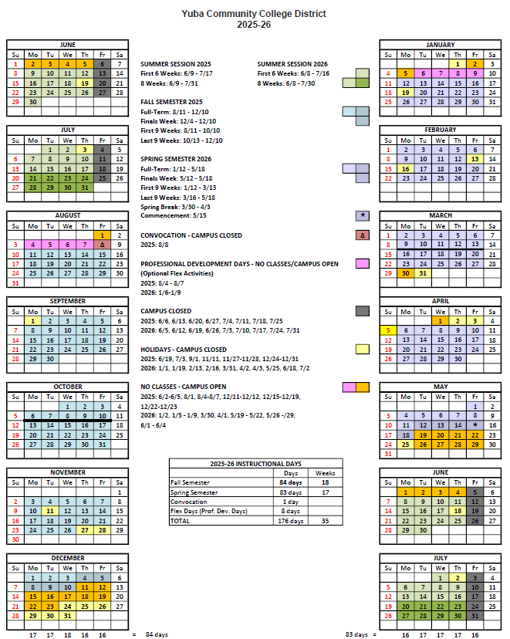

Appendix F: Map of Yuba College
Irrigation Tank Location
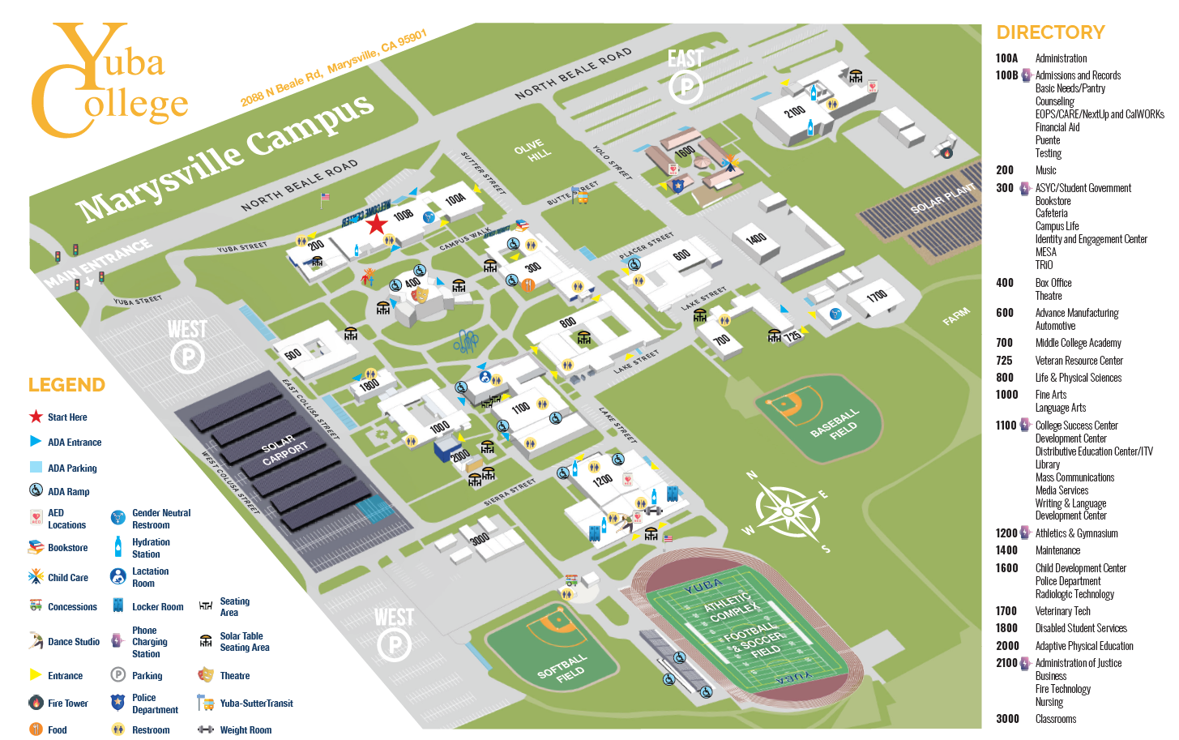

Appendix G: Pictures of the Failed Irrigation Tank

Link:
https://goyccd-my.sharepoint.com/:f:/g/personal/w0398409_yccd_edu/Ek6PMMqBzL1OsdN_OCybJgUBlIbFiDmVcFUNo-bmIOfOTg?e=FxBwpJ

Appendix H: Irrigation System Piping Sketches for the Campus System

Link: Not available
The Firm (contractor) is strongly encouraged to visit the campus and inspect the existing failed tank and investigate the site conditions and system, discuss the project with Bryan Epp, Assistant Director of Maintenance and Operations, email: bepp@yccd.edu prior to submitting a bid proposal. The Firm is required to accommodate all existing field conditions as part of the bid proposal to provide a complete solution to this tank replacement.

The End.

