Tuesday, April 8th, 2025

District: Yuba Community College District
District Offices
3301 E Onstott Rd
Yuba City, CA 95991
Contact: David Willis, Dir. Facilities Planning, Maintenance & Operations

Job Location: Yuba Community College
Building 1100 Library
2088 N Beale Rd
Marysville, CA 95901

Clarifications:

- Question: All walls that have existing insulation in the areas that have sheetrock that was removed will need to be replaced under the sheetrock areas?
Answer: Yes, where the drywall was removed up 24” from the base, the existing fiberglass batt insulation was removed to approximately 4’ above finish floor. This insulation will need to be replaced. Dense Glass sheetrock is used in many areas and needs to be like for like.

- Question: If a wall or column is being repainted and it has anything fastened to it, including a fire alarm annunciator, will it will need to be removed and then reinstalled by a fire alarm contractor?
Answer: Yes, Rex Moore is the District Specified fire alarm contractor so that programming changes will be consistent with the rest of the campus. Here’s some contact information:

  - Greg Stedman | Systems Sales Representative | http://www.rexmoore.com
Phone: | Fax: | Cell: 916-202-3431 | 6001 Outfall Circle, Sacramento, CA 95828

- Question: Does a Fire Suppression contractor needs to be involved to replace the ceiling tile in the grid with the sprinklers?
- Answer: Yes. Rex Moore subcontracts this work or another fire suppression contractor will need to do this work. The fire suppression system will need to be drained, the fire suppression fixture will need to be removed, the ceiling panel installed, the fire suppression fixture reinstalled, and then the fire suppression system will need to be slowly repressurized at the PRV.

- Question: What is the square footage of the carpet tile area to be replaced?
Answer: The contractor will need to either measure it or take it off per the drawings. A link to the drawings for this project is provided here:
Link:

https://goyccd-my.sharepoint.com/:f:/g/personal/w0398409_yccd_edu/Epmc8a0lF09Lh6EuBt0XLrwBvR6D6gGaKUgzHtrzUk9lUA?e=M5sgVC

- Question: Is there a marked up layout/sketch that shows the carpet tiles that are to be removed and replaced?
Answer: Yes, see attachment in Exhibit B.

- Question: What information is available regarding the existing carpet tile?
Answer: The information on the finish schedule of the drawings and the following information provided after one of the carpet tiles was measured and weighed per an ITEL report:

Construction: Tufted Textured Loop
Pile Height: 0.17 in
Face Weight: 27.2 oz
Fiber Type: Nylon
Tufts Per Sq. Inch: 76
Backing Material: PVC

Provide at least 5% in additional spare carpet floor tile for whatever carpet tile is provided.

- Question: What is the vapor barrier slip sheet specification for the sheet below the carpet tiles?
Answer: The District does not have a specification for this. Either refer to the finish schedule in the drawings or match existing, per the pictures and walk-through.

- Question: How far up the walls does the contractor need to paint?
Answer: From the finish floor to the natural break line in a change of surface material or to the ceiling materials. For example, the west wall has a wood panel at approximately the halfway point, the painting work will continue up to the wood panel.

- Question: How much electrical work will be required for this renovation?
Answer: The electrical work is limited to removing and replacing the existing outlets to allow the installation of sheetrock and covers, some of the existing outlets may be damaged as part of the work and will need to be replaced as needed. Some of the existing furnishings do have electrical tie-in requirements to the electrical services in the existing concrete floor. Due to the unknowns on this line item, a place holder number is provided by the District as a Time and Material line item, in a revised Appendix A Bid Form is attached to this Addendum as Exhibit A. Provide labor rates for each employee working on the project. This is a prevailing wage project.

- Question: The existing shelving was removed in almost all cases in the area affected. Does the contractor remove/grind off all floor anchors that are sticking up out of the concrete?
Answer: Yes. All floor anchors associated with the shelving units need to be removed, ground off. The line item in the Appendix A Bid Form for furnishings relocations shall also include new concrete anchors to match existing for the new or relocated furnishings.

- Question: Is there a specification for the ceiling tile?
Answer: No. Refer to the pictures 9586 and 9587 in the folder dated 4.03.2025 in the link. The contractor shall match existing tiles and replace all damaged tiles. If the existing tiles cannot be matched, then all of the tiles in the respective section between the black borders will need to be replaced so that this section does not look like a patchwork.

Link to pictures:

Fire and Water Dam https://goyccd-my.sharepoint.com/:f:/g/personal/w0398409_yccd_edu/EtU37ctBQsFAvMC04Mhc290BRGijMFvx4yFSkDnrHhgg7g?e=rwBoSJage Mitigation Pictures

- Question: Does the HVAC ductwork need to be cleaned?
Answer: No. It no longer smells like smoke in the spaces.

- Question: Does the contractor need to provide a thorough cleaning after the work is completed?
Answer: Yes, all surfaces in the affected area need to be cleaned and wiped down, including windows, HVAC diffusers and grilles, items attached to the walls, wood paneling, and any existing furnishings that are relocated back into the space. The second floor area where items are stored needs to be vacuumed.

- Question: Does the contractor need to provide temporary lighting?
Answer: Yes. The District is hiring another contractor to remove the existing light fixtures and install new light fixtures after the painting work is done. This will be coordinated with the restoration contractor.

- Question: Will the College need several options regarding carpet tiles to make a selection?
Answer: Yes, the College will need to select from several options.

- Question: Will the accent walls in the rooms, near the elevator, and in the hallways need to be painted?
Answer: Yes, the College will provide the designated color out of the College colors in Exhibit C.

- Question: Will the contractor need to maintain the plastic barriers around the area affected?
Answer: Yes, during construction, then remove and dispose prior to cleaning.

Exhibit A: Revised Bid Form

No. | Description | Cost
1 | General Conditions/Mobilization | $
2 | Construction | $
3 | Demobilization, Comprehensive Clean Up, Project Closeout, Punch List, Removal of plastic sheeting project boundary barriers, Certified Payroll Records to DIR and the District, etc.. | $
4 | Replace furnishings and books, and various items back into place. This is a place holder. Please provide labor rates. This cost will need to be tracked as a T&M line item since it is impossible to quantify and accurately estimate. | $30,000.00
5 | Miscellaneous electrical work is associated with outlet replacements, and wiring in the furnishings after they are placed back into position. This is a T & M item that will need to be tracked. Provide labor rates for all employees doing this work. This is a prevailing wage project. | $15,000.00
6 | Other: | $
7 | Other: | $
8 | Sub-Total Costs: | $
9 | Additive or Deductive Alternate: | $
10 | Additive or Deductive Alternate: | $
11 | Total Costs: | $

Provide schedule of values.
Prevailing wages apply to this project.

Provide a list of employee classifications and labor rates for the Yuba College prevailing wage location.

The move-in work on-line item 4 above will all need to be closely coordinated with the College and the District. The scope is impossible to accurately determine at this time.

List all First Tier Sub-Design Firms and Sub-Contractors.

Please round off numbers to the nearest dollar.

A preliminary overall start-to-finish project schedule is required with the proposal.

Exhibit B Carpet Tile Replacement Areas

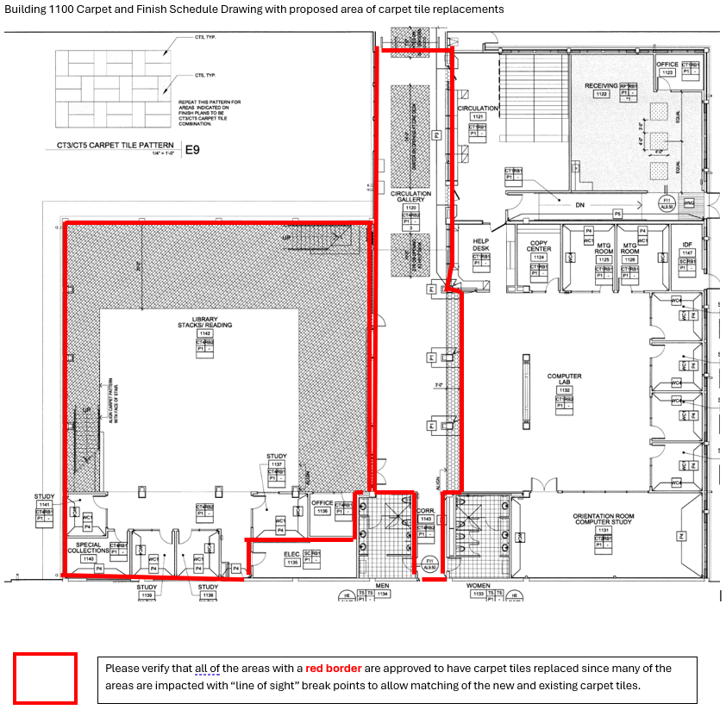

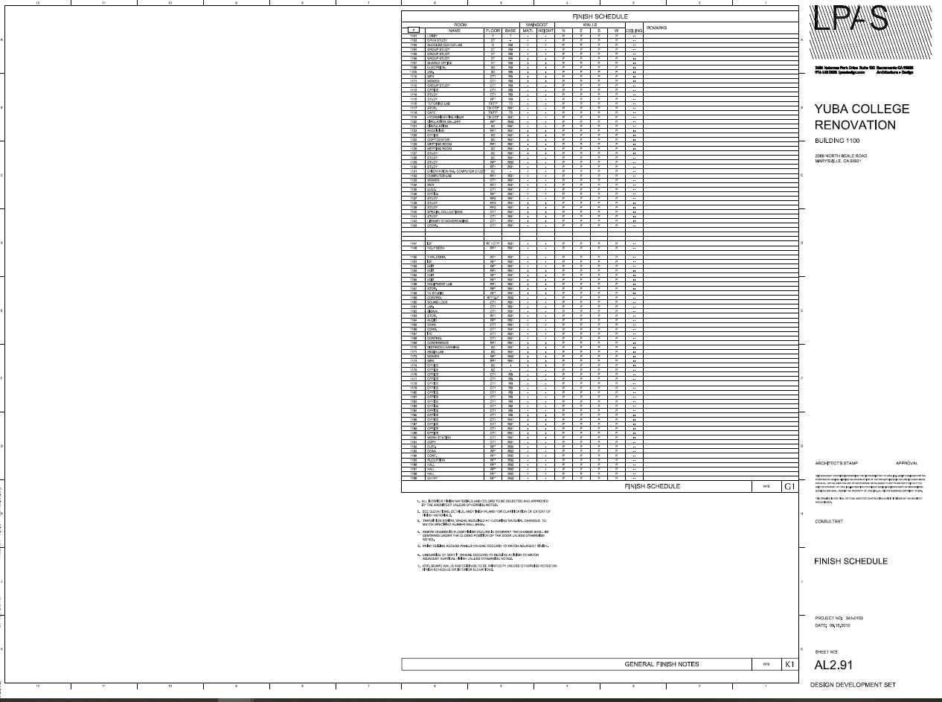
Exhibit C: College Colors

Wall paint color to match existing. Accent colors to be changed to College Colors.


Use Sherwin Williams Emerald quality acrylic latex paint on all walls.

End of Addendum No.1

