Request for Proposal
Yuba Community College District

Woodland Community College Campus
Synthetic Soccer Field Construction
Astro Turf (AT)
No. RFP 25-07a

Issue Date: April 14, 2025
Proposal Due: May 16, 2025, 1pm Sharp

Proposal Due Date: May 16, 2025, 1:00 PM Sharp, Yuba College Location Delivered To:

Yuba Community College District, District Offices
Attn.: David Willis
District Director of Facilities Planning, Maintenance & Operations
RFP No. 25-07a WCC Synthetic Soccer Field Construction—Astro-Turf (AT)
Address: Sutter County Campus, Second Floor, District Offices, Attention: David Willis, 3301 East Onstott Road, Yuba City, California 95991

Proposal Delivery at Second Floor
Yuba Community College District
Sutter County Campus
District Offices
3301 East Onstott Road (second floor)
Yuba City, California, 95991

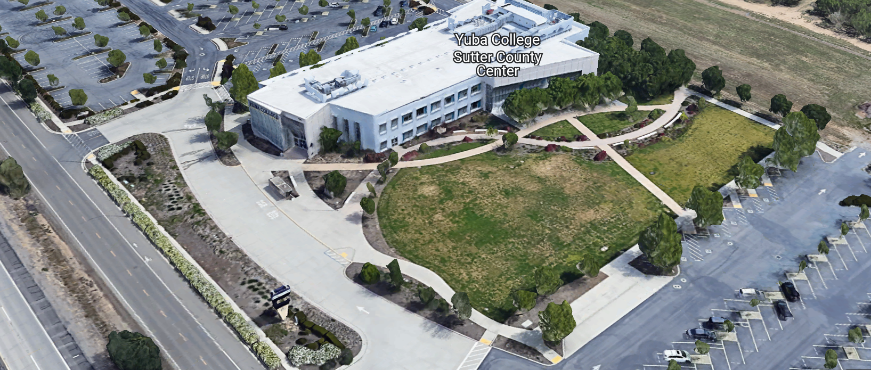
West Building Entrance
TABLE OF CONTENTS

1.0 INTRODUCTION
1.1 District Information
1.2 Yuba Community College District Background
1.3 Purpose of the Request
1.4 Applicable Codes
2.0 Scope of Work
2.1 Project Schedule
2.2 District Staff Contacts during Proposal Process
2.3 Project Safety Requirements
2.4 Demolition
3.0 Proposal Format Organization
3.1 Proposal Delivery, Contents, and Format
4.0 Selection of “Firm”
5.0 Basis of Award
6.0 Non-Discrimination
7.0 Response to Request for Proposal (RFP)
8.0 Requests for Information (RFI)
9.0 Proposal Schedule
10.0 District Parking
11.0 RFP Proposals
12.0 Award of Contract/Proposal
13.0 Reservation of Rights
14.0 Bid Bond Requirements
15.0 Performance Bond, Payment Bond Requirements
16.0 Liquidated Damages
17.0 Contractor and Subcontractors Information

Contractor Proposal Required Items:

Appendix A, Bid Form
Appendix B, Statement of Qualifications
Appendix C, Contractor References
Appendix D, Contractors Project Approach, Project Team Members and Credentials, Preliminary Schedule
Appendix E, Synthetic Turf Selection Criteria document, Support information per section 3.1.
Note: A Bid Bond required with proposal, Performance and Payment Bond required 7 days after award.

Informational Items:
Appendix F: YCCD Academic Calendars
Appendix G: Map of Woodland Community College
Appendix G: DSA Approved Drawings and Specifications, District Div. 0, 1, Front-End General Conditions Specifications
Appendix H: Synthetic Turf System Specifications
Appendix J: Contractor Agreement for Services (CAFS)

1. INTRODUCTION

  - District Information:

The District consists of two colleges, Woodland Community College and Yuba College, with campuses located at five different locations: Yuba College in Marysville, CA; Sutter County Center in Yuba City, CA; Woodland Community College in Woodland, CA; Colusa County Outreach Center in Williams, CA; and Lake County Campus in Clearlake, CA.

  - Yuba Community College District

The Yuba Community College District (YCCD) was founded in 1927 and spans eight counties (Yuba, Sutter, Colusa, Yolo, Lake, Butte, Glenn and Placer) and nearly 4,200 square miles of territory in rural, north-central California. It has colleges in Marysville and Woodland, an educational center in Clearlake, an educational center in Williams, an educational center in Yuba City.

  - Purpose of Request

The Yuba Community College District seeks comprehensive proposals from synthetic turf companies qualified Licensed installation Contractors to supply and install all items shown and listed within project documents for the new soccer facility at the Woodland Community College Campus. Items included, but not limited to, soil removal and off haul off existing site soil, demolition and pot-holing of existing utilities and miscellaneous items, rough and fine grading operations, utility installation including storm, irrigation, electrical, domestic water, sanitary sewer, and future sports field lighting infrastructure. Also included is the installation of new hardscape paving, fencing, scoreboard, shade structures, planting and landscape materials, drinking fountain and other site furnishings. As well as installation of new synthetic turf material, including fine grading, leveling as needed to achieve required planarity on field base, and the complete installation of a new drainage / shock pad and the new turf product (including the identified field of play lines and markings).

Included in the project contract, but priced separately, shall be a regular maintenance contract that shall be in effect for the duration of the product warranty period (which shall not be less than 8 years from the date of field acceptance) and replacement of high wear areas (soccer penalty spot and areas surrounding and including the goalie box).

An additional price for the installation of new 20’ tall netting system (Approx. 264 lf), including all materials required for netting system and footings, plus increasing size of the edgeband the netting system is to be embedded in form 6” to 18” (Approx 483 lf of upsized edgeband).

The District intends to award a single contract to the selected Turf Company through a Joint Power Authority (JPA) Program, such as Sourcewell, Omnia, or equivalent acceptable public purchasing program.

Woodland Community College Address: 2300 East Gibson Road, Woodland, California 95776

  - Applicable Codes
All work shall meet all State of California Building Codes, and Federal codes, and local ordinances.
All projects at the District/College are prevailing wage projects. The District will generate a project number with the Department of Industrial Relations (DIR) that the Contractor will be required to upload all project certified payroll records.
- Scope of Work
The scope includes all items shown in the drawings and in the specifications which includes, but not limited to, the following (refer to the drawings and specifications for complete description of the scope of work):
- Install a project boundary temporary fence as needed with signs to keep unauthorized personnel out the project construction areas.
- Prepare the project site as specified and per the drawings.
- Installation of all storm water pollution prevention devices and materials.
- Excavation and removal of existing soil at the plan facility area. Excess sub-grade materials can be spread out in the undeveloped land areas to the south. Care will need to be taken not to damage any of the existing underground utilities in the undeveloped areas. All excess sub-grade materials shall be spread out evenly and not create a high point or hill or mound.
- Install all underground utilities
- Survey and install all subgrade materials
- Prepare the site and install all gravel, paving, concrete, and a college direct purchased and provided synthetic field system materials per the manufacturers requirements.
- Provide and install a scoreboard with electrical service, commission it, and train college staff on the operations of the scoreboard.
- Provide and install a drinking fountain.
- Provide and install shading shelters.
- Provide and install soccer goals.
- Provide and install a perimeter fence with gates.
- Provide and install a sound PA system with poles, speakers, and electrical service.
- Provide dust control and coordinate all activities with the College to reduce the risk of impact.
- Install all landscape and irrigation systems, trees, bushes, etc..
- Provide and install all other items shown and specified on the drawings and specifications.
- Remove the temporary fence and finish grade around the project site, clean up the site.
- Repair any damage to surrounding landscape, sidewalks, or roadways.
The Contractor is expected to meet weekly as needed at the construction site or a designated location on campus to review progress, discuss issues, and provide a brief update on what is expected to occur as the project progresses.

The Contractor personnel must provide temporary restroom facilities.

The Contractor shall apply and follow all Cal-OSHA regulations. All required PPE shall be in good condition and used when needed to protect employees.
The District encourages a positive and open communication strategy that includes a sense of partnership and mutual success on its projects.
The Contractor mark-ups for profit and overhead for change orders is 10%. Subcontractor mark-ups are limited to 10%.
The selected Turf Company will be required to adequately protect the areas outside the new synthetic turf areas, such that no damage occurs to areas not included in the project scope of work areas.
The Turf Company shall be responsible for walking the project site prior to submitting a proposal to ensure they have an accurate understanding of the existing conditions and the scope of the project.
The proposed turf field has the following quantities: 93,600 square feet (roughly)
Proposal Respondents are fully responsible to verify final quantities of turf and all other materials required to complete the work described in the drawings and specifications.
All Insurance requirements are described in the Contractor Agreement for Services (CAFS) which is in Appendix K.
The insurance certificate holder is:
Yuba Community College District
3301 East Onstott Road
Yuba City, California 95991

2.1 Proposed Project Schedule
- College / District Review Period: May 16, 2025 through June 18, 2025.
- Board Authorization to Award: July 10, 2025
- Approximate Award Date: July 31, 2025 (may be sooner)
- Start Mobilization approximately: August 4, 2025
- Start Construction: August 11, 2025 (may be sooner)
- Submittals Received by: Within 2 weeks after the award date.
- Substantial Completion: November 26, 2025
- 100% Completion: December 12, 2025

Please note all College Holidays. Unless otherwise mutually agreed to, the Contractor shall not work on College/District holidays.
The contractor may work whatever hours are needed Monday through Friday. Normal working hours are 7:00am to 5:00pm but can be adjusted to meet whatever the Contractor needs.
This is a prevailing wage project. The Contractor is required to upload all certified payroll information to the Department of Industrial (DIR) Relations web site. YCCD will provide a DIR project number. The District will require a copy of all certified payroll records prior to the release of the 5% retainage and final payment to the contractor.
Provide a project schedule with the proposal with the District provided milestones clearly shown.
Project Proposed Change Orders (PCO’s): All PCO’s shall be submitted as soon as possible. PCO’s require a breakdown of all parts, materials, and labor. A thorough reasoning and justification shall be provided for the PCO to be considered by the District. PCO’s will not be considered “after the fact” after work has been started or completed without authorization by the District.
2.2 District Staff Contacts during the Proposal process:
Firms interested in submitting a Proposal are directed not to make personal contact with the Board of Trustees, District staff, or members of the evaluation committee. Any contact shall constitute grounds for disqualification from consideration.
Single Point of Contact during the Proposal Preparation Process:
David L. Willis
District Director of Maintenance, Operations, and Planning
YCCD District Offices, Sutter Center, (Second Floor)
3301 East Onstott Road
Yuba City, California, 95991
Cell Phone: 916-747-4262
Email: dwillis@yccd.edu

On-site coordination, first contact person access and immediate contact person during construction OR if additional site visits are needed during the bidding process.
Brian Splaine
Assistant Director of Maintenance, Operations
Woodland Community College
2300 East Gibson Road, Woodland, California 95776
Phone: 530-812-5866
Email: bsplaine@yccd.edu

No changes can be made to the project scope without authorization in writing by David Willis.

2.3 Project Safety and Security Requirements
Safety is a top priority for the District. All California OSHA requirements apply. Industry best practices apply. Contractor employees shall wear shirts with sleeves, a hard hat, eye protection, hearing protection as needed, gloves, substantial leather footwear, long pants, a reflective safety vest, and take all needed precautions to complete the work in a safe manner. Safety shall not be compromised at all during the work.
Enhanced fall protection precautions shall be taken.
During windy conditions, precautions shall be taken to ensure the safety of staff and to properly secure materials and debris. The Contractor shall also take precautions during windy days if there are any risks of material being carried by the wind and deposited on vehicles or other surfaces.
Dust control is required on this project.
Protection of College property shall be taken. Contractor is 100% responsible for any damage to College property and facilities.
These campuses have a moderate risk of theft. It is the sole responsibility of the Contractor to receive and secure all materials, equipment, tools, and other items associated with this work. The Contractor shall lock and secure the temporary project boundary fence and gates at the end of each work day. The Contractor shall carry all appropriate builders risk insurance while working at the campus.
The District/College does have 24/7 security guard presence at this campus. The guard will patrol the campus and the project site and report any suspicious people or activities to the local police and sheriff offices.
2.4 Demolition
The contractor shall provide a debris waste manifest for all items removed from the campus. Debris and waste shall be processed in accordance with all State and Federal codes, laws, and ordinances.
3.0 Proposal Format Organization
The Firm is requested to use the following proposal format:
3.1. Proposal Delivery, Contents, and Format:
Proposals should provide straightforward, concise information that satisfies the requirements noted in this RFP. Expensive binding, color displays, and the like are discouraged. Emphasis should be placed on brevity, conformity to the Districts instructions, selection criteria of this RFP, and completeness and clarity of content. Each Respondent’s proposal should clearly and accurately demonstrate specialized knowledge and experience required for consideration.
The District is requiring a signed hard copy original proposal, a flash drive with the proposal and support information, and that the proposal be emailed to the contacts below:
In a sealed box or envelope (clearly marked “), submit the following:
- One (1) flash drive containing the complete proposal and supporting documentation;
- One (1) original proposal in paper form, which consists of a Proposal Letter and responses to the proposal requirements of this RFP.

In addition to the delivery of the flash drive with the proposal information in it and the original signed hard copy, please also email the proposal to the following:

- David Willis, Director, email: dwillis@yccd.edu
- Wes Downing, Project Manager, Verde Design, email: wes@verdedesigninc.com
- Mark Baginski, Principle, Verde Design, email: mark@verdedesigninc.com

There is no page limit.

This RFP is not an offer by the District to contract with any party responding to this RFP.

In addition, no reimbursement for expenses incurred or time spent will be made. All submittals and information contained therein provided at an interview or in the proposal package shall become the property of the District. The Yuba Community College District is expecting to select the preferred product no later than August 14, 2025.

The District’s selection process is summarized below:

- Contractors are first pre-qualified based on Appendix B, “Statement of Qualifications” information.
- Once pre-qualified, the proposal will be considered.
- Criteria used to make a selection:
- “Best Value” as solely determined by the District will be used guide the process. Factors that will be considered include:
  - Lowest initial cost
  - Corporate Financials
  - Materials Proposed, Quality and Features of the Turf Manufacturers Products
  - Contractors’ Projects Experience, References and Performance on other similar projects
    - With proposed products
    - Crew installations
    - Local installations
  - Warranty
  - Customer Service
  - Lowest Life-Cycle Costs
  - Lowest Annual Maintenance costs to maintain the manufacturer’s warranty period which must be at least 8 years from completion.
- Other factors as described in this RFP or deemed pertinent by the District.

Please provide detailed information for each item in the synthetic Turf Selection Criteria Table which is included in this document.
Firms must comply with the provisions of these instructions for completion and submission of the Proposal. The failure of a Firm to comply with the Proposal Instructions and Requirements will likely result (at the sole discretion of the District) in rejection of the Proposal for non-responsiveness.
Proposal Section | Format
- Cover Letter | PDF
- Table of Contents | PDF

PROPOSAL SUBMITTAL REQUIREMENTS:
Included in the proposal package shall be the following information:
- Information to support Appendices A, B, C, D, E as well as:
- Synthetic Turf Selection Criteria document, including required supporting third party test data and information requested in the document, including the following:
- List of all complete installed fields with specified product, including those in California (This list may be limited to the forty (40) most recent completed installations)
- Proposed Foreman resume(s) as applicable
- Company turf warranty for this specific project, including insurer information
- Corporate financial information
- End of Life Recycling Plans
- Post-Consumer Recycled Content
- Heavy metals & material content

Proposal General Information Contents:

Information provided by the Contractor will help the District determine if the Firm is a “Responsible Bidder”.

Cover Letter

The Proposal shall include a Cover Letter on Respondent’s official business letterhead, which shall be signed by an individual authorized to legally bind Respondent. The Cover Letter shall also identify the name, telephone number, and email of a person who may be contacted during the Proposal evaluation process.

Table of Contents

Provide a Table of Contents that outlines in sequential order the major sections and sub-sections of the Proposal. Use tabs to allow information to be more easily located.

4.0 Selection of “Firm” Services Provider

The process of “Firm” selection is based upon the complete responsiveness of the RFP and the criteria as outlined in the RFP.

The District Project Evaluation Team will First pre-qualify contractors based on the Statement of Qualifications information provided by the Contractor. If qualified, then contractor proposals will be considered. Contractors that are not qualified based on the criteria and information provided by the Contractor associated with the Statement of Qualifications will not have their proposals considered even if they are the lowest cost proposing contractor.

The District reserves the right to reject any or all submittals, to amend the RFP process, and to discontinue or re-open the process at any time. The District reserves the right to request clarifications to RFP responses and to negotiate the terms of the agreement.

5.0 Basis of Award (Also, refer to section 3.0 of this RFP)

This project will be awarded based on the following criteria:

- “Best Value” as solely determined by the District will be used guide the process. Factors that will be considered include:
  - Lowest initial cost
  - Corporate Financials
  - Materials Proposed, Quality and Features of the Turf Manufacturers Products
  - Contractors’ Projects Experience, References and Performance on other similar projects
    - With proposed products
    - Crew installations
    - Local installations
  - Warranty
  - Customer Service
  - Lowest Life-Cycle Costs
  - Lowest Annual Maintenance costs to maintain the manufacturer’s warranty period which must be at least 8 years from completion.
- Other factors as described in this RFP or deemed pertinent by the District.
  - Contractor Capability to do the work
  - Qualified Contractor (per Appendix B, Statement of Qualifications)
    - District determined “Qualified Contractors” based on the information provided in the “Statement of Qualifications” information provided by the Contractor.
    - Proper State of California Contractor License in good standing
    - Information provided as requested in the RFP and Specifications.
    - All Addendums are acknowledged.
  - Contractor listed any exceptions or exclusions. Contractors should bid the project per the RFP and contract documents (using specified products) and then offer exceptions and exclusions or cost deductive or additive alternatives separately from the base bid.
  - Firms with historically poor performance on projects at Yuba Community College District will be disqualified from consideration. Poor performance is 100% solely and generally defined by the District for such issues as not meeting original schedule requirements within two months of the original schedule OR not ordering materials and supplies, tracking long-lead procurement items and then delaying the project such that the contractor cannot recover the project schedule, OR working unsafely and not following CAL OSHA requirements OR not providing/uploading certified payroll records in accordance with the Department of Industrial Relations requirements OR excessive change orders greater than 12% of the original awarded amount on typical older building renovation projects and greater than 7% on new buildings OR generally poor quality work not acceptable to the District OR not utilizing coating manufacturer specified application equipment OR that have threatened legal action toward the District OR having a history of difficult argumentative communications regarding change orders/schedules/and quality of work OR as any combination of the above items or other similar items as determined by the District.
  - Contractors’ ability to meet schedule requirements, recover delays in the schedule.
  - Contractors have demonstrated past project references of “like” projects
  - Contractors references are all good with respect to schedule, cost, and quality.
  - No other factors such as litigation, licenses in good standing, or other similar criteria.

Optional Interview Process:

The top 1 or 2 Proposers that are first pre-qualified by the District’s evaluation team per Appendix B and then also have provided the “Best Value” (as determined by the District) fully responsive proposals will likely be requested to participate in a ZOOM interview process with the District Evaluation Team. This interview process is fully at the discretion of the District. The District may decide that no interview is required. If an interview is needed, then it will be scored by the District and part of the evaluation process.

6.0 Non-Discrimination
The District does not discriminate with regard to race, color, gender, national origin, disability, or any other protected or other classification in the awarding of contracts/agreements. The District welcomes all Qualified Firms to participate in the project Request for Qualification/Proposal process.
The District encourages firms that are women or minority owned, emerging small businesses, veteran owned firms, disabled person owned firms, and all other qualified firms to participate in the proposal process.
The District encourages the submission of proposals from all Firms that can meet the stated requirements set for this RFP.

7.0 Responses to RFP
Sealed responses to this RFP must be clearly marked "RFP No. 25-07a WCC Synthetic Soccer Field Construction—Astro-Turf (AT)”.

Responses shall be mailed to or hand-delivered to the following address:

Yuba Community College District, District Offices
Attn.: David Willis
District Director of Facilities Planning, Maintenance & Operations

Envelope/Box Marked:
"RFP No. 25-07a WCC Synthetic Soccer Field Construction- Astro-Turf (AT)
.

Address: Yuba Community College District, Yuba College, Sutter County Center, District Services Offices, Second Floor, Attention: David Willis, Room 217, Yuba City, California, 95991

Note: Completely seal your proposals in envelope/box and make sure it gets date/time stamped when delivering proposal. Firms are each 100% responsible to make sure proposals that are mailed using a carrier such as UPS, FED Ex, etc.…are received and date/time stamped by District personnel prior to the proposal due date/time. No proposals will be considered if they are late, even if it is only 5 minutes late. Please make sure your proposals are delivered and received promptly prior to the due date/time. There will be a public proposal opening at the due date/time.

Email proposals to the following contacts:

- David Willis, Director, email: dwillis@yccd.edu
- Wes Downing, Project Manager, Verde Design, email: wes@verdedesigninc.com
- Mark Baginski, Principle, Verde Design, email: mark@verdedesigninc.com

8.0 Requests for Information (RFI)

Requests for Information concerning the RFP must be in writing and may be submitted via email no later than the date shown below. Please direct all questions to David Willis, email: dwillis@yccd.edu and cc copies to Wes Downing and Mark Baginski with Verde Design (emails are wes@verdedesigninc.com and mark@verdedesigninc.com).

Following the RFI deadline, all questions and answers will be summarized and posted on the District's website: https://www.yccd.edu/central-services/purchasing/ , then, click on the “Requests for Proposals / Quotes” tab on the right hand side of this web page. It is anticipated that responses to inquires received by the required time and date will be provided within 5 business days and posted on the District's website or responded to per the dates listed in the RFP for addendum publishing. Should more time be needed by the District to answer I respond to RFI’s, this information will also be posted on the above website.

- Include the following in the subject matter field on emails when requesting information: “RFP 25-07a”, RFI.

9.0 Proposal Schedule:

Important Dates and Times:

April 14, 2025: Release of Request for Proposal

April 25, 2025: 1:00PM to 3:00PM Optional On Campus Pre-Bid Meeting

Address: Woodland Community College, Building 100, Room 113, 2300 East Gibson Road, Woodland, California 95776

May 2, 2025: 5:00 PM, All questions and requests for information must be submitted to David Willis at: dwillis@yccd.edu.

May 5, 2025: 5:00 PM, Addendum Issued if needed.

May 16, 2025: Proposals due at 1:00 PM SHARP, Yuba Community College District, District Offices Location: Sutter Center, District Offices, Second Floor, Room 217, Attention: David Willis, 3301 East Onstott Road, Yuba City, Ca., 95991. There will be a public bid opening on this RFP in room 211 at the Sutter Center Building.

Note: All procurement documents associated with this procurement will be posted at this web page link: https://www.yccd.edu/district-services/requests-proposals-quotes/

10.0 District Parking: (Fees Not Applicable)

11.0 RFP Proposals

Proposals received after the deadline will not be opened. Each responder shall submit one (1) signed original hard paper copy in a binders. Provide one electronic format copy of the proposal using electronic media such as a flash drive. (No CD formatted Disks).

All materials submitted in response to the RFP shall be on 8-1/2"x11" paper, preferably in
Portrait orientation. All submitted materials must be bound in either a three-ring binder or spiral bound notebook. Content shall be tabbed and numbered per the items included in the Submittal Requirements. All Proposals will be reviewed and evaluated by a District Selection Committee. The District at its sole discretion may interview finalists or select a firm or firms to perform work based solely on the evaluation of the Proposal. There is no page limit.

All Proposals become the sole property of the District and the content will be held confidential until the selection of the Firm or Firm’s is made and the project is awarded.

12.0 Award of Contract

- Refer to sections 3.0 and 5.0 of this RFP.

B. The District reserves the right to enter into an Agreement without further discussion of the proposal submitted based on the initial offers received.

C. The District reserves the right to reject any or all proposals or any part of the proposal and to waive informalities and minor irregularities in the proposals received.

D. The RFP, its addendums, any follow-up clarifying information, and the proposal of the selected Firm will become part of any contract initiated by the District.

E. A formal contract shall be signed by the successful proposer and Yuba Community College District to perform this service.

F. The District reserves the right to enter into discussions with any one or all of the Responders after Proposals have been initially reviewed. Such responses shall be subject to all provisions, terms and conditions as set forth in the RFP, unless otherwise modified.

G. The District intends to award to a single RFP Responder.

H. BONDS: A Bid Bond is required with the Proposal. The Contractors Performance and Payment bonds are required within 7 calendar days after the Notice of Award is provided to the Contractor. The Bid Bond is required with the proposal.

I. Failure to acknowledge all of the addendums, provide the items listed in the RFP, may render the proposal unresponsive at the discretion of the District. Items listed in the RFP become part of the contract unless the Contractor provides an exception in the proposal. Contractor exceptions, depending on the magnitude, may render the proposal unresponsive, at the discretion of the District.

J. The District reserves the right to request clarification of proposal content during the review and evaluation process.

K. The District reserves the right to negotiate the terms of the agreement to align with budgetary constraints.

13.0 Reservation of Rights

The District reserves the right to:

- Reject any or all submittals at its sole discretions.
- Cancel the Request for Proposal (RFP), without cause.
- Modify any requirements contained within the RFP and request a revised submission from all Providers.
- Establish other evaluation criteria determined to be in the best interest of the District.
- Contract with any of the firms responding to the RFP based solely upon its judgment of the qualifications and capabilities of the firm.
- Clarify the content of any proposal to verify that the requirements of the RFP are included.
- Waive “minor” proposal inconsistencies that do not change the scope of work as outlined in the RFP.
- Request an alternative Superintendent on the project if the initially assigned Superintendent on the project is not performing well, not meeting project requirements, not working well with College staff and students, not applying best practice safety methods, OR not following College/District guidance regarding project approach. If the owner is the Superintendent, and has been replaced, the owner may visit the project briefly (less than 1 hour per day up to 2 times per week) to coordinate with the replacement Superintendent.
- The District will not allow or tolerate verbal abuse or any other type of abuse by the Contractor toward any College or District personnel or Contracted professional service providers. Abuse, defined solely by the District as verbal or physical, or written, may lead to a “Stop Work” order by the District until it can be resolved, and steps taken to ensure abuse is not repeated. If abuse occurs again, the District may issue a final “Stop Work” order, require the Contractor to leave the College/District project site and process a Performance Bond claim to complete the work. All costs associated with District “Stop Orders” are 100% the responsibility of the Contractor. The contractor will be required to catch up the project schedule if a “Stop Order” is required to be issued for up to 5 days due to unprofessional behavior on the part of the Contractors employees.
- Disqualify a Contractor after reviewing the proposal and finding concerning performance information in references, inadequate or incomplete proposal information, inadequate or information that is provided by the Contractor as part of the Statement of Qualifications process, and historically poor project performance at the District/Colleges (as solely defined by the District).

This RFP does not commit the District to award or negotiate a contract. The District will not be responsible for any expenses incurred by any firm in preparing and submitting a proposal or response to this RFP or in completing any of the specified work.

14.0 Bid Bond Requirements (Proposed Form—Contractor can use their standard form):

BID BOND

Know all persons by these presents:

That we, , as Principal, and , as Surety, are held and firmly bound unto Yuba Community College District, hereinafter called District, the sum of ten percent (10%) of the total bid amount of Principal for payment of which in lawful money of the United States, well and truly to be made, we bind ourselves, our heirs, executors, administrators, successors, and assigns, jointly and severally, firmly by these presents.

The condition of the above obligation is such that, whereas, the Principal has submitted a bid for the work described as follows: RFP 25-07a WCC Soccer Field Construction.

Now, therefore, if Principal shall not withdraw said bid within the time period specified after the bid date, as defined in the bidding documents, or within ninety (90) days after the bid date if no time period is specified, and, if selected as the apparent lowest responsive responsible bidder, Principal shall, within the time period specified in the bidding documents: Enter into a written agreement, in the form prescribed in the bidding documents, in accordance with its bid; file with the District all bonds required to be filed, including but not limited to faithful performance and payments bonds; and, furnish certificates of insurance and all other items required by the bidding documents.

In the event of the withdrawal of said bid within the time period specified, or within ninety (90) days if no time period is specified, or the failure of Principal to enter into such agreement and furnish such bonds, certificates of insurance, and all other items as required by the bidding documents, if Principal shall pay to the District an amount to the difference, between the amount specified in said bid and such larger amount for which the District procures the work covered by the bid, if the latter is in excess of the former, then this obligation shall be null and void, otherwise to remain in full force and effect.

In the event suit is brought upon this bond by District, in addition to the penal sum of this Bid Bond, Surety shall pay reasonable attorneys’ fees and costs incurred by District in such suit.

Surety hereby expressly waives the provisions of California Civil Code section 2845.

In witness whereof, we have hereunto set our hands this day of , 20 .

Principal: Surety: (Name of firm)

By: By:

Title: Title:

Broker Name or Agent Name:

License Number:

Bond or company appointments must be listed with the CA Department of Insurance Notary acknowledgments for Surety and Surety’s Power of Attorney must be attached.

Address for Notices:

Bid Bond Requirements:
Provide a Bid Bond per the following:

PUBLIC CONTRACT CODE - PCC

DIVISION 2. GENERAL PROVISIONS [1100 - 22355]

ARTICLE 4. Bids and Bidders [10160 - 10169]
( Article 4 enacted by Stats. 1981, Ch. 306. )
Section: 10167.
    - All bids shall be presented under sealed cover and accompanied by one of the following forms of bidder’s security:
      - An electronic bidder’s bond by an admitted surety insurer submitted using an electronic registry service approved by the department advertising the contract.
      - A signed bidder’s bond by an admitted surety insurer received by the department advertising the contract.
      - Cash, a cashier’s check, or certified check received by, and made payable to, the director of the department advertising the contract.
    - The required bidder’s security shall be in an amount equal to at least 10 percent of the amount bid. A bid shall not be considered unless one of the forms of bidder’s security is enclosed with it.
    - All bids submitted pursuant to this section shall also comply with the provisions of Section 1601 of the Public Contract Code.
(Amended by Stats. 2012, Ch. 290, Sec. 3. Effective January 1, 2013.)

The Bid Bond shall be provided with the Contractor’s Proposal.

15. Performance and Payment Bond Requirements: Required for this project and described in the District Agreement for Services form (Appendix K, Agreement for Services). The Performance and Payment bonds are due 7 to 10 days after the award date.
16.0 Liquidated Damages:
This paragraph applies to any Order that provides for payment of liquidated damages.
The Bidder also agrees to pay, as liquidated damages, the amounts specified below for each consecutive calendar day after the expiration of the consecutive calendar days allowed for each phase.

Liquidated Damages, 100% Construction Completion $500 / per calendar day Work is delayed and work is not 100% completed, after December 31, 2025. The December 31, 2025 date is 19 calendar days after the 100% completion date.

If Liquidated Damages are assessed, then, they will be deducted from the final release of retainage progress payment of the Firm. Retainage will be calculated at 5% of the awarded construction value of the project.
The Firm is however encouraged to complete the work asap and no later than the dates in this RFP unless otherwise mutually agreed upon by the Firm and the District due to factors that are outside the control of the Firm. Refer to section 2.1 of this RFP for the minimum project schedule requirements.

17. Contractor and Subcontractors Information:
No. | Name of Firm | Contractor License Number/Expiration Date | Department Of Industrial Relations Registration Number/Expiration Date
1
2
3
4
5
6
7
8
9
10

Appendix A: Proposal Bid Form

Refer to specification no. 00 41 00 Bid Form v2.0 in the following link:

https://goyccd-my.sharepoint.com/:f:/g/personal/w0398409_yccd_edu/EgacbyMneCVKlstOJrqz4PUBVii4th3TuFtNx79JX1_KTA?e=9fCA36

Appendix B: Statement of Qualifications
The Firm shall furnish the following information. Failure to comply with this requirement will render the submittal informal and may cause its rejection. Additional sheets may be attached if necessary.
Basic Firm Informational Items 1 through 17:

- Firm Name: ___________________________________________________________________

- Primary Address: ______________________________________________________________

- Firm’s Contact Person and Title: ___________________________________________________

- Telephone: ________________________________ Facsimile: ________________________

- Email Address: _________________________________________________________________

- License No.: _______________________________ Class: ____________________________

Responsible Managing Employee/Officer: ____________________________________________

- DIR Registration No.:________________________ Expiration Date: ___________________

- Names and titles of two officers of the Firm:

NAME TITLE

___________________________________ _______________________________________

___________________________________ _______________________________________

9. Specific type of Ownership (Check one)

Individual
Partnership
Corporation; If a corporation, state the following:

State of incorporation:
Date of incorporation: President/CEO:
Joint Venture
Other (Specify)

- Taxpayer Identification No.: _____________________
- List annual gross income for last three (3) years:
Year: _______________ $_____________________
Year: _______________ $_____________________
Year: _______________ $_____________________

- Number of years Firm has been in business:
If less than 5 years, please describe:

- Number of years Firm has conducted business under the present name:__________
- Has the Firm ever been licensed under a different name or different license number? . If Yes, give name(s) and license number(s) and dates or operation under that name(s) and license number(s) (attach separate sheets if necessary):___________________________________________ _________________________________________________________ _________________________________________________________
- Number of years’ experience in California Community College, University or educational facility projects .

- Do you now or have you ever had any direct or indirect business, financial or other connection with any official, employee or consultant of the District? ___. If Yes, please elaborate:
_________________________________________________________

- Has the Firm ever completed any work at the Yuba Community College District? If Yes, please elaborate:

Potentially Disqualifying Questions 18 through 30 (District may immediately disqualify Firm if its answer to any of Questions 18 through 26 is “Yes” or if the answer to questions 27 through 30 is “No”. Firm’s refusal to answer or omission of response to any of Questions 18 through 30 may result in disqualification of Firm.):

- Does the Firm possess a valid and currently in good standing California Contractors’ license for the classification(s) of Contractors’ License required for the Project? If Yes provide the license number(s). Yes/No______________________________________________________

- Has the Firm been defaulted or terminated (other than for convenience) by any California school district, community college district or other California public agency on any project within the past 5 years? Yes/No

If yes, identify agency and details:

- Has the Firm or any of its principals defaulted so as to cause a loss to a surety on a payment or performance bond? Yes/No

If yes, give dates, name and address of surety, and details:

- Has the Firm or any of its owners, officers, or partners, ever been convicted of a crime, or found guilty in a criminal action, involving fraud, theft, making any false claim or material representation to a public agency, or involving any federal, stet, or local law, rule, or regulation related to construction? Yes/No_____

If yes, explain, identify the agency, and provide case name and number.

- Has the Firm been assessed liquidated damages for any project in the past five years? Yes/No If so, identify owner and details:

- Has the Firm been disqualified, debarred, forbidden, or found non-responsible or otherwise prohibited from performing work or bidding won work for any California school district, community college district, or other California public agency within the past five years? Yes/No

If yes, identify agency and details:

- Has the Firm been in litigation (whether in court or arbitration) with any California school district, community college district, or other California public agency on an issue pertaining to any contract during the past five years? Yes/No:

If yes, explain, identify the agency, and provide case name and number.

- Has the Firm ever failed to complete a project in the past five years? Yes/No: If so, give owner and details:

- Is the Firm currently or has the Firm been in a state of “Bankruptcy” in the past five years? Yes/No:
If yes, please explain.

- Can the Firm provide at least up to $ 5,000,000 in bonding capacity for this project?
If no, please explain.

- Does the Firm have a liability insurance policy (project) limit of at least $1,000,000 per occurrence and $2,000,000 aggregate?
If no, please explain.

- Does the Firm have a current workers’ compensation insurance policy as required by the Labor Code or is legally self-insured pursuant to Labor Code Sections 3700 et seq.?
If no, please explain.

- Does the Firm have project experience that includes the installation of synthetic soccer fields projects at a School/Community College/University setting? Yes/No
If no, please explain.

- Has this Firm ever completed any similar projects or any work at Yuba Community College District? Yes/No
If no, please explain.

Note: Firms with historically poor performance on projects at Yuba Community College will be disqualified from consideration. Poor performance is defined in section 5.0 of this RFP.

Rating Questions 32 through 48:

- Please list and describe on separate sheets the Firm’s 40 (list as many as possible up to 40) most recent (page 11 of this RFP) synthetic soccer field construction projects references with current contact information. The project reference list should include the following criteria::
  - Project Name
  - Project Owner and Contact Information
  - Project Scope of Work
  - Original Contract Completion Date
  - Actual Project Completion Date
  - Original Contract Awarded Amount
  - Final Adjusted Contract Awarded Amount (with change orders)
  - Maintenance Service Agreement Information
  - Any issues that the Construction Installation Contractor had to overcome on the project

Scoring Criteria:
  - Multiple Projects with Similar Scope of Work (60 points)
  - Completed Multiple Projects on Schedule (up to 55 points)
  - Project Change Orders less than 5% (up to 55 points)
  - Project Completed at a Yuba Community College District Location with high quality, on schedule (within 30 days of original schedule). (10 points)

Total points for Question 32: up to 180 points

- Please describe in detail, your Firm’s approach to maintaining a safe project while students, faculty, and staff will be occupying the building:

(Up to 10 points.)

- List your Firm’s Workers’ Compensation Experience Modification Rate (EMR) for the three most recent years. Your EMR should be issued to your Firm by your workers’ compensation insurance carrier.

Year _______ EMR _______

Year _______ EMR _______

Year _______ EMR _______

(EMR numbers under 1.0 = 20 points; 1.0 to 1.24 = 5 points; 1.25 to 1.49 = 1 point; 1.50+ = 0 points.)
- Has your Firm had any OSHA violations or citations and penalties levied against it in the past five years? If Yes, how many violations (and please explain)________
(0 = 10 points; 1 = 3 points; 2+ = 0 points.)

- How many years has your Firm been in business in California as a contractor under your present business name and license number? __________
(less than 5 years = 0 points; 5-10 years = 10 points; 10+ years = 20 points.)

- In the last 10 years, how many legal proceedings (filed in court or arbitrations) has your Firm initiated against an owner, regardless of outcome? _______
(0 = 10 points; 1 = 3 points; 2+ = 0 points.)

- In the last 10 years, how many legal proceedings (filed in court or arbitrations) has an owner initiated against your Firm, regardless of outcome? _______
(0 = 20 points; 1 = 5 points; 2+ = 0 points.)

- Has any insurance carrier, for any policy of insurance, refused to renew a policy, or terminated a policy, for your Firm within the last five years? _____
(No = 10 points; Yes = 0 points.)

- Have any of your Firm’s employees or any other persons or entities filed a complaint against your Firm with the California Contractors State License Board within the last five years? If Yes, how many complaints were filed? ________________
(No = 10 points; 1-2 = 5 points; 3+ = 0 points.)

- Was your Firm required to pay either back wages or penalties for your Firm’s failure to comply with the state’s prevailing wage laws within the last five years? If Yes, identify the number of violations. ________________
(No = 10 points; 1-2 = 5 points; 3+ = 0 points.)

- Has any owner made a demand on a performance bond issued to your Firm on any construction project within the last 10 years? ________
(No = 10 points; Yes = 0 points.)

- Has any surety company made any payments on your Firm’s behalf as a result of a default to satisfy any claims made against a performance or payment bond issued on your Firm’s behalf in connection with any construction project within the last five years? _____
(No = 10 points; Yes = 0 points.)

- Has your Firm been denied bond coverage by a surety company, or was there a period of time when your Firm had no surety bond in place during a public construction project when one was required, within the last five years? _______
(No = 10 points; Yes = 0 points.)

- Has your Firm been denied an award of public works contract based on a public agency’s finding that your Firm was not a responsible bidder within the last five years? ______
(No = 10 points; Yes = 0 points.)

- Please describe the Capability/Capacity of your Firm. Please provide a comprehensive list of projects that the Contractor has in process and reasoning/justification regarding how the Contractor has capacity to perform the required construction services on this project.

(Up to 30 points.)

- Please describe the Firm’s commitment to maintaining a construction schedule. How will the Firm recover the schedule if it slips if the Firm gets busy with other projects? Please describe specific actions the Firm will take to maintain the Project schedule.

(Up to 30 points.)

- Please describe the Firm’s commitment to meeting regularly at project team meetings, maintaining positive communication, providing progress updates, and providing timely RFI’s and support information during the Project. Please describe specific actions the Firm will commit to maintain a positive relationship with the District and the applicable College through the above description:

(Up to 20 points.)

Qualification Criteria:
Questions 1 through 17 are general base level information that is required for pre-qualification.
Questions 18 through 31 are possible disqualifying questions that would render the Firm “not qualified” as determined by the District.
Questions 32 through 48 are rating questions that are scored and more deeply evaluated. Not scoring the minimum threshold value will render the Firm “not qualified”.
  - The District can disqualify a Firm (at it’s sole discretion) if the Firm does not meet the requirements of Questions 18 through 31.
  - There are a total of 400 points possible for questions 32 through 48.
  - To be determined as a qualified Firm, each Firm must score at least 320 points, and meet the minimum project experience noted in question 31.
  - If an interview of the top Firms is determined to be needed by the District, then it will be scored at 50 points and become part of the evaluation process.

Firms will be notified if they are determined meet minimum qualification criteria.

The undersigned is duly authorized to execute this Statement of Qualifications under penalty of perjury on behalf of the above-identified Firm. The undersigned warrants and represents that he/she has personal knowledge of each of the responses to this Statement of Qualifications and/or that he/she has conducted all necessary and appropriate inquiries to determine the truth, completeness, and accuracy of responses to this Statement of Qualifications. The undersigned declares and certifies that the responses to this Statement of Qualifications are complete and accurate; there are no omissions of material fact or information that render any response to be false or misleading and there are no misstatements of fact in any of the responses. The above-identified Firm acknowledges and agrees that if the District determines that any response herein is false or misleading or contains misstatements of fact so as to be false or misleading, the District may find the Firm is not qualified and the District can reject the proposal for non-responsiveness or non-responsibility.

Executed this___ day of __________________ 20__ at_____________________________.
(City and State)
I declare under penalty of perjury under California law that the foregoing is true and correct.

By: ____________________________________________
(Signature of Firm’s Authorized Officer or Representative)

____________________________________________
(Typed or Printed Name)

Title: ___________________________________________

General qualification process and comments:
- Firms with historically poor performance on projects at Yuba Community College District will be disqualified from consideration. Poor performance is 100% solely defined by the District for such issues as not meeting original schedule requirements within two months of the original schedule OR not ordering materials and supplies, tracking long-lead procurement items and then delaying the project such that the contractor cannot recover the project schedule, OR working unsafely and not following CAL OSHA requirements OR not providing/uploading certified payroll records in accordance with the Department of Industrial Relations requirements OR excessive change orders greater than 10% of the original awarded amount on renovation projects and greater than 7% on new buildings OR generally poor quality work not acceptable to the District OR not utilizing coating manufacturer specified application equipment OR that have threatened legal action toward the District OR having a history of difficult argumentative communications regarding change orders/schedules/and quality of work OR as any combination of the above items or other similar items as determined by the District.

- Firms that are “disqualified” by the District will not be considered for future project work.

- Firms that are not “qualified” through the “Statement of Qualifications” process will not have their proposals considered.

- Contractors are encouraged to provide complete and comprehensive information to support the “Statement of Qualifications” in Appendix “B” of the RFP.

- Proposals from other Contractors will remain confidential.

- Contractors “Statement of Qualifications” process evaluation by the District Evaluation team will remain confidential.

- The District is not required to interview Contractors as part of the evaluation and qualification process.

Appendix C: Contractor References Form (Example Template)

See page 11 of this proposal regarding the request for 40 references of “like” projects. For the purpose of checking references, just list 15 references of projects that are similar to this one and that have been completed during the past 10 years.
All phone numbers and emails must be current (please verify).
REFERENCE #1
NAME
ADDRESS
CITY, STATE ZIP CODE
TELEPHONE #
CONTACT
DATES OF SERVICE
REFERENCE #2
NAME
ADDRESS
CITY, STATE, ZIP CODE
TELEPHONE #
CONTACT
DATES OF SERVICE
REFERENCE #3
NAME
ADDRESS
CITY, STATE, ZIP CODE
TELEPHONE #
CONTACT
DATES OF SERVICE

You may of course use the Firm’s established reference template.

Appendix D: Contractors Project Approach, Project Team Members Experience, Education, and Credentials.

Describe how your project approach will work around the wet weather season to deliver the project as soon as is possible while maintaining the quality of the project and the overall outcomes.
Describe how quality will be managed and maintained. For example, how are the elevation levels maintained so that there are not any low areas, any higher areas, or settlement after the construction work is completed. What equipment will be used to shoot laser level elevations, and to maintain these finish level elevations throughout construction.
Describe how the surface turf will be protected from damage, inspected for manufacturer defects, and how repairs will be made in the field. For example, how will the turf be kept from being dragged around before rolling it out on the field.

Appendix E: Synthetic Turf Selection Criteria document

At time of the proposal, the following form needs to be completely filled in for each field and returned with other requested materials for EACH PROPOSED TURF PRODUCT. Turf Company shall provide values based on the units shown below and based on ASTM/Standard testing procedures, if applicable.
Property | Value (Fill in the blank) | Units | ASTM/Standard
Pile Yarn Type |  |  | n/a
Yarn Structure |  |  | n/a
Yarn Linear Density |  | Denier +/- 5% | D1907
Yarn Breaking Strength* |  | Lbs | D2256
Yarn Maximum Elongation* |  | % | D2256
Yarn Melting Point |  | °F | D789
Tape Thickness |  | Microns | n/a
Tape Width* |  |  | n/a
Number of tape per stitch |  |  | n/a
Pile Height* |  | Inches | D5848
Pile Weight* |  | oz/yd2 | D5848
Backing Composition |  |  | n/a
Type of Coating |  |  | n/a
Primary Backing Weight* |  | oz/yd2 | D5848
Secondary Backing Weight* |  | oz/yd2 | D5848
Coating Weight |  | oz/yd2 | D5848
Total Carpet Weight |  | oz/yd2 | D5848
Stitch Gauge |  |  | D5848
Stitches per Inch |  | stitches /inch | D5848
Tuft Bind* |  | Lbs/force | D1335
Grab Tear Strength* |  | Lbs/force | D5034
Grab Tear Width |  | Lbs/force | D5034
Pill Burn test (Pass/Fail) |  |  | D2859
Impact Attenuation |  | G-max | F1936
Permeability* |  | Inch/hour | DIN 18-035
Permeability with in-fill* |  | Inches/hr | F1551
Total Depth of In-fill |  | Inches | n/a
Infill type |  |  | n/a
Infill weight |  | Lbs/yd2 | n/a
Seams (Glued or Sewn) |  |  | n/a
Flame Resistance* |  |  | ASTM F1551

*Provide certified independent (3rd Party) laboratory reports on ASTM Test for these items.
In addition to the above form, the Turf Company shall provide the following information as part of the proposal package:
1. Contractor shall submit a list identifying the installed fields that have this exact turf product as identified in its proposal (including the proposed infill material). List of installations submitted and proposed site, field size (in s.f.), installation shall include project site, field name, and current District contact name and phone number.
2. Contractor shall submit the resume of the proposed turf installation foreman. This foreman shall be at the job site at any time work on the field is in progress. Each individual proposed to oversee the field will shall at a minimum have supervised no less than twenty synthetic turf fields in the past three (3) years.
- Turf Company is to describe their field maintenance and warranty repair capabilities and their approach to this work. This includes location of crews that can respond to District requests, equipment used, etc.

    - Warranty & Maintenance Plan
At time of proposal submission, the Turf Company shall submit its Manufacturer's Warranty which guarantees the usability and playability of the synthetic turf system for its intended uses for a minimum ten (10) year period commencing with the date of Notice of Completion. Intended uses include, but are not limited to the sports receiving permanent striping, including physical education, games and practice, summer camps, etc.
The warranty submitted must have the following characteristics:
1. Be a non-prorated, non-cancellable up-front pre-paid, third-party insured warranty. Warranty shall be covered by a third party insurance policy, non-cancelable and pre-paid, and is in effect covering this installation, and underwritten by a Best “A” Rated (or better) Insurance Carrier listed in the A.M. Best Key Rating Guide. Draft project specific warranty document to be provided for review by the District within ten (10) days after award of contract.
2. Insurance carrier must confirm that the policy is in force and premiums prepaid for entire warranty duration in full.
3. The policy must include a minimum annual aggregate of $10,000,000 per year and be based on claims arising from fields installed and completed only during the policy year.
4. The policy must provide full coverage for ten (10) years (minimum) from the date of Notice of Completion.
5. The policy shall cover all costs associated with full field replacement with new equal or better turf material, including labor, materials and any other costs to repair or replace the field.
6. District shall not be responsible for any deductible.
7. Warranty shall have no restrictions on hourly use limitations as long as the primary athletic use on the field is as anticipated in the original design.
8. Must warrant materials and workmanship, and that the materials installed meet or exceed the product specifications, including general wear and damage caused from UV degradation.
9. Must have a provision to either make a cash refund or repair or replace such portions of the installed materials that are no longer serviceable to maintain a serviceable and playable surface.
- Must be a warranty from a single source covering workmanship and all self-manufactured or procured materials.

- Guarantee the availability of replacement material for the synthetic turf system installed for the full warranty period.

- Turf must maintain an ASTM F355 G-Max of less than 160 for the life of the warranty.

- The Turf Company must verify that its onsite representative has inspected the installation and that the work conforms to the Manufacturer's requirements. The Manufacturer will submit written certification that the policy is in effect, fully funded and that the installation is added to the policy upon completion and acceptance.

- The warranty shall be made out to Yuba Community College District.

    - Heavy Metals and Material Content
The Turf Company will conduct and submit product analysis with the project proposal. Analysis will be presented in the form of current, certified laboratory results using specified standards and processes. Turf Company shall also fill in attached Tables C & D with applicable lab results. For threshold limits, reference Tables A & B below.

Analytical Methodologies: Representative samples of the turf fibers, turf backing, and infill material shall be analyzed for total metals content and semi-volatile organic compounds (SVOCs), as well as select analyses for leachable metals concentrations.

- Total Metals Analysis: All samples (fibers, infill, backing) shall be analyzed for the California Assessment Manual 17/Title 26 list of metals (CAM 17 metals). The submitted samples shall be prepared by the laboratory for analysis of total recoverable metals by USEPA method 3050B. The samples shall then be analyzed for total metals concentrations by USEPA method 6010B/7400.

- Leachable Metals Analysis: Infill samples only shall be analyzed for leachability of selected metals using the California Waste Extraction Test (WET). All samples shall be analyzed by the WET for lead, zinc, and total chromium. For other constituents, if the detected concentrations from the total metals analysis above are greater than or equal to ten times the Soluble Threshold Limit Concentration (STLC) value, as shown on attached Table A in Specification Section 02450, the WET shall be conducted for those individual metals as well.

- Analysis for SVOCs: All samples (fibers, infill, backing.) shall be analyzed for the SW-846 list of SVOCs. The submitted samples shall be prepared by the laboratory for analysis by USEPA method 3540 or 3550. The samples shall then be analyzed for SVOC concentrations by USEPA method 8270B or 8270C. Results shall at a minimum include data for aniline (CAS #62-53-3), phenol (108-95-2) and benzothiazole (95-16-9). Concentrations of SVOCs are to be provided for reference purposes only and are not being evaluated against any particular criteria.

Evaluation Criteria: The detected concentrations of lead, chromium, and zinc in the samples of the turf infill material shall not exceed the threshold values listed in Tables A & B, outlined below for total metals and leachable metals analyses. In no case shall the total metal concentration of any metal equal or exceed the TTLC values. In addition, concentrations of metals detected in any leachate tests shall not exceed the STLC value (for threshold values, see California Code of Regulations, Title 22, Chapter 11, Article 3.)

TABLE A. Maximum levels of metals permitted for synthetic turf products – recycled styrene butadiene rubber (SBR) infill materials
Metal | Total metals analysis  (mg/kg) | Leachable metals analysis  (ug/L)
Chromium | 750i | 50
Lead | 50 | 2.5
Zinc | 23,000ii | 250,000iii
i. No total chromium value promulgated in ESLs; chromium III value indicated instead.
ii. California Human Health Screening Levels (CHHSLs) for soil for residential land use.
iii. Selected soluble threshold limit concentration (STLC).

Table C (to be completed by Turf Company)
Metal | Total metals analysis  (mg/kg) | Leachable metals analysis  (ug/L)
Chromium
Lead
Zinc

TABLE B. Maximum levels of total metals permitted for synthetic turf products – fibers, underlayment, and backing
Metal | Total metals analysis  (mg/kg)
Chromium | 25
Lead | 50

Table D (to be completed by Turf Company)
Metal | Total metals analysis  (mg/kg)
Chromium
Lead

C. Brominated flame retardants

The Turf Company shall provide verification that brominated flame retardants have not been intentionally added in the manufacture of the turf fiber, backing, underlayment or infill materials. Verification can take the form of a signed letter from the manufacturer, or appropriate laboratory analyses of the product proving that levels of elemental bromine are lower than 1% by weight.

Additional Manufacturer Specific Product Information in this link:
https://goyccd-my.sharepoint.com/:f:/g/personal/w0398409_yccd_edu/Egv2KOlCIc5AsguL1BxGKSYBNHDODeViKMImM4rIlrfOcg?e=cEHlaf

Appendix F: YCCD Academic Calendar
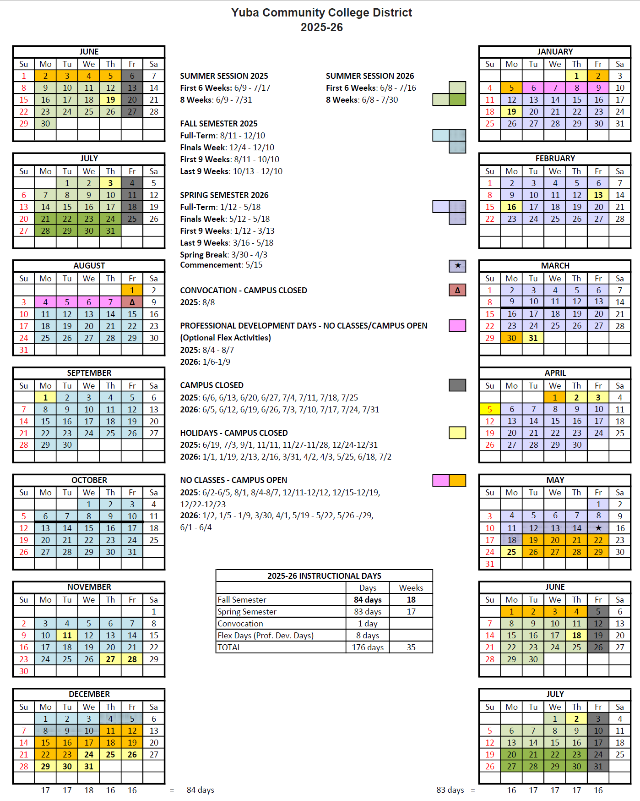
Appendix G: Map of Woodland Community College
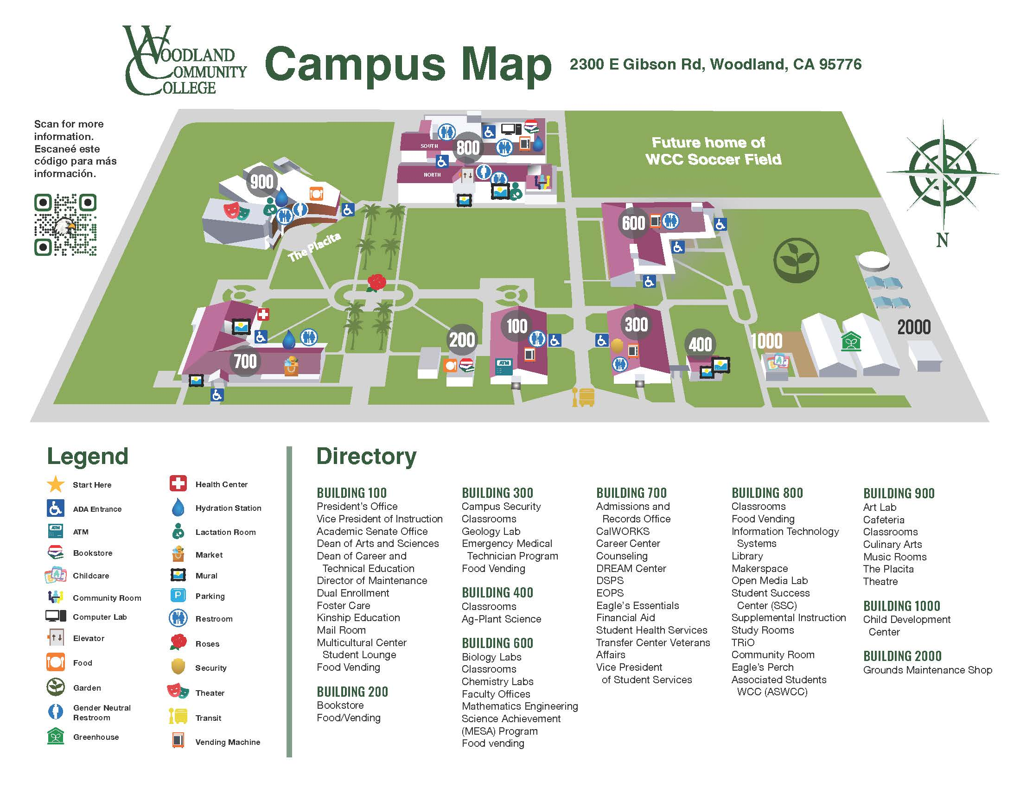
New Soccer Field

Appendix H: DSA Approved Drawings and Specifications, District Front-End General Conditions Specifications

Link:
https://goyccd-my.sharepoint.com/:f:/g/personal/w0398409_yccd_edu/EhKSo_ihjnFDjWsqiMv53SIBgwylPR-O55rPa8EVZjO66Q?e=DhZOEM

Link for District Division 0 and 1 Front End General Conditions Specifications:
https://goyccd-my.sharepoint.com/:f:/g/personal/w0398409_yccd_edu/EgacbyMneCVKlstOJrqz4PUBVii4th3TuFtNx79JX1_KTA?e=9fCA36

Appendix I: Synthetic Turf System Specifications

SECTION 32 18 13

SYNTHETIC TURF PLAYING FIELD

PART 1 GENERAL

1.01 SCOPE OF WORK

- It shall be the responsibility of the successful turf contractor to provide all labor, materials, equipment and tools necessary for the complete installation of a synthetic grass material, as called out in the RFP and this specification section.

  - JOB CONDITIONS

- Contractor shall be responsible for reviewing the base and ensuring it conforms to the project requirements prior to placement of the synthetic turf.

- Playing field subgrade preparation shall be completed and accepted by the District’s Representative prior to commencement of Work under this Section.

1.03 REFERENCES

- ASTM Standard Test Methods:
1. D1335 - Standard Test Method for Tuft Bind of Pile Yarn Floor Coverings
2. D1577 - Standard Test Method for Linear Density of Textile Fiber
3. D2859 - Standard Test Method for Ignition Characteristics of Finished Textile Floor Covering
4. D4491 - Standard Test Methods for Water Permeability of Geotextiles by Permittivity
5. D5034 - Standard Test Method of Breaking Strength and Elongation of Textile Fabrics (Grab Test)
6. D5848 - Standard Test Method for Mass Per Unit Area of Pile Yarn Floor Covering
7. F355 - Standard Test Method for Shock-Absorbing Properties of Playing Surfaces.
8. F1015 - Standard Test Method for Relative Abrasiveness of Synthetic Turf Playing Surfaces
9. F1936 - Standard Test Method for Shock-Absorbing Properties of North American Football Field Playing Systems as Measured in the Field

- Current NCAA soccer rules and local Bay Valley Soccer League rules as applicable.

  - SUBMITTALS

- The turf manufacturer shall submit a project specific letter on the company letterhead certifying that the products of this section meet or exceed all specified requirements, and state that the installer has complied with the qualifications above and is certified by the manufacturer to install this type of synthetic turf.

- Submit Drawings for:
- Seaming plan.
- Installation details; edge detail, utility box detail, etc.
- Field Layout and Striping Plan (including field colors), including field line layouts (including colors), etc.
- The Turf Manufacturer shall submit color samples for approval for all color and/or logo work, including final electronic versions of artwork.

C. Certified copies of independent (third-party) laboratory reports on ASTM tests as follows:
1. Pile Height, Face Width & Total Fabric Weight, ASTM D5848
2. Primary & Secondary Backing Weights, ASTM D5848
3. Tuft Bind, ASTM D1335
4. Grab Tear Strength, ASTM D5034
5. Water Permeability, ASTM D1551
6. Flame Resistance, ASTM F1551
7. Tuft Yarn Tensile Strength and Elongation, ASTM D2256

D. One 12” square of the proposed product fibers, including one for each fiber color.

E. Submit a copy of the 8-year (minimum), prepaid, non-prorated, third-party insured warranty and insurance policy information.

F. PFAS Certification as called out in the RFP document.

PART 2 MATERIALS

2.01 INFILL SYNTHETIC TURF

- Shall be the following (50mm minimum tall PE fibers, extruded with both monofilament and slit film) preapproved product:
- AstroTurf Rhino blend 46, with minimum infill rates of Cork (1.2 lbs) and Sand (4.5 lbs). Contact is Dominick Berarducci, CA Sales Mgr, Ph. No. (559) 612-9065.
- The preapproved products shall meet the following criteria at a minimum:
N/A Pile Yard type UV-Resistant Polyethylene
N/A Yarn Structure Dual Fiber (Ridged Monofilament
and Fibrillated Slit-Film)
ASTM D1577 Fiber Denier min. 1,800 (mono) / 10,000 (slit)
ASTM D3218 Tape Thickness (in microns) > 330 (mono) / > 115 (slit)
ASTM D2256 Yarn Breaking Strength min. 20 lbs
ASTM D5823 Pile Height min. 2.0” (50mm)
ASTM D5793 Stitch Gauge 3/8”
ASTM D5848 Pile Weight min. 46 oz/square yard
ASTM D5848 Total Backing Weight min. 25 oz/square yard
ASTM D5848 Total Weight (without infill) min. 72.5 oz/square yard
ASTM D1335 Tuft Bind (Without Infill) min. 8 lbs
ASTM D5034 Grab Tear (Width) min. 200 lbs/force
ASTM D5034 Grab Tear (Length) min. 200 lbs/force
ASTM D4491 Carpet Permeability >30 inches/hour
ASTM F355A Impact Attenuation (Gmax) <160
Infill Material Depth 1.25 inches (min.)

2.02 TURF PRODUCT REQUIREMENTS

- Sand shall be rounded silica sand and dust free. Coarse jagged sand will not be accepted. Sand shall have the following gradation:
Sieves (US Mesh Size) | % Retained
16 | 0
25 | 10-30
30 | 30-50
35 | 15-35
40 | 5-15
50 | <5
70 | <1

- The carpet shall be delivered in 15-foot wide rolls. The perimeter white and yellow lines can be tufted into the individual sideline rolls. The rolls shall be of sufficient length to extend from sideline to sideline. Head seams, between the sidelines, will not be acceptable.
- All field of play lines shall be inlaid or tufted. The sport’s field lines shall be conforming to USA Soccer and local little league requirements, or as noted in the RFP document.

- Thread for sewing seams of turf shall be as recommended by the Synthetic Turf Manufacturer.

- Glue for inlaying lines and markings shall be as recommended by the synthetic turf manufacturer. Seams between turf panels must be sewn. Inlaid markings may not be installed by means of cutting through the fabric and adhering the colored turf to a separate reinforcing tape or cloth. Rather, inlaid markings (that cannot be tufted into the fabric), shall be installed by means of shearing out the existing fiber and laying in a new piece of colored fabric into a bed of suitable “hot melt” adhesive placed directly on the original turf backing material. Systems that cut through the turf fabric for inlaid lines are not acceptable due to the fact that such a procedure shall weaken the structural integrity of the turf fabric backing.

2.03 MANUFACTURED POROUS CLOSED CELL COMPOSITE BASE AND SHOCK PAD MATERIAL

A. New pad shall be min. 1 inch thickness and shall be one of the following brand / product (contact info is above):
a. Brock Power BaseYSRXD

2.04 PERMEABLE GEOTEXTILE FILTER FABRIC

- Geotextile Filter Fabric: Mirafi 140 N, or accepted equal, conforming to the following minimum specifications, unless otherwise recommended by the Geotechnical Engineer:
Property | Test Method | Typical Values
Grab Strength | ASTM D4632 | 80 lb.
Puncture Strength | ASTM D4833 | 25 lb.
Burst Strength | ASTM D3786 | 130 lb.
Trapezoid Tear | ASTM D4533 | 25 lb.
Permeability | ASTM D4491 | 0.1 cm/sec
Apparent Opening Size | ASTM D4751 | #50 Sieve size
Permittivity | ASTM D4491

2.05 SYNTHETIC TURF MAINTENANCE EQUIPMENT (GROOMER AND SWEEPER)

- Contractor shall supply one field groomer and one sweeper. Sweeper to have a debris collection attachment that shall pick up ¼" diameter (and larger) material, but leave infill material (i.e. sand and rubber). The groomer shall have plastic brushes and metal tines that are adjustable.

- Acceptable grooming product is Synthetic Turf Groomer w/ height adjustable front and rear multi-V brushes, central rotating tines, drag tines, and wheels.

- The field sweeper shall be LitterKat Synthetic Turf Sweeper by Greens Groomer with sports field magnet, or acceptable equivalent product.

PART 3 EXECUTION

  - GEOTEXTILE AND SHOCK/ DRAIN PAD PRODUCT INSTALLATION

- Contractor shall review field base and ensure planarity is acceptable. Once the planarity of the permeable rock base has been reviewed and accepted by the District and Verde Design, the Contractor shall install the geotextile material and shock pad product per the Contract Drawings and in strict compliance with the manufacturer installation instructions. Contractor to exercise extreme care in order to avoid disturbing the permeable crushed rock base.

- Contractor to take measures to ensure that the pad product is not exposed to the outdoor elements longer than the manufacturer’s recommendations. Any product that exceeds this time duration shall be removed from the project site immediately and not used on the project.

- All sections of the pad material shall be interlocked and/or connected to adjacent pieces of the pad material in strict conformance with the manufacturer’s written recommendations.
3.02 INSTALLING THE SYNTHETIC TURF SYSTEM PRODUCTS

A. Upon review and acceptance of the installed rock base by others, the Turf Contractor shall initiate the installation of all products shall be performed in full compliance with the reviewed and accepted product submittal.

B. Only trained technicians, skilled in the installation of athletic caliber synthetic turf systems working under the direct supervision of the approved installer/manufacturer supervisors, shall undertake any cutting, sewing, gluing, shearing, topdressing or brushing operations.

- The turf contractor shall strictly adhere to the installation procedures outlined in this section. Any variance from these requirements must be submitted to and accepted in writing, by the manufacturer’s onsite representative, and submitted to the District, verifying that the changes do not, in any way, affect the warranty.

- The surface must be perfectly clean as turf installation commences and shall be maintained in that condition throughout the process.

- The turf manufacturer and installation subcontractor shall inspect and accept the field base, and provide documentation to that effect, prior to the installation of the synthetic grass system. The surface must be perfectly clean as installation commences and shall be maintained in that condition throughout the process.

- The carpet rolls are to be installed directly over the properly installed manufactured shock pad material. No equipment with loads greater than 35 pounds per square inch (35 psi) shall be allowed on the field. As required, Contractor is responsible for altering operations in order to adhere to this requirement. Contractor and synthetic turf installer shall strictly adhere to the written instructions provided by the shock pad manufacturer for installing turf on top of their product. Contractor shall always make sure that those vehicles driving on the shock pad product are equipped with pneumatic (air-filled) tires, preferably turf tires. These tires are designed to spread loads and minimize damage to surface. Foam Filled or solid tires as well as tires with aggressive lug patterns should not be used on the shock pad, without synthetic turf installed. If possible, use of an A-frame for unrolling of the synthetic turf is strongly recommended. Extreme care should be taken to avoid disturbing the base, both in regard to compaction and planarity.

- Any cutouts in the synthetic turf shall be per plans. Coordinate all cutouts in turf with the District’s Representative before cutting turf for utility boxes or other structures.

- The full width rolls shall be laid out across the width of the field. Utilizing standard state of the art sewing procedures each roll shall be attached to the next. When all of the rolls of the playing surface have been installed, the sideline areas shall be installed at right angles to the playing field turf. GLUING OF ROLLS SHALL NOT BE ACCEPTABLE.

- The synthetic turf field shall utilize sewn seams. Minimum gluing will only be permitted to repair problem areas, corner completions, and to cut in any logos or inlaid lines as required by the specifications. Seams between turf panels must be sewn. Inlaid markings may not be installed by means of cutting through the fabric and adhering the colored turf to a separate reinforcing tape or cloth. Rather, inlaid markings (that cannot be tufted into the fabric), shall be installed by means of shearing out the existing fiber and laying in a new piece of colored fabric into a bed of suitable “hot melt” adhesive placed directly on the original turf backing material. Systems that cut through the turf fabric for inlaid lines are not acceptable due to the fact that such a procedure shall weaken the structural integrity of the turf fabric backing. All seams shall be sewn using double bagger stitches and polyester thread or adhered using seaming tape and high grade adhesive (per the manufacturer’s standard procedures). Seams shall be flat, tight, and permanent with no separation or fraying.

- Connections of the existing perimeter synthetic turf edges shall be completed by a manufacturer-approved adhesive or by industrial staples (min. depth embedment is one inch (1”) at maximum 2 inch (2”) on center staple spacing, whichever is appropriate.

- Infill materials shall be applied in thin lifts. The turf shall be brushed as the mixture is applied. The infill material shall be installed to a depth as specified in this section. The mix shall be uniform and even in thickness to assure proper playing characteristics.

- The infill materials shall be installed to fill the voids between the fibers and allow the fibers to remain vertical and non-directional. The infill shall be placed so that there is a void of ¾” to the top of the fibers.

- At near Substantial Completion of the synthetic turf fields, the turf contractor shall test for shock absorbency. The turf contractor and/or manufacturer shall pay for an independent testing laboratory accredited for such tests (who shall be pre-approved by the District). All testing and analysis of findings shall be completed by qualified persons utilizing correct techniques. The laboratory shall provide the necessary testing data to the District that verifies the finished field meets or exceeds the required shock attenuation. The G-max range shall be between 70 and 160 for the life of the warranty, as determined by the ASTM F355A and F1936 test procedures. Any test results that do not meet the requirements of this specification or if any one test value is greater than ten percent (10%) greater in variance as specified in 3.03-G, then the Contractor’s field installer shall address the failed test area, be required to retest the entire field as stated above, and conform to these requirements prior to the issuance of the Certificate of Substantial Completion.

3.03 MAINTENANCE & WARRANTY

A. The Turf Company shall provide the following prior to Final Acceptance and the District filing the Project Notice of Completion:
- The Turf Company shall provide the written warranty for the project per the minimum requirements identified in this specification section. Submit Manufacturer Warranty and ensure that forms have been completed in District's name and registered with Manufacturer and Insurance Carrier. Submit information confirming that the third party insurance policy, non-cancelable and pre-paid, is in effect covering this installation, and underwritten by a Best “A” Rated Insurance Carrier. Insurance carrier must confirm that the policy is in force and premiums paid.
- Three (3) copies of Maintenance Manuals, which will include all necessary instructions for the proper care and preventive maintenance of the turf system, including painting and markings.
- Project Record Documents: Record actual locations of seams and other pertinent information.
- Upon completion of the field installation, the Turf Company shall have a supervisory personnel provide a minimum one hour field training seminar per field with the District on how to care for the field. At a minimum, seminar shall include a demonstration of how to care for the field with the provided groomer / sweeper address use of the sweeper and groomer, review the entire provided maintenance manual (including the proper procedure for removal of gum and other debris) and answer any questions.
- Supply a field groomer and/or sweeper as specified.

- Turf Company shall be responsible for the testing of the G-max levels of the installed synthetic turf at the completion of the installation, as well at the completion of years two, four, six, and six months prior to the completion of year eight. If any of these tests do not fall within the G-max range as specified in this specification section, the Turf Company will be required to modify the field composition to the sole satisfaction of the District so that it falls within the target G-max range. All costs associated with such work shall be borne solely by the Turf Company and/or installer. Any failed test shall be retested to verify that the field meets the specifications. All testing shall be paid by the Manufacturer and/or installer. All testing shall be completed by an independent testing laboratory accredited for such tests, and shall be pre-approved by the District. All testing and analysis of findings shall be completed by qualified persons utilizing the required techniques outlined in the ASTM F355 test standard.

- Alternate: Turf contractor shall provide one maintenance service visit per year for the first three years of the 8 year warranty, then semi-annual visits for the remaining five years of the warranty period as part of this proposal. Each maintenance service visit shall include the following:
- One (1) SMG Sportchamp grooming session including:
- A general sweeping to remove foreign objects such as dirt, leaves, bird droppings, gum and other debris that may collect on the field surface.
- A deep groom, sweep and rejuvenation to de-compact infill and in an effort to maintain appropriate G-Max levels, as well as clean the infill from deleterious matter contaminating the infill material. All accumulated debris and contaminating material shall be off-hauled and disposed of in a legal manner by the Turf Company.
- Minor repairs (sewing/adhesive failures, inlay separation, and general workmanship) as needed shall be completed by the Turf Company for items found relating to the synthetic surface.
- Overall analysis and inspection of the field and its applicable systems, including fiber wear analysis, ultraviolet degradation, infill depth and consistency, infill migration, field edging attachments, sewn and glued seams, line verification and field inserts (inlays).
- High wear areas (specifically the soccer penalty kick areas) are to be replaced up to four times (or every two years), at the discretion and request of the District.

End of Specification Section

Appendix J: Contractor Agreement for Services (CAFS)

Link:
https://goyccd-my.sharepoint.com/:w:/g/personal/w0398409_yccd_edu/EQqF1lS2btJJm87M6C9oeb0BZwzqqjiuPIdJDbUHk_5yhQ?e=zngydb

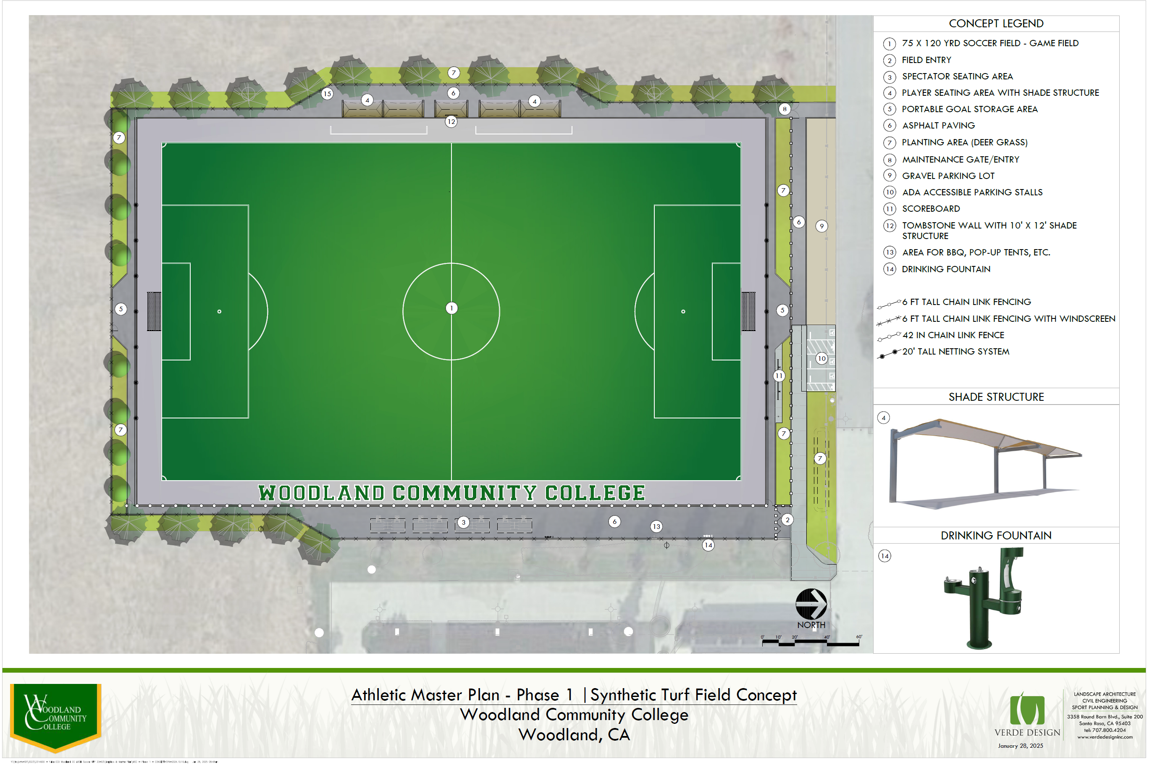
Appendix K: Soccer Field Layout Plan

The End.

