Request for Proposal
Yuba Community College District

Yuba College Campus
Building 1100 (Library)
Restoration and General Contractors
Small Fire and Water Damage Repairs and Restoration Project
No. RFP 25-05

Issue Date: March 19, 2024
Proposal Due: April 15, 2024, 1pm Sharp

Proposal Due Date: April 15, 2024, 1:00 PM Sharp, Yuba College Location Delivered To:

Yuba Community College District, District Offices
Attn.: David Willis
District Director of Facilities Planning, Maintenance & Operations
RFP No. 25-05 Yuba College, Building 1100 (Library) Smal Fire and Water Damage Repairs and Restoration Project
Address: Sutter County Campus, Second Floor, District Offices, Attention: David Willis, 3301 East Onstott Road, Yuba City, California 95991

Proposal Delivery at Second Floor
Yuba Community College District
Sutter County Campus
District Offices
3301 East Onstott Road (second floor)
Yuba City, California, 95991

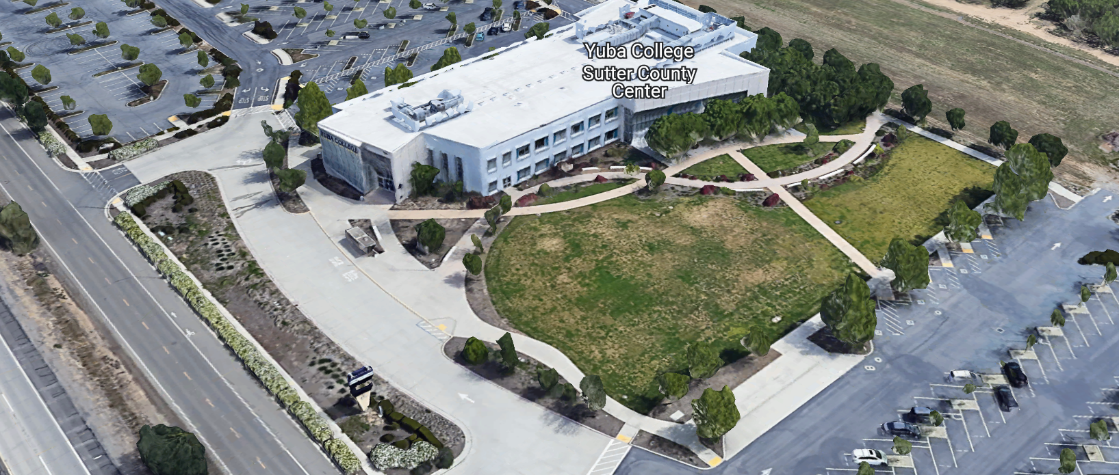
West Building Entrance
TABLE OF CONTENTS

1.0 INTRODUCTION
1.1 District Information
1.2 Yuba Community College District Background
1.3 Purpose of the Request
1.4 Applicable Codes
2.0 Scope of Work
2.1 Project Schedule
2.2 District Staff Contacts during Proposal Process
2.3 Project Safety Requirements
2.4 Demolition
3.0 Proposal Format Organization
3.1 Proposal Delivery, Contents, and Format
4.0 Selection of “Firm”
5.0 Basis of Award
6.0 Non-Discrimination
7.0 Response to Request for Proposal (RFP)
8.0 Requests for Information (RFI)
9.0 Proposal Schedule
10.0 District Parking
11.0 RFP Proposals
12.0 Award of Contract/Proposal
13.0 Reservation of Rights
14.0 Bid Bond Requirements
15.0 Performance Bond, Payment Bond Requirements
16.0 Liquidated Damages
17.0 Contractor and Subcontractors Information:

Contractor Proposal Required Items:

Appendix A, Bid Form
Appendix B, Statement of Qualifications
Appendix C, Contractor References
Appendix D, Contractors Project Approach, Project Team Members and Credentials, Preliminary Schedule
Note: A Bid Bond, Performance and Payment Bond, area all required.

Informational Items:
Appendix E: YCCD Academic Calendars
Appendix F: Map of Yuba College Campus
Appendix G: Pictures of Affected Areas in building 1100 (Library)
Appendix H: Rough materials take-off estimate. (contractors encouraged to do their own measurements and estimates)

1. INTRODUCTION

  - District Information:

The District consists of two colleges, Woodland Community College and Yuba College, with campuses located at five different locations: Yuba College in Marysville, CA; Sutter County Center in Yuba City, CA; Woodland Community College in Woodland, CA; Colusa County Center in Williams, CA; and Lake County Campus in Clearlake, CA.

  - Yuba Community College District

The Yuba Community College District (YCCD) was founded in 1927 and spans eight counties (Yuba, Sutter, Colusa, Yolo, Lake, Butte, Glenn and Placer) and nearly 4,200 square miles of territory in rural, north-central California. It has colleges in Marysville and Woodland, an educational center in Clearlake, an educational center in Williams, an educational center in Yuba City.

  - Purpose of Request

The Yuba Community College District seeks proposals from qualified Licensed Restoration Contractors and/or General Contractors to restore the Yuba College, building 1100 library after a recent small electrical fire in a light fixture resulted in some fire damage (early on March 1, 2025) and some water damage as a result of the fire suppression system and the fire departments work to put out the fire. The water remediation work has been completed, and the spaces have been dried out.
Yuba College Campus Address: 2088 North Beale Road, Yuba City, California 95901

  - Applicable Codes
All work shall meet all State of California Building Codes, and Federal codes, and local ordinances.
All projects at the District/College are prevailing wage projects.
- Scope of Work
- Make all needed repairs to restore, repair, and reconstruct the Yuba College Library building 1100 and repair all fire and water damage locations including the following:
  - Repair all sheetrock walls, finish to match existing, match and replace vinyl base, prime and paint walls with two coats finish paint using Sherwin Williams paint. Texture drywall to match existing. Paint entire walls affected by the reconstruction work. Vinyl base should match existing. Remove and reinstall outlet covers, thermostat covers, white boards, and other items that are on walls prior to repairing and painting walls. Repair minor damage to wall surfaces prior to painting.
  - Repair and place all needed carpet tiles to match as close as possible to existing carpet tiles. Place moisture barrier below carpet tiles to match existing. On the library side (east side) of the high ceiling area, remove and replace ceiling tiles as noted in Appendix H. Replace wall base as needed to match existing. Provide 2% carpet tile stock to the College M & O department. It is acceptable to use carpet tile corner adhesive tabs to secure the carpet tiles to the concrete flooring.
  - Replace all ceiling tiles over the high ceiling area of the library to match existing. Provide 2% ceiling tile stock to M & O department.
  - Provide and Install door threshold as needed for room 1137, 1138, 1139, 1140, 1141, and any other rooms that may need a new door threshold.
  - Replace fire damaged ceiling grid over the high ceiling area.
  - Provide and install all the necessary preparation work for resilient flooring areas.
  - Provide and install wall batt insulation per existing conditions and the referenced rough materials take-off estimate in Appendix H.
  - Maintain plastic barrier around the work boundaries to limit dust, fumes, and construction impacts into surrounding areas.
  - Maintain project boundaries and signs to keep unauthorized staff from entering the work area.
  - Protect all existing items inside the work area with plastic sheeting as needed to keep dust and debris off of them.
  - After the work is completed, remove all temporary plastic sheeting and provide a thorough cleaning of all surfaces, including stairs, hand rails, windows and frames, doors and frames, furnishings in the work area including shelving, and all other items inside the work area.

Note: The District is contracting separately with a lighting contractor to award the lighting fixture replacement work. Do not include the lighting fixture replacements in your proposal.

General Comments:

The Contractor shall visit the Yuba College building 1100 library affected areas prior to bidding the repair work.

The Contractor is 100% responsible to coordinate and securely store materials, tools, equipment, and other items required for the project. The Contractor must receive, inspect, unload, move, properly store, and sign for all materials. No exceptions. All materials need to be locked up and stored properly. The construction area must be cleaned up and organized to reduce trip hazards. Deliveries that arrive without a Contractor representative on site will not likely be received. All materials must be as specified and pre-approved by the District before orders are placed or delivered. The District cannot pay for materials until they arrive on site.

No unopened paint containers shall arrive at the campus. All paint containers shall arrive sealed and mixed at the campus. No left-over paint shall be poured down the drains in the sinks and toilets.

The Contractor shall provide all waste removal in accordance with State regulations and provide the District with a waste manifest as support documentation for future progress payments. The contractor shall provide a waste container as needed for this project. All pathways to outside areas to the work areas shall be protected with floor coverings to minimize dirt and debris grinding into the carpet tiles.

The Contractor shall use and maintain plastic sheeting barriers, barricades or delineators, barricade tape, and signs to delineate all project boundary areas.

The Contractor shall provide and install dust protection plastic tarps and barriers to keep dust off of office furnishings and other furnishings and equipment not removed during construction.

The Contractor shall protect all fire alarm system smoke detectors and sensors from construction dusts during construction.

The Contractor shall coordinate closely with the M & O department to turn off HVAC systems prior to painting to protect the smoke detectors in the HVAC ductwork from getting impacted by airborne paint particles and construction debris.

The Contractor shall clean all areas thoroughly after work is completed in each area to meet all College/District requirements.

The Contractor is expected to meet weekly as needed at the construction site (likely at building 1100, library building), during the project with District/College staff at the project site to review progress, discuss issues, and provide a brief update on what is expected to occur as the project progresses.

The Contractor personnel must provide temporary restroom facilities.

The Contractor shall apply and follow all Cal-OSHA regulations. All required PPE shall be in good condition and used when needed to protect employees.
The District encourages a positive and open communication strategy that includes a sense of partnership and mutual success on its projects.
The Contractor mark-ups for profit and overhead for change orders is 10%. Subcontractor mark-ups are limited to 10%.
2.1 Proposed Project schedule
Approximate Award Date: May 22, 2025
Start Mobilization approximately: May 27, 2025

Start Construction: June 2, 2025

Submittals Received by: June 5, 2025, returned to the contractor within 2 business days.

Substantial Completion: July 11, 2025

100% Completion: July 18, 2025

College Move-in: July 21, 2025 through July 24, 2025

Please note all College Holidays. Unless otherwise mutually agreed to, the Contractor shall not work on College/District holidays.
The contractor may work whatever hours are needed Monday through Friday. Normal working hours are 7:00am to 5:00pm but can be adjusted to meet whatever the Contractor needs. The District is closed on Fridays in June and July but the contractor may work on these days.
This is a prevailing wage project. The Contractor is required to upload all certified payroll information to the Department of Industrial (DIR) Relations web site. YCCD will provide a DIR project number. The District will require a copy of all certified payroll records prior to the release of the 5% retainage and final payment to the contractor.
Provide a project schedule with the proposal with the District provided milestones clearly shown.
Project Proposed Change Orders (PCO’s): All PCO’s shall be submitted as soon as possible. PCO’s require a breakdown of all parts, materials, and labor. A thorough reasoning and justification shall be provided for the PCO to be considered by the District. PCO’s will not be considered “after the fact” after work has been done without authorization by the District.

2.2 District Staff Contacts during the Proposal process:
Firms interested in submitting a Proposal are directed not to make personal contact with the Board of Trustees, District staff, or members of the evaluation committee. Any contact shall constitute grounds for disqualification from consideration.
Single Point of Contact during the Proposal Preparation Process:
David L. Willis
District Director of Maintenance, Operations, and Planning
YCCD District Offices, Sutter Center, (Second Floor)
3301 East Onstott Road
Yuba City, California, 95991
Cell Phone: 916-747-4262
Email: dwillis@yccd.edu

On-site coordination, first contact person access and immediate contact person during construction OR if additional site visits are needed during the bidding process.
Bryan Epp
Assistant Director of Maintenance, Operations
2088 North Beale Road
Phone: 530-740-1722
Email: bepp@yccd.edu

No changes can be made to the project scope without authorization in writing by David Willis.

2.3 Project Safety and Security Requirements
Safety is a top priority for the District. All California OSHA requirements apply. Industry best practices apply. Contractor employees shall wear shirts with sleeves, a hard hat, eye protection, hearing protection as needed, gloves, substantial leather footwear, long pants, a reflective safety vest, and take all needed precautions to complete the work in a safe manner. Safety shall not be compromised at all during the work.
Enhanced fall protection precautions shall be taken.
During windy conditions, precautions shall be taken to ensure the safety of staff and to properly secure materials and debris. The Contractor shall also take precautions during windy days if there are any risks of material being carried by the wind and deposited on vehicles or other surfaces.
Protection of College property shall be taken. Contractor is 100% responsible for any damage to College property and facilities.
These campuses have a moderate risk of theft. It is the sole responsibility of the Contractor to receive and secure all materials, equipment, tools, monument signs, and other items associated with this work. The contractor shall unlock and secure all exterior doors on all buildings each workday.

COVID 19 BEST PRACTICES APPLY:
Contractors are required to notify the District in writing within 24 hours after a construction employee that has been working on the project has been determined to have COVID. No sick employees shall report to work.
2.4 Demolition
The contractor shall provide a debris waste manifest for all items removed from the campus. Debris and waste shall be processed in accordance with all State and Federal codes, laws, and ordinances.
3.0 Proposal Format Organization
The Firm is requested to use the following proposal format:
3.1. Proposal Delivery, Contents, and Format:
Proposals should provide straightforward, concise information that satisfies the requirements noted in this RFP. Expensive binding, color displays, and the like are discouraged. Emphasis should be placed on brevity, conformity to the Districts instructions, selection criteria of this RFP, and completeness and clarity of content. Each Respondent’s proposal should clearly and accurately demonstrate specialized knowledge and experience required for consideration.
In a sealed box or envelope (clearly marked “), submit the following:
- One (1) flash memory stick containing the complete proposal and supporting documentation; You may also in addition to the flash drive, email your proposal to: dwillis@yccd.edu.
- One (1) original proposal in paper form, which consists of a Proposal Letter and responses to the proposal requirements of this RFP.

There is no page limit.

Firms must comply with the provisions of these instructions for completion and submission of the Proposal. The failure of a Firm to comply with the Proposal Instructions and Requirements will likely result (at the sole discretion of the District) in rejection of the Proposal for non-responsiveness.
Proposal Section | Format
- Cover Letter | PDF
- Table of Contents | PDF
Appendices (See Table of Contents for each one) Submit a response to each Appendix that requires Contractor information. Please submit responses to Appendices A, B, C, D. Appendices E, F, are informational only. | PDF

Proposal General Information Contents:

Information provided by the Contractor will help the District determine if the Firm is a “Responsible Bidder”.

Cover Letter

The Proposal shall include a Cover Letter on Respondent’s official business letterhead, which shall be signed by an individual authorized to legally bind Respondent. The Cover Letter shall also identify the name, telephone number, and email of a person who may be contacted during the Proposal evaluation process.

Table of Contents

Provide a Table of Contents that outlines in sequential order the major sections and sub-sections of the Proposal. Use tabs to allow information to be more easily located.

4.0 Selection of “Firm” Services Provider

The process of “Firm” selection is based upon the complete responsiveness of the RFP and the criteria as outlined in the RFP.

The District Project Evaluation Team will First pre-qualify contractors based on the Statement of Qualifications information provided by the Contractor. If qualified, then contractor proposals will be considered. Contractors that are not qualified based on the criteria and information provided by the Contractor associated with the Statement of Qualifications will not have their proposals considered even if they are the lowest cost proposing contractor.

The District reserves the right to reject any or all submittals, to amend the RFP process, and to discontinue or re-open the process at any time. The District reserves the right to request clarifications to RFP responses and to negotiate the terms of the agreement.

5.0 Basis of Award

This project will be awarded based on the following criteria:

- Lowest Total Cost Responsive Qualified Bidder
  - Lowest Total Cost
  - Contractor Capability to do the work
  - Qualified Contractor (per Appendix B, Statement of Qualifications)
    - District determined “Qualified Contractors” based on the information provided in the “Statement of Qualifications” information provided by the Contractor.
    - Proper State of California Contractor License in good standing
    - Information provided as requested in the RFP and Specifications.
    - All Addendums are acknowledged.
    - Contractor listed any exceptions or exclusions. Contractors should bid the project per the RFP and contract documents (using specified products) and then offer exceptions and exclusions or cost deductive or additive alternatives separately from the base bid.
      - Due to the nature of this restoration project, there area not any specified products other than matching as closely as possible to t he existing materials.

    - Firms with historically poor performance on projects at Yuba Community College District will be disqualified from consideration. Poor performance is 100% solely defined by the District for such issues as not meeting original schedule requirements within two months of the original schedule OR not ordering materials and supplies, tracking long-lead procurement items and then delaying the project such that the contractor cannot recover the project schedule, OR working unsafely and not following CAL OSHA requirements OR not providing/uploading certified payroll records in accordance with the Department of Industrial Relations requirements OR excessive change orders greater than 10% of the original awarded amount on renovation projects and greater than 7% on new buildings OR generally poor quality work not acceptable to the District OR not utilizing coating manufacturer specified application equipment OR that have threatened legal action toward the District OR having a history of difficult argumentative communications regarding change orders/schedules/and quality of work OR as any combination of the above items or other similar items as determined by the District.
    - Contractors’ ability to meet schedule requirements, recover delays in the schedule.
    - Contractors have demonstrated past project references of “like” projects
    - Contractors references are all good with respect to schedule, cost, and quality.
    - No other factors such as litigation, licenses in good standing, or other similar criteria.
    - At least five (5) project references of similar projects completed in the past seven (7) years with contact information, scope of work, initial awarded cost, change orders cost, pictures if possible.

Optional Interview Process:

The top one or two of the lowest total cost responsive qualified bidders may be requested to participate in a ZOOM interview process with the District Project Proposal Evaluation Team. This interview process is fully at the discretion of the District. The District may decide that no interview is required. If an interview is needed, then it will be scored by the District and part of the evaluation process.

6.0 Non-Discrimination
The District does not discriminate with regard to race, color, gender, national origin, disability, or any other protected or other classification in the awarding of contracts/agreements. The District welcomes all Qualified Firms to participate in the project Request for Qualification/Proposal process.
The District encourages firms that are women or minority owned, emerging small businesses, veteran owned firms, disabled person owned firms, and all other qualified firms to participate in the proposal process.
The District encourages the submission of proposals from all Firms that can meet the stated requirements set for this RFP.

7.0 Responses to RFP
Sealed responses to this RFP must be clearly marked "RFP No. 25-05 Yuba College, Building 1100 Library Fire and Water Damage Repairs and Restoration Project”.

Responses shall be mailed to or hand-delivered to the following address:

Yuba Community College District, District Offices
Attn.: David Willis
District Director of Facilities Planning, Maintenance & Operations

Envelope/Box Marked:
"RFP No. 25-05 Yuba College, Building 1100 Library Fire and Water Damage Repairs and Restoration Project”.
.

Address: Yuba Community College District, Yuba College, Sutter County Center, District Services Offices, Second Floor, Attention: David Willis, Room 217, Yuba City, California, 95991

Note: Completely seal your proposals in envelope/box and make sure it gets date/time stamped when delivering proposal. Firms are each 100% responsible to make sure proposals that are mailed using a carrier such as UPS, FED Ex, etc.…are received and date/time stamped by District personnel prior to the proposal due date/time. No proposals will be considered if they are late, even if it is only 5 minutes late. Please make sure your proposals are delivered and received promptly prior to the due date/time. There will be a public proposal opening at the due date/time.

Do NOT just email your proposals. Emailed proposals, if sent, are required in addition to the above requirements.

8.0 Requests for Information (RFI)

Requests for Information concerning the RFP must be in writing and may be submitted via email no later than the date shown below. Please direct all questions to David Willis, email: dwillis@yccd.edu.

Following the RFI deadline, all questions and answers will be summarized and posted on the District's website: https://www.yccd.edu/central-services/purchasing/ , then, click on the “Requests for Proposals / Quotes” tab on the right hand side of this web page. It is anticipated that responses to inquires received by the required time and date will be provided within 5 business days and posted on the District's website or responded to per the dates listed in the RFP for addendum publishing. Should more time be needed by the District to answer I respond to RFI’s, this information will also be posted on the above website.

- Include the following in the subject matter field on emails when requesting information: “RFP 25-05”, RFI.

9.0 Proposal Schedule:

Important Dates and Times:

March 19, 2025: Release of Request for Proposal

March 26, 2025: 9:00AM to 10:00AM Optional Pre-Bid ZOOM Meeting

Join Zoom Meeting:

https://yccd-edu.zoom.us/j/89950098030

Meeting ID: 899 5009 8030

Dial by your location
• +1 669 444 9171 US

March 27, 2025: 1:00PM to 2:30PM MANDATORY On Campus Pre-Bid Meeting

Address: Yuba College, Building 1100 Library, 2088 North Beale Road, Marysville, California 95901

OR

April 3, 2025 1:00PM to 2:30PM MANDATORY On Campus Pre-Bid Meeting

Address: Yuba College, Building 1100 Library, 2088 North Beale Road, Marysville, California 95901

OR

If you cannot make it to one of the two Mandatory meetings above, please contact Bryan Epp at 530-701-9202 or email: bepp@yccd.edu to schedule another time to meet and walk through the library affected areas.

All Firms must attend one of the Mandatory Pre-Bid meetings and sign the login sheet OR meet with Bryan Epp at the College and sign a login sheet.

April 7, 2025: 5:00 PM, All questions and requests for information must be submitted to David Willis at: dwillis@yccd.edu.

April 8th, 2025: 5:00 PM, Addendum Issued if needed.

April 15, 2025: Proposals due at 1:00 PM SHARP, Yuba Community College District, District Offices Location: Sutter Center, District Offices, Second Floor, Room 217, Attention: David Willis, 3301 East Onstott Road, Yuba City, Ca., 95991. There will be a public bid opening on this RFP in room 211 at the Sutter Center Building.

Note: All procurement documents associated with this procurement will be posted at this web page link: https://www.yccd.edu/district-services/requests-proposals-quotes/

10.0 District Parking: (Fees Not Applicable)

-No parking in Reserved Spaces without a proper permit
-Permit Parking is enforced in all general lots between 6:00 am and 6:00 pm, Monday through Friday. All general lots require a properly displayed, valid permit during these times
-Daily Parking Permits are $2.00
-Permits are available for purchase at any of the permit machines located in the student parking lots
-All other parking regulations are enforced 24 hours a day, seven days a week. This includes designated staff spaces, handicap spaces, timed spaces, red zones, yellow zones, and areas not marked (no parking at any time)
-Once this project is awarded, temporary parking permits will be processed as requested by the successful firm for all employees associated with this project at no cost to the Firm for the duration of the project at each Campus location. These temporary permits must be displayed at all times on the dashboard of employee vehicles.

11.0 RFP Proposals

Proposals received after the deadline will not be opened. Each responder shall submit one (1) signed original hard paper copy in a binders. Provide one electronic format copy of the proposal using electronic media such as a flash drive. (No CD formatted Disks).

All materials submitted in response to the RFP shall be on 8-1/2"x11" paper, preferably in
Portrait orientation. All submitted materials must be bound in either a three-ring binder or spiral bound notebook. Content shall be tabbed and numbered per the items included in the Submittal Requirements. All Proposals will be reviewed and evaluated by a District Selection Committee. The District at its sole discretion may interview finalists or select a firm or firms to perform work based solely on the evaluation of the Proposal. There is no page limit.

All Proposals become the sole property of the District and the content will be held confidential until the selection of the Firm or Firm’s is made and the project is awarded.

12.0 Award of Contract

- The Contract will be awarded to the lowest total cost, most responsive responsible District qualified Firm, whose proposal, conforming to the request for proposal and associated addendums, will be most advantageous to the District.

B. The District reserves the right to enter into an Agreement without further discussion of the proposal submitted based on the initial offers received.

C. The District reserves the right to reject any or all proposals or any part of the proposal and to waive informalities and minor irregularities in the proposals received.

D. The RFP, its addendums, any follow-up clarifying information, and the proposal of the selected Firm will become part of any contract initiated by the District.

E. A formal contract shall be signed by the successful proposer and Yuba Community College District to perform this service.

F. The District reserves the right to enter into discussions with any one or all of the Responders after Proposals have been initially reviewed. Such responses shall be subject to all provisions, terms and conditions as set forth in the RFP, unless otherwise modified.

G. The District intends to award to a single RFP Responder.

H. BONDS: A Bid Bond is required with the Proposal. The Contractors Performance and Payment bonds are required within 7 calendar days after the Notice of Award is provided to the Contractor. The Bid Bond is required with the proposal.

I. Failure to acknowledge all of the addendums, provide the items listed in the RFP, may render the proposal unresponsive at the discretion of the District. Items listed in the RFP become part of the contract unless the Contractor provides an exception in the proposal. Contractor exceptions, depending on the magnitude, may render the proposal unresponsive, at the discretion of the District.

J. The District reserves the right to request clarification of proposal content during the review and evaluation process.

K. The District reserves the right to negotiate the terms of the agreement to align with budgetary constraints.

13.0 Reservation of Rights

The District reserves the right to:

- Reject any or all submittals at its sole discretions.
- Cancel the Request for Proposal (RFP), without cause.
- Modify any requirements contained within the RFP and request a revised submission from all Providers.
- Establish other evaluation criteria determined to be in the best interest of the District.
- Contract with any of the firms responding to the RFP based solely upon its judgment of the qualifications and capabilities of the firm.
- Clarify the content of any proposal to verify that the requirements of the RFP are included.
- Waive “minor” proposal inconsistencies that do not change the scope of work as outlined in the RFP.
- Request an alternative Superintendent on the project if the initially assigned Superintendent on the project is not performing well, not meeting project requirements, not working well with College staff and students, not applying best practice safety methods, OR not following College/District guidance regarding project approach. If the owner is the Superintendent, and has been replaced, the owner may visit the project briefly (less than 1 hour per day up to 2 times per week) to coordinate with the replacement Superintendent.
- The District will not allow or tolerate verbal abuse or any other type of abuse by the Contractor toward any College or District personnel or Contracted professional service providers. Abuse, defined solely by the District as verbal or physical, or written, may lead to a “Stop Work” order by the District until it can be resolved, and steps taken to ensure abuse is not repeated. If abuse occurs again, the District may issue a final “Stop Work” order, require the Contractor to leave the College/District project site and process a Performance Bond claim to complete the work. All costs associated with District “Stop Orders” are 100% the responsibility of the Contractor. The contractor will be required to catch up the project schedule if a “Stop Order” is required to be issued for up to 5 days due to unprofessional behavior on the part of the Contractors employees.
- Disqualify a Contractor after reviewing the proposal and finding concerning performance information in references, inadequate or incomplete proposal information, inadequate or information that is provided by the Contractor as part of the Statement of Qualifications process, and historically poor project performance at the District/Colleges (as solely defined by the District).

This RFP does not commit the District to award or negotiate a contract. The District will not be responsible for any expenses incurred by any firm in preparing and submitting a proposal or response to this RFP or in completing any of the work specified.

14.0 Bid Bond Requirements (Proposed Form—Contractor can use their standard form):

BID BOND

Know all persons by these presents:

That we, , as Principal, and , as Surety, are held and firmly bound unto Yuba Community College District, hereinafter called District, the sum of ten percent (10%) of the total bid amount of Principal for payment of which in lawful money of the United States, well and truly to be made, we bind ourselves, our heirs, executors, administrators, successors, and assigns, jointly and severally, firmly by these presents.

The condition of the above obligation is such that, whereas, the Principal has submitted a bid for the work described as follows: RFP 25-05 Yuba College, Building 1100 Library Fire and Water Damage Repairs and Restoration Project.

Now, therefore, if Principal shall not withdraw said bid within the time period specified after the bid date, as defined in the bidding documents, or within ninety (90) days after the bid date if no time period is specified, and, if selected as the apparent lowest responsive responsible bidder, Principal shall, within the time period specified in the bidding documents: Enter into a written agreement, in the form prescribed in the bidding documents, in accordance with its bid; file with the District all bonds required to be filed, including but not limited to faithful performance and payments bonds; and, furnish certificates of insurance and all other items required by the bidding documents.

In the event of the withdrawal of said bid within the time period specified, or within ninety (90) days if no time period is specified, or the failure of Principal to enter into such agreement and furnish such bonds, certificates of insurance, and all other items as required by the bidding documents, if Principal shall pay to the District an amount to the difference, between the amount specified in said bid and such larger amount for which the District procures the work covered by the bid, if the latter is in excess of the former, then this obligation shall be null and void, otherwise to remain in full force and effect.

In the event suit is brought upon this bond by District, in addition to the penal sum of this Bid Bond, Surety shall pay reasonable attorneys’ fees and costs incurred by District in such suit.

Surety hereby expressly waives the provisions of California Civil Code section 2845.

In witness whereof, we have hereunto set our hands this day of , 20 .

Principal: Surety: (Name of firm)

By: By:

Title: Title:

Broker Name or Agent Name:

License Number:

Bond or company appointment must be listed with the CA Department of Insurance Notary acknowledgments for Surety and Surety’s Power of Attorney must be attached.

Address for Notices:

Bid Bond Requirements:
Provide a Bid Bond per the following:

PUBLIC CONTRACT CODE - PCC

DIVISION 2. GENERAL PROVISIONS [1100 - 22355]

ARTICLE 4. Bids and Bidders [10160 - 10169]
( Article 4 enacted by Stats. 1981, Ch. 306. )
Section: 10167.
    - All bids shall be presented under sealed cover and accompanied by one of the following forms of bidder’s security:
      - An electronic bidder’s bond by an admitted surety insurer submitted using an electronic registry service approved by the department advertising the contract.
      - A signed bidder’s bond by an admitted surety insurer received by the department advertising the contract.
      - Cash, a cashier’s check, or certified check received by, and made payable to, the director of the department advertising the contract.
    - The required bidder’s security shall be in an amount equal to at least 10 percent of the amount bid. A bid shall not be considered unless one of the forms of bidder’s security is enclosed with it.
    - All bids submitted pursuant to this section shall also comply with the provisions of Section 1601 of the Public Contract Code.
(Amended by Stats. 2012, Ch. 290, Sec. 3. Effective January 1, 2013.)

The Bid Bond shall be provided with the Contractor’s Proposal.

15. Performance and Payment Bond Requirements: Required for this project and described in the District Agreement for Services form (Appendix E, Agreement for Services). The Performance and Payment bonds are due 7 to 10 days after the award date.

16.0 Liquidated Damages:
This paragraph applies to any Order that provides for payment of liquidated damages.
The Bidder also agrees to pay, as liquidated damages, the amounts specified below for each consecutive calendar day after the expiration of the consecutive calendar days allowed for each phase.

Liquidated Damages, 100% Construction Completion $250 / per calendar day Work is delayed, after July 25, 2025.

If Liquidated Damages are assessed, then, they will be deducted from the final release of retainage progress payment of the Firm. Retainage will be calculated at 5% of the completed value of the project.
The Firm is however encouraged to complete the work asap and by the mentioned dates in this RFP unless otherwise mutually agreed upon by the Firm and the District due to factors that are outside the control of the Firm. The contractor is encouraged to source materials that are readily available and that will meet the project schedule requirements.

17. Contractor and Subcontractors Information:
No. | Name of Firm | Contractor License Number/Expiration Date | Department Of Industrial Relations Registration Number/Expiration Date
1
2
3
4
5
6
7
8
9
10

Appendix A: Proposal Bid Form:

No. | Description | Cost
1 | General Conditions/Mobilization | $
2 | Construction | $
3 | Demobilization, Comprehensive Clean Up, Project Closeout, Punch List, Removal of plastic sheeting project boundary barriers, Certified Payroll Records to DIR and the District, etc.. | $
4 | Replace furnishings and books, and various items back into place. This is a place holder. Please provide labor rates. This cost will need to be tracked as a T&M line item since it is impossible to quantify and accurately estimate. | $30,000.00
5 | Other: | $
6 | Total Costs: | $

Provide schedule of values.
Prevailing wages apply to this project.

Provide a list of employee classifications and labor rates for the Yuba College prevailing wage location.

The move-in work on-line item 4 above will all need to be closely coordinated with the College and the District. The scope is impossible to accurately determine at this time.

List all First Tier Sub-Design Firms and Sub-Contractors.

Please round off numbers to the nearest dollar.

A preliminary overall start-to-finish project schedule is required with the proposal.

Appendix B: Statement of Qualifications
The Firm shall furnish the following information. Failure to comply with this requirement will render the submittal informal and may cause its rejection. Additional sheets may be attached if necessary.
Basic Firm Informational Items 1 through 17:

- Firm Name:___________________________________________________________________

- Primary Address: ______________________________________________________________

- Firm’s Contact Person and Title:___________________________________________________

- Telephone: ___________ Facsimile: ____________________

- Email Address: ___________________

- License No.: ______________________________ Class: __________________________

Responsible Managing Employee/Officer:_________________________________________

- DIR Registration No.:________________________ Expiration Date:___________________

- Names and titles of two officers of the Firm:

NAME TITLE

___________________________________ _______________________________________

___________________________________ _______________________________________

9. Specific type of Ownership (Check one)

Individual
Partnership
Corporation; If a corporation, state the following:

State of incorporation:
Date of incorporation: President/CEO:
Joint Venture
Other (Specify)

- Taxpayer Identification No.: _______________________
- List annual gross income for last three (3) years:
Year: _______________ $_____________________
Year: _______________ $_____________________
Year: _______________ $_____________________

- Number of years Firm has been in business:
If less than 5 years, please describe:

- Number of years Firm has conducted business under the present name:__________
- Has the Firm ever been licensed under a different name or different license number? . If Yes, give name(s) and license number(s) and dates or operation under that name(s) and license number(s) (attach separate sheets if necessary):___________________________________________ _________________________________________________________ _________________________________________________________
- Number of years’ experience in California Community College, University or educational facility projects .

- Do you now or have you ever had any direct or indirect business, financial or other connection with any official, employee or consultant of the District? ___. If Yes, please elaborate:
_________________________________________________________

- Has the Firm ever completed any work at the Yuba Community College District? If Yes, please elaborate:

Potentially Disqualifying Questions 18 through 30 (District may immediately disqualify Firm if its answer to any of Questions 18 through 26 is “Yes” or if the answer to questions 27 through 30 is “No”. Firm’s refusal to answer or omission of response to any of Questions 18 through 30 may result in disqualification of Firm.):

- Does the Firm possess a valid and currently in good standing California Contractors’ license for the classification(s) of Contractors’ License required for the Project? If Yes provide the license number(s). Yes/No______________________________________________________

- Has the Firm been defaulted or terminated (other than for convenience) by any California school district, community college district or other California public agency on any project within the past 5 years? Yes/No

If yes, identify agency and details:

- Has the Firm or any of its principals defaulted so as to cause a loss to a surety on a payment or performance bond? Yes/No

If yes, give dates, name and address of surety, and details:

- Has the Firm or any of its owners, officers, or partners, ever been convicted of a crime, or found guilty in a criminal action, involving fraud, theft, making any false claim or material representation to a public agency, or involving any federal, stet, or local law, rule, or regulation related to construction? Yes/No_____

If yes, explain, identify the agency, and provide case name and number.

- Has the Firm been assessed liquidated damages for any project in the past five years? Yes/No If so, identify owner and details:

- Has the Firm been disqualified, debarred, forbidden, or found non-responsible or otherwise prohibited from performing work or bidding won work for any California school district, community college district, or other California public agency within the past five years? Yes/No

If yes, identify agency and details:

- Has the Firm been in litigation (whether in court or arbitration) with any California school district, community college district, or other California public agency on an issue pertaining to any contract during the past five years? Yes/No:

If yes, explain, identify the agency, and provide case name and number.

- Has the Firm ever failed to complete a project in the past five years? Yes/No: If so, give owner and details:

- Is the Firm currently or has the Firm been in a state of “Bankruptcy” in the past five years? Yes/No:
If yes, please explain.

- Can the Firm provide at least up to $ 250,000 in bonding capacity for this project?
If no, please explain.

- Does the Firm have a liability insurance policy (project) limit of at least $1,000,000 per occurrence and $2,000,000 aggregate?
If no, please explain.

- Does the Firm have a current workers’ compensation insurance policy as required by the Labor Code or is legally self-insured pursuant to Labor Code Sections 3700 et seq.?
If no, please explain.

- Does the Firm have project experience that includes restoration and repair projects at a School/College/University setting? Yes/No
If no, please explain.

- Has this Firm ever completed any similar projects or any work at Yuba Community College District? Yes/No
If no, please explain.

Note: Firms with historically poor performance on projects at Yuba Community College will be disqualified from consideration. Poor performance is defined in section 5.0 of this RFP.

Rating Questions 32 through 48:

- Please list and describe on separate sheets the Firm’s top 5 restoration and repair and remodel projects most recent (within the past 7 years) references with current contact information. At least three (3) of the projects must have been completed for California public schools, community college districts, or other California public agencies. The project reference list should include the following criteria:
  - Project Name
  - Project Owner and Contact Information
  - Project Scope of Work
  - Original Contract Completion Date
  - Actual Project Completion Date
  - Original Contract Awarded Amount
  - Final Adjusted Contract Awarded Amount (with change orders)
  - Any issues that Firm had to overcome on the project

Scoring Criteria:
  - Multiple Projects with Similar Scope of Work (50 points)
  - Completed Multiple Projects on Schedule (up to 50 points)
  - Project Change Orders less than 5% (up to 50 points)
  - Project Completed at a Yuba Community College District Location with high quality, on schedule (within 30 days of original schedule). (30 points)

Total points for Question 32: up to 180 points

- Please describe in detail, your Firm’s approach to maintaining a safe project while students, faculty, and staff will be occupying the building:

(Up to 10 points.)

- List your Firm’s Workers’ Compensation Experience Modification Rate (EMR) for the three most recent years. Your EMR should be issued to your Firm by your workers’ compensation insurance carrier.

Year _______ EMR _______

Year _______ EMR _______

Year _______ EMR _______

(EMR numbers under 1.0 = 20 points; 1.0 to 1.24 = 5 points; 1.25 to 1.49 = 1 point; 1.50+ = 0 points.)
- Has your Firm had any OSHA violations or citations and penalties levied against it in the past five years? If Yes, how many violations (and please explain)________
(0 = 10 points; 1 = 3 points; 2+ = 0 points.)

- How many years has your Firm been in business in California as a contractor under your present business name and license number? __________
(less than 5 years = 0 points; 5-10 years = 10 points; 10+ years = 20 points.)

- In the last 10 years, how many legal proceedings (filed in court or arbitrations) has your Firm initiated against an owner, regardless of outcome? _______
(0 = 10 points; 1 = 3 points; 2+ = 0 points.)

- In the last 10 years, how many legal proceedings (filed in court or arbitrations) has an owner initiated against your Firm, regardless of outcome? _______
(0 = 20 points; 1 = 5 points; 2+ = 0 points.)

- Has any insurance carrier, for any policy of insurance, refused to renew a policy, or terminated a policy, for your Firm within the last five years? _____
(No = 10 points; Yes = 0 points.)

- Have any of your Firm’s employees or any other persons or entities filed a complaint against your Firm with the California Contractors State License Board within the last five years? If Yes, how many complaints were filed? ________________
(No = 10 points; 1-2 = 5 points; 3+ = 0 points.)

- Was your Firm required to pay either back wages or penalties for your Firm’s failure to comply with the state’s prevailing wage laws within the last five years? If Yes, identify the number of violations. ________________
(No = 10 points; 1-2 = 5 points; 3+ = 0 points.)

- Has any owner made a demand on a performance bond issued to your Firm on any construction project within the last 10 years? ________
(No = 10 points; Yes = 0 points.)

- Has any surety company made any payments on your Firm’s behalf as a result of a default to satisfy any claims made against a performance or payment bond issued on your Firm’s behalf in connection with any construction project within the last five years? _____
(No = 10 points; Yes = 0 points.)

- Has your Firm been denied bond coverage by a surety company, or was there a period of time when your Firm had no surety bond in place during a public construction project when one was required, within the last five years? _______
(No = 10 points; Yes = 0 points.)

- Has your Firm been denied an award of public works contract based on a public agency’s finding that your Firm was not a responsible bidder within the last five years? ______
(No = 10 points; Yes = 0 points.)

- Please describe the Capability/Capacity of your Firm. Please provide a comprehensive list of projects that the Contractor has in process and reasoning/justification regarding how the Contractor has capacity to perform the required construction services on this project.

(Up to 30 points.)

- Please describe the Firm’s commitment to maintaining a construction schedule. How will the Firm recover the schedule if it slips if the Firm gets busy with other projects? Please describe specific actions the Firm will take to maintain the Project schedule.

(Up to 30 points.)

- Please describe the Firm’s commitment to meeting regularly at project team meetings, maintaining positive communication, providing progress updates, and providing timely RFI’s and support information during the Project. Please describe specific actions the Firm will commit to maintain a positive relationship with the District and the applicable College through the above description:

(Up to 20 points.)

Qualification Criteria:
Questions 1 through 17 are general base level information that is required for pre-qualification.
Questions 18 through 31 are possible disqualifying questions that would render the Firm “not qualified” as determined by the District.
Questions 32 through 48 are rating questions that are scored and more deeply evaluated. Not scoring the minimum threshold value will render the Firm “not qualified”.
  - The District can disqualify a Firm (at it’s sole discretion) if the Firm does not meet the requirements of Questions 18 through 31.
  - There are a total of 400 points possible for questions 32 through 48.
  - To be determined as a qualified Firm, each Firm must score at least 340 points, and meet the minimum project experience noted in question 31.
  - If an interview of the top Firms is determined to be needed by the District, then it will be scored at 50 points and become part of the evaluation process.

Firms will be notified if they are determined meet minimum qualification criteria.

The undersigned is duly authorized to execute this Statement of Qualifications under penalty of perjury on behalf of the above-identified Firm. The undersigned warrants and represents that he/she has personal knowledge of each of the responses to this Statement of Qualifications and/or that he/she has conducted all necessary and appropriate inquiries to determine the truth, completeness, and accuracy of responses to this Statement of Qualifications. The undersigned declares and certifies that the responses to this Statement of Qualifications are complete and accurate; there are no omissions of material fact or information that render any response to be false or misleading and there are no misstatements of fact in any of the responses. The above-identified Firm acknowledges and agrees that if the District determines that any response herein is false or misleading or contains misstatements of fact so as to be false or misleading, the District may find the Firm is not qualified and the District can reject the proposal for non-responsiveness or non-responsibility.

Executed this___ day of __________________ 20__ at_____________________________.
(City and State)
I declare under penalty of perjury under California law that the foregoing is true and correct.

By: ____________________________________________
(Signature of Firm’s Authorized Officer or Representative)

____________________________________________
(Typed or Printed Name)

Title: ___________________________________________

General qualification process and comments:
- Firms with historically poor performance on projects at Yuba Community College District will be disqualified from consideration. Poor performance is 100% solely defined by the District for such issues as not meeting original schedule requirements within two months of the original schedule OR not ordering materials and supplies, tracking long-lead procurement items and then delaying the project such that the contractor cannot recover the project schedule, OR working unsafely and not following CAL OSHA requirements OR not providing/uploading certified payroll records in accordance with the Department of Industrial Relations requirements OR excessive change orders greater than 10% of the original awarded amount on renovation projects and greater than 7% on new buildings OR generally poor quality work not acceptable to the District OR not utilizing coating manufacturer specified application equipment OR that have threatened legal action toward the District OR having a history of difficult argumentative communications regarding change orders/schedules/and quality of work OR as any combination of the above items or other similar items as determined by the District.

- Firms that are “disqualified” by the District will not be considered for future project work.

- Firms that are not “qualified” through the “Statement of Qualifications” process will not have their proposals considered.

- Contractors are encouraged to provide complete and comprehensive information to support the “Statement of Qualifications” in Appendix “B” of the RFP.

- Proposals from other Contractors will remain confidential.

- Contractors “Statement of Qualifications” process evaluation by the District Evaluation team will remain confidential.

- The District is not required to interview Contractors as part of the evaluation and qualification process.

Appendix C: Contractor References Form (Example Template)

Bidder shall provide a minimum of Five (5) verifiable references with current contact information, preferably from a California public educational institution and/or California public agency, representing projects started and completed within the last 5 years. See clarification note below regarding reference requirements.
All phone numbers and emails must be current (please verify).
REFERENCE #1
NAME
ADDRESS
CITY, STATE ZIP CODE
TELEPHONE #
CONTACT
DATES OF SERVICE
REFERENCE #2
NAME
ADDRESS
CITY, STATE, ZIP CODE
TELEPHONE #
CONTACT
DATES OF SERVICE
REFERENCE #3
NAME
ADDRESS
CITY, STATE, ZIP CODE
TELEPHONE #
CONTACT
DATES OF SERVICE

You may of course use the Firm’s established reference template.

Appendix D: Contractors Project Approach, Project Team Members and Credentials.

This is a pretty small project. It is however important to have experienced Superintendents/Foreman, trades with expertise to do a good job and in meeting the journeyperson to apprenticeship ratios per the Department of Industrial Relations, and to be able to complete the work on schedule with good quality finishes.

Appendix E: YCCD Academic Calendar
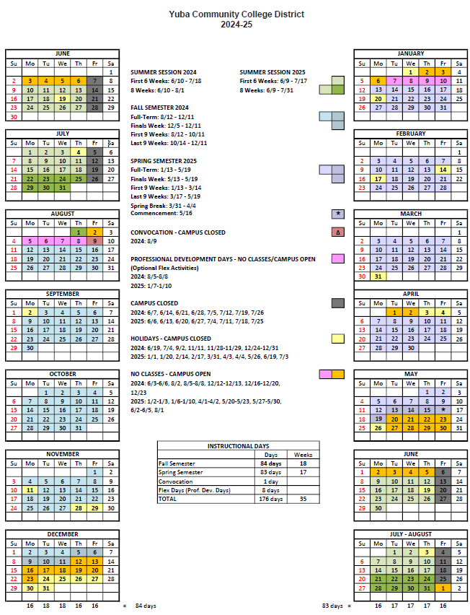
Appendix F: Map of Yuba College
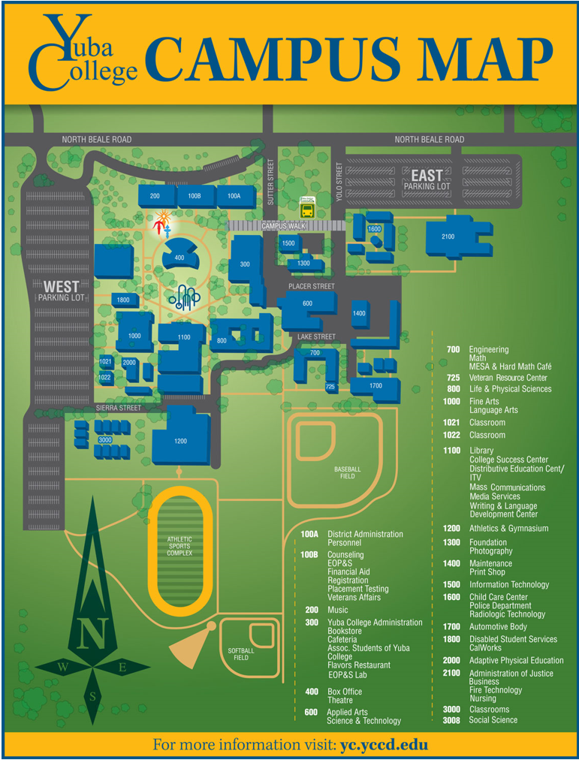

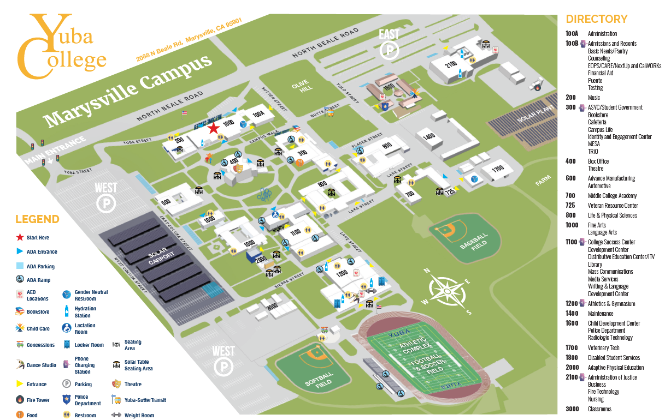

Appendix G: Pictures of Affected Areas in building 1100 (Library)

Link:
https://goyccd-my.sharepoint.com/:f:/g/personal/w0398409_yccd_edu/EtU37ctBQsFAvMC04Mhc290BRGijMFvx4yFSkDnrHhgg7g?e=ENNkQD

Appendix H: Rough materials take-off estimate. (contractors encouraged to do their own measurements and estimates)

Link to Rough materials take-off:
https://goyccd-my.sharepoint.com/:b:/g/personal/w0398409_yccd_edu/Eb8t8EWWWeZCvMKfhOp8y8oBSwU-Tmgv2OvGFgpaUQ9A6A?e=xizX6R

The End.

