Request for Proposal
Yuba Community College District

New Cell Phone Towers
Long-Term 50-Year Land Lease
(Four Possible College Campus Locations)
No. RFP 25-03

Issue Date: March 18, 2025
RFP Due: June 10, 2025

RFP Due Date: June 10, 2025, 1:00 PM Sharp, Yuba College Location Delivered To:

Yuba Community College District, District Offices
Attn.: David Willis
District Director of Facilities Planning, Maintenance & Operations
RFP No. 25-03 YCCD, New Cell Phone Towers
Address: Sutter County Campus, Second Floor, District Offices, Attention: David Willis, 3301 East Onstott Road, Yuba City, California 95991

Proposal Delivery at Second Floor
Yuba Community College District
Sutter County Campus
District Offices
3301 East Onstott Road (second floor)
Yuba City, California, 95991

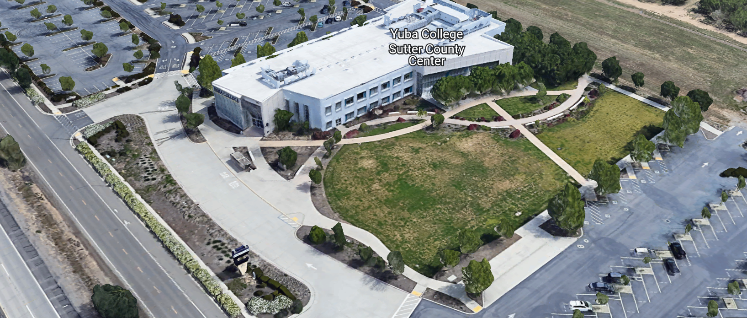
West Building Entrance
TABLE OF CONTENTS

1.0 INTRODUCTION
1.1 District Information
1.2 Yuba Community College District Background
1.3 Purpose of the Request
1.4 Applicable Codes
2.0 Scope of Work
2.1 Project Schedule
2.2 District Staff Contacts during Proposal Process
3.0 Proposal Format Organization
3.1 Proposal Delivery, Contents, and Format
4.0 Selection of “Firm”
5.0 Basis of Award
6.0 Non-Discrimination
7.0 Response to Request for Proposal (RFP)
8.0 Requests for Information (RFI)
9.0 Proposal Schedule
10.0 Evaluation of Proposals Form
11.0 District Parking
12.0 RFP Proposals
13.0 Award of Contract/Proposal
14.0 Reservation of Rights
15.0 Bid Bond Requirements
16.0 Performance Bond, Payment Bond Requirements

Proposal Required Items:

Appendix A, Proposal Bid Form (Not Applicable)
Appendix B, Statement of Qualifications
Appendix C, Acknowledgement of Addenda Form
Appendix D, Non-Collusion Affidavit Form
Appendix E, Vendor Firm DRAFT Land Lease Agreement, Payment Amortization Schedule to the District, Preliminary Tower location maps, Preliminary Projects Schedules, Preliminary list of Cell Phone Service Providers, Other Information as needed.
Appendix F, Signature Proposal Form
Appendix G, Firm References in California

Informational Items:
Appendix H: YCCD Contractor Agreement for Services (CAFS)
Appendix I: YCCD Academic Calendars
Appendix J: Maps of Various Campus Locations
Appendix K: Typical Cell Tower Aesthetic Design Appearance

1. INTRODUCTION

  - District Information:

The District consists of two colleges, Woodland Community College and Yuba College, with campuses located at five different locations: Yuba College in Marysville, CA; Sutter County Center in Yuba City, CA; Woodland Community College in Woodland, CA; Colusa County Center in Williams, CA; and Lake County Campus in Clearlake, CA.

  - Yuba Community College District

The Yuba Community College District (YCCD) was founded in 1927 and spans eight counties (Yuba, Sutter, Colusa, Yolo, Lake, Butte, Glenn and Placer) and nearly 4,200 square miles of territory in rural, north-central California.

  - Purpose Of Request

The Yuba Community College District seeks to lease space to a federally licensed communications company or a real estate company established to own, operate and develop wireless communications facilities (cell phone towers) for the installation of telecommunications equipment upon property owned by the District and located at any of the described College/District locations listed in this document. Respondents shall analyze the potential of each of the campus locations and submit a proposal.

All costs associated with the new Cell Towers must be paid by the Firm. The District will initially pay for the DSA Inspector of Record and the Structural Inspections and Testing Firm so that there are not any conflicts of interest. In addition, the District will hire and pay for the California Environmental Quality Assessments to be completed by a qualified Firm. The Cell Phone Tower Firm shall reimburse the District for all costs associated with these projects.

All Cell Phone Tower proposals must include all costs such as site investigation, surveys, electrical utilities infrastructure and locations for tie-in and new services, separate PG&E meter, fencing, roadway improvements and secure gate access, generator, power conditioning, signs, restoring the site with grading and restoration to return the site to a clean sloped draining condition with construction waste materials removed, and the cell phone tower itself, all permits and local city/county approvals, trees removal and site condition requirements, design construction documents and specifications, all construction, all monitoring tie-in such as cell phone transmitter or other means, security camera, exterior lighting, roadway access, and other site improvements required for the installation of specific cell phone towers.

Example pictures of other similar Cell Phone Towers similar to that which is included in this RFP shall be provided in this proposal. The height of the tower shall be described. The frequency and strength of the signals on the tower and if there are any possible adverse effects to Campus WIFI signals and Police/Maintenance radio signals shall be noted in this proposal.

The District would like to have artificial coniferous tree towers used that would provide an aesthetically pleasing cell tower look.

All Cell Tower Firm required or included security camera monitoring services shall be included and costs covered by the Cell Phone Tower provider.

The Lessee shall be fully responsible for obtaining all permits in accordance with all applicable federal, state, and local laws, regulations and codes; shall bear all costs of construction and maintenance of its facilities; and shall install all equipment and facilities in such manner as will minimize any impact upon the operation or use of the property by the District. Any damages to the property that occur as a consequence of the installation of equipment and facilities by the Lessee apparatus will be repaired to the satisfaction of the District by the Lessee.

For example, all District properties require that the design of the new towers be submitted to the Division of the State Architects office (DSA) for review and approval. The DSA Fees for submission will be directly paid by the District and will need to be reimbursed by the Cell Tower Firm.

All required permits and ongoing expenses with PG&E (including utilities, testing, metering, monitoring, etc..) shall be processed, coordinated, and paid for by the Cell Phone Tower provider.

The District requires that the Cell Phone Tower Firm have a dedicated electricity service with separate metering for the Cell Phone Tower Equipment through PG&E. If there are any required PG&E easements to run the new electrical service, then, these easements require District YCCD Board approval at a regularly scheduled Board meeting.

Even though the Cell Tower Design will be approved by DSA, the local County may also have ordinances and regulations that also require approval. If there are any airports in the local region near the proposed Cell Tower, then, the frequencies of the Cell Tower and the height of the tower need to be approved in advance by the Airport Authorities and FCC.

All required permits, code compliance coordination, local ordinances, and meetings with local Planning Commissions and City/County regulators and councils shall be provided and supported including all costs by the Cell Phone Tower providers as part of this proposal.

Cell phone signal strength studies shall be made as required and all costs provided by the Cell Phone Tower provider.

The District strongly supports multiple cell service vendors such as T-Mobil, AT&T, Verizon, and others to be considered for the cell tower with 4 or more cell service providers considered for the same tower on the property.

A study of all other cell phone towers in the area shall be, as required, included in this proposal process.

All FCC and other Federal and State licenses shall be provided and included with all costs and coordination shall be included in this proposal process.

All utilities costs, maintenance, testing, permitting, reporting, and other operational requirements and all costs associated with the ongoing operations of the cell phone towers shall be borne by the cell phone tower provider, and included in this proposal.

A Memorandum of Understanding and Agreement shall be developed and included as a proposal draft reference document that describes the contractual relationship that the proposer is willing to provide. Monthly compensation to the District shall be included in the agreement to lease the land for a determined number of years with a percentage increase per year. The District would like to see the percentage increase to be tied the CPI or other nationally recognized annual cost standard for increases for similar services.

A description of all proposed cell phone service providers shall be listed and described as part of this agreement. If additional providers are added to the tower later after the initial contract is processed, then additional compensation to the District is required as part of this proposal process.

The District would like 6 half-sized 24” x 30” drawings and specifications of the design construction drawings at the 50%, 95%, and 100% (DSA Approved) and at completion (As-Built) phases of the process for review and approval by the District/College teams. Electronic digital copies of the drawings and specifications are also required. Elevations of the towers must be included in the drawings. A site drawing showing the exact location and all underground utilities must be included. All designs must be stamped and signed by a licensed engineer in the State of California. Structural calculations must be included.

The design construction drawings for the New Wireless Communications/Cell Phone Towers must be approved with signed and stamped Division of the State Architect (DSA) prior to bidding the construction work. All fees must be paid by the proposer.

The District will hire a DSA, Inspector of Record (IOR) to inspect the work of the Proposer in constructing the tower and footing, underground utilities, etc. All DSA IOR services that are required remotely in other regions, States, or in other Countries to support the fabrication of the cell tower or this project shall be initially paid by the District with approval by the Cell Tower Firm and then later, reimbursed fully and totally by the Cell Tower Firm.

Sample drawings/sketches of the proposed location of the Cell Phone Towers with height of the tower shall be submitted with the proposals.

The District requests the submission of Request for Proposal (RFP) with complete and detailed information in the Standard of Qualification with support documentation, from qualified firms, partnerships, corporations, associations, or professional organizations to provide New Cell Phone Tower services to the District for, but not limited to, those types of projects described in this RFP and associated documents.

Each New Cell Phone Tower shall be submitted separately as a separate agreement, schedule, list of cell phone service providers and all other items listed and referenced in this RFP for Land Lease Agreement. Since this RFP is listing up to four new cell tower locations, each location shall have it’s own proposal, draft agreement, draft land lease agreement, payment amortization schedule, etc.…

All California OSHA requirements apply on this project. All project area work shall be temporarily fenced off with construction fencing. All construction associated equipment traffic shall be coordinated with the College to eliminate any conflicts with student and staff traffic and use of the campus. All large structural deliveries need to be coordinated closely to with the College to ensure that there are not any conflicts with instructional activities and events. The contractor shall take wildfire mitigation steps (weed abatement) to reduce the risk of fires during the spring, summer, and fall seasons. The contractor is responsible to secure and protect all of their site equipment and materials and tools. The contractor is required to have builders risk insurance. The contractor is responsible to take steps to keep all unauthorized personnel from entering the project boundaries. The contractor shall provide temporary portable restrooms, trash waste containers, and secure all items within the project boundary fencing. All cranes and boom lifts shall have all maintenance records up to date and be operated by a certified licensed operator with experience on the size of equipment being used. The Cell Tower Firm shall provide the needed ½ size hard copy DSA certified drawings and specifications for the District and the DSA IOR at least 14 days prior to the work starting. The Firm is also required to provide an electronic copy of the DSA IOR drawings and specifications. The Firm is required to prepare and submit all required DSA forms to support and close the project. The Firm shall also clean up the site after the work is completed to the satisfaction of the District. The Firm is required to attend remotely TEAMs or Zoom regularly scheduled project team meetings with the District to provide updates on the progress and coordination with the DSA IOR and Structural Inspection and Testing Firm.

A desirable outcome is to safely increase the cell service strengths of multiple cell service vendors at the four described College campus locations.

Note: The Firm shall provide, in the proposal, several cell tower location options for each College Campus location that will work for the Firm in locating a Cell Tower on the campus property with minimal impact to the College. The Colleges/District will review and determine which locations are most advantageous to the College.

The Land Lease for a new cell tower is typically a 50 feet x 50 feet fenced in area with access to an existing or a new roadway on the campus property. All costs to be born by the Cell Tower Firm.

District/College Locations:

- Yuba College Campus
2088 North Beale Road, Marysville, California 95901 (Already Has a Cell Tower)

  - Yuba College (Sutter Campus) (No Current Cell Tower)
3301 East Onstott Road, Yuba City, California 95991

- Woodland Community College (No Current Cell Tower)
2300 East Gibson Road, Woodland, California 95776

  - Woodland Community College (Lake County Campus) (No Current Cell Tower)
15880 Dam Road Extension, Clear Lake, California 95422

  - Woodland Community College (Colusa County Center) (No Current Cell Tower)
99 Elis Street, Williams, California 95987

It is possible that up to 4 new Cell Phone Tower locations would be included in this proposal process.
The District reserves the right to cancel or to amend this RFP by issuance of addenda hereto.

  - Applicable Codes
All work shall meet all State of California Building Codes, and Federal codes, and local ordinances.
All projects at the District/College are prevailing wage projects. The District will provide a Department of Industrial Relations (DIR) project number to allow all certified payroll records to be uploaded.
- Scope of Work
The District is seeking Cell Phone Tower proposals for each College/District location that are feasible. Firms are not required to propose Cell Phone Towers at all locations or any locations but encouraged to submit proposals for each location that is feasible. Each Cell Phone Tower shall be considered a separate project. The District reserves the right to select one or more or none of the Cell Phone Tower locations.

2.1 District Staff Contacts during the Proposal process:
Firms interested in submitting a Proposal are directed not to make personal contact with the Board of Trustees, District staff, or members of the evaluation committee. Any contact shall constitute grounds for disqualification from consideration.
Single Point of Contact during the Proposal Preparation Process:
David L. Willis
District Director of Maintenance, Operations, and Planning
Sutter Center, YCCD District Offices, room 217
3301 East Onstott Road
Yuba City, California, 95991
Cell Phone: 916-747-4262
Email: dwillis@yccd.edu

Please email Dave Willis to verify that your firm will be submitting a proposal in response to this procurement process.
On-site coordination, first contact person (Yuba College, Sutter Campus Location):
Bryan Epp
Assistant Director of Maintenance, Operations
2088 North Beale Road
Marysville, California, 95901
Cell Phone: 530-701-9202
Email: bepp@yccd.edu

On-site coordination, first contact person (Woodland Community College, Lake County Campus, Colusa County Center Locations):
Brian Splaine
Assistant Director of Maintenance, Operations
2300 East Gibson Road
Woodland, California, 95776
Cell Phone: 530-812-5866
Email: bsplaine@yccd.edu

3.0 Proposal Format Organization
The Firm is requested to use the following proposal format:
3.1. Proposal Delivery, Contents, and Format:
Proposals should provide straightforward, concise information that satisfies the requirements noted in this RFP. Expensive binding, color displays, and the like are discouraged. Emphasis should be placed on brevity, conformity to the Districts instructions, selection criteria of this RFP, and completeness and clarity of content. Each Respondent’s proposal should clearly and accurately demonstrate specialized knowledge and experience required for consideration.
In a sealed box or envelope (clearly marked “), submit the following:
- One (1) flash memory stick containing the complete proposal and supporting documentation;
- One (1) original signed hard copy in paper form of the proposal, which consists of a Proposal Letter and responses to the proposal requirements of this RFP.

There is no page limit.

Firms must comply with the provisions of these instructions for completion and submission of the Proposal. The failure of a Firm to comply with the Proposal Instructions and Requirements will likely result (at the sole discretion of the District) in rejection of the Proposal for non-responsiveness.
Proposal Section | Format
- Cover Letter | PDF
- Table of Contents | PDF
Appendices (See Table of Contents for each one) Submit a response to each Appendix that requires Firm information. Please submit responses to Appendices A, B, C, D, E, F, G. Appendices H, I, J are informational only. | PDF

Proposal General Information Contents:

The information requested will help the District determine if the Firm is a “Responsible Proposer”.

Cover Letter

The Proposal shall include a Cover Letter on Respondent’s official business letterhead, which shall be signed by an individual authorized to legally bind Respondent. The Cover Letter shall also identify the name, telephone number, and email of a person who may be contacted during the Proposal evaluation process.

Table of Contents

Provide a Table of Contents that outlines in sequential order the major sections and sub-sections of the Proposal. Use tabs to allow information to be more easily located.

4.0 Selection of “Firm” Services Provider

The process of “Firm” selection is based upon the complete responsiveness of the RFP and the criteria as outlined in the RFP.

The District Project Evaluation Team will read the written proposals. The District Evaluation Team will discuss the proposals and verify that the “Basis of Award” information below, the Statement of Qualifications, and information submitted in response to the RFP are complete and responsive.

Process Summary:

- Evaluation of the Statement of Qualifications, and prequalification of Firms
- Proposal Review
- Interview with Firm—if determined to be required by the District.
- Selection of most qualified, highest Land Lease payments amounts to the District proposal which includes all needed and requested services as described in this RFP.

The District reserves the right to reject any or all submittals, to amend the RFP process, and to discontinue or re-open the process at any time. The District reserves the right to request clarifications to RFP responses and to negotiate the terms of the agreement.

5.0 Basis of Award

This project will be awarded based on the following criteria:

- The Firm that first is pre-qualified by the District and then also provides a proposal with the most value that best meets the scope requirements, provides the highest payments over time, and provides a timely implementation strategy for multiple cell phone service providers, with consideration and least impact to the cell tower location on the College/District property.
  - Statement of Qualifications Evaluation, Interview, resulting in Prequalification.
  - Proposal Review, Complete and Comprehensive with draft land lease agreement, payment amortizations, list of cell phone service providers, preliminary schedule, any needed PG&E easements descriptions and mapping, experience with DSA and the State of California codes and regulations.

- Other Factors Considered in the above process:
  - Project Team, Credentials, Time Commitment
  - Ability to provide the Proper State of California License’s and registrations in good standing:
    - Architectural License
    - General Contractors License
    - Department of Industrial Relations, Registration
  - All Addendums are acknowledged.
  - Signature Form
  - There is no Bid Bond required on this project.
  - The Firm will be required to have a performance and a payment bond to be submitted to the District prior to the start of construction.
  - Firm’s exceptions or exclusions.
  - Firm’s ability to meet schedule requirements. It is expected that new cell towers proposed in this RFP will be fully constructed and operational within 36 months of the date of submission of this RFP. Exclusions or Exceptions to this preliminary schedule shall be included in this proposal, draft land lease agreement.
  - Firm has demonstrated past project references of “like” projects
    - Project Team is Professional and Respectful, Collaborative.
  - No other factors such as litigation, licenses not in good standing, bankruptcy, or other similar criteria.

The one or two of the best qualified and lowest total cost responsive proposer’s may be requested to participate in a ZOOM interview process with the District Project Proposal Evaluation Team.

6.0 Non-Discrimination

The District does not discriminate with regard to race, color, gender, national origin, disability, or any other protected or other classification in the awarding of contracts/agreements. The District welcomes all Qualified Firms to participate in the project Request for Qualification/Proposal process.
The District encourages firms that are women or minority owned, emerging small businesses, veteran owned firms, disabled person owned firms, and all other qualified firms to participate in the proposal process.
The District encourages the submission of proposals from all Firms that can meet the stated requirements set for this RFP.
7.0 Responses to RFP:
Sealed responses to this RFP must be clearly marked "RFP NO. 25-03 YCCD New Cell Phone Towers”.

Responses shall be mailed to or hand-delivered to the following address:

Yuba Community College District, District Offices
Attn.: David Willis
District Director of Facilities Planning, Maintenance & Operations

Envelope/Box Marked:
"RFP NO. RFP NO. 25-03 YCCD New Cell Phone Towers”.
.

Address: Sutter Center, District Offices, Second Floor, Room 217, Yuba City, California, 95991

Note: Completely seal your proposals in envelope/box and make sure it gets date/time stamped when delivering proposal. Firms are each 100% responsible to make sure proposals that are mailed using a carrier such as UPS, FED Ex, etc.…are received and date/time stamped by District personnel prior to the proposal due date/time. No proposals will be considered if they are late, even if it is only 5 minutes late. Please make sure your proposals are delivered and received promptly prior to the due date/time. There will be a public proposal opening at the due date/time.

Do NOT email your proposals. Emailed proposals that are not sent per the above guidance requirements will not be considered.

8.0 Requests for Information (RFI)

Requests for Information concerning the RFP must be in writing and may be submitted via email no later than the date shown below. Please direct all questions to David Willis, email: dwillis@yccd.edu.

Following the RFI deadline, all questions and answers will be summarized and posted on the District's website: https://www.yccd.edu/central-services/purchasing/ , then, click on the “Requests for Proposals / Quotes” tab on the right hand side of this web page. It is anticipated that responses to inquires received by the required time and date will be provided within 5 business days and posted on the District website or responded to per the dates listed in the RFP for addendum publishing. Should more time be needed by the District to answer I respond to RFI’s, this information will also be posted on the above website.

- Include the following in the subject matter field on emails when requesting information: “RFP 25-03”, RFI.

9.0 Proposal Schedule:

Important Dates and Times:

March 18, 2025: Release of Request for Proposal

All Pre-Bid Meetings Are Optional.

March 25, 2025: 1:00PM to 2:00PM Optional ZOOM Pre-Bid Meeting:

Join Zoom Meeting
https://yccd-edu.zoom.us/j/85748810207

Meeting ID: 857 4881 0207

Dial by your location
• +1 669 444 9171 US

April 1, 2025: 1:00PM to 2:00PM Optional ZOOM Pre-Bid Meeting:

Join Zoom Meeting
https://yccd-edu.zoom.us/j/81421477671

Meeting ID: 814 2147 7671

Dial by your location
• +1 669 444 9171 US

April 8, 2025: 1:00PM to 2:00PM Optional ZOOM Pre-Bid Meeting:

Join Zoom Meeting
https://yccd-edu.zoom.us/j/81418752584

Meeting ID: 814 1875 2584

Dial by your location
• +1 669 444 9171 US

April 9, 2025: 10:00AM to 12:00pm Noon Optional On-Campus Pre-Bid Meeting: Meet first in building 100, room 113, then, tour potential cell tower locations.

Address: Woodland Community College, 2300 East Gibson Road, Woodland, California 95776.

April 9, 2025: 1:30PM to 2:30PM Optional On Campus Pre-Bid Meeting, Meet in the lobby at the Colusa County Center.
Address: Colusa County Center: 99 Elis Street, Williams, California 95987
April 11, 2025: 10:00AM to 12:00pm Noon Optional On-Campus Pre-Bid Meeting: Meet first in building 100 lobby, then, tour potential cell tower locations.
Address: Lake County Campus, 15880 Dam Road Extension, Clear Lake, California 95422
April 16, 2025: 11:00AM to 12:00pm Noon Optional On-Campus Pre-Bid Meeting: Meet first in room 211, then, tour potential cell tower locations.
Address: Sutter County Campus, 3301 East Onstott Road, Yuba City, California 95991

June 2, 2025: 5:00 PM, All questions and requests for information must be submitted to David Willis at: dwillis@yccd.edu. Please email David Willis that your Firm is planning to submit a proposal.

June 3, 2025: 5:00 PM, Addendum Issued if needed.

June 10, 2025: Proposals due at 1:00 PM SHARP, Yuba Community College District, District Offices Location: Sutter Center, District Offices, Second Floor, Room 217, Attention: David Willis, 3301 East Onstott Road, Yuba City, Ca., 95991. There will be a public bid opening on this RFP in room 211 at the Sutter Center Building.

Note: All procurement documents associated with this procurement will be posted at this web page link: https://www.yccd.edu/district-services/requests-proposals-quotes/

If you need to visit either the Woodland Community College campus, Lake County Campus, or the Colusa County Center at another time and date, please contact Brian Splaine, Assistant Director of Maintenance and Operations at email: bsplaine@yccd.edu.

If you need to visit the Sutter County Campus at another time and date, please contact David Willis at email: dwillis@yccd.edu.

9.1 Preliminary DRAFT Overall Project Schedule:
Proposals Due Date: June 10, 2025
Colleges / District Review Process: June 10, 2025 through September 12, 2025 (could extend into late September)
Contract Negotiations Process: June 10, 2025 through September 12, 2025 (could be wrapped up much sooner)
Board Informational Agenda Item/Land Lease Agreement and any Easements, Public Hearing: October 9, 2025
Board Action Item/Land Lease Agreement and any Easements, Public Hearing: November 14, 2025
Fully Executing of the Agreement: November 21, 2025
Cell Tower (‘s) Design: December 2025 through April 2026
DSA Design Review: April 2026 through August 2026
Contractor Bidding: September 2026 through November 2026
Construction: December 2026 through March 2028.
All Cell Phone Service Vendors Equipment Operational: June 2028
Note:
It is expected that the cell tower vendor begin making payments to the District once the cell tower vendor Firm takes control of the project site and begins construction work.
The Firm is required to provide a draft preliminary project schedule with the proposal.

10.0 Evaluation of Proposals Form

Firm: .

Proposals of Qualified Firms will be evaluated by a District Facilities Management Team, based on a number of factors which are described below:

Evaluation Criteria:

- Lease Payments per Cell Service Provider on the Tower (up to 4): 40 Points

- Annual Lease Payment Increase Percentage (CPR or other Standard): 15 Points

- Preliminary Lease Agreement Terms, Duration, Preliminary Schedule: 15 Points
- Cell Tower Location on the Campus Property: 10 Points
- Division of the State Architect, DSA Experience: 10 Points
- Other Factors Listed in the RFP, including References, 10 Points
PG&E experience, aesthetics of the tower, etc..
.
.
Total Score: /100 Points

Comments:

Evaluator Name (Print): . Evaluator Signature: .
Date: . Recommendation to Interview: Yes/No: .

The Top 1 to 3 Best Qualified Firms with the Most Advantageous Proposal for the District will be interviewed. The interview will have a 50-point value with questions developed after reviewing the proposals.

The District may negotiate terms with the most qualified Firm that provides the most advantageous proposal for the District, at the full discretion of the District.

11.0 District Parking:

-No parking in Reserved Spaces without a proper permit
-Permit Parking is enforced in all general lots between 6:00 am and 6:00 pm, Monday through Friday. All general lots require a properly displayed, valid permit during these times
-Daily Parking Permits is $2.00
-Permits are available for purchase at any of the permit machines located in the student parking lots
-All other parking regulations are enforced 24 hours a day, seven days a week. This includes designated staff spaces, handicap spaces, timed spaces, red zones, yellow zones, and areas not marked (no parking at any time)
-Once this project is awarded, temporary parking permits will be processed as requested by the successful firm for all employees associated with this project at no cost to the Firm for the duration of the project at each Campus location. These temporary permits must be displayed at all times on the dashboard of employee vehicles.

12.0 RFP Proposals

Proposals received after the deadline date and time will not be opened. Each responder shall submit one (1) signed original written paper copy, in separate binders. Provide one electronic format copy of the proposal using electronic media such as a flash drive. (No CD formatted Disks).

All materials submitted in response to the RFP shall be on 8-1/2"x11" paper, preferably in
Portrait orientation. All submitted materials must be bound in either a three-ring binder or spiral bound notebook. Content shall be tabbed and numbered per the items included in the Submittal Requirements. All Proposals will be reviewed and evaluated by a District Selection Committee. The District at its sole discretion may interview finalists or select a firm or firms to perform work based solely on the evaluation of the Proposal. There is no page limit.

All Proposals become the sole property of the District and the content will be held confidential until the selection of the Firm or Firm’s is made and the project is awarded.

13.0 Award of Contract

- The Contract will be awarded to the Firm most responsive District prequalified Firm, whose proposal, conforming to the request for proposal and associated addendums, will be most advantageous to the District.

B. The District reserves the right to enter into an Agreement without further discussion of the proposal submitted based on the initial offers received.

C. The District reserves the right to reject any or all proposals or any part of the proposal and to waive informalities and minor irregularities in the proposals received.

D. The RFP, its addendums, any follow-up clarifying information, and the proposal of the selected Firm will become part of any contract initiated by the District.

E. A formal contract shall be signed by the successful proposer and Yuba Community College District to perform this service.

F. The District reserves the right to enter into discussions with any one or all of the Responders after Proposals have been initially reviewed. Such responses shall be subject to all provisions, terms and conditions as set forth in the RFP, unless otherwise modified.

G. The District intends to award to a single RFP Responder.

H. Failure to acknowledge all of the addendums, provide the items listed in the RFP, may render the proposal unresponsive at the discretion of the District. Items listed in the RFP become part of the contract unless the Firm provides an exception in the proposal. Firm exceptions, depending on the magnitude, may render the proposal unresponsive, at the discretion of the District.

I. The District reserves the right to request clarification of proposal content during the review and evaluation process.

J. The District reserves the right to negotiate the terms of the agreement to align with land lease requirements per each specific location.

K. Each Land Lease location requires a separate draft agreement with proposed location of the cell tower, type of tower, schedule, number of cell service providers, and other factors as listed in this RFP. Each Land Lease location will be acted on separately by the District Board of Trustees. The District may award one or more of the Cell Tower locations agreements. If there is a benefit to the District for awarding more than one cell phone tower, please describe this benefit in the proposals.

14.0 Reservation of Rights

The District reserves the right to:

- Reject any or all submittals at its sole discretions.
- Cancel the Request for Proposal (RFP), without cause.
- Modify any requirements contained within the RFP and request a revised submission from all Providers.
- Establish other evaluation criteria determined to be in the best interest of the District.
- Contract with any of the firms responding to the RFP based solely upon its judgment of the qualifications and capabilities of the firm.
- Clarify the content of any proposal to verify that the requirements of the RFP are included.
- Waive “minor” proposal inconsistencies that do not change the scope of work as outlined in the RFP.
- Request an alternative Superintendent on the project if the initially assigned Superintendent on the project is not performing well, not meeting project requirements, not working well with College staff and students, not applying best practice safety methods, OR not following College/District guidance regarding project approach. If the owner is the Superintendent, and has been replaced, the owner may visit the project briefly (less than 1 hour per day up to 2 times per week) to coordinate with the replacement Superintendent.
- The District will not allow or tolerate verbal abuse or any other type of abuse by the Firm toward any College or District personnel or Contracted professional service providers. Abuse, defined solely by the District as verbal or physical, or written, may lead to a “Stop Work” order by the District until it can be resolved, and steps taken to ensure abuse is not repeated. If abuse occurs again, the District may issue a final “Stop Work” order, require the Firm to leave the College/District project site and process a Performance Bond claim to complete the work. All costs associated with District “Stop Orders” are 100% the responsibility of the Firm.
- Disqualify a Firm after reviewing the proposal and finding concerning performance information in references, inadequate or incomplete proposal information, and historically poor project performance at the District/Colleges (as solely defined by the District).

This RFP does not commit the District to award or negotiate a contract. The District will not be responsible for any expenses incurred by any firm in preparing and submitting a proposal or response to this RFP or in completing any of the work specified.

This is a NO-COST RFP to the District. All District expenses listed and agreed to in this RFP will be reimbursed by the Firm. The Firm will bear all costs associated with the planning, design, fabrication and manufacturing, and construction and operation of the cell phone towers.

15.0 Bid Bond Requirements (not applicable)

16. Performance and Payment Bond Requirements: Required for this project for the contractor’s portion of the work and described in the District Agreement for Services form (Appendix E, Agreement for Services). The Performance and Payment bonds are prior to the start of any construction work at the College / District locations.
Link to the District’s Agreement for Services AFS:
https://goyccd-my.sharepoint.com/:w:/g/personal/w0398409_yccd_edu/ET7YQmwm7uhHlf8TFgXtmdcB_5ZsMtPgR_iSpJjfPljdbw?e=Yhm8lN
Refer to appendix C and D in the Agreement for Services document. The AFS will not be used as the agreement for the cell tower projects. It is only shown here for the reference for the Performance and Payment bond information. The negotiated Cell Tower Vendor standard agreement form will be used for the Cell Towers agreements.
17. Liquidated Damages: Not Applicable
18. Architect, Contractor and Subcontractors Information:
No. | Name of Firm | Architect License, Contractor License Number/Expiration Date | Department Of Industrial Relations Registration Number/Expiration Date
1
2
3
4
5
6
7
8
9
10

The District typically requires the above information with all of it’s construction projects. At the very least, all of the above information will be required before construction work starts on the District property. Prevailing wages apply to this project. All contractors that will be bidding the new cell towers will be required to be registered with DIR. The District will provide a DIR project number to be used to upload certified payroll records by the Firm.
Appendix A: Proposal Bid Form: Not Applicable.

Appendix B: Statement of Qualifications
The Firm shall furnish the following information. Failure to comply with this requirement will render the submittal informal and may cause its rejection. Additional sheets may be attached if necessary.
Basic Firm Informational Items 1 through 16:

- Firm Name:___________________________________________________________________

- Primary Address: ______________________________________________________________

- Firm’s Contact Person and Title:___________________________________________________

- Telephone: ___________ Facsimile: ____________________

- Email Address: ___________________

- License No.: ______________________________ Class: __________________________

Responsible Managing Employee/Officer:___________________________________________

- Names and titles of two officers of the Firm:

NAME TITLE

8. Specific type of Ownership (Check one)

Individual
Partnership
Corporation; If a corporation, state the following:

State of incorporation:
Date of incorporation: President/CEO:
Joint Venture
Other (Specify)

- Taxpayer Identification No.: _______________________

- List annual gross income for last three (3) years:
Year: _______________ $_____________________
Year: _______________ $_____________________
Year: _______________ $_____________________

- Number of years Firm has been in business:
If less than 5 years, please describe:

- Number of years Firm has conducted business under the present name:__________
- Has the Firm ever been licensed under a different name or different license number? . If Yes, give name(s) and license number(s) and dates or operation under that name(s) and license number(s) (attach separate sheets if necessary):___________________________________________ _________________________________________________________ _________________________________________________________
- Number of years’ experience in California Community College, University or educational projects .

- Do you now or have you ever had any direct or indirect business, financial or other connection with any official, employee or consultant of the District? ___. If Yes, please elaborate:
_________________________________________________________

- Has the Firm ever completed any work at the Yuba Community College District? If Yes, please elaborate:

Potentially Disqualifying Questions 17 through 23 Firm’s refusal to answer or omission of response to any of Questions 17 through 23 may result in disqualification of Firm.:

- Does the Firm possess a valid and currently in good standing California Architects’ and Contractors license? If Yes provide the license number(s). Yes/No______________________________________________________

- Has the Firm been defaulted or terminated (other than for convenience) by any California school district, community college district or other California public agency on any project within the past 5 years? Yes/No

If yes, identify agency and details:

- Has the Firm or any of its owners, officers, or partners, ever been convicted of a crime, or found guilty in a criminal action, involving fraud, theft, making any false claim or material representation to a public agency, or involving any federal, state, or local law, rule, or regulation related to Architectural Services or Construction or Operation of Cell Phone Service Towers? Yes/No_____

If yes, explain, identify the agency, and provide case name and number.

- Has the Firm been assessed for liquidated damages for any project in the past five years? Yes/No If so, identify owner and details:

- Has the Firm ever failed to complete a project in the past five years? Yes/No: If so, give owner and details:

- Is the Firm currently or has the Firm been in a state of “Bankruptcy” in the past five years? Yes/No:
If yes, please explain.

- Please describe the Firm’s commitment to maintaining a Cell Tower construction schedule. How will the Firm recover the schedule if it slips due to weather or subcontractors not performing, or the Firm gets busy with other projects? Please describe specific actions the Firm will take to maintain the Project schedule.

Scoring/Rating Questions:

- Please list and describe on separate sheets the Firm’s top 10 “like” Cell Tower projects references with current contact information. The project reference list should include the following criteria:
  - Project Name
  - Project Owner and Contact Information
  - Project Scope, Number of Cell Service Vendors per Tower
  - Division of the State Architect (DSA) Experience: Yes/No
  - Any issues that Firm had to overcome on the project

Scoring Criteria:
  - “Like” type Projects (40 points)
  - DSA Experience (20 points)
  - Other criteria noted above (up to 10 points)

Total points: up to 70 points

- How many years has your Firm been in business in California as a Cell Tower Firm under your present business name and license number? __________
(less than 5 years = 0 points; 5-7 years = 3 points; 8+ years = 10 points.)

- In the last 10 years, how many legal proceedings (filed in court or arbitrations) has your Firm initiated against an owner, regardless of outcome? _______
(0 = 10 points; 1 = 5 points; 2+ = 0 points.)

- In the last 10 years, how many legal proceedings (filed in court or arbitrations) has an owner initiated against your Firm, regardless of outcome? _______
(0 = 10 points; 1 = 5 points; 2+ = 0 points.)

- Has your Firm been denied an award of public works contract based on a public agency’s finding that your Firm was not a responsible Proposer within the last 10 years? ______
(No = 5 points; Yes = 0 points.)

- Please describe the Capability/Capacity of your Firm. Please provide a comprehensive list of projects that the Firm has in process and reasoning/justification regarding how the Firm has capacity to perform the required services on this project.

(Up to 20 points.)

- Please list and describe the Firms Team Members that will be working on the project, roles, percent of time commitment, and provide support information of their experience working on “like” projects and credentials. Has this team worked together before? Provide examples.

(Up to 40 points.)

Qualification Criteria:
Questions 1 through 16 are general base level information that is required for pre-qualification.
Questions 17 through 23 are possible disqualifying questions that would render the Firm “not qualified” as determined by the District.
Questions 24 through 30 are rating questions that are scored and more deeply evaluated. Not scoring the minimum threshold value will render the Firm “not qualified”.
  - There are a total of 165 points possible.
  - The District can disqualify a Firm (at it’s sole discretion) if the Firm does not meet the requirements of Questions 17 through 23.
  - Each Firm must score at least 140 points.
  - Once a Firm meets the 140 point threshold, the top 2 Firms will be interviewed if the District evaluation team determines the need. Interviews score 50 points.
  - The associated Proposal will be evaluated by the District. The best qualified Firm with the most cost effective and fully responsive proposal will be selected by the District.

The undersigned is duly authorized to execute this Statement of Qualifications under penalty of perjury on behalf of the above-identified Firm. The undersigned warrants and represents that he/she has personal knowledge of each of the responses to this Statement of Qualifications and/or that he/she has conducted all necessary and appropriate inquiries to determine the truth, completeness, and accuracy of responses to this Statement of Qualifications. The undersigned declares and certifies that the responses to this Statement of Qualifications are complete and accurate; there are no omissions of material fact or information that render any response to be false or misleading and there are no misstatements of fact in any of the responses. The above-identified Firm acknowledges and agrees that if the District determines that any response herein is false or misleading or contains misstatements of fact so as to be false or misleading, the District may find the Firm is not qualified and the District can reject the proposal for non-responsiveness or non-responsibility.

Executed this___ day of __________________ 20__ at_____________________________.
(City and State)
I declare under penalty of perjury under California law that the foregoing is true and correct.

By: ____________________________________________
(Signature of Firm’s Authorized Officer or Representative)
____________________________________________
(Typed or Printed Name)
Title: ___________________________________________

Appendix C: Acknowledgement of Addenda Form

The undersigned acknowledges receipt of the following addenda from the District pursuant to the Request for Proposal:
Acknowledgement: Yes or Not Applicable
Addendum No. 1: .
Addendum No. 2: .
Addendum No. 3: .
Addendum No. 4: .
Addendum No. 5: .

Firms are required to acknowledge all addenda’s within the submitted proposal at the time of submission.

Appendix D: Non-Collusion Affidavit Form

STATE OF CALIFORNIA, COUNTY OF I, being first duly sworn, deposes and says that I am the of , the party submitting the foregoing proposal (“the Proposal”). In connection with the foregoing Proposal, the undersigned declares, states and certifies that:
- The Proposal is not made in the interest of, or on behalf of, any undisclosed person, partnership, company, association, organization or corporation.
- The Proposal is genuine and not collusive or a sham.
- The Firm has not directly or indirectly induced or solicited another Firm to put in a false or sham proposal, and has not directly or indirectly colluded, conspired, connived, or agreed with any other Firm or anyone else to put in a sham proposal, or to refrain from bidding.
- The Firm has not in any manner, directly or indirectly, sought by agreement, communication, or conference with anyone to fix the proposal price, or that of any other Firm, or to fix any overhead, profit or cost element of the proposal price or that of any other Firm, or to secure any advantage against the public body awarding the contract of anyone interested in the proposed contract.
- All statements contained in the Proposal and related documents are true.
- The Firm has not, directly or indirectly, submitted the proposal price or any breakdown thereof, or the contents there of, or divulged information or data relative thereto, or paid, and will not pay any fee to any person, corporation, partnership, company, association, organization, proposal depository, or to any member or agent thereof to effectuate a collusive or sham proposal.
Executed on this date: , 2025/2026, at:

(City, County, and State)
I declare under penalty of perjury under the laws of the State of California that the foregoing is true and correct.
Signature Printed Name .
Address: .
Area Code & Phone Number: .
Note: In addition to other bid documents, bidders on public works projects are required by Public Contract Code section 7106 to submit a certification form that they have not colluded with another proposer.

Appendix E: Vendor Firm DRAFT Land Lease Agreement, Payment Amortization Schedule to the District, Preliminary Tower location maps, Preliminary Projects Schedules, Preliminary list of Cell Phone Service Providers (T-Mobile, AT&T, Verizon, or Others), other information as needed.

Appendix “F” Proposal Signature Form
The undersigned acknowledges the following:
- Having become familiar with the specifications and requirements of the Request for Proposal, hereby offers to provide all services in accordance with the proposal set forth herein, including all referenced material and attachments.
- By submitting a signed proposal in response to this solicitation, the Firm acknowledges that they completely understand the scope of the services needed and that the proposed services as described in the proposal will meet or exceed the needs of the District.
- Late proposals will not be accepted (even if they are only 5 minutes late).
- The District reserves the right to reject any and all proposals and that this proposal shall remain open and not be withdrawn for a minimum of 90 days.
- Cancellation Clause: The District may, without cause, terminate the contract(s) or a project under the contract(s) by giving written notice of such termination to the awarded firm. In the event of such termination the District shall reimburse the firm for services performed and reasonable expenses actually incurred by the firm in relation to the terminated project prior to the firm’s receipt of such notice of termination. The cost of proposal generation, associated travel, copies, postage, etc.., will not be reimbursed and is considered a typical and normal part of the bid process and is not reimbursed for any of the proposers.
- If the prospective Firm is a corporation, the undersigned hereby represents and warrants that the corporation is duly incorporated and is in good standing in the state of California , and that, , is authorized to act for and bind the corporation.

Entity Type (Select One):

Sole Owner: Partnership: .

Corporation: .

Other; Please specify;

- Regular monthly progress payments are made using NET 30 as a basis for payment, with Net 30 time starting after receipt of the invoice with all required support documentation, and once this information is reviewed and approved by the District.

Invoices must be emailed to the following with all support documentation:
      - Accounts Payable: accountspayable@yccd.edu
      - Rachel Harvey: rharvey@yccd.edu
It is critical that invoices have all required support documentation including an updated schedule of values with 5% retainage for construction projects, updated project schedule, description of completed work, and any other information that will help to justify and support the progress payment request.

Signature_____________________________ Date: _______________________
Position: _____________________________
Print name____________________________ Title________________________

Notary Required On This Project
Notary Stamp:

Appendix “G” References Form (Example Template)

Bidder shall provide a minimum of five (5) verifiable references with current contact information, preferably from a California public educational institution and/or California public agency, representing projects started and completed within the last 5 years. See clarification note below regarding reference requirements. This information can be provided as part of the Statement of Qualifications.
All phone numbers and emails must be current (please verify).
REFERENCE #1
NAME
ADDRESS
CITY, STATE ZIP CODE
TELEPHONE #
CONTACT
DATES OF SERVICE
REFERENCE #2
NAME
ADDRESS
CITY, STATE, ZIP CODE
TELEPHONE #
CONTACT
DATES OF SERVICE
REFERENCE #3
NAME
ADDRESS
CITY, STATE, ZIP CODE
TELEPHONE #
CONTACT
DATES OF SERVICE

You may of course use the Firm’s established reference template.

Appendix H: YCCD Contractor Agreement for Services (CAFS)
Agreement for Services (AFS):
https://goyccd-my.sharepoint.com/:w:/g/personal/w0398409_yccd_edu/EW3eZniBz3RJgE9QajoFm2cB4FL7Igq6kiPq-eY3jq-stw?e=qCQUB1
This agreement is shown only as a reference for the required performance and payment bonds on the project.

Appendix I: YCCD Academic Calendar
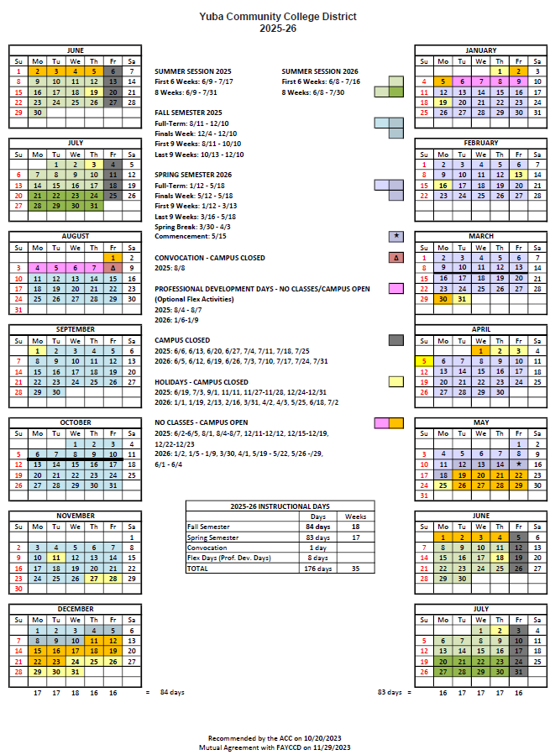

Appendix J: College Campus Maps
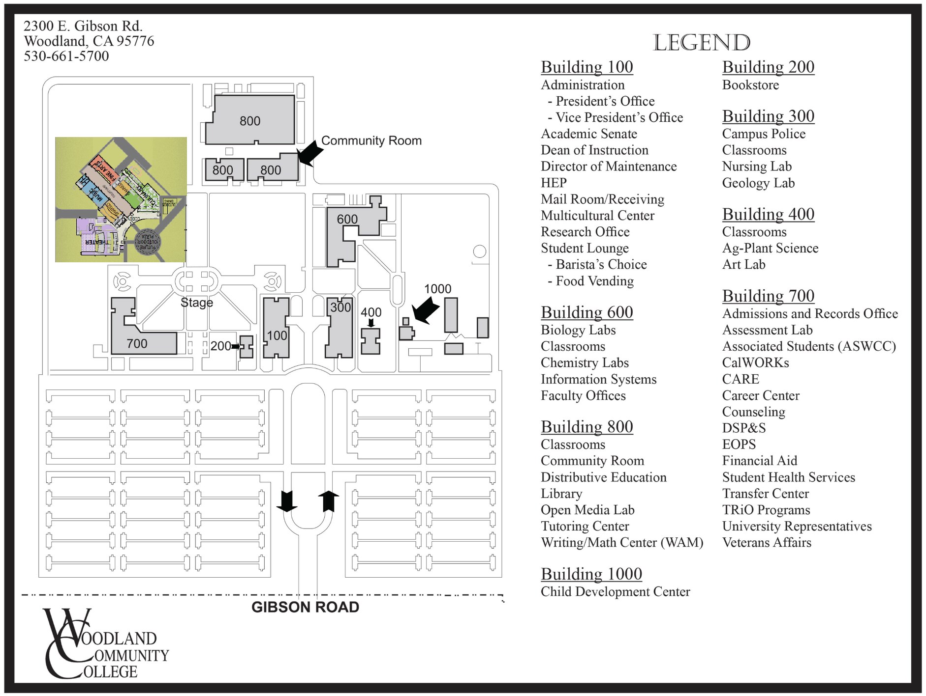

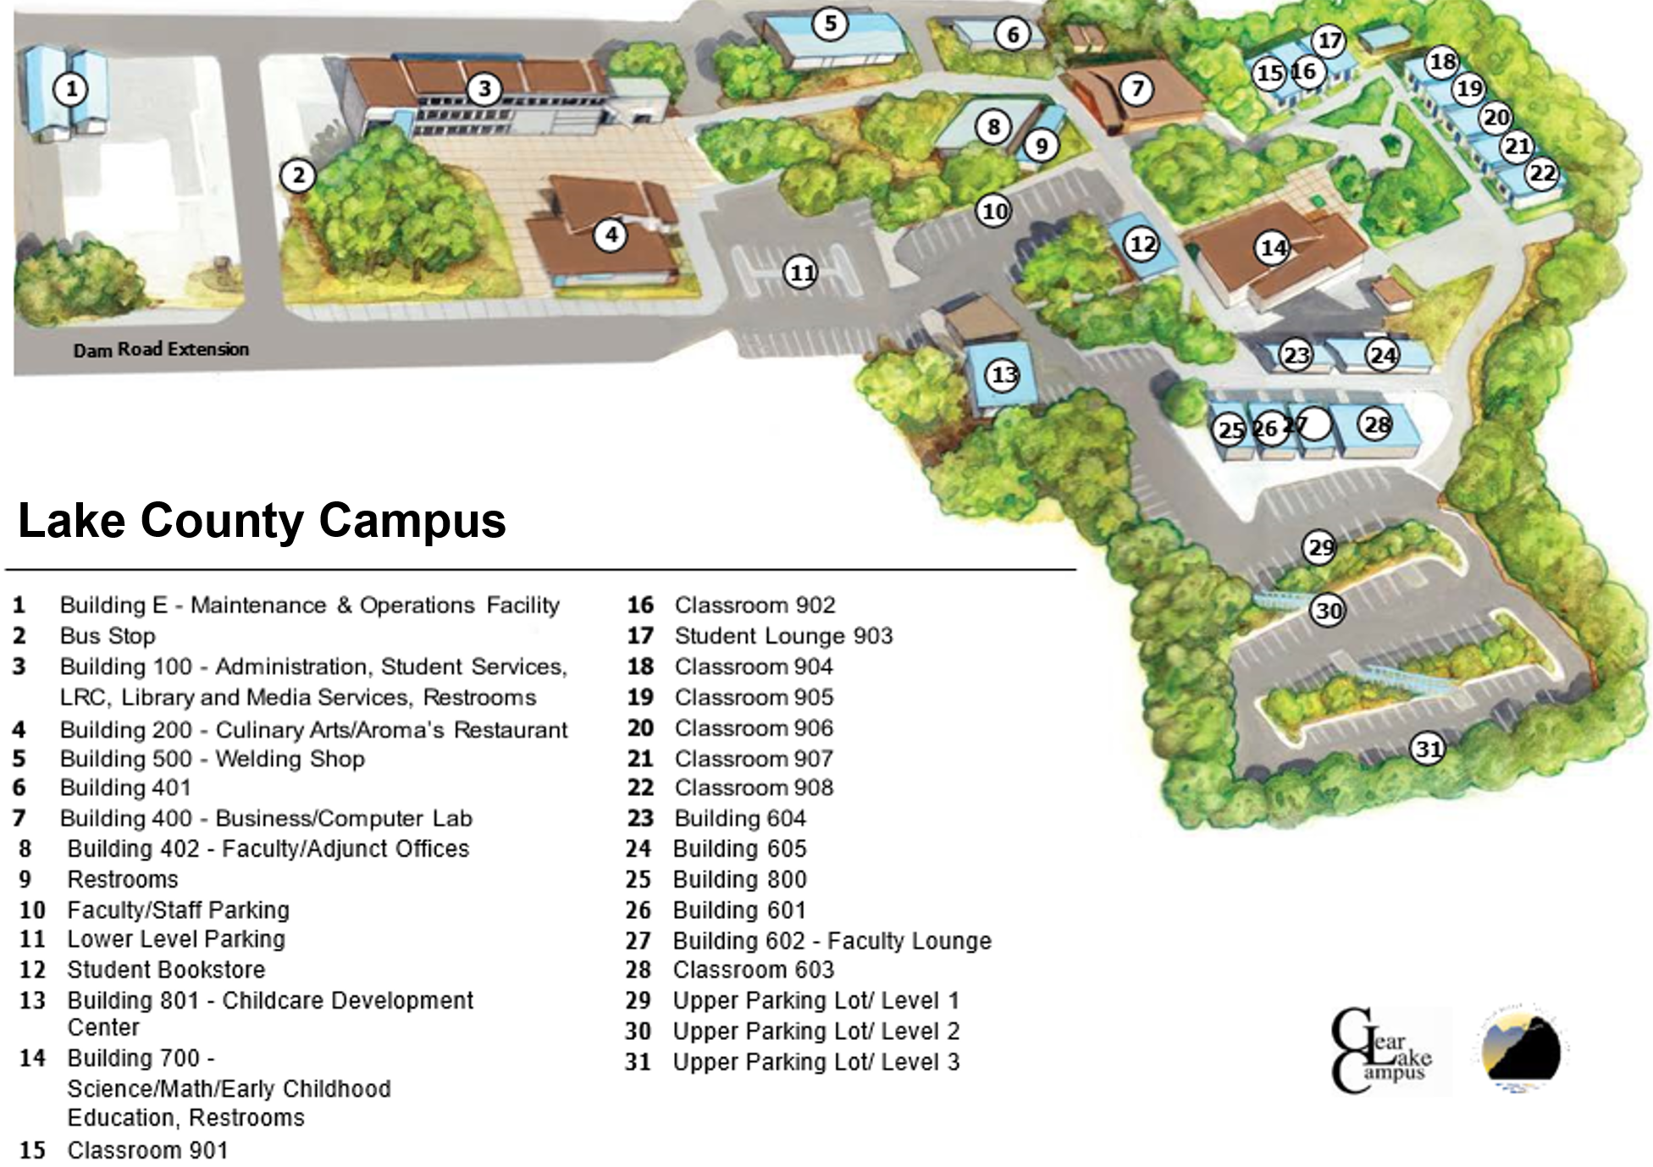

Map of the Colusa County Center: 99 Ella Rd, Williams, Ca.

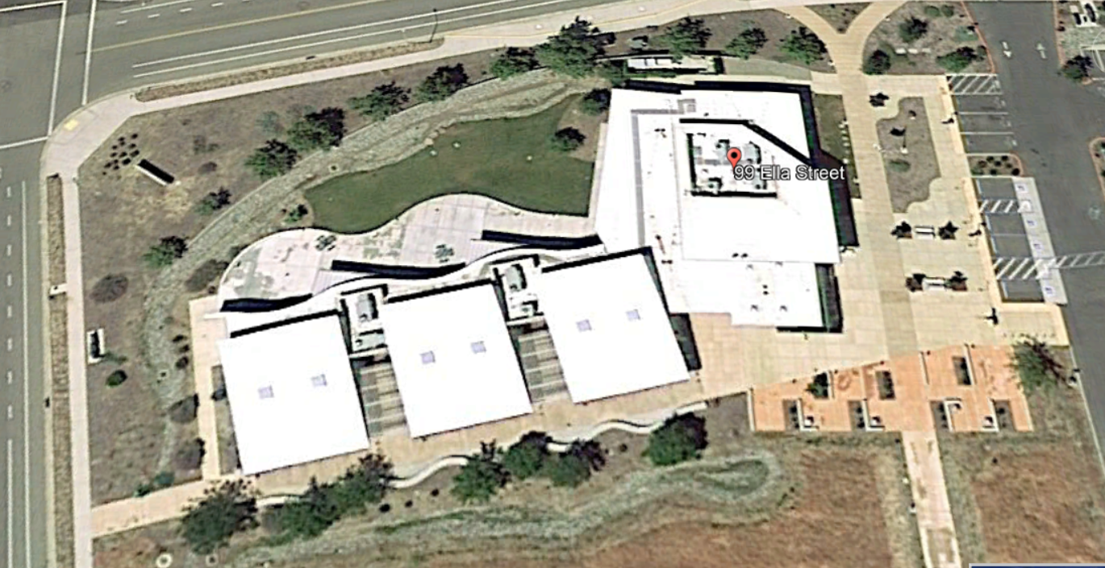

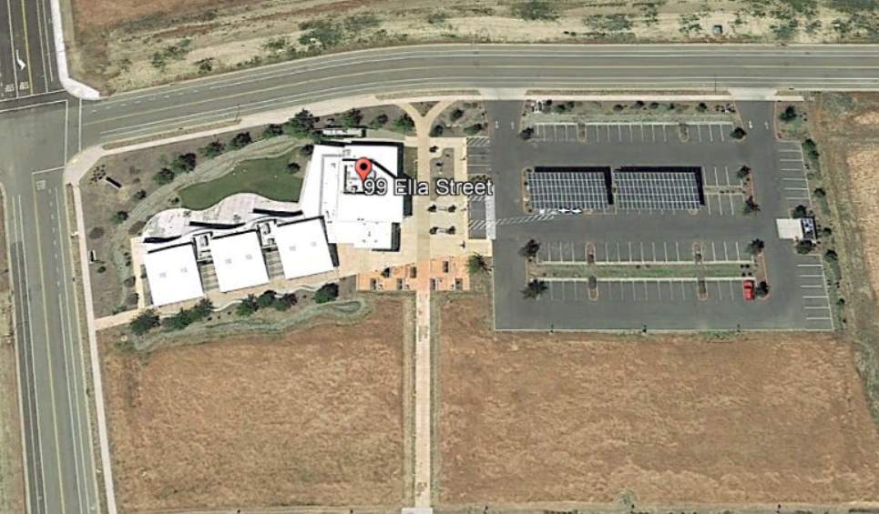

Sutter County Center Map: 3301 East Onstott Road, Yuba City, California 95993
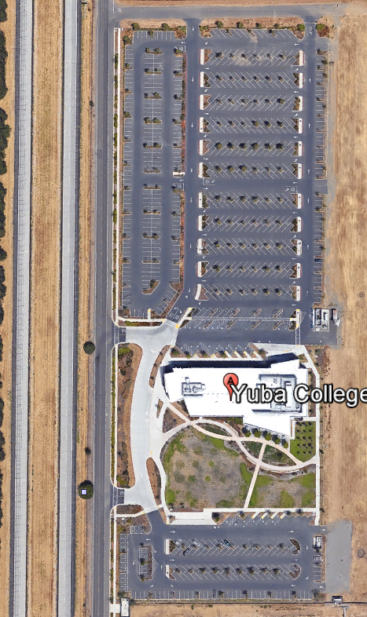
Appendix K: Typical Cell Tower Aesthetic Design Appearance:

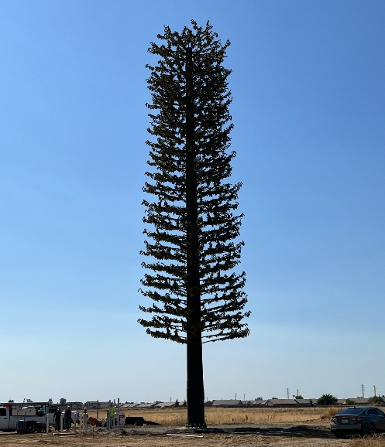
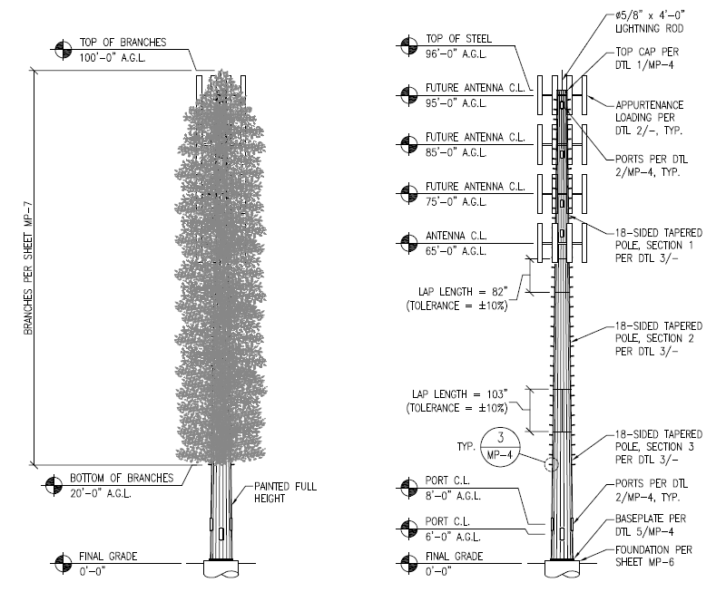

Appendix L: College Campus Land Snippets and General Information:
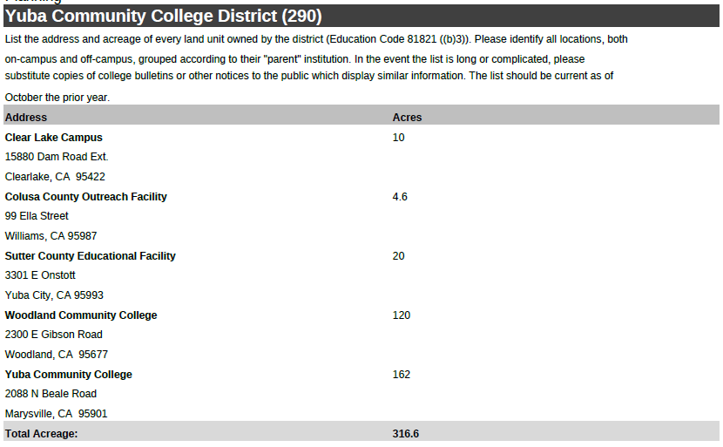
The Yuba College location at 2088 North Beale Road, Marysville, California 95901 already has a cell tower at the campus.

Woodland Community College Campus:
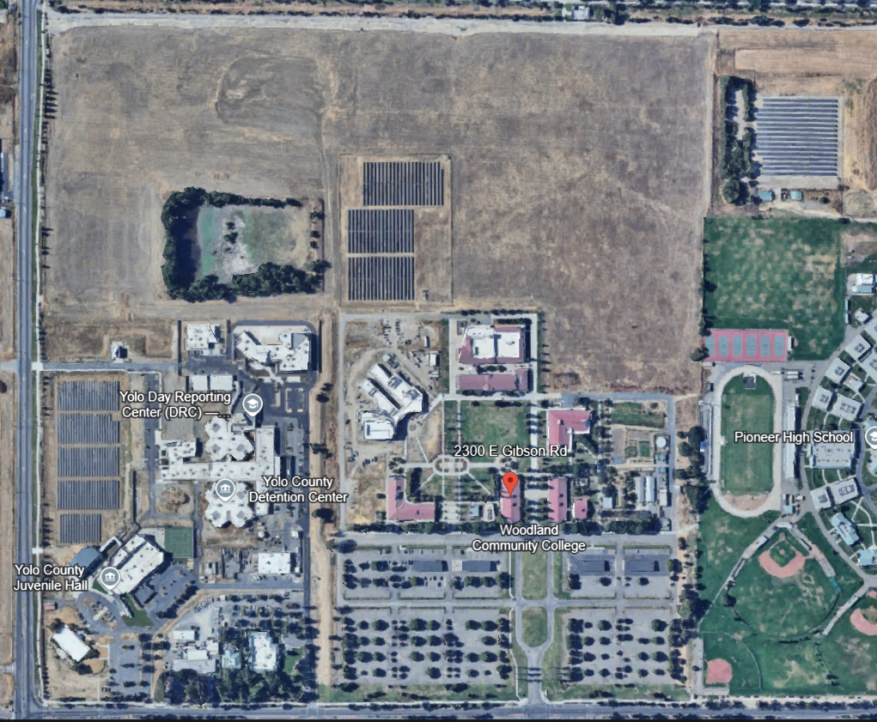

Lake County Campus:
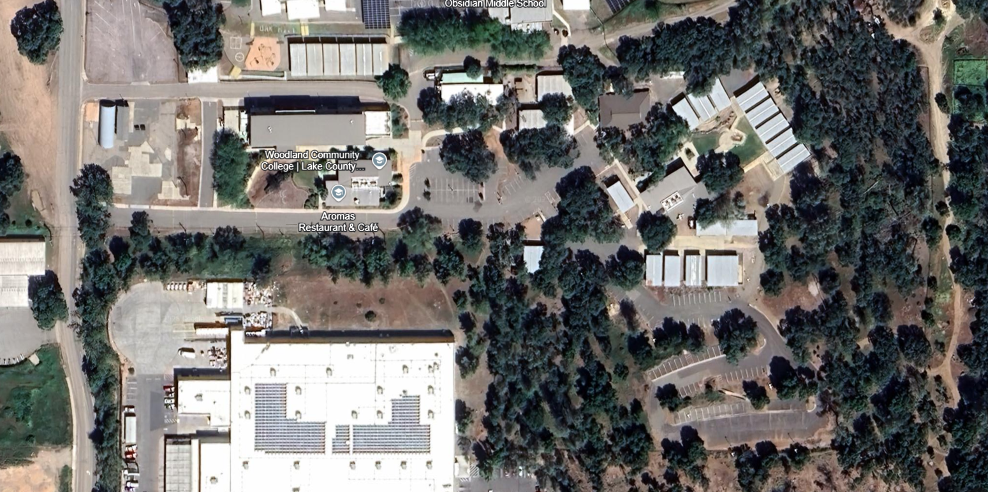

Colusa County Center:
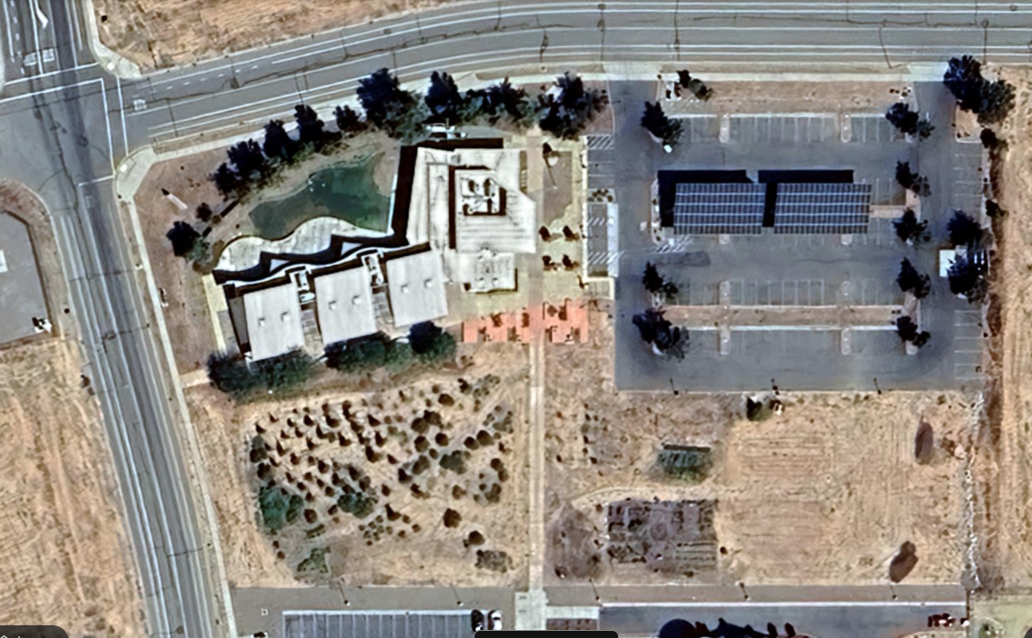
Sutter County Campus:
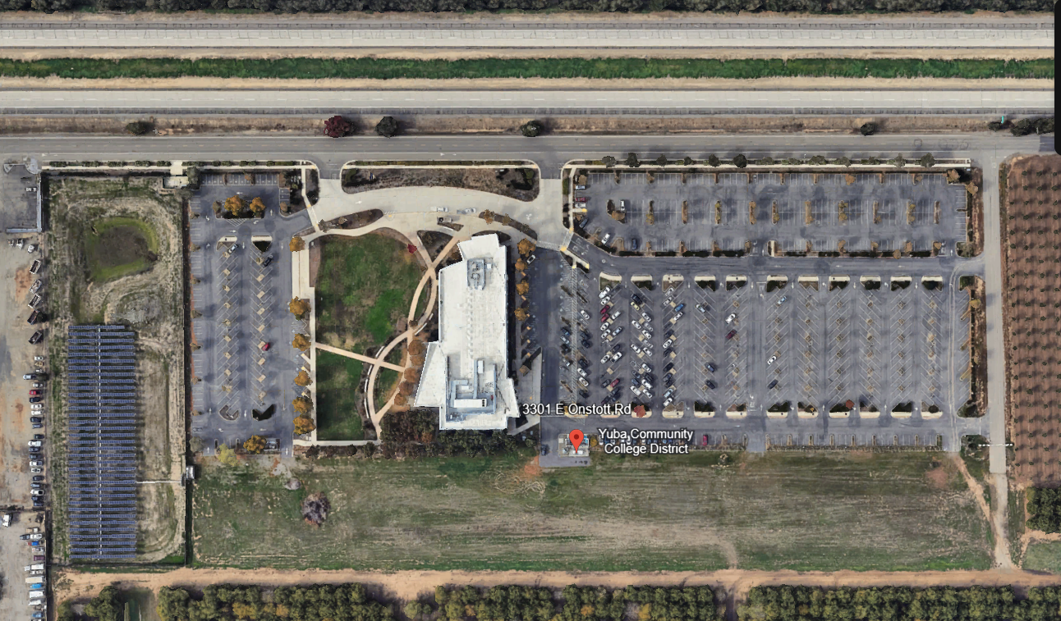

The End.

