Request for Proposal
Yuba Community College District

Woodland Community College
Design/Bid Services
Metal Storage Building
Fixed Price Proposal
No. RFP 25-02

Issue Date: March 6, 2025
RFP Due: April 15, 2025

RFP Due Date: April 15, 2025, 1:00 PM Sharp, Yuba College Location Delivered To:

Yuba Community College District, District Offices
Attn.: David Willis
District Director of Facilities Planning, Maintenance & Operations
RFP No. 25-02 WCC, Metal Storage Building
Address: Sutter County Campus, Second Floor, District Offices, Attention: David Willis, 3301 East Onstott Road, Yuba City, California 95991

Proposal Delivery at Second Floor
Yuba Community College District
Sutter County Campus
District Offices
3301 East Onstott Road (second floor)
Yuba City, California, 95991

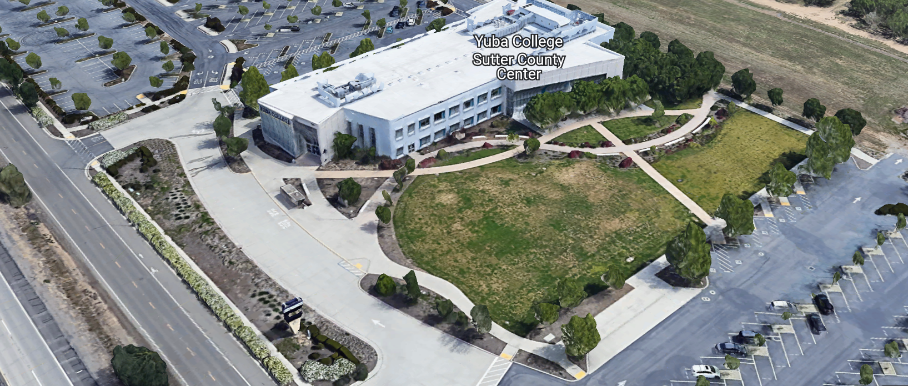
West Building Entrance
TABLE OF CONTENTS

1.0 INTRODUCTION
1.1 District Information
1.2 Yuba Community College District Background
1.3 Purpose of the Request
1.4 Applicable Codes
2.0 Scope of Work
2.1 Project Schedule
2.2 District Staff Contacts during Proposal Process
3.0 Proposal Format Organization
3.1 Proposal Delivery, Contents, and Format
4.0 Selection of “Firm”
5.0 Basis of Award
6.0 Non-Discrimination
7.0 Response to Request for Proposal (RFP)
8.0 Requests for Information (RFI)
9.0 Proposal Schedule
10.0 Evaluation of Proposals Form
11.0 District Parking
12.0 RFP Proposals
13.0 Award of Contract/Proposal
14.0 Reservation of Rights
15.0 Bid Bond Requirements
16.0 Performance Bond, Payment Bond Requirements
17.0 Liquidated Damages
18.0 Architect, Contractor, and Subcontractors Information

Proposal Required Items:

Appendix A, Proposal Bid Form
Appendix B, Statement of Qualifications
Appendix C, Acknowledgement of Addenda Form
Appendix D, Non-Collusion Affidavit Form
Appendix E, YCCD Professional Services Agreement, PSA and Contractor Agreement for Services (CAFS) (Can be provided by Successful Firm, not required on proposal due date)
Appendix F, Signature Proposal Form
Appendix G, Architectural Firm References
Appendix H, Preliminary Schedule, List of first tier Sub-Design Firms, Architectural License, General Contractor License, DIR Numbers Primary Firm and all sub-design or sub-contractors.

Informational Items:
Appendix I: YCCD Academic Calendars
Appendix J: Map of Woodland Community College Campus
Appendix K: Early Preliminary Project Information
Appendix L: Various Campus Site Plans / Utilities Information:

1. INTRODUCTION

  - District Information:

The District consists of two colleges, Woodland Community College and Yuba College, with campuses located at five different locations: Yuba College in Marysville, CA; Sutter County Center in Yuba City, CA; Woodland Community College in Woodland, CA; Colusa County Center in Williams, CA; and Lake County Campus in Clearlake, CA.

  - Yuba Community College District

The Yuba Community College District (YCCD) was founded in 1927 and spans eight counties (Yuba, Sutter, Colusa, Yolo, Lake, Butte, Glenn and Placer) and nearly 4,200 square miles of territory in rural, north-central California.

  - Purpose of Request

The Yuba Community College District seeks Design/Build Proposals and Statements of Qualification from Licensed Architectural Design/General Contractor Firms to provide design/build services, DSA submission, and contract administration through construction.
Woodland Community College Campus Address: 2300 East Gibson Road, Woodland, California 95776.

  - Applicable Codes
All work shall meet all State of California Building Codes, and Federal codes, and local ordinances.
All projects at the District/College are prevailing wage projects.
- Scope of Work
The District is accepting proposals for design/build services to work closely with the College/District to plan and design a metal storage building to store college instructional materials associated with various programs including the Performing Arts theater and maintenance operations. This metal building shall be close to the building number 900 (Performing Arts and Culinary Services) theater shop with good access to the perimeter access roadway. All required drawings and specifications, engineering calculations and Architect/Engineer stamps, and coordination with DSA are included in the scope of work. Preliminary features of the metal storage facility include the following (not in priority):

- Approximately 2,700 + square feet (larger if possible) Approximate minimum size: 45 feet x 60 feet.
- The physical size of the metal storage building should be configured to allow an efficient internal racking layout with rows and access.
- Clear Interior height: 18’-0” +/-
- Perimeter interior protection against low level wall damage (low cost railing, etc.. )
- At least 5’ wide x 8” thick gravel area around the building to keep weeds from growing right up next to the building.
- Concrete slab floor
- Asphalt paving entrance with at least a 20-foot-wide asphalt area at one end of the building. Large trucks will need access to unload at one end of the building.
- Two (2) 3’-0” x 7’-0” Hollow Metal Doors, one at each end.
- R-21 fiberglass batt in Walls, R-30 fiberglass batt at roof.
- Natural Light through either roof panels or wall panels.
- 12’-0” wide x 12’-0” steel roll-up door with electric motor opener. Bollards at roll-up door on both sides.
- LED Lighting to provide industry acceptable interior and perimeter lighting levels. Bright lighting outside the 12’ x 12’ roll-up door
- Building sealed at doors and walls to keep rodents and pests out of the building.
- The building shall be weather-tight. Wind driven rains shall not enter the building. The doors shall all have seals. All roof penetrations shall be completely sealed, flashed and counter-flashed per the pre-engineered and pre-fabricated roof manufacturer standard details.
- Fire Alarm System (Edwards EST 4 System, tied into the campus fire alarm system)
- Fire Suppression System
- Intrusion Alarm System (roll up door and personnel access doors only)
- Perimeter 6’-0” high chain link security fence with 12’-0” wide roll-open gate at roadway.
- The College has several pallets of left over wall blocks from the construction of the Theater building. If it can be cost effectively used for accents, to tie-it into the theater building along one wall, or part of one wall, great.
- Natural venting with screens to keep out pests to allow heat in the summer to leave the building.
- Power outlets in strategic locations.
- At least 80 amps extra spare breaker capacity in the electrical panel.
- No restrooms or offices inside the building.
- Interior racking will be purchased and installed later. All other interior upgrades will be constructed later.
- The exact size, shape, and location of the building will be determined during the planning and design process with the College/District. The College preliminary layouts and planning work through tBP Architecture did address some of the code fire separation requirements that will need to be considered. The College would like this building to be secure and minimize through engineering design features that will help it to be protected from vandalism and theft. The College does on occasion have community visitors from either the Sherriff’s detention center next door when clients are released, from the local homeless population, and from community demographics that can result in graffiti, broken windows, and small trash fires.
- Include a topography survey and all due diligence to thoroughly inspect the site conditions at the Campus. Consider and plan for all traffic flows and required clearances to meet code requirements.
- Quality Assurance: No damaged or discolored, or weathered, or dented, or warped components, parts, panels, warn or rubbed finished panels, dented doors, uneven or poorly finished concrete or asphalt paving, will be acceptable. All components to be new. The metal building shall meet all California code requirements. Any damaged components must be replaced at the cost of the Firm and the discretion of the District.
- The preliminary list above does NOT include a domestic water source or evaporative cooling due to budget constraints and the purpose/use of this storage building.

The District is not specifying a metal building manufacturer. If it will reduce costs, the District is willing to directly purchase the metal building through a public purchasing consortium to attain a competitively priced pre-engineered building.

The metal building will need to be presented to the Division of the State Architect’s office for review and approval. The District will pay all DSA design review fees directly.

The District will hire a DSA Inspector of Record and a Structural Inspections and Testing Service.

The District will perform California Environmental Quality Act evaluations and study through an independent geo-technical consultant complete with geotechnical borings.

Provide 6 half-size drawings sets and specifications and digital copy on a flash drive or shared folder to the College/District.

The total project budget is $1,800,000. This budget includes hard and soft costs.

Roughly estimated preliminary project budget breakdown:

Description | Amount
Soft Costs:
DSA Review Fee: | $22,320
DSA Inspector of Record | $40,000
California Environmental Quality Act Study | $40,000
Structural Inspections and Testing | $75,000
Sub-Total: | $177,320
Hard Construction Costs:
Project total Budget: | $1,800,000
Less Soft Costs: | -$177,320
Total Estimated Construction Hard Costs: | $1,622,680

The hard construction costs include the cost of all site conditions improvements.

This project’s delivery method is a design/build project. The College/District is bidding this project as a fixed cost project based on the project budget amount and will consider options to “fit” the storage building into the project budget.

The District intends to pre-qualify Firms as part of the RFP No. 25-02 procurement process. If a Firm is not qualified, then, their respective proposal will not be considered. The District’s pre-qualification process is based on the information provided in support of Appendix B of this RFP. Firms are encouraged to provide all needed information to properly and fully evaluate each question and request in this “Statement of Qualification”.

The Firm shall do all required on campus due diligence, research, surveys (including Topographical elevation surveys), measurements, photo’s, of all site conditions and utilities to provide all required planning, design, engineering, drawing and specifications development required to provide the College with the design/build college metal storage building.

The Firm shall provide an estimated project scope that can be included into the project budget with line itemized features, size, and other items as listed above. Items that cannot be fit into the project budgeted amount shall also be listed as alternatives for budgetary planning.

All Firms general conditions, profit, overhead, and contingency amounts shall be listed in the Firms overall project draft preliminary project budget that includes the estimated soft costs noted in this RFP and all costs for this project such that the Firm is providing a Fixed cost design/build proposal.

Provide manufacturer data sheets and renderings for the metal building that is included in the proposal. Note features that are likely included and any experience and history with installing the manufacturers metal buildings. If colored renderings are available in the marketing pamphlets and building specifications and data, please include them in the proposal so that we can get a better feel of the type and quality of the building that is being proposed by the Firm.

Typical MEETINGS and PROJECT ADMINISTRATION:

The Firm shall Include the following meetings in the proposal:

Due Diligence Campus Investigation:

Two (2) on campus visits with needed planning and design professionals, four (4) hours each visit.

Deliverable: All measurements, pictures of all existing conditions.

Planning Phase:

Four (4) remote meetings: 1 hour in length

Deliverable: The Firm shall provide a site plan with at least 3 location options for the new metal storage building. The College will select one of these locations.

Cost Estimate Provided by Regional Cost Estimating Firm.

Design Phase:

Four (4) remote meetings: 1 hour in length

Deliverable: The Firm shall provide a 50%, 75%, and 95% review meeting to review drawings status with the College/District team.

Updated Cost Estimate Provided at 75% Design and at 95% Design.

DSA Phase:

Do a pre-submission meeting with DSA to verify that the design meets all requirements prior to submission of the construction documents package.

District to pay DSA submission fee.

Make corrections and submit the design to DSA, support the process, back-check, etc..

Construction Phase:

Support short weekly project team meetings to review status, schedule, submittals, etc..

Project Close-out:

Complete walk-through with the College/District team and Complete the Punch List
Make any roof repairs or wall/door sealing repairs after the first major rainstorm.
Provide as-built drawings.
Submit all the required DSA forms.
Provide warranties and other information
Clean up the site and grade the surrounding area of the project boundary to be smooth and promote drainage to the storm water drain swells and drainage pathways. The project boundary shall not have ponding after the project is completed.
Submit final progress payment after the project closeout items and punch list are completed.
The one-year contractor warranty period shall not commence until after the College occupies the building or the project close out items are all completed.

Additional meetings or on campus inspection and due diligence work may be required to adequately bid and plan, design this project than what is proposed above.

2.1 Project schedule (Approximate)
RFI’s Due: Monday, April 7th, 2025, 5:00PM to David Willis: dwillis@yccd.edu
Addendum Issued (if required): Tuesday, April 8th, 2025, 5pm
Proposals Due: Tuesday, April 15, 2025, 1:00PM Sharp. Proposal delivery to YCCD District Services, Sutter County Campus, Room 219, Attention: David Willis, 3301 East Onstott Road, Yuba City, California 95991
College/District Proposals Review and Approval Period: April 15 to May 16, 2025
Board Meeting Action Item Recommendation: June 12, 2025
Approximate Award Date: July 25, 2025
Drawings and Specifications Completed, Submission to DSA Date: December 4, 2026
DSA review completed: March 13, 2026
Board Review and Approval of Working Drawings: April 9, 2026
Construction Period Begins after Mobilization: May 4, 2026
Substantial Completion: June 12, 2027
Construction 100% Completed: July 10, 2027
The District does understand that manufacturer pre-engineered and pre-fabricated buildings may have an extended led time that can push the construction period out into the wet weather periods. Please show the lead times in the preliminary project schedule attached to the proposal. The Firm can certainly beat the above preliminary scheduled dates. If however the project gets impacted from wet weather causing delays, then the College/District will not support change orders that are weather related to extend the project past the presented schedule submitted by the Firm in the proposal. The College/District will provide additional time up to the dates listed above.
If for some reason, the above dates need to be extended to meet metal building manufacturer lead time requirements, the above dates will be extended along with the dates in section 17 entitled, “liquidated damages” to dates that are mutually acceptable to both the Firm and the College/District.
Provide a project schedule with the proposal.

2.2 District Staff Contacts during the Proposal process:
Firms interested in submitting a Proposal are directed not to make personal contact with the Board of Trustees, District staff, or members of the evaluation committee. Any contact shall constitute grounds for disqualification from consideration.
Single Point of Contact during the Proposal Preparation Process:
David L. Willis
District Director of Maintenance, Operations, and Planning
Sutter Center, YCCD District Offices, room 217
3301 East Onstott Road
Yuba City, California, 95991
Cell Phone: 916-747-4262
Email: dwillis@yccd.edu

3.0 Proposal Format Organization
The Firm is requested to use the following proposal format:
3.1. Proposal Delivery, Contents, and Format:
Proposals should provide straightforward, concise information that satisfies the requirements noted in this RFP. Expensive binding, color displays, and the like are discouraged. Emphasis should be placed on brevity, conformity to the Districts instructions, selection criteria of this RFP, and completeness and clarity of content. Each Respondent’s proposal should clearly and accurately demonstrate specialized knowledge and experience required for consideration.
In a sealed box or envelope (clearly marked “), submit the following:
- One (1) flash memory stick containing the complete proposal and supporting documentation;
- One (1) original signed hard copy in paper form of the proposal, which consists of a Proposal Letter and responses to the proposal requirements of this RFP.

There is no page limit.

Firms must comply with the provisions of these instructions for completion and submission of the Proposal. The failure of a Firm to comply with the Proposal Instructions and Requirements will likely result (at the sole discretion of the District) in rejection of the Proposal for non-responsiveness.

Proposal Section | Format
- Cover Letter | PDF
- Table of Contents | PDF
Appendices (See Table of Contents for each one) Submit a response to each Appendix that requires Firm information. Please submit responses to Appendices A, B, C, D, E, F, G, and H. Appendices I, J, K, and L are informational only. | PDF

Proposal General Information Contents:

The information requested will help the District determine if the Firm is a “Responsible Proposer”.

Cover Letter

The Proposal shall include a Cover Letter on Respondent’s official business letterhead, which shall be signed by an individual authorized to legally bind Respondent. The Cover Letter shall also identify the name, telephone number, and email of a person who may be contacted during the Proposal evaluation process.

Table of Contents

Provide a Table of Contents that outlines in sequential order the major sections and sub-sections of the Proposal. Use tabs to allow information to be more easily located.

4.0 Selection of “Firm” Services Provider

The process of “Firm” selection is based upon the complete responsiveness of the RFP and the criteria as outlined in the RFP.

The District Project Evaluation Team will read the written proposals. The District Evaluation Team will discuss the proposals and verify that the “Basis of Award” information below, the Statement of Qualifications, and information submitted in response to the RFP are complete and responsive.

Process Summary:

- Evaluation of the Statement of Qualifications, and prequalification of Firms
- Proposal Review
- Interview with Firm—if determined to be required by the District.
- Selection of most qualified, cost-effective comprehensive proposal which includes all needed and requested services as described in this RFP.

The District reserves the right to reject any or all submittals, to amend the RFP process, and to discontinue or re-open the process at any time. The District reserves the right to request clarifications to RFP responses and to negotiate the terms of the agreement.

5.0 Basis of Award

This project will be awarded based on the following criteria:

- The Firm that first is pre-qualified by the District and then also provides a proposal with the most value that best meets the scope requirements, ensures quality materials and workmanship, and with a project schedule that meets the requirements of the District/College within the stated District project budget.
  - Statement of Qualifications Evaluation, Interview, resulting in Prequalification.
  - Proposal Review, Complete and Comprehensive.

- Other Factors Considered in the above process:
  - Project Team, Credentials, Time Commitment
  - Proper State of California License’s and registrations in good standing
    - Architectural License
    - General Contractors License
    - Department of Industrial Relations, Registration
  - All Addendums are acknowledged.
  - Signature Form
  - Bid Bond with proposal
  - Performance Bond, Payment Bond (able to provide within 7 days after notice of intent to award)
  - Firm’s exceptions or exclusions.
  - Firm with historical good performance on YCCD projects regarding minimal number and cost of change orders, maintaining project schedules and completing the work promptly, and overall quality of work.
  - Firm’s ability to meet schedule requirements.
  - Firm has demonstrated past project references of “like” projects
    - Percentage change orders less than 5%
    - Greater than one month beyond agreed completion date.
    - Project quality and owner satisfaction
    - Project Team is Professional and Respectful, Collaborative.
  - No other factors such as litigation, licenses not in good standing, bankruptcy, or other similar criteria.

The one or two of the best qualified and lowest total cost responsive proposer’s may be requested to participate in a ZOOM interview process with the District Project Proposal Evaluation Team.

6.0 Non-Discrimination

The District does not discriminate with regard to race, color, gender, national origin, disability, or any other protected or other classification in the awarding of contracts/agreements. The District welcomes all Qualified Firms to participate in the project Request for Qualification/Proposal process.
The District encourages firms that are women or minority owned, emerging small businesses, veteran owned firms, disabled person owned firms, and all other qualified firms to participate in the proposal process.
The District encourages the submission of proposals from all Firms that can meet the stated requirements set for this RFP.

7.0 Responses to RFP:
Sealed responses to this RFP must be clearly marked "RFP NO. 25-02 WCC College Metal Storage Building”.

Responses shall be mailed to or hand-delivered to the following address:

Yuba Community College District, District Offices
Attn.: David Willis
District Director of Facilities Planning, Maintenance & Operations

Envelope/Box Marked:
"RFP NO. 25-02 WCC College Metal Storage Building”.
.

Address: Sutter Center, District Offices, Second Floor, Room 217, Yuba City, California, 95991

Note: Completely seal your proposals in envelope/box and make sure it gets date/time stamped when delivering proposal. Firms are each 100% responsible to make sure proposals that are mailed using a carrier such as UPS, FED Ex, etc…are received and date/time stamped by District personnel prior to the proposal due date/time. No proposals will be considered if they are late, even if it is only 5 minutes late. Please make sure your proposals are delivered and received promptly prior to the due date/time. There will be a public proposal opening at the due date/time.

Do NOT email your proposals. Emailed proposals that are not sent per the above guidance requirements will not be considered.

8.0 Requests for Information (RFI)

Requests for Information concerning the RFP must be in writing and may be submitted via email no later than the date shown below. Please direct all questions to David Willis, email: dwillis@yccd.edu.

Following the RFI deadline, all questions and answers will be summarized and posted on the District's website: https://www.yccd.edu/central-services/purchasing/ , then, click on the “Requests for Proposals / Quotes” tab on the right hand side of this web page. It is anticipated that responses to inquires received by the required time and date will be provided within 5 business days and posted on the District website or responded to per the dates listed in the RFP for addendum publishing. Should more time be needed by the District to answer I respond to RFI’s, this information will also be posted on the above website.

- Include the following in the subject matter field on emails when requesting information: “RFP 25-02”, RFI.

9.0 Proposal Schedule:

Important Dates and Times:

March 6, 2025: Release of Request for Proposal

All Pre-Bid Meetings Are Optional.

March 11, 2025: 11:00am to 12:00PM (noon) Optional ZOOM Pre-Bid Meeting:

Join Zoom Meeting
https://yccd-edu.zoom.us/j/81584493976

Meeting ID: 815 8449 3976

Dial by your location
• +1 669 444 9171 US

March 18, 2025: 11:00am to 12:00PM (noon) Optional ZOOM Pre-Bid Meeting:

Join Zoom Meeting
https://yccd-edu.zoom.us/j/81348773155

Meeting ID: 813 4877 3155

Dial by your location
• +1 669 444 9171 US

March 26, 2025: 1:00pm to 2:30pm Optional On-Campus Pre-Bid Meeting: Meet first in building 100, room 113, then, tour potential college metal storage building locations.

Address: Woodland Community College, 2300 East Gibson Road, Woodland, California 95776.

April 7, 2025: 5:00 PM, All questions and requests for information must be submitted to David Willis at: dwillis@yccd.edu.

April 8th, 2025: 5:00 PM, Addendum Issued if needed.

April 15, 2025: Proposals due at 1:00 PM SHARP, Yuba Community College District, District Offices Location: Sutter Center, District Offices, Second Floor, Room 217, Attention: David Willis, 3301 East Onstott Road, Yuba City, Ca., 95991. There will be a public bid opening on this RFP in room 211 at the Sutter Center Building.

Note: All procurement documents associated with this procurement will be posted at this web page link: https://www.yccd.edu/district-services/requests-proposals-quotes/

If you need to visit Woodland Community College campus at another time and date, please contact Brian Splaine, Assistant Director of Maintenance and Operations at email: bsplaine@yccd.edu.

10.0 Evaluation of Proposals Form

Firm: .

Proposals of Qualified Firms will be evaluated by a District Facilities Management Team, based on a number of factors which are described below:

Evaluation Criteria:

- Firm/Project Team Qualifications, Roles, Experience, Project Examples,
Time Commitment, DSA Experience, References: 20 Points

- Proposal includes the largest possible metal storage building
with the most features within the stated project budget. 50 Points

- Previous successful work for the District 10 Points
- Maintaining Quality of Materials and Equipment: 20 Points
.
.
Total Score: /100 Points

Comments:

Evaluator Name (Print): . Evaluator Signature: .
Date: . Recommendation to Interview: Yes/No: .

The Top 1 to 3 Best Qualified Firms with the Most Advantageous Proposal for the District will be interviewed. The interview will have a 50-point value with questions developed after reviewing the proposals.

The District may negotiate terms with the most qualified Firm that provides the most advantageous proposal for the District, at the full discretion of the District.

11.0 District Parking:

-No parking in Reserved Spaces without a proper permit
-Permit Parking is enforced in all general lots between 6:00 am and 6:00 pm, Monday through Friday. All general lots require a properly displayed, valid permit during these times
-Daily Parking Permits is $2.00
-Permits are available for purchase at any of the permit machines located in the student parking lots
-All other parking regulations are enforced 24 hours a day, seven days a week. This includes designated staff spaces, handicap spaces, timed spaces, red zones, yellow zones, and areas not marked (no parking at any time)
-Once this project is awarded, temporary parking permits will be processed as requested by the successful firm for all employees associated with this project at no cost to the Firm for the duration of the project at each Campus location. These temporary permits must be displayed at all times on the dashboard of employee vehicles.

12.0 RFP Proposals

Proposals received after the deadline date and time will not be opened. Each responder shall submit one (1) signed original written paper copy, in separate binders. Provide one electronic format copy of the proposal using electronic media such as a flash drive. (No CD formatted Disks).

All materials submitted in response to the RFP shall be on 8-1/2"x11" paper, preferably in
Portrait orientation. All submitted materials must be bound in either a three-ring binder or spiral bound notebook. Content shall be tabbed and numbered per the items included in the Submittal Requirements. All Proposals will be reviewed and evaluated by a District Selection Committee. The District at its sole discretion may interview finalists or select a firm or firms to perform work based solely on the evaluation of the Proposal. There is no page limit.

All Proposals become the sole property of the District and the content will be held confidential until the selection of the Firm or Firm’s is made and the project is awarded.

13.0 Award of Contract

- The Contract will be awarded to the lowest total cost, most responsive responsible District prequalified Firm, whose proposal, conforming to the request for proposal and associated addendums, will be most advantageous to the District.

B. The District reserves the right to enter into an Agreement without further discussion of the proposal submitted based on the initial offers received.

C. The District reserves the right to reject any or all proposals or any part of the proposal and to waive informalities and minor irregularities in the proposals received.

D. The RFP, its addendums, any follow-up clarifying information, and the proposal of the selected Firm will become part of any contract initiated by the District.

E. A formal contract shall be signed by the successful proposer and Yuba Community College District to perform this service.

F. The District reserves the right to enter into discussions with any one or all of the Responders after Proposals have been initially reviewed. Such responses shall be subject to all provisions, terms and conditions as set forth in the RFP, unless otherwise modified.

G. The District intends to award to a single RFP Responder.

H. Failure to acknowledge all of the addendums, provide the items listed in the RFP, may render the proposal unresponsive at the discretion of the District. Items listed in the RFP become part of the contract unless the Architect provides an exception in the proposal. Architectural Firm exceptions, depending on the magnitude, may render the proposal unresponsive, at the discretion of the District.

I. The District reserves the right to request clarification of proposal content during the review and evaluation process.

J. The District reserves the right to negotiate the terms of the agreement to align with budgetary constraints.

14.0 Reservation of Rights

The District reserves the right to:

- Reject any or all submittals at its sole discretions.
- Cancel the Request for Proposal (RFP), without cause.
- Modify any requirements contained within the RFP and request a revised submission from all Providers.
- Establish other evaluation criteria determined to be in the best interest of the District.
- Contract with any of the firms responding to the RFP based solely upon its judgment of the qualifications and capabilities of the firm.
- Clarify the content of any proposal to verify that the requirements of the RFP are included.
- Waive “minor” proposal inconsistencies that do not change the scope of work as outlined in the RFP.
- Request an alternative Superintendent on the project if the initially assigned Superintendent on the project is not performing well, not meeting project requirements, not working well with College staff and students, not applying best practice safety methods, OR not following College/District guidance regarding project approach. If the owner is the Superintendent, and has been replaced, the owner may visit the project briefly (less than 1 hour per day up to 2 times per week) to coordinate with the replacement Superintendent.
- The District will not allow or tolerate verbal abuse or any other type of abuse by the Contractor toward any College or District personnel or Contracted professional service providers. Abuse, defined solely by the District as verbal or physical, or written, may lead to a “Stop Work” order by the District until it can be resolved, and steps taken to ensure abuse is not repeated. If abuse occurs again, the District may issue a final “Stop Work” order, require the Contractor to leave the College/District project site and process a Performance Bond claim to complete the work. All costs associated with District “Stop Orders” are 100% the responsibility of the Contractor.
- Disqualify a Contractor after reviewing the proposal and finding concerning performance information in references, inadequate or incomplete proposal information, and historically poor project performance at the District/Colleges (as solely defined by the District).

This RFP does not commit the District to award or negotiate a contract. The District will not be responsible for any expenses incurred by any firm in preparing and submitting a proposal or response to this RFP or in completing any of the work specified.

15.0 Bid Bond Requirements (Proposed Form—Contractor can use their standard form):

BID BOND

Know all persons by these presents:

That we, , as Principal, and , as Surety, are held and firmly bound unto Los Rios Community College District, hereinafter called District, the sum of ten percent (10%) of the total bid amount of Principal for payment of which in lawful money of the United States, well and truly to be made, we bind ourselves, our heirs, executors, administrators, successors, and assigns, jointly and severally, firmly by these presents.

The condition of the above obligation is such that, whereas, the Principal has submitted a bid for the work described as follows: RFP 25-02 WCC College Metal Storage Building.

Now, therefore, if Principal shall not withdraw said bid within the time period specified after the bid date, as defined in the bidding documents, or within ninety (90) days after the bid date if no time period is specified, and, if selected as the apparent lowest responsive responsible bidder, Principal shall, within the time period specified in the bidding documents: Enter into a written agreement, in the form prescribed in the bidding documents, in accordance with its bid; file with the District all bonds required to be filed, including but not limited to faithful performance and payments bonds; and, furnish certificates of insurance and all other items required by the bidding documents.

In the event of the withdrawal of said bid within the time period specified, or within ninety (90) days if no time period is specified, or the failure of Principal to enter into such agreement and furnish such bonds, certificates of insurance, and all other items as required by the bidding documents, if Principal shall pay to the District an amount to the difference, between the amount specified in said bid and such larger amount for which the District procures the work covered by the bid, if the latter is in excess of the former, then this obligation shall be null and void, otherwise to remain in full force and effect.

In the event suit is brought upon this bond by District, in addition to the penal sum of this Bid Bond, Surety shall pay reasonable attorneys’ fees and costs incurred by District in such suit.

Surety hereby expressly waives the provisions of California Civil Code section 2845.

In witness whereof, we have hereunto set our hands this day of , 20 .

Principal: Surety: (Name of firm)

By: By:

Title: Title:

Broker Name or Agent Name:

License Number:

Bond or company appointment must be listed with the CA Department of Insurance Notary acknowledgments for Surety and Surety’s Power of Attorney must be attached.

Address for Notices:

Bid Bond Requirements:
Provide a Bid Bond per the following:

PUBLIC CONTRACT CODE - PCC

DIVISION 2. GENERAL PROVISIONS [1100 - 22355]

ARTICLE 4. Bids and Bidders [10160 - 10169]
( Article 4 enacted by Stats. 1981, Ch. 306. )
Section: 10167.
    - All bids shall be presented under sealed cover and accompanied by one of the following forms of bidder’s security:
      - An electronic bidder’s bond by an admitted surety insurer submitted using an electronic registry service approved by the department advertising the contract.
      - A signed bidder’s bond by an admitted surety insurer received by the department advertising the contract.
      - Cash, a cashier’s check, or certified check received by, and made payable to, the director of the department advertising the contract.
    - The required bidder’s security shall be in an amount equal to at least 10 percent of the amount bid. A bid shall not be considered unless one of the forms of bidder’s security is enclosed with it.
    - All bids submitted pursuant to this section shall also comply with the provisions of Section 1601 of the Public Contract Code.
(Amended by Stats. 2012, Ch. 290, Sec. 3. Effective January 1, 2013.)

The Bid Bond shall be provided with the Contractor’s Proposal.

16. Performance and Payment Bond Requirements: Required for this project and described in the District Agreement for Services form (Appendix E, Agreement for Services). The Performance and Payment bonds are due 7 to 10 days after the award date.

17.0 Liquidated Damages:
This paragraph applies to any Order that provides for payment of liquidated damages.
The Bidder also agrees to pay, as liquidated damages, the amounts specified below for each consecutive calendar day after the expiration of the consecutive calendar days allowed for each phase.

Liquidated Damages, Substantial Completion $300 / per calendar day Work is delayed, after June 12, 2027.

Liquidated Damages, Remaining Work and Final Completion an additional amount: $200 / per calendar day Remaining Work is delayed, after June 12, 2027. The Total amount to be paid after July 10, 2027 for work not completed $300/day plus $200/day=$500/calendar day.

If Liquidated Damages are assessed, then, they will be deducted from the final release of retainage progress payment of the Firm. Retainage will be calculated at 5% of the completed value of the project.
The Firm is however encouraged to complete the work asap and by the mentioned dates in this RFP unless otherwise mutually agreed upon by the Firm and the District due to factors that are outside the control of the Firm.
Since the project schedule is already generous, there will not be any weather-related time extensions authorized by the District to extend the liquidated damages assessment dates.

18. Architect, Contractor and Subcontractors Information:
No. | Name of Firm | Architect License, Contractor License Number/Expiration Date | Department Of Industrial Relations Registration Number/Expiration Date
1
2
3
4
5
6
7
8
9
10

Appendix A: Proposal Bid Form:

No. | Description | Cost
1 | Planning:
2 | On Campus Site Conditions Investigation of Existing Conditions | $
3 | Schematic Design, including Topographical Survey, etc… | $
4 | Cost Estimates at various phases of planning and design, generated by a local qualified cost estimating Firm. | $
5 | Design, DSA:
6 | Construction Documents | $
7 | DSA Submission and support, DSA Fees paid by District directly to DSA. | $
8 | Construction, Contract Administration:
9 | General Conditions/Mobilization | $
10 | Sitework, Asphalt Paving, Concrete, Drainage, Perimeter Fencing | $
11 | Metal Building, Doors, Daylighting, Insulation, Painting and Finishing | $
12 | Electrical, Lighting | $
13 | Fire Alarm System | $
14 | Fire Suppression System | $
15 | Intrusion Alarm System | $
16 | Building Number | $
17 | Construction | $
18 | Demobilization, Site Clean Up, Project Closeout, Punch List, etc.. | $
19 | Reimbursable Expenses for drawings and specifications requested by the District. Need 6 half size DSA approved drawing and specification sets. | $
20 | Unforeseen Conditions (placeholder number) that can be utilized for change orders or other District/College approved items at the full discretion of the District. | $ 50,000
21 | Other: | $
22 | Total Costs: | $
23 | Deductive Alternative No. 1: | $
24 | Deductive Alternative No. 2: | $
25 | Deductive Alternative No. 3: | $
26 | Deductive Alternative No. 4 | $

The District realizes that it has a very tight budget on this project and will consider creative options to maximize the size of the building and the features that can be provided. The color of the building needs to tie into the existing building number 900 Performing Arts and Culinary Services building that is adjacent to this building.
This is a design-build project. This building will not have assigned instructional classes. This is a storage building for College secure storage. The College currently does not have adequate storage.
Interior racking and shelving will be added at a later date and is not included in the scope of work of this project.
Although fiberglass batt insulation is specified, the College/District will support other means to insulate the building.
The roll-up door and the personnel access doors do need to be of heavy gauge steel to reduce the risk of vandalism and damage during use.
It is important to have bright lighting inside and outside around the perimeter of the building. Exterior lights should have two levels and be activated by motion to raise to a higher level. All the lighting be LED lighting.
Provide schedule of values.
Prevailing wages apply to this project.

List all First Tier Sub-Design Firms and Sub-Contractors.

Please round off numbers to the nearest dollar.

A preliminary overall start-to-finish project schedule is required with the proposal.

Provide alternatives that should be considered to enhance value, maximize the size of the building, and meet the majority of the listed scope items desired by the College/District.

Please see page 6 for project specific requirements and project budget constraints.

Appendix B: Statement of Qualifications
The Firm shall furnish the following information. Failure to comply with this requirement will render the submittal informal and may cause its rejection. Additional sheets may be attached if necessary.
Basic Firm Informational Items 1 through 16:

- Firm Name:___________________________________________________________________

- Primary Address: ______________________________________________________________

- Firm’s Contact Person and Title:___________________________________________________

- Telephone: ___________ Facsimile: ____________________

- Email Address: ___________________

- License No.: ______________________________ Class: __________________________

Responsible Managing Employee/Officer:___________________________________________

- Names and titles of two officers of the Firm:

NAME TITLE

8. Specific type of Ownership (Check one)

Individual
Partnership
Corporation; If a corporation, state the following:

State of incorporation:
Date of incorporation: President/CEO:
Joint Venture
Other (Specify)

- Taxpayer Identification No.: _______________________

- List annual gross income for last three (3) years:
Year: _______________ $_____________________
Year: _______________ $_____________________
Year: _______________ $_____________________

- Number of years Firm has been in business:
If less than 5 years, please describe:

- Number of years Firm has conducted business under the present name:__________
- Has the Firm ever been licensed under a different name or different license number? . If Yes, give name(s) and license number(s) and dates or operation under that name(s) and license number(s) (attach separate sheets if necessary):___________________________________________ _________________________________________________________ _________________________________________________________
- Number of years’ experience in California Community College, University or educational facility projects .

- Do you now or have you ever had any direct or indirect business, financial or other connection with any official, employee or consultant of the District? ___. If Yes, please elaborate:
_________________________________________________________

- Has the Firm ever completed any work at the Yuba Community College District? If Yes, please elaborate:

Potentially Disqualifying Questions 17 through 23 Firm’s refusal to answer or omission of response to any of Questions 17 through 23 may result in disqualification of Firm.:

- Does the Firm possess a valid and currently in good standing California Architects’ and Contractors license? If Yes provide the license number(s). Yes/No______________________________________________________

- Has the Firm been defaulted or terminated (other than for convenience) by any California school district, community college district or other California public agency on any project within the past 5 years? Yes/No

If yes, identify agency and details:

- Has the Firm or any of its owners, officers, or partners, ever been convicted of a crime, or found guilty in a criminal action, involving fraud, theft, making any false claim or material representation to a public agency, or involving any federal, state, or local law, rule, or regulation related to Architectural Services or Construction? Yes/No_____

If yes, explain, identify the agency, and provide case name and number.

- Has the Firm been assessed liquidated damages for any project in the past five years? Yes/No If so, identify owner and details:

- Has the Firm ever failed to complete a project in the past five years? Yes/No: If so, give owner and details:

- Is the Firm currently or has the Firm been in a state of “Bankruptcy” in the past five years? Yes/No:
If yes, please explain.

- Please describe the Firm’s commitment to maintaining a construction schedule. How will the Firm recover the schedule if it slips due to weather or subcontractors not performing, or the Firm gets busy with other projects? Please describe specific actions the Firm will take to maintain the Project schedule.

Scoring/Rating Questions:

- Please list and describe on separate sheets the Firm’s top 10 “like” Design-Build projects references with current contact information. The project reference list should include the following criteria:
  - Project Name
  - Project Owner and Contact Information
  - Project Scope
  - Division of the State Architect (DSA) Experience: Yes/No
  - Original Contract Completion Date
  - Actual Project Completion Date
  - Original Construction Contract Price
  - Final Adjusted Construction Contract Price
  - Any issues that Firm had to overcome on the project

Scoring Criteria:
  - “Like” type Projects (30 points)
  - DSA Experience (20 points)
  - Project Change Orders less than 5% (up to 10 points)
  - Other criteria noted above (up to 10 points)

Total points: up to 70 points

- How many years has your Firm been in business in California as an Design-Build Firm under your present business name and license number? __________
(less than 5 years = 0 points; 5-7 years = 3 points; 8+ years = 10 points.)

- In the last 10 years, how many legal proceedings (filed in court or arbitrations) has your Firm initiated against an owner, regardless of outcome? _______
(0 = 10 points; 1 = 5 points; 2+ = 0 points.)

- In the last 10 years, how many legal proceedings (filed in court or arbitrations) has an owner initiated against your Firm, regardless of outcome? _______
(0 = 10 points; 1 = 5 points; 2+ = 0 points.)

- Has your Firm been denied an award of public works contract based on a public agency’s finding that your Firm was not a responsible Proposer within the last 10 years? ______
(No = 5 points; Yes = 0 points.)

- Please describe the Capability/Capacity of your Firm. Please provide a comprehensive list of projects that the Firm has in process and reasoning/justification regarding how the Firm has capacity to perform the required services on this project.

(Up to 20 points.)

- Please list and describe the Firms Team Members that will be working on the project, roles, percent of time commitment, and provide support information of their experience working on “like” projects and credentials. Has this team worked together before? Provide examples.

(Up to 40 points.)

Qualification Criteria:
Questions 1 through 16 are general base level information that is required for pre-qualification.
Questions 17 through 23 are possible disqualifying questions that would render the Firm “not qualified” as determined by the District.
Questions 24 through 30 are rating questions that are scored and more deeply evaluated. Not scoring the minimum threshold value will render the Firm “not qualified”.
  - There are a total of 165 points possible.
  - The District can disqualify a Firm (at it’s sole discretion) if the Firm does not meet the requirements of Questions 17 through 23.
  - Each Firm must score at least 140 points.
  - Once a Firm meets the 140 point threshold, the top 2 Firms will be interviewed if the District evaluation team determines the need. Interviews score 50 points.
  - The associated Proposal will be evaluated by the District. The best qualified Firm with the most cost effective and fully responsive proposal will be selected by the District.

The undersigned is duly authorized to execute this Statement of Qualifications under penalty of perjury on behalf of the above-identified Firm. The undersigned warrants and represents that he/she has personal knowledge of each of the responses to this Statement of Qualifications and/or that he/she has conducted all necessary and appropriate inquiries to determine the truth, completeness, and accuracy of responses to this Statement of Qualifications. The undersigned declares and certifies that the responses to this Statement of Qualifications are complete and accurate; there are no omissions of material fact or information that render any response to be false or misleading and there are no misstatements of fact in any of the responses. The above-identified Firm acknowledges and agrees that if the District determines that any response herein is false or misleading or contains misstatements of fact so as to be false or misleading, the District may find the Firm is not qualified and the District can reject the proposal for non-responsiveness or non-responsibility.

Executed this___ day of __________________ 20__ at_____________________________.
(City and State)
I declare under penalty of perjury under California law that the foregoing is true and correct.

By: ____________________________________________
(Signature of Firm’s Authorized Officer or Representative)
____________________________________________
(Typed or Printed Name)
Title: ___________________________________________

Appendix C: Acknowledgement of Addenda Form

The undersigned acknowledges receipt of the following addenda from the District pursuant to the Request for Proposal:
Acknowledgement: Yes or Not Applicable
Addendum No. 1: .
Addendum No. 2: .
Addendum No. 3: .
Addendum No. 4: .
Addendum No. 5: .

Firms are required to acknowledge all addenda’s within the submitted proposal at the time of submission.

Appendix D: Non-Collusion Affidavit Form

STATE OF CALIFORNIA, COUNTY OF I, being first duly sworn, deposes and says that I am the of , the party submitting the foregoing proposal (“the Proposal”). In connection with the foregoing Proposal, the undersigned declares, states and certifies that:
- The Proposal is not made in the interest of, or on behalf of, any undisclosed person, partnership, company, association, organization or corporation.
- The Proposal is genuine and not collusive or a sham.
- The Firm has not directly or indirectly induced or solicited another Firm to put in a false or sham proposal, and has not directly or indirectly colluded, conspired, connived, or agreed with any other Firm or anyone else to put in a sham proposal, or to refrain from bidding.
- The Firm has not in any manner, directly or indirectly, sought by agreement, communication, or conference with anyone to fix the proposal price, or that of any other Firm, or to fix any overhead, profit or cost element of the proposal price or that of any other Firm, or to secure any advantage against the public body awarding the contract of anyone interested in the proposed contract.
- All statements contained in the Proposal and related documents are true.
- The Firm has not, directly or indirectly, submitted the proposal price or any breakdown thereof, or the contents there of, or divulged information or data relative thereto, or paid, and will not pay any fee to any person, corporation, partnership, company, association, organization, proposal depository, or to any member or agent thereof to effectuate a collusive or sham proposal.
Executed on this date: , 2025/2026, at:

(City, County, and State)
I declare under penalty of perjury under the laws of the State of California that the foregoing is true and correct.
Signature Printed Name .
Address: .
Area Code & Phone Number: .
Note: In addition to other bid documents, bidders on public works projects are required by Public Contract Code section 7106 to submit a certification form that they have not colluded with another proposer.

Appendix E: YCCD Professional Services Agreement (PSA) and Contractor Agreement for Services (CAFS)
Link:
Professional Services Agreement:
https://goyccd-my.sharepoint.com/:w:/g/personal/w0398409_yccd_edu/EdaqryNo7x5HkZRWbt3_jskBg1yUcoqOECtKh2UlYxiRmA?e=0wjYcb
Agreement for Services (AFS):
https://goyccd-my.sharepoint.com/:w:/g/personal/w0398409_yccd_edu/EW3eZniBz3RJgE9QajoFm2cB4FL7Igq6kiPq-eY3jq-stw?e=qCQUB1

These two agreements apply to this project. The District does not currently have a single agreement that applies just to design-build delivery method projects. These agreements are optional at the time of the proposal submission.
The successful Firm will be required to provide this agreement within 7 days after requested by the District.

Appendix “F” Proposal Signature Form
The undersigned acknowledges the following:
- Having become familiar with the specifications and requirements of the Request for Proposal, hereby offers to provide all services in accordance with the proposal set forth herein, including all referenced material and attachments.
- By submitting a signed proposal in response to this solicitation, the Firm acknowledges that they completely understand the scope of the services needed and that the proposed services as described in the proposal will meet or exceed the needs of the District.
- Late proposals will not be accepted (even if they are only 5 minutes late).
- The District reserves the right to reject any and all proposals and that this proposal shall remain open and not be withdrawn for a minimum of 90 days.
- Cancellation Clause: The District may, without cause, terminate the contract(s) or a project under the contract(s) by giving written notice of such termination to the awarded firm. In the event of such termination the District shall reimburse the firm for services performed and reasonable expenses actually incurred by the firm in relation to the terminated project prior to the firm’s receipt of such notice of termination. The cost of proposal generation, associated travel, copies, postage, etc.., will not be reimbursed and is considered a typical and normal part of the bid process and is not reimbursed for any of the proposers.
- If the prospective Firm is a corporation, the undersigned hereby represents and warrants that the corporation is duly incorporated and is in good standing in the state of California , and that, , is authorized to act for and bind the corporation.

Entity Type (Select One):

Sole Owner: Partnership: .

Corporation: .

Other; Please specify;

- Regular monthly progress payments are made using NET 30 as a basis for payment, with Net 30 time starting after receipt of the invoice with all required support documentation, and once this information is reviewed and approved by the District.

Invoices must be emailed to the following with all support documentation:
      - Accounts Payable: accountspayable@yccd.edu
      - Rachel Harvey: rharvey@yccd.edu
It is critical that invoices have all required support documentation including an updated schedule of values with 5% retainage for construction projects, updated project schedule, description of completed work, and any other information that will help to justify and support the progress payment request.

Signature_____________________________ Date: _______________________
Position: _____________________________
Print name____________________________ Title________________________

Notary Required On This Project
Notary Stamp:

Appendix “G” References Form (Example Template)

Bidder shall provide a minimum of Ten (10) verifiable references with current contact information, preferably from a California public educational institution and/or California public agency, representing projects started and completed within the last 5 years. See clarification note below regarding reference requirements. This information can be provided as part of the Statement of Qualifications.
All phone numbers and emails must be current (please verify).
REFERENCE #1
NAME
ADDRESS
CITY, STATE ZIP CODE
TELEPHONE #
CONTACT
DATES OF SERVICE
REFERENCE #2
NAME
ADDRESS
CITY, STATE, ZIP CODE
TELEPHONE #
CONTACT
DATES OF SERVICE
REFERENCE #3
NAME
ADDRESS
CITY, STATE, ZIP CODE
TELEPHONE #
CONTACT
DATES OF SERVICE

You may of course use the Firm’s established reference template.

Appendix H: Preliminary Schedule, Architectural License, General Contractor License, other credentials

Appendix I: YCCD Academic Calendar
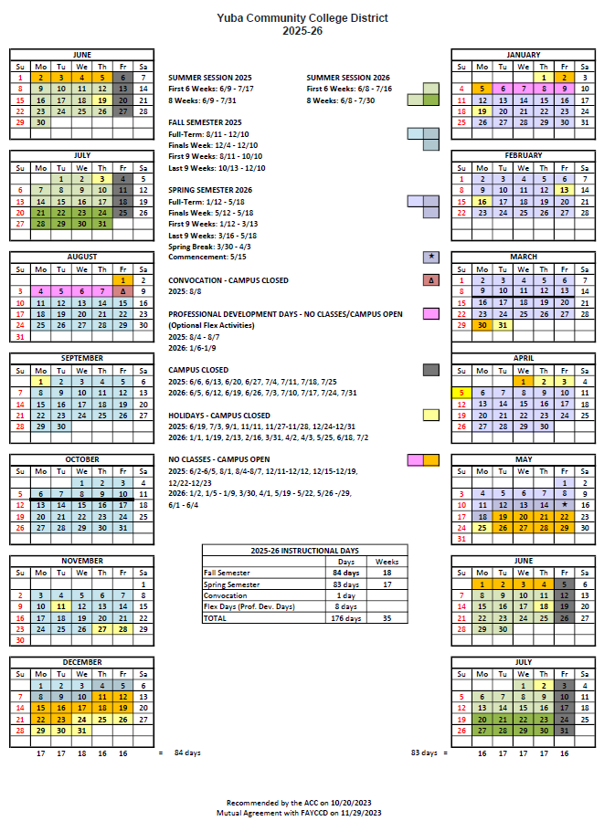

Appendix J: Map of Woodland Community College Campus
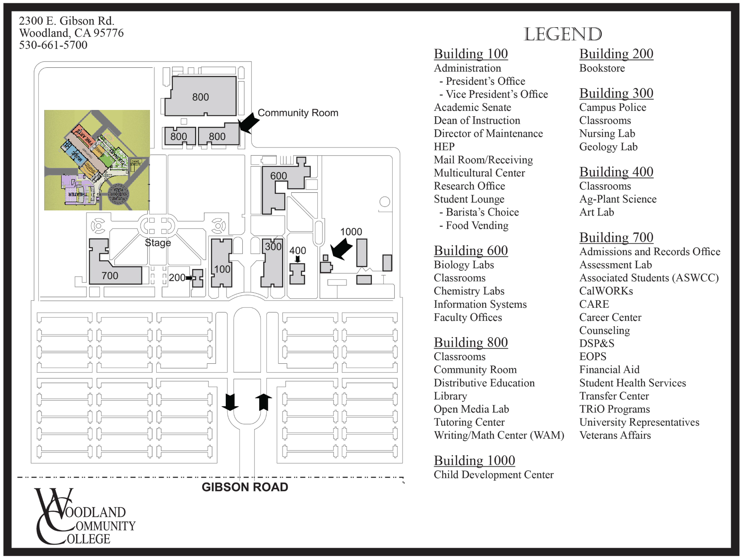

Appendix K: Preliminary College Metal Building Project Information Link:

https://goyccd-my.sharepoint.com/:f:/g/personal/w0398409_yccd_edu/EkvcqQ9COU5Ir2NqXD2g708BFyGzjZzMr_LISvtaR2H_Iw?e=FN9zBc
Note: The information shared in this folder is a starting point. Due to budgetary considerations the size of the storage building will be smaller than originally planned.

Appendix L: Various Campus Site Plans / Utilities Information Links:

Campus Site Plans and Utilities Link:

https://goyccd-my.sharepoint.com/:f:/g/personal/w0398409_yccd_edu/EjIMKlFdL0FBt4ef7rnDmlABdwyKvyaFpJ10qrIctSWrBA?e=yncYQq
Building 900 Performing Arts and Culinary Services Building Link:
https://goyccd-my.sharepoint.com/:f:/g/personal/w0398409_yccd_edu/EsL3nhgk6w5LvHIMFEuQsD8B32q5SXZKBCEl9cPw8zZ_uw?e=zjgn1G

The End.

