Addendum No. 1

RFP 24-04
Date: 02/11/2025

Date: January 26, 2016

Proposal Important Dates and Times Clarifications:

The District will be holding a second alternative “Optional” Pre-Bid Meeting on Tuesday, February 18th from 2:30pm to 3:30pm. Location: Building 1400 (maintenance building) conference room.
This alternative “Optional” Pre-Bid Meeting will be in lieu of the previously scheduled “Optional” Pre-Bid Meeting that is scheduled to be held on Monday, February 17th (George Washington’s Birthday) per the following:

First Optional Pre-Bid Meeting On Campus:
February 17, 2025: 1:00PM to 2:30:PM (Noon) Optional On-Campus Pre-Bid Meeting in Building 1400, Maintenance Conference Room, then tour campus. Yuba College, 2088 North Beale Road, Marysville, Ca., 95901.

The District is officially closed on February 17th but Dave Willis will meet those that arrive at Yuba College for this meeting since it was previously scheduled and advertised. A login sheet will be presented at each meeting.

Second Optional Pre-Bid Meeting On Campus:
February 18, 2025: 2:30PM to 3:30:PM (Noon) Optional On-Campus Pre-Bid Meeting in Building 1400, Maintenance Conference Room, then tour campus. Yuba College, 2088 North Beale Road, Marysville, Ca., 95901.

Updated RFI Schedule:

February 18, 2025: 5:00 PM, All questions and requests for information must be submitted to David Willis at: dwillis@yccd.edu.

February 19, 2025: 5:00 PM, Addendum Issued if needed.

The Proposals Due Date and Time Remains Unchanged:

February 25, 2025: Proposals due at 1:00 PM SHARP, Yuba Community College District, District Offices Location: Sutter Center, District Offices, Second Floor, Room 217, Attention: David Willis, 3301 East Onstott Road, Yuba City, Ca., 95991. There will be a public bid opening on this RFP in room 211 at the Sutter Center Building.

Map of Yuba College Campus
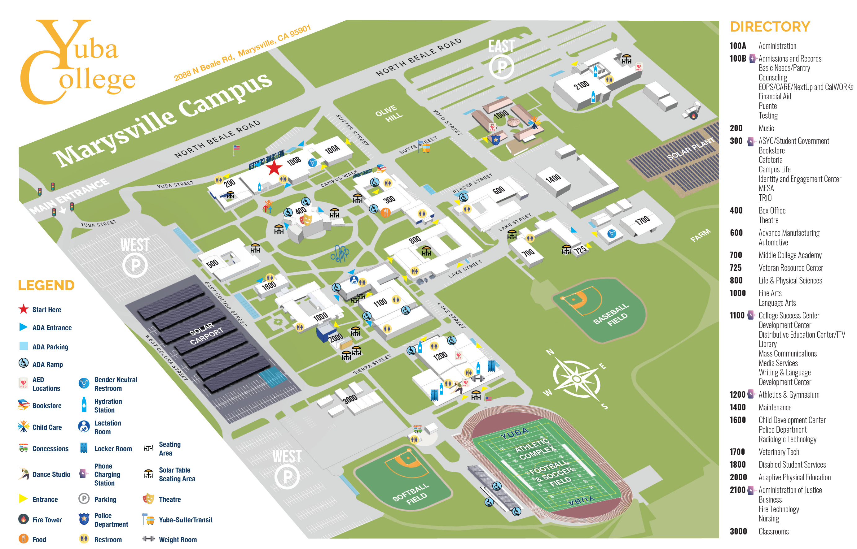

The End.

