33

Request for Proposal / Request for Qualification Yuba Community College District

Yuba College, Buildings 200 and 1000 Partial Renovation Project
For
Construction Management/Quality Assurance Services
RFP No. 23-10

Issue Date: April 16, 2024
RFP/RFQ Package Due Date: May 7, 2024

RFP/RFQ Package Due Date: May 7, 1:00pm Sharp, Yuba College Location Delivered To:

Yuba Community College District, District Offices
Attn.: David Willis
District Director of Facilities Planning, Maintenance & Operations
RFP/RFQ No. 23-10,” Yuba College, Buildings 200 and 1000 Partial Renovation Project, Construction Management / Quality Assurance Services”
Address:
Sutter County Campus, Second Floor, District Offices
Room 217, Attention: David Willis
3301 East Onstott Road, Yuba City, California 95991

Proposal Delivery at Second Floor, Attn.: Dave Willis, Room 217
Yuba Community College District
Sutter County Campus
District Offices
3301 East Onstott Road (second floor)
Yuba City, California, 95991

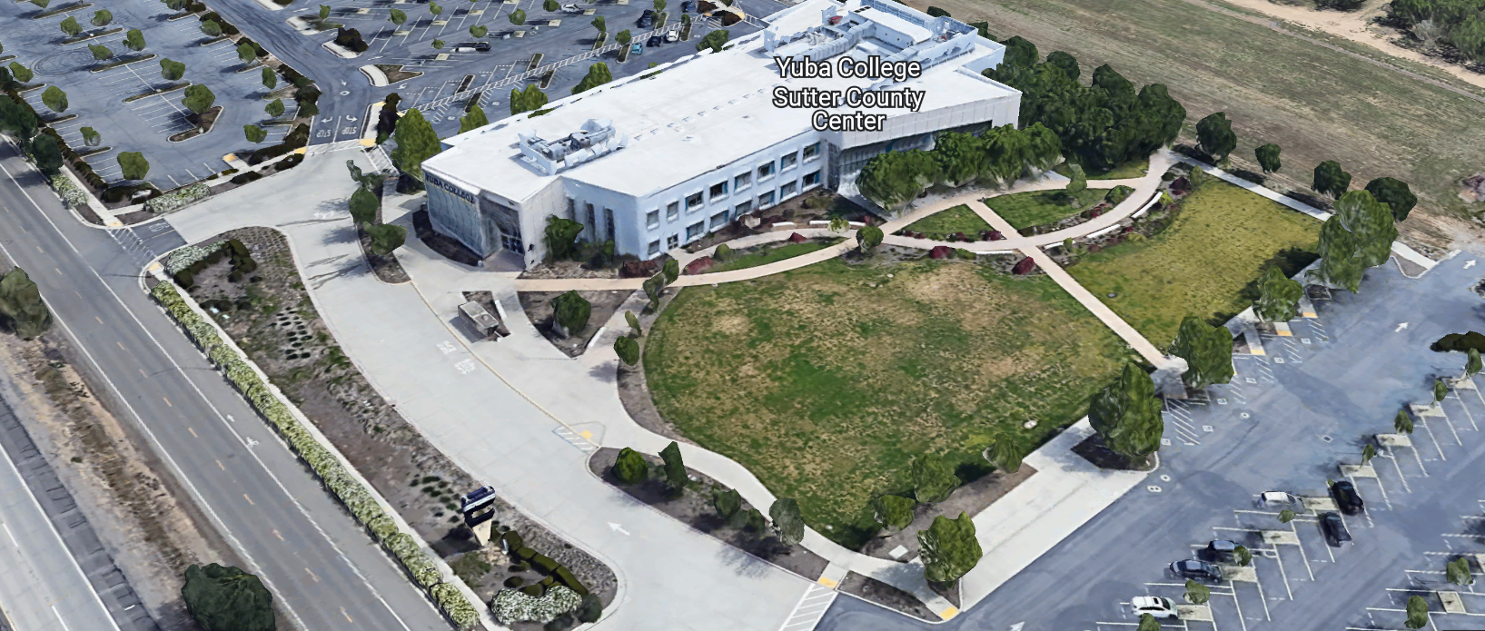
West Building Entrance
TABLE OF CONTENTS
  - INTRODUCTION
  - District Information
  - Yuba Community College District Background
  - Purpose of the Request
  - Applicable Codes
  - Scope of Work
  - Project Schedule
  - Scope of Construction Management and Quality Assurance Services
  - District Staff Contacts during Proposal Process
  - Project Safety Requirements
  - Proposal Format Organization
  - Proposal Delivery, Contents, and Format
4.0 Selection of “Firm”
5.0 Basis of Award
6.0 Non-Discrimination
7.0 Response to Request for Proposal (RFP)
8.0 Requests for Information (RFI)
9.0 Proposal Schedule
10.0 District Parking
11.0 RFP Proposals
12.0 Award of Contract/Proposal
13.0 Reservation of Rights
14.0 Bid Bond Requirements: N/A
15.0 Performance Bond, Payment Bond Requirements
16.0 Liquidated Damages
17.0 Insurance
18.0 Evaluation of Proposals
19.0 Unsatisfactory or Unacceptable Behavior

Firm Proposal Required Items:

Appendix A, Proposal Base Bid Costs Appendix B, Statement of Qualifications
Appendix C, Acknowledgement of Addenda Form Appendix D, Non-Collusion Affidavit Form
Appendix E, YCCD Professional Services Agreement (PSA) Appendix F, Signature Proposal Form
Appendix G, References

Informational Items:
Appendix H: Project Information Appendix I, YCCD Academic Calendars
Appendix J, Map of Woodland Community College Campus
Appendix K, Not Applicable

INTRODUCTION

  - District Information:

The District consists of two colleges, Woodland Community College and Yuba College, with campuses located at six different locations: Yuba College in Marysville, CA; Sutter County Center in Yuba City, CA; Beale Education Center, Beale AFB, CA; Woodland Community College in Woodland, CA; Colusa County Center in Williams, CA; and Lake County Campus in Clearlake, CA.

Yuba Community College District

The Yuba Community College District (YCCD) was founded in 1927 and spans eight counties (Yuba, Sutter, Colusa, Yolo, Lake, Butte, Glenn and Placer) and nearly 4,200 square miles of territory in rural, north-central California. It has colleges in Marysville and Woodland, an educational center in Clearlake, an educational center in Williams, an educational center in Yuba City, and outreach operations at Beale Air Force Base.

Purpose of Request

The Yuba Community College District seeks proposals from qualified Construction Management Firms to provide construction management services as outlined in this RFP for this project.
.
Yuba College: 2088 North Beale Road, Marysville, California 95901

Applicable Codes

All work shall meet all State of California Building Codes, and Federal codes, and local ordinances and shall include but are not limited to the following:
- 2019 EDITION OF TITLE 24 (CALIFORNIA BUILDING STANDARDS CODE) OF THE CALIFORNIA CODE OF REGULATIONS (CCR) AND
- THE LATEST SUPPLEMENTS:
  - PART 01 CALIFORNIA STANDARDS BUILDING ADMINISTRATIVE CODE (CAC)
  - PART 02 CALIFORNIA BUILDING CODE (CBC)
  - PART 03 CALIFORNIA ELECTRICAL CODE (CEC)
  - PART 04 CALIFORNIA MECHANICAL CODE (CMC)
  - PART 05 CALIFORNIA PLUMBING CODE (CPC)
  - PART 06 CALIFORNIA ENERGY CODE
  - PART 09 CALIFORNIA FIRE CODE (CFC)
  - PART 11 CALIFORNIA GREEN BUILDING STANDARDS CODE CALGREEN CODE)
  - PART 12 CALIFORNIA REFERENCE STANDARDS CODE
- STATE OF CALIFORNIA, TITLE 19, STATE FIRE MARSHAL (SFM) - PUBLIC SAFETY REGULATIONS
  - NATIONAL FIRE PROTECTION ASSOCIATION, LATEST ADOPTION WITH AMENDMENTS
  - NFPA 13 AUTOMATIC SPRINKLER SYSTEMS EDITION
  - NFPA 14 STANDPIPE SYSTEMS
  - NFPA 20 STATIONARY PUMPS

  - NFPA 25 CALIFORNIA EDITION, INSPECTION, TESTING AND MAINTENANCE OF WATER-BASED FIRE PROTECTION SYSTEMS
  - NFPA 72 NATIONAL FIRE ALARM CODE
  - NFPA 80 FIRE DOOR AND OTHER OPENING PROTECTIVES
  - NFPA 92 STANDARD FOR SMOKE CONTROL SYSTEMS
  - NFPA 101 LIFE SAFETY CODE, 2018 EDITION

CFC Chapter 33 - FIRE SAFETY DURING CONSTRUCTION AND DEMOLITION REFERENCE CODE SECTION FOR NFPA STANDARDS - 2019 CBC (SFM) CHAPTER 35. SEE CHAPTER

Scope of Work

The construction scope includes but is not limited to the following:

- Exterior specified concrete sidewalks replacement to meet ADA slope and elevation requirements.
- Various low voltage wiring.
- Various electrical wiring.
- LED Lighting Fixtures.
- Restrooms Upgrades
- Minor Mechanical HVAC systems work.
- Various Flooring repairs and new flooring.
- Various Painting and finish work.
- Various Doors and Door hardware work.
- Critical timeline to complete work on schedule per District milestones dates to allow and support College classes to occur during the Spring Term, 2025 in both building 200 and building 1000..
The estimated total cost of construction is $2,500,000 to $3,000,000.

Project Team Members (partial list):

Architect of Record: Howard Cho, HY Architects, (and associated design team members)

District Project Manager: David Willis, Director of Facilities Planning, M & O.

District Contracted DSA Inspector of Record: Bob Boyer, Yuba Sutter Inspection Services

District Contracted Structural/Special Inspections and Testing Services: TBD

District Contracted Construction Manager/Quality Assurance Manager: TBD

District Contracted Commissioning Agent: N/A

2.2 Scope of Construction Management and Quality Assurance Services:

The selected firm will have current knowledge and experience in construction and computer aided management practices and construction quality assurance inspections that include construction projects in higher education and specifically within community college campuses.

Construction Management/Quality Assurance Services will include but not necessarily be limited to the following:

1. General:
a. Coordinate project activities with and assist District’s Project DSA Inspector of Record (IOR);
b. Coordinate project activities with District’s Architect and consultants.
c. Coordinate project activities with the District’s Project Manager and College/District associates.
d. Make recommendations, if appropriate, which may be incorporated into drawings and specifications for project.

2. Construction Phase:
a. Schedule and conduct site meetings weekly and prepare complete and accurate meeting minutes for such meetings for distribution.
b. Attend monthly project review meetings with College and District Leadership as required.
c. Review and advise the District Project Manager concerning submittals, product samples, and specifications provided to Architect by Construction Management Firm, sub-Construction Management Firms, and material suppliers for the project.
d. Review all Construction Management Firm RFIs and Architect Reponses to Construction Management Firm RFI for potential changes to the Contract Documents.
e. Analyze recommendations from Construction Management Firm, Architect, or other consultants, and the District Project Manager which could improve the project or decrease construction time or costs.
f. Review all change order requests issued by Construction Management Firms and advise the College/District about the form and content of such change orders in relation to the drawings, specifications, and the contract documents. Analyze all costs and negotiate lower costs on change orders to the benefit of the District. Provide cost analysis review of the Construction Management Firms change order costs breakdowns to ensure maximum fair value to the District.
j. Review and make recommendations on all payment requests pursuant to the contract documents, architect agreement, or other consultant agreements related to the project.
k. Perform on-site visits to the project at least 3 x weekly June, 2023 through August 2024: at least twice per week September, 2024 through mid-December 2024.to verify:
- Materials and labor being furnished are according to drawings, specifications, change orders, and authorized substitutions.
- Work billed for in each payment request is completed in accordance with the drawings and specifications.
- Construction Management Firm time schedule is maintained as required by construction contact documents.
- Project costs are maintained within the District’s approved budget. Make recommendations regarding change orders and items that add costs to the project.
- Construction Management Firm means and methods provide high quality workmanship and project results and do not “create” additional change order costs due to many reasons including “unforeseen conditions”.
- Make recommendations that maintain project lowest cost of ownership and lowest long-term maintenance, operations, and energy costs.
m. Provide monthly Project Status Reports by the 15th of each month to the District Project Manager.

4. Close-Out Activities:
a. Assist the Architect and the District Project Manager in the preparation of punch lists for Construction Management Firm, sub-Construction Management Firms, and other consultants on the project, coordinate and assist Architect and District Project Manager in scheduling the completion of all such corrective work and participate in all back checks with Architect and the District Project Manager of punch list work.
b. Assist the Architect in coordinating and assembling all warranties and guarantees as required by construction contract documents from the Construction Management Firm and submit to the District Project Manager.
c. Coordinate with Architect, DSA, the District Project Manager regarding the final acceptance of Project.
d. Assist the Commissioning Agent and the Construction Management Firm as required to ensure that all mechanical, HVAC, lighting, energy management, fire alarm, fire suppression, and all other systems are started up, programmed, and are operating properly.
e. Advise the District Project Manager on project closeout and final hard costs;

3.0 Project schedule:

IMPORTANT BIDDING DATES INFORMATION:

Pre-Bid Optional ZOOM Meeting April 22, 2024; 1:00pm; Link: https://yccd-edu.zoom.us/j/81725705626

There are no optional or mandatory pre-bid meetings at the College location for this project. If, however, you would like to visit the project buildings, please contact Bryan Epp at email: bepp@yccd.edu.

Last Date / Time for Bidder’s
Requests for Information: April 29, 2024; 1:00pm
Last Day to Issue Addendum: April 30, 2024; 1:00pm
Bids Due No Later Than, Date / Time: May 7, 2024; 1:00pm
Bids Must Be Received at: Yuba Community College District, Sutter County Campus
Attn.: David Willis, Room 219 (second floor)
3301 East Onstott Road, Yuba City, California 95991

Construction Schedule:

Start Construction: June 4, 2024

Substantial Completion: November 5, 2024

Construction 100% Completion: December 16, 2024

Project Close-Out Completion: January 30, 2025

2.3 District Staff Contacts during the Proposal process:

Firm interested in submitting a Proposal are directed not to make personal contact with the Board of Trustees, District staff, or members of the evaluation committee. Any contact shall constitute grounds for disqualification from consideration.
Single Point of Contact during the Proposal Preparation Process:

David L. Willis
District Director of Maintenance, Operations, and Planning
Yuba College, Sutter County Center
District Offices
3301 East Onstott Road (Second Floor)
Yuba City, California, 95991 Cell Phone: 916-747-4262 Email: dwillis@yccd.edu

Please email Dave Willis to verify that your firm will be submitting a proposal in response to this procurement process.
No changes can be made to the project scope without authorization in writing by David Willis.

2.4 Project Safety and Security Requirements

Safety is a top priority for the District. All California OSHA requirements apply. Industry best practices apply. Firm employees shall wear shirts with sleeves, a hard hat, eye protection, hearing protection as needed, gloves, substantial leather footwear, long pants, a reflective safety vest, and take all needed precautions to complete the work in a safe manner. Safety shall not be compromised at all during the work.
These campuses have a moderate risk of theft. It is the sole responsibility of the Firm to secure all materials, equipment, tools, and the affected buildings.

3.0 Proposal Format Organization
The Firm is requested to use the following proposal format:

3.1. Proposal Delivery, Contents, and Format:
Proposals should provide straightforward, concise information that satisfies the requirements noted in this RFP. Expensive binding, color displays, and the like are discouraged. Emphasis should be placed on brevity, conformity to the Districts instructions, selection criteria of this RFP, and completeness and clarity of content. Each Respondent’s proposal should clearly and accurately demonstrate specialized knowledge and experience required for consideration.

In a sealed box or envelope (clearly marked “), submit the following:
- One (1) flash memory stick containing the complete proposal and supporting documentation; You may also in addition to the flash drive, email your proposal to: dwillis@yccd.edu.
- One (1) original proposal in paper form, which consists of a Proposal Letter and responses to the proposal requirements of this RFP.

There is no page limit.

Firms must comply with the provisions of these instructions for completion and submission of the Proposal. The failure of a Firm to comply with the Proposal Instructions and Requirements will likely result (at the sole discretion of the District) in rejection of the Proposal for non-responsiveness.

Proposal Section | Format
- Cover Letter | PDF
- Table of Contents | PDF
Appendices (See Table of Contents for each one) Submit a response to each Appendix that requires Construction Management Firm information. Please submit responses to Appendices A, B, C, D. Appendices E, F, are informational only. | PDF

Proposal General Information Contents:

Information provided by the Construction Management Firm will help the District determine if the Firm is a “Responsible Bidder”.

Cover Letter

The Proposal shall include a Cover Letter on Respondent’s official business letterhead, which shall be signed by an individual authorized to legally bind Respondent. The Cover Letter shall also identify the name, telephone number, and email of a person who may be contacted during the Proposal evaluation process.

Table of Contents

Provide a Table of Contents that outlines in sequential order the major sections and sub-sections of the Proposal. Use tabs to allow information to be more easily located.

4.0 Selection of “Firm” Services Provider

The process of “Firm” selection is based upon the complete responsiveness of the RFP and the criteria as outlined in the RFP.

The District Project Evaluation Team will First pre-qualify Construction Management Firms based on the Statement of Qualifications information provided by the Construction Management Firm. If qualified, then Construction Management Firm proposals will be considered. Construction Management Firms that are not qualified based on the criteria and information provided by the Construction Management Firm associated with the Statement of Qualifications will not have their proposals considered even if they are the lowest cost proposing Construction Management Firm.

The District reserves the right to reject any or all submittals, to amend the RFP process, and to discontinue or re-open the process at any time. The District reserves the right to request clarifications to RFP responses and to negotiate the terms of the agreement.

5.0 Basis of Award

This project will be awarded based on the following criteria:

- Lowest Total Cost Responsive Qualified Bidder
  - Lowest Total Cost
  - Construction Management Firm Capability to do the work
  - Qualified Construction Management Firm (per Appendix B, Statement of Qualifications)
    - District determined “Qualified Construction Management Firms” based on the information provided in the “Statement of Qualifications” information provided by the Construction Management Firm.
    - Proper State of California Construction Management Firm License in good standing
    - Information provided as requested in the RFP and Specifications.
    - All Addendums are acknowledged.
    - Construction Management Firm listed any exceptions or exclusions. Construction Management Firms should bid the project per the RFP and contract documents and then offer exceptions and exclusions or cost deductive or additive alternatives separately from the base bid.

    - Firms with historically poor performance on projects at Yuba Community College District will be disqualified from consideration. Poor performance is 100% solely defined by the District for such issues as not meeting original schedule requirements within two months of the original schedule OR not tracking long-lead procurement items and then delaying the project such that the Construction Management Firm cannot recover the project schedule, OR working unsafely and not following CAL OSHA requirements OR excessive change orders greater than 10% of the original awarded amount on renovation projects and greater than 7% on new buildings OR generally poor quality work not acceptable to the District OR not utilizing coating manufacturer specified application equipment OR or that have threatened legal action toward the District OR having a history of difficult argumentative communications regarding change orders/schedules/and quality of work OR as any combination of the above items or other similar items as determined by the District.
    - Construction Management Firms’ ability to meet schedule requirements, recover delays in the schedule.
    - Construction Management Firms have demonstrated past project references of “like” projects
    - Construction Management Firms references are all good with respect to schedule, cost, and quality.
    - No other factors such as litigation, licenses in good standing, or other similar criteria.
    - At least five (5) project references of similar projects completed in the past seven (7) years with contact information, scope of work, initial awarded cost, change orders cost, pictures if possible.

Optional Interview Process:

The top one or two of the lowest total cost responsive qualified bidders may be requested to participate in a ZOOM/Teams interview process with the District Project Proposal Evaluation Team. This interview process is fully at the discretion of the District. The District may decide that no interview is required. If an interview is needed, then it will be scored by the District and part of the evaluation process.

6.0 Non-Discrimination

The District does not discriminate with regard to race, color, gender, national origin, disability, or any other protected or other classification in the awarding of contracts/agreements. The District welcomes all Qualified Firms to participate in the project Request for Qualification/Proposal process.

The District encourages firms that are women or minority owned, emerging small businesses, veteran owned firms, disabled person owned firms, and all other qualified firms to participate in the proposal process.

The District encourages the submission of proposals from all Firms that can meet the stated requirements set for this RFP.

7.0 Responses to RFP:
Sealed responses to this RFP must be clearly marked "RFP No. 23-10 Yuba College, Construction Management / Quality Assurance Services, Buildings 200 and 1000 Partial Renovation Project”.

Responses shall be mailed to or hand-delivered to the following address:

Yuba Community College District, District Offices
Attn.: David Willis
District Director of Facilities Planning, Maintenance & Operations

Envelope/Box Marked:
"RFP No. 23-10 Yuba College, Construction Management, Buildings 200 and 1000 Partial Renovation Project”.
.

Address: Yuba Community College District, Yuba College, Sutter County Center, District Services Offices, Second Floor, Attention: David Willis, Room 217, Yuba City, California, 95991

Note: Completely seal your proposals in envelope/box and make sure it gets date/time stamped when delivering proposal. Firms are each 100% responsible to make sure proposals that are mailed using a carrier such as UPS, FED Ex, etc…are received and date/time stamped by District personnel prior to the proposal due date/time. No proposals will be considered if they are late, even if it is only 5 minutes late. Please make sure your proposals are delivered and received promptly prior to the due date/time. There will be a public proposal opening at the due date/time.

Do NOT just email your proposals. Emailed proposals, if sent, are required in addition to the above requirements.

8.0 Requests for Information (RFI)

Requests for Information concerning the RFP must be in writing and may be submitted via email no later than the date shown below. Please direct all questions to David Willis, email: dwillis@yccd.edu.

Following the RFI deadline, all questions and answers will be summarized and posted on the District's website: https://www.yccd.edu/central-services/purchasing/ , then, click on the “Requests for Proposals / Quotes” tab on the right hand side of this web page. It is anticipated that responses to inquires received by the required time and date will be provided within 5 business days and posted on the District's website or responded to per the dates listed in the RFP for addendum publishing. Should more time be needed by the District to answer I respond to RFI’s, this information will also be posted on the above website.

- Include the following in the subject matter field on emails when requesting information: “RFP 23-10”, RFI.

9.0 Proposal Schedule: Refer to Specification 00 11 13.

This is a prevailing wage project.

10.0 District Parking: (Fees Not Applicable)

11.0 RFP Proposals

Proposals received after the deadline will not be opened. Each responder shall submit one (1) signed original hard paper copy in a binders. Provide one electronic format copy of the proposal using electronic media such as a flash drive. (No CD formatted Disks).

All materials submitted in response to the RFP shall be on 8-1/2"x11" paper, preferably in
Portrait orientation. All submitted materials must be bound in either a three-ring binder or spiral bound notebook. Content shall be tabbed and numbered per the items included in the Submittal Requirements. All Proposals will be reviewed and evaluated by a District Selection Committee. The District at its sole discretion may interview finalists or select a firm or firms to perform work based solely on the evaluation of the Proposal. There is no page limit.

All Proposals become the sole property of the District and the content will be held confidential until the selection of the Firm or Firm’s is made and the project is awarded.

12.0 Award of Contract

- The Contract will be awarded to the lowest total cost, most responsive responsible District qualified Firm, whose proposal, conforming to the request for proposal and associated addendums, will be most advantageous to the District.

B. The District reserves the right to enter into an Agreement without further discussion of the proposal submitted based on the initial offers received.

C. The District reserves the right to reject any or all proposals or any part of the proposal and to waive informalities and minor irregularities in the proposals received.

D. The RFP, its addendums, any follow-up clarifying information, and the proposal of the selected Firm will become part of any contract initiated by the District.

E. A formal contract shall be signed by the successful proposer and Yuba Community College District to perform this service.

F. The District reserves the right to enter into discussions with any one or all of the Responders after Proposals have been initially reviewed. Such responses shall be subject to all provisions, terms and conditions as set forth in the RFP, unless otherwise modified.

G. The District intends to award to a single RFP Responder.

H. Failure to acknowledge all of the addendums, provide the items listed in the RFP, may render the proposal unresponsive at the discretion of the District. Items listed in the RFP become part of the contract unless the Construction Management Firm provides an exception in the proposal. Construction Management Firm exceptions, depending on the magnitude, may render the proposal unresponsive, at the discretion of the District.

I. The District reserves the right to request clarification of proposal content during the review and evaluation process.

K. The District reserves the right to negotiate the terms of the agreement to align with budgetary constraints.

13.0 Reservation of Rights

The District reserves the right to:

- Reject any or all submittals at its sole discretions.
- Cancel the Request for Proposal (RFP), without cause.
- Modify any requirements contained within the RFP and request a revised submission from all Providers.
- Establish other evaluation criteria determined to be in the best interest of the District.
- Contract with any of the firms responding to the RFP based solely upon its judgment of the qualifications and capabilities of the firm.
- Clarify the content of any proposal to verify that the requirements of the RFP are included.
- Waive “minor” proposal inconsistencies that do not change the scope of work as outlined in the RFP.
- Request an alternative Superintendent on the project if the initially assigned Superintendent on the project is not performing well, not meeting project requirements, not working well with College staff and students, not applying best practice safety methods, OR not following College/District guidance regarding project approach. If the owner is the Superintendent, and has been replaced, the owner may visit the project briefly (less than 1 hour per day up to 2 times per week) to coordinate with the replacement Superintendent.
- The District will not allow or tolerate verbal abuse or any other type of abuse by the Construction Management Firm toward any College or District personnel or Contracted professional service providers. Abuse, defined solely by the District as verbal or physical, or written, may lead to a “Stop Work” order by the District until it can be resolved, and steps taken to ensure abuse is not repeated. If abuse occurs again, the District may issue a final “Stop Work” order, require the Construction Management Firm to leave the College/District project site and process a Performance Bond claim to complete the work. All costs associated with District “Stop Orders” are 100% the responsibility of the Construction Management Firm. The Construction Management Firm will be required to catch up the project schedule if a “Stop Order” is required to be issued for up to 5 days due to unprofessional behavior on the part of the Construction Management Firms employees.
- Disqualify a Construction Management Firm after reviewing the proposal and finding concerning performance information in references, inadequate or incomplete proposal information, inadequate or information that is provided by the Construction Management Firm as part of the Statement of Qualifications process, and historically poor project performance at the District/Colleges (as solely defined by the District).

This RFP does not commit the District to award or negotiate a contract. The District will not be responsible for any expenses incurred by any firm in preparing and submitting a proposal or response to this RFP or in completing any of the work specified.

The District Project Evaluation Team will First pre-qualify Construction Management Firms based on the Statement of Qualifications information provided by the Construction Management Firm. If qualified, then Construction Management Firm proposals will be considered. Construction Management Firms that are not qualified based on the criteria and information provided by the Construction Management Firm associated with the Statement of Qualifications will not have their proposals considered even if they are the lowest cost proposing Construction Management Firm.

The District reserves the right to reject any or all submittals, to amend the RFP process, and to discontinue or re-open the process at any time. The District reserves the right to request clarifications to RFP responses and to negotiate the terms of the agreement.

Bid Bond Requirement: Not Applicable

- Performance and Payment Bond Requirements: Not Applicable

Liquidated Damages: Not Applicable

- Insurance: The Firm shall provide evidence of adequate liability and professional liability insurance, as determined by the District.

- Unsatisfactory or Unacceptable Behavior: The District’s Project Manager will investigate and evaluate any case of unacceptable behavior or unsatisfactory performance by the personnel performing work under any resultant contract. Unacceptable behavior or unsatisfactory performance by contract personnel will result in their removal from the project at the request of District’s Project Manager. The decision of the District’s Project Manager will be final in these matters.

Appendix A: Bid Form

No. | Description | Cost
1 | Construction Management / Quality Assurance Services: | $
2 | “Unforeseen or Unexpected” CM Services | $ 7,500.00
3 | Other costs: | $
4 | Total Costs: | $

Round all figures to the nearest dollar.

Do not include any hotel or meal costs.

This is a prevailing wage project.

Provide a detailed breakdown of the costs of this proposal as an attachment to this Bid Form.

Provide hourly rate costs for future additional scope of work items and attach to this Bid Form.

Describe how many and duration of site visits, approach to keeping costs down and encouraging the project schedule to remain on schedule. Describe approach to negotiating PCO’s, tracking PCO’s, and criteria to accept or deny PCO’s.

Provide detailed information regarding credentials and experience of the Construction Manager, the back-up CM, and the software that they have used as a project information and management such as PROCORE.

Please describe any reimbursable expenses that may be included in item numbers 1 and 3 above.

The Firm shall furnish the following information. Failure to comply with this requirement will render the submittal informal and may cause its rejection. Additional sheets may be attached if necessary.

Phase 1: Basic Firm Informational Items 1 through 7:

- Firm Name:

Primary Address:

Firm’s Contact Person and Title:

Telephone: Facsimile:

Email Address:

Responsible Managing Employee/Officer:

- Licenses or Certifications:

- Number of years Firm has been in business: If less than 5 years, please describe:

- Number of years Firm has conducted business under the present name:

- Number of years’ experience in California Community College, University or educational facility projects .

- Has the Firm ever completed any work at the Yuba Community College District? If Yes, please elaborate:

Phase 2: Potentially Disqualifying Questions 8 through 13 (District may immediately disqualify Firm if its answer to any of Questions 8 through 12 is “NO.” Firm’s refusal to answer or omission of response to any of Questions may result in disqualification of Firm.):

- Has the Firm been defaulted or terminated (other than for convenience) by any California school district, community College district or other California public agency on any project within the past 5 years? Yes/No

If yes, identify agency and details:

- Has the Firm been disqualified, debarred, forbidden, or found non-responsible or otherwise prohibited from performing work for any California school district, community College district, or other California public agency within the past ten years? Yes/No

If yes, identify agency and details:

- Has the Firm been in litigation (whether in court or arbitration) with any California school district, community College district, or other California public agency on an issue pertaining to any contract during the past ten years? Yes/No:

If yes, explain, identify the agency, and provide case name and number.

- Has the Firm ever failed to complete a project in the past ten years? Yes/No:
If so, give owner and details:

- Is the Firm currently or has the Firm been in a state of “Bankruptcy” in the past ten years? Yes/No:
If yes, please explain.

- Does the Firm have project experience that includes a Multiple Building Partial Renovation Project in a K-14 or College/University setting? Yes/No
Please explain.

Phase 3: Rating Questions (200 points):

- Please list and describe on separate sheets the Firm’s top 5 public K-12 and other public works project references with current contact t information in the past 8 years. Multiple projects for same client are allowed, however a minimum of two (2) different Districts/clients must be represented. It is required that five (5) of the projects have been completed within the past eight (8) years and must be in similar in size and construction value as the Project.

Scoring Criteria:
    - At least Five (5) projects value at least $3,000,000 in the past 5 years. (up to 30 points)
    - At least Three (3) projects with a value of $3,000,000 or more in the past 8 years in a K-14 public school in California (up to 40 points).
    - At least three (3) projects of similar size and scope that have been submitted to the Division of the State Architects (DSA) office in the past 8 years. (up to 20 points)

Total points for Question 13: up to 90 points

- In the last 10 years, how many legal proceedings (filed in court or arbitrations) has your Firm initiated against an owner, regardless of outcome?
(0 = 20 points; 1 = 10 points; 2+ = 0 points.)

- In the last 10 years, how many legal proceedings (filed in court or arbitrations) has an owner initiated against your Firm, regardless of outcome?
(0 = 20 points; 1 = 10 points; 2+ = 0 points.)

- Please describe the Capability/Capacity of your Firm.

(Up to 20 points.)

- Please describe the Firm’s commitment to maintaining a construction schedule

(Up to 10 points.)

18. Please describe the Firm’s commitment to meeting regularly at project team meetings

(Up to 10 points.)

19. Please describe the Firm’s Quality Assurance Services and how they will be applied on this project to ensure that the work is high quality and uses only specified materials and equipment?

(Up to 50 points.)

Note: The District Project Evaluation Team will likely schedule a ZOOM interview with the top 1 to 3 Firms.

Qualification Criteria:

Phase 1: Questions 1 through 7 are general base level information that is required for pre-qualification.
Phase 2: Questions 8 through 13 are possible disqualifying questions that would render the Firm “not qualified” as determined by the District.
Phase 3: Questions 14 through 19 are rating questions that are scored and more deeply evaluated. (220 points possible) To be considered for a Finalist Interview, each Firm must score at least 190 points in this Phase 3.

Firms must pass phases 1, 2, and 3 and score at least 170 points to be considered for an interview. Only the top 1 or 2 Firms will be considered for an Interview.

Phase 4: Interview (100 points possible)

- There are a total of 300 points possible. Firms must score a total of 250 points out of 300 points to be prequalified.
- The District can disqualify a Firm (at it’s sole discretion).

The Firm must be first pre-qualified. Then, if pre-qualified, the proposal for will be considered. The District may decide not to have an interview or a phase 4.

Addendum C: Acknowledgement of Addenda Form

The undersigned acknowledges receipt of the following addenda from the District pursuant to the Request for Proposal:

Acknowledgement: Yes or Not Applicable Addendum No. 1: . Addendum No. 2: . Addendum No. 3: . Addendum No. 4: . Addendum No. 5: .

Firm are required to acknowledge all addenda’s within the submitted proposal at the time of submission.

Appendix D: Non-Collusion Affidavit Form
STATE OF CALIFORNIA, COUNTY OF I, being first duly sworn, deposes and says that I am the of , the party submitting the foregoing proposal (“the Proposal”). In connection with the foregoing Proposal, the undersigned declares, states and certifies that:
- The Proposal is not made in the interest of, or on behalf of, any undisclosed person, partnership, company, association, organization or corporation.
- The Proposal is genuine and not collusive or a sham.
- The Firm has not directly or indirectly induced or solicited another Firm to put in a false or sham proposal, and has not directly or indirectly colluded, conspired, connived, or agreed with any other Firm or anyone else to put in a sham proposal, or to refrain from bidding.
- The Firm has not in any manner, directly or indirectly, sought by agreement, communication, or conference with anyone to fix the proposal price, or that of any other Firm, or to fix any overhead, profit or cost element of the proposal price or that of any other Firm, or to secure any advantage against the public body awarding the contract of anyone interested in the proposed contract.
- All statements contained in the Proposal and related documents are true.
- The Firm has not, directly or indirectly, submitted the proposal price or any breakdown thereof, or the contents there of, or divulged information or data relative thereto, or paid, and will not pay any fee to any person, corporation, partnership, company, association, organization, proposal depository, or to any member or agent thereof to effectuate a collusive or sham proposal.
Executed on this date: , 2024 at:

(City, County, and State)
I declare under penalty of perjury under the laws of the State of California that the foregoing is true and correct.
Signature Printed Name . Address: .
Area Code & Phone Number: .

Note: In addition to other bid documents, bidders on public works projects are required by Public Contract Code section 7106 to submit a certification form that they have not colluded with another proposer.

Appendix “E” Professional Services Agreement

Link:

https://goyccd-my.sharepoint.com/:w:/g/personal/w0398409_yccd_edu/ESVgSfSA3rJOgYNsgPssjBMBKFJsh8K2KLVDJ-p7fKrosg?e=cBc03i

Note: This PSA is only required to be filled out by the successful Firm, once selected.

Appendix “F” Signature Form

The undersigned acknowledges the following:

- Having become familiar with the specifications and requirements of the Request for Proposal, hereby offers to provide all services in accordance with the proposal set forth herein, including all referenced material and attachments.
- By submitting a signed proposal in response to this solicitation, the Firm acknowledges that they completely understand the scope of the needed services and that the proposed services as described in the proposal will meet or exceed the needs of the District.
- Late proposals will not be accepted (even if they are only 5 minutes late).
- The District reserves the right to reject any and all proposals and that this proposal shall remain open and not be withdrawn for a minimum of 90 days.
- Cancellation Clause: The District may, without cause, terminate the contract(s) or a project under the contract(s) by giving written notice of such termination to the awarded firm. In the event of such termination the District shall reimburse the firm for services performed and reasonable expenses actually incurred by the firm in relation to the terminated project prior to the firm’s receipt of such notice of termination. The cost of proposal generation, associated travel, copies, postage, etc.., will not be reimbursed and is considered a typical and normal part of the bid process and is not reimbursed for any of the proposers.
- If the prospective Firm is a corporation, the undersigned hereby represents and warrants that the corporation is duly incorporated and is in good standing in the state of California , and that, , is authorized to act for and bind the corporation.

Entity Type (Select One):

Sole Owner: Partnership: .

Corporation: .

Other; Please specify;

- Regular monthly progress payments are made using NET 30 as a basis for payment, with Net 30 time starting after receipt of the invoice with all required support documentation, and once this information is reviewed and approved by the District.

Invoices must be emailed to the following with all support documentation: Vendors with a first letter of A through N: hgardner@yccd.edu; rharvey@yccd.edu Vendors with a first letter of O through Z: hgardner@yccd.edu; rharvey@yccd.edu
It is critical that invoices have all required support documentation including an updated schedule of values with 5% retainage for construction projects, updated project schedule, description of completed work, and any other information that will help to justify and support the progress payment request.

Signature Date: Position:
Print name Title

Notary Required On This Project

Notary Stamp:

Appendix “G” References Form (Example Template)

Bidder shall provide a minimum of Five (5) verifiable references with current contact information, preferably from a California public educational institution and/or California public agency, representing projects started and completed within the last 5 years. See clarification note below regarding reference requirements.
All phone numbers and emails must be current (please verify).
REFERENCE #1
NAME
ADDRESS
CITY, STATE ZIP CODE
TELEPHONE #
CONTACT
DATES OF SERVICE
REFERENCE #2
NAME
ADDRESS
CITY, STATE, ZIP CODE
TELEPHONE #
CONTACT
DATES OF SERVICE
REFERENCE #3
NAME
ADDRESS
CITY, STATE, ZIP CODE
TELEPHONE #
CONTACT
DATES OF SERVICE
You may of course use the Firm’s established reference template.

Appendix H: Project Information—
DSA Approved Drawings and Specifications Link:

https://goyccd-my.sharepoint.com/:f:/g/personal/w0398409_yccd_edu/EiDNLptd_DRPnxeL3-sc4SkB0RdCF59C3UaE4jBoaDaxjQ?e=atEvsD

Appendix I: YCCD Academic Calendars—see next page

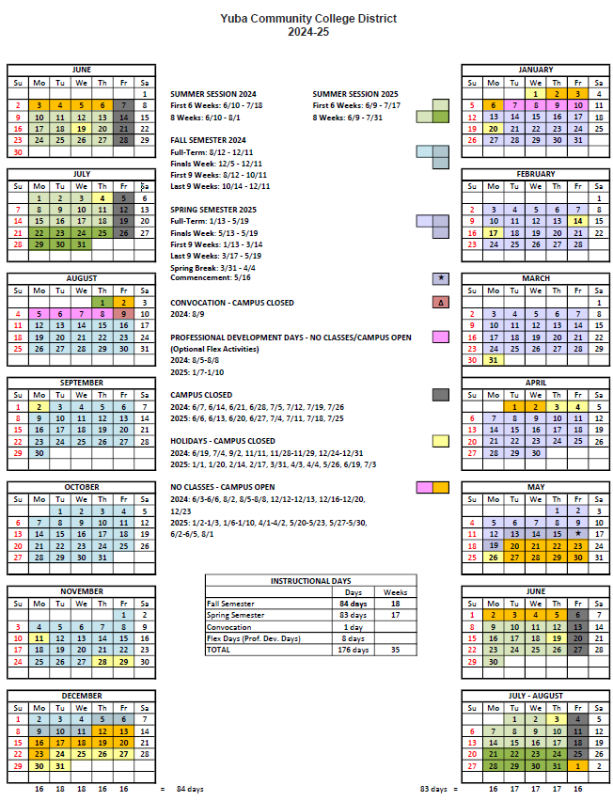
Appendix J: Map of Yuba College Campus, 2088 North Beale Road, Marysville, California, 95901 Map of Yuba College
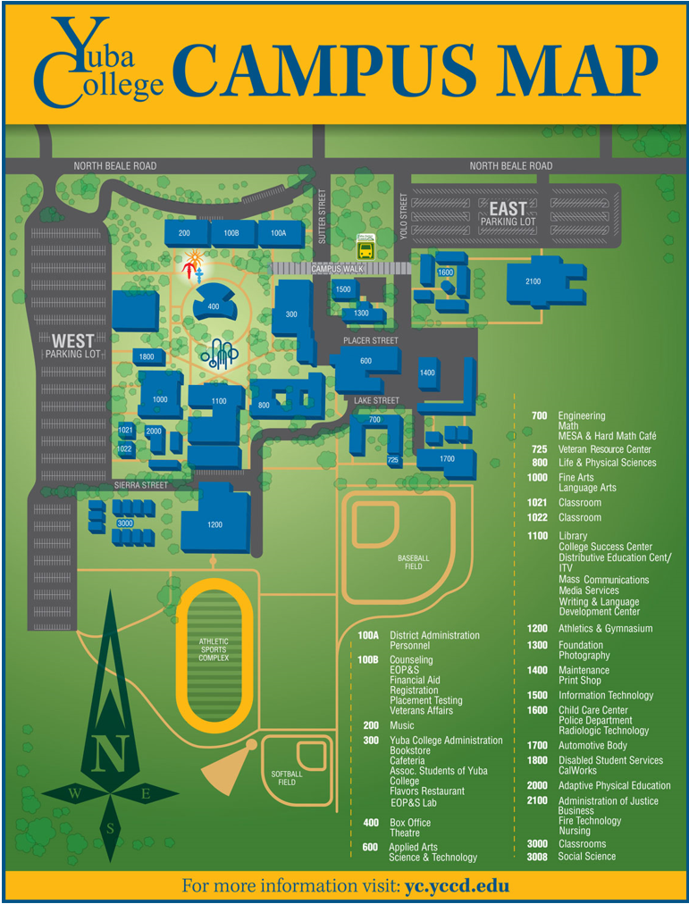

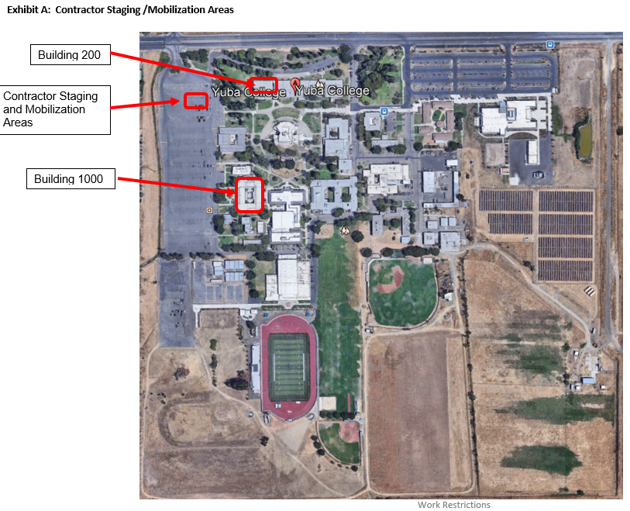

Appendix K: Not Applicable.

The end.

