Request for Proposal
Yuba Community College District

REQUEST FOR PROPOSAL for
UNARMED SECURITY SERVICES

RFP # 23-07

RFP Questions Deadline:
Monday, March 25, 2024 by 12pm

Issue Date: March 8, 2024
RFP Due: April 8, 2024

RFP Due Date: April 8, 2024; 1:00 PM Sharp, Location Delivered To:

Yuba Community College District, District Offices
Attn.: Kuldeep Kaur
Vice Chancellor of Administrative Services
RFP No. 23-07 Unarmed Security Services
Address: Sutter County Campus, Second Floor, District Offices, Attention: Kuldeep Kaur,
3301 East Onstott Road, Yuba City, California 95991

Proposal Delivery at Second Floor
Yuba Community College District
Sutter County Campus
District Offices
3301 East Onstott Road (second floor)
Yuba City, California, 95991

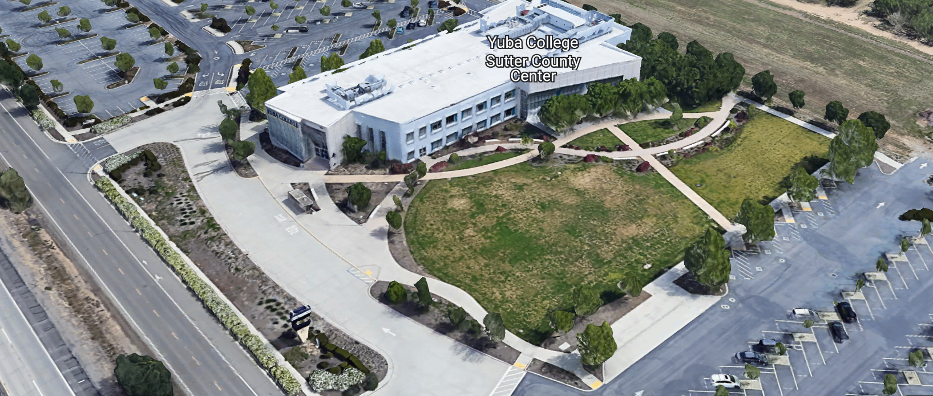
West Building Entrance

TABLE OF CONTENTS

1.0 INTRODUCTION
1.1 District Information
1.2 Yuba Community College District Background
1.3 Purpose of the Request
1.4 Applicable Codes
2.0 Scope of Work
2.1 Security Services Firm’s Responsibilities
2.2 District Right to Audit
2.3 Schedule of Hours
2.4 Qualifications of Bidders
2.5 Experience and Reference Information
2.6 Price Proposal
2.7 Oral Evaluation
2.8 District Staff Contact during the Proposal Process
3.0 Proposal Format Organization
3.1 Proposal Delivery, Contents, and Format
4.0 Selection of “Firm” Services Provider
5.0 Basis of Award
6.0 Non-Discrimination
7.0 Response to Request for Proposal (RFP)
8.0 Requests for Information (RFI)
9.0 Proposal Schedule
10.0 District Parking
11.0 RFP Proposals
12.0 Award of Contract
13.0 Reservation of Rights

Security Services Firm Proposal Required Items:

Appendix A, Proposal Base Bid Form
Appendix B, Statement of Qualifications Form
Appendix C, Acknowledgement of Addenda Form
Appendix D, Non-Collusion Affidavit Form
Appendix E, YCCD Agreement for Services
Appendix F, Proposal Signature Form
Appendix G, References Form
Appendix H, Comprehensive Description of All Security Services Included in this Proposal.
Appendix I: Security Firm Information, Licenses, Credentials, and Security Services Approach.
Informational Items:
Appendix J: YCCD Academic Calendars

1. INTRODUCTION

  - District Information:

The District consists of two colleges, Woodland Community College, and Yuba College, with campuses located at five different locations: Yuba College in Marysville, CA; Sutter County Center in Yuba City, CA; Woodland Community College in Woodland, CA; Colusa County Center in Williams, CA; and Lake County Campus in Clearlake, CA.

  - Yuba Community College District

The Yuba Community College District (YCCD) was founded in 1927 and spans eight counties (Yuba, Sutter, Colusa, Yolo, Lake, Butte, Glenn, and Placer) and nearly 4,200 square miles of territory in rural, north-central California. It has colleges in Marysville and Woodland, an educational center in Clearlake, an educational center in Williams, and an educational center in Yuba City.

  - Purpose of Request

The purpose of this Request for Proposal (RFP) is to solicit proposals from a qualified security services firm to provide “Unarmed Security Services” (Services) for the Yuba Community College District. Any resulting agreement will be between the supplier whose proposal is selected and the Yuba Community College District ("District" or “YCCD”).

  - Applicable Codes
All work shall meet all State of California Codes, and Federal codes, and local ordinances.
- Scope of Work
The Yuba Community College District on behalf of its Board of Trustees is seeking a successful vendor to work collaboratively with the District in offering unarmed security services at multiple locations including:

- Yuba College, Marysville Campus: 2088 North Beale Road, Marysville, Ca. 95901
- Yuba College, Sutter County Center: 3301 East Onstott Road, Yuba City, Ca., 95991
- Woodland Community College, Woodland Campus: 2300 East Gibson Road, Woodland, Ca. 95776
- Woodland Community College, Lake County Center: 15880 Dam Road Extension, Clear Lake, Ca., 95422

Security Services Firm will provide unarmed campus security personnel to perform the following duties throughout the District:

    - Perform a variety of patrols of District locations to ensure security of all campus locations.
    - Perform a variety of access control.
    - Provide safety escorts of personnel on District properties.
    - Document activities, incidents, crimes, and other items as directed.
    - Respond to a variety of incidents or issues that may have occurred or are in progress.
    - Enforce parking regulations and support with parking permits issuance.
    - Support with restraining orders.
    - Supporting the Child Development Center with various needs including that families transport children in appropriate Child Safety Seats.
    - Custody disputes and conflicts resolution associated with it.
    - Locking up buildings and other District facilities at the end of the day.
    - Utilizing the district or the firm issued phone to respond to calls from the District.
    - Conduct wellness checks when needed.
    - Respond to escalated interactions and provide support to the District personnel.
    - Conduct threat assessments when concerns are reported.
    - Walk the buildings periodically.

    - All personnel must have received the requisite training as listed in section 2.1 below language.

Assigned campus security personnel will seek direction from the District’s Director of Safety and Risk Management or other assigned District manager and shall comply with all chain of command and reporting requirements set forth by the District, as well as all established policies and procedures applicable to the performance of their duties.

Specific routes and duties to be determined by the District. When new individuals are assigned to the District, they shall be directed to interview with the District’s Director of Safety and Risk Management or other assigned District manager prior to assignment. It is there that they will receive specific directions on the routes, building keys, access codes, and other District expectations.

Subcontracting is not allowed without prior written approval of the District.

2.1 Security Services Firm’s Responsibilities (75 points)
District security personnel are employees of the Security Services Firm, and the Security Services Firm will pay all wages, benefits, and applicable taxes.

Supervision and Labor: Security Services Firm will, at all times, furnish adequate quantities of qualified supervision and labor to maintain the progress of work. Supervisors assigned to the District shall report to the Director of Safety and Risk Management.

Safety and Protection:
- The Security Services Firm is exclusively responsible for initiating, maintaining, and supervising all safety precautions and programs in connection with the performance of the Work.
- Security Services Firm will observe best practices, and take all precautions required by Applicable Laws, to provide for the safety and protection of all workers and persons that may be affected by the Work, and all real and personal property that may be affected by the Work.
- Without limiting Security Services Firm's duty to comply with all Applicable Laws in connection with worker safety and safety in general, Security Services Firm will specifically comply with all applicable requirements of the Federal Occupational Safety and Health Administration (OSHA), the California Occupational Safety and Health Act, and applicable California Occupational Safety and Health regulations.
- Security Services Firm will comply with all the District’s site-specific safety and environmental protection rules, regulations, requirements, and practices.
Training:
- All Personnel provided by Security Services Firm will have received proper and complete training as needed to be thoroughly familiar with and compliant under the following:
- School Security Officers: Training - California Senate Bill 1626
- Private Security Services Act - Assembly Bill 2880
- Sexual Harassment: Training and Education - Assembly Bill 1825
- District Catapult Emergency Messaging Application/Process
- All Personnel will have been trained in the following:
- Mandatory Reporting
- Family Educational Rights and Privacy Act (FERPA)
- Confidential Information and Emergency Management trainings as required by the District.

Prosecution of Work: Security Services Firm will continue to diligently prosecute the Work notwithstanding any disputes or differences with the District or others, including disputes regarding the scope of work, changes in the Work, and Security Services Firm's right, if any, to an adjustment in the Contract Price or Contract Time.

Daily Reports: Assigned security personnel will document incidents and activities while assigned to the District through the Districts proprietary system and as specified by the District.

Uniforms: All campus security personnel will be in clean, military pressed uniforms at all times while on duty. All campus security personnel must wear name tags stating Security Officer with their name. Uniforms will be worn to clearly display security insignia. No items should be repaired, mended, or darned to the degree that it is distracting or appears unkempt. Uniforms should provide adequate support from extreme weather conditions-both hot and cold. While on duty, all security personnel shall present a professional appearance. Jackets or coats should have security insignia and identifying information on the front and back. Uniforms are preferred to be a hi-visibility polo shirt with BDU-style pants. Security personnel must wear a security belt with a flashlight, nightstick, etc, During the summer period, appropriate and professional shorts are recommended.
Cell Phone: On duty personnel will carry a District provided cell phone and two-way radio to be used for communication within the District Security Department.
Security Vehicles: All security vehicles shall have the easily identifiable insignia of the security services Firm, have professional security light bar on the top of the vehicle (not a small portable magnetic unit)

Security Officers are expected to walk or drive a security vehicle around the assigned campus to provide a visible security presence. Security Officers are not expected to spend a large percentage of their time in their vehicles while on shift.

Security Officers are expected to remain at the assigned campus during their entire work shift unless an exception is required to fulfill their assigned duties and responsibilities for the campus.

2.2 District Right to Audit
Security Services Firm shall maintain complete and accurate records of all work performed, including quantities of labor, equipment, materials, and supplies used or consumed in the performance of the Work and a job cost report recording costs incurred in the performance of the Work. Security Services Firm shall make its records of the Work performed available for inspection and copying by the District upon 5 (five) days written notice.

2.3 Schedule of Hours
The normal operation schedule of hours will be determined by the District’s Director of Safety and Risk Management and may change based upon a variety of factors. The schedules may be adjusted during non-semester time periods. The minimum hours of coverage are described below for each campus within the District (the hours are provided to get an estimate; however, the actual coverage may change based on the District’s final needs):

 |  | Staff Position
Campus | Address | Hours/ Year | Schedule
Yuba College | 2088 North Beale Road  Marysville, CA 95901 | 8,760 | 24 hours per day/7  days/week  (including holidays)
Yuba College | 2088 North Beale Road  Marysville, CA 95901 | 2,080 | and an additional 8 hours per day/5  days/week  (including holidays)
Sutter County Center | 3301 E. Onstott Rd  Yuba City, CA 95991 | 3,567 | 14.5 hours per day/5  days/week  (excluding holidays)
Woodland Community College | 2300 E. Gibson Road  Woodland, CA 95776 | 8,760 | 24 hours per day/7  days/week  (including holidays)
Lake County Campus | 15880 Dam Road Extension  Clearlake, CA 95422 | 8,760 | 24 hours per day/7  days/week  (including holidays)

Schedules may be adjusted, as determined by the District. The District will provide Security Services Firm 72 hours’ notice of any change in schedules. The District may ask the firm to provide a proposal for additional locations in the future based on this proposal.

Additional hours may be requested for events, emergency situations or increased presence needs based on issues or incidents that have or may occur.

Hours assigned for holidays during the semester may be reduced, as determined by the District.

The Security Service Firm shall provide qualified staffing capacity to cover all gaps associated with employees taking leave of absence of any type including sick leave, vacation, medical leave, FMLA, or other leave of absence.

2.4 Qualifications of Bidder (max 75 points)

Evidence of meeting the following Preferred Qualifications must be included with submittal:
    - The bidder’s principal staff member is preferred to have a minimum of five years’ experience relevant to the work described herein.

    - Bidder’s established corporate or company must have a minimum of five years’ experience relevant to the work described herein.

    - Bidder must hold licensing as a security guard agency/private patrol operator per the State of California.

    - Bidder is preferred to have a minimum of two years’ experience in an educational environment.

2.5 Experience and Reference Information (max 75 points)

Proposals will be considered from experienced companies who can demonstrate the capacity to meet all of the needs stated in this RFP. The successful bidder shall be an organization that has an excellent record as a provider of the type and scope of work detailed in this RFP. To illustrate this, bidders must provide as part of their response to the RFP:

    - Name and address of operating firm, names of owners or principals of firm. Also include a completed W-9, Request for Taxpayer Identification Number and Certification. List of at least 5 references with current contact information for the Firm in the past 5 years.
    - List and describe any claims or lawsuits that have been made against Vendor for non-performance or inadequate performance.
    - Insurance requirements as listed in section 3.
    - Provide historical background of the company.
    - Organizational Chart
    - Resumes of key individuals who will be directly involved with this contract, if awarded. Resumes should be no longer than one page in length per employee. Include the contract manager, supervisors, and employees you intend to assign. Include employee hire date, time in service, guard card number and issuance/expiration dates. Include evidence that minimum training standards have been satisfied, including annual in-service training certification.
    - A portfolio of relevant; similar work.
    - Identify proposed project director or point person for coordinating the services for the district.
    - Describe the uniforms worn by your employees.
    - Describe how meal and break periods will be addressed while ensuring continued coverage and how shift plans will be coordinated to ensure the District receives all hours of sought services, including during an unexpected absence of the primary campus security personnel.
    - Describe the Security Services Firm’s invoicing process.
    - Describe the training standards you require of employees assigned to service this contract.
    - Describe in detail your company’s vehicle use policy; i.e. use of personal vehicle or campus vehicle, travel/mileage to/from location, paid more for the operation of, etc.
    - Describe your company’s recruiting process; i.e. do you hire from the local surrounding community where security services are provided?

2.6 Price Proposal (100 points)

The rates proposed shall include all support services in effect for all district security services and campus locations including, but not limited to, training, benefits, licensing, certifications, dispatching, administration, overhead costs, and wages.

Provide price proposals (Appendix A) for unarmed security personnel for regular, overtime, and holiday coverage. Explain in detail your company’s overtime pay; i.e. what is considered overtime pay and how is it calculated? Explain in detail your company’s holiday pay; i.e. how it is calculated?

A list of the types of employees and their hourly burdened wage rates shall be provided.

2.7 Oral Evaluation (120 possible points)
A District’s Selection Committee member will contact each vendor to schedule a Zoom or in-person interview during the week of April 15, 2024.

The Oral Interview will be based on a series of pre-scripted questions below and will be evaluated an assigned points ranging from 0 – 20 for a combined total maximum of 120 possible points.

Q1: Explain hours, staffing and ongoing basis of staffing to meet needs of all campus locations (0-20 points)
Q2: Recruitment process and plans for not finding anyone to service a designated location (0-20 points)
Q3: Explain how your company will maintain compliance and training (0-20 points)
Q4: Explain any programs or benefits that are utilized for employee retention. (0-20 points)
Q5: Chain of command of guard with our Safety & Security Program Manager, what does it look like when we have our employee inserted into the chain of command (0-20 points)
Overall Presentation: Organized, Professional, Followed scripts (0-20 points)

2.8 District Staff Contacts during the Proposal process:
Firms interested in submitting a Proposal are directed not to make personal contact with the Board of Trustees, District staff, or members of the evaluation committee. Any contact shall constitute grounds for disqualification from consideration.
Single Point of Contact during the Proposal Preparation Process:
Kuldeep Kaur
Vice Chancellor, Administrative Services
3301 E. Onstott Road (Second Floor)
Yuba City, California, 95991
Phone: 530-741-6723
Email: kkaur@yccd.edu

No changes can be made to the scope without authorization in writing by Kuldeep Kaur.

3.0 Proposal Format Organization
The Firm is requested to use the following proposal format:
3.1. Proposal Delivery, Contents, and Format:
Proposals should provide straightforward, concise information that satisfies the requirements noted in this RFP. Expensive binding, color displays, and the like are discouraged. Emphasis should be placed on brevity, conformity to the District’s instructions, selection criteria of this RFP, and completeness and clarity of content. Each Respondent’s proposal should clearly and accurately demonstrate specialized knowledge and experience required for consideration.
In a sealed box or envelope (clearly marked “), submit the following:
- One (1) flash memory stick containing the complete proposal and supporting documentation;
- One (1) original signed copy in paper form of the proposal, which consists of a Proposal Letter and responses to the proposal requirements of this RFP.

There is no page limit.

Insurance requirements as listed below:

CONTRACTOR shall, at its own cost and expense, procure and maintain in force, throughout the term of this Agreement, insurance as follows:

1.Commercial General Liability insurance, with limits not less than $1,000,000 each occurrence and $2,000,000 general aggregate for personal injury, bodily injury, death, and property and other damage, including coverages for contractual liability, personal injury, broad form property damage, independent contractors, products and completed operations (required from all contractors);

2.Commercial Automobile Liability insurance, with limits not less than $1,000,000 each occurrence for Bodily Injury and Property Damage, including coverages for owned, non-owned, and hired vehicles for all activities of CONTRACTOR arising out of or in connection with the work to be performed under this Agreement. If CONTRACTOR or Contractor’s employees, officers, agents, consultants, or subcontractors will use personal automobiles in any way to perform the Services, CONTRACTOR shall obtain evidence of personal automobile liability coverage for each such person.

3.Workers' Compensation coverage in the amount required by law, and Employers' Liability insurance with limits not less than $1,000,000 each accident, $1,000,000 employee and$1,000,000 each disease, provided that CONTRACTOR has employees as defined by the California Labor Code (applicable only if the CONTRACTOR plans to employ workers in carrying out the scope of work). In addition, CONTRACTOR shall require any and every subcontractor to procure and maintain Workers' Compensation and Employer's Liability Insurance in the limits described above.

4.Professional Liability insurance, with limits not less than $1,000,000 each claim and$2,000,000 aggregate, with respect to coverage for errors and omissions arising from professional services rendered under this Agreement by CONTRACTOR or any of Contractor’s employees, officers, agents, consultants, or subcontractors, and with any deductible not to exceed $25,000 each claim.

Firms must comply with the provisions of these instructions for completion and submission of the Proposal. The failure of a Firm to comply with the Proposal Instructions and Requirements will likely result (at the sole discretion of the District) in rejection of the Proposal for non-responsiveness.
Proposal Section | Format
- Cover Letter | PDF
- Table of Contents | PDF
- Narrative | PDF
Appendices (See Table of Contents for each one) Submit a response to each Appendix that requires Security Services Firm information. Please submit responses to Appendices A, B, C, D, E, F, G, H, I. Appendix J is for informational only. | PDF

Proposal General Information Contents:

Cover Letter

The Proposal shall include a Cover Letter on Respondent’s official business letterhead, which shall be signed by an individual authorized to legally bind Respondent. The Cover Letter shall also identify the name, telephone number, and email of a person who may be contacted during the Proposal evaluation process.

Table of Contents

Provide a Table of Contents that outlines in sequential order the major sections and sub-sections of the Proposal. Use tabs to allow information to be more easily located.

4.0 Selection of “Firm” Services Provider

The process of “Firm” selection is based upon the complete responsiveness of the RFP and the criteria as outlined in the RFP.

The District Project Evaluation Team will read the written proposals. The District Evaluation Team will discuss the proposals and verify that the “Basis of Award” information below and information submitted in response to the RFP are complete and responsive.

The District reserves the right to reject any or all submittals, to amend the RFP process, and to discontinue or re-open the process at any time. The District reserves the right to request clarifications to RFP responses and to negotiate the terms of the agreement.

5.0 Basis of Award

This project will be awarded based on the following criteria:

- Lowest Total Cost Responsive Qualified Bidder
  - Lowest Total Cost
  - Security Services Firm Capability to do the work.
  - Qualified Security Services Firm (per section 1.3 and below)
    - Proper State of California Security Services Firm License in good standing
    - Information provided as requested in the RFP.
    - All Addendums are acknowledged.
    - Security Services Firm listed any exceptions or exclusions. Security Services Firm should bid the project per the RFP and contract documents and then offer exceptions and exclusions or cost deductive or additive alternatives separately from the base bid.
    - General qualification process and comments:
    - Firms with historically poor performance at Yuba Community College District will be disqualified from consideration.
    - Security Services Firm have demonstrated past references of “like” services.
    - Security Services Firm professional references are within the past 5 years.
    - No other factors such as litigation, licenses in good standing, or other similar criteria.
    - At least five (5) references of similar services completed in the past five (5) years with contact information, scope of work, initial awarded cost, change orders cost, pictures if possible.

The selected lowest total cost responsive qualified bidders may be requested to participate in a ZOOM or in person interview process with the District Project Proposal Evaluation Team. If Zoom Interviews are used as part of the evaluation process, they are scored at 120 points. The criteria of the zoom interview will be provided prior to the zoom interviews to each Firm being interviewed. Follow-up clarification questions regarding their proposal may also be generated by the District and shared prior to the interview.

The scoring process, interview process, and Firm(‘s) proposals will remain confidential property of the District and will not be shared publicly. The Decision of the District regarding which Firm to hire is final and any information associated with this process is confidential.

6.0 Non-Discrimination
The District does not discriminate with regard to race, color, gender, national origin, disability, or any other protected or other classification in the awarding of contracts/agreements. The District welcomes all Qualified Firms to participate in the project Request for Qualification/Proposal process.
The District encourages firms that are women or minority owned, emerging small businesses, veteran owned firms, disabled person owned firms, and all other qualified firms to participate in the proposal process.
The District encourages the submission of proposals from all Firms that can meet the stated requirements set for this RFP.
7.0 Responses to RFP:
Sealed responses to this RFP must be clearly marked "RFP No. 23-07 Unarmed Security Services.”

Responses shall be mailed to or hand-delivered to the following address:

Yuba Community College District, District Offices
Attn.: Kuldeep Kaur
Vice Chancellor, Administrative Services

Envelope/Box Marked:
"RFP No. 23-07 Unarmed Security Services”.

Address: Sutter County Center, Second Floor, District Offices, Room 218, Attention: Kuldeep Kaur, 3301 East Onstott Road, Yuba City, California 95991.

Note: Completely seal your proposals in an envelope/box and make sure it gets date/time stamped when delivering proposal. Firms are 100% responsible for making sure proposals that are mailed using a carrier such as UPS, FED Ex, etc. are received and date/time stamped by District personnel prior to the proposal due date/time. No proposals will be considered if they are late, even if it is only 5 minutes late. Please make sure your proposals are delivered and received promptly prior to the due date/time. There will be a public proposal opening at the due date/time.

Do NOT email your proposals. Emailed proposals are not accepted.

8.0 Requests for Information (RFI)

Requests for Information concerning the RFP must be in writing and may be submitted via email no later than the date shown below. Please direct all questions to Kuldeep Kaur, email: kkaur@yccd.edu.

Following the RFI deadline, all questions and answers will be summarized and posted on the District's website: https://www.yccd.edu/district-services/, then, click on the “Requests for Proposals / Quotes” tab on the right hand side of this web page. It is anticipated that responses to inquiries received by the required time and date will be provided within 5 business days and posted on the District's website or responded to per the dates listed in the RFP for addendum publishing. Should more time be needed by the District to answerIrespond to RFI’s, this information will also be posted on the above website.

- Include the following in the subject matter field on emails when requesting information: “RFP 23-07”, RFI.

9.0 Proposal Schedule:

Important Dates and Times:

March 8, 2024: Release of Request for Proposal

Pre-Bid Meeting is Optional.

March 19, 2024: 1:30pm to 2:00 pm Optional ZOOM Pre-Bid Meeting

Join Zoom Meeting:
https://yccd-edu.zoom.us/j/87222303775

Dial by your location
+1 669 444 9171 US

March 20, 2024: 12:00 PM NOON, All questions and requests for information must be submitted to Kuldeep Kaur at: kkaur@yccd.edu.

March 27, 2024: 5:00 PM, Addendum Issued if needed.

April 8, 2024: Proposals due at 1:00 PM SHARP, Yuba Community College District, Sutter County Center, District Offices, Second Floor, Room 218, Attention: Kuldeep Kaur, 3301 East Onstott Road, Yuba City, California, 95991. There will be a public bid opening on this RFP.

10.0 District Parking: Parking Fees—Not Applicable

11.0 RFP Proposals

Proposals received after the deadline will not be opened. Each responder shall submit one (1) signed original hard paper copy, all in separate binders. Provide one electronic format copy of the proposal using electronic media such as a flash drive. (No CD formatted Disks).

All materials submitted in response to the RFP shall be on 8-1/2"x11" paper, preferably in
Portrait orientation. All submitted materials must be bound in either a three-ring binder or spiral bound notebook. Content shall be tabbed and numbered per the items included in the Submittal Requirements. All Proposals will be reviewed and evaluated by a District Selection Committee. The District at its sole discretion may interview finalists or select a firm or firms to perform work based solely on the evaluation of the Proposal. There is no page limit.

All Proposals become the sole property of the District and the content will be held confidential.

12.0 Award of Contract

- The Contract will be awarded to the lowest total cost, most responsive qualified Security Services Firm whose proposal, conforming to the request for proposal and associated addendums, will be most advantageous to the District. “

B. The District reserves the right to enter into an Agreement without further discussion of the proposal submitted based on the initial offers received.

C. The District reserves the right to reject any or all proposals or any part of the proposal and to waive informalities and minor irregularities in the proposals received.

D. The RFP, its addendums, any follow-up clarifying information, and the proposal of the selected Firm will become part of any contract initiated by the District.

E. A formal contract shall be signed by the successful proposer and Yuba Community College District to perform this service.

F. The District reserves the right to enter into discussions with anyone or all of the Responders after Proposals have been initially reviewed. Such responses shall be subject to all provisions, terms and conditions as set forth in the RFP, unless otherwise modified.

G. The District intends to award a single RFP Responder.

H. Failure to acknowledge all of the addendums, provide the items listed in the RFP, may render the proposal unresponsive at the discretion of the District. Items listed in the RFP become part of the contract unless the Security Services Firm provides an exception in the proposal. Security Services Firm exceptions, depending on the magnitude, may render the proposal unresponsive, at the discretion of the District.

I. The District reserves the right to request clarification of proposal content during the review and evaluation process.

J. The District reserves the right to negotiate the terms of the agreement to align with budgetary considerations.

K. Due to the heightened risk of illness that could then affect the performance of the Security Services Firm, Firms with multiple employee work teams and the resources to adapt and complete the scope of work per the RFP, will be perceived to provide enhanced service and value during the evaluation process.

13.0 Reservation of Rights

The District reserves the right to:

- Reject any or all submittals at its sole discretion.
- Cancel the Request for Proposal (RFP), without cause.
- Modify any requirements contained within the RFP and request a revised submission from all Providers.
- Establish other evaluation criteria determined to be in the best interest of the District.
- Contract with any of the firms responding to the RFP based solely upon its judgment of the qualifications and capabilities of the firm.
- Clarify the content of any proposal to verify that the requirements of the RFP are included.
- Waive “minor” proposal inconsistencies that do not change the scope of work as outlined in the RFP.
- Request an alternative Superintendent, Supervisor, or Security Lead Person if the initially assigned employee is not performing well, not meeting security service requirements, not working well with college staff and students, not applying best practice safety methods, OR not following College/District guidance regarding project approach. If the owner is the Superintendent or Security Employee, and has been replaced, the owner may visit the project briefly (less than 1 hour per day up to 2 times per week) to coordinate with the replacement Employee.
- The District will not allow or tolerate verbal abuse or any other type of abuse by the Security Services Firm toward any College or District personnel or students or Contracted professional service providers. Abuse, defined solely by the District as verbal or physical, or written, may lead to a “Stop Work” order by the District until it can be resolved, and steps taken to ensure abuse is not repeated. If abuse occurs again, the District may issue a final “Stop Work” order, require the Security Services Firm to leave the College/District project site and process a Performance Bond claim to complete the work. All costs associated with District “Stop Orders” are 100% the responsibility of the Firm.
- Disqualify a Security Services Firm after reviewing the proposal and finding concerning performance information in references, inadequate or incomplete proposal information.

This RFP does not commit the District to award or negotiate a contract. The District will not be responsible for any expenses incurred by any firm in preparing and submitting a proposal or response to this RFP or in completing any of the work specified.

Appendix A: Proposal Base Bid Form:

No. | Description | Hourly Rate | Annual Cost
1 | Yuba College Coverage (24 hours/day, 7 days/week including holidays). Include hourly rate and total annual cost – estimated annual hours 8,760 | $ | $
2 | Yuba College Coverage (8 hours/day, 5 days/week including holidays). Include hourly rate and total annual cost – estimated annual hours 2,080 | $ | $
3 | Yuba College Security Firm Vehicle | $ | $
4 | Woodland Community College Coverage (24 hours/day, 7 days/week including holidays). Include hourly rate and total annual cost – estimated annual hours 8,760 | $ | $
5 | Woodland Community College Security Firm Vehicle | S | S
6 | Lake County Campus Coverage (24 hours/day, 7 days/week including holidays). Include hourly rate and total annual cost – estimated annual hours 8,760 | $ | $
7 | Lake County Campus Security Firm Vehicle | $ | $
8 | Sutter County Center Coverage (14.5 hours/day, 5 days/week excluding holidays). Include hourly rate and total annual cost – estimated annual hours 3,570 | $ | $
9 | Sutter County Center Security Firm Vehicle | $ | $
10 | Other | $ | $
11 | Sub-Total Cost: | $ | $
12 | Total Costs: | $ | $

Provide price proposals (Appendix A) for unarmed security personnel for regular, overtime, and holiday coverage. Explain in detail your company’s overtime pay; i.e. what is considered overtime pay and how is it calculated? Explain in detail your company’s holiday pay; i.e. how it is calculated?

A list of the types of employees and their hourly burdened wage rates shall be provided.
Appendix B: Statement of Qualifications Form
The Firm shall furnish the following information. Failure to comply with this requirement will render the submittal informal and may cause its rejection. Additional sheets may be attached if necessary.
Basic Firm Informational Items 1 through 16:

- Firm Name:___________________________________________________________________

- Primary Address: ______________________________________________________________

- Firm’s Contact Person and Title: ___________________________________________________

- Telephone: ___________ Facsimile: ____________________

- Email Address: ___________________

- License No.: ______________________________ Class: __________________________

Responsible Managing Employee/Officer: _________________________________________

- Names and titles of two officers of the Firm:

NAME TITLE

___________________________________ _______________________________________

___________________________________ _______________________________________

8. Specific type of Ownership (Check one)

Individual
Partnership
Corporation; If a corporation, state the following:

State of incorporation:
Date of incorporation: President/CEO:
Joint Venture
Other (Specify)

9. Taxpayer Identification No.: _______________________
- List annual gross income for last three (3) years:
Year: _______________ $_____________________
Year: _______________ $_____________________
Year: _______________ $_____________________

- Number of years Firm has been in business:
If less than 5 years, please describe:

- Number of years Firm has conducted business under the present name: __________
- Has the Firm ever been licensed under a different name or different license number? . If Yes, give name(s) and license number(s) and dates or operation under that name(s) and license number(s) (attach separate sheets if necessary):___________________________________________ _________________________________________________________ _________________________________________________________
- Number of years’ experience in California Community College, University or educational entities .

- Do you now or have you ever had any direct or indirect business, financial or other connection with any official, or employee of the District? ____
If Yes, please elaborate: ____
_______________________________________________________________

- Has the Firm ever completed any work at the Yuba Community College District? If Yes, please elaborate:

Potentially Disqualifying Questions 17 through 24(District may immediately disqualify Firm if its answer to any of Questions 17 through 21 is “Yes” or if its answer to Questions 22 through 24 is “No”):

- Has the Firm been defaulted or terminated (other than for convenience) by any California school district, community college district or other California public agency on any Security Services Contract within the past 5 years? Yes/No

If yes, identify agency and details:

- Has the Firm or any of its owners, officers, or partners, or security guards ever been convicted of a crime, or found guilty in a criminal action, involving fraud, theft, making any false claim or material representation to a public agency, or involving any federal, state, or local law, rule, or regulation related to security services agreements or contracts awarded to the firm? Yes/No_____

If yes, explain, identify the agency, and provide case name and number.

- Has the Firm been disqualified, debarred, forbidden, or found non-responsible or otherwise prohibited from performing Security Services work or bidding won work for any California school district, community college district, or other California public agency within the past five years? Yes/No

If yes, identify agency and details:

- Has the Firm been in litigation (whether in court or arbitration) with any California school district, community college district, or other California public agency on an issue pertaining to any Security Services contract during the past five years? Yes/No:

If yes, explain, identify the agency, and provide case name and number.

- Is the Firm currently or has the Firm been in a state of “Bankruptcy” in the past five years? Yes/No:
If yes, please explain.

- Does the Firm have a liability insurance policy (project) limit of at least $1,000,000 per occurrence and $2,000,000 aggregate?
If no, please explain.

- Does the Firm have a current workers’ compensation insurance policy as required by the Labor Code or is legally self-insured pursuant to Labor Code Sections 3700 et seq.?
If no, please explain.

- Has this Firm every completed any similar Security Services work at Yuba Community College District? Yes/No
If no, please explain.

Note: Firms with historically poor Security Services performance at Yuba Community College will be disqualified from consideration. Poor Security Services performance is defined as inconsistent and unreliable security services during assigned shifts and days, irregular or incomplete reporting and documentation, argumentative or difficult working relationships, unprofessional conduct, poorly qualified staff and services not meeting minimum standards, inadequate training of security staff, delayed or inadequate responses to emergency incidents, lack of complete and timely communications, poor quality uniforms and vehicles for security staff, and late, inconsistent, incomplete and undocumented progress payments for security services

Rating Questions 25 through 29:
- Does the bidder’s principal staff member have a minimum of five years’ experience relevant to the work described herein. Up to 25 points

26.Does the bidder’s established corporate or company have a minimum of five years’ experience relevant to the work described herein. . Up to 25 points

27. Does the Bidder hold licensing as a security guard agency/private patrol operator per the State of California? Up to 25 points.

28.Does the Bidder have a minimum of two years’ experience in an educational environment? Up to 25 points

29.Provide general information regarding Security Services provided at various clients in the Northern California region. Up to 100 points
- Examples of 7 days, 24 hours per day Security Services: Up to 25 points
- Examples of full-service Security Services, including Clery Act reporting, incident reporting, emergency response and incident command first responder training and services and reporting, and other similar examples of services provided. Up to 25 points
- At least five (5) references with similar Security Services provided in the past five (5) years to K-16 institutions, or public entities, or large commercial entities. Up to 25 points
- Information regarding qualified staff that will likely be assigned to provide services on this agreement. Include credentials, experience, and work histories of security services staff. Up to 25 points

Executed this___ day of __________________ 20__ at_____________________________.
(City and State)
I declare under penalty of perjury under California law that the foregoing is true and correct.

By: ____________________________________________
(Signature of Firm’s Authorized Officer or Representative)

____________________________________________
(Typed or Printed Name)

Title: ___________________________________________

General qualification process and comments:

- Firms that are “disqualified” by the District will not be considered for future Security Services work.

- Firms that are not “qualified” through the “Statement of Qualifications” process will not have their proposals considered.

- Security Services Firms are encouraged to provide complete and comprehensive information to support the “Statement of Qualifications” in Appendix “B” of the RFP.

- Proposals from other Security Services Firms will remain confidential.

- Security Services Firms “Statement of Qualifications” process evaluation by the District Evaluation team will remain confidential.

- The District is not required to interview Security Services Firms as part of the evaluation and qualification process.

Appendix C: Acknowledgement of Addenda Form
If applicable, the Firm acknowledges receipt of the following addenda from the District pursuant to the Request for Qualifications:
Acknowledgement: Yes or Not Applicable
Addendum No. 1: .
Addendum No. 2: .
Addendum No. 3: .
Addendum No. 4: .
Addendum No. 5: .

Firms are required to acknowledge all addenda’s within the submitted proposal at the time of submission.
Security Services Firm Proposals must both acknowledge addendums and include all items in the addendums.

Appendix D: Non-Collusion Affidavit Form

STATE OF CALIFORNIA, COUNTY OF I, being first duly sworn, deposes and says that I am the of , the party submitting the foregoing proposal (“the Proposal”). In connection with the foregoing Proposal, the undersigned declares, states and certifies that:
- The Proposal is not made in the interest of, or on behalf of, any undisclosed person, partnership, company, association, organization or corporation.
- The Proposal is genuine and not collusive or a sham.
- The Firm has not directly or indirectly induced or solicited another Firm to put in a false or sham proposal, and has not directly or indirectly colluded, conspired, connived, or agreed with any other Firm or anyone else to put in a sham proposal, or to refrain from bidding.
- The Firm has not in any manner, directly or indirectly, sought by agreement, communication, or conference with anyone to fix the proposal price, or that of any other Firm, or to fix any overhead, profit or cost element of the proposal price or that of any other Firm, or to secure any advantage against the public body awarding the contract of anyone interested in the proposed contract.
- All statements contained in the Proposal and related documents are true.
- The Firm has not, directly or indirectly, submitted the proposal price or any breakdown thereof, or the contents thereof, or divulged information or data relative thereto, or paid, and will not pay any fee to any person, corporation, partnership, company, association, organization, proposal depository, or to any member or agent thereof to effectuate a collusive or sham proposal.
Executed on this date: , 2024, at:

(City, County, and State)
I declare under penalty of perjury under the laws of the State of California that the foregoing is true and correct.
Signature Printed Name .
Address: .
Area Code & Phone Number: .
Note: In addition to other bid documents, bidders on public works projects are required by Public Contract Code section 7106 to submit a certification form that they have not colluded with another proposer.

Appendix E: YCCD Agreement for Services
Link: Agreement for Services
This agreement is optional at the time of the proposal submission.
The successful Firm will be required to provide this agreement within 7 days after requested by the District.

Appendix “F” Proposal Signature Form
The undersigned acknowledges the following:
- Having become familiar with the specifications and requirements of the Request for Proposal, hereby offers to provide all services in accordance with the proposal set forth herein, including all referenced material and attachments.
- By submitting a signed proposal in response to this solicitation, the Firm acknowledges that they completely understand the scope of the needed services and that the proposed services as described in the proposal will meet or exceed the needs of the District.
- Late proposals will not be accepted (even if they are only 5 minutes late).
- The District reserves the right to reject any and all proposals and that this proposal shall remain open and not be withdrawn for a minimum of 90 days.
- Cancellation Clause: The District may, without cause, terminate the contract(s) or a project under the contract(s) by giving written notice of such termination to the awarded firm. In the event of such termination the District shall reimburse the firm for services performed and reasonable expenses actually incurred by the firm in relation to the terminated project prior to the firm’s receipt of such notice of termination. The cost of proposal generation, associated travel, copies, postage, etc.., will not be reimbursed and is considered a typical and normal part of the bid process and is not reimbursed for any of the proposers.
- If the prospective Firm is a corporation, the undersigned hereby represents and warrants that the corporation is duly incorporated and is in good standing in the state of California , and that, , is authorized to act for and bind the corporation.

Entity Type (Select One):

Sole Owner: Partnership: .

Corporation: .

Other; Please specify;

- Regular monthly progress payments are made using NET 30 as a basis for payment, with Net 30 time starting after receipt of the invoice with all required support documentation, and once this information is reviewed and approved by the District.

Invoices must be emailed to the following with all support documentation:
Vendors with a first letter of A through N: hgardner@yccd.edu ; jgaytan@yccd.edu
Vendors with a first letter of O through Z: hgardner@yccd.edu; jgaytan@yccd.edu
Certified payroll records are required to be submitted to the District prior to final payment being processed.
Signature_____________________________ Date: _______________________
Position: _____________________________
Print name____________________________ Title________________________

Appendix “G” References Form (Example Template)

Bidder shall provide a minimum of Five (5) verifiable references with current contact information, preferably from a California public educational institution and/or California public agency, representing Large Entity Comprehensive Security Service Contracts or Agreements provided in Northern California within the last 5 years. See clarification note below regarding reference requirements.
All phone numbers and emails must be current (please verify).
REFERENCE #1
NAME
ADDRESS
CITY, STATE ZIP CODE
TELEPHONE #
CONTACT
DATES OF SERVICE
REFERENCE #2
NAME
ADDRESS
CITY, STATE, ZIP CODE
TELEPHONE #
CONTACT
DATES OF SERVICE
REFERENCE #3
NAME
ADDRESS
CITY, STATE, ZIP CODE
TELEPHONE #
CONTACT
DATES OF SERVICE

You may of course use the Firm’s established reference template.

Appendix H: Comprehensive Description of All Security Services Included in this Proposal

Appendix I: Security Firm Information, Licenses, Credentials, and Security Services Approach.

Appendix J: YCCD Academic Calendar
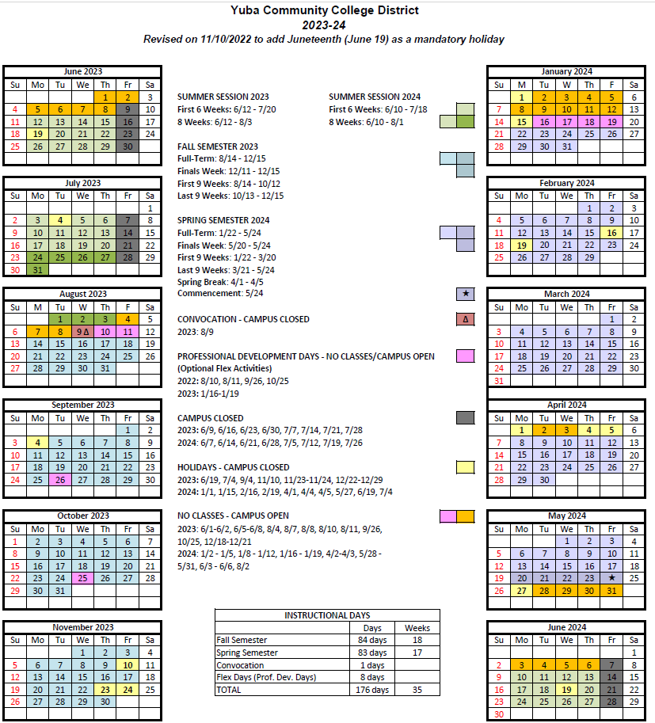

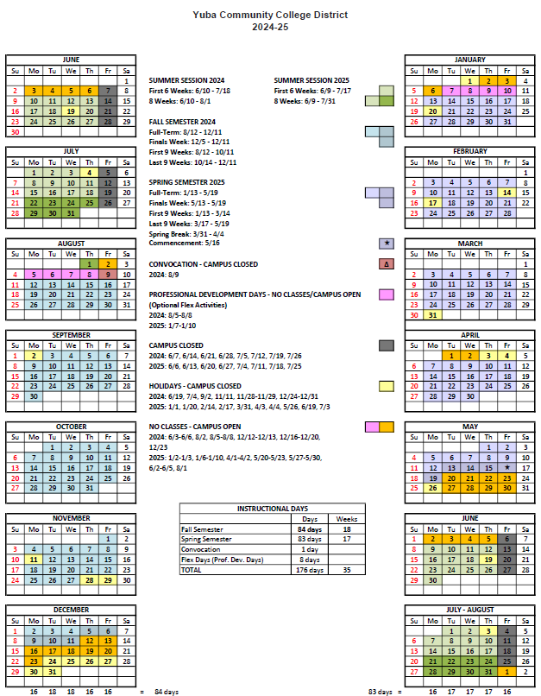
THE END.

