Addendum No. 1

RFP 23-06 WCC Repair and Paint Exterior Walls of Buildings 100, 300, 400, and 700
Date: 03/06/2024

Date: January 26, 2016

Clarifications:

- Question: Will a Builders Risk Insurance Policy or an Installation Floater policy be required for this project?
Answer: Yes, please refer to the Contractor Agreement for Services (CAFS) which describes all of the insurance requirements for this project.

Please refer to this link for this CAFS:

https://goyccd-my.sharepoint.com/:w:/g/personal/w0398409_yccd_edu/EaBRp_V8y2FEpsbPDJXZwc0BZy7a9eaponPsbLbN-RZ3-w?e=ih4g08

- Question: Does the Contractor need to paint the window mullions?
Answer: Yes, please paint the window cross bar mullions to match the rest of the frame and flashing.

- Question: Does the Contactor need to replace the failing window mullion and frame rubber seals that are either showing gaps or fall out of place?
Answer: Yes. All Window seals that are showing failure and falling out of place or if there are gaps in the end of the seals all need to be replaced. The District is modifying the Bid Form to include a place holder value for this at $20,000. Please refer to the updated Bid Form at the back of this Addendum No. 1.
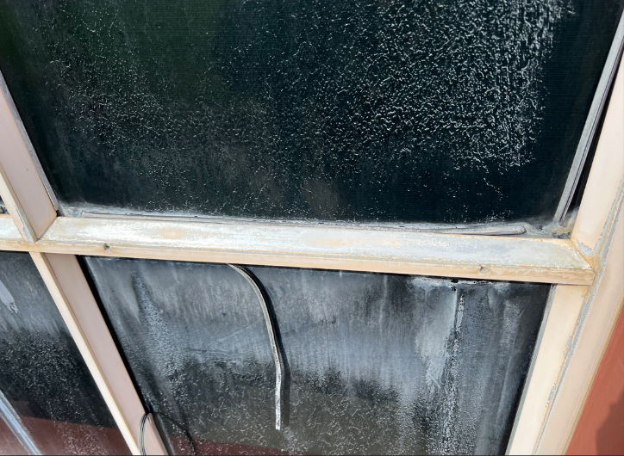
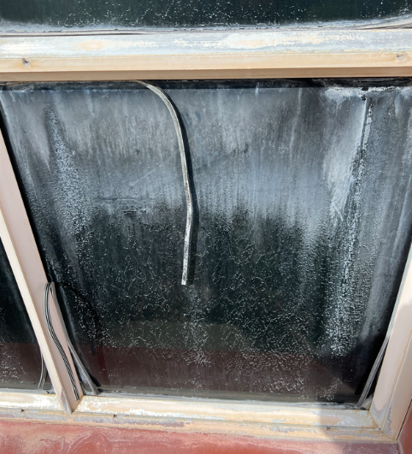

- Question: Does the Contractor need to fill in the damage divots and scrapes on the stucco to help provide a smoother and more consistent finish? For example, the south wall of building 400 has a lot of damage to the surface of the stucco from scrapes.

Answer: Yes, the stucco on this particular wall will need to be filled in and the finish of the stucco will need to be re-worked on this entire south wall of building 400. The existing stucco on this wall of building 400 will not need to be fully removed, just the top surface of the stucco will need to be re-worked to provide a consistent finish. I have added a placeholder value for the stucco of this wall of $10,000 on the updated Bid Form to rework the stucco finish on this wall.

- Question: Should the Contractor powerwash, prepare, repair, and paint the small chiller compound walls and steel gates just east of Building 700?
Answer: Yes, include this in the scope of work. I have added it as a line item on the revised Bid Form.
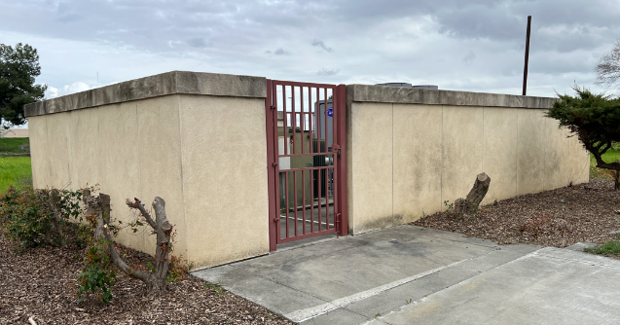

Appendix A: Revised Proposal Base Bid Form:
No. | Description | Cost
1 | Building 100 Power Washing, Repair and Caulk all connections and joints that connect to buildings, apply 1 Coat Primer/Sealer and 2 Coats Elastomeric Paint Coating, Back rolled. Include power washing, preparing, primer painting and painting all exterior doors frames, window frames and mullions, and accent flashing and trim pieces typical all buildings. | $
2 | Building 100 Remove and Replace Existing Stucco South Wall and South Entrance Columns Caulking, Primer and 2 Coats Painting. Repair all cracks and chips and damaged stucco areas to minimize the look of the patch yet have it blend in with the existing stucco finish. | $
3 | Building 100 Wood Framing Boards Repairs and Preparation for 1 coat Priming and 2 coats Painting: Include all exposed cracked and damaged wood. | $
4 | Building 300 Power Washing, Repair and Caulk all connections and joints that connect to buildings, apply 1 Coat Primer/Sealer and 2 Coats Elastomeric Paint Coating, Back rolled. . Include power washing, preparing, primer painting and painting all exterior doors frames, window frames and mullions, and accent flashing and trim pieces typical all buildings. | $
5 | Building 300 Repair all cracks and chips and damaged stucco areas to minimize the look of the patch yet have it blend in with the existing stucco finish. | $
6 | Building 300 Wood Framing Boards Repairs and Preparation for 1 coat Priming and 2 coats Painting: Include all exposed cracked and damaged wood. | $
7 | Paint Chiller Compound Gate (located south of building 300) | $
8 | Building 400 Power Washing, Repair and Caulk all connections and joints that connect to buildings, apply 1 Coat Primer/Sealer and 2 Coats Elastomeric Paint Coating, Back rolled. Include power washing, preparing, primer painting and painting all exterior doors frames, window frames and mullions, and accent flashing and trim pieces typical all buildings. | $
9 | Building 400 Completely remove and replace the east wall stucco, repair all cracks and chips and damaged stucco areas to minimize the look of the patch yet have it blend in with the existing stucco finish. | $
10 | Building 400 Wood Framing Boards Repairs and Preparation for 1 coat Priming and 2 coats Painting: Include all exposed cracked and damaged wood. | $
11 | Building 700 Power Washing, Repair and Caulk all connections and joints that connect to buildings, apply 1 Coat Primer/Sealer and 2 Coats Elastomeric Paint Coating, Back rolled. Include power washing, preparing, primer painting and painting all exterior doors frames, window frames and mullions, and accent flashing and trim pieces typical all buildings. | $
12 | Building 700 Repair all cracks and chips and damaged stucco areas to minimize the look of the patch yet have it blend in with the existing stucco finish. | $
13 | Building 700 Wood Framing Boards Repairs and Preparation for 1 coat Priming and 2 coats Painting: Include all exposed cracked and damaged wood. | $
14 | Building 700 Paint Architectural Steel Fence and Gate around Courtyard. | $
15 | Building 700 Wood Framing Board Replacements as designated by the College/District: | $25,000
16 | Building 700 only: add new flashing on top of all wood framing members and short joist sections that stick out from the framing and walls so that all wood has flashing on top with 2” sides and ½? Drip edge all around, prepare and paint with 1 coat primer and two coats paint. | $
17 | Window Mullion and Frame Rubber Seals Replacements to ensure the windows are weather tight. | $20,000
18 | Building 400 South Wall Stucco Scrapes and Wall Re-Work to provide a smooth consistent surface | $10,000
19 | Building 700 East Chiller Compound Walls and Gates: Power wash, Repair, prepare surfaces, and Paint all Surfaces. | $
20 | *Contingencies--"Unforeseen Conditions" and other miscellaneous items approved by the College during the project. | $ 25,000
21 | Other | $
22 | Sub-Total Cost: | $
23 | Contractor Additive Alternate: | $
24 | Contractor Deductive Alternate: | $
25 | Total Costs: | $

This is a CUPCCAA project.

Prevailing wages apply to this project.

List all First Tier Sub-Contractors.

List Department of Industrial Relations (DIR) numbers for the Prime Contractor and First Tier Sub-Contractors.

Please round off numbers to the nearest dollar.

A preliminary overall start to finish project schedule is required with the proposal.

If funding does not allow, then, some of the above listed work may not be awarded.

This project requires a contractor “B” license.

The End.

