Request for Proposal
Yuba Community College District

Woodland Community College
Woodland Campus
Repair and Paint Exterior Walls of Buildings 100, 300, 400, and 700.
No. RFP 23-05

Issue Date: January 9, 2024
RFP Due: February 13, 2024

RFP Due Date: February 13, 1:00 PM Sharp, Location Delivered To:

Yuba Community College District, District Offices
Attn.: David Willis
District Director of Facilities Planning, Maintenance & Operations
RFP No. 23-05 WCC, Repair and Paint Exterior Walls of Buildings 100, 300, 400, and 700
Address: Sutter County Campus, Second Floor, District Offices, Attention: David Willis,
3301 East Onstott Road, Yuba City, California 95991

Proposal Delivery at Second Floor
Yuba Community College District
Sutter County Campus
District Offices
3301 East Onstott Road (second floor)
Yuba City, California, 95991

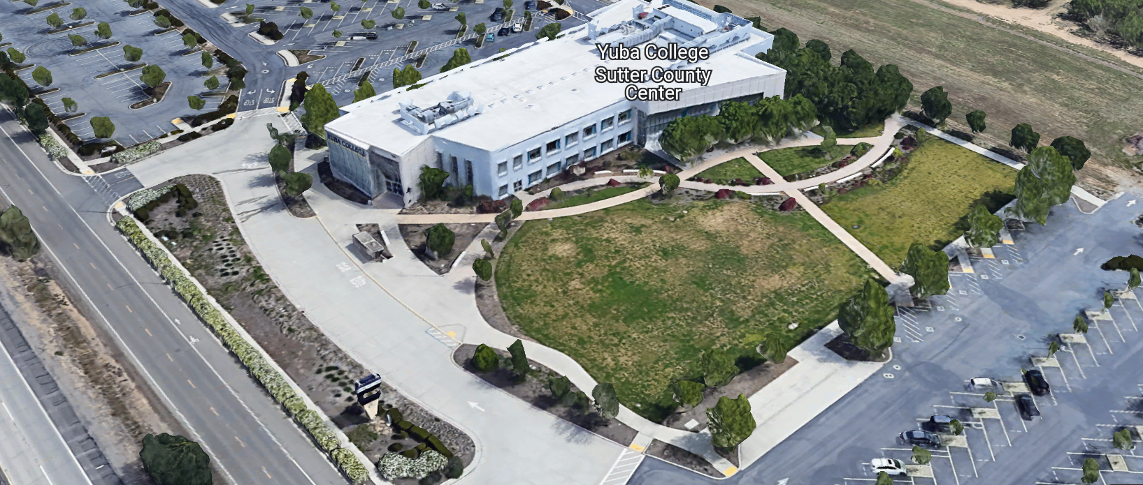
West Building Entrance

TABLE OF CONTENTS

1.0 INTRODUCTION
1.1 District Information
1.2 Yuba Community College District Background
1.3 Purpose of the Request
1.4 Applicable Codes
2.0 Scope of Work
2.1 Project Schedule
2.2 District Staff Contacts during Proposal Process
2.3 Project Safety Requirements
2.4 Demolition
3.0 Proposal Format Organization
3.1 Proposal Delivery, Contents, and Format
4.0 Selection of “Firm”
5.0 Basis of Award
6.0 Non-Discrimination
7.0 Response to Request for Proposal (RFP)
8.0 Requests for Information (RFI)
9.0 Proposal Schedule
10.0 District Parking
11.0 RFP Proposals
12.0 Award of Contract/Proposal
13.0 Reservation of Rights
14.0 Bid Bond Requirements
15.0 Performance Bond, Payment Bond Requirements
16.0 Liquidated Damages

Contractor Proposal Required Items:

Appendix A, Proposal Base Bid Form
Appendix B, Statement of Qualifications
Appendix C, Acknowledgement of Addenda Form
Appendix D, Non-Collusion Affidavit Form
Appendix E, YCCD Agreement for Services (AFS).
Appendix F, Signature Proposal Form
Appendix G, Contractor References
Appendix H, Contractors Project Approach, Safety, Protection of Existing Landscape, Exterior Sidewalks, Staffing Resources, Preliminary Schedule, etc…
Appendix I: YCCD District Tremco Paint Coating Direct Purchase Signature Form

Informational Items:
Appendix J: Project Team, Superintendent, Credentials, Experience, Contact Information.
Appendix K: YCCD Academic Calendars
Appendix L: Map of Woodland Community College Campus

1. INTRODUCTION

  - District Information:

The District consists of two colleges, Woodland Community College and Yuba College, with campuses located at six different locations: Yuba College in Marysville, CA; Sutter County Center in Yuba City, CA; Beale Education Center, Beale AFB, CA; Woodland Community College in Woodland, CA; Colusa County Center in Williams, CA; and Lake County Campus in Clearlake, CA.

  - Yuba Community College District

The Yuba Community College District (YCCD) was founded in 1927 and spans eight counties (Yuba, Sutter, Colusa, Yolo, Lake, Butte, Glenn and Placer) and nearly 4,200 square miles of territory in rural, north-central California. It has colleges in Marysville and Woodland, an educational center in Clearlake, an educational center in Williams, an educational center in Yuba City, and outreach operations at Beale Air Force Base.

  - Purpose of Request

The Yuba Community College District seeks proposals from qualified Licensed Contractors to prepare and paint the exterior walls of several buildings at the Woodland Community College campus.
Woodland Community College Campus Address: 2300 East Gibson Road, Woodland, Ca., 95776

  - Applicable Codes
All work shall meet all State of California Building Codes, and Federal codes, and local ordinances.
All projects at the District/College are prevailing wage projects.

- Scope of Work

The Yuba Community College District is accepting proposals for “RFP 23-05 WCC, Repair and Paint Exterior Walls of Buildings 100, 300, 400, and 700.

General Comments:

The Contractor is 100% responsible to coordinate and securely store materials, tools, equipment, and other items required for the project. The Contractor must receive, inspect, unload, move, properly store, and sign for all materials. No exceptions. All materials need to be locked up and stored properly. The construction area must be cleaned up and organized to reduce trip hazards. Deliveries that arrive without a Contractor representative on site will not likely be received. All materials must be as specified and pre-approved by the District before orders are placed or delivered. The District cannot pay for materials until they arrive on site.

The Contractor shall provide all waste removal in accordance with State regulations and provide the District with a waste manifest as support documentation for future progress payments.

The Contractor shall use and maintain barricades and rolled plastic construction fencing, and signs to delineate all project boundary areas. Barricade tape and delineators may be used if approved by the College.

The Contractor is expected to meet briefly as needed at the construction site, during the project with District/College staff at the project site to review progress, discuss issues, and provide a brief update on what is expected to occur as the project progresses.

The Contractor shall provide “Portable Restrooms” as needed.

The Contractor shall apply and follow all Cal-OSHA regulations. All required PPE shall be in good condition and used when needed to protect employees.
The District encourages a positive and open communication strategy that includes a sense of partnership and mutual success on its projects.
General Painting Comments:
A thorough and complete power-washing and cleaning of all exterior surfaces shall be made before any painting work is done. This powerwashing work must be done to the satisfaction of the College , and must be done to support a proper bond of the paint to the existing surfaces. If multiple power washes are required, then the contractor is required to provide these cleanings. All painting equipment shall be in good working order and appropriate for the painting applications per the manufacturer specifications. No clumps of paint shall be allowed to be sprayed out over the walls. The sprayed paint shall be consistent and very small particles that provide an even layer of coating. All painting work shall be of high quality, free of drips, runs, and overspray. All paint coatings shall be applied at the manufacturer rates and shall follow all manufacturer applications preparation and application instructions and requirements. No paint shall be applied if these conditions are not met. If the weather conditions are forecast to turn wet and rainy, then painting work shall not be done on that day. Special precautions shall be made to protect landscape, sidewalks, windows, roof materials, and vehicles in the area from overspray, drips, and spills. The contractor shall not pour any waste paint down the drain at the College. If concrete sidewalks are cracked or damaged with paint spills that cannot be cleaned up, then, the contractor shall replace the concrete to the full satisfaction of the College. All work shall be planned and scheduled in advance. All entrances to the buildings shall be maintained in a safe way so that there is no risk of overhead or painting work for those entering the building. All paint containers shall arrive to the campus in sealed (not previously opened) containers. All safety data sheets for all chemicals shall be provided and be at the project site during painting. The contractor shall provide all power (generators) needed for paint sprayers. All required PPE shall be worn at all times to meet all CAL OSHA requirements. All ladders shall be in very good condition and properly tied off.
Paint colors shall match existing colors. All products and paint colors shall be submitted as a submittal prior to ordering any materials for this project.
General Stucco Repair Comments:
Building 100: Remove and Replace the Stucco on the entire south wall of building 100. Include the stucco around the entrance columns.
Buildings 100, 300, 400, and 700:
Remove and patch all large crack areas. Seal all existing cracks prior to painting. The finish product shall not show crack repairs. The crack repairs shall be made to provide a consistent look and aesthetic appearance.

General Wood Framing Repairs and Repainting:
Excessively rotted wood framing shall be replaced with treated wood. All new wood to be clear and knot free as much as possible.
Weathered wood with cracks shall be sanded and cracks filled and all exterior surfaces shall be sanded smooth and prepared for painting. All connections to existing buildings shall be caulked with Sika-Flex exterior rated paintable elastomeric caulking.
All wood framing without a flashing cap and drip edge shall have a new flashing cap fabricated and installed, prepared, and painted over the top of the existing wood. The sides of the flashing shall extend at least 2” with a 1/” drip edge. Existing wood framing flashing caps shall remain, be prepared and repainted.
The Contractor is 100% responsible for all waste material disposal. All nails, debris, etc… shall be cleaned up around the buildings. Any spills or spots on the existing concrete shall be cleaned up and repaired.
Damaged landscape and irrigation systems shall be repaired to the satisfaction of the College. Protection of all trees, bushes, grass, and other planting areas shall be made by the contractor.
2.1 Project schedule
Approximate Award Date: March 29, 2024
Substantial Completion Date: July 31, 2024
100% Completion Date: August 12, 2024
The contractor may work whatever hours are needed Monday through Friday. Normal working hours are 6:30am to 3:30pm but can be adjusted to meet whatever the Contractor needs.
The District is closed on Fridays during June and July. The Contractor may still work on days that the District is closed.
This is a prevailing wage project. The Contractor is required to upload all certified payroll information to the Department of Industrial (DIR) Relations web site. YCCD will provide a DIR project number.
Provide a brief project schedule with the proposal with the completion date clearly shown.

2.2 District Staff Contacts during the Proposal process:
Firms interested in submitting a Proposal are directed not to make personal contact with the Board of Trustees, District staff, or members of the evaluation committee. Any contact shall constitute grounds for disqualification from consideration.
Single Point of Contact during the Proposal Preparation Process:
David L. Willis
District Director of Maintenance, Operations, and Planning
425 Plumas Blvd., Suite 200 (Second Floor)
Yuba City, California, 95991
Cell Phone: 916-747-4262
Email: dwillis@yccd.edu

On-site coordination, first contact person access and immediate contact person during construction OR if additional site visits are needed during the bidding process.
Brian Splaine
Assistant Director of Maintenance, Operations
2300 East Gibson Road, Woodland, California, 95776
Work Phone: 530-668-3690
Email: bspaine@yccd.edu

No changes can be made to the project scope without authorization in writing by David Willis.

2.3 Project Safety and Security Requirements

Safety is a top priority for the District. All California OSHA requirements apply. Industry best practices apply. Contractor employees shall wear shirts with sleeves, a hard hat, eye protection, hearing protection as needed, gloves, substantial leather footwear, long pants, a reflective safety vest, and take all needed precautions to complete the work in a safe manner. Safety shall not be compromised at all during the work.
Enhanced fall protection precautions shall be taken. During windy conditions, precautions shall be taken to ensure the safety of staff and to properly secure materials and debris. The Contractor shall also take precautions during windy days if there are any risks of material being carried by the wind and deposited on vehicles or other surfaces.
The affected areas of construction shall be properly barricaded, have signs placed, and all reasonable precautions taken to keep staff and students out of the project boundary areas. Debris shall be removed promptly. Protection of College property shall be taken. Contractor is 100% responsible for any damage to College property and facilities.
These campuses have a moderate risk of theft. It is the sole responsibility of the Contractor to receive and secure all materials, equipment, tools, monument signs, and other items associated with this work.
2.4 Demolition
The contractor shall provide a debris waste manifest for all items removed from the campus. Debris and waste shall be processed in accordance with all State and Federal codes, laws, and ordinances.
3.0 Proposal Format Organization
The Firm is requested to use the following proposal format:
3.1. Proposal Delivery, Contents, and Format:
Proposals should provide straightforward, concise information that satisfies the requirements noted in this RFP. Expensive binding, color displays, and the like are discouraged. Emphasis should be placed on brevity, conformity to the Districts instructions, selection criteria of this RFP, and completeness and clarity of content. Each Respondent’s proposal should clearly and accurately demonstrate specialized knowledge and experience required for consideration.
In a sealed box or envelope (clearly marked “), submit the following:
- One (1) flash memory stick containing the complete proposal and supporting documentation;
- One (1) original signed copy in paper form of the proposal, which consists of a Proposal Letter and responses to the proposal requirements of this RFP.

There is no page limit.

Firms must comply with the provisions of these instructions for completion and submission of the Proposal. The failure of a Firm to comply with the Proposal Instructions and Requirements will likely result (at the sole discretion of the District) in rejection of the Proposal for non-responsiveness.
Proposal Section | Format
- Cover Letter | PDF
- Table of Contents | PDF
Appendices (See Table of Contents for each one) Submit a response to each Appendix that requires Contractor information. Please submit responses to Appendices A, B, C, D, E, F, G, and H. Appendices I, J, K, and L are informational only. | PDF

Proposal General Information Contents:

Cover Letter

The Proposal shall include a Cover Letter on Respondent’s official business letterhead, which shall be signed by an individual authorized to legally bind Respondent. The Cover Letter shall also identify the name, telephone number, and email of a person who may be contacted during the Proposal evaluation process.

Table of Contents

Provide a Table of Contents that outlines in sequential order the major sections and sub-sections of the Proposal. Use tabs to allow information to be more easily located.

4.0 Selection of “Firm” Services Provider

The process of “Firm” selection is based upon the complete responsiveness of the RFP and the criteria as outlined in the RFP.

The District Project Evaluation Team will read the written proposals. The District Evaluation Team will discuss the proposals and verify that the “Basis of Award” information below and information submitted in response to the RFP are complete and responsive.

The District reserves the right to reject any or all submittals, to amend the RFP process, and to discontinue or re-open the process at any time. The District reserves the right to request clarifications to RFP responses and to negotiate the terms of the agreement.

5.0 Basis of Award

This project will be awarded based on the following criteria:

- Lowest Total Cost Responsive Qualified Bidder
  - Lowest Total Cost
  - Contractor Capability to do the work
  - Qualified Contractor (per section 1.3 and below)
    - Proper State of California Contractor License in good standing
    - Information provided as requested in the RFP.
    - All Addendums are acknowledged.
    - Contractor listed any exceptions or exclusions. Contractors should bid the project per the RFP and contract documents (using specified products) and then offer exceptions and exclusions or cost deductive or additive alternatives separately from the base bid.
    - Contractors with historical good performance on YCCD projects regarding minimal number and cost of change orders, maintaining project schedules and completing the work promptly, and overall quality of work. It is not required that contractors have previously completed similar work for the District.
    - Contractors ability to meet schedule requirements.
    - Contractors have demonstrated past project references of “like” projects
    - Contractors professional references are within the past 10 years and demonstrate projects completed on schedule (within 30 days) of the original completion date, with less than 5% change orders (other than owner requested items), and with good quality results.
    - No other factors such as litigation, licenses in good standing, or other similar criteria.
    - At least ten (10) project references of similar projects completed in the past five (5) years with contact information, scope of work, initial awarded cost, change orders cost, pictures if possible.

The one or two lowest total cost responsive qualified bidder’s may be requested to participate in a ZOOM interview process with the District Project Proposal Evaluation Team.

6.0 Non-Discrimination
The District does not discriminate with regard to race, color, gender, national origin, disability, or any other protected or other classification in the awarding of contracts/agreements. The District welcomes all Qualified Firms to participate in the project Request for Qualification/Proposal process.
The District encourages firms that are women or minority owned, emerging small businesses, veteran owned firms, disabled person owned firms, and all other qualified firms to participate in the proposal process.
The District encourages the submission of proposals from all Firms that can meet the stated requirements set for this RFP.
7.0 Responses to RFP:
Sealed responses to this RFP must be clearly marked "RFP No. 23-05 WCC, Repair and Paint Exterior Walls of Buildings 100, 300, 400, and 700”.

Responses shall be mailed to or hand-delivered to the following address:

Yuba Community College District, District Offices
Attn.: David Willis
District Director of Facilities Planning, Maintenance & Operations

Envelope/Box Marked:
"RFP No. 23-05 WCC, Repair and Paint Exterior Walls of Buildings 100, 300, 400, and 700”.

Address: Sutter County Center, Second Floor, District Offices, Room 219, Attention: David Willis, 3301 East Onstott Road, Yuba City, California 95991.

Note: Completely seal your proposals in envelope/box and make sure it gets date/time stamped when delivering proposal. Firms are each 100% responsible to make sure proposals that are mailed using a carrier such as UPS, FED Ex, etc…are received and date/time stamped by District personnel prior to the proposal due date/time. No proposals will be considered if they are late, even if it is only 5 minutes late. Please make sure your proposals are delivered and received promptly prior to the due date/time. There will be a public proposal opening at the due date/time.

Do NOT email your proposals. Emailed proposals that are not sent per the above guidance requirements will not be considered.

8.0 Requests for Information (RFI)

Requests for Information concerning the RFP must be in writing and may be submitted via email no later than the date shown below. Please direct all questions to David Willis, email: dwillis@yccd.edu.

Following the RFI deadline, all questions and answers will be summarized and posted on the District's website: https://www.yccd.edu/central-services/purchasing/ , then, click on the “Requests for Proposals / Quotes” tab on the right hand side of this web page. It is anticipated that responses to inquires received by the required time and date will be provided within 5 business days and posted on the District's website or responded to per the dates listed in the RFP for addendum publishing. Should more time be needed by the District to answer I respond to RFI’s, this information will also be posted on the above website.

- Include the following in the subject matter field on emails when requesting information: “RFP 23-05”, RFI.

9.0 Proposal Schedule:

Important Dates and Times:

January 9,2024: Release of Request for Proposal

All Pre-Bid Meetings Are Optional.

January 23, 2024: 1:00pm to 2:00pm Optional ZOOM Pre-Bid Meeting

Join Zoom Meeting: https://yccd-edu.zoom.us/j/85949320805

Dial by your location: +1 669 444 9171 US

January 24, 2024: 1pm to 2pm, Optional ON Campus Pre-Bid Meeting at the Woodland Community College Campus, Building 100, Room 113, 2300 East Gibson Road, Woodland, California 95776.

If you need to visit the campus during an alternative time/date, please coordinate Brian Splaine below to coordinate access:

Brian Splaine
Assistant Director of Maintenance, Operations
2300 East Gibson Road, Woodland, California, 95776
Work Phone: 530-668-3690
Email: bspaine@yccd.edu

February 5, 2024: 5:00 PM, All questions and requests for information must be submitted to David Willis at: dwillis@yccd.edu.

February 6, 2024: 5:00 PM, Addendum Issued if needed.

February 13, 2024: Proposals due at 1:00 PM SHARP, Yuba Community College District, Sutter County Center, District Offices, Second Floor, Room 219, Attention: David Willis, 3301 East Onstott Road, Yuba City, California, 95991. There will be a public bid opening on this RFP.

This is a prevailing wage project.

This is a CUPCCAA project.

10.0 District Parking: Parking Fees—Not Applicable

11.0 RFP Proposals

Proposals received after the deadline will not be opened. Each responder shall submit one (1) signed original hard paper copy, all in separate binders. Provide one electronic format copy of the proposal using electronic media such as a flash drive. (No CD formatted Disks).

All materials submitted in response to the RFP shall be on 8-1/2"x11" paper, preferably in
Portrait orientation. All submitted materials must be bound in either a three-ring binder or spiral bound notebook. Content shall be tabbed and numbered per the items included in the Submittal Requirements. All Proposals will be reviewed and evaluated by a District Selection Committee. The District at its sole discretion may interview finalists or select a firm or firms to perform work based solely on the evaluation of the Proposal. There is no page limit.

All Proposals become the sole property of the District and the content will be held confidential.

12.0 Award of Contract

- The Contract will be awarded to the lowest total cost, most responsive responsible District qualified, and Tremco Manufacturer authorized and certified applicator contractor, whose proposal, conforming to the request for proposal and associated addendums, will be most advantageous to the District.

B. The District reserves the right to enter into an Agreement without further discussion of the proposal submitted based on the initial offers received.

C. The District reserves the right to reject any or all proposals or any part of the proposal and to waive informalities and minor irregularities in the proposals received.

D. The RFP, its addendums, any follow-up clarifying information, and the proposal of the selected Firm will become part of any contract initiated by the District.

E. A formal contract shall be signed by the successful proposer and Yuba Community College District to perform this service.

F. The District reserves the right to enter into discussions with any one or all of the Responders after Proposals have been initially reviewed. Such responses shall be subject to all provisions, terms and conditions as set forth in the RFP, unless otherwise modified.

G. The District intends to award to a single RFP Responder.

H. BONDS: The Contractors Performance and Payment bonds are required within 7 calendar days after the award of the project with a purchase order. The Bid Bond is required with the proposal.

I. Failure to acknowledge all of the addendums, provide the items listed in the RFP, may render the proposal unresponsive at the discretion of the District. Items listed in the RFP become part of the contract unless the Contractor provides an exception in the proposal. Contractor exceptions, depending on the magnitude, may render the proposal unresponsive, at the discretion of the District.

J. The District reserves the right to request clarification of proposal content during the review and evaluation process.

K. The District reserves the right to negotiate the terms of the agreement to align with budgetary constraints.

L. Due to the heightened risk of illness that could then affect the performance of the Contractor, Firms with multiple employee work teams and the resources to adapt and complete the scope of work per the RFP, will be perceived to provide enhanced service and value during the evaluation process.

13.0 Reservation of Rights

The District reserves the right to:

- Reject any or all submittals at its sole discretions.
- Cancel the Request for Proposal (RFP), without cause.
- Modify any requirements contained within the RFP and request a revised submission from all Providers.
- Establish other evaluation criteria determined to be in the best interest of the District.
- Contract with any of the firms responding to the RFP based solely upon its judgment of the qualifications and capabilities of the firm.
- Clarify the content of any proposal to verify that the requirements of the RFP are included.
- Waive “minor” proposal inconsistencies that do not change the scope of work as outlined in the RFP.
- Request an alternative Superintendent on the project if the initially assigned Superintendent on the project is not performing well, not meeting project requirements, not working well with College staff and students, not applying best practice safety methods, OR not following College/District guidance regarding project approach. If the owner is the Superintendent, and has been replaced, the owner may visit the project briefly (less than 1 hour per day up to 2 times per week) to coordinate with the replacement Superintendent.
- The District will not allow or tolerate verbal abuse or any other type of abuse by the Contractor toward any College or District personnel or Contracted professional service providers. Abuse, defined solely by the District as verbal or physical, or written, may lead to a “Stop Work” order by the District until it can be resolved, and steps taken to ensure abuse is not repeated. If abuse occurs again, the District may issue a final “Stop Work” order, require the Contractor to leave the College/District project site and process a Performance Bond claim to complete the work. All costs associated with District “Stop Orders” are 100% the responsibility of the Contractor.
- Disqualify a Contractor after reviewing the proposal and finding concerning performance information in references, inadequate or incomplete proposal information, and historically poor project performance at the District/Colleges (as solely defined by the District).

This RFP does not commit the District to award or negotiate a contract. The District will not be responsible for any expenses incurred by any firm in preparing and submitting a proposal or response to this RFP or in completing any of the work specified.

14. Bid Bond Requirements (Proposed Form—Contractor can use their standard form):

BID BOND

Know all persons by these presents:

That we, , as Principal, and , as Surety, are held and firmly bound unto Yuba Community College District, hereinafter called District, the sum of ten percent (10%) of the total bid amount of Principal for payment of which in lawful money of the United States, well and truly to be made, we bind ourselves, our heirs, executors, administrators, successors, and assigns, jointly and severally, firmly by these presents.

The condition of the above obligation is such that, whereas, the Principal has submitted a bid for the work described as follows: RFP 23-05 WCC, Repair and Paint Exterior Walls of Buildings 100, 300, 400, and 700.

Now, therefore, if Principal shall not withdraw said bid within the time period specified after the bid date, as defined in the bidding documents, or within ninety (90) days after the bid date if no time period is specified, and, if selected as the apparent lowest responsive responsible bidder, Principal shall, within the time period specified in the bidding documents: Enter into a written agreement, in the form prescribed in the bidding documents, in accordance with its bid; file with the District all bonds required to be filed, including but not limited to faithful performance and payments bonds; and, furnish certificates of insurance and all other items required by the bidding documents.

In the event of the withdrawal of said bid within the time period specified, or within ninety (90) days if no time period is specified, or the failure of Principal to enter into such agreement and furnish such bonds, certificates of insurance, and all other items as required by the bidding documents, if Principal shall pay to the District an amount to the difference, between the amount specified in said bid and such larger amount for which the District procures the work covered by the bid, if the latter is in excess of the former, then this obligation shall be null and void, otherwise to remain in full force and effect.

In the event suit is brought upon this bond by District, in addition to the penal sum of this Bid Bond, Surety shall pay reasonable attorneys’ fees and costs incurred by District in such suit.

Surety hereby expressly waives the provisions of California Civil Code section 2845.

In witness whereof, we have hereunto set our hands this day of , 20 .

Principal: Surety: (Name of firm)

By: By:

Title: Title:

Broker Name or Agent Name:

License Number:

Bond or company appointment must be listed with the CA Department of Insurance Notary acknowledgments for Surety and Surety’s Power of Attorney must be attached.

Address for Notices:

Bid Bond Requirements:
Provide a Bid Bond per the following:

PUBLIC CONTRACT CODE - PCC

DIVISION 2. GENERAL PROVISIONS [1100 - 22355]

ARTICLE 4. Bids and Bidders [10160 - 10169]
( Article 4 enacted by Stats. 1981, Ch. 306. )
Section: 10167.
    - All bids shall be presented under sealed cover and accompanied by one of the following forms of bidder’s security:
      - An electronic bidder’s bond by an admitted surety insurer submitted using an electronic registry service approved by the department advertising the contract.
      - A signed bidder’s bond by an admitted surety insurer received by the department advertising the contract.
      - Cash, a cashier’s check, or certified check received by, and made payable to, the director of the department advertising the contract.
    - The required bidder’s security shall be in an amount equal to at least 10 percent of the amount bid. A bid shall not be considered unless one of the forms of bidder’s security is enclosed with it.
    - All bids submitted pursuant to this section shall also comply with the provisions of Section 1601 of the Public Contract Code.
(Amended by Stats. 2012, Ch. 290, Sec. 3. Effective January 1, 2013.)

The Bid Bond shall be provided with the Contractor’s Proposal.

15. Performance and Payment Bond Requirements: Required for this project and described in the District Agreement for Services form (Appendix E, Agreement for Services). The Performance and Payment bonds are due 7 to 10 days after the award date.

16.0 Liquidated Damages:
Liquidated damages of $500/ calendar day will be imposed by the District to the Contractor every calendar day after October 1, 2024. The Liquidated Damages will be withheld from the contractor’s 5% retainage on the project until it is exhausted, then, it will become a performance bond claim.
Exceptions: If weather conditions impact the schedule, it may be extended as mutually agreed between the Contractor and the District. Another exception may be granted if the paint is not available due to documented extended supply chain issues.
The Contractor is however encouraged to complete the work asap and by the mentioned dates in this RFP unless otherwise mutually agreed upon by the Contractor and the District due to factors that are outside the control of the Contractor. Other projects that the Contractor is or may be awarded do not qualify for a time extension after October 1, 2024.
Appendix A: Proposal Base Bid Form:

No. | Description | Cost
1 | Building 100 Power Washing, Stucco Repair, 2 Coats Painting. | $
2 | Building 100 Wood Entrance Framing Repairs, Cap Flashing, Wood Crack Filler, Rotten Boards Replacements, Caulking, Primer and 2 Coats Painting. | $
3 | Building 300 Power Washing, Stucco Repair, 2 Coats Painting. | $
4 | Building 300 Wood Entrance Framing Repairs, Cap Flashing, Wood Crack Filler, Rotten Boards Replacements, Caulking, Primer and 2 Coats Painting. | $
5 | Paint Chiller Compound Gate (located south of building 300) | $
6 | Building 400 Power Washing, Stucco Repair, 2 Coats Painting. | $
7 | Building 400 Wood Entrance Framing Repairs, Cap Flashing, Wood Crack Filler, Rotten Boards Replacements, Caulking, Primer and 2 Coats Painting. | $
8 | Building 700 Power Washing, Stucco Repair, 2 Coats Painting. | $
9 | Building 700 Wood Entrance Framing Repairs, Cap Flashing, Wood Crack Filler, Rotten Boards Replacements, Caulking, Primer and 2 Coats Painting. | $
10 | Building 700 Paint Architectural Steel Fence and Gate around Courtyard. | $
11 | Other: | $
12 | Sub-Total Cost: | $
13 | *Contingencies--"Unforeseen Conditions" and other miscellaneous items approved by the College during the project. | $ 15,000.00
14 | Total Costs: | $

This is a CUPCCAA project.

Prevailing wages apply to this project.

List all First Tier Sub-Contractors.

List Department of Industrial Relations (DIR) numbers for the Prime Contractor and First Tier Sub-Contractors.

Please round off numbers to the nearest dollar.

A preliminary overall start to finish project schedule is required with the proposal.

If funding does not allow, then, some of the above listed work may not be awarded.

Appendix B: Statement of Qualifications Form
The Firm shall furnish the following information. Failure to comply with this requirement will render the submittal informal and may cause its rejection. Additional sheets may be attached if necessary.
Basic Firm Informational Items 1 through 17:

- Firm Name:___________________________________________________________________

- Primary Address: ______________________________________________________________

- Firm’s Contact Person and Title:___________________________________________________

- Telephone: ___________ Facsimile: ____________________

- Email Address: ___________________

- License No.: ______________________________ Class: __________________________

Responsible Managing Employee/Officer:_________________________________________

- DIR Registration No.:________________________ Expiration Date:___________________

- Names and titles of two officers of the Firm:

NAME TITLE

___________________________________ _______________________________________

___________________________________ _______________________________________

9. Specific type of Ownership (Check one)

Individual
Partnership
Corporation; If a corporation, state the following:

State of incorporation:
Date of incorporation: President/CEO:
Joint Venture
Other (Specify)

- Taxpayer Identification No.: _______________________
- List annual gross income for last three (3) years:
Year: _______________ $_____________________
Year: _______________ $_____________________
Year: _______________ $_____________________

- Number of years Firm has been in business:
If less than 5 years, please describe:

- Number of years Firm has conducted business under the present name:__________
- Has the Firm ever been licensed under a different name or different license number? . If Yes, give name(s) and license number(s) and dates or operation under that name(s) and license number(s) (attach separate sheets if necessary):___________________________________________ _________________________________________________________ _________________________________________________________
- Number of years’ experience in California Community College, University or educational facility projects .

- Do you now or have you ever had any direct or indirect business, financial or other connection with any official, employee or consultant of the District? ___. If Yes, please elaborate:
_________________________________________________________

- Has the Firm ever completed any work at the Yuba Community College District? If Yes, please elaborate:

Potentially Disqualifying Questions 18 through 30 (District may immediately disqualify Firm if its answer to any of Questions 18 through 26 is “Yes” or if the answer to questions 27 through 30 is “No”. Firm’s refusal to answer or omission of response to any of Questions 18 through 30 may result in disqualification of Firm.):

- Does the Firm possess a valid and currently in good standing California Contractors’ license for the classification(s) of Contractors’ License required for the Project? If Yes provide the license number(s). Yes/No______________________________________________________

- Has the Firm been defaulted or terminated (other than for convenience) by any California school district, community college district or other California public agency on any project within the past 5 years? Yes/No

If yes, identify agency and details:

- Has the Firm or any of its principals defaulted so as to cause a loss to a surety on a payment or performance bond? Yes/No

If yes, give dates, name and address of surety, and details:

- Has the Firm or any of its owners, officers, or partners, ever been convicted of a crime, or found guilty in a criminal action, involving fraud, theft, making any false claim or material representation to a public agency, or involving any federal, stet, or local law, rule, or regulation related to construction? Yes/No_____

If yes, explain, identify the agency, and provide case name and number.

- Has the Firm been assessed liquidated damages for any project in the past five years? Yes/No If so, identify owner and details:

- Has the Firm been disqualified, debarred, forbidden, or found non-responsible or otherwise prohibited from performing work or bidding won work for any California school district, community college district, or other California public agency within the past five years? Yes/No

If yes, identify agency and details:

- Has the Firm been in litigation (whether in court or arbitration) with any California school district, community college district, or other California public agency on an issue pertaining to any contract during the past five years? Yes/No:

If yes, explain, identify the agency, and provide case name and number.

- Has the Firm ever failed to complete a project in the past five years? Yes/No: If so, give owner and details:

- Is the Firm currently or has the Firm been in a state of “Bankruptcy” in the past five years? Yes/No:
If yes, please explain.

- Can the Firm provide at least up to $ 400,000 in bonding capacity for this project?
If no, please explain.

- Does the Firm have a liability insurance policy (project) limit of at least $1,000,000 per occurrence and $2,000,000 aggregate?
If no, please explain.

- Does the Firm have a current workers’ compensation insurance policy as required by the Labor Code or is legally self-insured pursuant to Labor Code Sections 3700 et seq.?
If no, please explain.

- Does the Firm have project experience that includes exterior wall repairs, stucco repairs, wood framing replacements, flashing installation, and repainting multiple buildings at a College/University setting? Yes/No
If no, please explain.

- Has this Firm every completed any similar projects at Yuba Community College District? Yes/No
If no, please explain.

Note: Firms with historically poor performance on projects at Yuba Community College will be disqualified from consideration. Poor performance is 100% defined by the District as not meeting original schedule requirements, excessive change orders greater than 10% of the original awarded amount, and poor quality work.

Rating Questions 32 through 48:

- Please list and describe on separate sheets the Firm’s top 5 projects most recent (within the past 8 years) references with current contact information. At least three of the projects must have been completed for California public schools, community college districts, or other California public agencies. The project reference list should include the following criteria:
  - Project Name
  - Project Owner and Contact Information
  - Project Scope of Work
  - Original Contract Completion Date
  - Actual Project Completion Date
  - Original Contract Awarded Amount
  - Final Adjusted Contract Awarded Amount (with change orders)
  - Any issues that Firm had to overcome on the project

Scoring Criteria:
  - Multiple Projects with Similar Scope of Work (50 points)
  - Completed Multiple Projects on Schedule (up to 50 points)
  - Project Change Orders less than 5% (up to 50 points)
  - Project Completed at a Yuba Community College District Location with high quality, on schedule (within 60 days of original schedule), and less than 5% contractor requested change orders. (30 points)

Total points for Question 32: up to 180 points

- Please describe in detail, your Firm’s approach to maintaining a safe project while students, faculty, and staff will be occupying the building:

(Up to 10 points.)

- List your Firm’s Workers’ Compensation Experience Modification Rate (EMR) for the three most recent years. Your EMR should be issued to your Firm by your workers’ compensation insurance carrier.

Year _______ EMR _______

Year _______ EMR _______

Year _______ EMR _______

(EMR numbers under 1.0 = 20 points; 1.0 to 1.24 = 5 points; 1.25 to 1.49 = 1 point; 1.50+ = 0 points.)
- Has your Firm had any OSHA violations or citations and penalties levied against it in the past five years? If Yes, how many violations (and please explain)________
(0 = 10 points; 1 = 3 points; 2+ = 0 points.)

- How many years has your Firm been in business in California as a contractor under your present business name and license number? __________
(less than 5 years = 0 points; 5-10 years = 10 points; 10+ years = 20 points.)

- In the last 10 years, how many legal proceedings (filed in court or arbitrations) has your Firm initiated against an owner, regardless of outcome? _______
(0 = 10 points; 1 = 3 points; 2+ = 0 points.)

- In the last 10 years, how many legal proceedings (filed in court or arbitrations) has an owner initiated against your Firm, regardless of outcome? _______
(0 = 20 points; 1 = 5 points; 2+ = 0 points.)

- Has any insurance carrier, for any policy of insurance, refused to renew a policy, or terminated a policy, for your Firm within the last five years? _____
(No = 10 points; Yes = 0 points.)

- Have any of your Firm’s employees or any other persons or entities filed a complaint against your Firm with the California Contractors State License Board within the last five years? If Yes, how many complaints were filed? ________________
(No = 10 points; 1-2 = 5 points; 3+ = 0 points.)

- Was your Firm required to pay either back wages or penalties for your Firm’s failure to comply with the state’s prevailing wage laws within the last five years? If Yes, identify the number of violations. ________________
(No = 10 points; 1-2 = 5 points; 3+ = 0 points.)

- Has any owner made a demand on a performance bond issued to your Firm on any construction project within the last 10 years? ________
(No = 10 points; Yes = 0 points.)

- Has any surety company made any payments on your Firm’s behalf as a result of a default to satisfy any claims made against a performance or payment bond issued on your Firm’s behalf in connection with any construction project within the last five years? _____
(No = 10 points; Yes = 0 points.)

- Has your Firm been denied bond coverage by a surety company, or was there a period of time when your Firm had no surety bond in place during a public construction project when one was required, within the last five years? _______
(No = 10 points; Yes = 0 points.)

- Has your Firm been denied an award of public works contract based on a public agency’s finding that your Firm was not a responsible bidder within the last five years? ______
(No = 10 points; Yes = 0 points.)

- Please describe the Capability/Capacity of your Firm. Please provide a comprehensive list of projects that the Contractor has in process and reasoning/justification regarding how the Contractor has capacity to perform the required construction services on this project.

(Up to 30 points.)

- Please describe the Firm’s commitment to maintaining a construction schedule. How will the Firm recover the schedule if it slips due to weather or COVID-19 or similar illness impacts, or the Firm gets busy with other projects? Please describe specific actions the Firm will take to maintain the Project schedule.

(Up to 30 points.)

- Please describe the Firm’s commitment to meeting regularly at project team meetings, maintaining positive communication, providing progress updates, and providing timely RFI’s and support information during the Project. Please describe specific actions the Firm will commit to maintain a positive relationship with the District and the applicable College through the above description:

(Up to 20 points.)

Qualification Criteria:
Questions 1 through 17 are general base level information that is required for pre-qualification.
Questions 18 through 31 are possible disqualifying questions that would render the Firm “not qualified” as determined by the District.
Questions 32 through 48 are rating questions that are scored and more deeply evaluated. Not scoring the minimum threshold value will render the Firm “not qualified”.
  - The District can disqualify a Firm (at it’s sole discretion) if the Firm does not meet the requirements of Questions 18 through 31.
  - There are a total of 400 points possible for questions 32 through 48.
  - To be determined as a qualified Firm, each Firm must score at least 340 points, and meet the minimum project experience noted in question 31.

Firms will be notified if they are determined meet minimum qualification criteria.

The undersigned is duly authorized to execute this Statement of Qualifications under penalty of perjury on behalf of the above-identified Firm. The undersigned warrants and represents that he/she has personal knowledge of each of the responses to this Statement of Qualifications and/or that he/she has conducted all necessary and appropriate inquiries to determine the truth, completeness, and accuracy of responses to this Statement of Qualifications. The undersigned declares and certifies that the responses to this Statement of Qualifications are complete and accurate; there are no omissions of material fact or information that render any response to be false or misleading and there are no misstatements of fact in any of the responses. The above-identified Firm acknowledges and agrees that if the District determines that any response herein is false or misleading or contains misstatements of fact so as to be false or misleading, the District may find the Firm is not qualified and the District can reject the proposal for non-responsiveness or non-responsibility.

Executed this___ day of __________________ 20__ at_____________________________.
(City and State)
I declare under penalty of perjury under California law that the foregoing is true and correct.

By: ____________________________________________
(Signature of Firm’s Authorized Officer or Representative)

____________________________________________
(Typed or Printed Name)

Title: ___________________________________________

Appendix C: Acknowledgement of Addenda Form
If applicable, the Firm acknowledges receipt of the following addenda from the District pursuant to the Request for Qualifications:
Acknowledgement: Yes or Not Applicable
Addendum No. 1: .
Addendum No. 2: .
Addendum No. 3: .
Addendum No. 4: .
Addendum No. 5: .

Firms are required to acknowledge all addenda’s within the submitted proposal at the time of submission.

Appendix D: Non-Collusion Affidavit Form

STATE OF CALIFORNIA, COUNTY OF I, being first duly sworn, deposes and says that I am the of , the party submitting the foregoing proposal (“the Proposal”). In connection with the foregoing Proposal, the undersigned declares, states and certifies that:
- The Proposal is not made in the interest of, or on behalf of, any undisclosed person, partnership, company, association, organization or corporation.
- The Proposal is genuine and not collusive or a sham.
- The Firm has not directly or indirectly induced or solicited another Firm to put in a false or sham proposal, and has not directly or indirectly colluded, conspired, connived, or agreed with any other Firm or anyone else to put in a sham proposal, or to refrain from bidding.
- The Firm has not in any manner, directly or indirectly, sought by agreement, communication, or conference with anyone to fix the proposal price, or that of any other Firm, or to fix any overhead, profit or cost element of the proposal price or that of any other Firm, or to secure any advantage against the public body awarding the contract of anyone interested in the proposed contract.
- All statements contained in the Proposal and related documents are true.
- The Firm has not, directly or indirectly, submitted the proposal price or any breakdown thereof, or the contents there of, or divulged information or data relative thereto, or paid, and will not pay any fee to any person, corporation, partnership, company, association, organization, proposal depository, or to any member or agent thereof to effectuate a collusive or sham proposal.
Executed on this date: , 2024, at:

(City, County, and State)
I declare under penalty of perjury under the laws of the State of California that the foregoing is true and correct.
Signature Printed Name .
Address: .
Area Code & Phone Number: .
Note: In addition to other bid documents, bidders on public works projects are required by Public Contract Code section 7106 to submit a certification form that they have not colluded with another proposer.

Appendix E: YCCD Agreement for Services
Link:
https://goyccd-my.sharepoint.com/:w:/g/personal/w0398409_yccd_edu/ERasNpZMXrZBlfby0g4mpnwB-166m9AZcVoqBTy8HXS-jw?e=PvTksJ
This agreement is optional at the time of the proposal submission.
The successful Firm will be required to provide this agreement within 7 days after requested by the District.

Appendix “F” Proposal Signature Form
The undersigned acknowledges the following:
- Having become familiar with the specifications and requirements of the Request for Proposal, hereby offers to provide all services in accordance with the proposal set forth herein, including all referenced material and attachments.
- By submitting a signed proposal in response to this solicitation, the Firm acknowledges that they completely understand the scope of the needed services and that the proposed services as described in the proposal will meet or exceed the needs of the District.
- Late proposals will not be accepted (even if they are only 5 minutes late).
- The District reserves the right to reject any and all proposals and that this proposal shall remain open and not be withdrawn for a minimum of 90 days.
- Cancellation Clause: The District may, without cause, terminate the contract(s) or a project under the contract(s) by giving written notice of such termination to the awarded firm. In the event of such termination the District shall reimburse the firm for services performed and reasonable expenses actually incurred by the firm in relation to the terminated project prior to the firm’s receipt of such notice of termination. The cost of proposal generation, associated travel, copies, postage, etc.., will not be reimbursed and is considered a typical and normal part of the bid process and is not reimbursed for any of the proposers.
- If the prospective Firm is a corporation, the undersigned hereby represents and warrants that the corporation is duly incorporated and is in good standing in the state of California , and that, , is authorized to act for and bind the corporation.

Entity Type (Select One):

Sole Owner: Partnership: .

Corporation: .

Other; Please specify;

- Regular monthly progress payments are made using NET 30 as a basis for payment, with Net 30 time starting after receipt of the invoice with all required support documentation, and once this information is reviewed and approved by the District.

Invoices must be emailed to the following with all support documentation:
Vendors with a first letter of A through N: hgardner@yccd.edu ; rharvey@yccd.edu
Vendors with a first letter of O through Z: hgardner@yccd.edu; rharvey@yccd.edu
It is critical that invoices have all required support documentation including an updated schedule of values with 5% retainage for construction projects, updated project schedule, description of completed work, and any other information that will help to justify and support the progress payment request.

Signature_____________________________ Date: _______________________
Position: _____________________________
Print name____________________________ Title________________________

Notary Required On This Project
Notary Stamp:

Appendix “G” References Form (Example Template)

Bidder shall provide a minimum of Ten (10) verifiable references with current contact information, preferably from a California public educational institution and/or California public agency, representing projects started and completed within the last 5 years. See clarification note below regarding reference requirements.
All phone numbers and emails must be current (please verify).
REFERENCE #1
NAME
ADDRESS
CITY, STATE ZIP CODE
TELEPHONE #
CONTACT
DATES OF SERVICE
REFERENCE #2
NAME
ADDRESS
CITY, STATE, ZIP CODE
TELEPHONE #
CONTACT
DATES OF SERVICE
REFERENCE #3
NAME
ADDRESS
CITY, STATE, ZIP CODE
TELEPHONE #
CONTACT
DATES OF SERVICE

You may of course use the Firm’s established reference template.

Appendix H: Contractors Project Approach, Safety, Protection of Existing Landscape, Exterior Sidewalks, Staffing Resources, Preliminary Schedule, etc…

Protective barriers and signs need to be in place before the painting work begins. Safe access must be maintained into and out of the buildings with signs and directions.
All painting areas must be cleaned up thoroughly after the work is completed. All damage to sidewalks, landscaping, vehicles, buildings, must be promptly repaired at the Contractor’s expense.
There is a 5% retainage on this project for each progress payment.
Use the standard AIA form G702 (modified to include the District’s signature), along with the standard schedule of values.
A three-week look ahead schedule and a total project schedule shall be provided within 10 days after the award of the contract.
This is a CUPCCAA project.
The College will be operational during the painting project. Precautions to protect building windows, roofs, concrete sidewalks, and landscape from overspray shall be made. Precautions shall be made to protect vehicles from overspray. No paint spraying shall be done during windy days when the wind exceeds 20 mph. The Contractor shall be 100% responsible for any overspray and shall make all required repairs to the full satisfaction of the District.
The contractor shall not bring any previously “opened” paint containers to the campus. All containers shall be opened and mixed at the College. No substitute products are acceptable unless approved in advance and in writing by the District.

Appendix I: Building Drawings and Specified Paint, Caulking, Coating Products, Pictures of the Exterior Walls of the Buildings

Building Drawings Link:
https://goyccd-my.sharepoint.com/:f:/g/personal/w0398409_yccd_edu/ElMx4ANXHCVLnS-c-VpKW2ABy8mzl8-_2cwlDkhDpygZ5g?e=2hoaSJtions

Paint, Caulking, Stucco Repair:
https://goyccd-my.sharepoint.com/:f:/g/personal/w0398409_yccd_edu/Eqo5yLX-Rf1PsWypoTxfnkUB3-2l9HyUSvMz4qjdVhOkDA?e=o6ietg Caulking

Exterior Walls Pictures of the Buildings:
https://goyccd-my.sharepoint.com/:f:/g/personal/w0398409_yccd_edu/EizCvRTgmzdIpM1CUwgLadkBs66g_5ND7K3AyujZMPyyTw?e=RlNbdm

Appendix J: Project Team, Superintendent, Credentials, Experience, Contact Information.

Appendix K: YCCD Academic Calendar

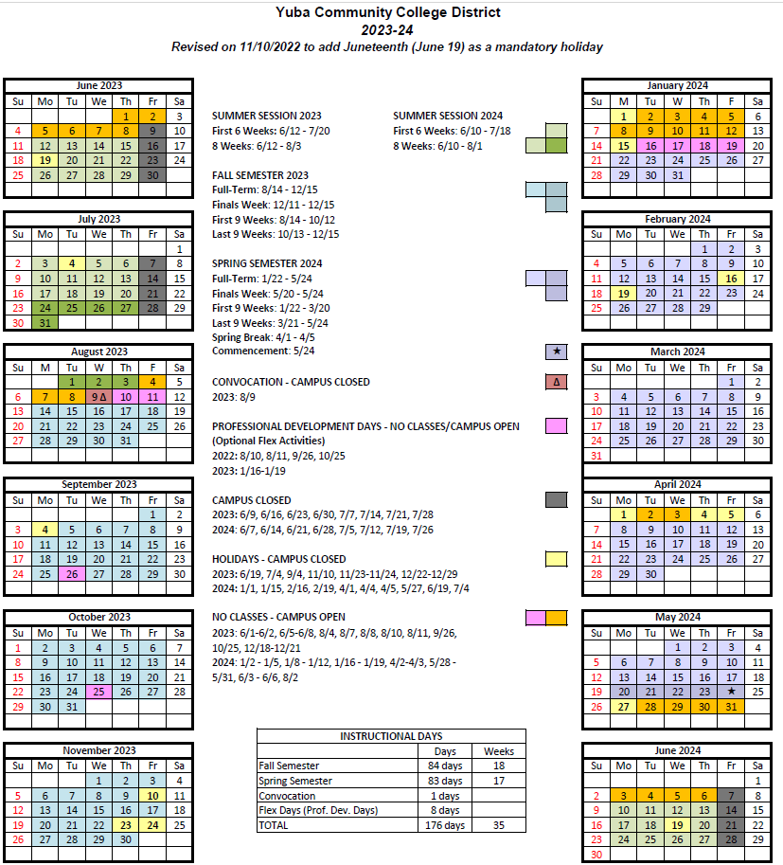

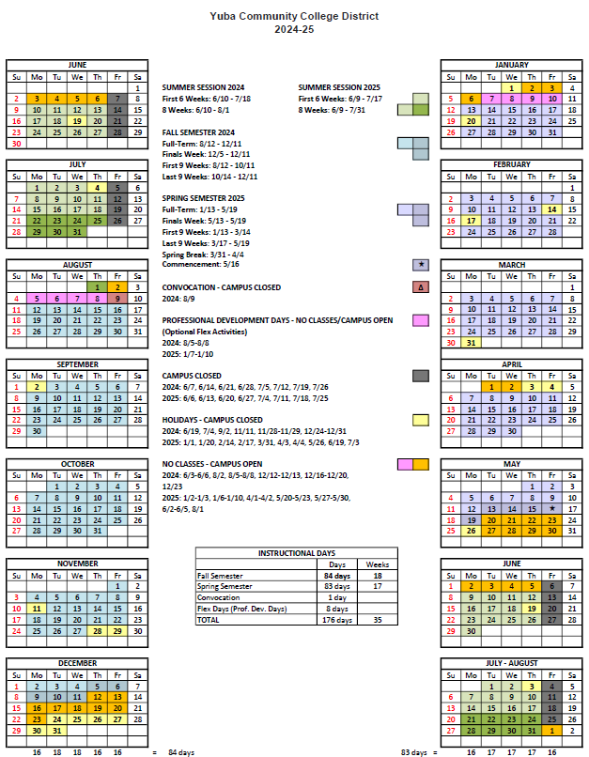
Appendix L: Map of Woodland Community College Campus

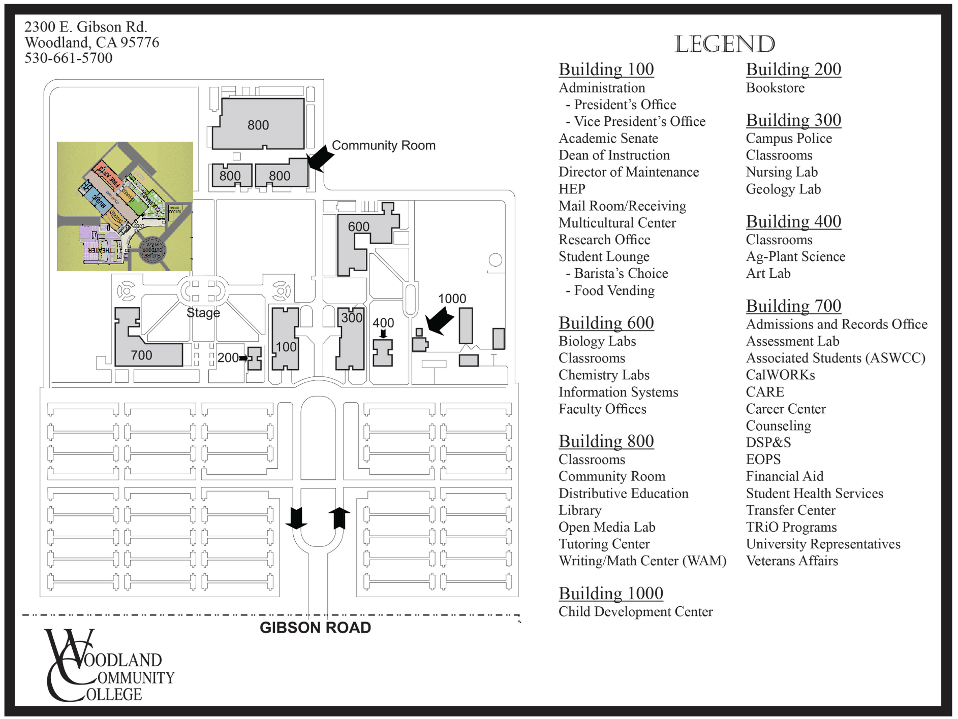

The End.

