Request for Proposal

YCCD, Yuba College, Sutter County Center

District Offices, “Minimized” Remodel

No. RFP 23-04

Issue Date: November 13, 2023
Bid Packages Due: December 12, 2023, 2pm Sharp

RFP Due Date: December 12, 2023, 2:00 PM Sharp, Location Delivered To:

Yuba Community College District, District Offices
Attn.: David Willis
District Director of Facilities Planning, Maintenance & Operations
RFP No. 23-04 YCCD, Yuba College, Sutter County Center, District Offices “Minimized” Remodel
Address: Sutter County Campus, Second Floor, District Offices, Attention: David Willis,
3301 East Onstott Road, Yuba City, California 95991

Proposal Delivery at Second Floor
Yuba Community College District
Sutter County Campus
District Offices
3301 East Onstott Road (second floor)
Yuba City, California, 95991

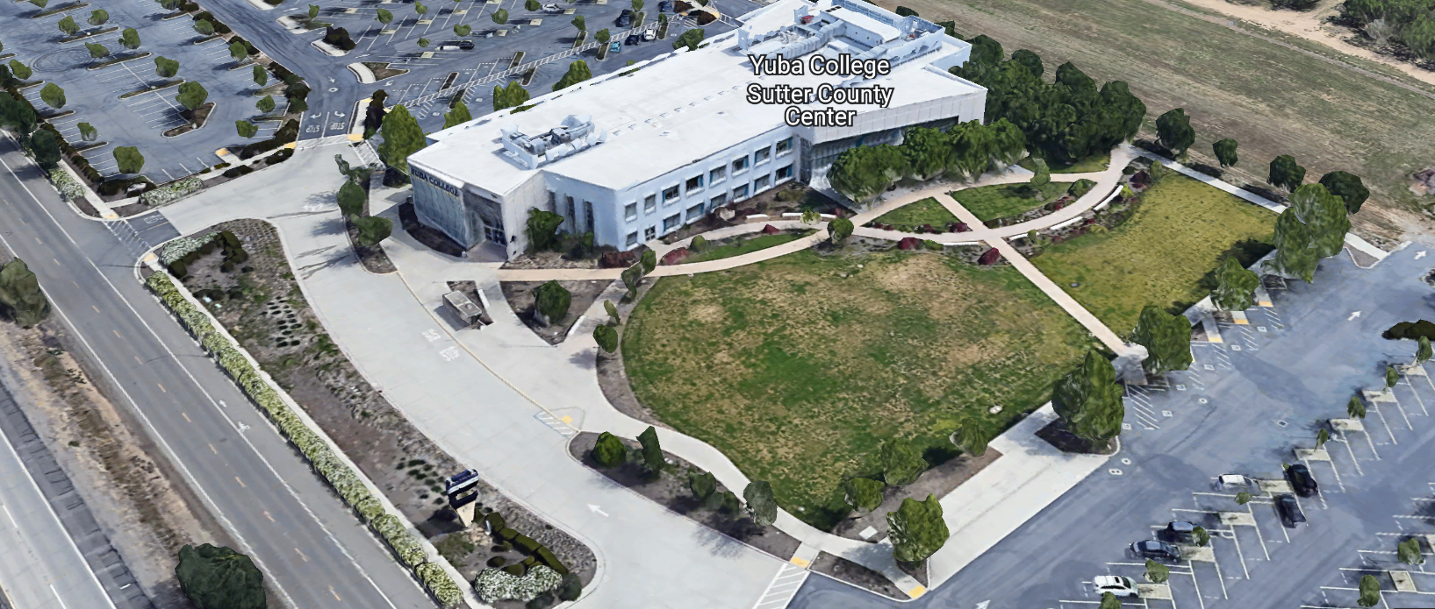
West Building Entrance
TABLE OF CONTENTS

1.0 INTRODUCTION
1.1 District Information
1.2 Yuba Community College District Background
1.3 Purpose of the Request
1.4 Applicable Codes
2.0 Scope of Work
2.1 Project Schedule
2.2 District Staff Contacts during Proposal Process
2.3 Project Safety Requirements
2.4 Demolition
3.0 Proposal Format Organization
3.1 Proposal Delivery, Contents, and Format
4.0 Selection of “Firm”
5.0 Basis of Award
6.0 Non-Discrimination
7.0 Response to Request for Proposal (RFP)
8.0 Requests for Information (RFI)
9.0 Proposal Schedule
10.0 District Parking
11.0 RFP Proposals
12.0 Award of Contract/Proposal
13.0 Reservation of Rights
14.0 Bid Bond Requirements
15.0 Performance Bond, Payment Bond Requirements
16.0 Liquidated Damages

Contractor Proposal Required Items:

Appendix A, DSA Approved Drawings and Specifications
Appendix B, Statement of Qualifications
Appendix C, Contractor References
Appendix D, Contractors Project Approach, Project Team Members and Credentials.

Informational Items:
Appendix E: YCCD Academic Calendars
Appendix F: Map of Yuba College, Sutter County Center

1. INTRODUCTION

  - District Information:

The District consists of two colleges, Woodland Community College and Yuba College, with campuses located at six different locations: Yuba College in Marysville, CA; Sutter County Center in Yuba City, CA; Beale Education Center, Beale AFB, CA; Woodland Community College in Woodland, CA; Colusa County Center in Williams, CA; and Lake County Campus in Clearlake, CA.

  - Yuba Community College District

The Yuba Community College District (YCCD) was founded in 1927 and spans eight counties (Yuba, Sutter, Colusa, Yolo, Lake, Butte, Glenn and Placer) and nearly 4,200 square miles of territory in rural, north-central California. It has colleges in Marysville and Woodland, an educational center in Clearlake, an educational center in Williams, an educational center in Yuba City, and outreach operations at Beale Air Force Base.

  - Purpose of Request

The Yuba Community College District seeks proposals from qualified Licensed Contractors to provide “minimized” remodel of the existing District Offices spaces at the Yuba College, Sutter County Center location.
Yuba College, Sutter County Center Address: 3301 East Onstott Road, Yuba City, California 95991

  - Applicable Codes
All work shall meet all State of California Building Codes, and Federal codes, and local ordinances.
All projects at the District/College are prevailing wage projects.
- Scope of Work

The Yuba Community College District is accepting proposals for “RFP 23-04 YCCD Yuba College, Sutter County Center, District Services Offices Minimized Remodel. The scope includes but is not limited to the following:

- Relocation and shifting of existing partitions and cubicles to allow construction of walls, etc…
- Minor Demolition
- Construction of Walls/New Doors for four offices/office areas.
- LED Lighting
- Minor changes to the HVAC ductwork, Fire Suppression, and Fire Alarm systems.
- Minor Electrical wiring changes.
- Painting and finish work.
- Relocation of existing partitions and cubicles to complete the new layouts for furnishings per the construction drawings.
- District Requirement: Utilize Campbell Keller as sub-contractor/vendor to relocate and move cubicles and associated furnishings.
Craig Campbell | President | Campbell Keller
- 65th Street, Suite 3 | Sacramento, CA 95820
Direct (916) 231-9236 | Web
- The contractor is required to protect all chairs, desks, computers, and other furnishings from damage.
- The District will award separately to Campbell Keller, new cubicles and furnishings as part of this project for the new high wall offices and as needed in other cubicle and office spaces per the attached future furnishings layout.

General Comments:

The Contractor is 100% responsible to coordinate and securely store materials, tools, equipment, and other items required for the project. The Contractor must receive, inspect, unload, move, properly store, and sign for all materials. No exceptions. All materials need to be locked up and stored properly. The construction area must be cleaned up and organized to reduce trip hazards. Deliveries that arrive without a Contractor representative on site will not likely be received. All materials must be as specified and pre-approved by the District before orders are placed or delivered. The District cannot pay for materials until they arrive on site.

The Contractor shall provide all waste removal in accordance with State regulations and provide the District with a waste manifest as support documentation for future progress payments.

The Contractor shall use and maintain barricades or delineators, barricade tape, and signs to delineate all project boundary areas.

The Contractor shall cover furnishings with tarps/plastic and clean all areas thoroughly after work is completed in each area to meet all College/District requirements.

The Contractor is expected to meet weekly as needed at the construction site (in room 211) during the project with District/College staff at the project site to review progress, discuss issues, and provide a brief update on what is expected to occur as the project progresses.

The Contractor personnel may use College restrooms, drinking fountains, and electrical outlets.

The Contractor shall apply and follow all Cal-OSHA regulations. All required PPE shall be in good condition and used when needed to protect employees.
The District encourages a positive and open communication strategy that includes a sense of partnership and mutual success on its projects.
The Contractor mark-ups for profit and overhead for change orders is 10%. Subcontractor mark-ups are limited to 10%.
2.1 Project schedule
Approximate Award Date: January 19, 2024

Mobilization and Start Construction: TBD, must be coordinated at least 3 weeks in advance with District Offices staff.

District Offices Construction Period: TBD: The HR area in the western office areas will likely require District Offices staff to work remotely for an approximately four (4) to five (5) week period to minimize the impacts of dust, noise, and shifting of the existing cubicles and partitions.

Submittals Received by March 1, 2024 (or sooner)

Substantial Completion: July 12, 2024 (or sooner)

Final 100% Completion: July 26, 2024 (or sooner)
Please note all College Holidays. Unless otherwise mutually agreed to, the Contractor shall not work on College/District holidays.
The contractor may work whatever hours are needed Monday through Friday. Normal working hours are 7:30 am to 4:30pm but can be adjusted to meet whatever the Contractor needs.
The District is closed on Fridays during June and July. The Contractor may work Fridays.
Note: The best and most optimal construction period is May 28th, 2024, through July 26, 2024.
This is a prevailing wage project. The Contractor is required to upload all certified payroll information to the Department of Industrial (DIR) Relations web site. YCCD will provide a DIR project number.
Provide a project schedule with the proposal with the completion date clearly shown.
2.2 District Staff Contacts during the Proposal process:
Firms interested in submitting a Proposal are directed not to make personal contact with the Board of Trustees, District staff, or members of the evaluation committee. Any contact shall constitute grounds for disqualification from consideration.
Single Point of Contact during the Proposal Preparation Process:
David L. Willis
District Director of Maintenance, Operations, and Planning
YCCD District Offices, Sutter Center, (Second Floor)
3301 East Onstott Road
Yuba City, California, 95991
Cell Phone: 916-747-4262
Email: dwillis@yccd.edu

Back-up contact:
Bryan Epp
Assistant Director of Maintenance, Operations
2088 North Beale Road
Phone: 530-740-1722
Email: bepp@yccd.edu

No changes can be made to the project scope without authorization in writing by David Willis.
2.3 Project Safety and Security Requirements
Safety is a top priority for the District. All California OSHA requirements apply. Industry best practices apply. Contractor employees shall wear shirts with sleeves, a hard hat, eye protection, hearing protection as needed, gloves, substantial leather footwear, long pants, a reflective safety vest, and take all needed precautions to complete the work in a safe manner. Safety shall not be compromised at all during the work.
Enhanced fall protection precautions shall be taken. Protection of College property shall be taken. Contractor is 100% responsible for any damage to College property and facilities.
This campus has a moderate risk of theft. It is the sole responsibility of the Contractor to receive and secure all materials, equipment, tools, monument signs, and other items associated with this work.
2.4 Demolition
The contractor shall provide a debris waste manifest for all items removed from the campus. Debris and waste shall be processed in accordance with all State and Federal codes, laws, and ordinances.
3.0 Proposal Format Organization
The Firm is requested to use the following proposal format:
3.1. Proposal Delivery, Contents, and Format:
Proposals should provide straightforward, concise information that satisfies the requirements noted in this RFP. Expensive binding, color displays, and the like are discouraged. Emphasis should be placed on brevity, conformity to the Districts instructions, selection criteria of this RFP, and completeness and clarity of content. Each Respondent’s proposal should clearly and accurately demonstrate specialized knowledge and experience required for consideration.
In a sealed box or envelope (clearly marked “), submit the following:
- One (1) flash memory stick containing the complete proposal and supporting documentation; You may also in addition to the flash drive, email your proposal to: dwillis@yccd.edu.
- One (1) original proposal in paper form, which consists of a Proposal Letter and responses to the proposal requirements of this RFP.

There is no page limit.

Firms must comply with the provisions of these instructions for completion and submission of the Proposal. The failure of a Firm to comply with the Proposal Instructions and Requirements will likely result (at the sole discretion of the District) in rejection of the Proposal for non-responsiveness.
Proposal Section | Format
- Cover Letter | PDF
- Table of Contents | PDF
Appendices (See Table of Contents for each one) Submit a response to each Appendix that requires Contractor information. Please submit responses to Appendices A, B, C, D. Appendices E, F, are informational only. | PDF

Proposal General Information Contents:

Information provided by the Contractor will help the District determine if the Firm is a “Responsible Bidder”.

Cover Letter

The Proposal shall include a Cover Letter on Respondent’s official business letterhead, which shall be signed by an individual authorized to legally bind Respondent. The Cover Letter shall also identify the name, telephone number, and email of a person who may be contacted during the Proposal evaluation process.

Table of Contents

Provide a Table of Contents that outlines in sequential order the major sections and sub-sections of the Proposal. Use tabs to allow information to be more easily located.

4.0 Selection of “Firm” Services Provider

The process of “Firm” selection is based upon the complete responsiveness of the RFP and the criteria as outlined in the RFP.

The District Project Evaluation Team will read the written proposals. The District Evaluation Team will discuss the proposals and verify that the “Basis of Award” information below and information submitted in response to the RFP are complete and responsive.

The District reserves the right to reject any or all submittals, to amend the RFP process, and to discontinue or re-open the process at any time. The District reserves the right to request clarifications to RFP responses and to negotiate the terms of the agreement.

5.0 Basis of Award

This project will be awarded based on the following criteria:

- Lowest Total Cost Responsive Qualified Bidder
  - Lowest Total Cost
  - Contractor Capability to do the work
  - Qualified Contractor (per Appendix B, Statement of Qualifications)
    - Proper State of California Contractor License in good standing
    - Information provided as requested in the RFP and Specifications.
    - All Addendums are acknowledged.
    - Contractor listed any exceptions or exclusions. Contractors should bid the project per the RFP and contract documents (using specified products) and then offer exceptions and exclusions or cost deductive or additive alternatives separately from the base bid.
    - Contractors with historical good performance on YCCD projects regarding minimal number and cost of change orders, maintaining project schedules and completing the work promptly, and overall quality of work.
    - Contractors ability to meet schedule requirements.
    - Contractors have demonstrated past project references of “like” projects
    - Contractors references are all good with respect to schedule, cost, and quality.
    - No other factors such as litigation, licenses in good standing, or other similar criteria.
    - At least ten (10) project references of similar projects completed in the past five (5) years with contact information, scope of work, initial awarded cost, change orders cost, pictures if possible.

Optional Interview Process:

The top one to two of the lowest total cost responsive qualified bidder’s may be requested to participate in a ZOOM interview process with the District Project Proposal Evaluation Team. This interview process is optional and fully at the discretion of the District. The District may decide that no interview is required.

6.0 Non-Discrimination
The District does not discriminate with regard to race, color, gender, national origin, disability, or any other protected or other classification in the awarding of contracts/agreements. The District welcomes all Qualified Firms to participate in the project Request for Qualification/Proposal process.
The District encourages firms that are women or minority owned, emerging small businesses, veteran owned firms, disabled person owned firms, and all other qualified firms to participate in the proposal process.
The District encourages the submission of proposals from all Firms that can meet the stated requirements set for this RFP.
7.0 Responses to RFP:
Sealed responses to this RFP must be clearly marked "RFP NO. 23-04 YCCD Yuba College, Sutter County Center, District Services Offices, Minimized Remodel”.

Responses shall be mailed to or hand-delivered to the following address:

Yuba Community College District, District Offices
Attn.: David Willis
District Director of Facilities Planning, Maintenance & Operations

Envelope/Box Marked:
"RFP NO. 23-04 YCCD Yuba College, Sutter County Center, District Services Offices, Minimized Remodel”.

Address: Yuba Community College District, Yuba College, Sutter County Center, District Services Offices, Second Floor, Attention: David Willis, Room 217, Yuba City, California, 95991

Note: Completely seal your proposals in envelope/box and make sure it gets date/time stamped when delivering proposal. Firms are each 100% responsible to make sure proposals that are mailed using a carrier such as UPS, FED Ex, etc…are received and date/time stamped by District personnel prior to the proposal due date/time. No proposals will be considered if they are late, even if it is only 5 minutes late. Please make sure your proposals are delivered and received promptly prior to the due date/time. There will be a public proposal opening at the due date/time.

Do NOT email your proposals. Emailed proposals can be sent to David Willis at email: dwillis@yccd.edu in addition to the above requirements.

8.0 Requests for Information (RFI)

Requests for Information concerning the RFP must be in writing and may be submitted via email no later than the date shown below. Please direct all questions to David Willis, email: dwillis@yccd.edu.

Following the RFI deadline, all questions and answers will be summarized and posted on the District's website: https://www.yccd.edu/central-services/purchasing/ , then, click on the “Requests for Proposals / Quotes” tab on the right hand side of this web page. It is anticipated that responses to inquires received by the required time and date will be provided within 5 business days and posted on the District's website or responded to per the dates listed in the RFP for addendum publishing. Should more time be needed by the District to answer I respond to RFI’s, this information will also be posted on the above website.

- Include the following in the subject matter field on emails when requesting information: “RFP 23-04”, RFI.

9.0 Proposal Schedule: Refer to Specification 00 11 13.

Important Dates and Times:

      - Optional Pre-Bid Zoom Meeting: November 21, 2023: 2:00pm
Join Zoom Meeting
https://yccd-edu.zoom.us/j/87144832215
Meeting ID: 871 4483 2215
Dial by your location
• +1 669 444 9171 US
      - Optional On Campus Meeting: November 28, 2023; 2:00pm

Location:

Sutter County Center, District Offices, Attn.: David Willis

3301 East Onstott Road, Room 211 (second floor)

Yuba City, California, 95991

Note: There are no mandatory pre-bid meetings for this project.

3. Requests for Information Due Date: December November 30, 2023: 5:00pm

4. Proposals Due Date: December 12, 2023, 2:00PM Sharp.

Deliver proposal to the following address:

Yuba Community College District, Sutter County Center
District Offices, Second Floor, Room 217
Attention: David Willis
3301 East Onstott Road
Yuba City, California 95991
All procurement documents, including Addenda’s (as required) may be obtained only on the YCCD Purchasing website: https://www.yccd.edu/central-services/
This is a prevailing wage project.

10.0 District Parking:

-No parking in Reserved Spaces without a proper permit
-Permit Parking is enforced in all general lots between 6:00 am and 6:00 pm, Monday through Friday. All general lots require a properly displayed, valid permit during these times
-Daily Parking Permits are $2.00
-Permits are available for purchase at any of the permit machines located in the student parking lots
-All other parking regulations are enforced 24 hours a day, seven days a week. This includes designated staff spaces, handicap spaces, timed spaces, red zones, yellow zones, and areas not marked (no parking at any time)
-Once this project is awarded, temporary parking permits will be processed as requested by the successful firm for all employees associated with this project at no cost to the Firm for the duration of the project at each Campus location. These temporary permits must be displayed at all times on the dashboard of employee vehicles.

11.0 RFP Proposals

Proposals received after the deadline will not be opened. Each responder shall submit one (1) signed original hard paper copy in a binder. Provide one electronic format copy of the proposal using electronic media such as a flash drive. (No CD formatted Disks).

All materials submitted in response to the RFP shall be on 8-1/2"x11" paper, preferably in
Portrait orientation. All submitted materials must be bound in either a three-ring binder or spiral bound notebook. Content shall be tabbed and numbered per the items included in the Submittal Requirements. All Proposals will be reviewed and evaluated by a District Selection Committee. The District at its sole discretion may interview finalists or select a firm or firms to perform work based solely on the evaluation of the Proposal. There is no page limit.

All Proposals become the sole property of the District and the content will be held confidential until the selection of the Firm or Firm’s is made and the project is awarded.

12.0 Award of Contract

- The Contract will be awarded to the lowest total cost, most responsive responsible District qualified Firm, whose proposal, conforming to the request for proposal and associated addendums, will be most advantageous to the District. If a Contractor is not first qualified per the “Statement of Qualifications”, then, the District will not review or consider the Contractor’s proposal.

B. The District reserves the right to enter into an Agreement without further discussion of the proposal submitted based on the initial offers received.

C. The District reserves the right to reject any or all proposals or any part of the proposal and to waive informalities and minor irregularities in the proposals received.

D. The RFP, its addendums, any follow-up clarifying information, and the proposal of the selected Firm will become part of any contract initiated by the District.

E. A formal contract shall be signed by the successful proposer and Yuba Community College District to perform this service.

F. The District reserves the right to enter into discussions with any one or all of the Responders after Proposals have been initially reviewed. Such responses shall be subject to all provisions, terms and conditions as set forth in the RFP, unless otherwise modified.

G. The District intends to award to a single RFP Responder.

H. BONDS: The Contractors Performance and Payment bonds are required within 7 calendar days after the Notice of Award is provided to the Contractor. The Bid Bond is required with the proposal.

I. Failure to acknowledge all of the addendums, provide the items listed in the RFP, may render the proposal unresponsive at the discretion of the District. Items listed in the RFP become part of the contract unless the Contractor provides an exception in the proposal. Contractor exceptions, depending on the magnitude, may render the proposal unresponsive, at the discretion of the District.

J. The District reserves the right to request clarification of proposal content during the review and evaluation process.

K. The District reserves the right to negotiate the terms of the agreement to align with budgetary constraints.

13.0 Reservation of Rights

The District reserves the right to:

- Reject any or all submittals at its sole discretions.
- Cancel the Request for Proposal (RFP), without cause.
- Modify any requirements contained within the RFP and request a revised submission from all Providers.
- Establish other evaluation criteria determined to be in the best interest of the District.
- Contract with any of the firms responding to the RFP based solely upon its judgment of the qualifications and capabilities of the firm.
- Clarify the content of any proposal to verify that the requirements of the RFP are included.
- Waive “minor” proposal inconsistencies that do not change the scope of work as outlined in the RFP.
- Request an alternative Superintendent on the project if the initially assigned Superintendent on the project is not performing well, not meeting project requirements, not working well with College staff and students, not applying best practice safety methods, OR not following College/District guidance regarding project approach. If the owner is the Superintendent, and has been replaced, the owner may visit the project briefly (less than 1 hour per day up to 2 times per week) to coordinate with the replacement Superintendent.
- The District will not allow or tolerate verbal abuse or any other type of abuse by the Contractor toward any College or District personnel or Contracted professional service providers. Abuse, defined solely by the District as verbal or physical, or written, may lead to a “Stop Work” order by the District until it can be resolved, and steps taken to ensure abuse is not repeated. If abuse occurs again, the District may issue a final “Stop Work” order, require the Contractor to leave the College/District project site and process a Performance Bond claim to complete the work. All costs associated with District “Stop Orders” are 100% the responsibility of the Contractor.
- Disqualify a Contractor after reviewing the proposal and finding concerning performance information in references, inadequate or incomplete proposal information, and historically poor project performance at the District/Colleges (as solely defined by the District).

This RFP does not commit the District to award or negotiate a contract. The District will not be responsible for any expenses incurred by any firm in preparing and submitting a proposal or response to this RFP or in completing any of the work specified.

14. Bid Bond Requirements: See Specification 00 61 00

15. Performance and Payment Bond Requirements: See Specification 00 52 00
16. Liquidated Damages: See Specification 00 52 00, section 4.06
Appendix A: DSA Approved Drawings and Project Specifications

Link to shared file folder:
DSA Approved Drawings and Specifications
OR:
DSA Appro https://goyccd-my.sharepoint.com/:f:/g/personal/w0398409_yccd_edu/EsVOiD02w-RLgcc3XuXMdoIB0AcRcY6d2vJTTdu_IbZBCA?e=vHkPFNved Drawings and Specifications

Future Furnishings Layout with New Walls Layout Link:
Future Furnishings Layout
or
Future Furnishttps://goyccd-my.sharepoint.com/:f:/g/personal/w0398409_yccd_edu/EvkAXgBp7HRCsHx9bzwENG8BBByPLQo0-I1suZTjrgyf8w?e=00E7bZhings Layout

Appendix B: Statement of Qualifications
The Firm shall furnish the following information. Failure to comply with this requirement will render the submittal informal and may cause its rejection. Additional sheets may be attached if necessary.
Basic Firm Informational Items 1 through 15:

- Firm Name:___________________________________________________________________

- Primary Address: ______________________________________________________________

- Firm’s Contact Person and Title:___________________________________________________

- Telephone: ___________ Facsimile: ____________________

- Email Address: ___________________

- License No.: ______________________________ Class: __________________________

Responsible Managing Employee/Officer:___________________________________________

- DIR Registration No.:________________________ Expiration Date:___________________

- Names and titles of two officers of the Firm:

NAME TITLE

9. Specific type of Ownership (Check one)

Individual
Partnership
Corporation; If a corporation, state the following:

State of incorporation:
Date of incorporation: President/CEO:
Joint Venture
Other (Specify)

- Taxpayer Identification No.: _______________________
- List annual gross income for last three (3) years:
Year: _______________ $_____________________
Year: _______________ $_____________________
Year: _______________ $_____________________

- Number of years Firm has been in business:
If less than 5 years, please describe:

- Number of years Firm has conducted business under the present name:_________

- Number of years’ experience in California Community College, University or educational facility projects .

- Has the Firm ever completed any work at the Yuba Community College District? If Yes, please list projects

Potentially Disqualifying Questions 16 through 20 Firm’s refusal to answer or omission of response to any of Questions 16 through 20 may result in disqualification of Firm.:

- Does the Firm possess a valid and currently in good standing California Contractors’ license for the classification(s) of Contractors’ License required for the Project? If Yes provide the license number(s). Yes/No______________________________________________________

- Has the Firm been defaulted or terminated (other than for convenience) by any California school district, community college district or other California public agency on any project within the past 5 years? Yes/No

If yes, identify agency and details:

- Has the Firm been assessed liquidated damages for any project in the past five years? Yes/No If so, identify owner and details:

- Is the Firm currently or has the Firm been in a state of “Bankruptcy” in the past five years? Yes/No:
If yes, please explain.

- Please describe the Firm’s commitment to maintaining a construction schedule. How will the Firm recover the schedule if it slips or the Firm gets busy with other projects? Please describe specific actions the Firm will take to maintain the Project schedule.

Question No. 21 and 22 are the ONLY scoring Questions. Please provide complete information to score the highest possible points.
- Please list five (5) remodel projects completed in the past 5 years that included interior remodel and finish work. Include the following criteria:
  - Project Name and Location
  - Description of the Scope of Work
  - Contract Amount
  - Original and Final Completion Dates
  - Change Order Amount
  - Issues that may have needed to be addressed during construction.
Scoring Criteria with each project scoring a total of 50 points:
California, Public Project, Prevailing Wage? 10 points
- California, K-12, Community College, or University, and Division of the State Architect (DSA)? 10 points
- Size of the projects: Greater than $300,000 10 points
- Completed on schedule or close to it? On or within one month of the original completion date. 10 points.
- Change order amounts less than 5% of the original awarded amount. 10 points
Attach information as needed to fully answer this question.
- Describe up to 5 projects that the Contractor has completed for the Yuba Community College District in the past seven (7) years. Please provide the following information:
  - Project Name and Location
  - Description of the Scope of Work
  - Contract Amount
  - Original and Final Completion Dates
  - Change Order Amount
  - Issues that may have needed to be addressed during construction.

Scoring Criteria:
- For projects greater than $300,000 in value, completed within 30 days of the original construction schedule. (5 points)
- Completed with less than 5% (of the original awarded amount) change orders= 5 points

Attach information as needed to fully answer this question.
Total points: 60 points, Must score at least 40 points to be pre-qualified.

Qualification Criteria:

Questions 1 through 15 are general base level information that is required for pre-qualification.

Questions 16 through 20 are possible disqualifying questions that would render the Firm “not qualified” as determined by the District.

Questions 21, 22: 60 points possible. Must score at least 40 points.

The undersigned is duly authorized to execute this Statement of Qualifications under penalty of perjury on behalf of the above-identified Firm. The undersigned warrants and represents that he/she has personal knowledge of each of the responses to this Statement of Qualifications and/or that he/she has conducted all necessary and appropriate inquiries to determine the truth, completeness, and accuracy of responses to this Statement of Qualifications. The undersigned declares and certifies that the responses to this Statement of Qualifications are complete and accurate; there are no omissions of material fact or information that render any response to be false or misleading and there are no misstatements of fact in any of the responses. The above-identified Firm acknowledges and agrees that if the District determines that any response herein is false or misleading or contains misstatements of fact so as to be false or misleading, the District may find the Firm is not qualified and the District can reject the proposal for non-responsiveness or non-responsibility.

Executed this___ day of __________________ 20__ at_____________________________.
(City and State)
I declare under penalty of perjury under California law that the foregoing is true and correct.

By: ____________________________________________
(Signature of Firm’s Authorized Officer or Representative)
____________________________________________
(Typed or Printed Name)
Title: ___________________________________________

Appendix C: Contractor References Form (Example Template)

Bidder shall provide a minimum of Five (5) verifiable references with current contact information, preferably from a California public educational institution and/or California public agency, representing projects started and completed within the last 5 years. See clarification note below regarding reference requirements.
All phone numbers and emails must be current (please verify).
REFERENCE #1
NAME
ADDRESS
CITY, STATE ZIP CODE
TELEPHONE #
CONTACT
DATES OF SERVICE
REFERENCE #2
NAME
ADDRESS
CITY, STATE, ZIP CODE
TELEPHONE #
CONTACT
DATES OF SERVICE
REFERENCE #3
NAME
ADDRESS
CITY, STATE, ZIP CODE
TELEPHONE #
CONTACT
DATES OF SERVICE

You may of course use the Firm’s established reference template.

Appendix D: Contractors Project Approach, Project Team Members and Credentials. (Provided by the Contractor)

Appendix E: YCCD Academic Calendar
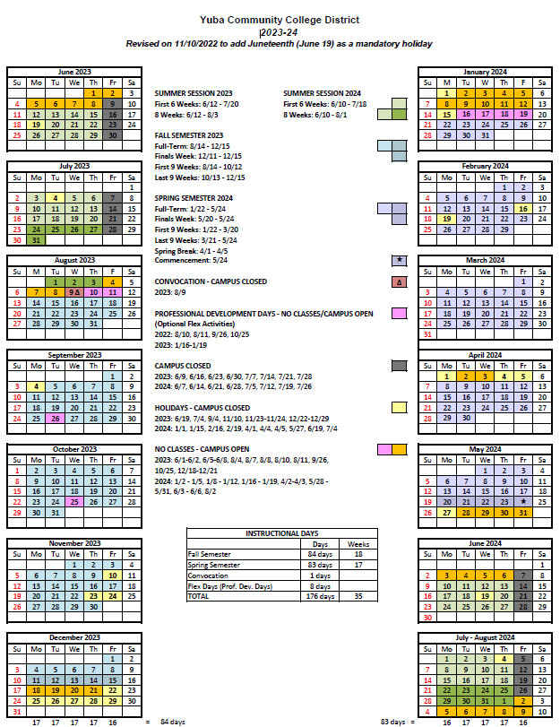
Appendix F: Sutter County Center Map: 3301 East Onstott Road, Yuba City, California 95991
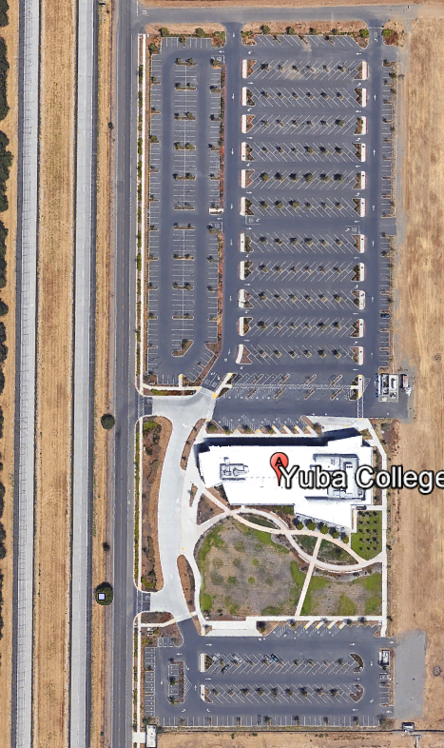

The End.

