Addendum No. 2

RFP 23-03, WCC Architectural Design Services, Soccer Fields Project
Date: 08/15/2023

Date: January 26, 2016

Clarifications:

- Remove all work associated with the noted modular. The College has decided not to use this building for the men’s and women’s soccer team program. At this point, this building is not planned to be relocated. Here’s a picture of the modular building:

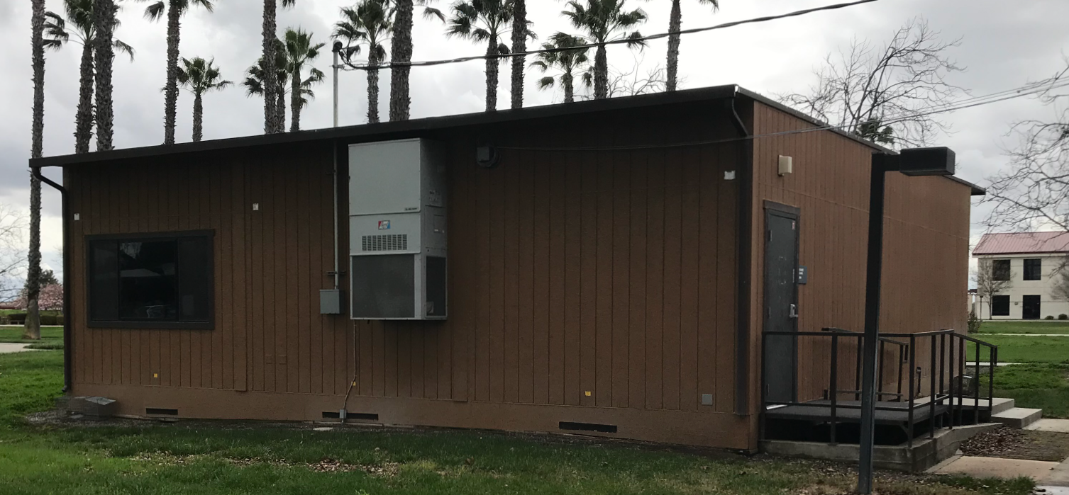

- The scope of the “Soccer Fields (2) Project” will likely include the following:
- Campus Site Research and Investigation of Existing Utilities and Site Conditions
- Game Soccer Field
- Practice Soccer Field
- Pest/rodent control underground control fence barriers around the fields to 18” depth.
- High Pressure Irrigation Systems with minimal sprinkler heads, a new underground main line from the main campus well/storage tank which is approximately 300 feet north of the proposed soccer field location.
- Gravel Parking Areas
- Minimal Landscaping with addition of drought tolerant non-allergenic low maintenance shade trees around the practice field, and the game field. Include deep watering tree root irrigation system.
- Accessibility access path to both paved parking stalls, and existing restrooms in building 800.
- Minimal fencing along the roadways or as needed to protect the fields.
- Repurposing/repairs of an existing double modular building to be used as a temporary training/locker room for the soccer program. Paint exterior and interior. Design new wayfinding sign for this building.
- Wayfinding signs from the large north parking lot to the soccer fields to make it easy to find the soccer fields.
- Update the campus main wayfinding “kiosk” signs to include the new Performing Arts and Culinary Services building and the two new soccer fields. Include a new style mounting post and design to meet ADA requirements.
- Preliminary Project Schedule
- Schematic Design, Topographical Survey
- Construction Documents (drawings and specifications)
- Division of the State Architect (DSA) submission.
- Minimal Daktronics Scoreboard with underground electrical service with remote cell phone APP to update the score.
- Minimal PA System with underground electrical service
- Bleachers: Home=200 seating capacity; Visitor=100 seating capacity
- Digital Electronic Colored rendering of the phase I soccer fields project scope
- Rough Cost Estimate the rest of the future sports complex.
- DSA Submission and process support through DSA approval.
- Contract Administration through construction completion
- Two New Soccer Fields Project cost estimate, generated by a local (Sacramento Regional Area) qualified third-party licensed cost estimating firm.
- Schematic (early planning design) and Rough Order Estimate for the College Storage/Soccer Field Equipment and Supplies/Grounds Maintenance Building and Fenced Yard.
- Note: The College/District would like natural grass soccer fields.
- Additive Alternate No. 1: College Storage/Soccer Field Equipment and Supplies/Grounds Maintenance Building and Fenced Yard.
  - Complete Design Documents, Third-Party Qualified Firm to provide a project estimate, DSA submittal, construction administration per DSA.

- Updated Schedule Dates:

Important Dates and Times:

August 22, 2022: Proposals due at 1:00 PM SHARP, Yuba Community College District, District Offices Location: Sutter Center, District Offices, Second Floor, Room 217, Attention: David Willis, 3301 East Onstott Road, Yuba City, Ca., 95991. There will be a public bid opening on this RFP in room 211 at the Sutter Center Building.

- Question: Is the existing portable DSA approved?
Answer: The work associated with the portable building has been removed from the scope of work.

- Question: Are we to plan future infrastructure for lighting of the game field as part of this project?
Answer: No.

- Question: Are the wayfinding signs to be illuminated?
Answer: No.

The End.

