Addendum No. 1

RFP 23-03, WCC Architectural Design Services, Soccer Fields Project
Date: 08/14/2023

Date: January 26, 2016

Clarifications:

- Question: Is the scoreboard still part of the project?
Answer: Yes, the District standard is Daktronics (manufacturer)

- Question: Are bleachers still part of the project?
Answer: Yes

- Question: Is the building that is going to be relocated a DSA-approved building?
Answer: The old modular building is no longer planned to be relocated as part of the scope of this project.

- Question: The schedule that is listed in the RFP does not align with the DSA process and the time needed to schedule a project (6 weeks after the initial request for project review) and the time it takes for DSA to review a project (6 to 8 weeks). That, along with the time needed for surveying and a geotechnical report, will there be more time than the current schedule is showing? Can the proposed schedule be modified?
Answer: Yes, please provide a preliminary schedule with your proposal that reflects realistic timelines and milestone dates.

- The current modular building is a triple wide modular building. Not much to add. Its at least 15 years old. It will need some repairs and a separation wall to provide a men’s and women’s locker/training room. At this point, this building is not planned to be relocated. Here’s a picture of the modular building:

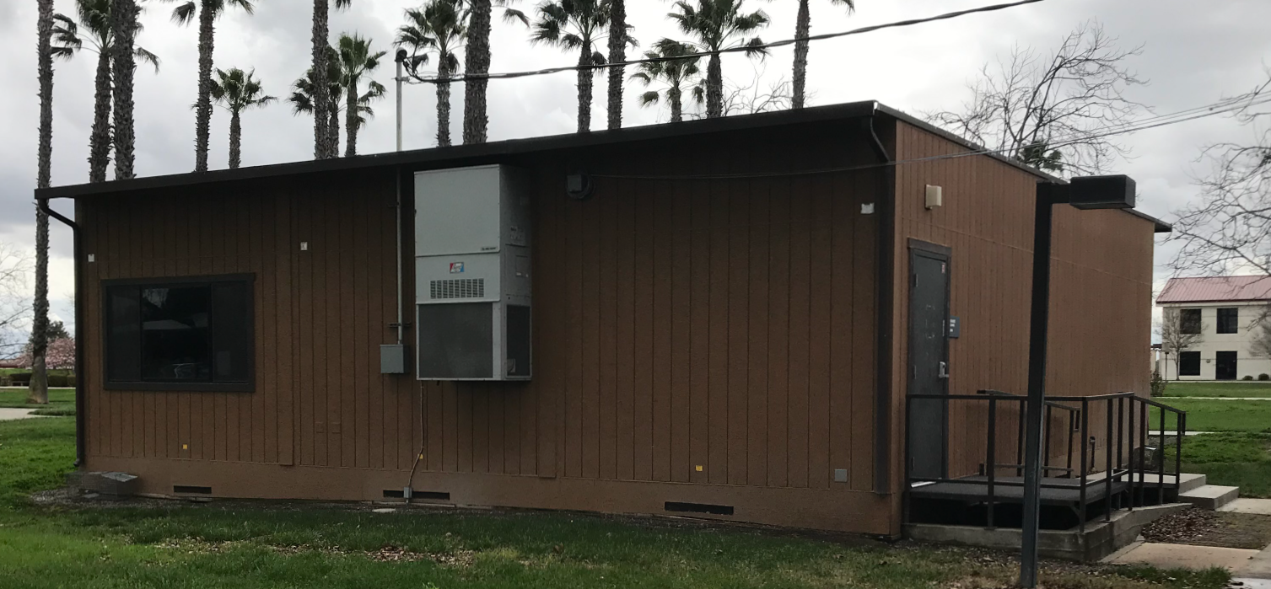

- The scope of the “Soccer Fields (2) Project” will likely include the following:
- Campus Site Research and Investigation of Existing Utilities and Site Conditions
- Game Soccer Field
- Practice Soccer Field
- Pest/rodent control underground control fence barriers around the fields to 18” depth.
- Irrigation Systems
- Gravel Parking Areas
- Minimal Landscaping with addition of drought tolerant non-allergenic low maintenance shade trees around the practice field, and the game field. Include deep watering tree root irrigation system.
- Accessibility access path to both paved parking stalls, and existing restrooms in building 800.
- Minimal fencing along the roadways or as needed to protect the fields.
- Repurposing/repairs of an existing double modular building to be used as a temporary training/locker room for the soccer program. Paint exterior and interior. Design new wayfinding sign for this building.
- Wayfinding signs from the large north parking lot to the soccer fields to make it easy to find the soccer fields.
- Update the campus main wayfinding “kiosk” signs to include the new Performing Arts and Culinary Services building and the two new soccer fields.
- Preliminary Project Schedule
- Schematic Design, Topographical Survey
- Construction Documents (drawings and specifications)
- Division of the State Architect (DSA) submission.
- Daktronics Scoreboard with underground electrical service
- Minimal PA System with underground electrical service
- Bleachers: Home=200 seating capacity; Visitor=100 seating capacity
- Digital Electronic Colored rendering of the phase I soccer fields project scope
- Rough Cost Estimate the rest of the future sports complex.
- DSA Submission and process support through DSA approval.
- Contract Administration through construction completion
- Two New Soccer Fields Project cost estimate, generated by a local (Sacramento Regional Area) qualified third-party licensed cost estimating firm.
- Schematic (early planning design) and Rough Order Estimate for the College Storage/Soccer Field Equipment and Supplies/Grounds Maintenance Building and Fenced Yard.
- Note: The College/District would like natural
- Additive Alternate No. 1: College Storage/Soccer Field Equipment and Supplies/Grounds Maintenance Building and Fenced Yard.
  - Complete Design Documents, Third-Party Qualified Firm to provide a project estimate, DSA submittal, construction administration per DSA.

- Updated Schedule Dates:

Important Dates and Times:

August 14, 2022: 5:00 PM, All questions and requests for information must be submitted to David Willis at: dwillis@yccd.edu.

August 15, 2022: 5:00 PM, Addendum Issued if needed.

August 22, 2022: Proposals due at 1:00 PM SHARP, Yuba Community College District, District Offices Location: Sutter Center, District Offices, Second Floor, Room 217, Attention: David Willis, 3301 East Onstott Road, Yuba City, Ca., 95991. There will be a public bid opening on this RFP in room 211 at the Sutter Center Building.

- Appendix A: Updated Proposal Base Bid Form:

No. | Description | Cost
1 | On Campus Site Conditions Investigation of Existing Conditions | $
2 | Schematic Design, including Topographical Survey for ADA requirements. | $
3 | Game and Practice Soccer Fields Construction Documents | $
4 | DSA Submission and support, DSA Fees paid by District directly to DSA. | $
5 | Contract Administration for the base bid Soccer Fields project (not the additive alternates) | $
6 | Two New Soccer Fields Project cost estimate, generated by a local (Sacramento Regional Area) qualified third-party licensed cost estimating firm. | $
7 | Schematic (early planning design) and Rough Order Estimate for the College Storage/Soccer Field Equipment and Supplies/Grounds Maintenance Building and Fenced Yard. | $
8 | Reimbursable Expenses: Architect to Define/Explain  Note: No hotel or travel costs, or meal costs | $
9 | Additive Alternate No. 1: College Storage/Soccer Field Equipment and Supplies/Grounds Maintenance Building and Fenced Yard.  Complete Design Documents, Third-Party Qualified Firm to provide a project estimate, DSA submittal, construction administration per DSA. | $
10 | Other: | $
11 | Total Costs: | $

- Provide hourly rates for each design professional title.
- Provide schedule of values.
- Prevailing wages apply to this project.
- List all First Tier Sub-Design Firms.
- Please round off numbers to the nearest dollar.
- A preliminary overall start to finish project schedule is required with the proposal.

- Appendix E: YCCD Professional Services Agreement

Link:

YCCD PROFESSIONAL SERVICES AGREEMENT (PSF) WITH DESIGN, rev 1.2.docx

https://goyccd-my.sharepoint.com/:w:/g/personal/w0398409_yccd_edu/EaWg9vgughNAq1fQRGxGX1YB1IqnUqZ9yaMxoAP6s-4Iag?e=ELa9Hg

This agreement is optional at the time of the proposal submission.

The successful Firm will be required to provide this agreement within 7 days after requested by the District.

- Appendix K: Updated Various WCC Soccer Fields Early Preliminary Project Information

Updated Links:
Preliminary Early Planning Information
https://goyccd-my.sharepoint.com/:f:/g/personal/w0398409_yccd_edu/Ei90rk3RiExKrZNy_qZq5bcB3hEbcl97PVew-7dPDUO6gw?e=FOBKj5

Note: The information shared in this folder is a starting point. The locations of the soccer fields will change so that they can be in a North/South direction. Please include this planning work in your proposal.

- Appendix L: Updated Various Campus Site Plans / Utilities Information:

Updated Links:
Existing Campus Site Plans and Drawings
https://goyccd-my.sharepoint.com/:f:/g/personal/w0398409_yccd_edu/Et3qgEaSZv9FjSOBpBOBSRQBlOCkc8tML-H_cnamHL8qpA?e=QUjFey

The End.

