Request for Proposal
Yuba Community College District

Yuba College, Building 800 Life & Physical Science Modernization
Division of the State Architect (DSA)
Inspector of Record (IOR) Comprehensive Services

No. RFP/RFQ 22-10

Issue Date: March 6, 2023
RFP/RFQ Due: April 11, 2023

Due Date: April 11, 2023, 1:00 pm Sharp, YCCD District Offices Location- Delivered To:

Yuba Community College District, District Offices
Attn.: David Willis
District Director of Facilities Planning, Maintenance & Operations
RFP/RFQ No. 22-10,” Yuba College, Building 800 Life and Physical Science Modernization, DSA IOR Services”
Address:
Sutter County Campus, Second Floor, District Offices
Room 217, Attention: David Willis
3301 East Onstott Road, Yuba City, California 95991

Proposal Delivery at Second Floor, Attn.: Dave Willis, Room 217
Yuba Community College District
Sutter County Campus
District Offices
3301 East Onstott Road (second floor)
Yuba City, California, 95991

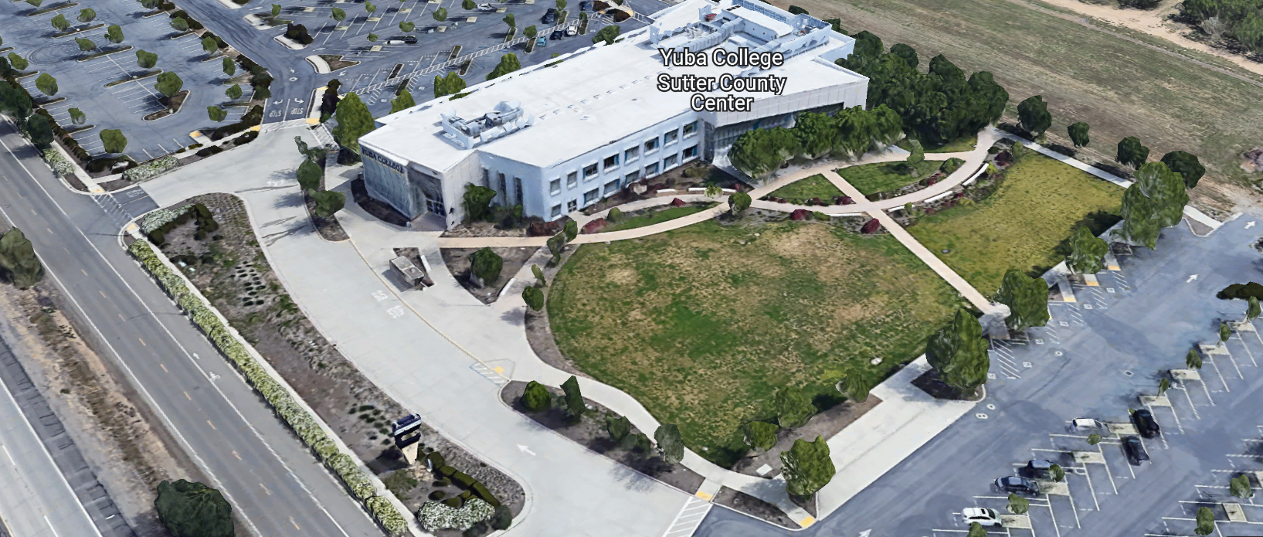
West Building Entrance
TABLE OF CONTENTS

1.0 INTRODUCTION
1.1 District Information
1.2 Yuba Community College District Background
1.3 Purpose of the Request
1.4 Applicable Codes
2.0 Scope of Work
2.1 Project Schedule
2.2 District Staff Contacts during Proposal Process
2.3 Project Safety Requirements
3.0 Proposal Format Organization
3.1 Proposal Delivery, Contents, and Format
4.0 Selection of “Firm”
5.0 Basis of Award
6.0 Non-Discrimination
7.0 Response to Request for Proposal (RFP/RFQ)
8.0 Requests for Information (RFI)
9.0 Proposal Schedule
10.0 District Parking
11.0 RFP/RFQ Proposals
12.0 Award of Contract/Proposal
13.0 Reservation of Rights
14.0 Bid Bond, Performance Bond, Payment Bond Requirements
15.0 Liquidated Damages

Proposal Required Items:

Appendix A, Bid Form
Appendix B, Completed Proposal Checklist
Appendix C, Acknowledgement of Addenda Form
Appendix D, Non-Collusion Affidavit Form
Appendix E, YCCD Professional Services Agreement (PSA).
Appendix F, Signature Proposal Form
Appendix G, Statement of Qualifications

Informational Items:
Appendix H: Project Scope Drawings and Specifications
Appendix I, YCCD Academic Calendars
Appendix J, Map of Yuba College Campus
Appendix K, State Chancellors Office Project Documents
1. INTRODUCTION

  - District Information:

The District consists of two colleges, Woodland Community College and Yuba College, with campuses located at six different locations: Yuba College in Marysville, CA; Sutter County Center in Yuba City, CA; Beale Education Center, Beale AFB, CA; Woodland Community College in Woodland, CA; Colusa County Center in Williams, CA; and Lake County Campus in Clearlake, CA.

  - Yuba Community College District

The Yuba Community College District (YCCD) was founded in 1927 and spans eight counties (Yuba, Sutter, Colusa, Yolo, Lake, Butte, Glenn and Placer) and nearly 4,200 square miles of territory in rural, north-central California. It has colleges in Marysville and Woodland, an educational center in Clearlake, an educational center in Williams, an educational center in Yuba City, and outreach operations at Beale Air Force Base.

  - Purpose of Request

The District is seeking proposals from qualified Division of the State Architect (DSA), Inspector of Record (IOR) Professionals to provide comprehensive services as required to support the Yuba College, Building 800 Modernization project. This project is a State-Matching funded project.

The construction budget is $3,623,000 and the total project budget is $4,824,000.

Yuba College Campus Address: 2088 North Beale Road, Marysville, California 95901.

  - Applicable Codes
All work shall meet all State of California Building Codes, and Federal codes, and local ordinances.

- Scope of Work
This project includes the following project inspection services:

DSA Inspector of Record Class: This project requires a minimum Class 2 classification. DSA Inspectors of Record with classifications at I and II levels are encouraged to provide a proposal.

Review and Understanding of Project
    - Thoroughly review all construction documents and have a full technical understanding of all the requirements of the project.
    - Meet, coordinate and confirm understanding with Architect of Record (AOR) on all the construction documents, the intent of the design, a full understanding of the schedule and areas of potential risk.

Inspection Services
    - Inspect all portions of the construction for compliance with the requirements of the DSA approved construction documents.
    - Identification, documentation, and reporting of deviations in the construction from the requirements of the DSA approved construction documents.
    - Submittal of Project Inspector Verified Report (form DSA 6-PI) per DSA requirements. In addition, at the conclusion of the project any outstanding deviations must be noted on the form DSA 6-PI.
    - Manage and monitor the work of specialty inspectors under the direction of the Architect of Record (AOR) and Engineer of Record (EOR).
    - Monitor the work of material testing laboratories under the direction of the AOR/EOR.
    - Verify Contractor/Architect maintain “as-builts” (record) drawings as work progresses.

  - Duties and Responsibilities (In addition to the above items)
    - The duties and responsibilities outlined in DSA Construction Oversight Process (PR 13-01) revised August 21, 2017, which may be updated by DSA.
    - The duties described in DSA IR A-8 “Project Inspector and Assistant Inspector Duties and Performance, as may be updated by DSA.
    - Provide daily reports per DSA-approved construction documents. These reports will record the general status and specific progress of construction. In addition, they will note the weather conditions at the site, meetings, incidents of significance, etc. and provide a history of the project. The Project Inspector’s Daily Reports are recognized by the courts as legitimate Contract recording documents and will be submitted for reference pursuant to any litigation.
    - It is the responsibility of Firm to check and remain informed of current updates to the above-mentioned documents.
    - The duties and responsibilities that DSA may enact and/or issue during the life of this contract, even if issued after award of this contract.

Regularly Scheduled Weekly Project Team Meetings
    - Inspection Firm and/or assigned Inspectors will be required to meet with the District’s Project Team for regularly scheduled meetings (weekly) the progress of the work, issues, challenges, and other matters related to the project and work.

Project Inspector (PI) Technology Skills
    - Proficient in the DSA Box procedures.
    - Proficient in Excel, Word, and Adobe.
    - Proficient in scanning, uploading, and sending documents.
    - Proficient in and have a current email system.
    - Proficient with all DSA forms for construction and the DSA Box.

Project Deliverables
    - IOR services as required to support a DSA approved State – Match Funded project and shall be completed/prepared in accordance with the applicable codes, regulations, and District standards.

Fee Schedule (Hourly Rates)
    - Fee Schedules submitted in response to this project for IOR services will include the position description(s), the hours associated with the specific position, and a detailed staffing plan.

2.1 District Staff Contacts during the Proposal process:
Firms interested in submitting a Proposal are directed not to make personal contact with the Board of Trustees, District staff, or members of the evaluation committee. Any contact shall constitute grounds for disqualification from consideration.
Single Point of Contact during the Proposal Preparation Process:
David L. Willis
District Director of Maintenance, Operations, and Planning
Yuba Community College District
Yuba College, Sutter County Center (Second Floor), Room 217
3301 East Onstott Road
Yuba City, California, 95991
Cell Phone: 916-747-4262
Email: dwillis@yccd.edu

Please email Dave Willis to verify that your firm will be submitting a proposal in response to this procurement process.
On-site coordination, first contact person access and immediate contact person during construction:
Bryan Epp
Assistant Director of Maintenance, Operations
2088 North Beale Road
Phone: 530-740-1722
Email: bepp@yccd.edu

No changes can be made to the project scope without authorization in writing by David Willis.

2.2 Project Safety and Security Requirements
Safety is a top priority for the District. All California OSHA requirements apply. Industry best practices apply. Safety shall not be compromised at all during the work.
Enhanced fall protection precautions shall be taken.
COVID 19 BEST PRACTICES APPLY:
Firms are required to wear facial coverings and maintain social distancing whenever entering buildings and as much as possible when working outside. The frequent use of hand sanitizer is strongly encouraged. The DSA Inspector of Record shall not report to work at the campus if sick or have been recently exposed to anyone knowingly that has tested positive to COVID 19. If the DSA IOR has been tested for COVID 19, he/she shall not report to work at the campus until after test results are known and after they are no longer symptomatic. If the DSA IOR has been tested or have tested positive for COVID 19, this information shall be immediately shared with the District/College project Managers. No sick employees shall report to work at the Yuba College Campus.
The DSA IOR is required to login each time at the campus, at the maintenance building 1400 on the log sheet to facilitate prompt notification in case there is a positive test result of COVID 19, and notification is required within 24 hours.
3.0 Proposal Format Organization
The Firm is requested to use the following proposal format:
3.1. Proposal Delivery, Contents, and Format:
Proposals should provide straightforward, concise information that satisfies the requirements noted in this RFP/RFQ. Expensive binding, color displays, and the like are discouraged. Emphasis should be placed on brevity, conformity to the Districts instructions, selection criteria of this RFP/RFQ, and completeness and clarity of content. Each Respondent’s proposal should clearly and accurately demonstrate specialized knowledge and experience required for consideration.
In a sealed box or envelope (clearly marked “), submit the following:
- One (1) flash memory stick containing the complete proposal and supporting documentation;
- One (1) original and one (1) copy in paper form of the proposal, which consists of a Proposal Letter and responses to the proposal requirements of this RFP/RFQ.

There is no page limit.

Firms must comply with the provisions of these instructions for completion and submission of the Proposal. The failure of a Firm to comply with the Proposal Instructions and Requirements will likely result (at the sole discretion of the District) in rejection of the Proposal for non-responsiveness.

Proposal Section | Format
- Cover Letter | PDF
- Table of Contents | PDF
Please submit responses to Appendices A, B, C, D, E, F, and G (if applicable). Appendices H, I, J, and K are informational only. | PDF

Proposal General Information Contents:

Information requested will help the District determine if the Firm is a “Responsible Bidder”.

Cover Letter

The Proposal shall include a Cover Letter on Respondent’s official business letterhead, which shall be signed by an individual authorized to legally bind Respondent. The Cover Letter shall also identify the name, telephone number, and email of a person who may be contacted during the Proposal evaluation process.

- Table of Contents

Provide a Table of Contents that outlines in sequential order the major sections and sub-sections of the Proposal. Use tabs to allow information to be more easily located.

4.0 Selection of Professional Services Provider

The process of Firm selection is based upon the complete responsiveness of the RFP/RFQ and the criteria as outlined below.

Subject to the District’s express reservation of rights to modify the selection process, the selection process anticipated by the District will consist of the following:

- Information received will be reviewed, scored, evaluated, and discussed, for responsiveness and completeness.
- Firms will be “Prequalified” with a scoring matrix as outlined in Appendix G. Firms that score higher in the pre-qualification process will also be given additional points and consideration regarding the review and evaluation of the proposal. Firms that do not meet minimum pre-qualification scores/criteria will not be considered during the proposal evaluation process.
- Lowest Total Cost.
- Firm Capability to do the work.
- References will be checked for the top firms.
- All Addendums are acknowledged.
- Firm listed any exceptions or exclusions.
- Firm with historical good performance on YCCD projects regarding minimal number and cost of change orders, maintaining project schedules and completing the work promptly, and overall quality of work.
- Proposals will be evaluated and scored per the criteria in the RFP/RFQ.
- In person interviews for the top 2 Firms and will likely just be a follow-up process to discuss the project in more detail. The interview will be scored using the same written evaluation form in the RFP/RFQ.

The District Project Proposal Review/Evaluation Team will then select and recommend the top Firm to the Board of Trustees for authorization to award.

Formal award of any Agreement will only be affected after the District’s Board of Trustees have formally approved of such award. The District reserves the right to waive minor irregularities in the solicitation process. The District may award one or more agreements, or no agreements, as a result of this Request for Proposal (RFP/RFQ) process.

The District reserves the right to reject any and all submittals, to amend the RFP/RFQ process, and to discontinue or re-open the process at any time. The submittals will be evaluated based on each respondent’s qualifications, proposal criteria, service approach, schedule, and relevant experience.

5.0 Non-Discrimination
The District does not discriminate with regard to race, color, gender, national origin, disability, or any other protected or other classification in the awarding of contracts/agreements.
The District welcomes all Qualified Firms to participate in the project Request for Qualification/Proposal process.
The District encourages firms that are women or minority owned, emerging small businesses, veteran owned firms, disabled person owned firms, and all other qualified firms to participate in the proposal process.
The District encourages the submission of proposals from all Firms that can meet the stated requirements set for this RFP/RFQ.

6.0 Evaluation of Proposals Form

Firm: .

This RFP/RFQ will be evaluated by a District Facilities Management Team and awarded based on a number of factors which are described below:

Evaluation Criteria:

- Fee Proposal: 40 Points
- Firm/Project Team Qualifications, Roles, Experience: 20 Points
- References: 10 Points
- “Other Factors” Described in the RFP/RFQ: 10 Points
.
.
- Interview: 20 Points
Total Score: /100 Points

Comments:

Evaluator Name (Print): . Evaluator Signature: .
Date: . Recommendation to Interview/ or Award: Yes/No: .

7.0 Responses to RFP/RFQ:
Sealed responses to this RFP/RFQ must be clearly marked "RFP/RFQ NO. 22-10 Yuba College, Building 800 Modernization Project, Division of the State Architect, (DSA) Inspector of Record (IOR) Comprehensive Services”.

Responses shall be mailed to or hand-delivered to the following address:

Yuba Community College District, District Offices
Attn.: David Willis
District Director of Facilities Planning, Maintenance & Operations

Envelope/Box Marked:

"RFP/RFQ NO. 22-10 Yuba College, Building 800 Modernization Project, Division of the State Architect, (DSA) Inspector of Record (IOR) Comprehensive Services”.

Address: YCCD, Yuba College, Sutter County Center, District Services Offices, Second Floor, Room 217, 3301 East Onstott Road, Yuba City, California, 95991

Note: Completely seal your proposals in envelope/box and make sure it gets date/time stamped when delivering proposal. Firms are each 100% responsible to make sure proposals that are mailed using a carrier such as UPS, FED Ex, etc.…are received and date/time stamped by District personnel prior to the proposal due date/time. No proposals will be considered if they are late, even if it is only 5 minutes late. Please make sure your proposals are delivered and received promptly prior to the due date/time. There will be a public proposal opening at the due date/time.

Do NOT email your proposals. Emailed proposals that are not sent per the above guidance requirements will not be considered.

8.0 Requests for Information (RFI)

Requests for Information concerning the RFP/RFQ must be in writing and may be submitted via email no later than the date shown below. Please direct all questions to David Willis, email: dwillis@yccd.edu.

Following the RFI deadline, all questions and answers will be summarized and posted on the District's website: https://www.yccd.edu/central-services/purchasing/ , then, click on the “Requests for Proposals / Quotes” tab on the right hand side of this web page. It is anticipated that responses to inquires received by the required time and date will be provided within 5 business days and posted on the District's website or responded to per the dates listed in the RFP/RFQ for addendum publishing. Should more time be needed by the District to answer I respond to RFI’s, this information will also be posted on the above website.

- Include the following in the subject matter field on emails when requesting information: “RFP/RFQ No. 22-10, RFI”.

9.0 Proposal Schedule:

Important Dates and Times:

March 6, 2023: Release of Request for Proposal at 4:00PM

March 23, 2023: 2:00 PM, Optional ZOOM Pre-Bid Meeting

Join Zoom Meeting
https://yccd-edu.zoom.us/j/83938615401

Dial by your location
+1 669 444 9171 US

April 3, 2023: 1:00 PM, All questions and requests for information must be submitted to David Willis at: dwillis@yccd.edu.

April 4, 2023: Addendum Issued if needed.

April 11, 2023: Proposals due at 1:00 PM SHARP, Yuba Community College District, District Offices Location: YCCD, Sutter County Center, District Services Offices, Second Floor, Room 217, Attention: David Willis, 3301 East Onstott Road, Yuba City, California 95991. There will be a public bid opening on this RFP/RFQ.

Note: This project is presently being bid to District Pre-Qualified General Contractors. It is planned to award this project by around May 17, 2023 and complete to the substantial completion date of January 12, 2024 and Final completion by April 11, 2024. The entire building 800 will not have classes between May 17, 2023 and January 12, 2024. Classes will be offered in all spaces starting January 16, 2024.

This is a prevailing wage project.

10.0 District Parking:

-No parking in Reserved Spaces without a proper permit
-Permit Parking is enforced in all general lots between 6:00 am and 6:00 pm, Monday through Friday. All general lots require a properly displayed, valid permit during these times
-Daily Parking Permits is $2.00
-Permits are available for purchase at any of the permit machines located in the student parking lots
-All other parking regulations are enforced 24 hours a day, seven days a week. This includes designated staff spaces, handicap spaces, timed spaces, red zones, yellow zones, and areas not marked (no parking at any time)
-Once this project is awarded, temporary parking permits will be processed as requested by the successful firm for all employees associated with this project at no cost to the Firm for the duration of the project at each Campus location. These temporary permits must be displayed at all times on the dashboard of employee vehicles.

11.0 RFP/RFQ Proposals

Proposals received after the deadline will not be opened. Each responder shall submit one (1) signed original copy in a three-ring binder with tabs. Provide one electronic format copy of the proposal using electronic media such as a flash drive. Only Flash Drives shall be used for the required electronic format copy.

All materials submitted in response to the RFP/RFQ shall be on 8-1/2"x11" paper, preferably in
Portrait orientation. All submitted materials must be bound in either a three-ring binder or spiral bound notebook. Content shall be tabbed and numbered per the items included in the Submittal Requirements. All Proposals will be reviewed and evaluated by a District Selection Committee. The District at its sole discretion may interview one or two finalists or select a firm or firms to perform work based solely on the evaluation of the Proposal. There is no page limit.

All Proposals become the sole property of the District and the content will be held confidential until the selection of the Firm or Firm’s is made, and the project is awarded.

12.0 Award of Contract

- The Contract will be awarded to the lowest total cost, most responsive responsible qualified proposer whose proposal, conforming to the request for proposal and associated addendums, will be most advantageous to the District.

B. The District reserves the right to enter into an Agreement without further discussion of the proposal submitted based on the initial offers received.

C. The District reserves the right to reject any or all proposals or any part of the proposal and to waive informalities and minor irregularities in the proposals received.

D. The RFP/RFQ, its addendums, any follow-up clarifying information, and the proposal of the selected Firm will become part of any contract initiated by the District.

E. A formal contract shall be signed by the successful proposer and Yuba Community College District to perform this service.

F. The District reserves the right to enter into discussions with any one or all of the Responders after Proposals have been initially reviewed. Such responses shall be subject to all provisions, terms and conditions as set forth in the RFP/RFQ unless otherwise modified.

G. The District intends to award to a single RFP/RFQ Responder.

H. Failure to acknowledge all of the addendums, provide the items listed in the RFP/RFQ, may render the proposal unresponsive at the discretion of the District.

I. The District reserves the right to request clarification of proposal content during the review and evaluation process.

J. The District reserves the right to negotiate the terms of the agreement to align with budgetary constraints.

13.0 Reservation of Rights

The District reserves the right to:

- Reject any or all submittals at its sole discretions.
- Cancel the Request for Proposal (RFP/RFQ), without cause.
- Modify any requirements contained within the RFP/RFQ and request a revised submission from all Providers.
- Establish other evaluation criteria determined to be in the best interest of the District.
- Contract with any of the firms responding to the RFP/RFQ based solely upon its judgment of the qualifications and capabilities of the firm.
- Clarify the content of any proposal to verify that the requirements of the RFP/RFQ are included.
- Waive “minor” proposal inconsistencies that do not change the scope of work as outlined in the RFP/RFQ.

This RFP/RFQ does not commit the District to award or negotiate a contract. The District will not be responsible for any expenses incurred by any firm in preparing and submitting a proposal or response to this RFP/RFQ or in completing any of the work specified.

Appendix A: Bid Form

- Provide a standard breakdown of your proposal with employees listed, hourly rates, number of hours and total cost. Such rates shall include all labor, materials, overhead and profit (OH&P), and other direct and indirect costs.
- Provide a list of any other costs that may be required to perform comprehensive DSA IOR services as listed in section 2.0.
- Note overtime rates
- Note any travel costs
- Please do not include hotel costs, meal costs, etc.…

Use whatever format you would prefer to share the requested cost information.

Appendix B: Completed Proposal Checklist

Completed Proposal Checklist:

      - Bid Form (Appendix A)
      - Acknowledgement of Addendums (Appendix C)
      - Non-Collusion Affidavit (Appendix D)
      - Professional Services Agreement (PSA) (Appendix E) Optional with proposal—Can be provided after notice of intent to award.
      - Proposal Signature Form (Appendix F)
      - Statement of Qualifications (Appendix G)

Addendum C: Acknowledgement of Addenda Form

The undersigned acknowledges receipt of the following addenda from the District pursuant to the Request for Proposal:
Acknowledgement: Yes, or Not Applicable
Addendum No. 1: .
Addendum No. 2: .
Addendum No. 3: .
Addendum No. 4: .
Addendum No. 5: .

Firms are required to acknowledge all addenda’s within the submitted proposal at the time of submission.

Appendix D: Non-Collusion Affidavit Form

STATE OF CALIFORNIA, COUNTY OF I, being first duly sworn, deposes and says that I am the of , the party submitting the foregoing proposal (“the Proposal”). In connection with the foregoing Proposal, the undersigned declares, states and certifies that:
- The Proposal is not made in the interest of, or on behalf of, any undisclosed person, partnership, company, association, organization or corporation.
- The Proposal is genuine and not collusive or a sham.
- The Firm has not directly or indirectly induced or solicited another Firm to put in a false or sham proposal, and has not directly or indirectly colluded, conspired, connived, or agreed with any other Firm or anyone else to put in a sham proposal, or to refrain from bidding.
- The Firm has not in any manner, directly or indirectly, sought by agreement, communication, or conference with anyone to fix the proposal price, or that of any other Firm, or to fix any overhead, profit or cost element of the proposal price or that of any other Firm, or to secure any advantage against the public body awarding the contract of anyone interested in the proposed contract.
- All statements contained in the Proposal and related documents are true.
- The Firm has not, directly or indirectly, submitted the proposal price or any breakdown thereof, or the contents there of, or divulged information or data relative thereto, or paid, and will not pay any fee to any person, corporation, partnership, company, association, organization, proposal depository, or to any member or agent thereof to effectuate a collusive or sham proposal.
Executed on this date: , 2023, at:

(City, County, and State)
I declare under penalty of perjury under the laws of the State of California that the foregoing is true and correct.
Signature Printed Name .
Address: .
Area Code & Phone Number: .
Note: In addition to other bid documents, bidders on public works projects are required by Public Contract Code section 7106 to submit a certification form that they have not colluded with another proposer.

Appendix E: YCCD Professional Services Agreement
Link:
https://goyccd-my.sharepoint.com/:w:/g/personal/w0398409_yccd_edu/EavP4YkY5gFPjkgySBnTSHUBlK8M9BnD3hfdy9Qw2Fcw_A?e=oz8cee

Appendix “F” Proposal Signature Form
The undersigned acknowledges the following:
- Having become familiar with the specifications and requirements of the Request for Proposal, hereby offers to provide all services in accordance with the proposal set forth herein, including all referenced material and attachments.
- By submitting a signed proposal in response to this solicitation, the Firm acknowledges that they completely understand the scope of the needed services and that the proposed services as described in the proposal will meet or exceed the needs of the District.
- Late proposals will not be accepted (even if they are only 5 minutes late).
- The District reserves the right to reject any and all proposals and that this proposal shall remain open and not be withdrawn for a minimum of 90 days.
- Cancellation Clause: The District may, without cause, terminate the contract(s) or a project under the contract(s) by giving written notice of such termination to the awarded firm. In the event of such termination the District shall reimburse the firm for services performed and reasonable expenses actually incurred by the firm in relation to the terminated project prior to the firm’s receipt of such notice of termination. The cost of proposal generation, associated travel, copies, postage, etc.., will not be reimbursed and is considered a typical and normal part of the bid process and is not reimbursed for any of the proposers.
- If the prospective Firm is a corporation, the undersigned hereby represents and warrants that the corporation is duly incorporated and is in good standing in the state of California , and that, , is authorized to act for and bind the corporation.

Entity Type (Select One):

Sole Owner: Partnership: .

Corporation: .

Other; Please specify.

- Regular monthly progress payments are made using NET 30 as a basis for payment, with Net 30 time starting after receipt of the invoice with all required support documentation, and once this information is reviewed and approved by the District.

Invoices must be emailed to the following with all support documentation:
Vendors with a first letter of A through N: hgardner@yccd.edu ; rharvey@yccd.edu
Vendors with a first letter of O through Z: hgardner@yccd.edu ; rharvey@yccd.edu
It is critical that invoices have all required support documentation including an updated schedule of values with 5% retainage for construction projects, updated project schedule, description of completed work, and any other information that will help to justify and support the progress payment request.

Signature_____________________________ Date: _______________________
Position: _____________________________
Print name____________________________ Title________________________

Notary Required on This Project
Notary Stamp:

Appendix G: Statement of Qualifications Form
The Firm shall furnish the following information. Failure to comply with this requirement will render the submittal informal and may cause its rejection. Additional sheets may be attached if necessary.
Phase 1: Basic Firm Informational Items 1 through 7:

- Firm Name:___________________________________________________________________

Primary Address: ______________________________________________________________

Firm’s Contact Person and Title:___________________________________________________

Telephone: ___________ Facsimile: ____________________

Email Address: ___________________

- Division of State Architect (DSA) Inspector of Record (IOR) Class: _______________________
(Provide a copy of the DSA IOR Certifications)

Responsible Managing Employee/Officer:_______________________________________ _____

- Licenses or Certifications: _______________________________________________________

- Number of years Firm has been in business:
If less than 5 years, please describe:

- Number of years Firm has conducted business under the present name:__________

- Number of years’ experience in California Community College, University or educational facility projects .

- Has the Firm ever completed any work at the Yuba Community College District? If Yes, please elaborate:

Phase 2: Potentially Disqualifying Questions 8 through 13 (District may immediately disqualify Firm if its answer to any of Questions 8 through 12 is “NO.” Firm’s refusal to answer or omission of response to any of Questions may result in disqualification of Firm.):

- Has the Firm been defaulted or terminated (other than for convenience) by any California school district, community college district or other California public agency on any project within the past 5 years? Yes/No

If yes, identify agency and details:

- Has the Firm been disqualified, debarred, forbidden, or found non-responsible or otherwise prohibited from performing work for any California school district, community college district, or other California public agency within the past ten years? Yes/No

If yes, identify agency and details:

- Has the Firm been in litigation (whether in court or arbitration) with any California school district, community college district, or other California public agency on an issue pertaining to any contract during the past ten years? Yes/No:

If yes, explain, identify the agency, and provide case name and number.

- Has the Firm ever failed to complete a project in the past ten years? Yes/No: If so, give owner and details:

- Is the Firm currently or has the Firm been in a state of “Bankruptcy” in the past ten years? Yes/No:
If yes, please explain.

- Does the Firm have project experience that includes STEM or Science Buildings in a K-14 or College/University setting? Yes/No
If no, please explain.

Phase 3: Rating Questions:

- Please list and describe on separate sheets the Firm’s top 10 project references with current contact information. It is strongly preferred that three (3) of the projects have been completed within the past ten (10) years and must be in similar in size, scope (STEM (Science, Technology, Engineering, Math) building), function, and construction value as the Project.

Scoring Criteria:
  - At least Three (3) Projects with (STEM (Science, Technology, Engineering, Math) building) in the past 10 years (25 points)
  - At least three (3) projects value at least $5,000,000 in the past 10 years. (up to 25 points)

Total points for Question 14: up to 50 points

- In the last 10 years, how many legal proceedings (filed in court or arbitrations) has your Firm initiated against an owner, regardless of outcome? _______
(0 = 5 points; 1 = 3 points; 2+ = 0 points.)

- In the last 10 years, how many legal proceedings (filed in court or arbitrations) has an owner initiated against your Firm, regardless of outcome? _______
(0 = 5 points; 1 = 3 points; 2+ = 0 points.)

- Please describe the Capability/Capacity of your Firm/the DSA IOR. Please provide a comprehensive list of Division of the State Architect (DSA) Inspectors of Record (IOR) that can perform the required DSA IOR services for this project. Please List start, completion dates, value of the projects of the projects that this Firm is providing DSA IOR services and which DSA IOR’s are performing the services.

(Up to 20 points.)

- Please describe the Firm’s commitment to maintaining a construction schedule. Please describe specific actions the Firm will take to provide timely DSA IOR services to help support and maintain the Project schedule.

(Up to 20 points.)

- Please describe the Firm’s commitment to meeting regularly at project team meetings, maintaining positive communication, providing progress updates, and providing timely support information during the Project. Please describe specific actions the Firm will commit to maintain a positive relationship with the District and the applicable College through the above description:

(Up to 10 points.)

Note: The District Project Evaluation Team will likely schedule a ZOOM interview with the top 1 to 3 Firms.

Qualification Criteria:

Phase 1: Questions 1 through 7 are general base level information that is required for pre-qualification.
Phase 2: Questions 8 through 13 are possible disqualifying questions that would render the Firm “not qualified” as determined by the District.
Phase 3: Questions 14 through 19 are rating questions that are scored and more deeply evaluated. (110 points possible) To be considered for a Finalist Interview, each Firm must score at least 90 points in this Phase 3.

Firms must pass phases 1, 2, and 3 to be considered for an interview.

Phase 4: Interview (20 points possible)

Not scoring the minimum threshold value of 120 points will render the Firm “not qualified”.
  - There are a total of 130 points possible.
  - The District can disqualify a Firm (at it’s sole discretion).

The Firm must be first pre-qualified. Then, if pre-qualified, the proposal for DSA IOR services will be considered.
The undersigned is duly authorized to execute this Statement of Qualifications under penalty of perjury on behalf of the above-identified Firm. The undersigned warrants and represents that he/she has personal knowledge of each of the responses to this Statement of Qualifications and/or that he/she has conducted all necessary and appropriate inquiries to determine the truth, completeness, and accuracy of responses to this Statement of Qualifications. The undersigned declares and certifies that the responses to this Statement of Qualifications are complete and accurate; there are no omissions of material fact or information that render any response to be false or misleading and there are no misstatements of fact in any of the responses. The above-identified Firm acknowledges and agrees that if the District determines that any response herein is false or misleading or contains misstatements of fact so as to be false or misleading, the District may find the Firm is not qualified and the District can reject the proposal for non-responsiveness or non-responsibility.

Executed this___ day of __________________ 20__ at_____________________________.
(City and State)
I declare under penalty of perjury under California law that the foregoing is true and correct.

By: ____________________________________________
(Signature of Firm’s Authorized Officer or Representative)

____________________________________________
(Typed or Printed Name)

Title: ___________________________________________

Appendix H: Project Information: Drawings and Specifications

DSA Stamped Drawings and Specifications, and Addendum No. 1 and 2 Link:
https://goyccd-my.sharepoint.com/:f:/g/personal/w0398409_yccd_edu/EqumQ6tHKhFAsFfz3X1hvncBt2RhVbQIuGnr0uuU9-PO6w?e=ny25cj

Appendix I: YCCD Academic Calendars—see next page

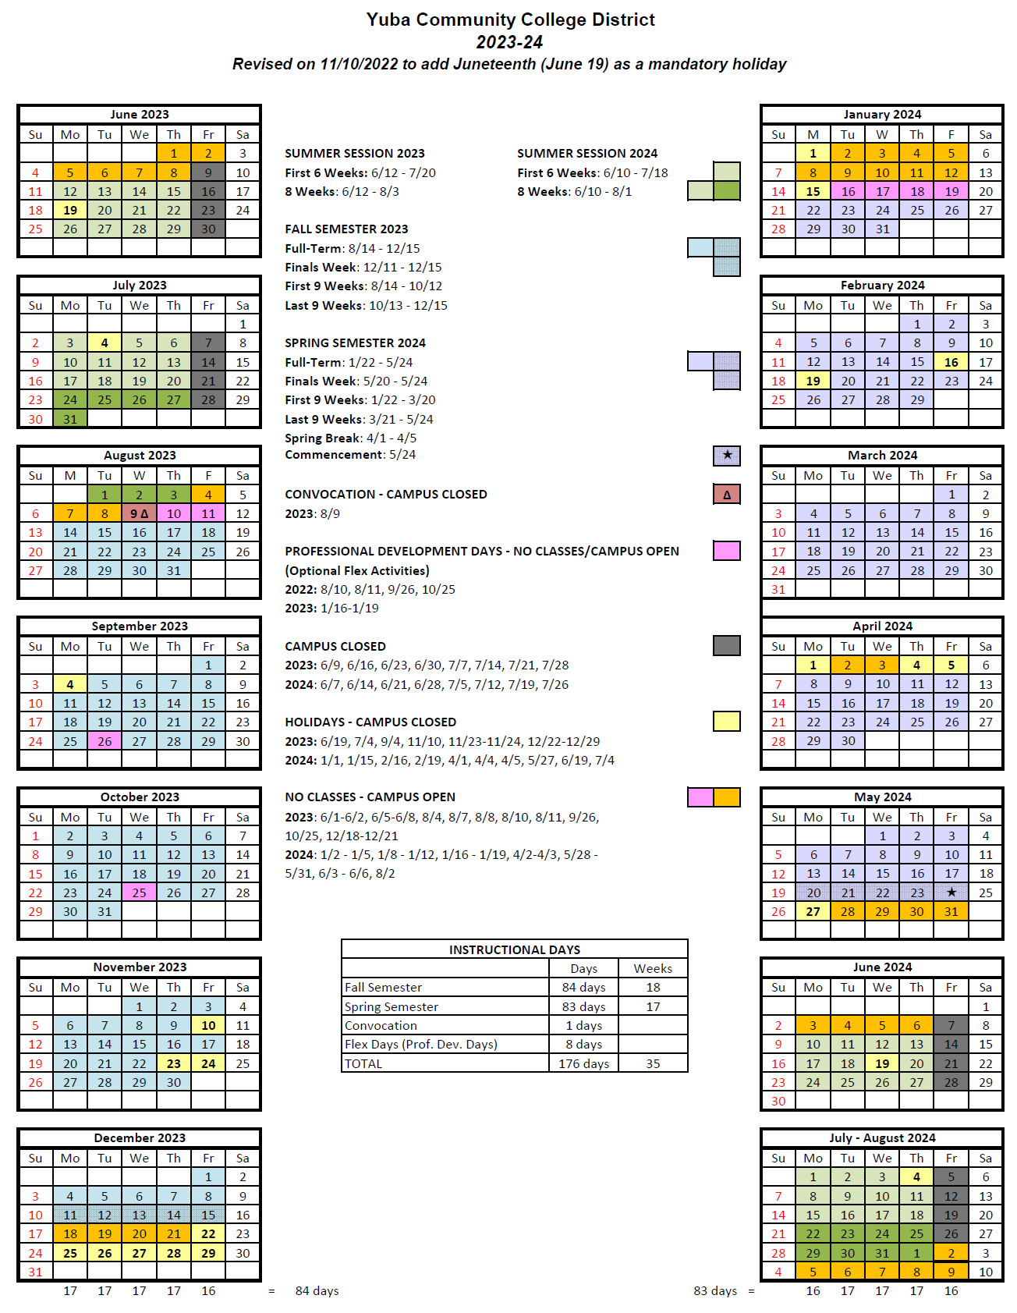
Appendix J: Map of Yuba College Campus, 2088 North Beale Road, Marysville, California, 95901

The End.

