Request for Proposal/Request for Qualification
Yuba Community College District

Design Services:
Multiple Buildings, LED Lighting Projects

No. RFP/RFQ 22-09

Issue Date: February 7, 2023
RFP/RFQ Package Due: March 14, 2023

Due Date: March 14, 2023, 1:00 pm Sharp, YCCD District Offices Location- Delivered To:

Yuba Community College District, District Offices
Attn.: David Willis
District Director of Facilities Planning, Maintenance & Operations
RFP No. 22-09, “Design Services: Multiple Buildings, LED Lighting Projects”
Address: Sutter County Campus, Second Floor, District Offices, Room 217, Attention: David Willis, 3301 East Onstott Road, Yuba City, California 95991

Proposal Delivery at Second Floor, Attn.: Dave Willis, Room 217
Yuba Community College District
Sutter County Campus
District Offices
3301 East Onstott Road (second floor)
Yuba City, California, 95991

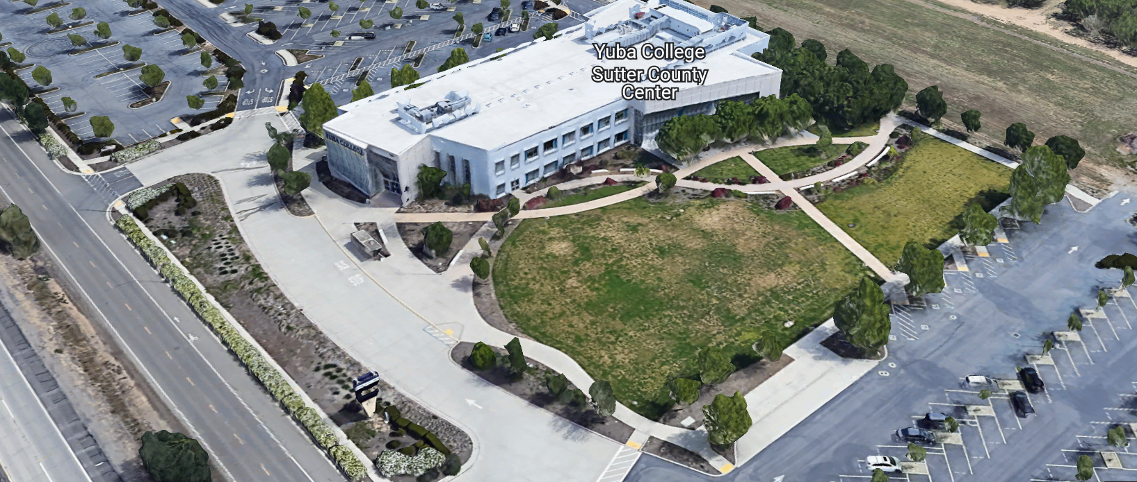
West Building Entrance
TABLE OF CONTENTS

1.0 INTRODUCTION
1.1 District Information
1.2 Yuba Community College District Background
1.3 Purpose of the Request
1.4 Applicable Codes
2.0 Scope of Work
2.1 Project Schedule
2.2 District Staff Contacts during Proposal Process
2.3 Project Safety Requirements
3.0 Proposal Format Organization
3.1 Proposal Delivery, Contents, and Format
4.0 Selection of “Firm”
5.0 Basis of Award
6.0 Non-Discrimination
7.0 Response to Request for Proposal (RFP)
8.0 Requests for Information (RFI)
9.0 Evaluation of Proposals Form (Not Applicable)
10.0 Proposal Schedule
11.0 District Parking
12.0 RFP/RFQ Proposals
13.0 Award of Contract/Proposal
14.0 Reservation of Rights
15.0 Bid Bond, Performance Bond, Payment Bond Requirements (Not Applicable)
16.0 Liquidated Damages

Proposal Required Items:

Appendix A, Bid Form Costs
Appendix B, Statement of Qualification
Appendix C, Acknowledgement of Addenda Form
Appendix D, Non-Collusion Affidavit Form
Appendix E, Reference Drawings Link
Appendix F, YCCD Professional Services Agreement (PSA). (Only the Successful Firm will need to fill this out)
Appendix G, Signature Proposal Form
Appendix H, Project Team / Approach

Informational Items:
Appendix I: Project Scope Information
Appendix J: Yuba Community College District, Space Inventory Report (Building Square Footages)
Appendix K; YCCD Academic Calendars
Appendix L; Map of College’s Locations:
- Yuba College Campus
- Sutter Center
- Woodland Community College
- Lake County Center
- Colusa County Center
1. INTRODUCTION

  - District Information:

The District consists of two colleges, Woodland Community College and Yuba College, with campuses located at five different locations: Yuba College in Marysville, CA; Sutter County Center in Yuba City, CA; Woodland Community College in Woodland, CA; Colusa County Center in Williams, CA; and Lake County Center in Clearlake, CA.

  - Yuba Community College District

The Yuba Community College District (YCCD) was founded in 1927 and spans eight counties (Yuba, Sutter, Colusa, Yolo, Lake, Butte, Glenn and Placer) and nearly 4,200 square miles of territory in rural, north-central California. It has colleges in Marysville and Woodland, an educational center in Clearlake, an educational center in Williams, and an educational center in Yuba City.

  - Purpose of Request

The Yuba Community College District seeks Proposals and “Statements of Qualifications” and “Proposals” from “Design Firms” described in section 2.0 below and in Appendix B.

District College Locations:

Woodland Community College Address: 2300 East Gibson Road, Woodland, California 95776
Lake County Center Address: 15880 Dam Extension Road, Clear Lake, California, 95422
Colusa County Center Address: 99 Ella Street, Williams, California, 95987
Yuba College Campus Address: 2088 North Beale Road, Marysville, California 95901.
Sutter County Center Address: 3301 East Onstott Road, Yuba City, California, 95991

  - Applicable Codes
All work shall meet all State of California Building Codes, and Federal codes, and local ordinances.

- Scope of Work / Pre-qualification Process

This LED project scope of work will include the following:

- On-Location Field Inspections and Survey to verify existing conditions in each building in the scope of work.
- Design Services to generate construction drawings and specifications.
- Determination and presentation whether PG&E offers any rebates or incentives that the District may be interested in.
- Contract Administration during the construction period.
  - Weekly OAC Zoom Project Team Meetings
  - Generating ASI’s, review of contractor RFI’s and Possible Change Orders (PCO’s), Submittal reviews, and review of Progress Payments.
- Project Close-Out, punch lists, as-built drawings, etc…

This project includes designing LED improvements to the following Buildings:

- Woodland Community College Campus
  - Building 100
  - Building 300
  - Building 400
  - Building 700
  - Building 800, North Building
  - Building 800, South Building
- Lake County Center
  - Building 100
  - Building 200
  - Building 400
  - Building 401
  - Building 402
  - Modular Restrooms Building
  - Building 700
  - Building 801, CDC
  - Student Bookstore Building
- Colusa County Center
- Yuba College Campus
  - Building 1100
  - Building 2100
  - Exterior Lighting Controls Across Campus, Tied into BAS systems (mostly Automated Logic Control ALC systems).
- Sutter County Center

Since this is a lighting fixture replacement project, it is not required to be submitted to DSA.

The LED lighting projects are being bid as two separate projects. The first project represents the Woodland Community College, Lake County Center, and the Colusa County Center locations. The second project represents the Yuba College and Sutter County Center locations. Funding for these projects is being tracked by College.
Important Field Investigation of Each Building Required:
It will be extremely important that the Design Team members do a thorough field investigation of existing conditions to reduce the risk of change orders, inaccurate line voltages, existing fixtures types and arrangements that are not shown on the as-built drawings, and to ensure that the design represents the needs of the Colleges and District. This work will help to reduce the risk of contractor change orders.
Prequalification Process: Reference Appendix B, entitled, “Statement of Qualification”. In order to save time, this project RFP is combining both the pre-qualification process and the proposal process.
Only Firms that are first pre-qualified will then have their proposals considered and evaluated by the District Project Evaluation Team. Please take the time to be thorough in your “Statement of Qualification” responses.

This RFP/RFQ requires both a “Statement of Qualification” and a Proposal.

The design drawings and specifications shall be submitted to the District digitally in both PDF and AutoCAD formats. The design drawings and specifications are the sole property of the District. All drawings words and information shall be easily legible on a 11 x 17 inch drawing size.

2.1 Project schedule
Approximate Design Start Date: April 24, 2023
Approximate Design Completion Date: July 7, 2023 (or sooner)
Provide a brief project schedule with the proposal.
2.2 District Staff Contacts during the Proposal process:
Firms interested in submitting a Proposal are directed not to make personal contact with the Board of Trustees, District staff, or members of the evaluation committee. Any contact shall constitute grounds for disqualification from consideration.
Single Point of Contact during the Proposal Preparation Process:
David L. Willis
District Director of Maintenance, Operations, and Planning
425 Plumas Blvd., Suite 200 (Second Floor)
Yuba City, California, 95991
Cell Phone: 916-747-4262
Email: dwillis@yccd.edu

2.3 Project Safety and Security Requirements
Safety is a top priority for the District. All California OSHA requirements apply. Designs shall incorporate safe industry proven approaches.
COVID 19 BEST PRACTICES APPLY:
Design professionals are required to login at the maintenance building 1400 on the log sheet to facilitate prompt notification in case there is a positive test result of COVID 19 and notification is required within 24 hours. Design Firms have the same notification requirements.
3.0 Proposal Format Organization
The Design Firm is requested to use the following proposal format:
3.1. Proposal Delivery, Contents, and Format:
Proposals should provide straightforward, concise information that satisfies the requirements noted in this RFP/RFQ. Expensive binding, color displays, and the like are discouraged. Emphasis should be placed on brevity, conformity to the Districts instructions, selection criteria of this RFP/RFQ, and completeness and clarity of content. Each Respondent’s proposal should clearly and accurately demonstrate specialized knowledge and experience required for consideration.

In a sealed box or envelope (clearly marked “), submit the following:
- One (1) flash memory stick containing the complete proposal and supporting documentation;
- One (1) original and two (2) copies in paper form of the proposal, which consists of a Proposal Letter and responses to the proposal requirements of this RFP/RFQ.

There is no page limit.

Firms must comply with the provisions of these instructions for completion and submission of the Proposal. The failure of a Firm to comply with the Proposal Instructions and Requirements will likely result (at the sole discretion of the District) in rejection of the Proposal for non-responsiveness.
Proposal Section | Format
- Cover Letter | PDF
- Table of Contents | PDF
Appendices (See Table of Contents for each one) Submit a response to each Appendix that requires Contractor information. Please submit responses to Appendices A, B, C, D, E, F, G, H. Appendices I, J, K, and L are informational only. | PDF

Proposal General Information Contents:

Cover Letter

The Proposal shall include a Cover Letter on Respondent’s official business letterhead, which shall be signed by an individual authorized to legally bind Respondent. The Cover Letter shall also identify the name, telephone number, and email of a person who may be contacted during the Proposal evaluation process.

Table of Contents

Provide a Table of Contents that outlines in sequential order the major sections and sub-sections of the Proposal. Use tabs to allow information to be more easily located.

4.0 Selection of “Firm” Services Provider

The process of “Firm” selection is based upon the complete responsiveness of the RFP/RFQ and the criteria as outlined in the RFP/RFQ.

The District Project Evaluation Team will read the written proposals. The District Evaluation Team will discuss the proposals and verify that the “Basis of Award” information below and information submitted in response to the RFP/RFQ are complete and responsive.

The District reserves the right to reject any and all submittals, to amend the RFP/RFQ process, and to discontinue or re-open the process at any time. The District reserves the right to request clarifications to RFP/RFQ responses and to negotiate the terms of the agreement.

5.0 Basis of Award

This project will be awarded based on the following criteria:

- Best Qualified/Lowest Total Cost Responsive Proposing Firm
  - Best Qualified Firm
    - Proper State of California License in good standing
    - Appendix B Statement of Qualifications Information
    - Design Team Members/Credentials, Roles, Time Commitments
    - Information provided as requested in the RFP/RFQ.
    - All Addendums are acknowledged.
    - Design Firm listed any exceptions or exclusions.
    - Design Firms with historical good performance on YCCD projects.
    - The one or two of the lowest total cost responsive qualified proposers may be requested to participate in a ZOOM interview process with the District Project Proposal Evaluation Team.
  - Design Firm Capability to do the work, meet the schedule requirements
  - Lowest Total Cost
- Process:
  - Evaluate Statement of Qualifications (Appendix A)
  - Evaluate Proposals of Qualified Firms
  - Interview top Qualified 1 to 3 Firms with high scoring (rank order) proposals as determined by the District. There may not be interviews with Firms if the District determines that it is not needed.

6.0 Non-Discrimination
The District does not discriminate with regard to race, color, gender, national origin, disability, or any other protected or other classification in the awarding of contracts/agreements. The District welcomes all Firms to participate in the project Request for Qualification/Proposal process.
The District encourages firms that are women or minority owned, emerging small businesses, veteran owned firms, disabled person owned firms, and all other qualified firms to participate in the proposal process.
The District encourages the submission of proposals from all Firms that can meet the stated requirements set for this RFP/RFQ.

7.0 Responses to RFP/RFQ:
Sealed responses to this RFP/RFQ must be clearly marked "RFP/RFQ NO.22-09 Design Services: Multiple Buildings, LED Lighting Projects”.

Responses shall be mailed to or hand-delivered to the following address:

Yuba Community College District, District Offices
Attn.: David Willis
District Director of Facilities Planning, Maintenance & Operations

Envelope/Box Marked:
“RFP/RFQ No. 22-09; Design Services, LED Lighting Projects”.

Address: Sutter Center, District Offices, 3301 East Onstott Road, Yuba City, California 95991

Note: Completely seal your proposals in envelope/box and make sure it gets date/time stamped when delivering proposal. Firms are each 100% responsible to make sure proposals that are mailed using a carrier such as UPS, FED Ex, etc…are received and date/time stamped by District personnel prior to the proposal due date/time. No proposals will be considered if they are late, even if it is only 5 minutes late. Please make sure your proposals are delivered and received promptly prior to the due date/time. There will be a public proposal opening at the due date/time.

Do NOT email your proposals. Emailed proposals that are not sent per the above guidance requirements will not be considered.

8.0 Requests for Information (RFI)

Requests for Information concerning the RFP/RFQ must be in writing and may be submitted via email no later than the date shown below. Please direct all questions to David Willis, email: dwillis@yccd.edu.

Following the RFI deadline, all questions and answers will be summarized and posted on the District's website: https://www.yccd.edu/central-services/purchasing/ , then, click on the “Requests for Proposals / Quotes” tab on the right hand side of this web page. It is anticipated that responses to inquires received by the required time and date will be provided within 5 business days and posted on the District's website or responded to per the dates listed in the RFQ for addendum publishing. Should more time be needed by the District to answer I respond to RFI’s, this information will also be posted on the above website.

- Include the following in the subject matter field on emails when requesting information: “RFP/RFQ 22-09”, RFI.

9.0 Evaluation of Proposals Form (Not Applicable)
10.0 Proposal Schedule:

Important Dates and Times:

February 7, 2023: Release of Request for Proposal at 4:00PM

February 21, 2023: 1:00 PM, Optional Zoom Only Pre-Proposal Meeting

Zoom Link: https://yccd-edu.zoom.us/j/84541066334

Dial by your location: +1 669 444 9171 US

February 22, 2023: 1:00 PM, Optional On-Campus Pre-Proposal Meeting
Location: Woodland Community College Campus, Building 100, Room 113, 2300 East Gibson Road, Woodland, California, 95776.

February 23, 2023: 2:00 PM, Optional On-Campus Pre-Proposal Meeting
Location: Yuba College, Building 1400 (Maintenance Building), East Side of the Campus, Conference Room, 2088 North Beale Road, Marysville, California, 95901.

February 24, 2023: 10:00 AM, Optional On-Campus Pre-Proposal Meeting
Location: Lake County Center, Building 200, North Side Classroom, 15880 Dam Road Extension, Clear Lake, California 95422.

February 24, 2023: 2:00 PM, Optional On-Campus Pre-Proposal Meeting
Location: Colusa County Center, 99 Ella Street, Williams, California, 95987

February 28, 2023: 1:00 PM, Optional On-Campus Pre-Proposal Meeting
Location: Sutter County Center, North Entrance/Lobby Area First Floor, 3301 East Onstott Road, Yuba City, California, 95991.

To coordinate an alternative date/time to visit Woodland Community College, Lake County Center, or Colusa County Center, please contact Brian Splaine at bsplaine@yccd.edu.

To coordinate an alternative date/time to visit Yuba College or Sutter County Center, please contact Bryan Epp at bepp@yccd.edu.

There are no mandatory meetings required for this procurement process.

March 6, 2023: 1:00 PM, All questions and requests for information must be submitted to David Willis at: dwillis@yccd.edu.

March 7, 2023: Addendum Issued if needed.

March 14, 2023: Proposal/Statement of Qualifications Packages due at 1:00 PM SHARP, to Location: Sutter County Center, District Offices, 2nd Floor, Room 219, Attention Dave Willis, 3301 East Onstott Road, Yuba City, California 95991. There will be a public bid opening on this RFP/RFQ.

April 28, 2023: Expected date of Award with Purchase Order.

This is a prevailing wage project.
11.0 District Parking:

-No parking in Reserved Spaces without a proper permit
-Permit Parking is enforced in all general lots between 6:00 am and 6:00 pm, Monday through Friday. All general lots require a properly displayed, valid permit during these times
-Daily Parking Permits are $2.00
-Permits are available for purchase at any of the permit machines located in the student parking lots
-All other parking regulations are enforced 24 hours a day, seven days a week. This includes designated staff spaces, handicap spaces, timed spaces, red zones, yellow zones, and areas not marked (no parking at any time)
-Once this project is awarded, temporary parking permits will be processed as requested by the successful firm for all employees associated with this project at no cost to the Firm for the duration of the project at each Campus location. These temporary permits must be displayed at all times on the dashboard of employee vehicles.

12.0 RFP/RFQ Proposals

Proposals received after the deadline will not be opened. Each responder shall submit one (1) signed original, two (2) additional hard paper copies, all in separate binders. Provide one electronic format copy of the proposal using electronic media such as a flash drive. Only Flash Drives shall be used for the required electronic format copy.

All materials submitted in response to the RFP/RFQ shall be on 8-1/2"x11" paper, preferably in
Portrait orientation. All submitted materials must be bound in either a three-ring binder or spiral bound notebook. Content shall be tabbed and numbered per the items included in the Submittal Requirements. All Proposals will be reviewed and evaluated by a District Selection Committee. The District at its sole discretion may interview finalists, or select a firm or firms to perform work based solely on the evaluation of the Proposal. There is no page limit.

All Proposals become the sole property of the District and the content will be held confidential until the selection of the Firm or Firm’s is made and the project is awarded.

- Award of Contract

- The Contract will be awarded to the best qualified, most responsive, proposer whose proposal, conforming to the request for proposal/ request for qualification and associated addendums, will be most advantageous to the District. The lowest cost Proposing Firm may not be awarded the project.

- If a Firm has performed well on other projects at the District and is providing a very qualified team to work on this project then this will be factored into the evaluation process.

C. The District reserves the right to enter into an Agreement without further discussion of the proposal submitted based on the initial offers received.

D. The District reserves the right to reject any or all proposals or any part of the proposal and to waive informalities and minor irregularities in the proposals received.

E. The RFP/RFQ, its addendums, any follow-up clarifying information, and the proposal of the selected Firm will become part of any contract initiated by the District.

F. A formal contract shall be signed by the successful proposer and Yuba Community College District to perform this service.

G. The District reserves the right to enter into discussions with any one or all of the Responders after Proposals have been initially reviewed. Such responses shall be subject to all provisions, terms and conditions as set forth in the RFP/RFQ, unless otherwise modified.

H. The District intends to award to a single RFP/RFQ Responder.

I. Performance and Payment bonds are NOT required.

J. Failure to acknowledge all of the addendums, provide the items listed in the RFP/RFQ, may render the proposal unresponsive at the discretion of the District.

K. The District reserves the right to request clarification of proposal content during the review and evaluation process.

L. The District reserves the right to negotiate the terms of the agreement to align with budgetary constraints.

14.0 Reservation of Rights

The District reserves the right to:

- Reject any or all submittals at its sole discretions.
- Cancel the Request for Proposal/ Request for Qualifications (RFP/RFQ), without cause.
- Modify any requirements contained within the RFP/RFQ and request a revised submission from all Providers.
- Establish other evaluation criteria determined to be in the best interest of the District.
- Contract with any of the firms responding to the RFP/RFQ based solely upon its judgment of the qualifications and capabilities of the firm.
- Clarify the content of any proposal to verify that the requirements of the RFP/RFQ are included.
- Waive “minor” proposal inconsistencies that do not change the scope of work as outlined in the RFP/RFQ.

This RFP/RFQ does not commit the District to award or negotiate a contract. The District will not be responsible for any expenses incurred by any firm in preparing and submitting a proposal or response to this RFP/RFQ or in completing any of the work specified.

15. Bid Bond Requirements – Not Applicable

16. Performance and Payment Bond Requirements: Not Applicable
17. Liquidated Damages:
If the design of the construction documents (drawings and specifications) are not 100% completed to the sole satisfaction of the District by end of the business day August 15, 2023, there is a $300/calendar day liquidated damages requirement to be paid by the Design Firm to the District until the design of the construction documents (drawings and specifications) are completed.

Appendix A: Bid Form
Project No. 1: Woodland Community College Locations

No. | Description | Cost
1 | WCC-Building 100 | $
2 | WCC-Building 300 | $
3 | WCC-Building 400 | $
4 | WCC-Building 700 | $
5 | WCC-Building 800, North Building | $
6 | WCC-Building 800, South Building | $
7 | LCC-Building 100 | $
8 | LCC-Building 200 | $
9 | LCC-Building 400 | $
10 | LCC-Buildings 401, 402, modular restrooms building | $
12 | LCC-Building 700 | $
13 | LCC-Building 801 CDC | $
14 | LCC-Building-Student Bookstore | $
15 | CCC-Colusa County Center | $
16 | Contract Administration | $
17 | Sub-Total Cost: | $
18 | Other Costs: (Please describe and explain) | $
19 | Additive Alternate No. 1: (Defined By Design Firm) | $
20 | Additive Alternate No. 2: (Defined By Design Firm) | $
21 | Reimbursable Expenses: Design Firm to Define/Explain  Note: No hotel or travel costs allowed | $
22 | Project No. 1 Total Costs: | $

Project No. 2: Yuba College Locations
No. | Description | Cost
1 | YC-Building 1100 | $
2 | YC-Building 2100 | $
3 | YC-Exterior Lighting Controls Replacement | $
4 | SCC-Sutter County Center | $
5 | Contract Administration | $
6 | Sub-Total Cost: | $
7 | Other Costs: (Please describe and explain) | $
8 | Additive Alternate No. 1: (Defined By Design Firm) | $
9 | Additive Alternate No. 2: (Defined By Design Firm) | $
10 | Reimbursable Expenses: Design Firm to Define/Explain  Note: No hotel or travel costs allowed | $
11 | Total Costs: | $

The LED lighting projects are being bid as two separate projects. The first project represents the Woodland Community College, Lake County Center, and the Colusa County Center locations. The second project represents the Yuba College and Sutter County Center locations. Funding for these projects is being tracked by College.
WCC=Woodland Community College
LCC=Lake County Center
CCC=Colusa County Center
YC=Yuba College
SCC=Sutter County Center
Provide hourly rates for each position title.
List all sub-design firms with area of responsibility.
Provide a detailed preliminary draft schedule of design services.
The District may chose to not award all of the listed buildings.

Appendix B: Statement of Qualifications
The Firm shall furnish the following information. Failure to comply with this requirement will render the submittal informal and may cause its rejection. Additional sheets may be attached if necessary.
Basic Firm Informational Items 1 through 16:

- Firm Name:___________________________________________________________________

- Primary Address: ______________________________________________________________

- Firm’s Contact Person and Title:___________________________________________________

- Telephone: ___________ Facsimile: ____________________

- Email Address: ___________________

- License No.: ______________________________ Class: __________________________

Responsible Managing Employee/Officer:___________________________________________

- Names and titles of two officers of the Firm:

NAME TITLE

___________________________________ _______________________________________

___________________________________ _______________________________________

8. Specific type of Ownership (Check one)

Individual
Partnership
Corporation; If a corporation, state the following:

State of incorporation:
Date of incorporation: President/CEO:
Joint Venture
Other (Specify)

- Taxpayer Identification No.: _______________________
- List annual gross income for last three (3) years:
Year: _______________ $_____________________
Year: _______________ $_____________________
Year: _______________ $_____________________

- Number of years Firm has been in business:
If less than 5 years, please describe:

- Number of years Firm has conducted business under the present name:__________
- Has the Firm ever been licensed under a different name or different license number? . If Yes, give name(s) and license number(s) and dates or operation under that name(s) and license number(s) (attach separate sheets if necessary):___________________________________________ _________________________________________________________ _________________________________________________________
- Number of years’ experience in California Community College, University or educational facility projects .

- Has the Firm ever completed any work at the Yuba Community College District? If Yes, please elaborate:

Potentially Disqualifying Questions 16 through 22 (District may immediately disqualify Firm if its answer is “Yes.”(questions 16 through 21), and “No” for question 22. Firm’s refusal to answer or omission of response to any of Questions may result in disqualification of Firm:

- Has the Firm been defaulted or terminated (other than for convenience) by any California school district, community college district or other California public agency on any project within the past 10 years? Yes/No

If yes, identify agency and details:

- Has the Firm or any of its owners, officers, or partners, ever been convicted of a crime, or found guilty in a criminal action, involving fraud, theft, making any false claim or material representation to a public agency, or involving any federal, stet, or local law, rule, or regulation related to construction? Yes/No_____

If yes, explain, identify the agency, and provide case name and number.

- Has the Firm been disqualified, debarred, forbidden, or found non-responsible or otherwise prohibited from performing work or bidding on work for any California school district, community college district, or other California public agency within the past ten years? Yes/No

If yes, identify agency and details:

- Has the Firm been in litigation (whether in court or arbitration) with any California school district, community college district, or other California public agency on an issue pertaining to any contract during the past ten years? Yes/No:

If yes, explain, identify the agency, and provide case name and number.

- Has the Firm ever failed to complete a project in the past ten years? Yes/No: If so, give owner and details:

- Is the Firm currently or has the Firm been in a state of “Bankruptcy” in the past ten years? Yes/No:
If yes, please explain.

- Does the Firm have recent project experience that includes design and contract administration of LED Lighting remodel/renovation projects of at a Community College in California? Yes/No
Please explain.

Rating Questions:

- Please list and describe on separate sheets the Firm’s top 10 “like” k-12, Colleges, Universities projects references that were designed in the past 10 years, with current contact information. The project reference list should include the following criteria:
  - Project Name
  - Project Owner and Contact Information
  - Project Scope
  - Division of the State Architect (DSA) Experience (even though this project does not require DSA submission)
  - Original Contract Completion Date
  - Actual Project Completion Date
  - Original Construction Contract Price
  - Final Adjusted Construction Contract Price
  - Any issues that Firm had to overcome on the project

Scoring Criteria:
  - “Like” type LED Lighting Remodel/Renovation Projects at K-12, Colleges, and Universities in California (80 points)
  - DSA Experience (20 points)

Total points: up to 100 points

- Please provide the project team members, roles, experience of “like” LED lighting renovation/improvement projects, time commitment to this project, experience and examples of alternate funding sources if any (including PG&E incentive programs, Federal and State programs), education and other credentials of the Project Team.
(Up to 5 LED Lighting projects> $250,000 in value in the past 5 years= 20 points, 5 to 10 LED lighting projects> $250,000 in the past 5 years= 30 points, 11 or more LED lighting projects> $250,000 in the past 5 years= 40 points.) Can also earn up to an additional 20 points for funding alternatives, extraordinary time commitments and exceptional credentials for the Project Team. Total points available=60 points

- Historically good project performance on other projects at the District in the past 10 years. (0 projects=0 points; 1 to 3 projects= 10 points; 4 or more projects=20 points)

- How many years has your Firm been in business in California as a Design Firm under your present business name and license number? __________
(less than 5 years = 0 points; 5-7 years = 3 points; 8+ years = 10 points.)

- In the last 10 years, how many legal proceedings (filed in court or arbitrations) has your Firm initiated against an owner, regardless of outcome? _______
(0 = 10 points; 1 = 5 points; 2+ = 0 points.)

- In the last 10 years, how many legal proceedings (filed in court or arbitrations) has an owner initiated against your Firm, regardless of outcome? _______
(0 = 10 points; 1 = 5 points; 2+ = 0 points.)

- Has your Firm been denied an award of public works contract based on a public agency’s finding that your Firm was not a responsible Proposer within the last 10 years? ______
(No = 5 points; Yes = 0 points.)

- Please describe the Capability/Capacity of your Firm. Please provide a comprehensive list of projects that the Design Firm has currently in process and reasoning/justification regarding how the Firm has capacity to perform the required services on this project.

(Up to 20 points.)

- Please describe the Firm’s commitment to maintaining the design schedule. How will the Firm recover the schedule if it slips due to COVID-19 or similar illness impacts, or the Firm gets extremely busy with other projects? Please describe specific actions the Firm will take to maintain the Project schedule.

(Up to 15 points.)

- Please list and describe the Firms Team Members that will be working on the project, roles, percent of time commitment, and provide support information of their experience working on “like” projects and credentials. Has this team worked together before? Provide examples.

(Up to 40 points.)

- Please describe the Firm’s commitment to meeting regularly at project team meetings, maintaining positive communication, providing progress updates, and providing timely RFI’s and administrative contract support information during the Project. Please describe specific actions the Firm will commit to maintain a positive relationship with the District and the applicable College through the above description:

(Up to 20 points.)

Qualification Criteria:
Questions 1 through 16 are general base level information that is required for pre-qualification.
Questions 16 through 22 are possible disqualifying questions that would render the Firm “not qualified” as determined by the District.
Questions 23 through 33 are rating questions that are scored and more deeply evaluated. Not scoring the minimum threshold value will render the Firm “not qualified”.
  - There are a total of 310 points possible.
  - The District can disqualify a Firm (at it’s sole discretion) if the Firm does not meet the requirements of Questions 16 through 22.
  - To be determined as a Qualified Firm, and to have Proposals Considered, each Firm must score at least 250 points.
  - Once a Firm is Qualified, the associated Proposal will be evaluated by the District. The top 1 to 3 Firms may be interviewed.
  - If the District deems needed, Interviews are worth 50 points. If an interview is required, then the total points will be 360 points and the prequalifying threshold will be 300 points.

The undersigned is duly authorized to execute this Statement of Qualifications under penalty of perjury on behalf of the above-identified Firm. The undersigned warrants and represents that he/she has personal knowledge of each of the responses to this Statement of Qualifications and/or that he/she has conducted all necessary and appropriate inquiries to determine the truth, completeness, and accuracy of responses to this Statement of Qualifications. The undersigned declares and certifies that the responses to this Statement of Qualifications are complete and accurate; there are no omissions of material fact or information that render any response to be false or misleading and there are no misstatements of fact in any of the responses. The above-identified Firm acknowledges and agrees that if the District determines that any response herein is false or misleading or contains misstatements of fact so as to be false or misleading, the District may find the Firm is not qualified and the District can reject the proposal for non-responsiveness or non-responsibility.

Executed this___ day of __________________ 20__ at_____________________________.
(City and State)
I declare under penalty of perjury under California law that the foregoing is true and correct.

By: ____________________________________________
(Signature of Firm’s Authorized Officer or Representative)

____________________________________________
(Typed or Printed Name)

Title: ___________________________________________

Addendum C: Acknowledgement of Addenda Form

The undersigned acknowledges receipt of the following addenda from the District pursuant to the Request for Proposal:
Acknowledgement: Yes or Not Applicable
Addendum No. 1: .
Addendum No. 2: .
Addendum No. 3: .
Addendum No. 4: .
Addendum No. 5: .

Firms are required to acknowledge all addenda’s within the submitted proposal at the time of submission.

Appendix D: Non-Collusion Affidavit Form

STATE OF CALIFORNIA, COUNTY OF I, being first duly sworn, deposes and says that I am the of , the party submitting the foregoing proposal (“the Proposal”). In connection with the foregoing Proposal, the undersigned declares, states and certifies that:
- The Proposal is not made in the interest of, or on behalf of, any undisclosed person, partnership, company, association, organization or corporation.
- The Proposal is genuine and not collusive or a sham.
- The Firm has not directly or indirectly induced or solicited another Firm to put in a false or sham proposal, and has not directly or indirectly colluded, conspired, connived, or agreed with any other Firm or anyone else to put in a sham proposal, or to refrain from bidding.
- The Firm has not in any manner, directly or indirectly, sought by agreement, communication, or conference with anyone to fix the proposal price, or that of any other Firm, or to fix any overhead, profit or cost element of the proposal price or that of any other Firm, or to secure any advantage against the public body awarding the contract of anyone interested in the proposed contract.
- All statements contained in the Proposal and related documents are true.
- The Firm has not, directly or indirectly, submitted the proposal price or any breakdown thereof, or the contents there of, or divulged information or data relative thereto, or paid, and will not pay any fee to any person, corporation, partnership, company, association, organization, proposal depository, or to any member or agent thereof to effectuate a collusive or sham proposal.
Executed on this date: , 2023, at:

(City, County, and State)
I declare under penalty of perjury under the laws of the State of California that the foregoing is true and correct.
Signature Printed Name .
Address: .
Area Code & Phone Number: .
Note: In addition to other bid documents, bidders on public works projects are required by Public Contract Code section 7106 to submit a certification form that they have not colluded with another proposer.

Appendix E: Reference Drawings Link:
https://goyccd-my.sharepoint.com/:f:/g/personal/w0398409_yccd_edu/EtoN68B7IHNBt5kILCEsBNgBS8OBf5hTEk6krxxMvzu_Jw?e=jKSnMa

Appendix F: YCCD Professional Services Agreement (PSA)
Link:
https://goyccd-my.sharepoint.com/:w:/g/personal/w0398409_yccd_edu/EaOF1539HJpOkqkjSTfZUJgBNcWp12o6EIiAvUrtKOUMwA?e=lMwnaZ

Only the Firm that is awarded the project will need to fill out this form.
Appendix “G” Proposal Signature Form
The undersigned acknowledges the following:
- Having become familiar with the specifications and requirements of the Request for Proposal, hereby offers to provide all services in accordance with the proposal set forth herein, including all referenced material and attachments.
- By submitting a signed proposal in response to this solicitation, the Firm acknowledges that they completely understand the scope of the needed services and that the proposed services as described in the proposal will meet or exceed the needs of the District.
- Late proposals will not be accepted (even if they are only 5 minutes late).
- The District reserves the right to reject any and all proposals and that this proposal shall remain open and not be withdrawn for a minimum of 90 days.
- Cancellation Clause: The District may, without cause, terminate the contract(s) or a project under the contract(s) by giving written notice of such termination to the awarded firm. In the event of such termination the District shall reimburse the firm for services performed and reasonable expenses actually incurred by the firm in relation to the terminated project prior to the firm’s receipt of such notice of termination. The cost of proposal generation, associated travel, copies, postage, etc.., will not be reimbursed and is considered a typical and normal part of the bid process and is not reimbursed for any of the proposers.
- If the prospective Firm is a corporation, the undersigned hereby represents and warrants that the corporation is duly incorporated and is in good standing in the state of California , and that, , is authorized to act for and bind the corporation.

Entity Type (Select One):

Sole Owner: Partnership: .

Corporation: .

Other; Please specify;

- Regular monthly progress payments are made using NET 30 as a basis for payment, with Net 30 time starting after receipt of the invoice with all required support documentation, and once this information is reviewed and approved by the District.

Invoices must be emailed to the following with all support documentation:
Vendors with a first letter of A through N: hgardner@yccd.edu; rharvey@yccd.edu
Vendors with a first letter of O through Z: hgardner@yccd.edu; rharvey@yccd.edu
It is critical that invoices have all required support documentation including an updated schedule of values and any other information that will help to justify and support the progress payment request.

Signature_____________________________ Date: _______________________
Position: _____________________________
Print name____________________________ Title________________________

Notary Required On This Project
Notary Stamp:

Appendix H: Project Team / Approach
Provide an org. chart, resumes of team members, description of time commitment, and roles and responsibilities on the project.
Provide preliminary project schedule. Consideration regarding availability of faculty.
Provide a list of sub-designers with credentials, roles, resumes of key personnel.

Important Field Investigation of Each Building Required:
It will be extremely important that the Design Team members do a thorough field investigation of existing conditions to reduce the risk of change orders, inaccurate line voltages, existing fixtures types and arrangements that are not shown on the as-built drawings, and to ensure that the design represents the needs of the Colleges and District.

Appendix I: Project Scope Information:
General Lighting Standards & Guidance:
      - Interior Lighting: 3900 to 4100 Kelvin
      - Exterior Lighting: 5,000+ Kelvin
      - All Fixtures to be new.
      - No Retrofit Kits for existing fixtures.
      - Minimum Operational Life: 50,000 hours, if possible. Longer operational life without required maintenance or replacement is better.
      - At least a 1-year no-cost replacement warranty and a 5-year limited warranty is desired on all new LED light fixtures.
      - Some existing interior lighting controls may need to be repaired or re-programmed. The District would like to maintain the existing lighting controls in all spaces.
      - Light levels shall be designed to be 35% higher than existing light levels.
      - Conduct a photometric study of each building to verify existing light levels.
      - All interior spaces in the associated buildings are included.
      - Pendent lights in classrooms to be replaced with 2’ x 4’ light fixtures in T-bar grid ceilings.
      - Specialty light fixtures in common spaces need to be replaced with LED lighting fixtures.
      - Only major LED lighting fixture manufacturers that have a large market presence, have been in business for at least 20 years, have reliable proven lighting fixture solutions, and that have local regional distribution and support office/business are allowed.
      - The District has used the following light fixture and would like this fixture or a similar looking fixture to be used in these projects:
        - https://goyccd-my.sharepoint.com/:b:/g/personal/w0398409_yccd_edu/Ee6O3BIue0RHpYNuFDdicM4BUUV_ubALXaD5_z7B1RO_AA?e=ChkkqM
        - 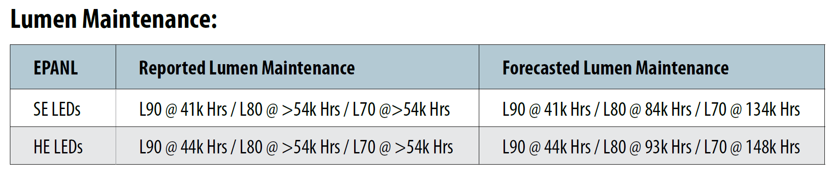

Appendix I: Project Scope Information: continued
      - YCCD Facilities Standards:
        - https://goyccd-my.sharepoint.com/:b:/g/personal/w0398409_yccd_edu/Ebb5n4Gz631MrQ-CmQpqIXwBJlwhzIibmtpQ1T_-7JWhcQ?e=dcXYUC

      - PG&E rebates and incentives will be considered. Reference link:
    - https://www.pge.com/en_US/small-medium-business/save-energy-and-money/energy-efficiency-financing.page
    - https://www.pge.com/en_US/residential/save-energy-money/savings-solutions-and-rebates/rebates-by-product/rebates-by-product.page?

- Alternative funding sources such as Federal or State programs, grants, initiatives, will also be considered.
- Include seismic bracing as needed to meet current codes on new fixtures.
- Include emergency LED battery powered light fixtures, as needed.
Important Field Investigation of Each Building Required:
It will be extremely important that the Design Team members do a thorough field investigation of existing conditions to reduce the risk of change orders, inaccurate line voltages, existing fixtures types, lighting control systems and switches, types of existing ceilings, existing lighting electrical services capacities, and arrangements that are not shown on the as-built drawings, and to ensure that the design represents the needs of the Colleges and District.

Appendix J: YCCD Space Inventory Report (Building Square Footages)
Link:
https://goyccd.sharepoint.com/:b:/s/YCCDMaintenanceOperations/EcUy3xXt6MRJjp3UVWzkDLQBWcsFGs75baQiUdFB8JyOgw?e=9a9GXK

Appendix K: YCCD Academic Calendar—see next page

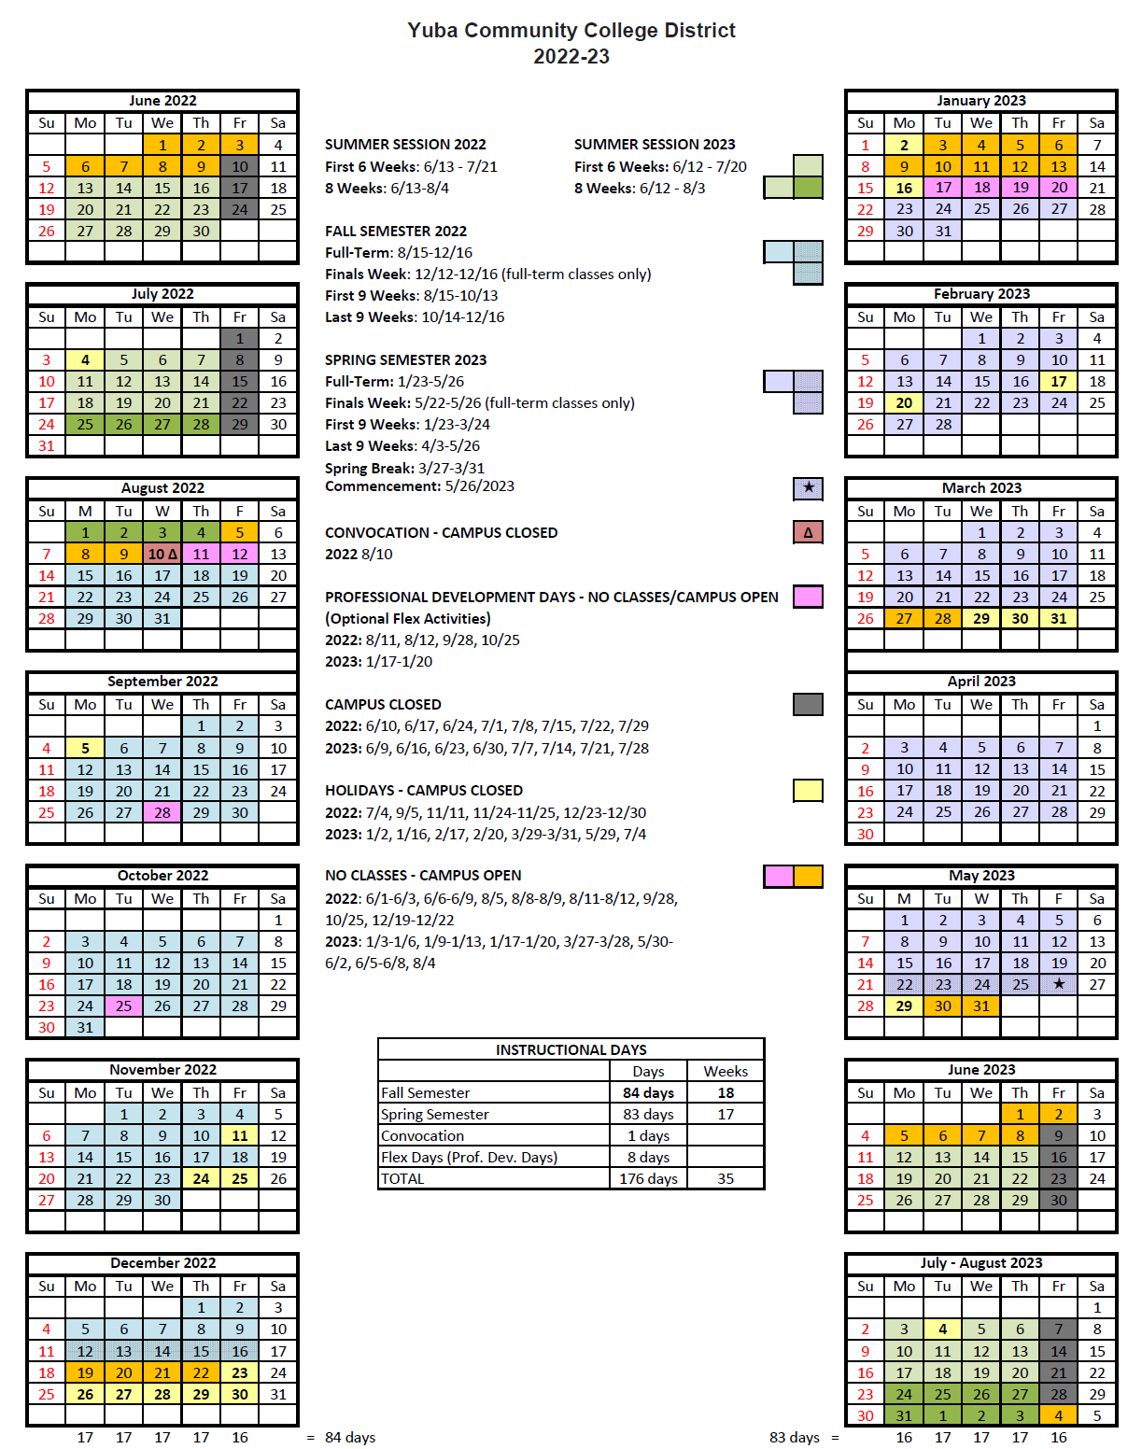
Appendix L: Map of Yuba College Campus, Woodland Community College Campus and associated locations

Map of Yuba College, 2088 North Beale Road, Marysville, California, 95901

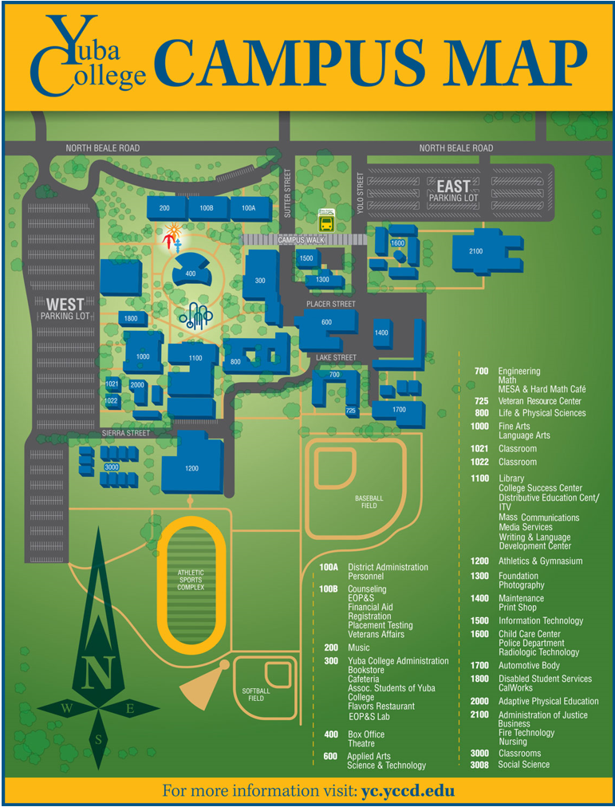
Second Map of Yuba College Campus:

Sutter County Center Map: 3301 East Onstott Road, Yuba City, California 95991
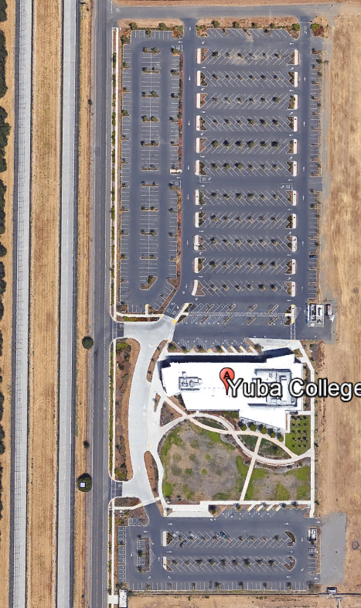
Map of Woodland Community College, 2300 East Gibson Road, Woodland, California, 95776
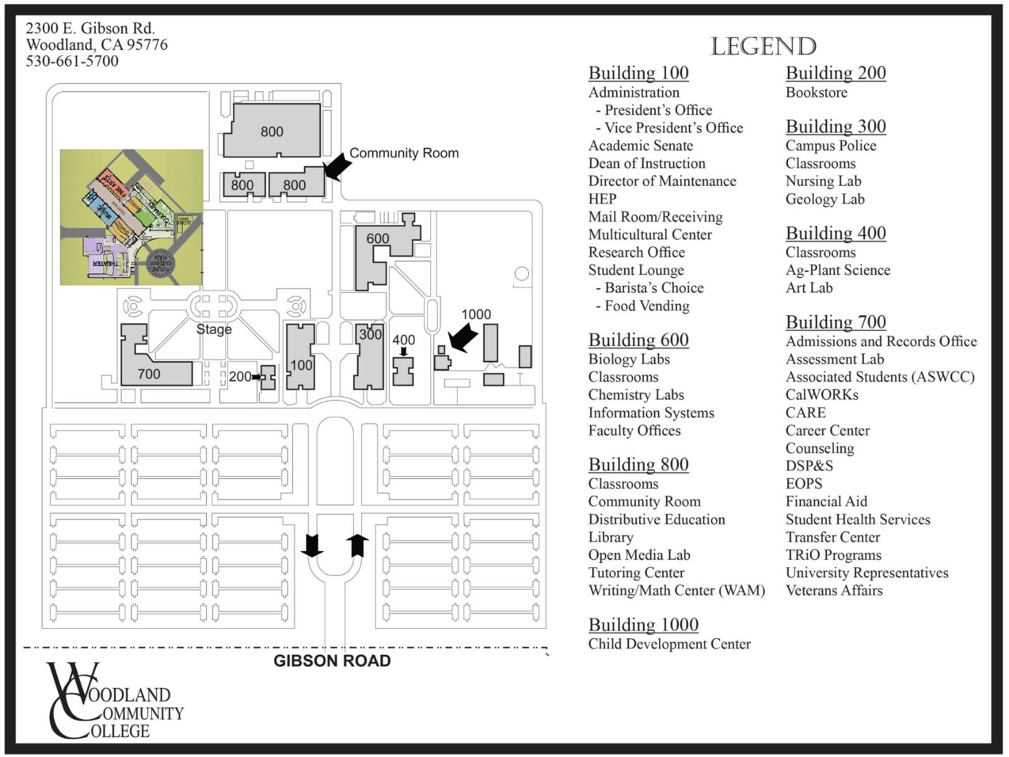

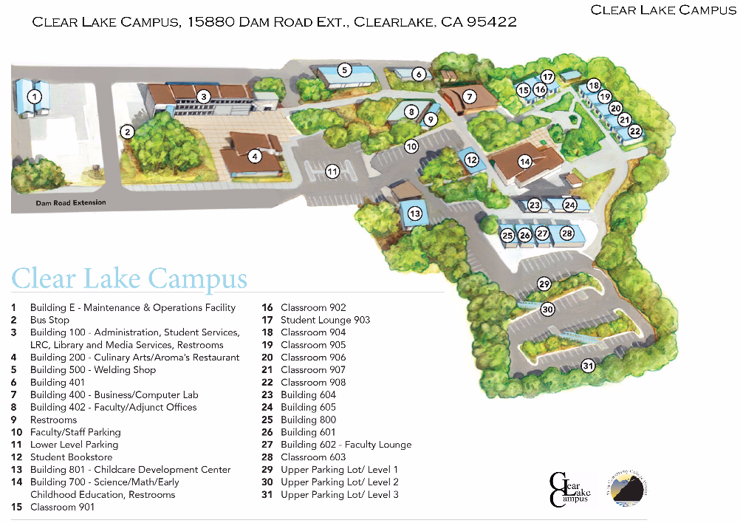
Map of Lake County Campus

Map of the Colusa County Center: 99 Ella Rd, Williams, Ca.
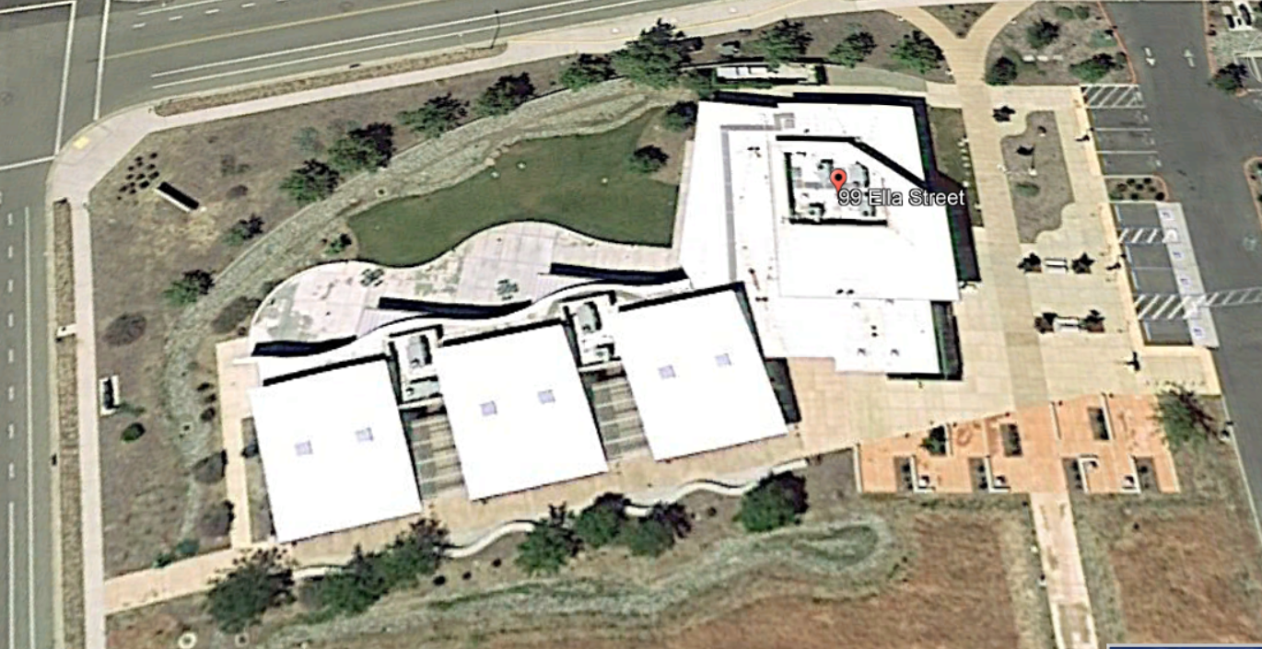

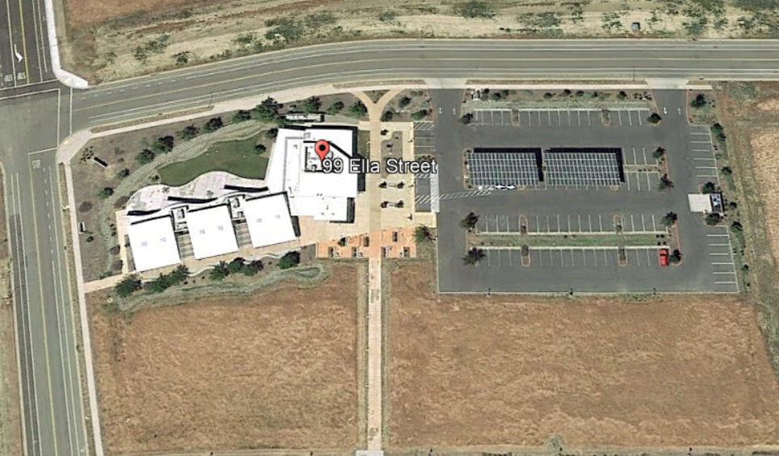

The End.

