REQUEST FOR QUALIFICATION
AND
REQUEST FOR PROPOSAL

FOR
PROFESSIONAL SERVICES:

DISTRICT FACILITIES MASTER PLANNING
(Second Procurement)

RFP/RFQ NO. 22-08.2
(Prequalification and Proposal Request)

Issue Date: January 27, 2023
Due Date: February 21, 2023

Due Date: February 21, 2023, 1:00 pm Sharp, YCCD District Offices Location- Delivered To:

Yuba Community College District, District Offices
Attn.: David Willis
District Director of Facilities Planning, Maintenance & Operations
RFP No. 22-08.2, “RFQ/RFP Professional Services-District Facilities Master Planning”
Address: Sutter County Campus, Second Floor, District Offices, Room 217, Attention: David Willis, 3301 East Onstott Road, Yuba City, California 95991

Proposal Delivery at Second Floor, Attn.: Dave Willis, Room 217
Yuba Community College District
Sutter County Campus
District Offices
3301 East Onstott Road (second floor)
Yuba City, California, 95991

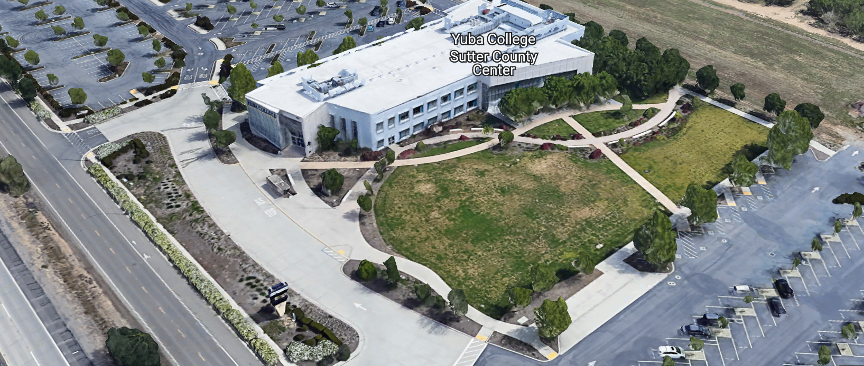
TABLE OF CONTENTS
West Building Entrance

1.0 INTRODUCTION
1.1 District Information
1.2 Yuba Community College District Background
1.3 Purpose of Request: Prequalification of Professional Services Firms
1.4 Applicable Codes
2.0 General Facilities Master Planning Information
3.0 District Staff Contact during Proposal Process
4.0 CUPCCAA (Not Applicable)
5.0 Proposal Delivery, Contents, and Format
6.0 Non-Discrimination
7.0 Responses to RFQ/RFP
8.0 Requests for Information (RFI)
9.0 RFQ/RFP Schedule
10.0 RFQ/RFP Clarifications
11.0 Reservation of Rights
12.0 Appeal of Prequalification/Proposal Evaluation Results

RFQ/RFP Proposal Package “Firm” Provided Required Items:
Appendix A, Bid Form
Appendix B, Statement of Qualifications Form (Provided By Firm)
Appendix C, Audited Financial Statement (Provided By Firm)
Appendix D, Acknowledgement of Addenda Form (Provided By Firm)
Appendix E, Business Licenses, Certifications, Other Credentials (Provided By Firm)
Appendix F, Non-Collusion Affidavit Form (Provided By Firm)
Appendix G, YCCD Professional Services Agreement (PSA). (Provided By Firm)
Appendix H, Signature Proposal Form (Provided By Firm)
Appendix I, Facilities Master Planning Project References (Provided By Firm)
Appendix J, Firm’s Professional Services Approach/Schedule/Team Members (Provided By Firm)

Informational Items:
Appendix K, Facilities Master Planning Informational Reference Documents
Appendix L: YCCD Academic Calendar
Appendix M: Map of Yuba College Campus, Woodland Community College Campus

1.0 INTRODUCTION

  - District Information:

The District consists of two colleges, Woodland Community College and Yuba College, with campuses located at six different locations: Yuba College in Marysville, CA; Sutter County Center in Yuba City, CA; Beale Education Center, Beale AFB, CA; Woodland Community College in Woodland, CA; Colusa County Center in Williams, CA; and Lake County Campus in Clearlake, CA.

  - Yuba Community College District

The Yuba Community College District (YCCD) was founded in 1927 and spans eight counties (Yuba, Sutter, Colusa, Yolo, Lake, Butte, Glenn and Placer) and nearly 4,200 square miles of territory in rural, north-central California. It has colleges in Marysville and Woodland, an educational center in Clearlake, an educational center in Williams, an educational center in Yuba City, and outreach operations at Beale Air Force Base.

  - Purpose of Request:

This is the second time this RFP/RFQ is being published. The District failed to get enough fully responsive proposals from qualified Firms in the last procurement to move this work forward. If your Firm has previously submitted a proposal, please revise and resubmit it as part of this procurement. Include all requested information so that your proposal and prequalification information is fully responsive and complete.

The purpose of the RFQ/RFP is to both pre-qualify Firms, and also to acquire proposals for the consulting services associated with the development of the District-Wide Facilities Master Plan. The Packages received by the Firms will first be used to prequalify Firms. If Firms are prequalified, then, their respective proposal will then be evaluated. Only the proposals from Prequalified Firms will be evaluated.
Proposal Statement:
This RFP/RFQ also requires a proposal Bid Form per Appendix A.
Prequalification Statement:

Public Contract Code section 20651.5 permits the governing board of any community college district to require each prospective bidder for a contract, as described in Public Contract Code section 20651, to complete and submit to the district a standardized questionnaire and financial statement, verified under oath by the bidder, in a form specified by the district, including a including a complete statement of the prospective bidder’s financial ability and experience in performing public works. Only applicants that are prequalified will be permitted to submit a proposal.

The District requests the FORMAL submission of Statements of Qualifications with support documentation for the District Facilities Master Plan (Reference Appendix B).

Facilities Master Planning Process:
The District and its two Colleges have recently updated the respective Educational Master Plans for each College. These Educational Master Plans (EMP’s) further develop current and potential academic program plans at each college to include the education/workforce development component of the District. Embedded within the District’s governance structures is a tradition of collegial governance and decision-making that will be an important factor in the development of the Facilities Master Plan. The District will use the proposed capital facilities planning process to identify the remaining facility needs for completion by the existing bond measures, to support requests for funding from future State-wide bond measures or to fund the facilities additions and enhancements as identified by the plan.

This Request for Proposal (RFP) is for the Facilities Planning component of the District-wide Educational Master Plans for each College. The selected consultant will be required to produce written, graphic, and digital documentation as needed to clearly describe the capital plans to accommodate the projected student enrollment in the academic master plan. The consultant will gather input from the District and College leadership, the Academic, Classified and Student Senates and other constituencies through the District’s Facilities Master Planning Project Team. The consultant will assist the District in the planning process through adoption of the plans by the District’s Board of Trustees.

The final product will include, but not be limited to, a capital plan that illustrates the potential building and infrastructure capacity/renewal of each of the college campuses and District facilities to accommodate current and potential educational program expansion, potential removal of buildings, renovation and repairs to old and outdated/worn-out facilities and infrastructure systems to meet current regulatory compliance and functional requirements. This work shall include yet not be limited to planning for the Following:

- Americans with Disabilities A……
- Fire Alarm and Suppression Systems
- Electrical Distribution Systems
- Chilled Water Heating and Boiler Hot Water Systems
- Underground Utilities and Utilities Systems Equipment
- Building Envelope Improvements to protect assets
- Energy Conservation Measure Projects
- Security Systems
- Technology Infrastructure
- Sustainable Environmental Stewardship
- “Total Cost of Ownership” and District/College “Right Sizing” (Number and Types of Buildings)

The Top Ten (10) High-Level priorities and Desirable Outcomes of this Facilities Master Planning process are:

- Development of Facilities Master Planning Principles and Criteria to move toward creating a “21st Century Academy” type Facilities, in alignment with and in support of the District/Yuba College/Woodland Community College Mission and Values in Serving Students in the most dynamic and impactful way possible leading to enhanced Student Success, with available resources.
- Gather and evaluate a broad spectrum of information such as student and community demographics, local and regional workforce development needs, emerging and growing industry needs for workforce development and associated Student career paths, existing instructional programs, instructional programs offered in regional Community Colleges in Northern California, and any other information that would be helpful to inform the needed Facilities Master Planning desired outcomes as noted in the RFP.
- Provide a thorough in-depth current status assessment of all facilities and technology infrastructure including all mechanical systems, utilities systems, and technology systems, equipment, and control systems. This assessment shall be completed by an Qualified Engineering Consulting Firm with extensive successful experience of “like” assessments on Colleges and University campus’s. Turley & Associates did complete a thorough assessment for Yuba College years ago. A link to this assessment is located in Appendix K. Turley & Associates is willing to update this assessment. Recommendations should also include the future replacement of underground piping that may have outlived it’s useful life due to corrosion issues and underground electrical cabling that is over 40 years old and may also need to be replaced. An assessment of the Woodland Community College Campus is also needed. There have been some electrical issues at WCC regarding power quality and damage to sensitive equipment.
- Thoroughly review and consider all of the reference documents provided by the District.
- Development of a Short-Term District-Wide, College Specific, five (5) year Facilities Master Plan (STFMP).
- Development of a Long-Term District-Wide, College Specific, years five (5) through twenty-five (25) Facilities Master Plan (LTFMP). Emphasis shall be placed on the earlier years of the plan with more general planning in later years.
- Identify and Develop Prioritized Facilities Investment Opportunities to fully support the following:
  - District’s Strategic Plan
  - The Educational Master Plans for both Yuba College and Woodland Community College
  - New and Emerging Enrollment Growing Instructional Programs.
  - Existing Instructional Programs to further enrich and update Student and Faculty learning experiences.
  - Reduce Operating Costs. Reference to the FCMAT study, the Chancellors Cabinet recommendations, College Leadership Recommendations, FCMAT Task Force recommendations.
  - Prioritized Renewal/Renovation/Modernization Projects at each College location that will likely qualify for State Funding Match criteria.
  - Prioritized list of potential new buildings and/or site improvements and the potential removal of buildings at each College location. Include a “right sizing” strategy that aligns current and long-term future student enrollment (FTES) by instructional program with required Facilities spaces.
- The identification of a List of Prioritized Potential New and Enhanced Community and Regional Partnerships that have a facilities or land development component, or a facilities shared use. Consider Partnerships with Businesses, Agencies, and others that may need a “workforce” training program. Consider previous historic partnerships with as identified and provided by the Colleges and the District. Include Collaborative “Brainstorming” work sessions with various groups to fully develop a list of possible Facilities instructional and training use opportunities that will enhance Student enrollment.
- Research and Identify a Prioritized List of Potential New and Proven Funding Sources for identified prioritized “facilities and infrastructure” projects. Funding options include District Foundation Capital Campaigns, Various Grants, Legislative Appropriations, State and Federal Funding Programs and Sources, Zero interest financing, and the State Chancellor’s Office Five-Year Capital Projects Planning process that align with the District’s commitment to long-term Fiscal Sustainability commitments. Other sources of income such as partnerships with land developers, Universities, Colleges, Hospitals, Businesses, Manufacturers, or other entities should also be listed with possible specific sponsorship opportunities at each College location.
- All Facilities Master Planning work shall be done with close collaboration and participation of the District/College Facilities Master Planning Team, Focus Groups, with opportunities for Student, Staff, Faculty, Management, and Community participation. Possible participation in Board of Trustees work sessions, Chancellors Cabinet, College President Leadership Teams, College Governance committees, and Student Government.

FURTHER DEFINITION OF THE SCOPE OF REQUIRED SERVICES:

Program Definition/Data Collection: The Educational Master Plan’s information, growth capacity information from the Education Master Plan, and subsequent Program Reviews by the colleges will be used to determine the type and amount of building space that will be needed for the next 5 to 25 years as the District matures and local demographics trending with specific minimal/modest growth rates. Thorough investigation of the existing conditions and state of infrastructure and facilities are needed especially at the Yuba College Campus. The information will translate into space requirements, land use, adjacencies, capacity, circulation, technology, infrastructure, and utility requirements.

Site Analysis including Massing Analysis and Future Expansion and/or Contraction: The consultant will examine campus physical attributes and constraints, surrounding context, and existing and potential future program needs. As part of the capacity study, potential building sites would be identified, consideration for “moth-balling” into an out of service state or the option to demolition existing structures that are cost prohibitive to renew at a later date, and identify potential site issues. Options to increase space utilization should be presented and certainly will be considered.

Site Current Condition Analysis: The consultant will examine current campus infrastructure (both above and below ground), parking, technology, accessibility, way-finding, and condition of current facilities. Based on those studies, the consultant will propose way-finding, renovation, modernization and infrastructure projects, as well as new construction projects. Energy Conservation Measure projects such as interior LED lighting improvements, the replacement of old HVAC units, replacing old electrical system transformers/switchgear/panels/conductors, and Energy Management Control System improvements shall be considered.

Sustainability and Environmental Stewardship: The consultant is expected to consider and maximize sustainability and Environmental Stewardship in the preparation of all proposals and identify renewable energy opportunities. The District Board policy is minimum to design around LEED Silver for new buildings and renovated/modernized buildings.

Fiscal Sustainability and Stewardship: Enrollment in the Yuba Community College District has dropped by nearly 20 percent from 2016 through 2021. This has resulted in low space utilization and fiscal challenges with reduced available resources. Options and Strategies to re-align and “re-size” the College Campus facilities at all District/College locations shall be generated and presented by the Firm with associated fiscal cost reduction calculations in a prioritized cost/benefit, “Total Cost of Ownership” modeling format.

Facilities Investment Opportunities that Foster Enrollment Growth: Since enrollment has dropped by nearly 20 percent in recent years, it is imperative that future Facilities Investments are maximized and prioritized to have the highest possible chance of driving up enrollment and growth. Higher enrollment numbers by local and regional students can be viewed as a measurement of the effectiveness of the Yuba College and Woodland Community College and YCCD District in meeting the educational and workforce needs of the community. The aesthetic College Campus appearance’s, the care of the facilities, and the modern instructional quality of the instructional spaces and support areas are a strong factor in contributing to Student Enrollment, Retention, and Community Perception. The Successful Firm shall generate a prioritized list of facilities investments that support this critical criteria.
Final Product: The Firm will prepare a draft and final planning document which will include, but not be limited to, the elements listed below.

  - Executive Summary

  - Background, including:
    - The Master Planning Process
    - Facilities Master Planning Process
      - Timelines
      - Step-by-step process
    - State Rules & Guidelines
    - Funding for Capital Outlay Projects described in the Yuba Community College District/Colleges Education and Facilities Master Plans

  - The District and Colleges, including:
    - Description of the District
    - Description of Woodland Community College and Yuba Colleges
    - Mission, Vision, Values
    - Opportunities and Challenges
    - Capacity/Load Ratios, past, current and projected
    - Condition of Facilities
    - Condition and capacity of Infrastructure
    - Enrollments Projections
    - Available land
    - Parking
    - Campus Architecture
    - Campus Circulation
    - Land Use and Topography
    - Parking
    - Programs
    - Other Services
    - Adjoining Districts

  - Linkage Between Academic & Facilities Master Plans
    - Converting WSCH to ASF
    - Midterm and Long-term Information

  - Facilities Master Plan – for the District and each Campus
    - Capacity/Load Analysis and Projections
    - Goals of the Plan
    - Environmental Constraints
    - Specific Projects
    - Access Transitional Plans
    - Renovation, Modernization and New Facilities Plans
      - Prioritizing and Phasing Plan
    - Campus Aesthetic Enhancement Plans
    - Initial Project Proposal and Final Project Proposal plans
    - Total Cost of Ownership Plans
    - Infrastructure development Plans
    - Energy Conservation Plans
    - Sustainability/Environmental Stewardship Plans
    - Vehicular Circulation Plans
    - Pedestrian Circulation and Way-Finding Plans
    - Signage Plans
    - Public Transportation (if applicable)

FACILITIES MASTER PLANNING BUDGET:

Base Scope Budget: $250,000 Maximum
Possible Additive Alternates Budget: $ 50,000 Maximum
Total Budget: $300,000 Maximum

Please do not qualify your proposal to negotiate later a reduced scope of work. If your Firm is unable to complete the work as outlined with the above budget, list any exclusions or exceptions.

PROPOSED PRELIMINARY SCHEDULE

Following is the anticipated accelerated proposed schedule; however the actual schedule will be developed with the selected consultant.

Orientation March. 2023 – April. 2023
Initial Planning Meetings (1) April. 2023
Gathering Information and Analysis March 2023 – June 2023
Draft Plans Developed (2) July - September 2023
Draft Plans Reviewed (3) September-October 2023
Public Forums and Comment (4,5) November 2023
Final Plans Developed (6) January - February 2024
Board of Trustees First Reading (7) April 2024
Plan Adoption by the Board of Trustees (8) March 2024

Proposed Milestone Dates:

  - Draft FMP 70% Completion Date: October 10, 2023.
  - Draft FMP 85%Completion Date: November 13, 2023.
  - Final FMP 100% Completion Date: January 16, 2024.
  - First Reading and Presentation, Board of Trustees: February 8, 2024.
  - Final Presentation and Adoption, Board of Trustees: March 14, 2024.

Definition of Terms
- Orientation meetings with District Facilities Task Force, District and College leadership.
- Planning sessions with District leadership, academic planning councils, strategic planning committees, shared governance committees and others as required.
- Draft plans developed and available for District review and comment.
- Internal District presentations to the various College Governance Committees and Teams.
- Draft plans revised and made available for public review. Presented to shared governance for further comment and refinement.
- Final plans developed and made available for District review and approval.
- Board of Trustees First Reading.
- Board Action and Adoption

  - Applicable Codes
All planning and other work shall meet all Local, State, and Federal Codes, Regulations, and Ordinances.
2.0 General Facilities Master Planning Information
The following information will provide some context and support for the District Facilities Master Plan work:

- Yuba College and Woodland Community College Leadership has recently completed their respective Educational Master Plans.

- The YCCD Facilities Master Plan was last completed December 2018.

- The updated District-Wide Facilities Master Plan will be used to support other planning and potential future obligation bond planning work.

Introduction:
The Facilities Master Plan for the District, including both Colleges was last updated in 2018.
Purpose:
The Facilities Master Plan must be updated as required by the State Chancellors office and to support ongoing Accreditation planning and documentation. The Facilities Master Planning process is a collaborative work that includes input from a vast number of College/District groups which both represent the Colleges/District governance councils and committees, Chancellor, Presidents, District Services, Faculty, various staff, students, and others. The Facilities Master Plan provides a framework for future decision making associated with future investment in alignment with the Colleges/District instructional mission, strategic goals, and initiatives in support of student success and quality facilities that enhance local community higher education needs.
FMP updates must be informed by the updated Educational Master Plans for each College. Each College will have a separate section in the District Facilities Master Plan with all College locations included. The College Presidents and their designated staff will each respectively provide the needed program driven facilities needs for each College. The District Director of Facilities Planning, Maintenance, and Operations, will provide information regarding the needed physical plant/buildings, utilities, infrastructure, and site improvements that will also be part of each renovation/modernization and new building projects.
The Facilities Master Plan (FMP) work for each College and the District will certainly focus on the initial Short-Term Facilities Master Plan (STFMP), 0 to 5 years . This work will also include a Long-Term Facilities Master Plan (LTFMP) work that will help to inform future project planning from 5 year through 25 years. There will be both a Short-Term FMP and a Long-Term FMP for each College and when combined, represent the District Facilities Master Plan.
3.0 District Staff Contact during the RFQ/RFP Proposal process:
Firms interested in submitting a “Prequalification/Proposal Package” are directed not to make personal contact with the Board of Trustees, District staff, or members of the evaluation committee. Any contact may constitute grounds for disqualification from consideration.
Single Point of Contact during the Preparation Process:
Yuba Community College District, District Offices
Attn.: David L. Willis
Room 219 (Second Floor)
3301 East Onstott Road
Yuba City, California, 95991

Cell Phone: 916-747-4262
Email: dwillis@yccd.edu

4.0 CUPCCAA (Not applicable)
Firms are requested (not required) to fill-out CUPCCAA qualification and participation forms. Refer to this link for more information regarding the District’s CUPCCAA process and required forms:
https://www.yccd.edu/central-services/fiscal-services/purchasing-2/cupccaa/

5.0 Prequalification/Proposal Package: Delivery, Contents, and Format:
Packages should provide straightforward, concise information that satisfies the requirements noted in this RFQ/RFP. Emphasis should be placed on brevity, conformity to the Districts instructions, selection criteria, and completeness and clarity of content.
All fees and costs associated with the completion of the package shall be borne by the Firm. The District shall not, under any circumstances, be liable for any expenses incurred by the Firm in connection with the preparation, completion, or submission of the package.
Please use the following format with Tabs, when organizing the Prequalification/Proposal Package:
Pre-Qualification Packet | Format
- Cover Letter | PDF
Appendices
Required Items by Firm:
- Bid Form | PDF
- Statement of Qualifications Form | PDF
- Audited Financial Statement | PDF
- Acknowledgement of Addenda Form | PDF
- Business Licenses, Certifications, Other Credentials | PDF
- Non-Collusion Affidavit Form | PDF
- YCCD Professional Services Agreement (PSA) | PDF
- Signature Proposal Form | PDF
- Facilities Master Planning Project References | PDF
- Firm’s Professional Services Approach/Schedule/Team Members | PDF
Informational Reference Items:
- Facilities Master Planning Informational Reference Documents | PDF
- YCCD Academic Calendar | PDF
- Map of Yuba College Campus, Woodland Community College Campus | PDF

Please note that the District Offices have relocated and proposals need to be delivered to the new address as noted in this RFP/RFQ.
6.0 Non-Discrimination
The District does not discriminate with regard to race, color, gender, national origin, disability, or any other protected or other classification in the awarding of contracts/agreements. The District welcomes all qualified firms to participate in the project Request for Qualification/Proposal process.

The District encourages firms that are women or minority owned, emerging small businesses, veteran owned firms, disabled person owned firms, and all other qualified firms to participate in the qualification process.

The District encourages the submission packages from all firms that can meet the stated requirements set for this RFQ/RFP.

7.0 Responses to RFQ/RFP:
Sealed responses to this RFQ/RFP must be clearly marked "RFQ/RFP NO. 22-08 Professional Services, YCCD Facilities Master Planning”.

Responses shall be mailed to or hand-delivered to the following address:

Sealed Envelope/Box Marked:

Yuba Community College District, District Offices
Attn.: David Willis
District Director of Facilities Planning, Maintenance & Operations
“RFQ/RFP No. 22-08.2, Professional Services YCCD Facilities Master Planning”
Address: YCCD District Offices, Sutter County Center, Second Floor, Room 219, 3301 East Onstott Road, Yuba City, California, 95991

Note: Firms must completely seal their Packages in an envelope/box and must ensure the District personnel provides a date/time stamp on the delivered package. Firms are each 100% responsible to make sure packages that are mailed using a carrier such as UPS, FED Ex, etc., are received and date/time stamped by District personnel prior to the proposal due date/time. No packages will be considered if they are late. Firms must ensure packages are delivered and received promptly prior to the due date/time. There will be a public proposal opening.

8.0 Requests for Information (RFI)

Requests for Information concerning the RFQ/RFP must be in writing and may be submitted via email no later than the date shown below. Please direct all questions to David Willis, email: dwillis@yccd.edu.

Please share “RFQ/RFP 22-08.2, RFI” in the email subject field regarding all RFI’s.

9.0 Pre-Qualification Schedule:

Important Dates and Times:

January 27, 2023: Release of Request for Qualification at 4:00PM

February 9th, 2023: 11:00 AM OPTIONAL Pre-RFQ ZOOM Meeting

Join Zoom Meeting
https://yccd-edu.zoom.us/j/82833910986

Dial by your location
+1 669 444 9171 US

Note: Firms are encouraged to attend the Optional ZOOM Prequalification meeting.

February 13, 2023: All questions and requests for information must be submitted to David Willis at: dwillis@yccd.edu by 1pm.

February 14, 2023: Addendum Issued if needed.

February 21, 2023: Proposals and Prequalification Packets are due by no later than 1:00 PM SHARP, Yuba Community College District, Sutter County Center, District Services, Room 219, Second Floor, 3301 East Onstott Road, Yuba City, California 95991. There will be a public bid opening. Evaluation of the RFQ/RFP packages will begin after 1:00 PM. District will inform Firms if they are prequalified for the Project after review of the packages.

All questions associated with the process shall be addressed to David Willis, District Director of Facilities Planning, Maintenance, and Operations at email: dwillis@yccd.edu or cell phone: 916-747-4262.

Note: Firms that have previously submitted a Proposal/Prequalification package through RFP/RFQ No. 22-08 must resubmit their respective proposal/prequalification package for RFP/RFQ No. 22-08.2. Previously received proposals/prequalification packages information will not be published or shared.

Copies of RF All procurement documents, including Addenda’s (as required) may be obtained only on the YCCD Purchasing website: https://www.yccd.edu/central-services/
All RFQ/RFP packages received after stated date and time will be rejected.

10.0 RFQ/RFP Requirement Clarification

Each responder shall submit one (1) signed original, three (3) additional hard paper copies, all in separate binders. Provide one flash drive copy of the proposal.

All materials submitted in response to the RFQ/RFP shall be on 8-1/2"x11" paper, preferably in
Portrait orientation. All submitted materials must be bound in either a three-ring binder or spiral bound notebook. Content shall be tabbed and numbered per the items included in the Submittal Requirements. All Proposals will be reviewed and evaluated by a District Selection Committee. The District at its sole discretion may interview each of the Firms. There is no page limit. Please be brief.

Please submit an audited financial statement and the financial status of the Firm as Appendix C.

Prequalification Evaluation Questionnaire responses and Financial Statement Information of the Firm are confidential information and not subject to public records requests.

All RFQ/RFP Packages become the sole property of the District.

This RFQ /RFP does not commit the District to negotiate a contract.

Once Firms are prequalified, then their proposals will be evaluated. Proposals from unqualified Firms will not be considered. Firms are prequalified at the sole discretion of the District.

11.0 Reservation of Rights

The District reserves the right to:

- Reject any or all proposal submittals at its sole discretion, including for any inaccurate, incomplete information, or if Firms are not prequalified.
- Waive any irregularities contained in any submittals as defined by the District.
- Cancel the Request for Qualifications (RFQ) / Request for Proposals (RFP) process, without cause.
- Modify any requirements contained within the RFQ/RFP and request a revised submission from all firms.
- Establish other evaluation criteria determined to be in the best interest of the District.
- Request clarifications to information provided.
- Prequalify firms based on the information presented in this RFQ/RFP and at the sole discretion of the District. Firms may in some cases be disqualified if the information provided is incomplete, does not meet the requirements of the RFQ/RFP, if the overall score of the evaluation does not meet minimum thresholds (at the sole discretion of the District).
- The District may negotiate the terms of the contract.

12.0 Appeal of Prequalification Results

If a Firm chooses to challenge a District decision, the Firm must follow the following procedure:

- Firm must, within two (2) business days after notification of the District’s prequalification decision, submit in writing to David Willis, the District Director of Facilities Planning, Maintenance & Operations, a request that the District review or reconsider its determination. The Firm’s request must set forth in detail all grounds for the request, including all facts, supporting documentation, legal authorities, and arguments in support of the grounds for the request. Any matters not set forth in the request shall be deemed waived. If the Firm does not submit a timely request, the District’s determination shall be final and the Firm shall waive all rights to challenge the District’s decision, whether by administrative process, judicial process, or any other legal process or proceeding.

- If the Firm timely files the request for review, District staff shall schedule a time for a meeting to allow the Firm to rebut any evidence used as a basis for the decision and to present evidence as to why the Firm should be determined to be qualified to formally bid the Project. District staff shall then review the Firm’s evidence and subsequently notify the Firm regarding whether the Firm is determined qualified to formally bid the Project.

- If the Firm chooses to challenge District staff’s determination regarding the Firm’s prequalification rating after presenting evidence as described above, the Firm may then, within two (2) business days of being notified of District staff’s determination, request that the District establish a three (3) member committee for a hearing to review the facts and reconsider the prequalification decision. The Firm’s representative will be invited to appear in person to bring before the committee any information identified in the appeal. The Firm will then be released from the meeting and the committee members shall consider whether to recommend a change in the Firm’s rating. The committee shall render a recommendation to the Vice Chancellor, Administrative Services of the District who shall issue a final and binding decision. The Firm will be faxed or emailed notification of the final and binding decision.

- The Firm and the District will each bear their own attorneys’ costs and any other costs or fees associated with any appeal.

Appendix A: Proposal Base Bid Form:

No. | Description | Cost
1 | Base Bid Scope as Outlined in this RFQ/RFP: Include Reimbursable Expenses. | $
2 | Sub-Total: | $
 | Additive Alternates Provided by the proposing “Firm” to Enhance the needed services needed to fully develop the STFMP and LTFMP Plans:
3 | Additive Alternate No. 1: | $
4 | Additive Alternate No. 2: | $
5 | Additive Alternate No. 3: | $
6 | Total: | $

- The District may elect to not award any or all of the proposed Additive Alternates provide by the proposing Firm.
- Please provide a short narrative of what is included in each Additive Alternate with Team Members, Hours, Roles, and Desirable Outcome of the work. What will be the benefit to the Colleges/District?
- Provide hourly rates for each position title.
- Prevailing wages apply to this project.
- List all First Tier Sub-Consulting Firms.
- Please round off numbers to the nearest dollar.
- A preliminary overall DRAFT start to finish project schedule is required with the proposal.
- Please describe your overall approach, the team members, roles, responsibilities, percent time committed to this work.

Please describe the scope and reasoning for each proposed Additive Alternate.

FACILITIES MASTER PLANNING BUDGET:

Base Scope Budget: $250,000 Maximum
Possible Additive Alternates Budget: $ 50,000 Maximum
Total Budget: $300,000 Maximum

Please do not qualify your proposal to negotiate later a reduced scope of work. If your Firm is unable to complete the work as outlined with the above budget, list any exclusions or exceptions.

Appendix B: Statement of Qualifications Form
The Firm shall furnish the following information. Failure to comply with this requirement will render the submittal informal and may cause its rejection. Additional sheets may be attached if necessary.
Basic Firm Informational Items 1 through 17:

- Firm Name:___________________________________________________________________

- Primary Address: ______________________________________________________________

- Firm’s Contact Person and Title:___________________________________________________

- Telephone: ___________ Facsimile: ____________________

- Email Address: ___________________

- License No.: ______________________________ Class: __________________________

Responsible Managing Employee/Officer:_________________________________________

- DIR Registration No.:________________________ Expiration Date:___________________

- Names and titles of two officers of the Firm:

NAME TITLE

___________________________________ _______________________________________

___________________________________ _______________________________________

9. Specific type of Ownership (Check one)

Individual
Partnership
Corporation; If a corporation, state the following:

State of incorporation:
Date of incorporation: President/CEO:
Joint Venture
Other (Specify)

- Taxpayer Identification No.: _______________________
- List annual gross income for last three (3) years:
Year: _______________ $_____________________
Year: _______________ $_____________________
Year: _______________ $_____________________

- Number of years Firm has been in business:
If less than 5 years, please describe:

- Number of years Firm has conducted business under the present name:__________
- Has the Firm ever been licensed under a different name or different license number? . If Yes, give name(s) and license number(s) and dates or operation under that name(s) and license number(s) (attach separate sheets if necessary):___________________________________________ _________________________________________________________ _________________________________________________________
- Number of years’ experience in California Community College, University or educational facility projects .

- Do you now or have you ever had any direct or indirect business, financial or other connection with any official, employee or consultant of the District? ___. If Yes, please elaborate:
_________________________________________________________

- Has the Firm ever completed any work at the Yuba Community College District? If Yes, please elaborate:

Potentially Disqualifying Questions 18 through 27 (District may immediately disqualify Firm if its answer to any of Questions 18 through 27 is “NO.” Exception: Question 18 should be “Yes”. Firm’s refusal to answer or omission of response to any of Questions 18 through 30 may result in disqualification of Firm.):

- Has the Firm completed Community College Facilities Master Plans in California during the past 10 years? Yes/No

If yes, provide details:

- Has the Firm been defaulted or terminated (other than for convenience) by any California school district, community college district or other California public agency on any project within the past 5 years? Yes/No

If yes, identify agency and details:

- Has the Firm or any of its principals defaulted so as to cause a loss to a surety on a payment or performance bond? Yes/No

If yes, give dates, name and address of surety, and details:

- Has the Firm or any of its owners, officers, or partners, ever been convicted of a crime, or found guilty in a criminal action, involving fraud, theft, making any false claim or material representation to a public agency, or involving any federal, stet, or local law, rule, or regulation related to construction? Yes/No_____

If yes, explain, identify the agency, and provide case name and number.

- Has the Firm been assessed liquidated damages for any project in the past five years? Yes/No If so, identify owner and details:

- Has the Firm been disqualified, debarred, forbidden, or found non-responsible or otherwise prohibited from performing professional services work for any California school district, community college district, or other California public agency within the past five years? Yes/No

If yes, identify agency and details:

- Has the Firm been in litigation (whether in court or arbitration) with any California school district, community college district, or other California public agency on an issue pertaining to any contract during the past five years? Yes/No:

If yes, explain, identify the agency, and provide case name and number.

- Has the Firm ever failed to complete a project or professional services contract in the past five years? Yes/No: If so, give owner and details:

- Is the Firm currently or has the Firm been in a state of “Bankruptcy” in the past five years? Yes/No:
If yes, please explain.

- Does the Firm have a current workers’ compensation insurance policy as required by the Labor Code or is legally self-insured pursuant to Labor Code Sections 3700 et seq.?
If no, please explain.

Rating Questions:

- Please describe your Firms experience in providing comprehensive Facilities Master Planning work for Community Colleges in California. How many Community Colleges has your Firm provided FMP work for in the past 10 years? (0 Colleges=0 points, 1 to 3 Colleges=15 points, 4 or more Colleges= 25 points

- Please describe your Firms experience in providing comprehensive Facilities Master Planning work for Multi-Community College Districts in California. How many multi-Community College Districts has your Firm provide FMP work in the past 15 years?
(0 multi-College Districts=0 points, 1 to 3 multi-College Districts =15 points, 4 or more multi-College Districts= 25 points)

- How many years has your Firm been in business in California under your present business name and business license number? __________
(less than 3 years = 0 points; 3-6 years = 3 points; 6+ years = 5 points.)

- In the last 10 years, how many legal proceedings (filed in court or arbitrations) has your Firm initiated against an owner, regardless of outcome? _______
(0 = 10 points; 1 = 3 points; 2+ = 0 points.)

- In the last 10 years, how many legal proceedings (filed in court or arbitrations) has an owner initiated against your Firm, regardless of outcome? _______
(0 = 10 points; 1 = 3 points; 2+ = 0 points.)

- Has any insurance carrier, for any policy of insurance, refused to renew a policy, or terminated a policy, for your Firm within the last five years? _____
(No = 5 points; Yes = 0 points.)

- Was your Firm required to pay either back wages or penalties for your Firm’s failure to comply with the state’s prevailing wage laws within the last five years? If Yes, identify the number of violations. ________________
(No = 5 points; 1-2 = 3 points; 3+ = 0 points.)

- Has your Firm been denied an award of public works contract based on a public agency’s finding that your Firm was not a responsible bidder within the last five years? ______
(No = 5 points; Yes = 0 points.)

- Please describe the Capability/Capacity of your Firm. Please provide a comprehensive list of projects or professional services commitments that are in process and reasoning/justification regarding how your Firm has capacity to perform the required professional consulting services for the District-wide Facilities Master Planning work.

(Up to 40 points.)

- Please describe the Firm’s commitment to maintaining the Professionals Services District-wide Facilities Master Planning schedule. How will the Firm recover the schedule if the schedule slips? Please describe specific actions the Firm will take to maintain the schedule.

(Up to 20 points.)

- Please describe the Firm’s commitment to meeting regularly with the Colleges and District, maintaining positive communication, providing progress updates, and providing timely RFI’s and support information during the (Facilities Master Planning) FMP work. Please describe specific actions the Firm will commit to maintain a positive relationship with the District and the applicable College through the above description:

(Up to 10 points.)

Qualification Criteria:
Questions 1 through 17 are general base level information that is required for pre-qualification.
Questions 17 through 27 are possible disqualifying questions that would render the Firm “not qualified” as determined by the District.
Questions 28 through 38 are rating questions that are scored and more deeply evaluated. Not scoring the minimum threshold value will render the Firm “not qualified”.
  - There are a total of 160 points possible for questions 28 through 38.
  - The District can disqualify a Firm (at it’s sole discretion) if the Firm does not meet the requirements of Questions 17 through 27 or Questions 28 through 38.
  - To be determined as a qualified Firm, each Firm must score at least 130 points.

Firms will be notified if they are determined meet minimum qualification criteria.
The prequalification process evaluation documents are confidential to the District and not subject to public records requests.

The undersigned is duly authorized to execute this Statement of Qualifications under penalty of perjury on behalf of the above-identified Firm. The undersigned warrants and represents that he/she has personal knowledge of each of the responses to this Statement of Qualifications and/or that he/she has conducted all necessary and appropriate inquiries to determine the truth, completeness, and accuracy of responses to this Statement of Qualifications. The undersigned declares and certifies that the responses to this Statement of Qualifications are complete and accurate; there are no omissions of material fact or information that render any response to be false or misleading and there are no misstatements of fact in any of the responses. The above-identified Firm acknowledges and agrees that if the District determines that any response herein is false or misleading or contains misstatements of fact so as to be false or misleading, the District may find the Firm is not qualified and the District can reject the proposal for non-responsiveness or non-responsibility.

Executed this___ day of __________________ 20__ at_____________________________.
(City and State)
I declare under penalty of perjury under California law that the foregoing is true and correct.

By: ____________________________________________
(Signature of Firm’s Authorized Officer or Representative)

____________________________________________
(Typed or Printed Name)

Title: ___________________________________________

Appendix C: Audited Financial Statements

This information will be kept confidential. Please submit this information separately from the rest of the information in this RFQ/RFP.

Appendix D: Acknowledgement of Addenda Form

If applicable, the Firm acknowledges receipt of the following addenda from the District pursuant to the RFQ/RFP:
Acknowledgement: Yes or Not Applicable
Addendum No. 1: .
Addendum No. 2: .
Addendum No. 3: .
Addendum No. 4: .
Addendum No. 5: .

Appendix E: Business Licenses, Architectural Licenses, Certifications, and other credentials as applicable.

Appendix F: Non-Collusion Affidavit Form

STATE OF CALIFORNIA, COUNTY OF I, being first duly sworn, deposes and says that I am the of , the party submitting the foregoing proposal (“the Proposal”). In connection with the foregoing Proposal, the undersigned declares, states and certifies that:
- The Proposal is not made in the interest of, or on behalf of, any undisclosed person, partnership, company, association, organization or corporation.
- The Proposal is genuine and not collusive or a sham.
- The Firm has not directly or indirectly induced or solicited another Firm to put in a false or sham proposal, and has not directly or indirectly colluded, conspired, connived, or agreed with any other Firm or anyone else to put in a sham proposal, or to refrain from bidding.
- The Firm has not in any manner, directly or indirectly, sought by agreement, communication, or conference with anyone to fix the proposal price, or that of any other Firm, or to fix any overhead, profit or cost element of the proposal price or that of any other Firm, or to secure any advantage against the public body awarding the contract of anyone interested in the proposed contract.
- All statements contained in the Proposal and related documents are true.
- The Firm has not, directly or indirectly, submitted the proposal price or any breakdown thereof, or the contents there of, or divulged information or data relative thereto, or paid, and will not pay any fee to any person, corporation, partnership, company, association, organization, proposal depository, or to any member or agent thereof to effectuate a collusive or sham proposal.
Executed on this date: , 2023, at:

(City, County, and State)
I declare under penalty of perjury under the laws of the State of California that the foregoing is true and correct.
Signature Printed Name .
Address: .
Area Code & Phone Number: .
Note: In addition to other bid documents, bidders on public works projects are required by Public Contract Code section 7106 to submit a certification form that they have not colluded with another proposer.

Appendix G: YCCD Professional Services Agreement
Link:
https://goyccd-my.sharepoint.com/:w:/g/personal/w0398409_yccd_edu/EavP4YkY5gFPjkgySBnTSHUBPI82iGgYwYpezIEeUA2xVg?e=2WncP1
This agreement is optional at the time of the proposal submission.
The successful Firm will be required to provide this agreement within 7 days after it is requested by the District.

Appendix “H” Proposal Signature Form
The undersigned acknowledges the following:
- Having become familiar with the specifications and requirements of the Request for Proposal, hereby offers to provide all services in accordance with the proposal set forth herein, including all referenced material and attachments.
- By submitting a signed proposal in response to this solicitation, the Firm acknowledges that they completely understand the scope of the needed services and that the proposed services as described in the proposal will meet or exceed the needs of the District.
- Late proposals will not be accepted (even if they are only 5 minutes late).
- The District reserves the right to reject any and all proposals and that this proposal shall remain open and not be withdrawn for a minimum of 90 days.
- Cancellation Clause: The District may, without cause, terminate the contract(s) or a project under the contract(s) by giving written notice of such termination to the awarded firm. In the event of such termination the District shall reimburse the firm for services performed and reasonable expenses actually incurred by the firm in relation to the terminated project prior to the firm’s receipt of such notice of termination. The cost of proposal generation, associated travel, copies, postage, etc.., will not be reimbursed and is considered a typical and normal part of the bid process and is not reimbursed for any of the proposers.
- If the prospective Firm is a corporation, the undersigned hereby represents and warrants that the corporation is duly incorporated and is in good standing in the state of California , and that, , is authorized to act for and bind the corporation.

Entity Type (Select One):

Sole Owner: Partnership: .

Corporation: .

Other; Please specify;

- Regular monthly progress payments are made using NET 30 as a basis for payment, with Net 30 time starting after receipt of the invoice with all required support documentation, and once this information is reviewed and approved by the District.

Invoices must be emailed to the following with all support documentation:
Vendors with a first letter of A through N: hgardner@yccd.edu ; rharvey@yccd.edu
Vendors with a first letter of O through Z: hgardner@yccd.edu; rharvey@yccd.edu
It is critical that invoices have all required support documentation including an updated schedule of values with 5% retainage for construction projects, updated project schedule, description of completed work, and any other information that will help to justify and support the progress payment request.

Signature_____________________________ Date: _______________________
Position: _____________________________
Print name____________________________ Title________________________

Notary Required On This Project
Notary Stamp:

Appendix “I” References Form (Example Template)

Bidder shall provide a minimum of Ten (10) verifiable references with current contact information, preferably from a California public educational institution and/or California public agency, representing similar Facilities Master Planning started and completed within the last ten (10) years. See clarification note below regarding reference requirements. This information can be provided as part of the Statement of Qualifications.
All phone numbers and emails must be current (please verify).
REFERENCE #1
NAME
ADDRESS
CITY, STATE ZIP CODE
TELEPHONE #
CONTACT
DATES OF SERVICE
REFERENCE #2
NAME
ADDRESS
CITY, STATE, ZIP CODE
TELEPHONE #
CONTACT
DATES OF SERVICE
REFERENCE #3
NAME
ADDRESS
CITY, STATE, ZIP CODE
TELEPHONE #
CONTACT
DATES OF SERVICE

You may of course use the Firm’s established reference template.

Appendix J: Firm’s Professional Services Approach/Schedule/Team Members/Roles, List of First Tier Design Sub-Consultants

The Firm shall provide a detailed description of the professional services included in the proposal, those not included in the proposal, exceptions and exclusions, and how these services will be planned and provided to accomplish the RFQ/RFP Facilities Planning objectives and scope of work.
Provide a preliminary detailed schedule. Describe the Colleges/Districts role in the planning process.
Describe the proposed Firms Team Members, their roles, responsibilities, time commitment, credentials, and experience in providing College or University Facilities Master Planning work in California.

Appendix K, Facilities Master Planning Informational Reference Documents

YCCD District-Wide Strategic Plan:

https://www.yccd.edu/central-services/education-and-planning/strategic-plan/

YCCD Mission and Values:

https://www.yccd.edu/board/mission-and-vision/

YCCD Commitment to Diversity, Equity, and Inclusion:

https://www.yccd.edu/board/mission-and-vision/

YCCD Planning Documents:

https://www.yccd.edu/central-services/education-and-planning/planning/

YCCD Facilities Master Plan Reference Documents:

https://goyccd-my.sharepoint.com/:f:/g/personal/w0398409_yccd_edu/Eovmc2H2VGNPhA-83eKgG6sBp39EeSVGLqWpnIDoTcFFaw?e=wErVgL

Woodland Community College Educational Master Plan:

https://wcc.yccd.edu/about/educational-master-plan-2021/

Yuba College Educational Master Plan:

https://yc.yccd.edu/academics/educational-master-plan/

YCCD Obligation Bond Measure J:

https://www.yccd.edu/central-services/fiscal-services/citizens-bond-oversight-committee-cboc/measure-j-series-b-c-bond-funds/

Appendix K, Facilities Master Planning Informational Reference Documents, Continued:

YCCD Space Inventory Report:
https://goyccd-my.sharepoint.com/:b:/g/personal/w0398409_yccd_edu/Ef__xoxy6WtBgyr9pISOYB0Bj7L6XghrAWy-VePLelfbfw?e=AegPfv
YCCD 5-Year Capital Projects Plan:
https://goyccd-my.sharepoint.com/:f:/g/personal/w0398409_yccd_edu/El5UOf6BLuhApjAA75s6aH4Ba6giKL5MkTTskI-pzwBXyA?e=dRXT9Q
YCCD Facilities Condition Index (FCI) Report:
https://goyccd-my.sharepoint.com/:f:/g/personal/w0398409_yccd_edu/ElhQL-mBXxVEnSKdLSHc5SsBPTjiOqxWoKkn5lC53OAMOg?e=7Ruvnp
YCCD FCMAT Study and Prioritization:
https://www.yccd.edu/central-services/fcmat/
Yuba College Historical Electical and Mechanical Systems Assessments (Turley & Associates):
https://goyccd-my.sharepoint.com/:f:/g/personal/w0398409_yccd_edu/Ej_LbRfxrHlItggumqVE-l0BSbcu3RylLf8iSknwLj_HWg?e=ExxSoC
Yuba Community College District Projects Information:
https://goyccd-my.sharepoint.com/:f:/g/personal/w0398409_yccd_edu/EtJhadFDqtlOneHo9PsVxfEB7cDf01JIDXPWq_-nrqckeQ?e=aVo6sK

Appendix L: YCCD Academic Calendar
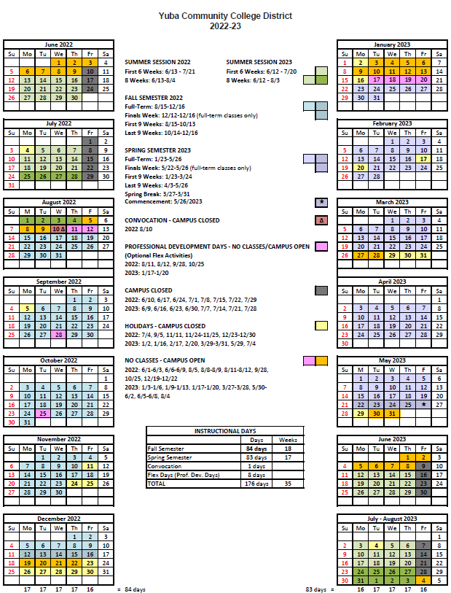

The End.

Appendix M: Map of Yuba College Campus, Woodland Community College Campus and associated locations

Map of Yuba College, 2088 North Beale Road, Marysville, California, 95901

Second Map of Yuba College Campus:
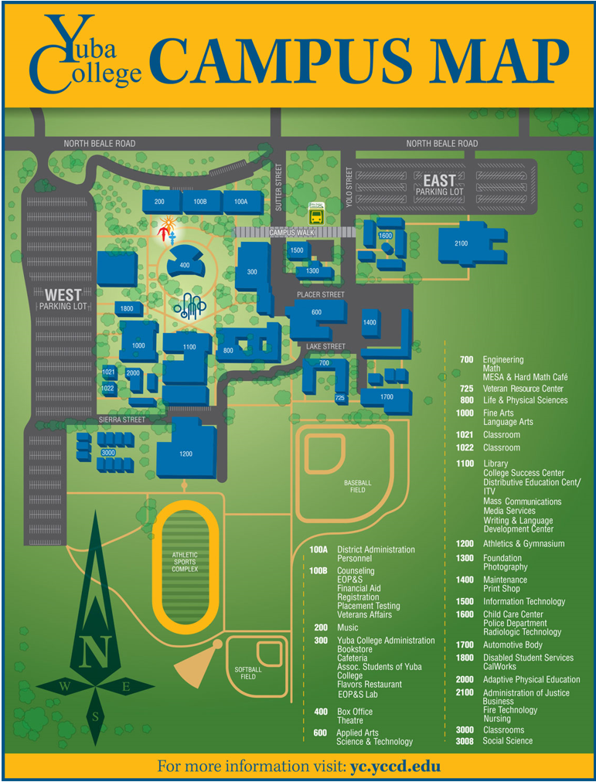
Sutter County Center Map: 3301 East Onstott Road, Yuba City, California 95993
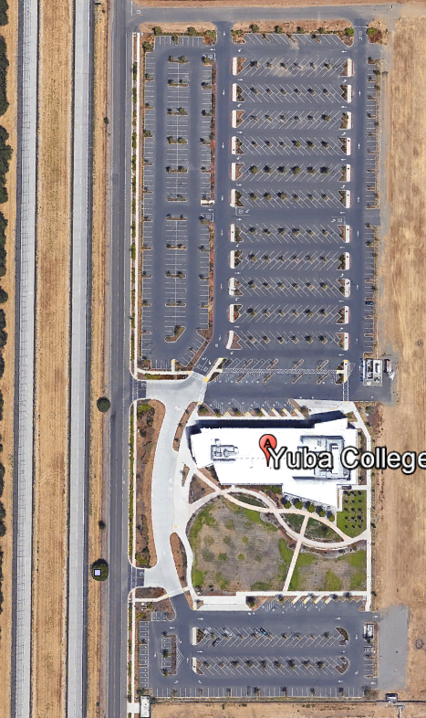
Map of Woodland Community College, 2300 East Gibson Road, Woodland, California, 95776
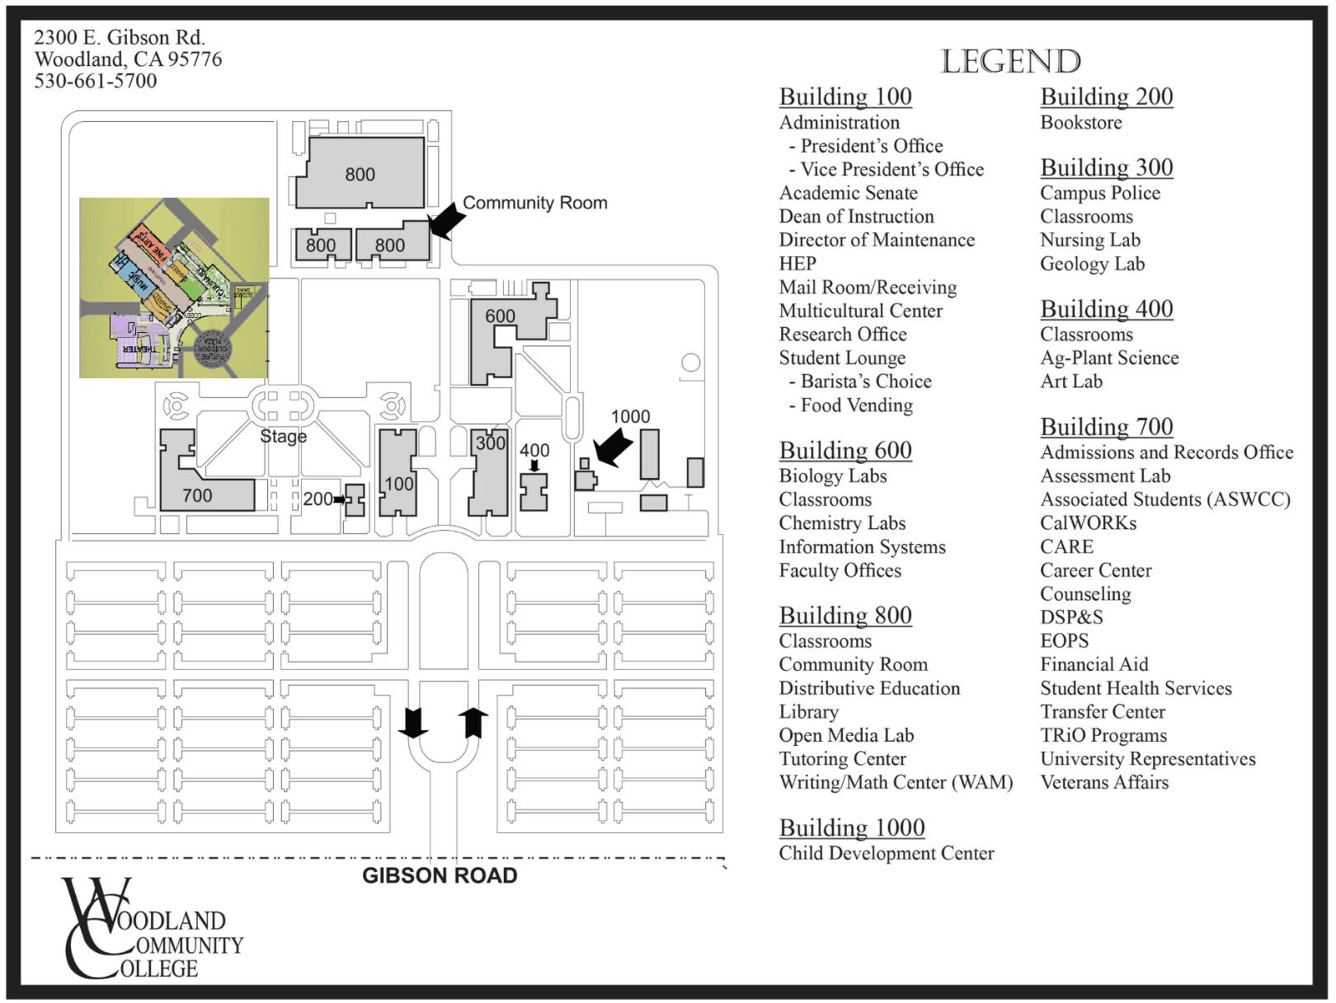

Map of Lake County Campus
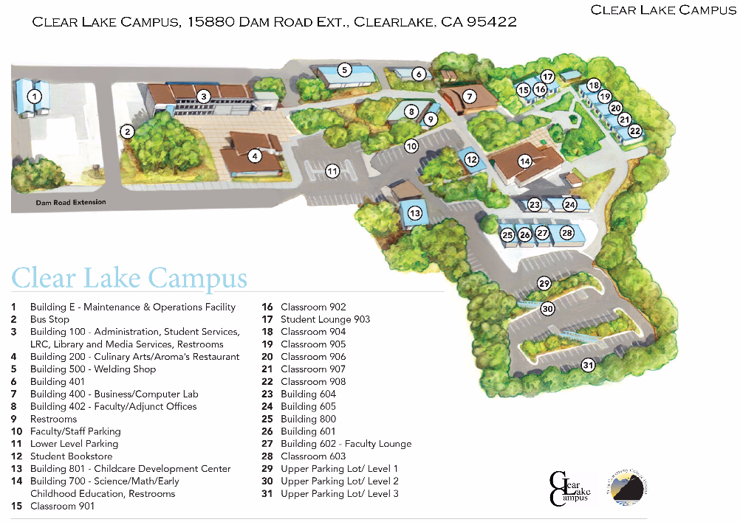

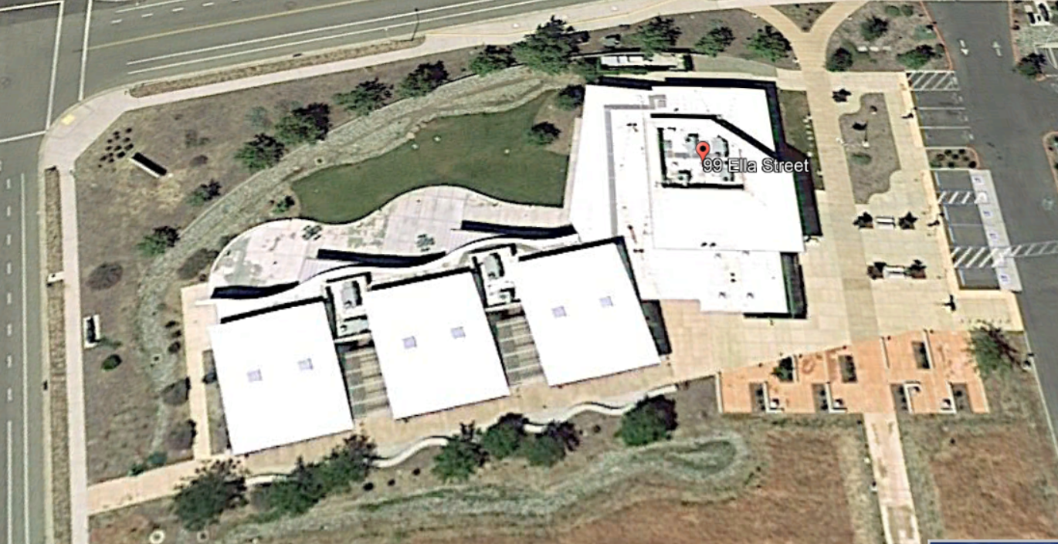
Map of the Colusa County Center: 99 Ella Rd, Williams, Ca.

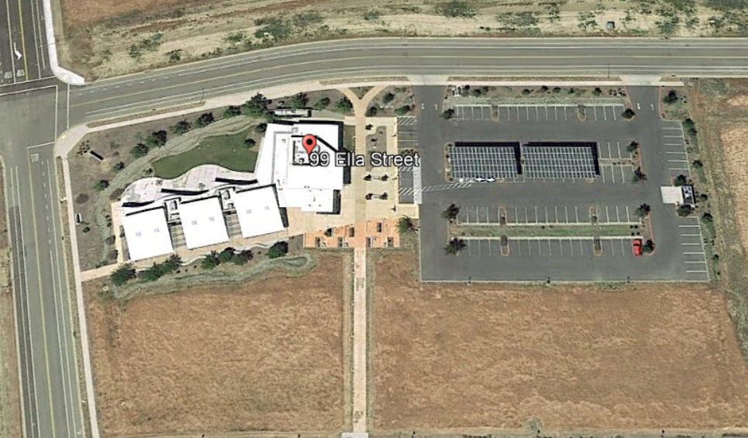

The End.

