Addendum No. 1

RFP 22-03 YCCD Solar Systems, O & M Agreements—Second Procurement
Date: 11/29/2022

Date: January 26, 2016

Clarifications:

- Reference: RFP Section 2.0: Scope of Services

Please include the following Solar Photovoltaic Systems in your Operation & Maintenance Service Agreements. Do not include the Battery Storage Systems. Include both the SunPower and the Borrego Solar Photovoltaic systems.
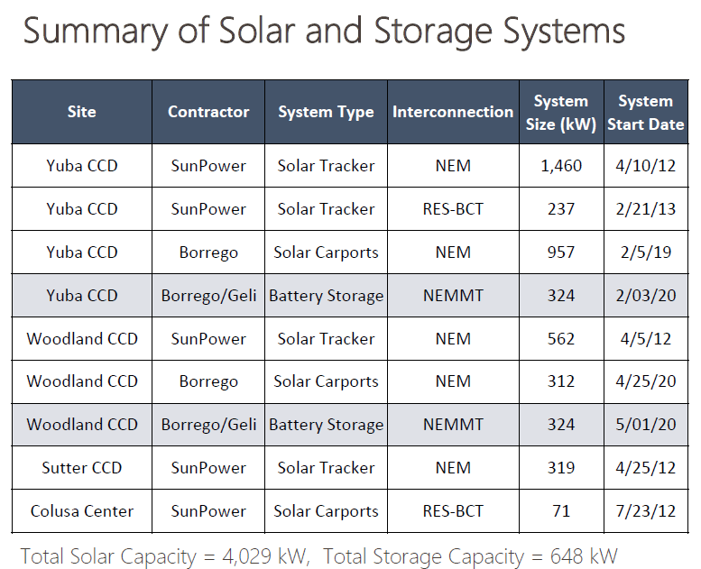

Link to Solar Systems Information:

https://goyccd-my.sharepoint.com/:f:/g/personal/w0398409_yccd_edu/EjXB1GAb0WZJs0PEh8DgZqwBooTby1NH6pIikQ5YNHrMEg?e=ADZGLH

- Revised Exhibit B, O & M Requirements Link:

https://goyccd-my.sharepoint.com/:w:/g/personal/w0398409_yccd_edu/ETqRys8IJqFCrYnB0YOGYx0BhYardIK3cKZZwsVC4f6XIg?e=BHVd7e

The End.

