Request for Proposal
Yuba Community College District

Repair, Operations, and Maintenance of Existing
Solar Photovoltaic Systems

Second Procurement Process

No. RFP 22-03

Issue Date: October 26, 2022
RFP Due: December 13, 2022

RFP Due Date: December 13, 2022, 1:00 PM Sharp, Yuba College Location Delivered To:

Yuba Community College District, District Offices
Attn.: David Willis
District Director of Facilities Planning, Maintenance & Operations
RFP No. 22-03, “Repair, Operations, and Maintenance of Existing Solar Photovoltaic Solar Systems
Address: Sutter County Campus, Second Floor, District Offices, Room 217, Attention: David Willis, 3301 East Onstott Road, Yuba City, California 95991

Proposal Delivery at Second Floor, Attn.: Dave Willis, Room 217
Yuba Community College District
Sutter County Campus
District Offices
3301 East Onstott Road (second floor)
Yuba City, California, 95991

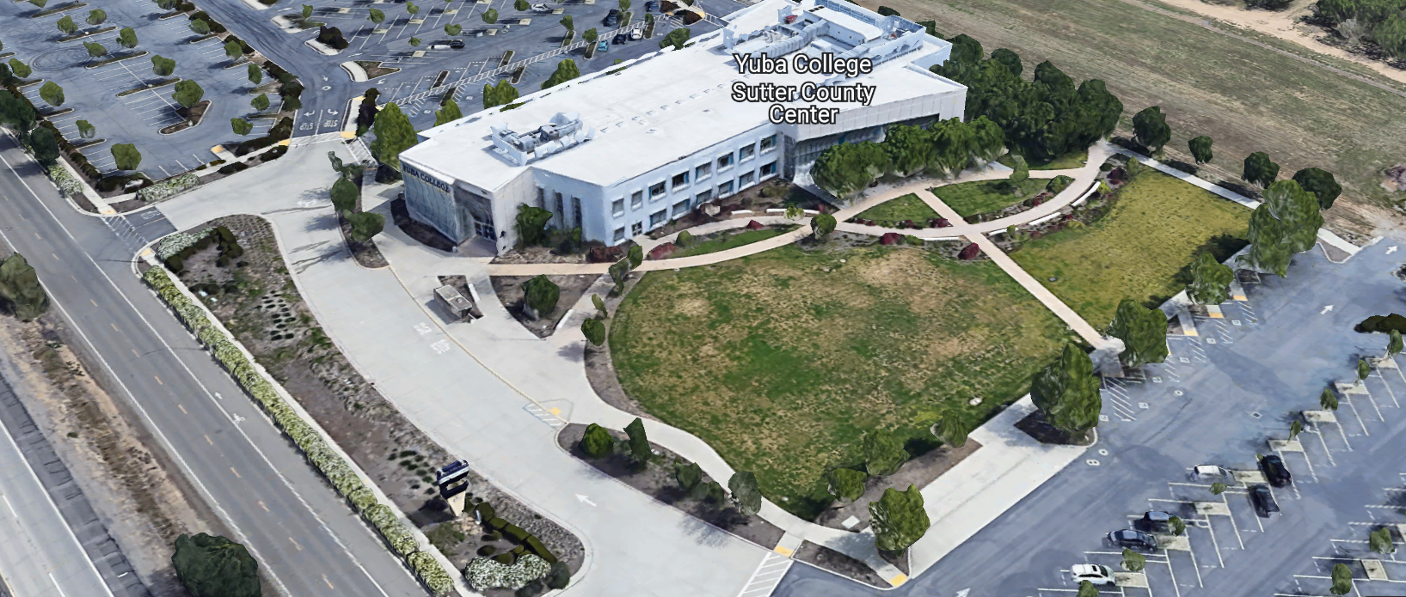
West Building Entrance
ABLE OF CONTENTS

1.0 INTRODUCTION
1.1 District Information
1.2 Yuba Community College District Background
1.3 Purpose of the Request
1.4 Applicable Codes
2.0 Scope of Work
2.1 Project Schedule
2.2 District Staff Contacts during Proposal Process
2.3 Project Safety Requirements
2.4 Demolition
3.0 Proposal Format Organization
3.1 Proposal Delivery, Contents, and Format
4.0 Selection of “Firm”
5.0 Basis of Award
6.0 Non-Discrimination
7.0 Response to Request for Proposal (RFP)
8.0 Requests for Information (RFI)
9.0 Proposal Schedule
10.0 District Parking
11.0 RFP Proposals
12.0 Award of Contract/Proposal
13.0 Reservation of Rights
14.0 Bid Bond Requirements
15.0 Performance Bond, Payment Bond Requirements- Not applicable
16.0 Liquidated Damages-Not applicable

Firm Proposal Required Items:

Appendix A, Proposal Base Bid Form, Bid Process Checklist
Appendix B, Statement of Qualifications
Appendix C, Acknowledgement of Addenda Form
Appendix D, Non-Collusion Affidavit Form
Appendix E, YCCD Agreement for Services (AFS).
Appendix F, Signature Proposal Form
Appendix G, Firm References
Appendix H, Firms Project Approach

Informational Items:
Appendix I: Project Scope Information
Appendix J: YCCD Academic Calendars
Appendix K: Map of Yuba College Campus; Map of Woodland Community College Campus

1. INTRODUCTION

  - District Information:

The District consists of two colleges, Woodland Community College and Yuba College, with campuses located at six different locations: Yuba College in Marysville, CA; Sutter County Center in Yuba City, CA; Beale Education Center, Beale AFB, CA; Woodland Community College in Woodland, CA; Colusa County Center in Williams, CA; and Lake County Campus in Clearlake, CA.

  - Yuba Community College District

The Yuba Community College District (YCCD) was founded in 1927 and spans eight counties (Yuba, Sutter, Colusa, Yolo, Lake, Butte, Glenn and Placer) and nearly 4,200 square miles of territory in rural, north-central California. It has colleges in Marysville and Woodland, an educational center in Clearlake, an educational center in Williams, an educational center in Yuba City, and outreach operations at Beale Air Force Base.

  - Purpose of Request

The Yuba Community College District seeks proposals from qualified Firms to provide repairs, maintenance and operations of existing solar photovoltaic systems.

Yuba College Campus Address: 2088 North Beale Road, Yuba City, California 95901
Sutter County Campus: 3301 E. Onstott Road, Yuba City, California 95991
Woodland Community College: 2300 East Gibson Road, Woodland, California 95776
Colusa County Center: 99 Ella Street, Williams, California 95987

  - Applicable Codes
All work shall meet all State of California Building Codes, and Federal codes, and local ordinances.
All projects at the District/College are prevailing wage projects.

- Scope of Services

Project Background

The District owns five photovoltaic systems that were installed in 2012 and 2013 by SunPower. The District also owns an additional three solar system installed by Borrego Solar that are currently being maintained under a separate contract. A summary of the systems covered in this RFP are provided below.
System Location | Total System Size (kWdc) | Type | Notes
Yuba Community College | 1,460 | Ground Mount Single-Axis Tracker | Interconnection: NEM  [inverter: SMA]  [module: SunPower]
Yuba Community College | 237 | Ground Mount Single-Axis Tracker | Interconnection: RES-BCT  [inverter: SMA]  [module: SunPower]
Woodland Community College | 562 | Ground Mount Single-Axis Tracker | Interconnection: NEM  [inverter: SMA]  [module: SunPower]
Sutter Community College | 319 | Ground Mount Single-Axis Tracker | Interconnection: NEM  [inverter: Satcon]  [module: SunPower]
Colusa Center | 71 | Solar Carports | Interconnection: RES-BCT  [inverter: Satcon]  [module: SunPower]

As-built documentation describing each system can be found in Appendix A, Exhibit D to this RFP.
The District intends to contract with a qualified vendor to provide operations and maintenance services for a five-year period, with an option to renew for an additional five years. The District will not be requesting a performance guarantee agreement for the existing solar photovoltaic systems.
The O & M service provider does not need to be a SunPower SPWR dealer to replace modules under warranty.
2.1 Schedule
Approximate Award Date: January 27, 2023
Please note all College Holidays. Unless otherwise mutually agreed to, the Firm shall not work on College/District holidays.
The Firm may work whatever hours are needed Monday through Friday. Normal working hours are 6:30am to 3:30pm. If other times and days are needed, they must be submitted in writing to the District at least 72 hours prior to the service date and time.
This is a prevailing wage service agreement. The Firm is required to upload all certified payroll information to the Department of Industrial (DIR) Relations web site. YCCD will provide a DIR project number.
Provide a brief draft service schedule.

2.2 District Staff Contacts during the Proposal process:
Firms interested in submitting a Proposal are directed not to make personal contact with the Board of Trustees, District staff, or members of the evaluation committee. Any contact shall constitute grounds for disqualification from consideration.
Primary Point of Contact during the Proposal Preparation Process:
Simon Olivieri
Senior Engineer, ARC Alternatives
510-852-4840
simon@arc-alternatives.com

Secondary Point of Contact during the Proposal Preparation Process:
David L. Willis
District Director of Maintenance, Operations, and Planning
425 Plumas Blvd., Suite 200 (Second Floor)
Yuba City, California, 95991
Cell Phone: 916-747-4262
Email: dwillis@yccd.edu

2.3 Project Safety and Security Requirements
Safety is a top priority for the District. All California OSHA requirements apply. Industry best practices apply. Firm employees shall wear shirts with sleeves, a hard hat, eye protection, hearing protection as needed, gloves, substantial leather footwear, long pants, a reflective safety vest, and take all needed precautions to complete the work in a safe manner. Safety shall not be compromised at all during the work.
3.0 Proposal Format Organization
The Firm is requested to use the following proposal format:
3.1. Proposal Delivery, Contents, and Format:
Proposals should provide straightforward, concise information that satisfies the requirements noted in this RFP. Expensive binding, color displays, and the like are discouraged. Emphasis should be placed on brevity, conformity to the Districts instructions, selection criteria of this RFP, and completeness and clarity of content. Each Respondent’s proposal should clearly and accurately demonstrate specialized knowledge and experience required for consideration.
In a sealed box or envelope (clearly marked “), submit the following:
- One (1) flash memory stick containing the complete proposal and supporting documentation;
- One (1) original proposal in paper form, which consists of a Proposal Letter and responses to the proposal requirements of this RFP.

There is no page limit.

Firms must comply with the provisions of these instructions for completion and submission of the Proposal. The failure of a Firm to comply with the Proposal Instructions and Requirements will likely result (at the sole discretion of the District) in rejection of the Proposal for non-responsiveness.
Proposal Section | Format
- Cover Letter | PDF
- Table of Contents | PDF
Appendices (See Table of Contents for each one) Submit a response to each Appendix that requires Firm information. Please submit responses to Appendices A, B, C, D, E, F, G, and H. Appendices I, J, and K are informational only. | PDF

Proposal General Information Contents:

Information requested will help the District determine if the Firm is a “Responsible Bidder”.

Cover Letter

The Proposal shall include a Cover Letter on Respondent’s official business letterhead, which shall be signed by an individual authorized to legally bind Respondent. The Cover Letter shall also identify the name, telephone number, and email of a person who may be contacted during the Proposal evaluation process.

Table of Contents

Provide a Table of Contents that outlines in sequential order the major sections and sub-sections of the Proposal. Use tabs to allow information to be more easily located.

4.0 Selection of “Firm” Services Provider

The process of “Firm” selection is based upon the complete responsiveness of the RFP and the criteria as outlined in the RFP.

The District Project Evaluation Team will read the written proposals. The District Evaluation Team will discuss the proposals and verify that the “Basis of Award” information below and information submitted in response to the RFP are complete and responsive.

The District reserves the right to reject any or all submittals, to amend the RFP process, and to discontinue or re-open the process at any time. The District reserves the right to request clarifications to RFP responses and to negotiate the terms of the agreement.

5.0 Basis of Award

This project will be awarded based on the following criteria:

- Lowest Total Cost Responsive Qualified Bidder
  - Lowest Total Cost
  - Firm Capability to do the work
  - Qualified Firm (per section 1.3 and below)
    - Proper State of California Firm License in good standing
    - Information provided as requested in the RFP.
    - All Addendums are acknowledged.
    - Firm listed any exceptions or exclusions. Firms should bid the project per the RFP and contract documents (using specified products) and then offer exceptions and exclusions or cost deductive or additive alternatives separately from the base bid.
    - Firms with historical good performance on YCCD projects regarding minimal number and cost of change orders, maintaining project schedules and completing the work promptly, and overall quality of work.
    - Firms ability to meet schedule requirements.
    - Firms have demonstrated past project references of “like” projects
    - Firms references are all good with respect to schedule, cost, and quality.
    - No other factors such as litigation, licenses in good standing, or other similar criteria.
    - At least ten (10) project references of similar projects completed in the past five (5) years with contact information, scope of work, initial awarded cost, change orders cost, pictures if possible.

Optional Interview Process:

The top one to three of the lowest total cost responsive qualified bidder’s may be requested to participate in a ZOOM interview process with the District Project Proposal Evaluation Team. This interview process is fully at the discretion of the District. The District may decide that no interview is required.

6.0 Non-Discrimination
The District does not discriminate with regard to race, color, gender, national origin, disability, or any other protected or other classification in the awarding of contracts/agreements. The District welcomes all Qualified Firms to participate in the project Request for Qualification/Proposal process.
The District encourages firms that are women or minority owned, emerging small businesses, veteran owned firms, disabled person owned firms, and all other qualified firms to participate in the proposal process.
The District encourages the submission of proposals from all Firms that can meet the stated requirements set for this RFP.
7.0 Responses to RFP:
Sealed responses to this RFP must be clearly marked "RFP NO. 22-03 Repair, Operations, and Maintenance of Existing Solar Systems”.

Responses shall be mailed to or hand-delivered to the following address:

Yuba Community College District, District Offices
Attn.: David Willis
District Director of Facilities Planning, Maintenance & Operations

Envelope/Box Marked:
"RFP NO. 22-03 Repair, Operations, and Maintenance of Existing Solar Systems”..

Address: 425 Plumas Blvd., Suite 200, Room 216, Yuba City, California, 95991

Note: Completely seal your proposals in envelope/box and make sure it gets date/time stamped when delivering proposal. Firms are each 100% responsible to make sure proposals that are mailed using a carrier such as UPS, FED Ex, etc…are received and date/time stamped by District personnel prior to the proposal due date/time. No proposals will be considered if they are late, even if it is only 5 minutes late. Please make sure your proposals are delivered and received promptly prior to the due date/time. There will be a public proposal opening at the due date/time.

Do NOT email your proposals. Emailed proposals that are not sent per the above guidance requirements will not be considered.

8.0 Requests for Information (RFI)

Requests for Information concerning the RFP must be in writing and may be submitted via email no later than the date shown below. Please direct all questions to David Willis, email: dwillis@yccd.edu.

Following the RFI deadline, all questions and answers will be summarized and posted on the District's website: https://www.yccd.edu/central-services/purchasing/ , then, click on the “Requests for Proposals / Quotes” tab on the right hand side of this web page. It is anticipated that responses to inquires received by the required time and date will be provided within 5 business days and posted on the District's website or responded to per the dates listed in the RFP for addendum publishing. Should more time be needed by the District to answer I respond to RFI’s, this information will also be posted on the above website.

- Include the following in the subject matter field on emails when requesting information: “RFP 22-03”, RFI.

9.0 Proposal Schedule:

Important Dates and Times:

October 26, 2022: Release of Request for Proposal at 1:00PM

November 9, 2022: 1:00 PM, OPTIONAL ON Campus Pre-Bid Meeting at the Woodland Community College, Building 100, Room 113, 2300 East Gibson Road, Woodland, California 95776

November 10, 2022: 3:00 PM, OPTIONAL ON Campus Pre-Bid Meeting at the Yuba College Campus, Maintenance Building 1400, Conference Room, 2088 North Beale Road, Marysville, California 95901.

If you need to visit the campus during an alternative time/date, please coordinate with Bryan Epp below:

Bryan Epp
Assistant Director of Maintenance, Operations
2088 North Beale Road
Phone: 530-740-1722
Email: bepp@yccd.edu

December 5, 2022: 5:00 PM, All questions and requests for information must be submitted to David Willis at: dwillis@yccd.edu.

December 6, 2022: 5:00 PM, Addendum Issued if needed.

December 13 2022: Proposals due at 1:00 PM SHARP, Yuba Community College District Offices.

There will be a public bid opening on this RFP.

This is a prevailing wage project.

10.0 District Parking:

-No parking in Reserved Spaces without a proper permit
-Permit Parking is enforced in all general lots between 6:00 am and 6:00 pm, Monday through Friday. All general lots require a properly displayed, valid permit during these times
-Daily Parking Permits are $2.00
-Permits are available for purchase at any of the permit machines located in the student parking lots
-All other parking regulations are enforced 24 hours a day, seven days a week. This includes designated staff spaces, handicap spaces, timed spaces, red zones, yellow zones, and areas not marked (no parking at any time)
-Once this project is awarded, temporary parking permits will be processed as requested by the successful firm for all employees associated with this project at no cost to the Firm for the duration of the project at each Campus location. These temporary permits must be displayed at all times on the dashboard of employee vehicles.

11.0 RFP Proposals

Proposals received after the deadline will not be opened. Each responder shall submit one (1) signed original hard paper copy in a binders. Provide one electronic format copy of the proposal using electronic media such as a flash drive. (No CD formatted Disks).

All materials submitted in response to the RFP shall be on 8-1/2"x11" paper, preferably in
Portrait orientation. All submitted materials must be bound in either a three-ring binder or spiral bound notebook. Content shall be tabbed and numbered per the items included in the Submittal Requirements. All Proposals will be reviewed and evaluated by a District Selection Committee. The District at its sole discretion may interview finalists or select a firm or firms to perform work based solely on the evaluation of the Proposal. There is no page limit.

All Proposals become the sole property of the District and the content will be held confidential until the selection of the Firm or Firm’s is made and the project is awarded.

12.0 Award of Contract

- The Contract will be awarded to the lowest total cost, most responsive responsible District qualified, whose proposal, conforming to the request for proposal and associated addendums, will be most advantageous to the District.

B. The District reserves the right to enter into an Agreement without further discussion of the proposal submitted based on the initial offers received.

C. The District reserves the right to reject any or all proposals or any part of the proposal and to waive informalities and minor irregularities in the proposals received.

D. The RFP, its addendums, any follow-up clarifying information, and the proposal of the selected Firm will become part of any contract initiated by the District.

E. A formal contract shall be signed by the successful proposer and Yuba Community College District to perform this service.

F. The District reserves the right to enter into discussions with any one or all of the Responders after Proposals have been initially reviewed. Such responses shall be subject to all provisions, terms and conditions as set forth in the RFP, unless otherwise modified.

G. The District intends to award to a single RFP Responder.

H. Failure to acknowledge all of the addendums, provide the items listed in the RFP, may render the proposal unresponsive at the discretion of the District. Items listed in the RFP become part of the contract unless the Firm provides an exception in the proposal. Firm exceptions, depending on the magnitude, may render the proposal unresponsive, at the discretion of the District.

I. The District reserves the right to request clarification of proposal content during the review and evaluation process.

J. The District reserves the right to negotiate the terms of the agreement to align with budgetary constraints.

K. Due to the heightened risk of illness that could then affect the performance of the Firm, Firms with multiple employee work teams and the resources to adapt and complete the scope of work per the RFP, will be perceived to provide enhanced service and value during the evaluation process.

L. Process Steps: A. Prequalification Process; B. Interview Process: The District may interview 1 or more of the top Firms at it’s discretion. The interview will be scored. The District may elect not to interview any of the Firms; C. Proposal Evaluation Process

13.0 Reservation of Rights

The District reserves the right to:

- Reject any or all submittals at its sole discretions.
- Cancel the Request for Proposal (RFP), without cause.
- Modify any requirements contained within the RFP and request a revised submission from all Providers.
- Establish other evaluation criteria determined to be in the best interest of the District.
- Contract with any of the firms responding to the RFP based solely upon its judgment of the qualifications and capabilities of the firm.
- Clarify the content of any proposal to verify that the requirements of the RFP are included.
- Waive “minor” proposal inconsistencies that do not change the scope of work as outlined in the RFP.
- Request an alternative Superintendent on the project if the initially assigned Superintendent on the project is not performing well, not meeting project requirements, not working well with College staff and students, not applying best practice safety methods, OR not following College/District guidance regarding project approach. If the owner is the Superintendent, and has been replaced, the owner may visit the project briefly (less than 1 hour per day up to 2 times per week) to coordinate with the replacement Superintendent.
- The District will not allow or tolerate verbal abuse or any other type of abuse by the Firm toward any College or District personnel or Contracted professional service providers. Abuse, defined solely by the District as verbal or physical, or written, may lead to a “Stop Work” order by the District until it can be resolved, and steps taken to ensure abuse is not repeated. If abuse occurs again, the District may issue a final “Stop Work” order, require the Firm to leave the College/District project site and process a Performance Bond claim to complete the work. All costs associated with District “Stop Orders” are 100% the responsibility of the Firm.
- Disqualify a Firm after reviewing the proposal and finding concerning performance information in references, inadequate or incomplete proposal information, and historically poor project performance at the District/Colleges (as solely defined by the District).

This RFP does not commit the District to award or negotiate a contract. The District will not be responsible for any expenses incurred by any firm in preparing and submitting a proposal or response to this RFP or in completing any of the work specified.

14. Bid Bond Requirements (Proposed Form—Firm can use their standard form):

BID BOND

Know all persons by these presents:

That we, , as Principal, and , as Surety, are held and firmly bound unto Los Rios Community College District, hereinafter called District, the sum of ten percent (10%) of the total bid amount of Principal for payment of which in lawful money of the United States, well and truly to be made, we bind ourselves, our heirs, executors, administrators, successors, and assigns, jointly and severally, firmly by these presents.

The condition of the above obligation is such that, whereas, the Principal has submitted a bid for the work described as follows: RFP 22-03 YCCD Solar Systems Operations & Maintenance Services

Now, therefore, if Principal shall not withdraw said bid within the time period specified after the bid date, as defined in the bidding documents, or within ninety (90) days after the bid date if no time period is specified, and, if selected as the apparent lowest responsive responsible bidder, Principal shall, within the time period specified in the bidding documents: Enter into a written agreement, in the form prescribed in the bidding documents, in accordance with its bid; file with the District all bonds required to be filed, including but not limited to faithful performance and payments bonds; and, furnish certificates of insurance and all other items required by the bidding documents.

In the event of the withdrawal of said bid within the time period specified, or within ninety (90) days if no time period is specified, or the failure of Principal to enter into such agreement and furnish such bonds, certificates of insurance, and all other items as required by the bidding documents, if Principal shall pay to the District an amount to the difference, between the amount specified in said bid and such larger amount for which the District procures the work covered by the bid, if the latter is in excess of the former, then this obligation shall be null and void, otherwise to remain in full force and effect.

In the event suit is brought upon this bond by District, in addition to the penal sum of this Bid Bond, Surety shall pay reasonable attorneys’ fees and costs incurred by District in such suit.

Surety hereby expressly waives the provisions of California Civil Code section 2845.

In witness whereof, we have hereunto set our hands this day of , 20 .

Principal: Surety: (Name of firm)

By: By:

Title: Title:

Broker Name or Agent Name:

License Number:

Bond or company appointment must be listed with the CA Department of Insurance Notary acknowledgments for Surety and Surety’s Power of Attorney must be attached.

Address for Notices:

Bid Bond Requirements:
Provide a Bid Bond per the following:

PUBLIC CONTRACT CODE - PCC

DIVISION 2. GENERAL PROVISIONS [1100 - 22355]

ARTICLE 4. Bids and Bidders [10160 - 10169]
( Article 4 enacted by Stats. 1981, Ch. 306. )
Section: 10167.
    - All bids shall be presented under sealed cover and accompanied by one of the following forms of bidder’s security:
      - An electronic bidder’s bond by an admitted surety insurer submitted using an electronic registry service approved by the department advertising the contract.
      - A signed bidder’s bond by an admitted surety insurer received by the department advertising the contract.
      - Cash, a cashier’s check, or certified check received by, and made payable to, the director of the department advertising the contract.
    - The required bidder’s security shall be in an amount equal to at least 10 percent of the amount bid. A bid shall not be considered unless one of the forms of bidder’s security is enclosed with it.
    - All bids submitted pursuant to this section shall also comply with the provisions of Section 1601 of the Public Contract Code.
(Amended by Stats. 2012, Ch. 290, Sec. 3. Effective January 1, 2013.)

The Bid Bond shall be provided with the Firm’s Proposal.

15. Performance and Payment Bond Requirements: Not Required for this service agreement.
16.0 Liquidated Damages: Not Required for this service agreement.
Appendix A: Proposal Instructions and Scope of Services
Exhibit A: Instructions to Proposers
Exhibit B: Operations and Maintenance Requirements
Exhibit C: Performance Guarantee Requirements—Not Applicable
This RFP is not requesting a proposal for Performance Guarantees.
Exhibit D: System Details
Exhibit E: Proposal Forms

Refer to this link for the above Exhibit Forms:
https://goyccd-my.sharepoint.com/:f:/g/personal/w0398409_yccd_edu/EmRrYSr8YSVLv2K72w_4wT8B-LzDa-5uhzk9RUiunbxNwA?e=BzWbld

Bidding Process Checklist (Verifies Proposal Completeness):
- Cover Letter
- Table of Contents
- Appendix A: Proposal Instructions and Scope of Services
  - Exhibit A: Instructions to Proposers
  - Exhibit B: Operations and Maintenance Requirements
  - Exhibit C: Performance Guarantee Requirements—Not Applicable
  - Exhibit D: System Details
  - Exhibit E: Proposal Forms
- Appendix B: Statement of Qualifications
- Appendix C: Acknowledgement of Addenda Form
- Appendix D: Non-Collusion Affidavit Form
- Appendix E: Professional Services Agreement (optional with proposal, the successful Firm will be required to provide this information within 7 days after notification of intent to award.
- Appendix F: Proposal Signature Form
- Appendix G: References Form
- Bid Bond- Applies
- Performance Bond – Not Applicable
- Payment Bond – Not Applicable

Appendix B: Statement of Qualifications

The Firm shall furnish the following information. Failure to comply with this requirement will render the submittal informal and may cause its rejection. Additional sheets may be attached if necessary.

Phase 1: Basic Firm Informational Items 1 through 7:

- Firm Name:

Primary Address:

Firm’s Contact Person and Title:

Telephone: Facsimile:

Email Address:

Responsible Managing Employee/Officer:

- Licenses or Certifications:

- Number of years Firm has been in business:
If less than 5 years, please describe:

- Number of years Firm has conducted business under the present name:

- Number of years’ experience in California Community College, University or educational facility projects .

- Has the Firm ever completed any work at the Yuba Community College District? If Yes, please elaborate:

Phase 2: Potentially Disqualifying Questions 7 through 11 (District may immediately disqualify Firm if its answer to any of Questions 7 through 11 is “Yes.” Firm’s refusal to answer or omission of response to any of Questions may result in disqualification of Firm.):

- Has the Firm been defaulted or terminated (other than for convenience) by any California school district, community college district or other California public agency on any project within the past 5 years? Yes/No

If yes, identify agency and details:

- Has the Firm been disqualified, debarred, forbidden, or found non-responsible or otherwise prohibited from performing work for any California school district, community college district, or other California public agency within the past ten years? Yes/No

If yes, identify agency and details:

- Has the Firm been in litigation (whether in court or arbitration) with any California school district, community college district, or other California public agency on an issue pertaining to any contract during the past ten years? Yes/No:

If yes, explain, identify the agency, and provide case name and number.

- Has the Firm ever failed to complete a project in the past ten years? Yes/No:
If so, give owner and details:

- Is the Firm currently or has the Firm been in a state of “Bankruptcy” in the past ten years? Yes/No:
If yes, please explain.

Phase 3: Rating Questions:

- Please list and describe on separate sheets the Firm’s top 5 project references with current contact information. It is strongly preferred that one (1) of the project has been completed within the past five (5) years and must be in similar in size and construction value as the Project.

Scoring Criteria:
    - At least two (2) projects with a capacity of at least 2 MW in the past 5 years. (up to 20 points)
    - At least one (1) project with a capacity of at least 5 MW in the past 10 years (up to 50 points)

Total points for Question 12: up to 70 points

- In the last 10 years, how many legal proceedings (filed in court or arbitrations) has your Firm initiated against an owner, regardless of outcome?
(0 = 20 points; 1 = 10 points; 2+ = 0 points.)

- In the last 10 years, how many legal proceedings (filed in court or arbitrations) has an owner initiated against your Firm, regardless of outcome?
(0 = 20 points; 1 = 10 points; 2+ = 0 points.)

- Please describe the Capability/Capacity of your Firm.

(Up to 20 points.)

- Please describe the Firm’s approach to preventive maintenance

(Up to 20 points.)

18. Please describe the Firm’s commitment to providing timely data and reports

(Up to 10 points.)

Qualification Criteria:

Phase 1: Questions 1 through 6 are general base level information that is required for pre-qualification.
Phase 2: Questions 7 through 11 are possible disqualifying questions that would render the Firm “not qualified” as determined by the District.
Phase 3: Questions 12 through 18 are rating questions that are scored and more deeply evaluated. (160 points possible) To be considered for a Finalist Interview, each Firm must score at least 130 points in this Phase 3.
Phase 4: Interviews. The District may choose to interview the top Firm or the top three Firms at it’s discretion. The interview is scored at 40 points.

Not scoring the minimum threshold value of 130 points in Phase 3 will render the Firm “not qualified”. The District can disqualify a Firm (at it’s sole discretion). A total score of 160 points after phase 4 will render the Firm pre-qualified.

After Firms are Pre-Qualified the proposals will be evaluated. All evaluation sheets and work is confidential and the sole property of the District.

The Firm must be first pre-qualified. Then, if pre-qualified, the proposal for solar O&M services will be considered.

The undersigned is duly authorized to execute this Statement of Qualifications under penalty of perjury on behalf of the above-identified Firm. The undersigned warrants and represents that he/she has personal knowledge of each of the responses to this Statement of Qualifications and/or that he/she has conducted all necessary and appropriate inquiries to determine the truth, completeness, and accuracy of responses to this Statement of Qualifications. The undersigned declares and certifies that the responses to this Statement of Qualifications are complete and accurate; there are no omissions of material fact or information that render any response to be false or misleading and there are no misstatements of fact in any of the responses. The above-identified Firm acknowledges and agrees that if the District determines that any response herein is false or misleading or contains misstatements of fact so as to be false or misleading, the District may find the Firm is not qualified and the District can reject the proposal for non-responsiveness or non-responsibility.

Executed this___ day of __________________ 20__ at_____________________________.
(City and State)
I declare under penalty of perjury under California law that the foregoing is true and correct.

By: ____________________________________________
(Signature of Firm’s Authorized Officer or Representative)
____________________________________________
(Typed or Printed Name)
Title: ___________________________________________

Appendix C: Acknowledgement of Addenda Form
The undersigned acknowledges receipt of the following addenda from the District pursuant to the Request for Proposal:
Acknowledgement: Yes or Not Applicable
Addendum No. 1: .
Addendum No. 2: .
Addendum No. 3: .
Addendum No. 4: .
Addendum No. 5: .

Firms are required to acknowledge all addenda’s within the submitted proposal at the time of submission.

Appendix D: Non-Collusion Affidavit Form

STATE OF CALIFORNIA, COUNTY OF I, being first duly sworn, deposes and says that I am the of , the party submitting the foregoing proposal (“the Proposal”). In connection with the foregoing Proposal, the undersigned declares, states and certifies that:
- The Proposal is not made in the interest of, or on behalf of, any undisclosed person, partnership, company, association, organization or corporation.
- The Proposal is genuine and not collusive or a sham.
- The Firm has not directly or indirectly induced or solicited another Firm to put in a false or sham proposal, and has not directly or indirectly colluded, conspired, connived, or agreed with any other Firm or anyone else to put in a sham proposal, or to refrain from bidding.
- The Firm has not in any manner, directly or indirectly, sought by agreement, communication, or conference with anyone to fix the proposal price, or that of any other Firm, or to fix any overhead, profit or cost element of the proposal price or that of any other Firm, or to secure any advantage against the public body awarding the contract of anyone interested in the proposed contract.
- All statements contained in the Proposal and related documents are true.
- The Firm has not, directly or indirectly, submitted the proposal price or any breakdown thereof, or the contents there of, or divulged information or data relative thereto, or paid, and will not pay any fee to any person, corporation, partnership, company, association, organization, proposal depository, or to any member or agent thereof to effectuate a collusive or sham proposal.
Executed on this date: , 2022, at:

(City, County, and State)
I declare under penalty of perjury under the laws of the State of California that the foregoing is true and correct.
Signature Printed Name .
Address: .
Area Code & Phone Number: .
Note: In addition to other bid documents, bidders on public works projects are required by Public Contract Code section 7106 to submit a certification form that they have not colluded with another proposer.

Appendix E: YCCD Professional Services Agreement (PSA):
Link:
https://goyccd-my.sharepoint.com/:w:/g/personal/w0398409_yccd_edu/EavP4YkY5gFPjkgySBnTSHUBPI82iGgYwYpezIEeUA2xVg?e=XEHsAp
This agreement is optional at the time of the proposal submission.
The successful Firm will be required to provide this agreement within 7 days after it is requested by the District.

Appendix “F” Proposal Signature Form
The undersigned acknowledges the following:
- Having become familiar with the specifications and requirements of the Request for Proposal, hereby offers to provide all services in accordance with the proposal set forth herein, including all referenced material and attachments.
- By submitting a signed proposal in response to this solicitation, the Firm acknowledges that they completely understand the scope of the needed services and that the proposed services as described in the proposal will meet or exceed the needs of the District.
- Late proposals will not be accepted (even if they are only 5 minutes late).
- The District reserves the right to reject any and all proposals and that this proposal shall remain open and not be withdrawn for a minimum of 90 days.
- Cancellation Clause: The District may, without cause, terminate the contract(s) or a project under the contract(s) by giving written notice of such termination to the awarded firm. In the event of such termination the District shall reimburse the firm for services performed and reasonable expenses actually incurred by the firm in relation to the terminated project prior to the firm’s receipt of such notice of termination. The cost of proposal generation, associated travel, copies, postage, etc.., will not be reimbursed and is considered a typical and normal part of the bid process and is not reimbursed for any of the proposers.
- If the prospective Firm is a corporation, the undersigned hereby represents and warrants that the corporation is duly incorporated and is in good standing in the state of California , and that, , is authorized to act for and bind the corporation.

Entity Type (Select One):

Sole Owner: Partnership: .

Corporation: .

Other; Please specify;

- Regular monthly progress payments are made using NET 30 as a basis for payment, with Net 30 time starting after receipt of the invoice with all required support documentation, and once this information is reviewed and approved by the District.

Invoices must be emailed to the following with all support documentation:
Vendors with a first letter of A through N: hgardner@yccd.edu; rharvey@yccd.edu
Vendors with a first letter of O through Z: hgardner@yccd.edu; rharvey@yccd.edu
It is critical that invoices have all required support documentation including an updated schedule of values with 5% retainage for construction projects, updated project schedule, description of completed work, and any other information that will help to justify and support the progress payment request.

Signature_____________________________ Date: _______________________
Position: _____________________________
Print name____________________________ Title________________________

Notary Required On This Project
Notary Stamp:

Appendix “G” References Form (Example Template)

Bidder shall provide a minimum of Ten (10) verifiable references with current contact information, preferably from a California public educational institution and/or California public agency, representing projects started and completed within the last 5 years. See clarification note below regarding reference requirements.
All phone numbers and emails must be current (please verify).
REFERENCE #1
NAME
ADDRESS
CITY, STATE ZIP CODE
TELEPHONE #
CONTACT
DATES OF SERVICE
REFERENCE #2
NAME
ADDRESS
CITY, STATE, ZIP CODE
TELEPHONE #
CONTACT
DATES OF SERVICE
REFERENCE #3
NAME
ADDRESS
CITY, STATE, ZIP CODE
TELEPHONE #
CONTACT
DATES OF SERVICE

You may of course use the Firm’s established reference template.

Appendix H: Description of Services
Service provider thorough description of services included in the proposal.
All exclusions or exceptions shall be listed.

Appendix I: YCCD Academic Calendar
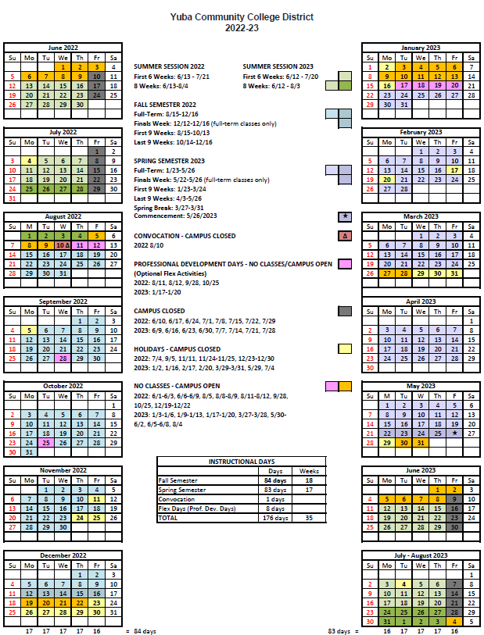

Appendix J: Map of Yuba College, Woodland Community College Campus’s
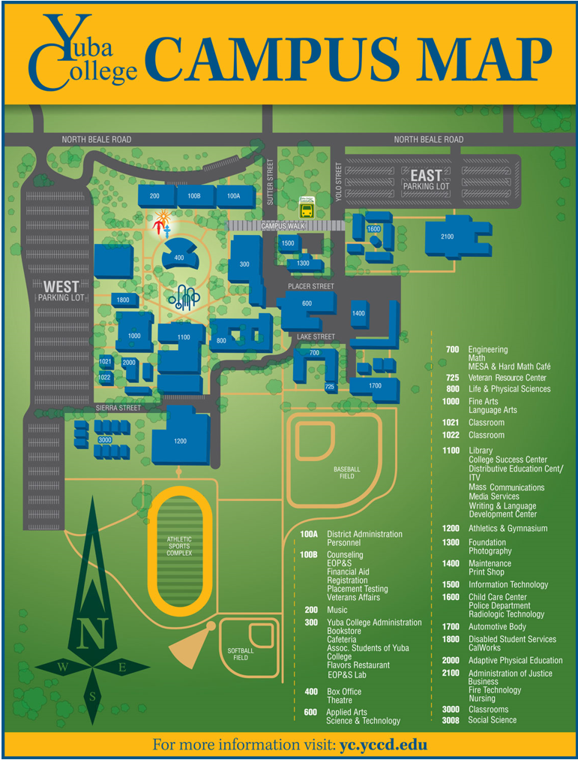

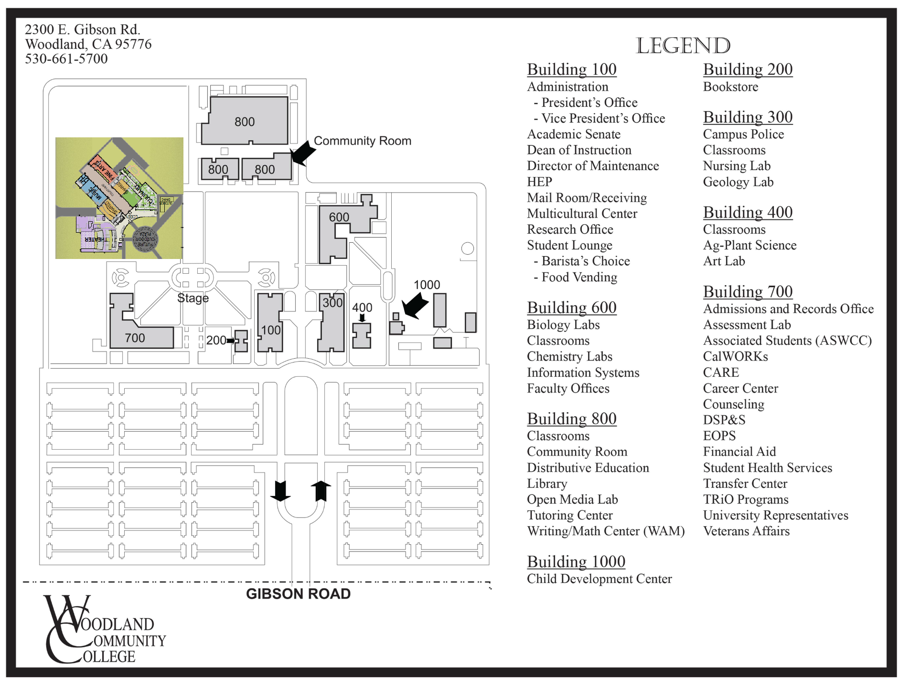
The End.

