Request for Proposal
Yuba Community College District

Yuba College Campus
Multiple Buildings, Ceiling Repairs
No. RFP 22-02
Second Procurement Process

Issue Date: September 19, 2022
RFP Due: October 20, 2022

RFP Due Date: October 20, 2022, 2:00 PM Sharp, Yuba College Location Delivered To:

Yuba Community College District, District Offices
Attn.: David Willis
District Director of Facilities Planning, Maintenance & Operations
RFP No. 22-02 Multiple Buildings, Ceiling Repairs
Address: Sutter County Campus, Second Floor, District Offices, Attention: David Willis, 3301 East Onstott Road, Yuba City, California 95991

Proposal Delivery at Second Floor
Yuba Community College District
Sutter County Campus
District Offices
3301 East Onstott Road (second floor)
Yuba City, California, 95991

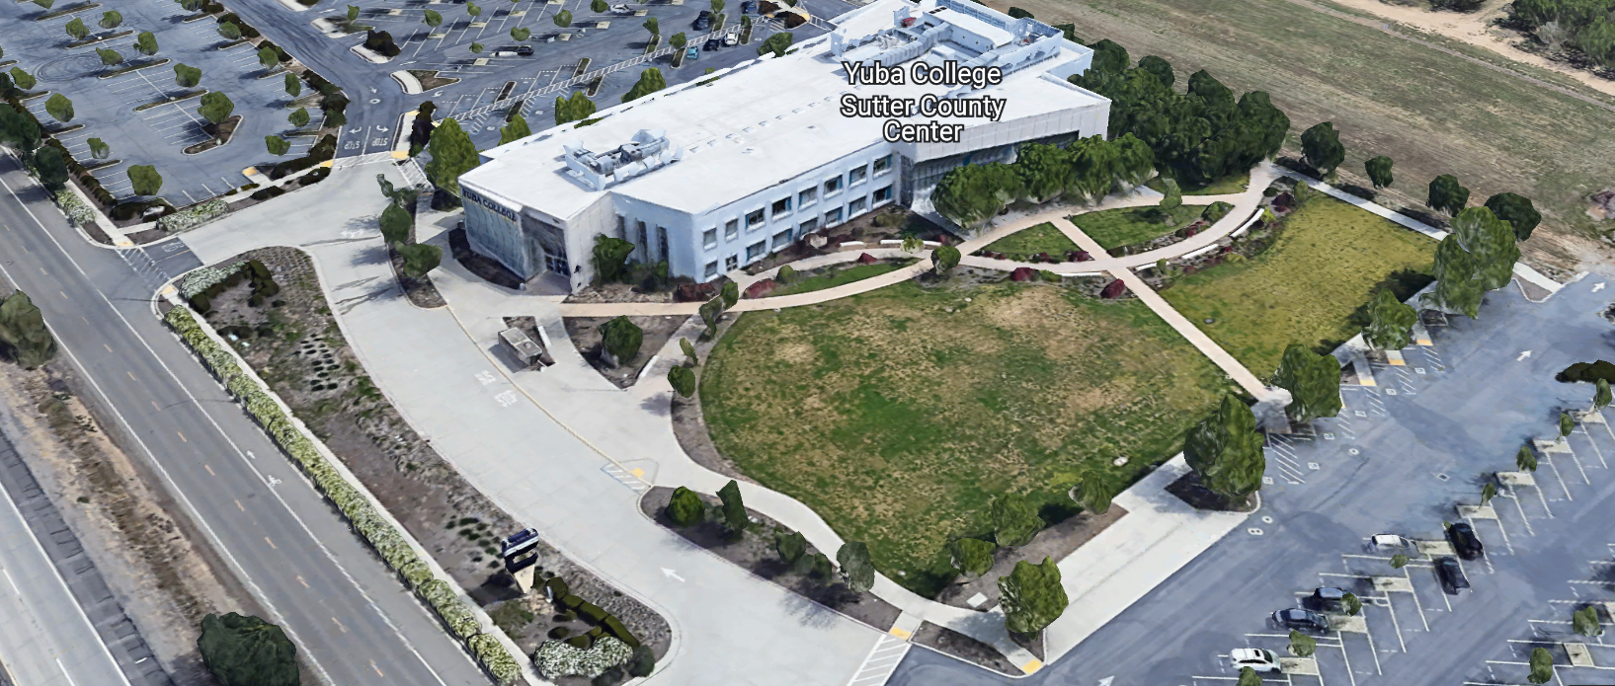
West Building Entrance
TABLE OF CONTENTS

1.0 INTRODUCTION
1.1 District Information
1.2 Yuba Community College District Background
1.3 Purpose of the Request
1.4 Applicable Codes
2.0 Scope of Work
2.1 Project Schedule
2.2 District Staff Contacts during Proposal Process
2.3 Project Safety Requirements
2.4 Demolition
3.0 Proposal Format Organization
3.1 Proposal Delivery, Contents, and Format
4.0 Selection of “Firm”
5.0 Basis of Award
6.0 Non-Discrimination
7.0 Response to Request for Proposal (RFP)
8.0 Requests for Information (RFI)
9.0 Proposal Schedule
10.0 District Parking
11.0 RFP Proposals
12.0 Award of Contract/Proposal
13.0 Reservation of Rights
14.0 Bid Bond Requirements
15.0 Performance Bond, Payment Bond Requirements
16.0 Liquidated Damages

Contractor Proposal Required Items:

Appendix A, Proposal Base Bid Form, Bid Process Checklist
Appendix B, Statement of Qualifications
Appendix C, Acknowledgement of Addenda Form
Appendix D, Non-Collusion Affidavit Form
Appendix E, YCCD Agreement for Services (AFS).
Appendix F, Signature Proposal Form
Appendix G, Contractor References
Appendix H, Contractors Project Approach

Informational Items:
Appendix I: Project Scope Information
Appendix J: YCCD Academic Calendars
Appendix K: Map of Yuba College Campus

1. INTRODUCTION

  - District Information:

The District consists of two colleges, Woodland Community College and Yuba College, with campuses located at six different locations: Yuba College in Marysville, CA; Sutter County Center in Yuba City, CA; Beale Education Center, Beale AFB, CA; Woodland Community College in Woodland, CA; Colusa County Center in Williams, CA; and Lake County Campus in Clearlake, CA.

  - Yuba Community College District

The Yuba Community College District (YCCD) was founded in 1927 and spans eight counties (Yuba, Sutter, Colusa, Yolo, Lake, Butte, Glenn and Placer) and nearly 4,200 square miles of territory in rural, north-central California. It has colleges in Marysville and Woodland, an educational center in Clearlake, an educational center in Williams, an educational center in Yuba City, and outreach operations at Beale Air Force Base.

  - Purpose of Request

The Yuba Community College District seeks proposals from qualified Licensed Contractors to make ceiling repairs in several buildings at the Yuba College campus. Note: This is the second procurement process for this project. No Contractor proposals were received on the first Procurement.
Yuba College Campus Address: 2088 North Beale Road, Yuba City, California 95901

  - Applicable Codes
All work shall meet all State of California Building Codes, and Federal codes, and local ordinances.
All projects at the District/College are prevailing wage projects.

- Scope of Work

The Yuba Community College District is accepting proposals for “RFP 22-02 Multiple Buildings, Ceiling Repairs Project. There are also some wall repairs in the scope of work. This work is not part of the Fire Alarm Systems project. This work will be a separate project. Although the Fire Alarm Systems work is shown on the drawings as a reference, it is not part of the scope of work of this project. Only ceiling and wall surface repairs are part of the scope of work of this project. There may be a few new locations not shown on the drawings which will be covered in the contingency line item in the Bid form in Appendix A.

The Contractor shall take steps to minimize dust during the repairs. The Contractor is required to do a comprehensive dusting and cleanup which includes wiping down surfaces, vacuuming, and removing all debris after the work is completed. The specific repair areas need to have plastic sheeting installed to separate dust migration from area to area. The repairs shall match existing finishes and be high quality repairs with painting of all surfaces using Sherwin Williams primer and ProClassic Interior Water based Acrylic with sheen and color to match existing. The repair locations shall be smooth with drywall tape and finished to match existing. Painting may be required of the entire ceiling area in areas where large repairs are required. The repair area shall not be visible after the repairs are made so that it looks like the surrounding surfaces. There shall not be any drips, runs, or bleeding through of the painted surfaces. Flat paint shall not be used as a primer. The repair locations include various finishes. The work shall be sequenced per the following:

- Building 100B
- Building 100A
- Building 200
- Building 300
- Building 500

There will be a need to coordinate around class schedules in buildings 200 and 300.

Include working on six Saturdays as overtime prevailing wage (only the increased cost of overtime/premium time) on a separate line item in the Bid Form in Appendix A.

General Comments:

The Contractor is 100% responsible to coordinate and securely store materials, tools, equipment, and other items required for the project. The Contractor must receive, inspect, unload, move, properly store, and sign for all materials. No exceptions. All materials need to be locked up and stored properly. The construction area must be cleaned up and organized to reduce trip hazards. Deliveries that arrive without a Contractor representative on site will not likely be received. All materials must be as specified and pre-approved by the District before orders are placed or delivered. The District cannot pay for materials until they arrive on site.

No unopened paint containers shall arrive at the campus. All paint containers shall arrive sealed and mixed at the campus. No left over paint shall be poured down the drains in the sinks and toilets.

The Contractor shall provide all waste removal in accordance with State regulations and provide the District with a waste manifest as support documentation for future progress payments.

The Contractor shall use and maintain barricades or delineators, barricade tape, and signs to delineate all project boundary areas.

Install plastic sheeting from the ceiling and over furnishings and flooring to reduce dust and debris migration in affected areas.

The Contractor shall clean all areas thoroughly after work is completed in each area to meet all College/District requirements. If light fixtures become dirty in the repair areas, they will need to be cleaned.

The Contractor is expected to meet briefly as needed at the construction site, during the project with District/College staff at the project site to review progress, discuss issues, and provide a brief update on what is expected to occur as the project progresses.

The Contractor personnel may use the Colleges restrooms. Please take steps not to track dust through the College spaces.

The Contractor shall apply and follow all Cal-OSHA regulations. All required PPE shall be in good condition and used when needed to protect employees.

Loud noisy work shall be coordinated closely with Bryan Epp.

It is the desire of the College to get all of the repairs completed asap.
The District encourages a positive and open communication strategy that includes a sense of partnership and mutual success on its projects.
The Contractor mark-ups for profit and overhead for change orders is 10%. Subcontractor mark-ups are limited to 10%.
Material submittals are due within 14 days after award date.
2.1 Project schedule
Approximate Award Date: November 29, 2022
100% Completion Date: February 3, 2023
Please note all College Holidays. Unless otherwise mutually agreed to, the Contractor shall not work on College/District holidays.
The contractor may work whatever hours are needed Monday through Friday. Normal working hours are 6:30am to 3:30pm but can be adjusted to meet whatever the Contractor needs.
This is a prevailing wage project. The Contractor is required to upload all certified payroll information to the Department of Industrial (DIR) Relations web site. YCCD will provide a DIR project number.
Provide a brief project schedule with the proposal with the completion date clearly shown.
This is a CUPCCAA project. Contractors shall fill out and submit the CUPCCAA form at this link with the proposal:
https://www.yccd.edu/central-services/fiscal-services/purchasing-2/cupccaa/

2.2 District Staff Contacts during the Proposal process:
Firms interested in submitting a Proposal are directed not to make personal contact with the Board of Trustees, District staff, or members of the evaluation committee. Any contact shall constitute grounds for disqualification from consideration.
Single Point of Contact during the Proposal Preparation Process:
David L. Willis
District Director of Maintenance, Operations, and Planning
425 Plumas Blvd., Suite 200 (Second Floor)
Yuba City, California, 95991
Cell Phone: 916-747-4262
Email: dwillis@yccd.edu

On-site coordination, first contact person access and immediate contact person during construction OR if additional site visits are needed during the bidding process.
Bryan Epp
Assistant Director of Maintenance, Operations
2088 North Beale Road
Phone: 530-740-1722
Email: bepp@yccd.edu

No changes can be made to the project scope without authorization in writing by David Willis.
2.3 Project Safety and Security Requirements
Safety is a top priority for the District. All California OSHA requirements apply. Industry best practices apply. Contractor employees shall wear shirts with sleeves, a hard hat, eye protection, hearing protection as needed, gloves, substantial leather footwear, long pants, a reflective safety vest, and take all needed precautions to complete the work in a safe manner. Safety shall not be compromised at all during the work.
Enhanced fall protection precautions shall be taken.
During windy conditions, precautions shall be taken to ensure the safety of staff and to properly secure materials and debris. The Contractor shall also take precautions during windy days if there are any risks of material being carried by the wind and deposited on vehicles or other surfaces.
Protection of College property shall be taken. Contractor is 100% responsible for any damage to College property and facilities.
These campuses have a moderate risk of theft. It is the sole responsibility of the Contractor to receive and secure all materials, equipment, tools, monument signs, and other items associated with this work.
COVID 19 BEST PRACTICES APPLY:
Contractors are required to wear facial coverings and maintain social distancing whenever entering buildings and as much as possible when working outside. No sick employees shall report to work.
Contractors are required to sign-in at building 1400. Coordinate this with Bryan Epp.
2.4 Demolition
The contractor shall provide a debris waste manifest for all items removed from the campus. Debris and waste shall be processed in accordance with all State and Federal codes, laws, and ordinances.

3.0 Proposal Format Organization
The Firm is requested to use the following proposal format:
3.1. Proposal Delivery, Contents, and Format:
Proposals should provide straightforward, concise information that satisfies the requirements noted in this RFP. Expensive binding, color displays, and the like are discouraged. Emphasis should be placed on brevity, conformity to the Districts instructions, selection criteria of this RFP, and completeness and clarity of content. Each Respondent’s proposal should clearly and accurately demonstrate specialized knowledge and experience required for consideration.
In a sealed box or envelope (clearly marked “), submit the following:
- One (1) flash memory stick containing the complete proposal and supporting documentation;
- One (1) original proposal in paper form, which consists of a Proposal Letter and responses to the proposal requirements of this RFP.

There is no page limit.

Firms must comply with the provisions of these instructions for completion and submission of the Proposal. The failure of a Firm to comply with the Proposal Instructions and Requirements will likely result (at the sole discretion of the District) in rejection of the Proposal for non-responsiveness.
Proposal Section | Format
- Cover Letter | PDF
- Table of Contents | PDF
Appendices (See Table of Contents for each one) Submit a response to each Appendix that requires Contractor information. Please submit responses to Appendices A, B, C, D, E, F, G, and H. Appendices I, J, and K are informational only. | PDF

Proposal General Information Contents:

Information requested will help the District determine if the Firm is a “Responsible Bidder”.

Cover Letter

The Proposal shall include a Cover Letter on Respondent’s official business letterhead, which shall be signed by an individual authorized to legally bind Respondent. The Cover Letter shall also identify the name, telephone number, and email of a person who may be contacted during the Proposal evaluation process.

Table of Contents

Provide a Table of Contents that outlines in sequential order the major sections and sub-sections of the Proposal. Use tabs to allow information to be more easily located.

4.0 Selection of “Firm” Services Provider

The process of “Firm” selection is based upon the complete responsiveness of the RFP and the criteria as outlined in the RFP.

The District Project Evaluation Team will read the written proposals. The District Evaluation Team will discuss the proposals and verify that the “Basis of Award” information below and information submitted in response to the RFP are complete and responsive.

The District reserves the right to reject any or all submittals, to amend the RFP process, and to discontinue or re-open the process at any time. The District reserves the right to request clarifications to RFP responses and to negotiate the terms of the agreement.

5.0 Basis of Award

This project will be awarded based on the following criteria:

- Lowest Total Cost Responsive Qualified Bidder
  - Lowest Total Cost
  - Contractor Capability to do the work
  - Qualified Contractor (per section 1.3 and below)
    - Proper State of California Contractor License in good standing
    - Information provided as requested in the RFP.
    - All Addendums are acknowledged.
    - Contractor listed any exceptions or exclusions. Contractors should bid the project per the RFP and contract documents (using specified products) and then offer exceptions and exclusions or cost deductive or additive alternatives separately from the base bid.
    - Contractors with historical good performance on YCCD projects regarding minimal number and cost of change orders, maintaining project schedules and completing the work promptly, and overall quality of work.
    - Contractors ability to meet schedule requirements.
    - Contractors have demonstrated past project references of “like” projects
    - Contractors references are all good with respect to schedule, cost, and quality.
    - No other factors such as litigation, licenses in good standing, or other similar criteria.
    - At least ten (10) project references of similar projects completed in the past five (5) years with contact information, scope of work, initial awarded cost, change orders cost, pictures if possible.

Optional Interview Process:

The top one to three of the lowest total cost responsive qualified bidder’s may be requested to participate in a ZOOM interview process with the District Project Proposal Evaluation Team. This interview process is fully at the discretion of the District. The District may decide that no interview is required.

6.0 Non-Discrimination
The District does not discriminate with regard to race, color, gender, national origin, disability, or any other protected or other classification in the awarding of contracts/agreements. The District welcomes all Qualified Firms to participate in the project Request for Qualification/Proposal process.
The District encourages firms that are women or minority owned, emerging small businesses, veteran owned firms, disabled person owned firms, and all other qualified firms to participate in the proposal process.
The District encourages the submission of proposals from all Firms that can meet the stated requirements set for this RFP.
7.0 Responses to RFP:
Sealed responses to this RFP must be clearly marked "RFP NO. 22-02 Multiple Buildings, Ceiling Repairs Project”.

Responses shall be mailed to or hand-delivered to the following address:

Yuba Community College District, District Offices
Attn.: David Willis
District Director of Facilities Planning, Maintenance & Operations

Envelope/Box Marked:
"RFP NO. 22-02 Multiple Buildings, Ceiling Repairs Project”.
.

Address: 425 Plumas Blvd., Suite 200, Room 216, Yuba City, California, 95991

Note: Completely seal your proposals in envelope/box and make sure it gets date/time stamped when delivering proposal. Firms are each 100% responsible to make sure proposals that are mailed using a carrier such as UPS, FED Ex, etc…are received and date/time stamped by District personnel prior to the proposal due date/time. No proposals will be considered if they are late, even if it is only 5 minutes late. Please make sure your proposals are delivered and received promptly prior to the due date/time. There will be a public proposal opening at the due date/time.

Do NOT email your proposals. Emailed proposals that are not sent per the above guidance requirements will not be considered.

8.0 Requests for Information (RFI)

Requests for Information concerning the RFP must be in writing and may be submitted via email no later than the date shown below. Please direct all questions to David Willis, email: dwillis@yccd.edu.

Following the RFI deadline, all questions and answers will be summarized and posted on the District's website: https://www.yccd.edu/central-services/purchasing/ , then, click on the “Requests for Proposals / Quotes” tab on the right hand side of this web page. It is anticipated that responses to inquires received by the required time and date will be provided within 5 business days and posted on the District's website or responded to per the dates listed in the RFP for addendum publishing. Should more time be needed by the District to answer I respond to RFI’s, this information will also be posted on the above website.

- Include the following in the subject matter field on emails when requesting information: “RFP 22-02”, RFI.

9.0 Proposal Schedule:

Important Dates and Times:

September 19, 2022: Release of Request for Proposal at 1:00PM

October 6, 2022: 2:00 PM, MANDATORY ON Campus Pre-Bid Meeting at the Yuba College Campus, Building 100B Lobby, 2088 North Beale Road, Marysville, California 95901.

If you need to visit the campus during an alternative time/date, please coordinate with Bryan Epp below:

Bryan Epp
Assistant Director of Maintenance, Operations
2088 North Beale Road
Phone: 530-740-1722
Email: bepp@yccd.edu

Contractors are required to either attend the Mandatory On-Campus meeting or a meeting with Bryan Epp AND sign the meeting login sheet for the meeting documenting attendance and that they have walked through the buildings.

October 12, 2022: 5:00 PM, All questions and requests for information must be submitted to David Willis at: dwillis@yccd.edu.

October 13, 2022: 5:00 PM, Addendum Issued if needed.

October 20, 2022: Proposals due at 2:00 PM SHARP, Yuba Community College District, Sutter Campus, 3301 E. Onstott Road, Yuba City, California, 95991, see page 1. There will be a public bid opening on this RFP.

This is a prevailing wage project.

This is a CUPCCAA project.

10.0 District Parking:

-No parking in Reserved Spaces without a proper permit
-Permit Parking is enforced in all general lots between 6:00 am and 6:00 pm, Monday through Friday. All general lots require a properly displayed, valid permit during these times
-Daily Parking Permits are $2.00
-Permits are available for purchase at any of the permit machines located in the student parking lots
-All other parking regulations are enforced 24 hours a day, seven days a week. This includes designated staff spaces, handicap spaces, timed spaces, red zones, yellow zones, and areas not marked (no parking at any time)
-Once this project is awarded, temporary parking permits will be processed as requested by the successful firm for all employees associated with this project at no cost to the Firm for the duration of the project at each Campus location. These temporary permits must be displayed at all times on the dashboard of employee vehicles.

11.0 RFP Proposals

Proposals received after the deadline will not be opened. Each responder shall submit one (1) signed original hard paper copy in a binders. Provide one electronic format copy of the proposal using electronic media such as a flash drive. (No CD formatted Disks).

All materials submitted in response to the RFP shall be on 8-1/2"x11" paper, preferably in
Portrait orientation. All submitted materials must be bound in either a three-ring binder or spiral bound notebook. Content shall be tabbed and numbered per the items included in the Submittal Requirements. All Proposals will be reviewed and evaluated by a District Selection Committee. The District at its sole discretion may interview finalists or select a firm or firms to perform work based solely on the evaluation of the Proposal. There is no page limit.

All Proposals become the sole property of the District and the content will be held confidential until the selection of the Firm or Firm’s is made and the project is awarded.

12.0 Award of Contract

- The Contract will be awarded to the lowest total cost, most responsive responsible District qualified, whose proposal, conforming to the request for proposal and associated addendums, will be most advantageous to the District.

B. The District reserves the right to enter into an Agreement without further discussion of the proposal submitted based on the initial offers received.

C. The District reserves the right to reject any or all proposals or any part of the proposal and to waive informalities and minor irregularities in the proposals received.

D. The RFP, its addendums, any follow-up clarifying information, and the proposal of the selected Firm will become part of any contract initiated by the District.

E. A formal contract shall be signed by the successful proposer and Yuba Community College District to perform this service.

F. The District reserves the right to enter into discussions with any one or all of the Responders after Proposals have been initially reviewed. Such responses shall be subject to all provisions, terms and conditions as set forth in the RFP, unless otherwise modified.

G. The District intends to award to a single RFP Responder.

H. BONDS: The Contractors Performance and Payment bonds are required within 7 calendar days after the award of the project with a purchase order. The Bid Bond is required with the proposal.

I. Failure to acknowledge all of the addendums, provide the items listed in the RFP, may render the proposal unresponsive at the discretion of the District. Items listed in the RFP become part of the contract unless the Contractor provides an exception in the proposal. Contractor exceptions, depending on the magnitude, may render the proposal unresponsive, at the discretion of the District.

J. The District reserves the right to request clarification of proposal content during the review and evaluation process.

K. The District reserves the right to negotiate the terms of the agreement to align with budgetary constraints.

L. Due to the heightened risk of illness that could then affect the performance of the Contractor, Firms with multiple employee work teams and the resources to adapt and complete the scope of work per the RFP, will be perceived to provide enhanced service and value during the evaluation process.

13.0 Reservation of Rights

The District reserves the right to:

- Reject any or all submittals at its sole discretions.
- Cancel the Request for Proposal (RFP), without cause.
- Modify any requirements contained within the RFP and request a revised submission from all Providers.
- Establish other evaluation criteria determined to be in the best interest of the District.
- Contract with any of the firms responding to the RFP based solely upon its judgment of the qualifications and capabilities of the firm.
- Clarify the content of any proposal to verify that the requirements of the RFP are included.
- Waive “minor” proposal inconsistencies that do not change the scope of work as outlined in the RFP.
- Request an alternative Superintendent on the project if the initially assigned Superintendent on the project is not performing well, not meeting project requirements, not working well with College staff and students, not applying best practice safety methods, OR not following College/District guidance regarding project approach. If the owner is the Superintendent, and has been replaced, the owner may visit the project briefly (less than 1 hour per day up to 2 times per week) to coordinate with the replacement Superintendent.
- The District will not allow or tolerate verbal abuse or any other type of abuse by the Contractor toward any College or District personnel or Contracted professional service providers. Abuse, defined solely by the District as verbal or physical, or written, may lead to a “Stop Work” order by the District until it can be resolved, and steps taken to ensure abuse is not repeated. If abuse occurs again, the District may issue a final “Stop Work” order, require the Contractor to leave the College/District project site and process a Performance Bond claim to complete the work. All costs associated with District “Stop Orders” are 100% the responsibility of the Contractor.
- Disqualify a Contractor after reviewing the proposal and finding concerning performance information in references, inadequate or incomplete proposal information, and historically poor project performance at the District/Colleges (as solely defined by the District).

This RFP does not commit the District to award or negotiate a contract. The District will not be responsible for any expenses incurred by any firm in preparing and submitting a proposal or response to this RFP or in completing any of the work specified.

14. Bid Bond Requirements (Proposed Form—Contractor can use their standard form):

BID BOND

Know all persons by these presents:

That we, , as Principal, and , as Surety, are held and firmly bound unto Los Rios Community College District, hereinafter called District, the sum of ten percent (10%) of the total bid amount of Principal for payment of which in lawful money of the United States, well and truly to be made, we bind ourselves, our heirs, executors, administrators, successors, and assigns, jointly and severally, firmly by these presents.

The condition of the above obligation is such that, whereas, the Principal has submitted a bid for the work described as follows: RFP 22-02 Multiple Buildings, Ceiling Repairs.

Now, therefore, if Principal shall not withdraw said bid within the time period specified after the bid date, as defined in the bidding documents, or within ninety (90) days after the bid date if no time period is specified, and, if selected as the apparent lowest responsive responsible bidder, Principal shall, within the time period specified in the bidding documents: Enter into a written agreement, in the form prescribed in the bidding documents, in accordance with its bid; file with the District all bonds required to be filed, including but not limited to faithful performance and payments bonds; and, furnish certificates of insurance and all other items required by the bidding documents.

In the event of the withdrawal of said bid within the time period specified, or within ninety (90) days if no time period is specified, or the failure of Principal to enter into such agreement and furnish such bonds, certificates of insurance, and all other items as required by the bidding documents, if Principal shall pay to the District an amount to the difference, between the amount specified in said bid and such larger amount for which the District procures the work covered by the bid, if the latter is in excess of the former, then this obligation shall be null and void, otherwise to remain in full force and effect.

In the event suit is brought upon this bond by District, in addition to the penal sum of this Bid Bond, Surety shall pay reasonable attorneys’ fees and costs incurred by District in such suit.

Surety hereby expressly waives the provisions of California Civil Code section 2845.

In witness whereof, we have hereunto set our hands this day of , 20 .

Principal: Surety: (Name of firm)

By: By:

Title: Title:

Broker Name or Agent Name:

License Number:

Bond or company appointment must be listed with the CA Department of Insurance Notary acknowledgments for Surety and Surety’s Power of Attorney must be attached.

Address for Notices:

Bid Bond Requirements:
Provide a Bid Bond per the following:

PUBLIC CONTRACT CODE - PCC

DIVISION 2. GENERAL PROVISIONS [1100 - 22355]

ARTICLE 4. Bids and Bidders [10160 - 10169]
( Article 4 enacted by Stats. 1981, Ch. 306. )
Section: 10167.
    - All bids shall be presented under sealed cover and accompanied by one of the following forms of bidder’s security:
      - An electronic bidder’s bond by an admitted surety insurer submitted using an electronic registry service approved by the department advertising the contract.
      - A signed bidder’s bond by an admitted surety insurer received by the department advertising the contract.
      - Cash, a cashier’s check, or certified check received by, and made payable to, the director of the department advertising the contract.
    - The required bidder’s security shall be in an amount equal to at least 10 percent of the amount bid. A bid shall not be considered unless one of the forms of bidder’s security is enclosed with it.
    - All bids submitted pursuant to this section shall also comply with the provisions of Section 1601 of the Public Contract Code.
(Amended by Stats. 2012, Ch. 290, Sec. 3. Effective January 1, 2013.)

The Bid Bond shall be provided with the Contractor’s Proposal.

15. Performance and Payment Bond Requirements: Required for this project and described in the District Agreement for Services form (Appendix E, Agreement for Services). The Performance and Payment bonds are due 7 to 10 days after the award date. Refer to specification section 00 00 21.

16.0 Liquidated Damages:
Liquidated damages of $200/ calendar day will be imposed by the District to the Contractor every calendar day after February 17, 2023. The Liquidated Damages will be withheld from the contractor’s 5% retainage on the project until it is exhausted, then, it will become a performance bond claim.
The Contractor is however encouraged to complete the work asap and by the mentioned dates in this RFP unless otherwise mutually agreed upon by the Contractor and the District due to factors that are outside the control of the Contractor. Other projects that the Contractor is or may be awarded do not qualify for a time extension.
Appendix A: Proposal Bid Form:

No. | Description | Cost
1 | Buildings 100A and 100B: | $
2 | Building 200: | $
2 | Building 300: | $
3 | Building 500: | $
4 | Six Saturdays Overtime/Premium Labor Rate Additional Costs: | $
5 | Other: | $
6 | Contingency for additional repairs | $ 20,000.00
7 | Total Costs: | $

This is a CUPCCAA project.

Prevailing wages apply to this project.

List all First Tier Sub-Contractors.

List Department of Industrial Relations (DIR) numbers for the Prime Contractor and First Tier Sub-Contractors.

Please round off numbers to the nearest dollar.

A preliminary overall start to finish project schedule is required with the proposal.

“Winter Break” is December 19, 2022 through January 13, 2023. This is a good time to get some of the work completed around scheduled holidays.

Fridays and Saturdays are the best days to get work done in classrooms areas in buildings 200, and 300.

Building 500 is not occupied and can be done anytime.

Building 100 A and 100B are busy areas with support staff and student services areas.

Bidding Process Checklist (Verifies Proposal Completeness):
- Cover Letter
- Table of Contents
- Appendix A: Proposal Bid Form
  - CUPCCAA Form
  - List of all first-tier sub-contractors
  - List of Department of Industrial Relations Contractor Registration Numbers
  - Preliminary Construction Schedule
  - Copy of Contractor License
- Appendix B: Statement of Qualifications
- Appendix C: Acknowledgement of Addenda Form
- Appendix D: Non-Collusion Affidavit Form
- Appendix E: Agreement for Services (optional with proposal, the successful contractor will be required to provide this information within 5 business days after notification of intent to award.
- Appendix F: Proposal Signature Form
- Appendix G: References Form
- Bid Bond
- Performance Bond (within 7 days after award)
- Payment Bond (within 7 days after award)

Appendix B: Statement of Qualifications
The Firm shall furnish the following information. Failure to comply with this requirement will render the submittal informal and may cause its rejection. Additional sheets may be attached if necessary.
Basic Firm Informational Items 1 through 15:

- Firm Name:___________________________________________________________________

- Primary Address: ______________________________________________________________

- Firm’s Contact Person and Title:___________________________________________________

- Telephone: ___________ Facsimile: ____________________

- Email Address: ___________________

- License No.: ______________________________ Class: __________________________

Responsible Managing Employee/Officer:___________________________________________

- DIR Registration No.:________________________ Expiration Date:___________________

- Names and titles of two officers of the Firm:

NAME TITLE

9. Specific type of Ownership (Check one)

Individual
Partnership
Corporation; If a corporation, state the following:

State of incorporation:
Date of incorporation: President/CEO:
Joint Venture
Other (Specify)

- Taxpayer Identification No.: _______________________
- List annual gross income for last three (3) years:
Year: _______________ $_____________________
Year: _______________ $_____________________
Year: _______________ $_____________________

- Number of years Firm has been in business:
If less than 5 years, please describe:

- Number of years Firm has conducted business under the present name:_________

- Number of years’ experience in California Community College, University or educational facility projects .

- Has the Firm ever completed any work at the Yuba Community College District? If Yes, please elaborate:

Potentially Disqualifying Questions 16 through 20 Firm’s refusal to answer or omission of response to any of Questions 16 through 20 may result in disqualification of Firm.:

- Does the Firm possess a valid and currently in good standing California Contractors’ license for the classification(s) of Contractors’ License required for the Project? If Yes provide the license number(s). Yes/No______________________________________________________

- Has the Firm been defaulted or terminated (other than for convenience) by any California school district, community college district or other California public agency on any project within the past 5 years? Yes/No

If yes, identify agency and details:

- Has the Firm been assessed liquidated damages for any project in the past five years? Yes/No If so, identify owner and details:

- Is the Firm currently or has the Firm been in a state of “Bankruptcy” in the past five years? Yes/No:
If yes, please explain.

- Please describe the Firm’s commitment to maintaining a construction schedule. How will the Firm recover the schedule if it slips due to weather or COVID-19 or similar illness impacts, or the Firm gets busy with other projects? Please describe specific actions the Firm will take to maintain the Project schedule.

- Please list five (5) projects completed in the past 5 years that included interior finish work. Include the following criteria:
  - Project Name and Location
  - Description of the Scope of Work
  - Contract Amount
  - Original Completion and Final Completion Dates
  - Change Order Amount
  - Issues that may have needed to be addressed during construction.
Scoring Criteria with each project scoring a total of 25 points: 125 points total, Must score at least 100 points
- California, Public Project, Prevailing Wage? 5 points
- California, K-12, Community College, or University? 5 points
- Size of the projects: Greater than $200,000 5 points
- Completed on schedule or close to it? On or within one month of the original completion date 5 points.
- Change order amounts less than 5%, 5 points
Attach information as needed to fully answer this question.
Qualification Criteria:

Questions 1 through 15 are general base level information that is required for pre-qualification.

Questions 16 through 20 are possible disqualifying questions that would render the Firm “not qualified” as determined by the District.

Question 21: Five (5) Projects Completed in the past 5 years which included interior finish scope of work. 125 points possible. Must score at least 100 points.

The undersigned is duly authorized to execute this Statement of Qualifications under penalty of perjury on behalf of the above-identified Firm. The undersigned warrants and represents that he/she has personal knowledge of each of the responses to this Statement of Qualifications and/or that he/she has conducted all necessary and appropriate inquiries to determine the truth, completeness, and accuracy of responses to this Statement of Qualifications. The undersigned declares and certifies that the responses to this Statement of Qualifications are complete and accurate; there are no omissions of material fact or information that render any response to be false or misleading and there are no misstatements of fact in any of the responses. The above-identified Firm acknowledges and agrees that if the District determines that any response herein is false or misleading or contains misstatements of fact so as to be false or misleading, the District may find the Firm is not qualified and the District can reject the proposal for non-responsiveness or non-responsibility.

Executed this___ day of __________________ 20__ at_____________________________.
(City and State)
I declare under penalty of perjury under California law that the foregoing is true and correct.

By: ____________________________________________
(Signature of Firm’s Authorized Officer or Representative)
____________________________________________
(Typed or Printed Name)
Title: ___________________________________________

Appendix C: Acknowledgement of Addenda Form
The undersigned acknowledges receipt of the following addenda from the District pursuant to the Request for Proposal:
Acknowledgement: Yes or Not Applicable
Addendum No. 1: .
Addendum No. 2: .
Addendum No. 3: .
Addendum No. 4: .
Addendum No. 5: .

Firms are required to acknowledge all addenda’s within the submitted proposal at the time of submission.

Appendix D: Non-Collusion Affidavit Form

STATE OF CALIFORNIA, COUNTY OF I, being first duly sworn, deposes and says that I am the of , the party submitting the foregoing proposal (“the Proposal”). In connection with the foregoing Proposal, the undersigned declares, states and certifies that:
- The Proposal is not made in the interest of, or on behalf of, any undisclosed person, partnership, company, association, organization or corporation.
- The Proposal is genuine and not collusive or a sham.
- The Firm has not directly or indirectly induced or solicited another Firm to put in a false or sham proposal, and has not directly or indirectly colluded, conspired, connived, or agreed with any other Firm or anyone else to put in a sham proposal, or to refrain from bidding.
- The Firm has not in any manner, directly or indirectly, sought by agreement, communication, or conference with anyone to fix the proposal price, or that of any other Firm, or to fix any overhead, profit or cost element of the proposal price or that of any other Firm, or to secure any advantage against the public body awarding the contract of anyone interested in the proposed contract.
- All statements contained in the Proposal and related documents are true.
- The Firm has not, directly or indirectly, submitted the proposal price or any breakdown thereof, or the contents there of, or divulged information or data relative thereto, or paid, and will not pay any fee to any person, corporation, partnership, company, association, organization, proposal depository, or to any member or agent thereof to effectuate a collusive or sham proposal.
Executed on this date: , 2022, at:

(City, County, and State)
I declare under penalty of perjury under the laws of the State of California that the foregoing is true and correct.
Signature Printed Name .
Address: .
Area Code & Phone Number: .
Note: In addition to other bid documents, bidders on public works projects are required by Public Contract Code section 7106 to submit a certification form that they have not colluded with another proposer.

Appendix E: YCCD Agreement for Services
Link:
https://goyccd-my.sharepoint.com/:w:/g/personal/w0398409_yccd_edu/Ed-C4ZFleABMr7vUQTN0YJwB95FKJ75WkJ3j42Hj8U38OA?e=7l56uO

This agreement is optional at the time of the proposal submission.
The successful Firm will be required to provide this agreement within 7 days after requested by the District.

Appendix “F” Proposal Signature Form
The undersigned acknowledges the following:
- Having become familiar with the specifications and requirements of the Request for Proposal, hereby offers to provide all services in accordance with the proposal set forth herein, including all referenced material and attachments.
- By submitting a signed proposal in response to this solicitation, the Firm acknowledges that they completely understand the scope of the needed services and that the proposed services as described in the proposal will meet or exceed the needs of the District.
- Late proposals will not be accepted (even if they are only 5 minutes late).
- The District reserves the right to reject any and all proposals and that this proposal shall remain open and not be withdrawn for a minimum of 90 days.
- Cancellation Clause: The District may, without cause, terminate the contract(s) or a project under the contract(s) by giving written notice of such termination to the awarded firm. In the event of such termination the District shall reimburse the firm for services performed and reasonable expenses actually incurred by the firm in relation to the terminated project prior to the firm’s receipt of such notice of termination. The cost of proposal generation, associated travel, copies, postage, etc.., will not be reimbursed and is considered a typical and normal part of the bid process and is not reimbursed for any of the proposers.
- If the prospective Firm is a corporation, the undersigned hereby represents and warrants that the corporation is duly incorporated and is in good standing in the state of California , and that, , is authorized to act for and bind the corporation.

Entity Type (Select One):

Sole Owner: Partnership: .

Corporation: .

Other; Please specify;

- Regular monthly progress payments are made using NET 30 as a basis for payment, with Net 30 time starting after receipt of the invoice with all required support documentation, and once this information is reviewed and approved by the District.

Invoices must be emailed to the following with all support documentation:
Vendors with a first letter of A through N: hgardner@yccd.edu ; cstoner@yccd.edu
Vendors with a first letter of O through Z: hgardner@yccd.edu; cstoner@yccd.edu
It is critical that invoices have all required support documentation including an updated schedule of values with 5% retainage for construction projects, updated project schedule, description of completed work, and any other information that will help to justify and support the progress payment request.

Signature_____________________________ Date: _______________________
Position: _____________________________
Print name____________________________ Title________________________

Notary Required On This Project
Notary Stamp:

Appendix “G” References Form (Example Template)

Bidder shall provide a minimum of Five (5) verifiable references with current contact information, preferably from a California public educational institution and/or California public agency, representing projects started and completed within the last 5 years. See clarification note below regarding reference requirements.
All phone numbers and emails must be current (please verify).
REFERENCE #1
NAME
ADDRESS
CITY, STATE ZIP CODE
TELEPHONE #
CONTACT
DATES OF SERVICE
REFERENCE #2
NAME
ADDRESS
CITY, STATE, ZIP CODE
TELEPHONE #
CONTACT
DATES OF SERVICE
REFERENCE #3
NAME
ADDRESS
CITY, STATE, ZIP CODE
TELEPHONE #
CONTACT
DATES OF SERVICE

You may of course use the Firm’s established reference template.

Appendix H: Contractors Project Approach, Safety, Protection of Interior Spaces, Dust Control and Clean-Up, Staffing Resources, Preliminary Schedule, etc…
Safe access must be maintained into and out of the buildings with signs and directions.
All damage to sidewalks, landscaping, vehicles, buildings, must be promptly repaired at the Contractor’s expense.
There is a 5% retainage on this project for each progress payment.
Use the standard AIA form G702 (modified to include the District’s signature), along with the standard schedule of values.
A three-week look ahead schedule and a total project schedule shall be provided within 10 days after the award of the contract.
This is a CUPCCAA project.

Appendix I: Project Information

Link:
https://goyccd-my.sharepoint.com/:f:/g/personal/w0398409_yccd_edu/EnS_-cCBgxlInsNDAEMUwVgB1zgogsqozWJeiGFugnikxg?e=QlxWqq

Appendix J: YCCD Academic Calendar
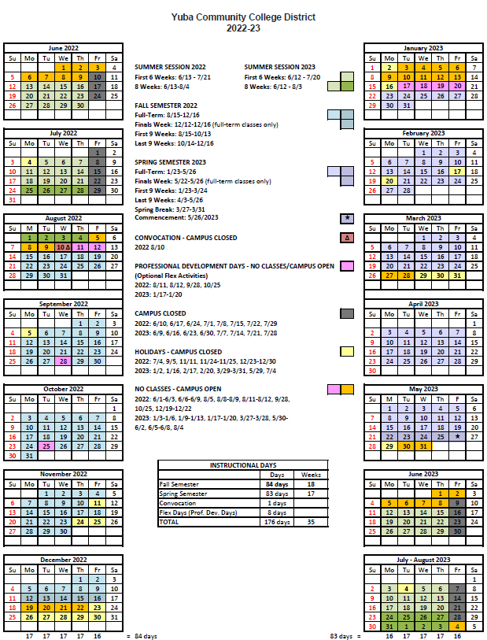

Appendix K: Map of Yuba College
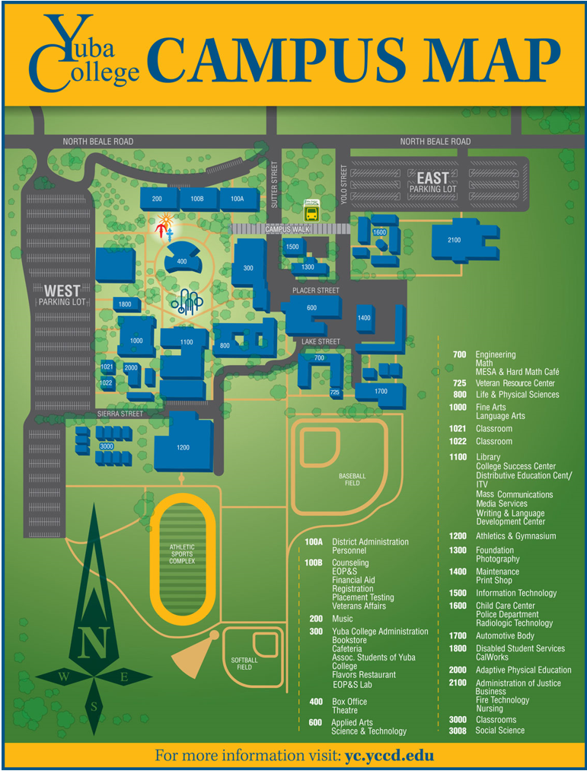

The End.

