Addendum No. 1

RFP 22-01, WCC Architectural Design Services, Soccer Fields Project
Date: 08/02/2022

Date: January 26, 2016

Clarifications:

- The current modular building is a triple wide modular building. Not much to add. Its at least 15 years old. It will need some repairs once moved. A new electrical service will be required. A new access ramp will likely also be required. The carpeted flooring will likely need to be replaced with a solid surface flooring. The interior walls will need Fiberglass Reinforced Panels. Other features may be needed. Here’s a picture of the modular building:

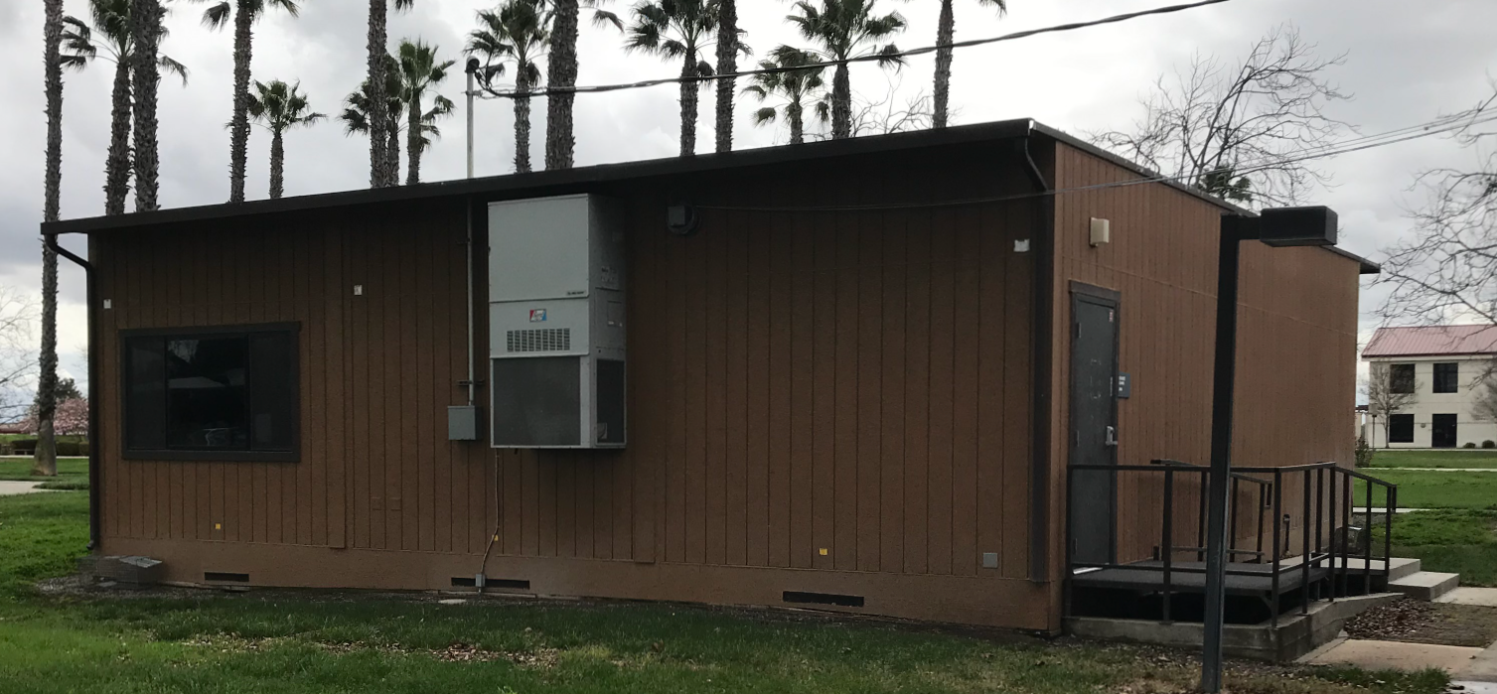

- The proposal evaluation form on page 12 of the RFP has been modified to reflect a reduction in the score for Firms that have previously done successful work at the District. Refer to the following:

10.0 Evaluation of Proposals Form

Firm: .

Proposals of Qualified Firms will be evaluated by a District Facilities Management Team, based on a number of factors which are described below:

Evaluation Criteria:

- Firm/Project Team Qualifications, Roles, Experience, Project Examples,
Time Commitment, DSA Experience, References: 40 Points

- Fee Proposal: 40 Points
- Previous successful work for the District 10 Points
- “Other Factors” Described in the RFP: 10 Points
.
.
Total Score: /100 Points

Comments:

Evaluator Name (Print): . Evaluator Signature: .
Date: . Recommendation to Interview: Yes/No: .

The Top 1 to 3 Best Qualified Firms with the Most Advantageous Proposal for the District will be interviewed. The interview will have a 50-point value with questions developed after reviewing the proposals.

The District may negotiate terms with the most qualified Firm that provides the most advantageous proposal for the District. The lowest cost proposer may not be awarded the project, at the full discretion of the District.

- Proposals remain due to the District Office location no later than 1:00 PM Sharp on August 9, 2022.

The End.

