Request for Proposal
Yuba Community College District

Woodland Community College Campus
Architectural Design Services
Soccer Fields Project
No. RFP 22-01

Issue Date: July 12, 2022
RFP Due: August 9, 2022

RFP Due Date: August 9, 2022, 1:00 PM Sharp, Yuba College Location Delivered To:

Yuba Community College District, District Offices
Attn.: David Willis
District Director of Facilities Planning, Maintenance & Operations
RFP No. 22-01 Architectural Design Services, WCC Soccer Fields Project
Address: 425 Plumas Blvd., Suite 200, Yuba City, California, 95991

Proposal Delivery Location, Front Counter at Second Floor
Yuba Community College District
District Offices
425 Plumas Blvd, Suite 200 (second floor)
Yuba City, California, 95991

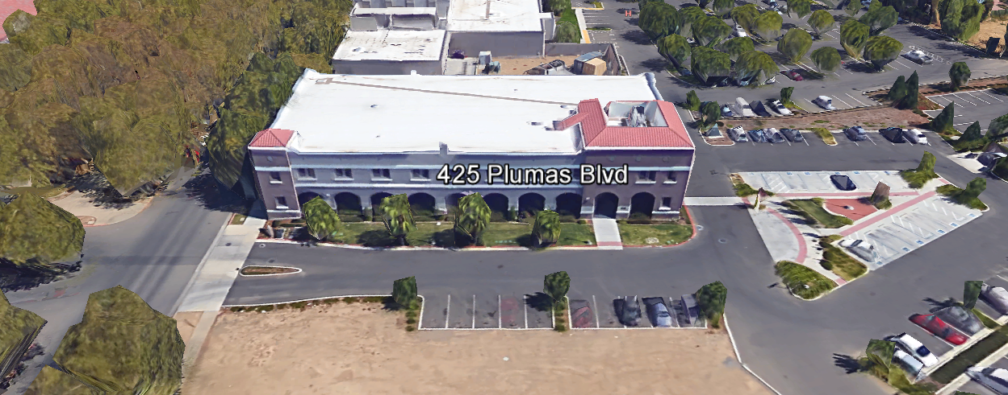
TABLE OF CONTENTS

1.0 INTRODUCTION
1.1 District Information
1.2 Yuba Community College District Background
1.3 Purpose of the Request
1.4 Applicable Codes
2.0 Scope of Work
2.1 Project Schedule
2.2 District Staff Contacts during Proposal Process
3.0 Proposal Format Organization
3.1 Proposal Delivery, Contents, and Format
4.0 Selection of “Firm”
5.0 Basis of Award
6.0 Non-Discrimination
7.0 Response to Request for Proposal (RFP)
8.0 Requests for Information (RFI)
9.0 Proposal Schedule
10.0 Evaluation of Proposals Form
11.0 District Parking
12.0 RFP Proposals
13.0 Award of Contract/Proposal
14.0 Reservation of Rights
15.0 Bid Bond Requirements (not applicable)
16.0 Performance Bond, Payment Bond Requirements (not applicable)
17.0 Liquidated Damages (not applicable)

Proposal Required Items:

Appendix A, Proposal Bid Form
Appendix B, Statement of Qualifications
Appendix C, Acknowledgement of Addenda Form
Appendix D, Non-Collusion Affidavit Form
Appendix E, YCCD Professional Services Agreement, PSA (Can be provided by Successful Firm, not required on proposal due date)
Appendix F, Signature Proposal Form
Appendix G, Architectural Firm References
Appendix H, Preliminary Schedule, List of first tier Sub-Design Firms, Architectural License, other credentials.

Informational Items:
Appendix I: YCCD Academic Calendars
Appendix J: Map of Woodland Community College Campus
Appendix K: Various WCC Soccer Fields Early Preliminary Project Information
Appendix L: Various Campus Site Plans / Utilities Information:

1. INTRODUCTION

  - District Information:

The District consists of two colleges, Woodland Community College and Yuba College, with campuses located at six different locations: Yuba College in Marysville, CA; Sutter County Center in Yuba City, CA; Beale Education Center, Beale AFB, CA; Woodland Community College in Woodland, CA; Colusa County Center in Williams, CA; and Lake County Campus in Clearlake, CA.

  - Yuba Community College District

The Yuba Community College District (YCCD) was founded in 1927 and spans eight counties (Yuba, Sutter, Colusa, Yolo, Lake, Butte, Glenn and Placer) and nearly 4,200 square miles of territory in rural, north-central California. It has colleges in Marysville and Woodland, an educational center in Clearlake, an educational center in Williams, an educational center in Yuba City, and outreach operations at Beale Air Force Base.

  - Purpose of Request

The Yuba Community College District seeks Proposals and Statements of Qualification from Licensed Architectural Firms to provide design services, DSA submission, and contract administration through construction.
Woodland Community College Campus Address: 2300 East Gibson Road, Woodland, California 95776.

  - Applicable Codes
All work shall meet all State of California Building Codes, and Federal codes, and local ordinances.
The design of the Soccer Fields project shall meet the requirements of the Bay Valley Conference.
All projects at the District/College are prevailing wage projects.
- Scope of Work

The Yuba Community College District is accepting proposals for “RFP 22-01 Architectural Design Services, WCC Soccer Fields Project”.

The “Soccer Fields” project is the first phase of a number of phases that will likely be needed to complete the WCC Sports complex. It is the intention of the College to have a fully functional “game field” and “practice field” no later than the Fall of 2024. There are also a number of additive alternates listed that will need to be designed and a cost estimate made to support a College/District Capital fund raising Campaign through the District Foundation. Future Sports Complex phases are not included in the design work of this project and will be contingent on a number of factors including whether a future Obligation Bond Measure is presented and approved by the voters of the College/District, and the success of the First Phase Soccer Fields project in successfully meeting it’s project objectives.

The scope of the “Soccer Fields (2) Project” will likely include the following:
- Campus Site Research and Investigation of Existing Utilities and Site Conditions
- Game Soccer Field
- Practice Soccer Field
- Irrigation Systems
- Gravel Parking Areas
- Minimal Landscaping with addition of shade trees around the practice field.
- Accessibility access path to both paved parking stalls, and existing restrooms in building 800.
- Fencing along the roadways or as needed to protect the fields.
- Repurposing/repairs, and possibly relocation of an existing double modular building to be used as a temporary training/locker room for the soccer program.
- Phase I Soccer Fields Project cost estimate, generated by a qualified cost estimating firm in the local area that uses actual project costs of other projects to generate the cost estimate. If a Firm has the capability and expertise to provide an accurate estimate +/- 10 percent, using the actual local similar project costs, then this is also acceptable.
- Project Schedule
- Schematic Design
- Construction Documents (drawings and specifications)
- Colored rendering of the phase I soccer fields project scope
- Colored rendering of the entire sports complex.
- Rough Cost Estimate of each of the future sports complex phases.
- General Overall Plan showing each future phase of the Sports Complex
- DSA Submission and process support
- Contract Administration through Completion
- Note: The College/District would like natural grass fields over artificial turf fields.

- Additive Alternates to be designed and a cost estimate generated as part of the scope of this RFP and bid by the contractor as additive alternates to the base bid items above.

  - Lighting around the game field, walkways, parking lot.
  - Bleacher pads and Bleachers. Seating: 300 sets for WCC, 100 for visitors
  - Electronic Scoreboard
  - PA announcement system
  - Restrooms
  - Concessions Building
  - Ticket Booth
  - Sports Fields Storage/Maintenance Building
  - Fencing around the game field

Note: The College/District plans to initiate a capital fund raising campaign for the above items through the Districts’ Foundation.

Note: The locations of the soccer fields may change so that they can be in a North/South direction. The other sports fields shown in the VERDE Design documents in Appendix K may also be relocated or changed during the planning work of this project. Please include this planning work in your proposal.
2.1 Project schedule
Approximate Award Date: September 20, 2022
Schematic Design completed: October 18, 2022
95% Construction Documents: November 1, 2022
Design Drawings and Specifications Completed, Submission to DSA Date: November 15, 2022.
Note: These are target dates which can be changed by the Architectural Firm to provide a preliminary schedule for this RFP.
Provide a brief project schedule with the proposal.

2.2 District Staff Contacts during the Proposal process:
Firms interested in submitting a Proposal are directed not to make personal contact with the Board of Trustees, District staff, or members of the evaluation committee. Any contact shall constitute grounds for disqualification from consideration.
Single Point of Contact during the Proposal Preparation Process:
David L. Willis
District Director of Maintenance, Operations, and Planning
425 Plumas Blvd., Suite 200 (Second Floor)
Yuba City, California, 95991
Cell Phone: 916-747-4262
Email: dwillis@yccd.edu

3.0 Proposal Format Organization
The Firm is requested to use the following proposal format:

3.1. Proposal Delivery, Contents, and Format:
Proposals should provide straightforward, concise information that satisfies the requirements noted in this RFP. Expensive binding, color displays, and the like are discouraged. Emphasis should be placed on brevity, conformity to the Districts instructions, selection criteria of this RFP, and completeness and clarity of content. Each Respondent’s proposal should clearly and accurately demonstrate specialized knowledge and experience required for consideration.
In a sealed box or envelope (clearly marked “), submit the following:
- One (1) flash memory stick containing the complete proposal and supporting documentation;
- One (1) original and one (1) copy in paper form of the proposal, which consists of a Proposal Letter and responses to the proposal requirements of this RFP.

There is no page limit.

Firms must comply with the provisions of these instructions for completion and submission of the Proposal. The failure of a Firm to comply with the Proposal Instructions and Requirements will likely result (at the sole discretion of the District) in rejection of the Proposal for non-responsiveness.
Proposal Section | Format
- Cover Letter | PDF
- Table of Contents | PDF
Appendices (See Table of Contents for each one) Submit a response to each Appendix that requires Firm information. Please submit responses to Appendices A, B, C, D, E, F, G, and H. Appendices I, J, K, and L are informational only. | PDF

Proposal General Information Contents:

Information requested will help the District determine if the Firm is a “Responsible Proposer”.

Cover Letter

The Proposal shall include a Cover Letter on Respondent’s official business letterhead, which shall be signed by an individual authorized to legally bind Respondent. The Cover Letter shall also identify the name, telephone number, and email of a person who may be contacted during the Proposal evaluation process.

Table of Contents

Provide a Table of Contents that outlines in sequential order the major sections and sub-sections of the Proposal. Use tabs to allow information to be more easily located.

4.0 Selection of “Firm” Services Provider

The process of “Firm” selection is based upon the complete responsiveness of the RFP and the criteria as outlined in the RFP.

The District Project Evaluation Team will read the written proposals. The District Evaluation Team will discuss the proposals and verify that the “Basis of Award” information below, the Statement of Qualifications, and information submitted in response to the RFP are complete and responsive.

Process Summary:

- Evaluation of the Statement of Qualifications.
- Interview with Firm
- Prequalification of Firms
- Proposal Review
- Selection of most qualified, cost-effective comprehensive proposal which includes all needed and requested services as described in this RFP.

The District reserves the right to reject any or all submittals, to amend the RFP process, and to discontinue or re-open the process at any time. The District reserves the right to request clarifications to RFP responses and to negotiate the terms of the agreement.

5.0 Basis of Award

This project will be awarded based on the following criteria:

- Lowest Total Cost Responsive Qualified Proposer
  - Statement of Qualifications Evaluation, Interview, resulting in Prequalification.
  - Proposal Review, Complete and Comprehensive, and Lowest Total Cost.

- Other Factors Considered in the above process:
  - Project Team, Credentials, Time Commitment
  - Proper State of California Architects License in good standing
  - Information provided as requested in the RFP.
  - All Addendums are acknowledged.
  - Architectural Firm’s exceptions or exclusions.
  - Architectural Firm with historical good performance on YCCD projects regarding minimal number and cost of change orders, maintaining project schedules and completing the work promptly, and overall quality of work.
  - Architectural Firm’s ability to meet schedule requirements.
  - Architectural Firm has demonstrated past project references of “like” projects
  - Architectural Firm’s references are all good with respect to schedule, cost, and quality.
  - No other factors such as litigation, licenses not in good standing, bankruptcy, or other similar criteria.

The one or two of the best qualified and lowest total cost responsive proposer’s may be requested to participate in a ZOOM interview process with the District Project Proposal Evaluation Team.

6.0 Non-Discrimination

The District does not discriminate with regard to race, color, gender, national origin, disability, or any other protected or other classification in the awarding of contracts/agreements. The District welcomes all Qualified Firms to participate in the project Request for Qualification/Proposal process.
The District encourages firms that are women or minority owned, emerging small businesses, veteran owned firms, disabled person owned firms, and all other qualified firms to participate in the proposal process.
The District encourages the submission of proposals from all Firms that can meet the stated requirements set for this RFP.
7.0 Responses to RFP:
Sealed responses to this RFP must be clearly marked "RFP NO. 22-01 Architectural Design Services, WCC Soccer Fields Project”.

Responses shall be mailed to or hand-delivered to the following address:

Yuba Community College District, District Offices
Attn.: David Willis
District Director of Facilities Planning, Maintenance & Operations

Envelope/Box Marked:
"RFP NO. 22-01 Architectural Design Services, WCC Soccer Fields Project”.
.

Address: 425 Plumas Blvd., Suite 200, Room 216, Yuba City, California, 95991

Note: Completely seal your proposals in envelope/box and make sure it gets date/time stamped when delivering proposal. Firms are each 100% responsible to make sure proposals that are mailed using a carrier such as UPS, FED Ex, etc…are received and date/time stamped by District personnel prior to the proposal due date/time. No proposals will be considered if they are late, even if it is only 5 minutes late. Please make sure your proposals are delivered and received promptly prior to the due date/time. There will be a public proposal opening at the due date/time.

Do NOT email your proposals. Emailed proposals that are not sent per the above guidance requirements will not be considered.

8.0 Requests for Information (RFI)

Requests for Information concerning the RFP must be in writing and may be submitted via email no later than the date shown below. Please direct all questions to David Willis, email: dwillis@yccd.edu.

Following the RFI deadline, all questions and answers will be summarized and posted on the District's website: https://www.yccd.edu/central-services/purchasing/ , then, click on the “Requests for Proposals / Quotes” tab on the right hand side of this web page. It is anticipated that responses to inquires received by the required time and date will be provided within 5 business days and posted on the District website or responded to per the dates listed in the RFP for addendum publishing. Should more time be needed by the District to answer I respond to RFI’s, this information will also be posted on the above website.

- Include the following in the subject matter field on emails when requesting information: “RFP 22-01”, RFI.

9.0 Proposal Schedule:

Important Dates and Times:

July 12, 2022: Release of Request for Proposal at 1:00PM

All Pre-Bid Meetings Are Optional.

July 19, 2022: 11:00am to 12:00pm Optional ZOOM Pre-Bid Meeting:

Join Zoom Meeting
https://yccd-edu.zoom.us/j/97731974670

Dial by your location
+1 669 444 9171 US
+1 669 900 9128 US (San Jose)

July 20, 2022: Optional On-Campus Pre-Bid Meeting in Building 100, Room 113. Woodland Community College address: 2300 East Gibson Road, Woodland, Ca., 95776.

July 21, 2022: 11:00am to 12:00pm Optional ZOOM Pre-Bid Meeting:

Join Zoom Meeting
https://yccd-edu.zoom.us/j/92584226562

Dial by your location
+1 669 444 9171 US
+1 669 900 9128 US (San Jose)

August 1, 2022: 5:00 PM, All questions and requests for information must be submitted to David Willis at: dwillis@yccd.edu.

August 2, 2022: 5:00 PM, Addendum Issued if needed.

August 9, 2022: Proposals due at 1:00 PM SHARP, Yuba Community College District, District Offices Location: 425 Plumas Blvd., Yuba City, Ca., 95991. There will be a public bid opening on this RFP.

This is a prevailing wage project.

10.0 Evaluation of Proposals Form

Firm: .

Proposals of Qualified Firms will be evaluated by a District Facilities Management Team, based on a number of factors which are described below:

Evaluation Criteria:

- Firm/Project Team Qualifications, Roles, Experience, Project Examples,
Time Commitment, DSA Experience, References: 35 Points

- Fee Proposal: 35 Points
- Previous successful work for the District 20 Points
- “Other Factors” Described in the RFP: 10 Points
.
.
Total Score: /100 Points

Comments:

Evaluator Name (Print): . Evaluator Signature: .
Date: . Recommendation to Interview: Yes/No: .

The Top 1 to 3 Best Qualified Firms with the Most Advantageous Proposal for the District will be interviewed. The interview will have a 50-point value with questions developed after reviewing the proposals.

The District may negotiate terms with the most qualified Firm that provides the most advantageous proposal for the District. The lowest cost proposer may not be awarded the project, at the full discretion of the District.
11.0 District Parking:

-No parking in Reserved Spaces without a proper permit
-Permit Parking is enforced in all general lots between 6:00 am and 6:00 pm, Monday through Friday. All general lots require a properly displayed, valid permit during these times
-Daily Parking Permits is $2.00
-Permits are available for purchase at any of the permit machines located in the student parking lots
-All other parking regulations are enforced 24 hours a day, seven days a week. This includes designated staff spaces, handicap spaces, timed spaces, red zones, yellow zones, and areas not marked (no parking at any time)
-Once this project is awarded, temporary parking permits will be processed as requested by the successful firm for all employees associated with this project at no cost to the Firm for the duration of the project at each Campus location. These temporary permits must be displayed at all times on the dashboard of employee vehicles.

12.0 RFP Proposals

Proposals received after the deadline date and time will not be opened. Each responder shall submit one (1) signed original, one (1) additional hard paper copy, all in separate binders. Provide one electronic format copy of the proposal using electronic media such as a flash drive. (No CD formatted Disks).

All materials submitted in response to the RFP shall be on 8-1/2"x11" paper, preferably in
Portrait orientation. All submitted materials must be bound in either a three-ring binder or spiral bound notebook. Content shall be tabbed and numbered per the items included in the Submittal Requirements. All Proposals will be reviewed and evaluated by a District Selection Committee. The District at its sole discretion may interview finalists or select a firm or firms to perform work based solely on the evaluation of the Proposal. There is no page limit.

All Proposals become the sole property of the District and the content will be held confidential until the selection of the Firm or Firm’s is made and the project is awarded.

13.0 Award of Contract

- The Contract will be awarded to the lowest total cost, most responsive responsible District prequalified Architectural Firm, whose proposal, conforming to the request for proposal and associated addendums, will be most advantageous to the District.

B. The District reserves the right to enter into an Agreement without further discussion of the proposal submitted based on the initial offers received.

C. The District reserves the right to reject any or all proposals or any part of the proposal and to waive informalities and minor irregularities in the proposals received.

D. The RFP, its addendums, any follow-up clarifying information, and the proposal of the selected Firm will become part of any contract initiated by the District.

E. A formal contract shall be signed by the successful proposer and Yuba Community College District to perform this service.

F. The District reserves the right to enter into discussions with any one or all of the Responders after Proposals have been initially reviewed. Such responses shall be subject to all provisions, terms and conditions as set forth in the RFP, unless otherwise modified.

G. The District intends to award to a single RFP Responder.

H. BONDS: There are no bid bond, payment bond, or performance bond requirements on this Architectural Design Services RFP.

I. Failure to acknowledge all of the addendums, provide the items listed in the RFP, may render the proposal unresponsive at the discretion of the District. Items listed in the RFP become part of the contract unless the Architect provides an exception in the proposal. Architectural Firm exceptions, depending on the magnitude, may render the proposal unresponsive, at the discretion of the District.

J. The District reserves the right to request clarification of proposal content during the review and evaluation process.

K. The District reserves the right to negotiate the terms of the agreement to align with budgetary constraints.

L. Due to the heightened risk of illness that could then affect the performance of the Architectural Firm, Firms with multiple employees and work teams with resources to adapt and complete the scope of work per the RFP, will be perceived to provide enhanced service and value during the evaluation process.

14.0 Reservation of Rights

The District reserves the right to:

- Reject any or all submittals at its sole discretions.
- Cancel the Request for Proposal (RFP), without cause.
- Modify any requirements contained within the RFP and request a revised submission from all Providers.
- Establish other evaluation criteria determined to be in the best interest of the District.
- Contract with any of the firms responding to the RFP based solely upon its judgment of the qualifications and capabilities of the firm.
- Clarify the content of any proposal to verify that the requirements of the RFP are included.
- Waive “minor” proposal inconsistencies that do not change the scope of work as outlined in the RFP.
- Disqualify a Firm after reviewing the proposal and finding concerning performance information in references, inadequate or incomplete proposal information which renders the proposal unresponsive, and historically poor project performance at the District/Colleges (as solely defined by the District).

This RFP does not commit the District to award or negotiate a contract. The District will not be responsible for any expenses incurred by any firm in preparing and submitting a proposal or response to this RFP or in completing any of the work specified.

15. Bid Bond Requirements (Not applicable)

16. Performance and Payment Bond Requirements (Not applicable
17. Liquidated Damages (Not applicable)
Appendix A: Proposal Base Bid Form:

No. | Description | Cost
1 | On Campus Site Conditions Investigation of Existing Conditions | $
2 | Schematic Design, including Topographical Survey for ADA requirements. | $
3 | Soccer Fields Construction Documents | $
4 | DSA Submission and support, DSA Fees paid by District directly to DSA. | $
5 | Contract Administration for the base bid Soccer Fields project (not the additive alternates) | $
6 | Cost Estimate generated by a local qualified cost estimating Firm that uses actual recent costs of other similar projects to help generate a cost estimate for this project. If a Firm has the capability and expertise to provide an accurate estimate +/- 10 percent, using the actual local similar project costs, then this is also acceptable.
7 | Other: | $
8 | Reimbursable Expenses: Architect to Define/Explain  Note: No hotel or travel costs | $
9 | Sub-Total: | $
10 | Additive Alternates listed in section 2.0:  Include contract administration services for these items in this line item. | $
11 | Total Costs: | $

Provide hourly rates for each position title.
Provide schedule of values. There is a 5% retainage on this project for each progress payment.
Prevailing wages apply to this project.

List all First Tier Sub-Design Firms.

Please round off numbers to the nearest dollar.

A preliminary overall start to finish project schedule is required with the proposal. Note: The District would like to have the soccer fields fully operational no later than the Fall of 2024.

Use the standard AIA form G702 (modified to include the District’s signature), along with the standard schedule of values.
Appendix B: Statement of Qualifications
The Firm shall furnish the following information. Failure to comply with this requirement will render the submittal informal and may cause its rejection. Additional sheets may be attached if necessary.
Basic Firm Informational Items 1 through 16:

- Firm Name:___________________________________________________________________

- Primary Address: ______________________________________________________________

- Firm’s Contact Person and Title:___________________________________________________

- Telephone: ___________ Facsimile: ____________________

- Email Address: ___________________

- License No.: ______________________________ Class: __________________________

Responsible Managing Employee/Officer:___________________________________________

- Names and titles of two officers of the Firm:

NAME TITLE

8. Specific type of Ownership (Check one)

Individual
Partnership
Corporation; If a corporation, state the following:

State of incorporation:
Date of incorporation: President/CEO:
Joint Venture
Other (Specify)

- Taxpayer Identification No.: _______________________

- List annual gross income for last three (3) years:
Year: _______________ $_____________________
Year: _______________ $_____________________
Year: _______________ $_____________________

- Number of years Firm has been in business:
If less than 5 years, please describe:

- Number of years Firm has conducted business under the present name:__________
- Has the Firm ever been licensed under a different name or different license number? . If Yes, give name(s) and license number(s) and dates or operation under that name(s) and license number(s) (attach separate sheets if necessary):___________________________________________ _________________________________________________________ _________________________________________________________
- Number of years’ experience in California Community College, University or educational facility projects .

- Do you now or have you ever had any direct or indirect business, financial or other connection with any official, employee or consultant of the District? ___. If Yes, please elaborate:
_________________________________________________________

- Has the Firm ever completed any work at the Yuba Community College District? If Yes, please elaborate:

Potentially Disqualifying Questions 17 through 23 Firm’s refusal to answer or omission of response to any of Questions 17 through 23 may result in disqualification of Firm.:

- Does the Firm possess a valid and currently in good standing California Architects’ license? If Yes provide the license number(s). Yes/No______________________________________________________

- Has the Firm been defaulted or terminated (other than for convenience) by any California school district, community college district or other California public agency on any project within the past 5 years? Yes/No

If yes, identify agency and details:

- Has the Firm or any of its owners, officers, or partners, ever been convicted of a crime, or found guilty in a criminal action, involving fraud, theft, making any false claim or material representation to a public agency, or involving any federal, state, or local law, rule, or regulation related to Architectural Services or Construction? Yes/No_____

If yes, explain, identify the agency, and provide case name and number.

- Has the Firm been assessed liquidated damages for any project in the past five years? Yes/No If so, identify owner and details:

- Has the Firm ever failed to complete a project in the past five years? Yes/No: If so, give owner and details:

- Is the Firm currently or has the Firm been in a state of “Bankruptcy” in the past five years? Yes/No:
If yes, please explain.

- Please describe the Firm’s commitment to maintaining a construction schedule. How will the Firm recover the schedule if it slips due to weather or COVID-19 or similar illness impacts, or the Firm gets busy with other projects? Please describe specific actions the Firm will take to maintain the Project schedule.

Scoring/Rating Questions:

- Please list and describe on separate sheets the Firm’s top 10 “like” Sports Fields College project references with current contact information. The project reference list should include the following criteria:
  - Project Name
  - Project Owner and Contact Information
  - Project Scope
  - Division of the State Architect (DSA) Experience: Yes/No
  - Original Contract Completion Date
  - Actual Project Completion Date
  - Original Construction Contract Price
  - Final Adjusted Construction Contract Price
  - Any issues that Firm had to overcome on the project

Scoring Criteria:
  - “Like” type Sports Fields College Projects (30 points)
  - DSA Experience (20 points)
  - Project Change Orders less than 5% (up to 10 points)
  - Other criteria noted above (up to 10 points)

Total points: up to 70 points

- How many years has your Firm been in business in California as an Architectural Firm under your present business name and license number? __________
(less than 5 years = 0 points; 5-7 years = 3 points; 8+ years = 10 points.)

- In the last 10 years, how many legal proceedings (filed in court or arbitrations) has your Firm initiated against an owner, regardless of outcome? _______
(0 = 10 points; 1 = 5 points; 2+ = 0 points.)

- In the last 10 years, how many legal proceedings (filed in court or arbitrations) has an owner initiated against your Firm, regardless of outcome? _______
(0 = 10 points; 1 = 5 points; 2+ = 0 points.)

- Has your Firm been denied an award of public works contract based on a public agency’s finding that your Firm was not a responsible Proposer within the last 10 years? ______
(No = 5 points; Yes = 0 points.)

- Please describe the Capability/Capacity of your Firm. Please provide a comprehensive list of projects that the Architectural Firm has in process and reasoning/justification regarding how the Firm has capacity to perform the required services on this project.

(Up to 20 points.)

- Please list and describe the Firms Team Members that will be working on the project, roles, percent of time commitment, and provide support information of their experience working on “like” projects and credentials. Has this team worked together before? Provide examples.

(Up to 40 points.)

Qualification Criteria:
Questions 1 through 16 are general base level information that is required for pre-qualification.
Questions 17 through 23 are possible disqualifying questions that would render the Firm “not qualified” as determined by the District.
Questions 24 through 30 are rating questions that are scored and more deeply evaluated. Not scoring the minimum threshold value will render the Firm “not qualified”.
  - There are a total of 165 points possible.
  - The District can disqualify a Firm (at it’s sole discretion) if the Firm does not meet the requirements of Questions 17 through 23.
  - Each Firm must score at least 140 points.
  - Once a Firm meets the 140 point threshold, the top 1 to 3 Firms will be interviewed. Interviews score 50 points.
  - The associated Proposal will be evaluated by the District. The best qualified Firm with the most cost effective and fully responsive proposal will be selected by the District.

The undersigned is duly authorized to execute this Statement of Qualifications under penalty of perjury on behalf of the above-identified Firm. The undersigned warrants and represents that he/she has personal knowledge of each of the responses to this Statement of Qualifications and/or that he/she has conducted all necessary and appropriate inquiries to determine the truth, completeness, and accuracy of responses to this Statement of Qualifications. The undersigned declares and certifies that the responses to this Statement of Qualifications are complete and accurate; there are no omissions of material fact or information that render any response to be false or misleading and there are no misstatements of fact in any of the responses. The above-identified Firm acknowledges and agrees that if the District determines that any response herein is false or misleading or contains misstatements of fact so as to be false or misleading, the District may find the Firm is not qualified and the District can reject the proposal for non-responsiveness or non-responsibility.

Executed this___ day of __________________ 20__ at_____________________________.
(City and State)
I declare under penalty of perjury under California law that the foregoing is true and correct.

By: ____________________________________________
(Signature of Firm’s Authorized Officer or Representative)
____________________________________________
(Typed or Printed Name)
Title: ___________________________________________
Appendix C: Acknowledgement of Addenda Form

The undersigned acknowledges receipt of the following addenda from the District pursuant to the Request for Proposal:
Acknowledgement: Yes or Not Applicable
Addendum No. 1: .
Addendum No. 2: .
Addendum No. 3: .
Addendum No. 4: .
Addendum No. 5: .

Firms are required to acknowledge all addenda’s within the submitted proposal at the time of submission.

Appendix D: Non-Collusion Affidavit Form

STATE OF CALIFORNIA, COUNTY OF I, being first duly sworn, deposes and says that I am the of , the party submitting the foregoing proposal (“the Proposal”). In connection with the foregoing Proposal, the undersigned declares, states and certifies that:
- The Proposal is not made in the interest of, or on behalf of, any undisclosed person, partnership, company, association, organization or corporation.
- The Proposal is genuine and not collusive or a sham.
- The Firm has not directly or indirectly induced or solicited another Firm to put in a false or sham proposal, and has not directly or indirectly colluded, conspired, connived, or agreed with any other Firm or anyone else to put in a sham proposal, or to refrain from bidding.
- The Firm has not in any manner, directly or indirectly, sought by agreement, communication, or conference with anyone to fix the proposal price, or that of any other Firm, or to fix any overhead, profit or cost element of the proposal price or that of any other Firm, or to secure any advantage against the public body awarding the contract of anyone interested in the proposed contract.
- All statements contained in the Proposal and related documents are true.
- The Firm has not, directly or indirectly, submitted the proposal price or any breakdown thereof, or the contents there of, or divulged information or data relative thereto, or paid, and will not pay any fee to any person, corporation, partnership, company, association, organization, proposal depository, or to any member or agent thereof to effectuate a collusive or sham proposal.
Executed on this date: , 2022/2023, at:

(City, County, and State)
I declare under penalty of perjury under the laws of the State of California that the foregoing is true and correct.
Signature Printed Name .
Address: .
Area Code & Phone Number: .
Note: In addition to other bid documents, bidders on public works projects are required by Public Contract Code section 7106 to submit a certification form that they have not colluded with another proposer.

Appendix E: YCCD Professional Services Agreement
Link:
https://goyccd-my.sharepoint.com/:w:/g/personal/w0398409_yccd_edu/EaOF1539HJpOkqkjSTfZUJgBmnNDF6Z3XTBwk2iS2fZ3wg?e=7tDtac
This agreement is optional at the time of the proposal submission.
The successful Firm will be required to provide this agreement within 7 days after requested by the District.

Appendix “F” Proposal Signature Form
The undersigned acknowledges the following:
- Having become familiar with the specifications and requirements of the Request for Proposal, hereby offers to provide all services in accordance with the proposal set forth herein, including all referenced material and attachments.
- By submitting a signed proposal in response to this solicitation, the Firm acknowledges that they completely understand the scope of the needed services and that the proposed services as described in the proposal will meet or exceed the needs of the District.
- Late proposals will not be accepted (even if they are only 5 minutes late).
- The District reserves the right to reject any and all proposals and that this proposal shall remain open and not be withdrawn for a minimum of 90 days.
- Cancellation Clause: The District may, without cause, terminate the contract(s) or a project under the contract(s) by giving written notice of such termination to the awarded firm. In the event of such termination the District shall reimburse the firm for services performed and reasonable expenses actually incurred by the firm in relation to the terminated project prior to the firm’s receipt of such notice of termination. The cost of proposal generation, associated travel, copies, postage, etc.., will not be reimbursed and is considered a typical and normal part of the bid process and is not reimbursed for any of the proposers.
- If the prospective Firm is a corporation, the undersigned hereby represents and warrants that the corporation is duly incorporated and is in good standing in the state of California , and that, , is authorized to act for and bind the corporation.

Entity Type (Select One):

Sole Owner: Partnership: .

Corporation: .

Other; Please specify;

- Regular monthly progress payments are made using NET 30 as a basis for payment, with Net 30 time starting after receipt of the invoice with all required support documentation, and once this information is reviewed and approved by the District.

Invoices must be emailed to the following with all support documentation:
Vendors with a first letter of A through N: rkaur1@yccd.edu ; cstoner@yccd.edu
Vendors with a first letter of O through Z: hgardner@yccd.edu; cstoner@yccd.edu
It is critical that invoices have all required support documentation including an updated schedule of values with 5% retainage for construction projects, updated project schedule, description of completed work, and any other information that will help to justify and support the progress payment request.

Signature_____________________________ Date: _______________________
Position: _____________________________
Print name____________________________ Title________________________

Notary Required On This Project
Notary Stamp:

Appendix “G” References Form (Example Template)

Bidder shall provide a minimum of Ten (10) verifiable references with current contact information, preferably from a California public educational institution and/or California public agency, representing projects started and completed within the last 5 years. See clarification note below regarding reference requirements. This information can be provided as part of the Statement of Qualifications.
All phone numbers and emails must be current (please verify).
REFERENCE #1
NAME
ADDRESS
CITY, STATE ZIP CODE
TELEPHONE #
CONTACT
DATES OF SERVICE
REFERENCE #2
NAME
ADDRESS
CITY, STATE, ZIP CODE
TELEPHONE #
CONTACT
DATES OF SERVICE
REFERENCE #3
NAME
ADDRESS
CITY, STATE, ZIP CODE
TELEPHONE #
CONTACT
DATES OF SERVICE

You may of course use the Firm’s established reference template.

Appendix H: Preliminary Schedule, List of first tier Sub-Design Firms, Architectural License, other credentials
Use the standard AIA form G702 (modified to include the District’s signature), along with the standard schedule of values.

Appendix I: YCCD Academic Calendar
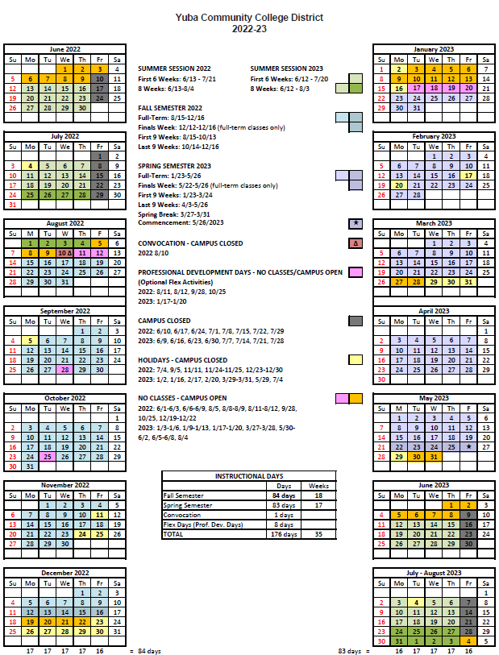

Appendix J: Map of Woodland Community College Campus

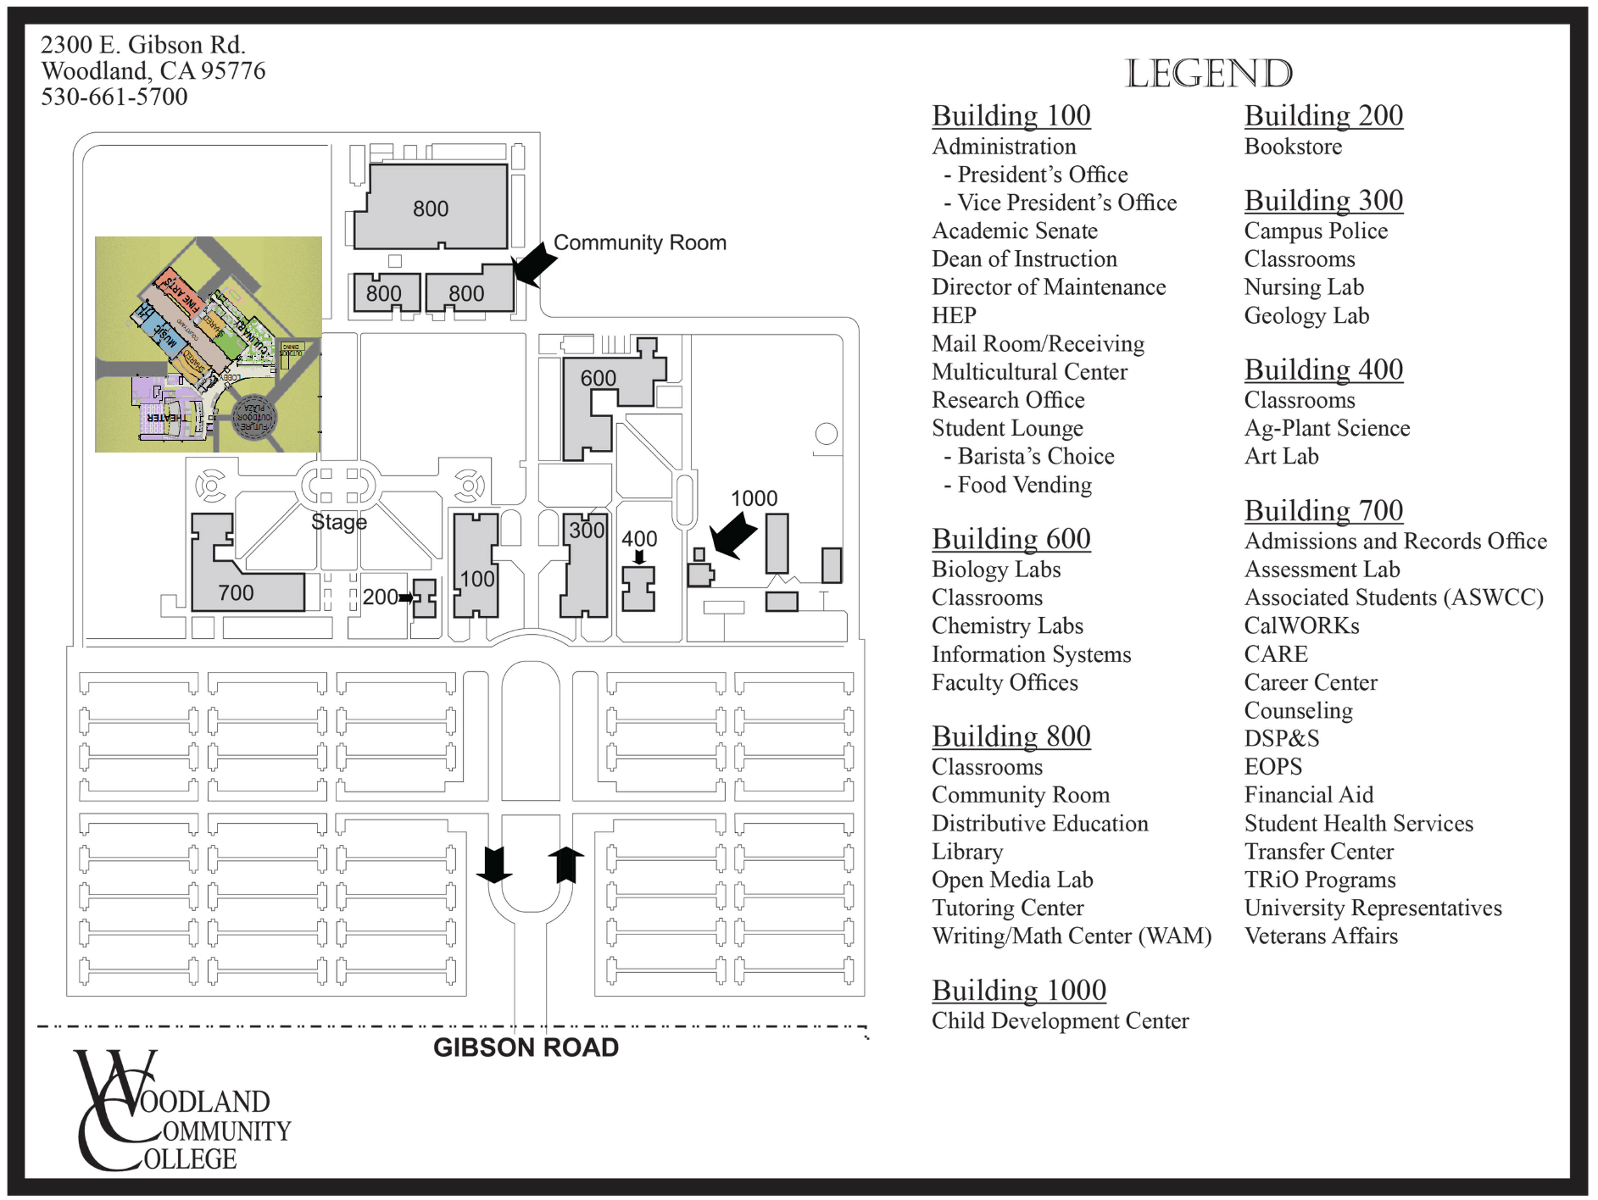

Appendix K: Various WCC Soccer Fields Early Preliminary Project Information

https://goyccd-my.sharepoint.com/:f:/g/personal/w0398409_yccd_edu/Eprg9iwvoVJEtM9IYiU4n9wBAg1NKq8iwL0KFI6lKHwhdQ?e=kJ7Fqn

Note: The information shared in this folder is a starting point. The locations of the soccer fields may change so that they can be in a North/South direction. The other sports fields shown in the VERDE Design documents may also be relocated or changed during the planning work of this project. Please include this planning work in your proposal.

Appendix L: Various Campus Site Plans / Utilities Information:

https://goyccd-my.sharepoint.com/:f:/g/personal/w0398409_yccd_edu/EtjAD5Yt_yBNk64fCoRstC4BpF7FKmZ2U6d50bAteIO5Sw?e=K274c4

The End.

