Addendum No. 1

RFP 21-04 Yuba College Fire Alarm Systems Project-Hazardous Material Abatement,
Date: 02/04/2022

Date: January 26, 2016

Please refer to the following informational links:

Hazardous Materials Abatement Study, Building By Building Analysis:
- Please refer to this link for this study:
  - https://goyccd-my.sharepoint.com/:f:/g/personal/w0398409_yccd_edu/EjySIniHJHJDjMBnK4HNr_ABn9cS0FRHqBICUSiwwSXosQ?e=IoRpfT
Hazardous Materials Assessments link:

https://goyccd-my.sharepoint.com/:f:/g/personal/w0398409_yccd_edu/EogCFujy_4xEkkdUdZFv2o0BqPHRf5Rjz1iQObr8ps3psA?e=uvUifd

Fire Alarm Systems Drawings and Specifications:

https://goyccd-my.sharepoint.com/:f:/g/personal/w0398409_yccd_edu/EsCW5pSwQ0dGrgzzR6r3UpUBNCsVRKNQCv1P1V10F-UO1w?e=6t5ayq

Request for Proposals-Qualifications No. 21-04 link:

https://goyccd-my.sharepoint.com/:f:/g/personal/w0398409_yccd_edu/Ev2t0MmVD31BuyuG86Z8-RMBso2poWXiWnlutWcBChvv_w?e=MPux1j

Note: Proposals are due February 17, 2022 at 1:00pm per the RFP/RFQ. No change in date and time. Refer to the RFP/RFP for specific details.

There is a mandatory pre-bid walk-through with the District/College and the Contractor (The Hankins Group) on Monday, February 7th at 1pm to clarify the requirements of the Hazardous Materials Abatement scope of work.
February 7, 2022 1:00 PM, Mandatory Pre-Bid Meeting at Yuba College Campus at Building 1400 Maintenance Conference Room: 2088 North Beale Road, Marysville, California 95901.

Prospective Contractors wishing to participate in this bidding process are required to have a representative attend, sign the login sheet, and conduct a field inspection and assessment of the scope of work per this walk-through of the buildings with the Fire Alarm Systems Contractor and the District. Only contractors that walk the project and have signed a login sheet are qualified to bid the project. No other walk-through meetings will be schedule.

COVID 19 Prevention Best Practices Apply

Facial Coverings Required at All Times.
Social Distancing shall be applied.
No sick employees shall attend meetings or report to work.
Frequent use of hand sanitizer is required.

Map of Yuba College Campus: (Building 1400 is on the east side of the campus)
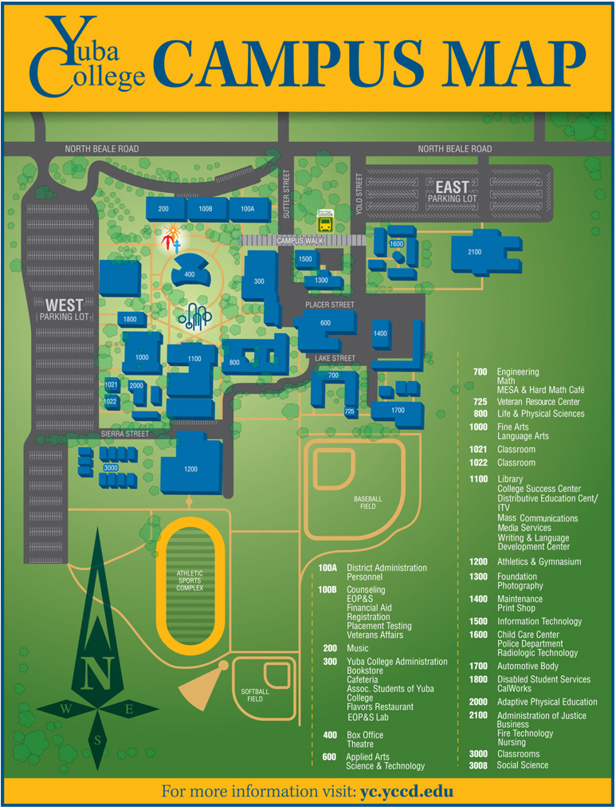

The End.

