Request for Proposal
Yuba Community College District

Woodland Community College Campus
and
Lake County Campus
MONUMENT LED SIGN PROJECTS

No. RFP 21-06
Revision 1.0

Issue Date: September 28, 2021
RFP Due: November 9, 2021

RFP Due Date: November 9, 2021, 1:00 PM Sharp, Yuba College Location Delivered To:

Yuba Community College District, District Offices
Attn.: David Willis
District Director of Facilities Planning, Maintenance & Operations
RFP No. 21-06 WCC and LCC Monument Sign Project
Address: 425 Plumas Blvd., Suite 200, Yuba City, California, 95991

Proposal Delivery Location, Front Counter at Second Floor
Yuba Community College District
District Offices
425 Plumas Blvd, Suite 200 (second floor)
Yuba City, California, 95991

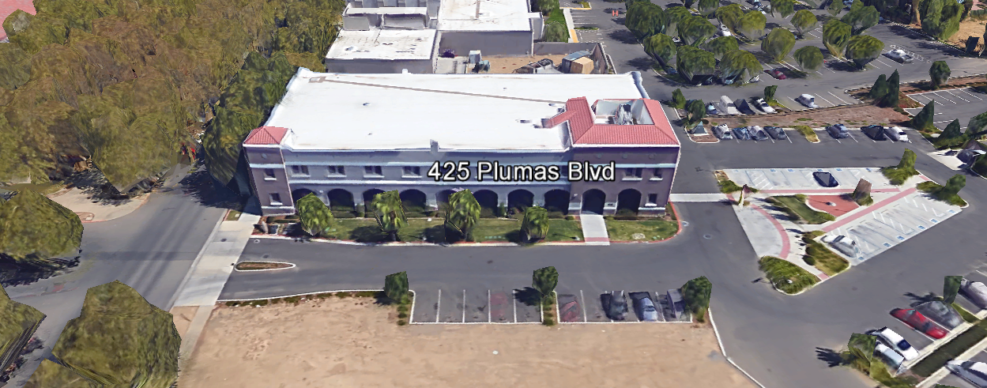
TABLE OF CONTENTS

1.0 INTRODUCTION
1.1 District Information
1.2 Yuba Community College District Background
1.3 Purpose of the Request
1.4 Applicable Codes
1.5 Qualifications
2.0 Scope of Work
2.1 Project Schedule
2.2 District Staff Contacts during Proposal Process
2.3 Project Safety Requirements
3.0 Proposal Format Organization
3.1 Proposal Delivery, Contents, and Format
4.0 Selection of “Firm”
5.0 Basis of Award
6.0 Non-Discrimination
7.0 Response to Request for Proposal (RFP)
8.0 Requests for Information (RFI)
9.0 Proposal Schedule
10.0 District Parking
11.0 RFP Proposals
12.0 Award of Contract/Proposal
13.0 Reservation of Rights
14.0 Bid Bond Requirements
15.0 Performance Bond, Payment Bond Requirements
16.0 Liquidated Damages

Contractor Proposal Required Items:

Appendix A, Proposal Base Bid Costs AND Product Data Sheets
Appendix B, Contractors Project Approach, Safety, COVID PPE and Incident Notification Plan, Staging areas, Preliminary Schedule, List of first tier Sub-Contractors, DIR and Contractors numbers and certificates, etc…
Appendix C, Acknowledgement of Addenda Form
Appendix D, Non-Collusion Affidavit Form
Appendix E, YCCD Agreement for Services (AFS).
Appendix F, Signature Proposal Form
Appendix G, Contractor References
Appendix H, Statement of Qualifications

Informational Items:
Appendix I: Project Scope Information
Appendix J: YCCD Academic Calendars
Appendix K: Map of Lake County Campus
Appendix L: Map of Woodland Community College Campus

1. INTRODUCTION

  - District Information:

The District consists of two colleges, Woodland Community College and Yuba College, with campuses located at six different locations: Yuba College in Marysville, CA; Sutter County Center in Yuba City, CA; Beale Education Center, Beale AFB, CA; Woodland Community College in Woodland, CA; Colusa County Center in Williams, CA; and Lake County Campus in Clearlake, CA.

  - Yuba Community College District

The Yuba Community College District (YCCD) was founded in 1927 and spans eight counties (Yuba, Sutter, Colusa, Yolo, Lake, Butte, Glenn and Placer) and nearly 4,200 square miles of territory in rural, north-central California. It has colleges in Marysville and Woodland, an educational center in Clearlake, an educational center in Williams, an educational center in Yuba City, and outreach operations at Beale Air Force Base.

  - Purpose of Request

The Yuba Community College District seeks proposals from qualified Licensed Contractors for LED Monument Signs as described in section 2.0 below and in Appendix H.

Lake County Campus Address: 15880 Dam Road Extension, Clear Lake, California, 95422
Woodland Community College Campus: 2033 North Beale Road, Marysville, California, 95901

  - Applicable Codes
All work shall meet all State of California Building Codes, and Federal codes, and local ordinances.
All projects at the District/College are prevailing wage projects.

  - Qualifications

The District may award a contract to the Vendor that, in its sole opinion, is the most capable of providing the range of services described in the RFP, and provides “best maximum value” to the District.

To be considered for this service contract the Vendor must demonstrate knowledge and experience in similar service contracts, capacity to provide needed services, with the following qualifications:
  - All contractors/vendors must complete California Uniform Public Construction Cost Accounting Act (CUPCCAA) online forms. Visit yccd.edu click on purchasing, click CUPCCAA. https://www.yccd.edu/central-services/fiscal-services/purchasing/cupccaa/

  - Vendor number of years in business.

  - Public projects and service contracts require prevailing wage. Contractor and Subs must be registered with Department of Industrial Relations prior to working for the District. http://www.dir.ca.gov/Public-Works/Contractors.html
    - No contractor or subcontractor may be listed on a bid proposal for a public works project (submitted on or after March 1, 2015) unless registered with the Department of Industrial Relations pursuant to Labor Code section 1725.5 [with limited exceptions from this requirement for bid purposes only under Labor Code section 1771.1(a)].
    - Provide proof of current DIR registration in good standing.
  - All workmanship must be warranted for one year.
  - Contractor / Qualified Firm will submit a Yuba College Agreement for Service Form, W-9, and Proof of Liability Insurance Policy that designates Yuba Community College District as the Secondary Insured, per the Contractor Agreement for Services with the Proposal at the proposal due date/time.
  - Submit proof of current State Contractors License.
  - Be in good legal standing with no outstanding judgments or liens owed to workers or to the State of California.
  - Not be debarred from doing public works by the United States Department of Labor or any state that has public works debarment law.
  - Have required license registration in the state of California or access to such services as part of the required project scope of services.

  - At least ten (10) project references of similar projects completed in the past five (5) years with contact information, scope of work, initial awarded cost, change orders cost, and anything else the contractor would like to share.

- Scope of Work

The Yuba Community College District is accepting proposals for “Monument LED Signs” at the entrance of both the Lake County Campus and the Woodland Community College Campus.

General Comments:

The Contractor is 100% responsible to coordinate and securely store materials, tools, equipment, and other items required for the project. The Contractor must receive, inspect, unload, move, properly store, and sign for all materials. No exceptions. All materials need to be locked up and stored properly. The construction area must be cleaned up and organized to reduce trip hazards. Deliveries that arrive without a Contractor representative on site will not likely be received. All materials must be as specified and pre-approved by the District before orders are placed or delivered. The District cannot pay for materials until they arrive on site.

The Contractor shall hire an underground utility locating service to identify all underground utilities. The Contractor may directionally bore the underground electrical service to the electrical panel at building 100. The Contractor shall be responsible for any damage to underground utilities due to trenching or directionally boring the electrical service pathway. All new electrical services shall be at least 18” below finished grade and 20 to 22” below finished grade in the parking lot area since the asphalt in this area will likely be removed and replaced at some point in the future.

The Contractor shall provide all waste removal in accordance with State regulations and provide the District with a waste manifest as support documentation for future progress payments.

The Contractor shall use and maintain barricades and rolled plastic construction fencing, and signs to delineate all project boundary areas.

The Contractor is expected to meet briefly as needed at the construction site, during the project with District/College staff at the project site to review progress, discuss issues, and provide a brief update on what is expected to occur as the project progresses.

The Contractor shall provide “Portable Restrooms” as needed.

The Contractor shall apply and follow all Cal-OSHA regulations. All required PPE shall be in good condition and used when needed to protect employees.

The District encourages a positive and open communication strategy that includes a sense of partnership and mutual success on its projects.
The Contractor shall provide design drawings and a site plan locating the new monument sign at the Lake County Campus location.

The Contractor shall provide shop drawings of both signs.

The Contractor shall verify that the existing sign base at the Woodland Community College location will work well for the new sign. If not, provide a new base and verify a match to the existing green paint color. The Rotary Club insignia shall be reapplied to the new base.

Note: The District standard for LED monument signs is “Daktronics” as a manufacturer. The base bid shall utilize Daktronics signs. Alternatives can be presented using other manufacturers. For the Base Bid, Contractors need to be Daktronics certified manufacturer installation Contractors.

2.1 Project schedule
Approximate Start Date: After January 10, 2022
Approximate 100% Completion Date: April 29, 2022
The contractor may work whatever hours are needed Monday through Friday. Normal working hours are 6:30am to 3:30pm but can be adjusted to meet whatever the Contractor needs.
This is a prevailing wage project. The Contractor is required to upload all certified payroll information to the Department of Industrial (DIR) Relations web site. YCCD will provide a DIR project number.
Provide a brief project schedule with the proposal with the completion date clearly shown.

2.2 District Staff Contacts during the Proposal process:
Firms interested in submitting a Proposal are directed not to make personal contact with the Board of Trustees, District staff, or members of the evaluation committee. Any contact shall constitute grounds for disqualification from consideration.
Single Point of Contact during the Proposal Preparation Process:
David L. Willis
District Director of Maintenance, Operations, and Planning
425 Plumas Blvd., Suite 200 (Second Floor)
Yuba City, California, 95991
Cell Phone: 916-747-4262
Email: dwillis@yccd.edu

On-site coordination, first contact person access and immediate contact person during construction OR if additional site visits are needed during the bidding process.
Michael Sinn
Assistant Director of Maintenance, Operations
2300 East Gibson Road
Woodland, California, 95776
Cell Phone: 530-575-0206
Email: msinn@yccd.edu

No changes can be made to the project scope without authorization in writing by David Willis.

2.3 Project Safety and Security Requirements
Safety is a top priority for the District. All California OSHA requirements apply. Industry best practices apply. Contractor employees shall wear shirts with sleeves, a hard hat, eye protection, hearing protection as needed, gloves, substantial leather footwear, long pants, a reflective safety vest, and take all needed precautions to complete the work in a safe manner. Safety shall not be compromised at all during the work.
Enhanced fall protection precautions shall be taken. During windy conditions, precautions shall be taken to ensure the safety of staff and to properly secure materials and debris. The Contractor shall also take precautions during windy days if there are any risks of material being carried by the wind and deposited on vehicles or other surfaces.
The affected areas of construction shall be properly barricaded, have signs placed, and all reasonable precautions taken to keep staff and students out of the project boundary areas. Debris shall be removed promptly. Protection of College property shall be taken. Contractor is 100% responsible for any damage to College property and facilities.
These campuses have a moderate risk of theft. It is the sole responsibility of the Contractor to receive and secure all materials, equipment, tools, monument signs, and other items associated with this work.
COVID 19 BEST PRACTICES APPLY:
Contractors are required to wear facial coverings and maintain social distancing whenever entering buildings and as much as possible when working outside. The frequent use of hand sanitizer is strongly encouraged. Contractor employees shall not report to work at the campus if they are sick or have been recently exposed to anyone knowingly that has tested positive to COVID 19. If a Contractor has been tested for COVID 19, they shall not report to work at the campus until after test results are known and after they are no longer symptomatic. If any contractor employees have been tested or have tested positive for COVID 19, this information shall be immediately shared in writing with the District/College project Managers. No sick employees shall report to work.
Contractors are required to sign-in at each College Campus location. Coordinate this with Michael Sinn.

2.4 Demolition
The contractor shall provide a debris waste manifest for all items removed from the campus. Debris and waste shall be processed in accordance with all State and Federal codes, laws, and ordinances.
3.0 Proposal Format Organization
The Firm is requested to use the following proposal format:
3.1. Proposal Delivery, Contents, and Format:
Proposals should provide straightforward, concise information that satisfies the requirements noted in this RFP. Expensive binding, color displays, and the like are discouraged. Emphasis should be placed on brevity, conformity to the Districts instructions, selection criteria of this RFP, and completeness and clarity of content. Each Respondent’s proposal should clearly and accurately demonstrate specialized knowledge and experience required for consideration.
In a sealed box or envelope (clearly marked “), submit the following:
- One (1) flash memory stick containing the complete proposal and supporting documentation;
- One (1) original and two (2) copies in paper form of the proposal, which consists of a Proposal Letter and responses to the proposal requirements of this RFP.

There is no page limit.

Firms must comply with the provisions of these instructions for completion and submission of the Proposal. The failure of a Firm to comply with the Proposal Instructions and Requirements will likely result (at the sole discretion of the District) in rejection of the Proposal for non-responsiveness.
Proposal Section | Format
- Cover Letter | PDF
- Table of Contents | PDF
Appendices (See Table of Contents for each one) Submit a response to each Appendix that requires Contractor information. Please submit responses to Appendices A, B, C, D, E, F, G, and H. Appendices I, J, K, and L are informational only. | PDF

Proposal General Information Contents:

Information requested will help the District determine if the Firm is a “Responsible Bidder”.

Cover Letter

The Proposal shall include a Cover Letter on Respondent’s official business letterhead, which shall be signed by an individual authorized to legally bind Respondent. The Cover Letter shall also identify the name, telephone number, and email of a person who may be contacted during the Proposal evaluation process.

Table of Contents

Provide a Table of Contents that outlines in sequential order the major sections and sub-sections of the Proposal. Use tabs to allow information to be more easily located.

4.0 Selection of “Firm” Services Provider

The process of “Firm” selection is based upon the complete responsiveness of the RFP and the criteria as outlined in the RFP.

The District Project Evaluation Team will read the written proposals. The District Evaluation Team will discuss the proposals and verify that the “Basis of Award” information below and information submitted in response to the RFP are complete and responsive.

The District reserves the right to reject any or all submittals, to amend the RFP process, and to discontinue or re-open the process at any time. The District reserves the right to request clarifications to RFP responses and to negotiate the terms of the agreement.

5.0 Basis of Award

This project will be awarded based on the following criteria:

- Lowest Total Cost Responsive Qualified Bidder
  - Lowest Total Cost
  - Contractor Capability to do the work
  - Qualified Contractor (per section 1.3 and below)
    - Proper State of California Contractor License in good standing
    - Information provided as requested in the RFP.
    - All Addendums are acknowledged.
    - Contractor listed any exceptions or exclusions. Contractors should bid the project per the RFP and contract documents (using specified products) and then offer exceptions and exclusions or cost deductive or additive alternatives separately from the base bid.
    - Contractors with historical good performance on YCCD projects regarding minimal number and cost of change orders, maintaining project schedules and completing the work promptly, and overall quality of work.
    - Contractors ability to meet schedule requirements.
    - Contractors have demonstrated past project references of “like” projects
    - Contractors references are all good with respect to schedule, cost, and quality.
    - No other factors such as litigation, licenses in good standing, or other similar criteria.
    - At least ten (10) project references of similar projects completed in the past five (5) years with contact information, scope of work, initial awarded cost, change orders cost, pictures if possible.

The two or three lowest total cost responsive qualified bidder’s may be requested to participate in a ZOOM interview process with the District Project Proposal Evaluation Team.

6.0 Non-Discrimination
The District does not discriminate with regard to race, color, gender, national origin, disability, or any other protected or other classification in the awarding of contracts/agreements. The District welcomes all Qualified Firms to participate in the project Request for Qualification/Proposal process.
The District encourages firms that are women or minority owned, emerging small businesses, veteran owned firms, disabled person owned firms, and all other qualified firms to participate in the proposal process.
The District encourages the submission of proposals from all Firms that can meet the stated requirements set for this RFP.
7.0 Responses to RFP:
Sealed responses to this RFP must be clearly marked "RFP NO. 21-06 WCC and LCC Monument LED Sign Projects”.

Responses shall be mailed to or hand-delivered to the following address:

Yuba Community College District, District Offices
Attn.: David Willis
District Director of Facilities Planning, Maintenance & Operations

Envelope/Box Marked:
"RFP NO. 21-06 WCC and LCC Monument LED Sign Projects”.

Address: 425 Plumas Blvd., Suite 200, Room 216, Yuba City, California, 95991

Note: Completely seal your proposals in envelope/box and make sure it gets date/time stamped when delivering proposal. Firms are each 100% responsible to make sure proposals that are mailed using a carrier such as UPS, FED Ex, etc…are received and date/time stamped by District personnel prior to the proposal due date/time. No proposals will be considered if they are late, even if it is only 5 minutes late. Please make sure your proposals are delivered and received promptly prior to the due date/time. There will be a public proposal opening at the due date/time.

Do NOT email your proposals. Emailed proposals that are not sent per the above guidance requirements will not be considered.

8.0 Requests for Information (RFI)

Requests for Information concerning the RFP must be in writing and may be submitted via email no later than the date shown below. Please direct all questions to David Willis, email: dwillis@yccd.edu.

Following the RFI deadline, all questions and answers will be summarized and posted on the District's website: https://www.yccd.edu/central-services/purchasing/ , then, click on the “Requests for Proposals / Quotes” tab on the right hand side of this web page. It is anticipated that responses to inquires received by the required time and date will be provided within 5 business days and posted on the District's website or responded to per the dates listed in the RFP for addendum publishing. Should more time be needed by the District to answer I respond to RFI’s, this information will also be posted on the above website.

- Include the following in the subject matter field on emails when requesting information: “RFP 21-06”, RFI.

9.0 Proposal Schedule:

Important Dates and Times:

September 28, 2021: Release of Request for Proposal at 1:00PM

All Pre-Bid Meetings Are Optional.

October 11, 2021: 1:00pm to 2:00pm Optional ZOOM Pre-Bid Meeting

Topic: RFP 21-06 WCC and LCC Monument LED Sign Project
Time: Oct 11, 2021 01:00 PM Pacific Time (US and Canada)

Join from PC, Mac, Linux, iOS or Android: https://cccconfer.zoom.us/j/95006243417

Or iPhone one-tap (US Toll): +16699006833,95006243417# or +13462487799,95006243417#

Or Telephone:
Dial:
+1 669 900 6833 (US Toll)
+1 346 248 7799 (US Toll)
+1 253 215 8782 (US Toll)

October 18, 2021: 11:00 AM, Optional ON Campus Pre-Bid Meeting at the Woodland Community College, Building 100, room 113 at 2300 East Gibson Road, Woodland, California 95776

If you need to visit the campus during an alternative time/date, please coordinate Michael Sinn below to coordinate access:

Michael Sinn
Assistant Director of Maintenance, Operations
2300 East Gibson Road
Woodland, California, 95776
Email: msinn@yccd.edu

October 20, 2021: 1:00 PM, Optional ON Campus Pre-Bid Meeting at the Lake County Campus, Building 200 (North Classroom), 15880 Dam Road Extension, Clear Lake, California, 95422.

If you need to visit the campus during an alternative time/date, please coordinate Michael Sinn below to coordinate access:

Michael Sinn
Assistant Director of Maintenance, Operations
2300 East Gibson Road
Woodland, California, 95776
Email: msinn@yccd.edu

November 1, 2021: 5:00 PM, All questions and requests for information must be submitted to David Willis at: dwillis@yccd.edu.

November 2, 2021: Addendum Issued if needed.

November 9, 2021: Proposals due at 1:00 PM SHARP, Yuba Community College District, District Offices Location, see page 1. There will be a public bid opening on this RFP.

This is a prevailing wage project.

10.0 District Parking:

-No parking in Reserved Spaces without a proper permit
-Permit Parking is enforced in all general lots between 6:00 am and 6:00 pm, Monday through Friday. All general lots require a properly displayed, valid permit during these times
-Daily Parking Permits are $2.00
-Permits are available for purchase at any of the permit machines located in the student parking lots
-All other parking regulations are enforced 24 hours a day, seven days a week. This includes designated staff spaces, handicap spaces, timed spaces, red zones, yellow zones, and areas not marked (no parking at any time)
-Once this project is awarded, temporary parking permits will be processed as requested by the successful firm for all employees associated with this project at no cost to the Firm for the duration of the project at each Campus location. These temporary permits must be displayed at all times on the dashboard of employee vehicles.

11.0 RFP Proposals

Proposals received after the deadline will not be opened. Each responder shall submit one (1) signed original, two (2) additional hard paper copies, all in separate binders. Provide one electronic format copy of the proposal using electronic media such as a flash drive. (No CD formatted Disks).

All materials submitted in response to the RFP shall be on 8-1/2"x11" paper, preferably in
Portrait orientation. All submitted materials must be bound in either a three-ring binder or spiral bound notebook. Content shall be tabbed and numbered per the items included in the Submittal Requirements. All Proposals will be reviewed and evaluated by a District Selection Committee. The District at its sole discretion may interview finalists or select a firm or firms to perform work based solely on the evaluation of the Proposal. There is no page limit.

All Proposals become the sole property of the District and the content will be held confidential until the selection of the Firm or Firm’s is made and the project is awarded.

12.0 Award of Contract

- The Contract will be awarded to the lowest total cost, most responsive responsible qualified proposer whose proposal, conforming to the request for proposal and associated addendums, will be most advantageous to the District.

B. The District reserves the right to enter into an Agreement without further discussion of the proposal submitted based on the initial offers received.

C. The District reserves the right to reject any or all proposals or any part of the proposal and to waive informalities and minor irregularities in the proposals received.

D. The RFP, its addendums, any follow-up clarifying information, and the proposal of the selected Firm will become part of any contract initiated by the District.

E. A formal contract shall be signed by the successful proposer and Yuba Community College District to perform this service.

F. The District reserves the right to enter into discussions with any one or all of the Responders after Proposals have been initially reviewed. Such responses shall be subject to all provisions, terms and conditions as set forth in the RFP, unless otherwise modified.

G. The District intends to award to a single RFP Responder.

H. BONDS: The Contractors Performance and Payment bonds are required within 7 calendar days after the award of the project with a purchase order. The Bid Bond is required with the proposal.

I. Failure to acknowledge all of the addendums, provide the items listed in the RFP, may render the proposal unresponsive at the discretion of the District. Items listed in the RFP become part of the contract unless the Contractor provides an exception in the proposal. Contractor exceptions, depending on the magnitude, may render the proposal unresponsive, at the discretion of the District.

J. The District reserves the right to request clarification of proposal content during the review and evaluation process.

K. The District reserves the right to negotiate the terms of the agreement to align with budgetary constraints.

L. Due to the heightened risk of illness that could then affect the performance of the Contractor, Firms with multiple employee work teams and the resources to adapt and complete the scope of work per the RFP, will be perceived to provide enhanced service and value during the evaluation process.

13.0 Reservation of Rights

The District reserves the right to:

- Reject any or all submittals at its sole discretions.
- Cancel the Request for Proposal (RFP), without cause.
- Modify any requirements contained within the RFP and request a revised submission from all Providers.
- Establish other evaluation criteria determined to be in the best interest of the District.
- Contract with any of the firms responding to the RFP based solely upon its judgment of the qualifications and capabilities of the firm.
- Clarify the content of any proposal to verify that the requirements of the RFP are included.
- Waive “minor” proposal inconsistencies that do not change the scope of work as outlined in the RFP.
- Request an alternative Superintendent on the project if the initially assigned Superintendent on the project is not performing well, not meeting project requirements, not working well with College staff and students, not applying best practice safety methods, OR not following College/District guidance regarding project approach. If the owner is the Superintendent, and has been replaced, the owner may visit the project briefly (less than 1 hour per day up to 2 times per week) to coordinate with the replacement Superintendent.
- The District will not allow or tolerate verbal abuse or any other type of abuse by the Contractor toward any College or District personnel or Contracted professional service providers. Abuse, defined solely by the District as verbal or physical, or written, may lead to a “Stop Work” order by the District until it can be resolved, and steps taken to ensure abuse is not repeated. If abuse occurs again, the District may issue a final “Stop Work” order, require the Contractor to leave the College/District project site and process a Performance Bond claim to complete the work. All costs associated with District “Stop Orders” are 100% the responsibility of the Contractor.
- Disqualify a Contractor after reviewing the proposal and finding concerning performance information in references, inadequate or incomplete proposal information, and historically poor project performance at the District/Colleges.

This RFP does not commit the District to award or negotiate a contract. The District will not be responsible for any expenses incurred by any firm in preparing and submitting a proposal or response to this RFP or in completing any of the work specified.

14. Bid Bond Requirements (Proposed Form—Contractor can use their standard form):

BID BOND

Know all persons by these presents:

That we, , as Principal, and , as Surety, are held and firmly bound unto Los Rios Community College District, hereinafter called District, the sum of ten percent (10%) of the total bid amount of Principal for payment of which in lawful money of the United States, well and truly to be made, we bind ourselves, our heirs, executors, administrators, successors, and assigns, jointly and severally, firmly by these presents.

The condition of the above obligation is such that, whereas, the Principal has submitted a bid for the work described as follows: RFP 21-06 WCC and LCC Monument LED Signs Project.

Now, therefore, if Principal shall not withdraw said bid within the time period specified after the bid date, as defined in the bidding documents, or within ninety (90) days after the bid date if no time period is specified, and, if selected as the apparent lowest responsive responsible bidder, Principal shall, within the time period specified in the bidding documents: Enter into a written agreement, in the form prescribed in the bidding documents, in accordance with its bid; file with the District all bonds required to be filed, including but not limited to faithful performance and payments bonds; and, furnish certificates of insurance and all other items required by the bidding documents.

In the event of the withdrawal of said bid within the time period specified, or within ninety (90) days if no time period is specified, or the failure of Principal to enter into such agreement and furnish such bonds, certificates of insurance, and all other items as required by the bidding documents, if Principal shall pay to the District an amount to the difference, between the amount specified in said bid and such larger amount for which the District procures the work covered by the bid, if the latter is in excess of the former, then this obligation shall be null and void, otherwise to remain in full force and effect.

In the event suit is brought upon this bond by District, in addition to the penal sum of this Bid Bond, Surety shall pay reasonable attorneys’ fees and costs incurred by District in such suit.

Surety hereby expressly waives the provisions of California Civil Code section 2845.

In witness whereof, we have hereunto set our hands this day of , 20 .

Principal: Surety: (Name of firm)

By: By:

Title: Title:

Broker Name or Agent Name:

License Number:

Bond or company appointment must be listed with the CA Department of Insurance Notary acknowledgments for Surety and Surety’s Power of Attorney must be attached.

Address for Notices:

Bid Bond Requirements:
Provide a Bid Bond per the following:

PUBLIC CONTRACT CODE - PCC

DIVISION 2. GENERAL PROVISIONS [1100 - 22355]

ARTICLE 4. Bids and Bidders [10160 - 10169]
( Article 4 enacted by Stats. 1981, Ch. 306. )
Section: 10167.
    - All bids shall be presented under sealed cover and accompanied by one of the following forms of bidder’s security:
      - An electronic bidder’s bond by an admitted surety insurer submitted using an electronic registry service approved by the department advertising the contract.
      - A signed bidder’s bond by an admitted surety insurer received by the department advertising the contract.
      - Cash, a cashier’s check, or certified check received by, and made payable to, the director of the department advertising the contract.
    - The required bidder’s security shall be in an amount equal to at least 10 percent of the amount bid. A bid shall not be considered unless one of the forms of bidder’s security is enclosed with it.
    - All bids submitted pursuant to this section shall also comply with the provisions of Section 1601 of the Public Contract Code.
(Amended by Stats. 2012, Ch. 290, Sec. 3. Effective January 1, 2013.)

The Bid Bond shall be provided with the Contractor’s Proposal.

15. Performance and Payment Bond Requirements: Required for this project and described in the District Agreement for Services form (Appendix E, Agreement for Services).

16.0 Liquidated Damages:
There are no liquidated damages on this project.
The Contractor is however encouraged to complete the work asap and by the mentioned dates in this RFP unless otherwise mutually agreed upon by the Contractor and the District due to factors that are outside the control of the Contractor.
Appendix A: Proposal Base Bid Costs

No. | Description | Cost
1 | WCC Monument LED Sign Costs: | $
2 | LCC Monument LED Sign Costs: | $
3 | Other: | $
4 | Sub-Total Cost: | $
5 | *Contingencies--"Unforeseen Conditions" | $ 20,000
6 | Other Costs: | $
7 | Additive Alternate 1: 10-Year Parts and Labor Warranty, both signs | $
8 | Additive Alternate 2: 8mm signs, both signs.
9 | Contractor Additive/Deductive Alternative No. 3:
10 | Contractor Additive/Deductive Alternative No. 4:
11 | Total Costs: | $

*Note: Each item will require approval by the District with proper documentation. Additional items will be considered on a case by case basis.

Note: The District standard for LED monument signs is “Daktronics” as a manufacturer. The base bid shall utilize Daktronics signs. Alternatives can be presented using other manufacturers. For the Base Bid, Contractors need to be Daktronics certified manufacturer installation Contractors.

List all First Tier Sub-Contractors.

List Department of Industrial Relations (DIR) numbers for Prime Contractor and First Tier Sub-Contractors.

Provide informational items as described in Section 1.5.

Appendix B: Contractors Project Approach, Safety, COVID PPE and Incident Notification Plan, Protection of Existing Underground Utilities, Exterior Sidewalks, Staffing Resources, Preliminary Schedule, etc…

Appendix C: Acknowledgement of Addenda Form

The undersigned acknowledges receipt of the following addenda from the District pursuant to the Request for Proposal:
Acknowledgement: Yes or Not Applicable
Addendum No. 1: .
Addendum No. 2: .
Addendum No. 3: .
Addendum No. 4: .
Addendum No. 5: .

Firms are required to acknowledge all addenda’s within the submitted proposal at the time of submission.

Appendix D: Non-Collusion Affidavit Form

STATE OF CALIFORNIA, COUNTY OF I, being first duly sworn, deposes and says that I am the of , the party submitting the foregoing proposal (“the Proposal”). In connection with the foregoing Proposal, the undersigned declares, states and certifies that:
- The Proposal is not made in the interest of, or on behalf of, any undisclosed person, partnership, company, association, organization or corporation.
- The Proposal is genuine and not collusive or a sham.
- The Firm has not directly or indirectly induced or solicited another Firm to put in a false or sham proposal, and has not directly or indirectly colluded, conspired, connived, or agreed with any other Firm or anyone else to put in a sham proposal, or to refrain from bidding.
- The Firm has not in any manner, directly or indirectly, sought by agreement, communication, or conference with anyone to fix the proposal price, or that of any other Firm, or to fix any overhead, profit or cost element of the proposal price or that of any other Firm, or to secure any advantage against the public body awarding the contract of anyone interested in the proposed contract.
- All statements contained in the Proposal and related documents are true.
- The Firm has not, directly or indirectly, submitted the proposal price or any breakdown thereof, or the contents there of, or divulged information or data relative thereto, or paid, and will not pay any fee to any person, corporation, partnership, company, association, organization, proposal depository, or to any member or agent thereof to effectuate a collusive or sham proposal.
Executed on this date: , 2021/2022, at:

(City, County, and State)
I declare under penalty of perjury under the laws of the State of California that the foregoing is true and correct.
Signature Printed Name .
Address: .
Area Code & Phone Number: .
Note: In addition to other bid documents, bidders on public works projects are required by Public Contract Code section 7106 to submit a certification form that they have not colluded with another proposer.

Appendix E: YCCD Agreement for Services
Link:
https://goyccd-my.sharepoint.com/:w:/g/personal/w0398409_yccd_edu/Ed-C4ZFleABMr7vUQTN0YJwB95FKJ75WkJ3j42Hj8U38OA?e=5EMRtH

Appendix “F” Proposal Signature Form
The undersigned acknowledges the following:
- Having become familiar with the specifications and requirements of the Request for Proposal, hereby offers to provide all services in accordance with the proposal set forth herein, including all referenced material and attachments.
- By submitting a signed proposal in response to this solicitation, the Firm acknowledges that they completely understand the scope of the needed services and that the proposed services as described in the proposal will meet or exceed the needs of the District.
- Late proposals will not be accepted (even if they are only 5 minutes late).
- The District reserves the right to reject any and all proposals and that this proposal shall remain open and not be withdrawn for a minimum of 90 days.
- Cancellation Clause: The District may, without cause, terminate the contract(s) or a project under the contract(s) by giving written notice of such termination to the awarded firm. In the event of such termination the District shall reimburse the firm for services performed and reasonable expenses actually incurred by the firm in relation to the terminated project prior to the firm’s receipt of such notice of termination. The cost of proposal generation, associated travel, copies, postage, etc.., will not be reimbursed and is considered a typical and normal part of the bid process and is not reimbursed for any of the proposers.
- If the prospective Firm is a corporation, the undersigned hereby represents and warrants that the corporation is duly incorporated and is in good standing in the state of California , and that, , is authorized to act for and bind the corporation.

Entity Type (Select One):

Sole Owner: Partnership: .

Corporation: .

Other; Please specify;

- Regular monthly progress payments are made using NET 30 as a basis for payment, with Net 30 time starting after receipt of the invoice with all required support documentation, and once this information is reviewed and approved by the District.

Invoices must be emailed to the following with all support documentation:
Vendors with a first letter of A through N: rlangley@yccd.edu; rordiway@yccd.edu
Vendors with a first letter of O through Z: hgardner@yccd.edu; rordiway@yccd.edu
It is critical that invoices have all required support documentation including an updated schedule of values with 5% retainage for construction projects, updated project schedule, description of completed work, and any other information that will help to justify and support the progress payment request.

Signature_____________________________ Date: _______________________
Position: _____________________________
Print name____________________________ Title________________________

Notary Required On This Project
Notary Stamp:

Appendix “G” References Form (Example Template)

Bidder shall provide a minimum of Ten (10) verifiable references with current contact information, preferably from a California public educational institution and/or California public agency, representing projects started and completed within the last 5 years. See clarification note below regarding reference requirements.
All phone numbers and emails must be current (please verify).
REFERENCE #1
NAME
ADDRESS
CITY, STATE ZIP CODE
TELEPHONE #
CONTACT
DATES OF SERVICE
REFERENCE #2
NAME
ADDRESS
CITY, STATE, ZIP CODE
TELEPHONE #
CONTACT
DATES OF SERVICE
REFERENCE #3
NAME
ADDRESS
CITY, STATE, ZIP CODE
TELEPHONE #
CONTACT
DATES OF SERVICE

You may of course use the Firm’s established reference template.

Appendix H: Statement of Qualifications
The Firm shall furnish the following information. Failure to comply with this requirement will render the submittal informal and may cause its rejection. Additional sheets may be attached if necessary.
Basic Firm Informational Items 1 through 17:

- Firm Name:___________________________________________________________________

- Primary Address: ______________________________________________________________

- Firm’s Contact Person and Title:___________________________________________________

- Telephone: ___________ Facsimile: ____________________

- Email Address: ___________________

- License No.: ______________________________ Class: __________________________

Responsible Managing Employee/Officer:___________________________________________

- DIR Registration No.:________________________ Expiration Date:___________________

- Names and titles of two officers of the Firm:

NAME TITLE

___________________________________ _______________________________________

___________________________________ _______________________________________

9. Specific type of Ownership (Check one)

Individual
Partnership
Corporation; If a corporation, state the following:

State of incorporation:
Date of incorporation: President/CEO:
Joint Venture
Other (Specify)

- Taxpayer Identification No.: _______________________
- List annual gross income for last three (3) years:
Year: _______________ $_____________________
Year: _______________ $_____________________
Year: _______________ $_____________________

- Number of years Firm has been in business:
If less than 5 years, please describe:

- Number of years Firm has conducted business under the present name:__________
- Has the Firm ever been licensed under a different name or different license number? . If Yes, give name(s) and license number(s) and dates or operation under that name(s) and license number(s) (attach separate sheets if necessary):___________________________________________ _________________________________________________________ _________________________________________________________
- Number of years’ experience in California Community College, University or educational facility projects .

- Do you now or have you ever had any direct or indirect business, financial or other connection with any official, employee or consultant of the District? ___. If Yes, please elaborate:
_________________________________________________________

- Has the Firm ever completed any work at the Yuba Community College District? If Yes, please elaborate:

Potentially Disqualifying Questions 18 through 25 (District may immediately disqualify a Firm if its answer to Questions 18, through 25 is “Yes.” Exception: Questions 18 should be “NO”. Firm’s refusal to answer or omission of response to any of Questions 18 through 25 may result in disqualification of Firm.):

- Does the Firm possess a valid and currently in good standing California Contractors’ license for the classification(s) of Contractors’ License required for the Project? If Yes provide the license number(s). Yes/No______________________________________________________

- Has the Firm been defaulted or terminated (other than for convenience) by any California school district, community college district or other California public agency on any project within the past 5 years? Yes/No

If yes, identify agency and details:

- Has the Firm or any of its principals defaulted so as to cause a loss to a surety on a payment or performance bond? Yes/No

If yes, give dates, name and address of surety, and details:

- Has the Firm or any of its owners, officers, or partners, ever been convicted of a crime, or found guilty in a criminal action, involving fraud, theft, making any false claim or material representation to a public agency, or involving any federal, stet, or local law, rule, or regulation related to construction? Yes/No_____

If yes, explain, identify the agency, and provide case name and number.

- Has the Firm been assessed liquidated damages for any project in the past five years? Yes/No If so, identify owner and details:

- Has the Firm ever failed to complete a project in the past five years? Yes/No: If so, give owner and details:

- Is the Firm currently or has the Firm been in a state of “Bankruptcy” in the past five years? Yes/No:
If yes, please explain.

- Please describe the Firm’s commitment to maintaining a construction schedule. How will the Firm recover the schedule if it slips due to weather or COVID-19 or similar illness impacts, or the Firm gets busy with other projects? Please describe specific actions the Firm will take to maintain the Project schedule.

Qualification Criteria:

Questions 1 through 17 are general base level information that is required for pre-qualification.

Questions 18 through 25 are possible disqualifying questions that would render the Firm “not qualified” as determined by the District.

The undersigned is duly authorized to execute this Statement of Qualifications under penalty of perjury on behalf of the above-identified Firm. The undersigned warrants and represents that he/she has personal knowledge of each of the responses to this Statement of Qualifications and/or that he/she has conducted all necessary and appropriate inquiries to determine the truth, completeness, and accuracy of responses to this Statement of Qualifications. The undersigned declares and certifies that the responses to this Statement of Qualifications are complete and accurate; there are no omissions of material fact or information that render any response to be false or misleading and there are no misstatements of fact in any of the responses. The above-identified Firm acknowledges and agrees that if the District determines that any response herein is false or misleading or contains misstatements of fact so as to be false or misleading, the District may find the Firm is not qualified and the District can reject the proposal for non-responsiveness or non-responsibility.

Executed this___ day of __________________ 20__ at_____________________________.
(City and State)
I declare under penalty of perjury under California law that the foregoing is true and correct.

By: ____________________________________________
(Signature of Firm’s Authorized Officer or Representative)
____________________________________________
(Typed or Printed Name)
Title: ___________________________________________

Appendix I: Project Information
Woodland Community College Monument Sign Concept Diagram:
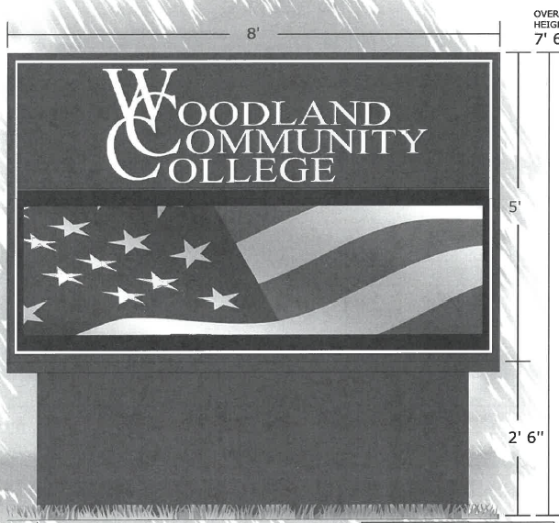
Existing Sign Base
(re-use if possible, protect Rotary Club emblem and paint finish)
The above dimensions are approximate. Utilize standard sign size dimensions. Verify that the existing base will support the proposed new LED sign. Utilize the existing electrical service for the new sign. Provide power-conditioning and protection features regarding “dirty” electrical service power. This is a two-sided dual sign that can be seen from both road travel directions.
Lake County Campus Monument Sign Concept Diagram:
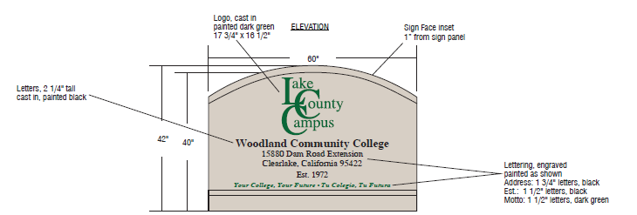
Lake County Campus Monument Sign Concept Diagram:

Welcome Students
Register Today for Fall 2021’
New LED Message Board Section

Sign Criteria:
- Please provide a similar concept diagram with your proposal to the above. The upper section of the sign is 36” high.
- Please provide enough space in the LED sign section for two rows of 6” high text with at least 1” between the rows and at least 2” above and below the text and approximately 15” high.
- The width of the LED sign shall allow for at least 75 characters of text in each line.
- The base of the sign below the LED sign section shall be at least 12” high.
- The letters on the above sign shall be ¼” thick fabricated aluminum letters with resilient baked on exterior high-quality paint. This note supersedes the above notes on the above sign diagram.
- The Depth of the sign shall be at least 4” deep.
- This sign shall be two sided with the sign and LED message on both sides of the sign.
- This LED sign component shall have electrical power conditioning to protect it from voltage surges, spikes, harmonics, and “dirty” power.
- If available, please provide protective features from graffiti, rock impacts, etc…
- If possible, provide screening to keep hornets from building nests in the sign.
- This sign shall include a concrete foundation to ensure that it does not settle and remains level and true.
- Provide an additive alternative for three lines of text, and at least 18” high LED section. (Use standard sign sizes)
- Note: The College/District is open to other similar sign designs.

LCC Campus Sign Electrical Power Panel Source—Building 100 (Contractor to verify the available power source and the routing). Recommendation: Use 480 volt, 3 phase power to reduce the voltage drop in the extended length of the service. It is recommended that the new electrical power source be directionally bored underground and not trenched to reduce the amount of asphalt and other site repairs:
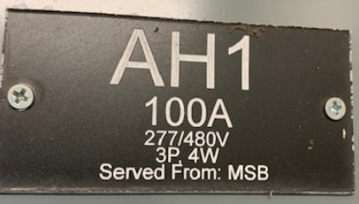
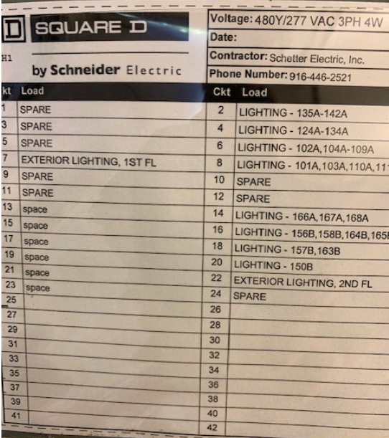

The contractor shall specify what power voltage will be used at LCC and that they had verified the existing power at the WCC location.

Signs (both WCC and LCC) Specifications:

      - Line Spacing: 10 mm
      - Matrix: 36 lines x 216 columns or greater (LCC Sign is a different size)
      - LED Color: RGB – state number of colors
      - The signs need to be easily seen during very bright sunny days as well as during the night hours.
      - All signs to be weather tight and protected from heavy rain, extreme sun exposure, and up to 90 mph wind events.
      - Display Configuration: Two, one sided displays with the same content.
      - Cabinet Design: Single section per face
      - Paint: Semi-Gloss Black All Around
      - State active and cabinet dimensions
      - State maximum power requirements per display panel and in total for the new sign.
      - State Ventilation requirements
      - State Service Access
      - State Signal Connections.
      - Frames Per Second: At least 60
      - Diming: Automatic, Scheduled, or Manual
      - Readable Viewing: 160 degrees horizontal x 90 degrees vertical….such that vehicle drivers driving by can read it clearly.
      - Optimal Viewing Angle: 140 degrees horizontal x 70 degrees vertical.
      - Compliance Info.: UL-Listed, FCC
      - Wireless HD Full Color Video LED Sign features.
      - State the Cellular Modem and Service Agreement Data Plan
      - State if an analog phone line or other service is required.
      - State if it has an external temperature sensor.
      - Minimum Exterior Operating Temperature Range: -30 F to 130 degrees F
      - Warranty Requirements: 5 Year Parts Only, 2 Year Labor (note additive alternate no. 1 to extend the warranty to a total of 10 years parts and labor)
      - Training: 5 hours per location (up to 5, 1 hour training sessions) for College employees.
      - If there are any software agreements or purchases, note them. Note if there are any annual software renewal licenses.
      - Provide options for service maintenance agreement services. This would be awarded as an Additive Alternate.
      - Provide options to protect the sign from rocks or graffiti spray paint.
      - Provide Additive Alternate for 8 mm resolution for both signs.
      - Include lead-time once ordered to delivery at the project location.

Woodland Community College Existing Signs Pictures:
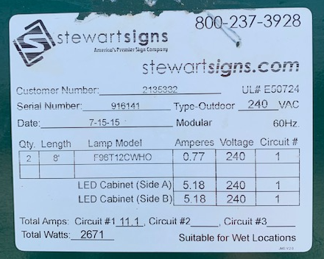
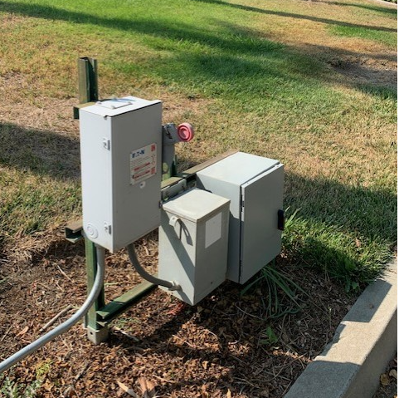

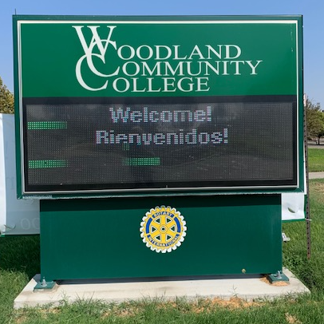
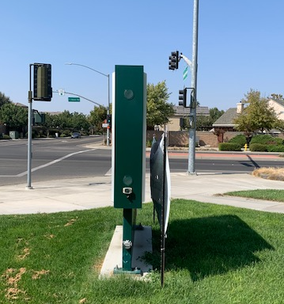
South Side -- Looking North
West Side -- Looking East
Appendix J: YCCD Academic Calendar
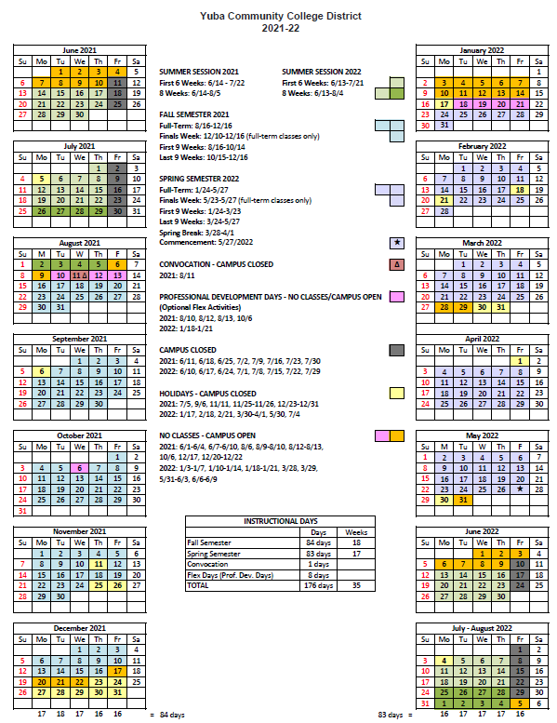

Appendix K: Map of Lake County Campus and Woodland Community College Campus
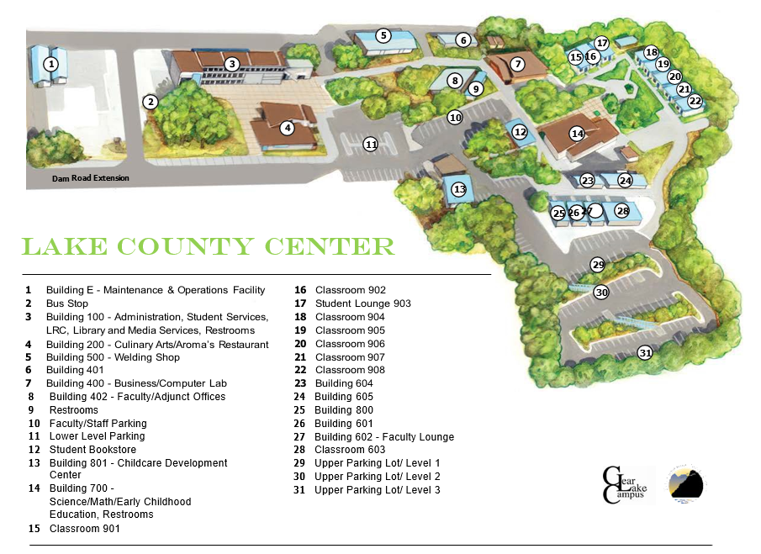
New Monument Sign Location

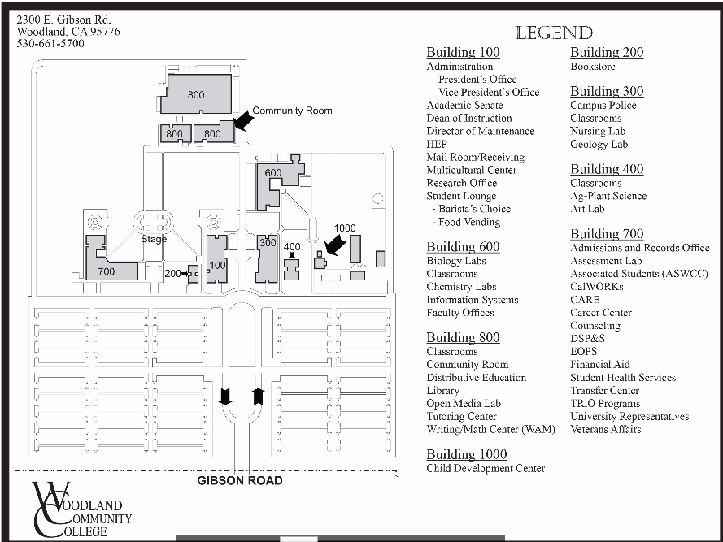

New Monument Sign Location:

The End.

