Request for Proposal
Yuba Community College District

Woodland Community College
Building 600 Chemical Storage Ventilation System Upgrades

No. RFP 20-28

Issue Date: July 8, 2021
RFP Due: August 12, 2021

RFP Due Date: August 12, 2021, 1:00 pm Sharp, Yuba College Location Delivered To:

Yuba Community College District, District Offices
Attn.: David Willis
District Director of Facilities Planning, Maintenance & Operations
RFP No. 20-28 WCC Building 600 Chemical Storage Ventilation System Upgrades
Address: 425 Plumas Blvd., Suite 200, Yuba City, California, 95991

Proposal Delivery Location, Front Counter at Second Floor
Yuba Community College District
District Offices
425 Plumas Blvd, Suite 200 (second floor)
Yuba City, California, 95991

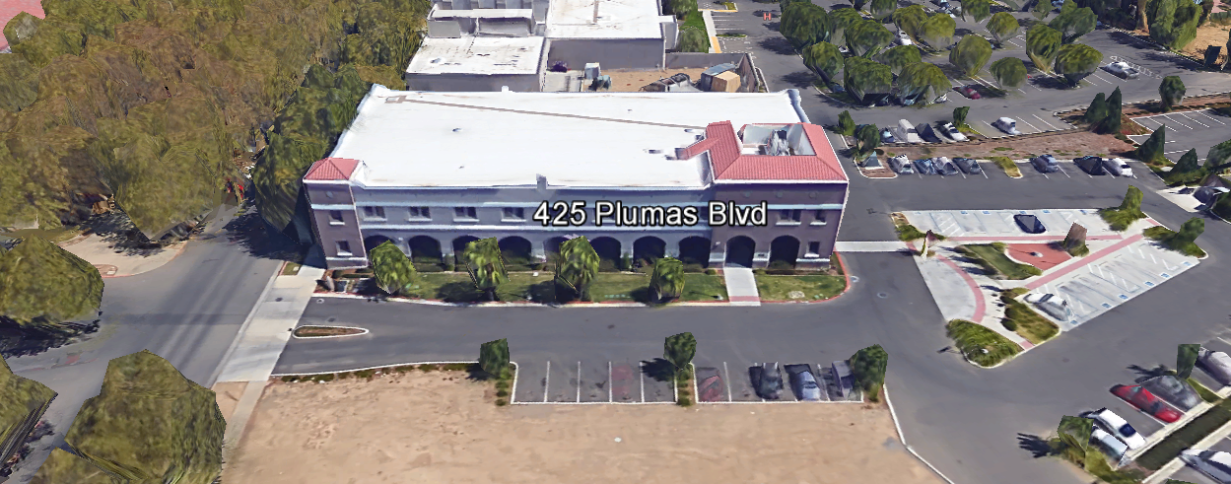
TABLE OF CONTENTS

1.0 INTRODUCTION
1.1 District Information
1.2 Yuba Community College District Background
1.3 Purpose of the Request
1.4 Applicable Codes
1.5 Qualifications
2.0 Scope of Work
2.1 Project Schedule
2.2 District Staff Contacts during Proposal Process
2.3 Project Safety Requirements
3.0 Proposal Format Organization
3.1 Proposal Delivery, Contents, and Format
4.0 Selection of “Firm”
5.0 Basis of Award
6.0 Non-Discrimination
7.0 Response to Request for Proposal (RFP)
8.0 Requests for Information (RFI)
9.0 Proposal Schedule
10.0 District Parking
11.0 RFP Proposals
12.0 Award of Contract/Proposal
13.0 Reservation of Rights
14.0 Bid Bond Requirements
15.0 Performance Bond, Payment Bond Requirements
16.0 Liquidated Damages

Contractor Proposal Required Items:

Appendix A, Proposal Base Bid Costs
Appendix B, Contractors Project Approach, Safety, COVID PPE and Incident Notification Plan, Staging areas, Preliminary Schedule, etc…
Appendix C, Acknowledgement of Addenda Form
Appendix D, Non-Collusion Affidavit Form
Appendix E, YCCD Agreement for Services (AFS).
Appendix F, Signature Proposal Form
Appendix G, Contractor References

Informational Items:
Appendix H: Project Scope Information: Drawings and Specifications
Appendix I, YCCD Academic Calendars
Appendix J, Map of Woodland Community College Campus
Appendix K, Reference Drawings for Building 600
1. INTRODUCTION

  - District Information:

The District consists of two colleges, Woodland Community College and Yuba College, with campuses located at six different locations: Yuba College in Marysville, CA; Sutter County Center in Yuba City, CA; Beale Education Center, Beale AFB, CA; Woodland Community College in Woodland, CA; Colusa County Center in Williams, CA; and Lake County Campus in Clearlake, CA.

  - Yuba Community College District

The Yuba Community College District (YCCD) was founded in 1927 and spans eight counties (Yuba, Sutter, Colusa, Yolo, Lake, Butte, Glenn and Placer) and nearly 4,200 square miles of territory in rural, north-central California. It has colleges in Marysville and Woodland, an educational center in Clearlake, an educational center in Williams, an educational center in Yuba City, and outreach operations at Beale Air Force Base.

  - Purpose of Request

The Yuba Community College District seeks proposals from qualified Licensed Contractors as described in section 2.0 below and in Appendix H.

Woodland Community College Campus Address: 2300 East Gibson Road, Woodland, California, 95776.

  - Applicable Codes
All work shall meet all State of California Building Codes, and Federal codes, and local ordinances.
All projects at the District/College are prevailing wage projects.

  - Qualifications

The District may award a contract to the Vendor that, in its sole opinion, is the most capable of providing the range of services described in the RFP, and provides “best maximum value” to the District.

To be considered for this service contract the Vendor must demonstrate knowledge and experience in similar service contracts, capacity to provide needed services, with the following qualifications:
  - All contractors/vendors must complete California Uniform Public Construction Cost Accounting Act (CUPCCAA) online forms. Visit yccd.edu click on purchasing, click CUPCCAA. https://www.yccd.edu/central-services/fiscal-services/purchasing/cupccaa/

  - Vendor number of years in business.

  - Public projects and service contracts require prevailing wage. Contractor and Subs must be registered with Department of Industrial Relations prior to working for the District. http://www.dir.ca.gov/Public-Works/Contractors.html
    - No contractor or subcontractor may be listed on a bid proposal for a public works project (submitted on or after March 1, 2015) unless registered with the Department of Industrial Relations pursuant to Labor Code section 1725.5 [with limited exceptions from this requirement for bid purposes only under Labor Code section 1771.1(a)].
  - All workmanship must be warranted for one year.
  - Contractor / Qualified Firm will submit a Yuba College Agreement for Service Form, W-9, and Proof of Liability Insurance Policy that designates Yuba Community College District as the Secondary Insured, per the Contractor Agreement for Services with the Proposal at the proposal due date/time.
  - Submit proof of current State Contractors License.
  - Be in good legal standing with no outstanding judgments or liens owed to workers or to the State of California.
  - Not be debarred from doing public works by the United States Department of Labor or any state that has public works debarment law.
  - Have required license registration in the state of California or access to such services as part of the required project scope of services.
  - Provide Technician qualifications regarding fence experience, types of fence, and number of years’ experience.

- Scope of Work

The Yuba Community College District is accepting proposals for Chemical Storage Ventilation System Upgrades per the drawings and specifications per Appendix H.

Scope summary:
The Contractor and his Subcontractors shall furnish all labor, materials, equipment, transportation, supervision, permits and incidentals required to safely and legally perform the work for the Yuba Community College District, Woodland Campus, building 600 chemical venting project including, but not limited to:

1. Demolition of existing finished surfaces.
2. Removal & replacement of ceiling tiles.
3. Installation of new T-Bar ceilings and acoustical tiles.
4. Demolition of existing HVAC ducting.
5. Installation of new HVAC ducting.
6. Installation of new exhaust fan.
7. Installation new reheat coil.
8. New DDC controller.
9. Programming of DDC controller.
10. New electrical.

This work is planned to be 100% completed by November 12, 2021.

General Comments:

The Contractor is 100% responsible to coordinate and securely store materials, tools, equipment, and other items required for the project. The Contractor must receive, inspect, unload, move, properly store, and sign for all materials. All materials need to be locked up and stored properly. The construction area must be cleaned up and organized to reduce trip hazards. Deliveries that arrive without a Contractor representative on site will not likely be received. All materials must be as specified and pre-approved by the District before orders are placed or delivered. The District cannot pay for materials until they arrive on site.

The Contractor shall provide all waste removal in accordance with State regulations and provide the District with a waste manifest as support documentation for future progress payments.

The Contractor shall use and maintain signs, barricades and barricade tape, and signs to delineate all project boundary areas.

The Contractor is expected to meet briefly as needed at the construction site, during the project with District/College staff at the project site to review progress, discuss issues, and provide a brief update on what is expected to occur as the project progresses.

The Contractor shall provide “Portable Restrooms” as needed.

The Contractor shall apply and follow all Cal-OSHA regulations. All required PPE shall be in good condition and used when needed to protect employees. During the summer, temperatures can exceed 100 degrees F. Measures shall be taken to protect employees from heat exhaustion or heat stress, or heat exposure.

The District encourages a positive and open communication strategy that includes a sense of partnership and mutual success on its projects.

2.1 Project schedule
Start Date: September 20, 2021 (Project will be awarded asap after the May 13, 2021 District Board Meeting)
100% Completion Date: November 12, 2021 (Sooner if possible)
The contractor may work whatever hours are needed Monday through Friday. Normal working hours are 7am to 4pm but can be adjusted to meet whatever the Contractor needs.
This is a prevailing wage project. The Contractor is required to upload all certified payroll information to the Department of Industrial Relations web site.
Provide a brief project schedule with the proposal with the completion date clearly shown.
2.2 District Staff Contacts during the Proposal process:
Firms interested in submitting a Proposal are directed not to make personal contact with the Board of Trustees, District staff, or members of the evaluation committee. Any contact shall constitute grounds for disqualification from consideration.
Single Point of Contact during the Proposal Preparation Process:
David L. Willis
District Director of Maintenance, Operations, and Planning
425 Plumas Blvd., Suite 200 (Second Floor)
Yuba City, California, 95991
Cell Phone: 916-747-4262
Email: dwillis@yccd.edu

Please email Dave Willis to verify that your firm will be submitting a proposal in response to this procurement process.

On-site coordination, first contact person access and immediate contact person during construction OR if additional site visits are needed during the bidding process.
Michael Sinn
Assistant Director of Maintenance, Operations
2300 East Gibson Road
Woodland, California, 95776
Cell Phone: 530-575-0206
Email: msinn@yccd.edu

No changes can be made to the project scope without authorization in writing by David Willis.

2.3 Project Safety and Security Requirements
Safety is a top priority for the District. All California OSHA requirements apply. Industry best practices apply. Contractor employees shall wear shirts with sleeves, a hard hat, eye protection, hearing protection as needed, gloves, substantial leather footwear, long pants, a reflective safety vest, and take all needed precautions to complete the work in a safe manner. Safety shall not be compromised at all during the work.
Enhanced fall protection precautions shall be taken. During windy conditions, precautions shall be taken to ensure the safety of staff and to properly secure materials and debris. The Contractor shall also take precautions during windy days if there are any risks of material being carried by the wind and deposited on vehicles or other surfaces.
The affected areas of construction shall be properly barricaded, have signs placed, and all reasonable precautions taken to keep staff and students out of the project boundary areas. Debris shall be removed promptly. Protection of College property shall be taken. Contractor is 100% responsible for any damage to College property and facilities.
These campuses have a moderate risk of theft. It is the sole responsibility of the Contractor to secure all materials, equipment, tools, and the affected buildings.
COVID 19 BEST PRACTICES APPLY:
Contractors are required to wear facial coverings and maintain social distancing whenever entering buildings and as much as possible when working outside. The frequent use of hand sanitizer is strongly encouraged. Contractor employees shall not report to work at the campus if they are sick or have been recently exposed to anyone knowingly that has tested positive to COVID 19. If a Contractor has been tested for COVID 19, they shall not report to work at the campus until after test results are known and after they are no longer symptomatic. If any contractor employees have been tested or have tested positive for COVID 19, this information shall be immediately shared with the District/College project Managers. No sick employees shall report to work at the Yuba College Campus.
Contractors are required to sign-in at a College M & O login sheet and list the staff working at the campus on that day. If the College has a positive COVID 19 test in building 600, prompt written notice will be provided within 24 hours. If the Contractor has a positive COVID 19 test from any of it’s employees working in the building, then they are required to provide the College with prompt written notice within 24 hours.
2.4 Demolition
The contractor shall provide a debris waste manifest for all items removed from the campus. Debris and waste shall be processed in accordance with all State and Federal codes, laws, and ordinances. The work shall be coordinated to greatly reduce possible impacts with students and staff.
3.0 Proposal Format Organization
The Firm is requested to use the following proposal format:
3.1. Proposal Delivery, Contents, and Format:
Proposals should provide straightforward, concise information that satisfies the requirements noted in this RFP. Expensive binding, color displays, and the like are discouraged. Emphasis should be placed on brevity, conformity to the Districts instructions, selection criteria of this RFP, and completeness and clarity of content. Each Respondent’s proposal should clearly and accurately demonstrate specialized knowledge and experience required for consideration.
In a sealed box or envelope (clearly marked “), submit the following:
- One (1) flash memory stick containing the complete proposal and supporting documentation;
- One (1) original and two (2) copies in paper form of the proposal, which consists of a Proposal Letter and responses to the proposal requirements of this RFP.

There is no page limit.

Firms must comply with the provisions of these instructions for completion and submission of the Proposal. The failure of a Firm to comply with the Proposal Instructions and Requirements will likely result (at the sole discretion of the District) in rejection of the Proposal for non-responsiveness.
Proposal Section | Format
- Cover Letter | PDF
- Table of Contents | PDF
Appendices (See Table of Contents for each one) Submit a response to each Appendix that requires Contractor information. Please submit responses to Appendices A, B, C, D, E, F, and G (if applicable). Appendices H, I, J, and K are informational only. | PDF

Proposal General Information Contents:

Information requested will help the District determine if the Firm is a “Responsible Bidder”.

Cover Letter

The Proposal shall include a Cover Letter on Respondent’s official business letterhead, which shall be signed by an individual authorized to legally bind Respondent. The Cover Letter shall also identify the name, telephone number, and email of a person who may be contacted during the Proposal evaluation process.

Table of Contents

Provide a Table of Contents that outlines in sequential order the major sections and sub-sections of the Proposal. Use tabs to allow information to be more easily located.

4.0 Selection of “Firm” Services Provider

The process of “Firm” selection is based upon the complete responsiveness of the RFP and the criteria as outlined in the RFP.

The District Project Evaluation Team will read the written proposals. The District Evaluation Team will discuss the proposals and verify that the “Basis of Award” information below and information submitted in response to the RFP are complete and responsive.

The District reserves the right to reject any and all submittals, to amend the RFP process, and to discontinue or re-open the process at any time. The District reserves the right to request clarifications to RFP responses and to negotiate the terms of the agreement.

5.0 Basis of Award

This project will be awarded based on the following criteria:

- Lowest Total Cost Responsive Qualified Bidder
  - Lowest Total Cost
  - Contractor Capability to do the work
  - Qualified Contractor
    - Proper State of California Contractor License in good standing
    - Appendix C Statement of Qualifications Information
    - Information provided as requested in the RFP.
    - All Addendums are acknowledged.
    - Contractor listed any exceptions or exclusions. Contractors should bid the project per the RFP and contract documents (using specified products) and then offer exceptions and exclusions or cost deductive or additive alternatives separately from the base bid.
    - Contractors with historical good performance on YCCD projects regarding minimal number and cost of change orders, maintaining project schedules and completing the work promptly, and overall quality of work.

The two or three lowest total cost responsive qualified bidder’s may be requested to participate in a ZOOM interview process with the District Project Proposal Evaluation Team.

6.0 Non-Discrimination
The District does not discriminate with regard to race, color, gender, national origin, disability, or any other protected or other classification in the awarding of contracts/agreements. The District welcomes all Qualified Firms to participate in the project Request for Qualification/Proposal process.
The District encourages firms that are women or minority owned, emerging small businesses, veteran owned firms, disabled person owned firms, and all other qualified firms to participate in the proposal process.
The District encourages the submission of proposals from all Firms that can meet the stated requirements set for this RFP.
7.0 Responses to RFP:
Sealed responses to this RFP must be clearly marked "RFP NO. 20-28 WCC Building 600 Chemical Storage Ventilation System Upgrades”.

Responses shall be mailed to or hand-delivered to the following address:

Yuba Community College District, District Offices
Attn.: David Willis
District Director of Facilities Planning, Maintenance & Operations

Envelope/Box Marked:
"RFP NO. 20-28 WCC Building 600 Chemical Storage Ventilation System Upgrades”.

Address: 425 Plumas Blvd., Suite 200, Room 216, Yuba City, California, 95991

Note: Completely seal your proposals in envelope/box and make sure it gets date/time stamped when delivering proposal. Firms are each 100% responsible to make sure proposals that are mailed using a carrier such as UPS, FED Ex, etc…are received and date/time stamped by District personnel prior to the proposal due date/time. No proposals will be considered if they are late, even if it is only 5 minutes late. Please make sure your proposals are delivered and received promptly prior to the due date/time. There will be a public proposal opening at the due date/time.

Do NOT email your proposals. Emailed proposals that are not sent per the above guidance requirements will not be considered.

8.0 Requests for Information (RFI)

Requests for Information concerning the RFP must be in writing and may be submitted via email no later than the date shown below. Please direct all questions to David Willis, email: dwillis@yccd.edu.

Following the RFI deadline, all questions and answers will be summarized and posted on the District's website: https://www.yccd.edu/central-services/purchasing/ , then, click on the “Requests for Proposals / Quotes” tab on the right hand side of this web page. It is anticipated that responses to inquires received by the required time and date will be provided within 5 business days and posted on the District's website or responded to per the dates listed in the RFP for addendum publishing. Should more time be needed by the District to answer I respond to RFI’s, this information will also be posted on the above website.

- Include the following in the subject matter field on emails when requesting information: “RFP 20-28”, RFI.

9.0 Proposal Schedule:

Important Dates and Times:

July 8, 2021: Release of Request for Proposal at 4:00PM

July 26, 2021: 10:00 AM, Mandatory Pre-Bid Meeting at Woodland Community College Campus, Building 600, Room 621, 2300 East Gibson Road, Woodland, California, 95776.

Prospective Contractors wishing to participate in this bidding process are required to have a representative attend, sign the login sheet, and conduct a field inspection of the campus existing conditions. If you cannot make it to this meeting, contact Michael Sinn to coordinate another time to review the RFP and walk the project location.

Michael Sinn
Assistant Director of Maintenance, Operations
2300 East Gibson Road
Woodland, California, 95776
Cell Phone: 530-575-0206
Email: msinn@yccd.edu

August 2, 2021: 5:00 PM, All questions and requests for information must be submitted to David Willis at: dwillis@yccd.edu.

August 3, 2021: Addendum Issued if needed.

August 12, 2021: Proposals due at 1:00 PM SHARP, Yuba Community College District, District Offices Location, see page 1. There will be a public bid opening on this RFP.

September 16, 2021: Expected date of Award with Purchase Order

November 12, 2021: COMPLETION DATE.
This is a prevailing wage project.

10.0 District Parking:

-No parking in Reserved Spaces without a proper permit
-Permit Parking is enforced in all general lots between 6:00 am and 6:00 pm, Monday through Friday. All general lots require a properly displayed, valid permit during these times
-Daily Parking Permits are $2.00
-Permits are available for purchase at any of the permit machines located in the student parking lots
-All other parking regulations are enforced 24 hours a day, seven days a week. This includes designated staff spaces, handicap spaces, timed spaces, red zones, yellow zones, and areas not marked (no parking at any time)
-Once this project is awarded, temporary parking permits will be processed as requested by the successful firm for all employees associated with this project at no cost to the Firm for the duration of the project at each Campus location. These temporary permits must be displayed at all times on the dashboard of employee vehicles.

11.0 RFP Proposals

Proposals received after the deadline will not be opened. Each responder shall submit one (1) signed original, two (2) additional hard paper copies, all in separate binders. Provide one electronic format copy of the proposal using electronic media such as a flash drive, CD, etc..

All materials submitted in response to the RFP shall be on 8-1/2”x11” paper, preferably in
Portrait orientation. All submitted materials must be bound in either a three-ring binder or spiral bound notebook. Content shall be tabbed and numbered per the items included in the Submittal Requirements. All Proposals will be reviewed and evaluated by a District Selection Committee. The District at its sole discretion may interview finalists, or select a firm or firms to perform work based solely on the evaluation of the Proposal. There is no page limit.

All Proposals become the sole property of the District and the content will be held confidential until the selection of the Firm or Firm’s is made and the project is awarded.

            - Award of Contract

- The Contract will be awarded to the lowest total cost, most responsive responsible qualified proposer whose proposal, conforming to the request for proposal and associated addendums, will be most advantageous to the District.

- The District reserves the right to enter into an Agreement without further discussion of the proposal submitted based on the initial offers received.

- The District reserves the right to reject any or all proposals or any part of the proposal and to waive informalities and minor irregularities in the proposals received.

- The RFP, its addendums, any follow-up clarifying information, and the proposal of the selected Firm will become part of any contract initiated by the District.

- A formal contract shall be signed by the successful proposer and Yuba Community College District to perform this service.

- The District reserves the right to enter into discussions with any one or all of the Responders after Proposals have been initially reviewed. Such responses shall be subject to all provisions, terms and conditions as set forth in the RFP, unless otherwise modified.

- The District intends to award to a single RFP Responder.

- The Contractors Performance and Payment bonds are required within 7 calendar days after the award of the project with a purchase order. The Bid Bond is required with the proposal.

- Failure to acknowledge all of the addendums, provide the items listed in the RFP, may render the proposal unresponsive at the discretion of the District.

- The District reserves the right to request clarification of proposal content during the review and evaluation process.

- The District reserves the right to negotiate the terms of the agreement to align with budgetary constraints.

- Due to the heightened risk of illness that could then affect the performance of the Contractor, Firms with multiple employee work teams and the resources to adapt and complete the scope of work per the RFP, will be perceived to provide enhanced service and value during the evaluation process.

13.0 Reservation of Rights

The District reserves the right to:

- Reject any or all submittals at its sole discretions.
- Cancel the Request for Proposal (RFP), without cause.
- Modify any requirements contained within the RFP and request a revised submission from all Providers.
- Establish other evaluation criteria determined to be in the best interest of the District.
- Contract with any of the firms responding to the RFP based solely upon its judgment of the qualifications and capabilities of the firm.
- Clarify the content of any proposal to verify that the requirements of the RFP are included.
- Waive “minor” proposal inconsistencies that do not change the scope of work as outlined in the RFP.
- Request an alternative Superintendent on the project if the initially assigned Superintendent on the project is not performing well, not meeting project requirements, not working well with College staff and students, not applying best practice safety methods, OR not following College/District guidance regarding project approach.

This RFP does not commit the District to award or negotiate a contract. The District will not be responsible for any expenses incurred by any firm in preparing and submitting a proposal or response to this RFP or in completing any of the work specified.

14. Bid Bond Requirements (Proposed Form—Contractor can use their standard form):

BID BOND

Know all persons by these presents:

That we, , as Principal, and , as Surety, are held and firmly bound unto Los Rios Community College District, hereinafter called District, the sum of ten percent (10%) of the total bid amount of Principal for payment of which in lawful money of the United States, well and truly to be made, we bind ourselves, our heirs, executors, administrators, successors, and assigns, jointly and severally, firmly by these presents.

The condition of the above obligation is such that, whereas, the Principal has submitted a bid for the work described as follows: RFP 20-28 WCC Building 600 Chemical Storage Ventilation Systems Upgrade.

Now, therefore, if Principal shall not withdraw said bid within the time period specified after the bid date, as defined in the bidding documents, or within ninety (90) days after the bid date if no time period is specified, and, if selected as the apparent lowest responsive responsible bidder, Principal shall, within the time period specified in the bidding documents: Enter into a written agreement, in the form prescribed in the bidding documents, in accordance with its bid; file with the District all bonds required to be filed, including but not limited to faithful performance and payments bonds; and, furnish certificates of insurance and all other items required by the bidding documents.

In the event of the withdrawal of said bid within the time period specified, or within ninety (90) days if no time period is specified, or the failure of Principal to enter into such agreement and furnish such bonds, certificates of insurance, and all other items as required by the bidding documents, if Principal shall pay to the District an amount to the difference, between the amount specified in said bid and such larger amount for which the District procures the work covered by the bid, if the latter is in excess of the former, then this obligation shall be null and void, otherwise to remain in full force and effect.

In the event suit is brought upon this bond by District, in addition to the penal sum of this Bid Bond, Surety shall pay reasonable attorneys’ fees and costs incurred by District in such suit.

Surety hereby expressly waives the provisions of California Civil Code section 2845.

In witness whereof, we have hereunto set our hands this day of , 20 .

Principal: Surety: (Name of firm)

By: By:

Title: Title:

Broker Name or Agent Name:

License Number:

Bond or company appointment must be listed with the CA Department of Insurance Notary acknowledgments for Surety and Surety’s Power of Attorney must be attached.

Address for Notices:

Bid Bond Requirements:
Provide a Bid Bond per the following:

PUBLIC CONTRACT CODE – PCC

DIVISION 2. GENERAL PROVISIONS [1100 – 22355]

ARTICLE 4. Bids and Bidders [10160 – 10169]
( Article 4 enacted by Stats. 1981, Ch. 306. )
Section: 10167.
    - All bids shall be presented under sealed cover and accompanied by one of the following forms of bidder’s security:
      - An electronic bidder’s bond by an admitted surety insurer submitted using an electronic registry service approved by the department advertising the contract.
      - A signed bidder’s bond by an admitted surety insurer received by the department advertising the contract.
      - Cash, a cashier’s check, or certified check received by, and made payable to, the director of the department advertising the contract.
    - The required bidder’s security shall be in an amount equal to at least 10 percent of the amount bid. A bid shall not be considered unless one of the forms of bidder’s security is enclosed with it.
    - All bids submitted pursuant to this section shall also comply with the provisions of Section 1601 of the Public Contract Code.
(Amended by Stats. 2012, Ch. 290, Sec. 3. Effective January 1, 2013.)

The Bid Bond shall be provided with the Contractor’s Proposal.

15. Performance and Payment Bond Requirements: Required for this project and described in the District Agreement for Services form (Appendix E, Agreement for Services).
16.0 Liquidated Damages:
There are no liquidated damages on this project.
Appendix A: Proposal Base Bid Costs

No. | Description | Cost
1 | Demolition of existing finished surfaces. | $
2 | Removal & replacement of ceiling tiles. | $
3 | Installation of new T-Bar ceilings and acoustical tiles. | $
4 | Demolition of existing HVAC ducting. | $
5 | Installation of new HVAC ducting. | $
6 | Installation of new exhaust fan. | $
7 | Installation of new reheat coil. | $
8 | New DDC controller. | $
9 | Programming of DDC controller. | $
10 | New electrical. | $
11 | Other: | $
12 | Sub-Total Cost: | $
13 | *Contingencies--"Unforeseen Conditions" | $10,000
14 | Other Costs: | $
15 | Total Costs: | $

*Note: Each item will require approval by the District with proper documentation. Additional items will be considered on a case by case basis.

Appendix B: Contractors Project Approach, Safety, Quality Control Process, COVID PPE and Incident Notification Plan, Protection of Building/Landscape/Vehicles, Staffing Resources, Preliminary Schedule, etc…

Please make sure you include the construction schedule with your proposal.

Addendum C: Acknowledgement of Addenda Form

The undersigned acknowledges receipt of the following addenda from the District pursuant to the Request for Proposal:
Acknowledgement: Yes or Not Applicable
Addendum No. 1: .
Addendum No. 2: .
Addendum No. 3: .
Addendum No. 4: .
Addendum No. 5: .

Firms are required to acknowledge all addenda’s within the submitted proposal at the time of submission.

Appendix D: Non-Collusion Affidavit Form

STATE OF CALIFORNIA, COUNTY OF I, being first duly sworn, deposes and says that I am the of , the party submitting the foregoing proposal (“the Proposal”). In connection with the foregoing Proposal, the undersigned declares, states and certifies that:
- The Proposal is not made in the interest of, or on behalf of, any undisclosed person, partnership, company, association, organization or corporation.
- The Proposal is genuine and not collusive or a sham.
- The Firm has not directly or indirectly induced or solicited another Firm to put in a false or sham proposal, and has not directly or indirectly colluded, conspired, connived, or agreed with any other Firm or anyone else to put in a sham proposal, or to refrain from bidding.
- The Firm has not in any manner, directly or indirectly, sought by agreement, communication, or conference with anyone to fix the proposal price, or that of any other Firm, or to fix any overhead, profit or cost element of the proposal price or that of any other Firm, or to secure any advantage against the public body awarding the contract of anyone interested in the proposed contract.
- All statements contained in the Proposal and related documents are true.
- The Firm has not, directly or indirectly, submitted the proposal price or any breakdown thereof, or the contents there of, or divulged information or data relative thereto, or paid, and will not pay any fee to any person, corporation, partnership, company, association, organization, proposal depository, or to any member or agent thereof to effectuate a collusive or sham proposal.
Executed on this date: , 2021, at:

(City, County, and State)
I declare under penalty of perjury under the laws of the State of California that the foregoing is true and correct.
Signature Printed Name .
Address: .
Area Code & Phone Number: .
Note: In addition to other bid documents, bidders on public works projects are required by Public Contract Code section 7106 to submit a certification form that they have not colluded with another proposer.

Appendix E: YCCD Agreement for Services
Link:
https://goyccd-my.sharepoint.com/:w:/g/personal/w0398409_yccd_edu/Ed-C4ZFleABMr7vUQTN0YJwB95FKJ75WkJ3j42Hj8U38OA?e=ZS3mmB

Appendix “F” Proposal Signature Form
The undersigned acknowledges the following:
- Having become familiar with the specifications and requirements of the Request for Proposal, hereby offers to provide all services in accordance with the proposal set forth herein, including all referenced material and attachments.
- By submitting a signed proposal in response to this solicitation, the Firm acknowledges that they completely understand the scope of the needed services and that the proposed services as described in the proposal will meet or exceed the needs of the District.
- Late proposals will not be accepted (even if they are only 5 minutes late).
- The District reserves the right to reject any and all proposals and that this proposal shall remain open and not be withdrawn for a minimum of 90 days.
- Cancellation Clause: The District may, without cause, terminate the contract(s) or a project under the contract(s) by giving written notice of such termination to the awarded firm. In the event of such termination the District shall reimburse the firm for services performed and reasonable expenses actually incurred by the firm in relation to the terminated project prior to the firm’s receipt of such notice of termination. The cost of proposal generation, associated travel, copies, postage, etc.., will not be reimbursed and is considered a typical and normal part of the bid process and is not reimbursed for any of the proposers.
- If the prospective Firm is a corporation, the undersigned hereby represents and warrants that the corporation is duly incorporated and is in good standing in the state of California , and that, , is authorized to act for and bind the corporation.

Entity Type (Select One):

Sole Owner: Partnership: .

Corporation: .

Other; Please specify;

- Regular monthly progress payments are made using NET 30 as a basis for payment, with Net 30 time starting after receipt of the invoice with all required support documentation, and once this information is reviewed and approved by the District.

Invoices must be emailed to the following with all support documentation:
Vendors with a first letter of A through N: rlangley@yccd.edu; rordiway@yccd.edu
Vendors with a first letter of O through Z: hgardner@yccd.edu; rordiway@yccd.edu
It is critical that invoices have all required support documentation including an updated schedule of values with 5% retainage for construction projects, updated project schedule, description of completed work, and any other information that will help to justify and support the progress payment request.

Signature_____________________________ Date: _______________________
Position: _____________________________
Print name____________________________ Title________________________

Notary Required On This Project
Notary Stamp:

Appendix “G” References Form (Example Template)

Bidder shall provide a minimum of Five (5) verifiable references with current contact information, preferably from a California public educational institution and/or California public agency, representing projects started and completed within the last 5 years. See clarification note below regarding reference requirements.
All phone numbers and emails must be current (please verify).
REFERENCE #1
NAME
ADDRESS
CITY, STATE ZIP CODE
TELEPHONE #
CONTACT
DATES OF SERVICE
REFERENCE #2
NAME
ADDRESS
CITY, STATE, ZIP CODE
TELEPHONE #
CONTACT
DATES OF SERVICE
REFERENCE #3
NAME
ADDRESS
CITY, STATE, ZIP CODE
TELEPHONE #
CONTACT
DATES OF SERVICE

You may of course use the Firm’s established reference template.

Appendix H: Project Information—
Drawings and Specifications Link:
https://goyccd-my.sharepoint.com/:f:/g/personal/w0398409_yccd_edu/EoS_ZvuevOtIr5dO7rlnMWkB9d-dr367A3dQR82iXU7YoQ?e=y6XQNz

Appendix I: YCCD Academic Calendars—see next page

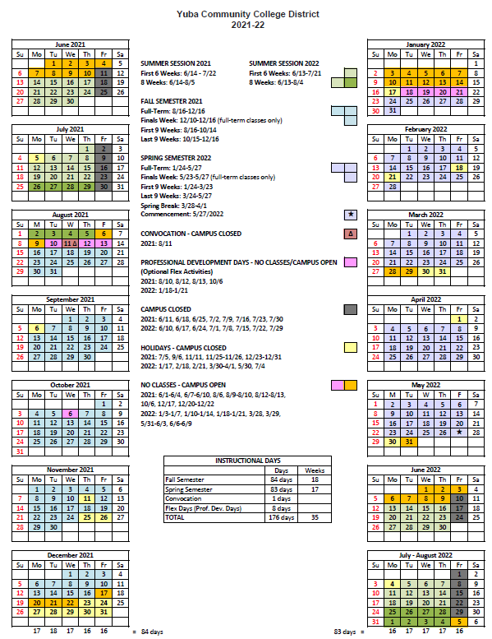

Appendix J: Map of Woodland Community College, 2300 East Gibson Road, Woodland, California, 95776
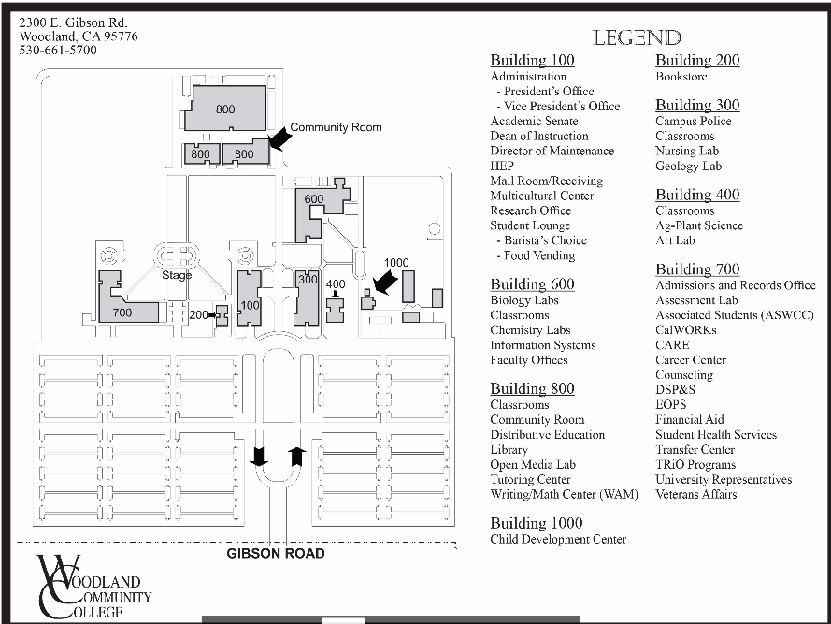

Appendix K: Reference Drawings for Building 600:
See Folder Link:
https://goyccd-my.sharepoint.com/:f:/g/personal/w0398409_yccd_edu/EoDtJKxHy-pKt8gl1WqQC9EBKn9iIjwQqaag8-Ei7gqaZg?e=n5g6b9

The End.

