- Question: For the building demolition project, what classification is required to bid on the project?

Addendum No. 2

RFP 20-22 YC Demolition and Removal of Buildings1300 and 1500
Date: 07/11/2021

Date: January 26, 2016

Is a General B license enough to qualify to bid on the project?

Answer: Regarding the license requirements, please follow State Contractor Licensing requirements for this per this web link:
https://www.cslb.ca.gov/About_Us/Library/Licensing_Classifications/C-21_-_Building_Moving_And_Demolition.aspx
Licensing Classifications - California
C-21 - Building Moving/Demolition Contractor. California Code of Regulations Title 16, Division 8, Article 3. Classifications. A building moving/demolition contractor raises, lowers, cribs, underpins, demolishes and moves or removes structures, including their foundations.
www.cslb.ca.gov
I'm not sure and cannot make recommendations regarding this question.

- Question: Do you know the total square footage of each building? And what is the material of the buildings?

Answer: OGSF= Gross square feet

The materials of the buildings vary and are evident in the drawings and during the walk-through. Building 1300 is a concrete tilt up building and building 1500 is a wood framed building. Concrete foundations and slabs are noted. Please do your research to ensure your proposal reflects what is present and the materials to be removed.

- Question: Is there a budget estimate?

Answer: The District does not have an accurate cost budget estimate for this project that we are publishing.

- Questions:
1. Could the college provide any existing As-builts of the buildings or utilities?
2. How much soil is needed to reach existing grade?
3. What % should compaction be reached?
Answers:
- The existing drawings are provided in the links in Addendum No. 1.
- The amount of soil must be calculated by the contractor to bring the finish grade within 1 inch of the surrounding grade.
- The Compaction percentage is defined in the specifications. Reference specification section:

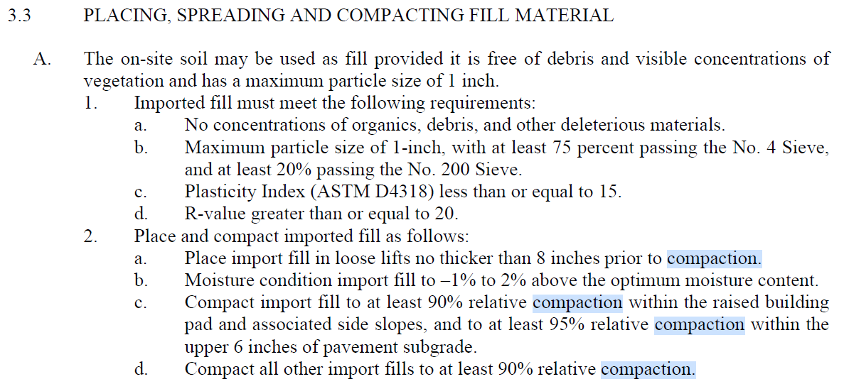

- Question: With regards to Appendix B, is there a link that we ought to open acknowledging the requirements in it? Also, Appendix E link does not open noting an error message.

Answer: Appendix B: No. The Contractor is requested to provide the items listed. Appendix E: Please refer to this link:

https://goyccd-my.sharepoint.com/:w:/g/personal/w0398409_yccd_edu/EZgsLcjqx2hKqJBQQFhcFJwBX_OjldKlCUNfX0kceJfcmw?e=JA50l8

- Contractors are now asked to include assumptions, exceptions, and exclusions in their proposal since this is the last Addendum to be published for this project.

The End.

