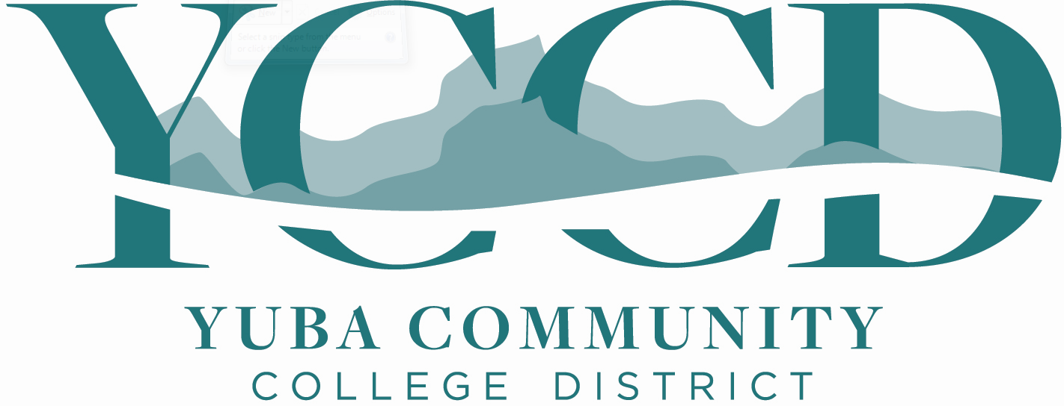

REQUEST FOR QUALIFICATION
(PRE-QUALIFICATION PROCESS)

FOR THE

YUBA COLLEGE
MULTIPLE BUILDINGS PAINT PROJECT

PAINT/COATING CONTRACTORS

Request for Qualification
RFQ NO. 20-16

Issue Date: March 10, 2021
RFQ Package Due: March 30, 2021

RFQ Due Date: March 30, 2021, 1:30pm Sharp, YCCD District Offices Location- Delivered To:

Yuba Community College District, District Offices
Attn.: David Willis
District Director of Facilities Planning, Maintenance & Operations

“RFQ No. 20-16 Pre-Qualification, Yuba College Multiple Buildings, Exterior Walls, Paint-Coatings Project”

Address: 425 Plumas Blvd., Suite 200, Yuba City, California, 95991

Proposal Delivery Location, Front Counter at Second Floor
Yuba Community College District
District Offices
425 Plumas Blvd, Suite 200 (second floor)
Yuba City, California, 95991

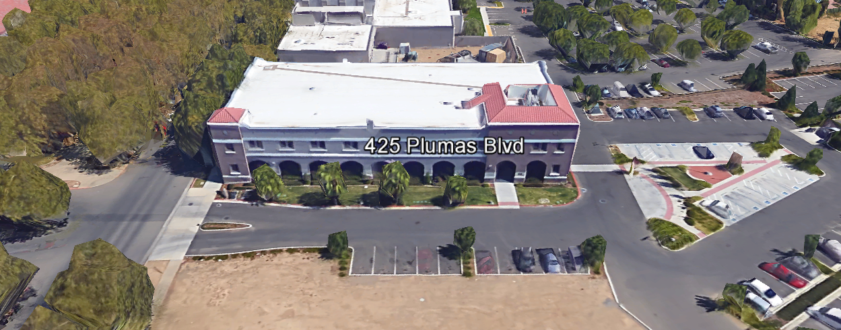
TABLE OF CONTENTS

1.0 INTRODUCTION
1.1 District Information
1.2 Yuba Community College District Background
1.3 Purpose of Request: Pre-Qualify Contractors for Various Renovation Projects
1.4 Applicable Codes
2.0 General Project Information
3.0 District Staff Contact during Proposal Process
4.0 CUPCCAA
5.0 Proposal Delivery, Contents, and Format
6.0 Non-Discrimination
7.0 Responses to RFQ
8.0 Requests for Information (RFI)
9.0 Pre-Qualification Schedule
10.0 District Parking
11.0 RFQ Proposal Requirement Clarifications
12.0 Reservation of Rights

Appendix A, Statement of Qualifications Form (Provided By Contractor)
Appendix B, Acknowledgement of Addenda Form (Provided By Contractor)
Appendix C, Contractor Firm Information (Provided By Contractor)
Appendix D, Project Specific Information (Reference Item)

1.0 INTRODUCTION

  - District Information:

The District consists of two colleges, Woodland Community College and Yuba College, with campuses located at six different locations: Yuba College in Marysville, CA; Sutter County Center in Yuba City, CA; Beale Education Center, Beale AFB, CA; Woodland Community College in Woodland, CA; Colusa County Center in Williams, CA; and Lake County Campus in Clearlake, CA.

  - Yuba Community College District

The Yuba Community College District (YCCD) was founded in 1927 and spans eight counties (Yuba, Sutter, Colusa, Yolo, Lake, Butte, Glenn and Placer) and nearly 4,200 square miles of territory in rural, north-central California. It has colleges in Marysville and Woodland, an educational center in Clearlake, an educational center in Williams, an educational center in Yuba City, and outreach operations at Beale Air Force Base.

  - Purpose of Request: Pre-Qualification of Architectural Firms

The District requests the FORMAL submission of Statements of Pre-Qualifications with support documentation for Painting / Coating Contractors to provide Construction Services for the Yuba College Multiple Buildings Paint / Coatings Project.

Contractor RFQ packages need to respond to Addendums A, B, and C.

  - Applicable Codes
All planning work shall meet all Local, State, and Federal Codes, Regulations, and Ordinances.

2.0 General Project Information
This project includes painting / coating the exterior walls of many of the buildings at the Yuba College Campus. PBK Architecture has generated a set of detailed drawings and specifications for this work. College colors will be used to refresh and modernize the campus. This work is planned to be done during the spring, summer, and early fall of 2021.
Typical Paint Project Scope of Work:

- Power wash all buildings, railings, concrete stops, bollards, and existing Yuba College entrance sign prior to exterior paint application.
- Exterior painting at all buildings on campus, unless otherwise noted.
- Paint building numbering with stencils as shown.
- Paint all railings, concrete stops, bollards, and Yuba College entrance sign.

The roughly estimated costs for the repair-restoration scope of this project: $ 1,200,000.

3.0 District Staff Contact during the “Pre-Qualification” process:
Firms interested in submitting a “Pre-Qualification Package” are directed not to make personal contact with the Board of Trustees, District staff, or members of the evaluation committee. Any contact shall constitute grounds for disqualification from consideration.
Single Point of Contact during the Request for Qualifications Preparation Process:
David L. Willis
District Director of Maintenance, Operations, and Planning
425 Plumas Blvd., Suite 200 (Second Floor)
Yuba City, California, 95991
Cell Phone: 916-747-4262
Email: dwillis@yccd.edu

4.0 CUPCCAA
Firms are requested (not required) to fill-out CUPCCAA qualification and participation forms. Refer to this link for more information regarding the District’s CUPCAA process and required forms:
https://www.yccd.edu/central-services/fiscal-services/purchasing-2/cupccaa/

5.0 “Pre-Qualification Packages”; Delivery, Contents, and Format:
Pre-qualification packages should provide straightforward, concise information that satisfies the requirements noted in this RFQ. Expensive binding, color displays, and the like are discouraged. Emphasis should be placed on brevity, conformity to the Districts instructions, selection criteria of this RFQ, and completeness and clarity of content.
Please use the following format when organizing the Request for Qualifications packet:
Pre-Qualification Packet | Format
- Cover Letter | PDF
Appendices
- Statement of Qualifications Form | PDF
- Acknowledgement of Addenda Form | PDF
- Contractor Firm Information | PDF
- Project Specific Information | PDF

6.0 Non-Discrimination
The District does not discriminate with regard to race, color, gender, national origin, disability, or any other protected or other classification in the awarding of contracts/agreements. The District welcomes all Qualified Firms to participate in the project Request for Qualification/Proposal process.

The District encourages firms that are women or minority owned, emerging small businesses, veteran owned firms, disabled person owned firms, and all other qualified firms to participate in the qualification process.

The District encourages the submission packages from all Firms that can meet the stated requirements set for this RFQ.

7.0 Responses to RFQ:
Sealed responses to this RFQ must be clearly marked "RFQ NO. 20-16 Pre-Qualification: Yuba College, Multiple Buildings, Exterior Walls, Paint-Coatings Project”.

Responses shall be mailed to or hand-delivered to the following address:

Sealed Envelope/Box Marked:

Yuba Community College District, District Offices
Attn.: David Willis
District Director of Facilities Planning, Maintenance & Operations
“RFQ No. 20-16 Pre-Qualification, Yuba College, Multiple Buildings, Exterior Walls, Paint – Coatings Project”
Address: Suite 200, 425 Plumas Blvd., Yuba City, California, 95991

Note: Completely seal your Pre-Qualification Packages in an envelop/box and make sure it gets date/time stamped when delivering proposal. Firms are each 100% responsible to make sure packages that are mailed using a carrier such as UPS, FED Ex, etc…are received and date/time stamped by District personnel prior to the proposal due date/time. No packages will be considered if they are late, even if it is only 5 minutes late. Please make sure your packages are delivered and received promptly prior to the due date/time. There will NOT be a public proposal opening since there are no proposals included in the RFP packages.

8.0 Requests for Information (RFI)

Requests for Information concerning the RFQ must be in writing and may be submitted via email no later than the date shown below. Please direct all questions to David Willis, email: dwillis@yccd.edu.

9.0 Pre-Qualification Schedule:

Important Dates and Times:

March 10, 2021: Release of Request for Qualification at 4:00PM

March 17, 2021: 1:00PM OPTIONAL Pre-RFQ ZOOM Meeting

Topic: RFQ 20-16 Pre-Qualification Meeting: Yuba College Paint Project
Time: Mar 17, 2021 01:00 PM Pacific Time (US and Canada)

Join from PC, Mac, Linux, iOS or Android: https://cccconfer.zoom.us/j/94342784295

Or iPhone one-tap (US Toll): +16699006833,94342784295# or +13462487799,94342784295#

Or Telephone:
Dial:
+1 669 900 6833 (US Toll)
Meeting ID: 943 4278 4295

Note: Firms are encourage to attend the Optional ZOOM Pre-Qualification meeting.

March 22, 2021: All questions and requests for information must be submitted to David Willis at: dwillis@yccd.edu by 1pm.

March 23, 2021: Addendum Issued if needed.

March 30, 2021: Pre-Qualification Packets are due at 1:30 PM SHARP, Yuba Community College District, District Offices Location. There will NOT be a public bid opening on this RFQ since NO proposals are part of this process. Evaluation of the RFQ packages will begin right after 1pm.

All questions associated with the procurement process shall be addressed to David Willis, District Director of Facilities Planning, Maintenance, and Operations at email: dwillis@yccd.edu or cell phone: 916-747-4262.

10.0 District Parking:

-No parking in Reserved Spaces without a proper permit
-Permit Parking is enforced in all general lots between 6:00 am and 6:00 pm, Monday through Friday. All general lots require a properly displayed, valid permit during these times
-Daily Parking Permits are $2.00
-Permits are available for purchase at any of the permit machines located in the student parking lots
-All other parking regulations are enforced 24 hours a day, seven days a week. This includes designated staff spaces, handicap spaces, timed spaces, red zones, yellow zones, and areas not marked (no parking at any time)
-Once this project is awarded, temporary parking permits will be processed as requested by the successful firm for all service Professional Consulting Firm employees associated with this project at no cost to the Professional Consulting Firm for the duration of the project at each Campus location. These temporary permits must be displayed at all times on the dash board of service Professional Consulting Firm vehicles.

11.0 RFQ Requirement Clarification

Each responder shall submit one (1) signed original, two (2) additional hard paper copies, all in separate binders. Provide one flash drive copy of the proposal.

All materials submitted in response to the RFQ shall be on 8-1/2"x11" paper, preferably in
Portrait orientation. All submitted materials must be bound in either a three-ring binder or spiral bound notebook. Content shall be tabbed and numbered per the items included in the Submittal Requirements. All Proposals will be reviewed and evaluated by a District Selection Committee. The District at its sole discretion may interview each of the Firms. There is no page limit. Please be brief.

Please submit financial status of the firm as a separate document from the RFQ. Financial information of the Firm will be maintained as confidential information.

All RFQ Packages become the sole property of the District. The RFQ information will be used for District evaluation purposes.

12.0 Reservation of Rights

The District reserves the right to:

- Reject any or all submittals at its sole discretions.
- Cancel the Request for Qualifications (RFQ) process, without cause.
- Modify any requirements contained within the RFQ and request a revised submission from all
- Providers.
- Establish other evaluation criteria determined to be in the best interest of the District.
- Request clarifications to information provide.
- Pre-Qualify Firms based on the information presented in this RFQ and at the Discretion of the District. Firms may in some cases be disqualified if the information provided is incomplete, does not meet the requirements of the RFQ, if the overall score of the evaluation does not meet minimum thresholds (at the sole Discretion of the District)
- Not consider RFQ packages that are delivered after the due date and time in the RFQ.

This RFQ does not commit the District to negotiate a contract. The District will not be responsible for any expenses incurred by any firm in preparing and submitting a proposal or response to this RFQ.

Appendix A: Statement of Qualifications Form

The FIRM shall furnish the following information. Failure to comply with this requirement will render the submittal informal and may cause its rejection. Additional sheets may be attached if necessary.
Basic Firm Informational Items 1 through 12:

- Firm name and primary address:

- Telephone: Facsimile:

- Email Address:

- Names and titles of two officers of the firm:
NAME TITLE

4.1
4.2

- Specific type of Ownership (Check one)

5.1 | Individual
5.2 | Partnership
5.3 | Corporation; If a corporation, state the following: State of incorporation:
 | Date of incorporation: President/CEO:
5.4 | Joint Venture
5.5 | Other (Specify)

- Taxpayer Identification
- Number of years FIRM has been in business:
If less than 5 years, please describe:

- Number of years FIRM has conducted business under the present name:
- Has the FIRM ever been licensed under a different name or different license number? ? If Yes, give name and license number:
- Number of years’ experience in California Community College, University or educational facility projects .

- Do you now or have you ever had any direct or indirect business, financial or other connection with any official, employee or consultant of the District?
If so, please elaborate.

- Has the FIRM ever completed any work at the Yuba Community College District? If so, please elaborate.

Potentially Disqualifying Questions 13 through 18:

- Has the FIRM or any of its principals defaulted to as to cause a loss to a surety on a payment or performance bond? Yes/No

If yes, give dates, name and address of surety, and details:

- Has the FIRM been assessed liquidated damages for any project in the past three years? Yes/No If so, give owner and details:

- Has the FIRM been in litigation on an issue pertaining to any contract during the past three years? Yes/No:
If yes, explain and provide case name and number.

- Has the FIRM ever failed to complete a project in the past three years? Yes/No: If so, give owner and details:

- Is the FIRM currently or has the FIRM been in a state of “Bankruptcy” in the past 5 years? Yes/No:
If yes, please explain.

- Can the FIRM provide up to $1.5 million in bonding capacity for this project?
If no, please explain.

Project Specific Questions:

- Please list and describe the Firms top 10 project references with current contact information. The project references should include the following criteria: 50 pts.
- Contract Amount $$
  - At least five (5) of these projects shall be greater than $500,000 for painting/coating contract services.
  - Total Change Orders Amount $$ and percentage of base bid.
- At least five (5) of these ten (10) projects shall be completed for schools, College, and Universities or Commercial Businesses with multiple buildings.
- Original and Final Project Schedule Completion Dates
- Was the Firm contracted directly with the Owner/Public Entity, or Business OR with a General Contractor?
- Any issues that came up that had to be overcome.

- Please describe in detail, your FIRMs approach to maintaining a safe project while students, faculty, and staff will be occupying the buildings and walking from building to building: 10 pts

What is your FIRMs safety insurance modifier number?

Note: Safety insurance modifier numbers under 1.0 will score the full 10 points, greater than 1.0 to 1.25 will score 5 points, 1.25 to 1.5 will score 1 point, and greater than 1.5 will not score any points.
- Please describe steps that your FIRM will take to protect building window, roofs, doors, sidewalks, landscape, parked vehicles, and other features of the campus while painting the exterior walls of the buildings: 10 pts

- Please describe the types of coatings, the surfaces, and the means and methods (airless sprayers, power rollers, back-rolling, rolling, hand painting, etc.., that your FIRM’s staff have experience applying: 10 pts

- Please describe how your Firm will maintain quality work without drips, runs, areas with light coverage of coatings, and professionally and evenly coated surfaces—even when colors of coatings change from one section or feature of the building to the other. 10 pts

Note: High Quality painting work is a requirement for this project. The District/College will have regular quality inspections by a licensed Architectural Firm, a DSA Inspector of Record, and by District Project Managers.

- Please describe the Capability/Capacity of your Firm. Please provide the number of Journeyperson Painters that your FIRM employs, the ratio of Journeypersons to apprentices on the project, and the ability of your FIRM to have multiple painting teams on the project. 10 pts

- Please describe the FIRM’s commitment to maintaining a construction schedule. How will the FIRM recover the schedule if it slips due to weather or COVID illness impacts, or the FIRM gets busy with other projects? Please describe specific actions the FIRM will take to maintain the project schedule. 10 pts

- Please describe the FIRM’s commitment to meeting regularly at project team meetings, maintaining positive communication, and providing progress updates, and providing timely RFI’s and support information during the project. Please describe specific actions the FIRM will commit to maintain a positive relationship with the District/College through the above description: 10 pts

Qualification Criteria:

Questions 1 through 12 are general base level information that is required for pre-qualification.

Questions 13 through 18 are possible disqualifying questions that would render the firm “not qualified”.

Questions 19 through 26 are project specific questions that are scored and more deeply evaluated. Not scoring the minimum threshold value will render the firm “not qualified”.

  - Questions 19 is worth 50 points.
  - Questions 20 through 27 are worth 10 points each.
  - There are a total of 120 points possible.
  - To be determined as a qualified firm, each firm must score at least 90 points.

Firms will be notified if they are determined meet minimum qualification criteria.

Appendix B: Acknowledgement of Addenda Form

The undersigned acknowledges receipt of the following addenda from the District pursuant to the Request for Qualifications:
Acknowledgement: Yes or Not Applicable
Addendum No. 1: .
Addendum No. 2: .
Addendum No. 3: .
Addendum No. 4: .
Addendum No. 5: .

Appendix C: Contractor Licenses, Certifications, etc…

Appendix D: Project Specific Information
Note: The Drawings for the project are not quite finished at the time of this publication. They will be available as an addendum and published on the following District Purchasing Web Page link on Monday, March 15, 2021 per this LINK:
https://www.yccd.edu/central-services/fiscal-services/purchasing-2/requests-proposals-quotes/

The End.

