Request for Proposal
Yuba Community College District
Yuba College Campus
Hazardous Materials Abatement
Buildings 1300 and 1500
No. RFP 20-09

Issue Date: December 18, 2020
RFP Due: January 19, 2020

RFP Due Date: January 19, 2021, 1:00 pm Sharp, Yuba College Location Delivered To:

Yuba Community College District, District Offices
Attn.: David Willis
District Director of Facilities Planning, Maintenance & Operations
RFP No. 20-09 Yuba College Campus, Hazardous Materials Abatement: Building 1300 and 1500
Address: 425 Plumas Blvd., Suite 200, Yuba City, California, 95991

Proposal Delivery Location, Front Counter at Second Floor
Yuba Community College District
District Offices
425 Plumas Blvd, Suite 200 (second floor)
Yuba City, California, 95991

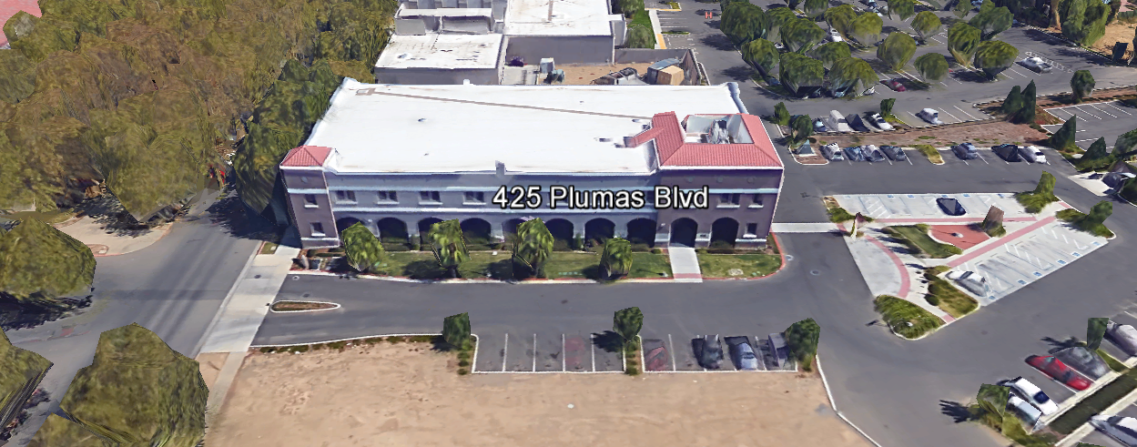
TABLE OF CONTENTS

1.0 INTRODUCTION
1.1 District Information
1.2 Yuba Community College District Background
1.3 Purpose of the Request
1.4 Applicable Codes
2.0 Scope of Work
2.1 Project Schedule
2.2 District Staff Contacts during Proposal Process
2.3 Project Safety Requirements
2.4 Demolition
3.0 Proposal Format Organization
3.1 Proposal Delivery, Contents, and Format
4.0 Selection of “Firm”
5.0 Basis of Award
6.0 Non-Discrimination
7.0 Response to Request for Proposal (RFP)
8.0 Requests for Information (RFI)
9.0 Proposal Schedule
10.0 District Parking
11.0 RFP Proposals
12.0 Award of Contract/Proposal
13.0 Reservation of Rights
14.0 Bid Bond, Performance Bond, Payment Bond Requirements
15.0 Liquidated Damages

Appendix A, Proposal Base Bid Costs
Appendix B, Acknowledgement of Addenda Form
Appendix C, Statement of Qualifications Form
Appendix D, General Specification: Asbestos, Lead Abatement Requirements
Appendix E, Description of Past “Like” Projects
Appendix F, YCCD Agreement for Services (AFS).
Appendix G, Non-Collusion Affidavit Form
Appendix H, References Form
Appendix I, Signature Proposal Form
Appendix J, Contractor Licenses, Certifications, etc..
Appendix K, Project Approach
Informational Items:
Appendix L, Hazardous Materials Survey: Buildings 1300 and 1500
Appendix M, YCCD Academic Calendar
Appendix N, Map of Yuba College Campus
Appendix O, N/A

1. INTRODUCTION

  - District Information:

The District consists of two colleges, Woodland Community College and Yuba College, with campuses located at six different locations: Yuba College in Marysville, CA; Sutter County Center in Yuba City, CA; Beale Education Center, Beale AFB, CA; Woodland Community College in Woodland, CA; Colusa County Center in Williams, CA; and Lake County Campus in Clearlake, CA.

  - Yuba Community College District

The Yuba Community College District (YCCD) was founded in 1927 and spans eight counties (Yuba, Sutter, Colusa, Yolo, Lake, Butte, Glenn and Placer) and nearly 4,200 square miles of territory in rural, north-central California. It has colleges in Marysville and Woodland, an educational center in Clearlake, an educational center in Williams, an educational center in Yuba City, and outreach operations at Beale Air Force Base.

  - Purpose Of Request

The Yuba Community College District seeks proposals from qualified Licensed Contractors to properly and carefully remove all hazardous materials from buildings 1300 and 1500 as identified in the Hazardous Materials Survey in Appendix L. This work is in preparation for a future demolition of the buildings.

Yuba College Campus Address: 2088 North Beale Road, Marysville, California 95901.

  - Applicable Codes
All work shall meet all State of California Building Codes, and Federal codes, and local ordinances.

All projects at the District/College are prevailing wage projects.

- Scope of Work (See Appendix D)

IMPORTANT SCOPE GUIDANCE:

Hazardous Materials Industry “Best Practices” shall be applied to reduce the risk of any hazardous materials from becoming airborne or spreading to the ground or surrounding area. Containment means and methods shall be applied. All required PPE shall be used.

General Comments:

The Contractor is 100% responsible to coordinate and securely store materials, tools, equipment, and other items required for the project. The construction area must be cleaned up and organized to reduce trip hazards.

The contractor shall provide quality work or it will not be acceptable to the District/College.

The Contractor shall provide all hazardous material removal in accordance with State regulations and provide the District with a hazardous waste material manifest.

The Contractor shall use and maintain barricades and barricade tape, and signs to delineate all project boundary areas.

The Contractor shall provide temporary lighting as needed to work safely.

The Contractor shall provide temporary electrical generators as needed. Ground fault protection shall be used.

The Contractor shall provide explosion proof lighting and other electrical safety provisions to reduce hazards.

The Contractor shall protect all landscape areas, sidewalks, and all other College property from damage.

The Contractor is expected to meet briefly as needed at the construction site, during the project with District/College staff at the project site to review progress, discuss issues, and provide a brief update on what is expected to occur as the project progresses.

The District encourages a positive and open communication strategy that includes a sense of partnership and mutual success on its projects.

2.1 Project schedule
See section 9.0 regarding dates.
The Contractor is required to provide a preliminary schedule with their respective proposal.
The contractor may work whatever hours are needed Monday through Friday. Normal working hours are 7am to 4pm but can possibly be adjusted depending on daylight conditions and the availability of District staff to be at the campus to support the project.
This is a prevailing wage project.
The Contractor is required to upload all certified payroll information to the Department of Industrial Relations web site before the final payment with retainage can be processed. This information is required with the final progress payment request.
Provide a brief project schedule with the proposal with the completion date clearly shown.

The Qualified Hazardous Materials Abatement Firm shall provide the following (Reference Appendix D):

  - Abatement Plan:
    - Clearly describe the physical abatement work and associated process.
    - Prepare the “Abatement Plan” and “Demolition and Abatement Project Work Plan” as defined in Appendix D.
    - Hazardous materials abatement program following all regulatory requirements and protecting the public.
    - Create a detailed pre-demolition survey, where applicable, including drawings or clearly drawn sketches showing the location, types, and quantities of hazardous materials to be abated, removed, or remediated.
    - The required sequence of the work.
    - Dust Mitigation Plan to submit along with the items noted above to comply with Authorities Having Jurisdiction and any other relevant regulatory requirements.

2.2 District Staff Contacts during the Proposal process:
Firms interested in submitting a Proposal are directed not to make personal contact with the Board of Trustees, District staff, or members of the evaluation committee. Any contact shall constitute grounds for disqualification from consideration.
Single Point of Contact during the Proposal Preparation Process:
David L. Willis
District Director of Maintenance, Operations, and Planning
425 Plumas Blvd., Suite 200 (Second Floor)
Yuba City, California, 95991
Cell Phone: 916-747-4262
Email: dwillis@yccd.edu

Please email Dave Willis to verify that your firm will be submitting a proposal in response to this procurement process.
On-site coordination, first contact person access and immediate contact person during construction:
Bryan Epp
Assistant Director of Maintenance, Operations
2088 North Beale Road
Phone: 530-740-1722
Email: bepp@yccd.edu

No changes can be made to the project scope without authorization in writing by David Willis.

2.3 Project Safety and Security Requirements
Safety is a top priority for the District. All California OSHA requirements apply. Industry best practices apply. Contractor employees shall wear shirts with sleeves, a hard hat, eye protection, hearing protection as needed, gloves, substantial leather footwear, long pants, a reflective safety vest, and take all needed precautions to complete the work in a safe manner. Safety shall not be compromised at all during the work.
Enhanced fall protection precautions shall be taken. During windy conditions, precautions shall be taken to ensure the safety of staff and to properly secure materials and debris.
The affected areas of construction shall be properly barricaded, have signs placed, and all reasonable precautions taken to keep staff and students out of the project boundary areas. Debris shall be removed promptly. Protection of College property shall be taken. Contractor is 100% responsible for any damage to College property and facilities.
These campuses have a moderate risk of theft. It is the sole responsibility of the Contractor to secure all materials, equipment, tools, and the affected building.
All YCCD properties are “Tobacco and Vaping Free”. No tobacco or vaping products of any type shall be used on District property.
COVID 19 BEST PRACTICES APPLY:
Contractors are required to wear facial coverings and maintain social distancing whenever entering buildings and as much as possible when working outside. The frequent use of hand sanitizer is strongly encouraged. Contractor employees shall not report to work at the campus if they are sick or have been recently exposed to anyone knowingly that has tested positive to COVID 19. If a Contractor has been tested for COVID 19, they shall not report to work at the campus until after test results are known and after they are no longer symptomatic. If any contractor employees have been tested or have tested positive for COVID 19, this information shall be immediately shared with the District/College project Managers within 24 hours of discovery of this information. The District shall also notify the contractor if any District or College employees have tested positive for COVID 19 if they have been in the general area of the project or any spaces near or in which the contractor employees have entered.
2.4 Demolition
The contractor shall provide a hazardous waste manifest for all items removed from the campus. This is a requirement to be submitted with progress payment. Demolition shall be done in accordance with all State and Federal codes, laws, and ordinances. Demolition shall be coordinated to greatly reduce possible impacts with students and staff.
3.0 Proposal Format Organization
The Firm is requested to use the following proposal format:

3.1. Proposal Delivery, Contents, and Format:
Proposals should provide straightforward, concise information that satisfies the requirements noted in this RFP. Expensive binding, color displays, and the like are discouraged. Emphasis should be placed on brevity, conformity to the Districts instructions, selection criteria of this RFP, and completeness and clarity of content. Each Respondent’s proposal should clearly and accurately demonstrate specialized knowledge and experience required for consideration.
In a sealed box or envelope (clearly marked “), submit the following:
- One (1) flash memory stick containing the complete proposal and supporting documentation;
- One (1) signed notarized original and two (2) copies in paper form of the proposal, which consists of a Proposal Letter and responses to the proposal requirements of this RFP.

There is no page limit.

Firms must comply with the provisions of these instructions for completion and submission of the Proposal. The failure of a Firm to comply with the Proposal Instructions and Requirements will likely result (at the sole discretion of the District) in rejection of the Proposal for non-responsiveness.
Proposal Section | Format
- Cover Letter, Section 3.1.A | PDF
- Table of Contents, Section 3.1.B | PDF
- Identification of the Firm, Section 3.1.C | PDF
- Executive Summary, Section 3.1.D | PDF
- Staffing Resources, Section 3.1.E | PDF
- Experience, Section 3.1.F | PDF
- Project Approach, Section 3.1. G | PDF
Appendices (See Table of Contents for each one) Submit a response to each Appendix that requires Contractor information. Please submit responses to Appendices A, B, C, F, G, H, I, J. | PDF

Proposal General Information Contents:

The following is a summary of the Contents. Please address each section in a Tabbed Format.

Information requested will help the District determine if the Firm is a “Responsible Bidder”.

3.1.A. Cover Letter

The Proposal shall include a Cover Letter on Respondent’s official business letterhead, which shall be signed by an individual authorized to legally bind Respondent. The Cover Letter shall also identify the name, telephone number, and email of a person who may be contacted during the Proposal evaluation process.

3.1.B. Table of Contents

Provide a Table of Contents that outlines in sequential order the major sections and sub-sections of the Proposal. All pages in the Proposal shall be clearly and consecutively numbered and correspond to the Table of Contents. Use tabs to allow information to be more easily located.

3.1.C. Identification of the Firm
1. Legal name and address of company.
2. Legal form of company (corporation, partnership, etc.).
3. Name, address, phone number, facsimile number, email address, website address, direct email address for the following: Firm’s Principal in Charge, person(s) who will be primarily responsible for providing services for this Qualifications Package, and the contact for scheduling an in-person interview
If the Firm is selected for one.
4. Contractor License Number
5. California Business License Number (as applicable)
6. Other Hazardous Material Abatement Certifications and Licenses
7. Department of Industrial Services Registration Number and Verification of Up to date status.
8. First Tier Sub-Contractors with the above information listed.

3.1.D. Executive Summary

The Proposal shall include an Executive Summary that briefly describes the Firm, the services and types of projects that are the core business, and why this project “fits” within the business model of the Firm.

3.1.E. Staffing Resources

Firm Staffing and Key Personnel Assigned to this Project
a. Provide total number of staff currently employed by the firm.
b. Identify person/s who will be principally responsible for the work and their role.
c. Provide a list of first tier sub-contractors, licenses, certifications, DIR registration and status of all items to be current.

3.1.F. Experience

- Provide a description of the Firm’s experience on these of type projects.
- State the number of years the firm has conducted business. Firm must have at least five (5) years related experience.
- Describe the experience and credentials of the staff assigned to this project. The Superintendent/Foreman shall be on site whenever work is being performed.

3.1.G. Project Approach

Describe the project approach that the contractor will take to provide a safe, efficient, cost effective, high quality project that will protect existing College property/buildings, minimize impacts to student classes, minimize the risk of hazardous materials from either spreading or being left after the abatement process, and meet all criteria outlined in this RFP.

4.0 Selection of “Firm” Services Provider

The process of “Firm” selection is based upon the complete responsiveness of the RFP and the criteria as outlined in the RFP.

The District Project Evaluation Team will read the written proposals. The District Evaluation Team will discuss the proposals and verify that the “Basis of Award” information below and information submitted in response to the RFP are complete and responsive.

The District reserves the right to reject any and all submittals, to amend the RFP process, and to discontinue or re-open the process at any time. The District reserves the right to request clarifications to RFP responses and to negotiate the terms of the agreement.

5.0 Basis of Award

This project will be awarded based on the following criteria:

- Lowest Total Cost Responsive Qualified Bidder
  - Lowest Total Cost
  - Contractor Capability to do the work
  - Qualified Contractor
    - Proper State of California Contractor License in good standing
    - Appendix C Statement of Qualifications Information
    - Information provided as requested in the RFP.
    - All Addendums are acknowledged.
    - Contractor listed any exceptions or exclusions. Contractors should bid the project per the RFP and contract documents and then offer exceptions and exclusions or cost deductive or additive alternatives separately from the base bid.
    - If there is a historical context of projects with the District, they have been completed on schedule, providing high quality workmanship, minimal/reasonable change orders, and per the construction documents. Warrantees were supported professionally, timely, without impact to College/District, and per manufacturer requirements.
    - First Tier Sub-Contractor Information
    - Contractor licenses, DIR Registration before the time of Bidding, and all in good standing.

The Lowest Total Cost Responsive Qualified Bidder that provides the most advantageous proposal to the District as determined solely by the District.

6.0 Non-Discrimination
The District does not discriminate with regard to race, color, gender, national origin, disability, or any other protected or other classification in the awarding of contracts/agreements. The District welcomes all Qualified Firms to participate in the project Request for Qualification/Proposal process.
The District encourages firms that are women or minority owned, emerging small businesses, veteran owned firms, disabled person owned firms, and all other qualified firms to participate in the proposal process.
The District encourages the submission of proposals from all Firms that can meet the stated requirements set for this RFP.

7.0 Responses to RFP:
Sealed responses to this RFP must be clearly marked "RFP NO. 20-09 Yuba College, Hazardous Materials Abatement, Buildings 1300 and 1500”.

Responses shall be mailed to or hand-delivered to the following address:

Yuba Community College District, District Offices
Attn.: David Willis
District Director of Facilities Planning, Maintenance & Operations
Envelope/Box Marked:
“RFP No. 20-09 Yuba College, Hazardous Materials Abatement: Buildings 1300 and 1500 Project”.

Address: 425 Plumas Blvd., Suite 200, Room 216, Yuba City, California, 95991

Note: Completely seal your proposals in envelope/box and make sure it gets date/time stamped when delivering proposal. Firms are each 100% responsible to make sure proposals that are mailed using a carrier such as UPS, FED Ex, etc…are received and date/time stamped by District personnel prior to the proposal due date/time. No proposals will be considered if they are late, even if it is only 5 minutes late. Please make sure your proposals are delivered and received promptly prior to the due date/time. There will be a public proposal opening at the due date/time.

Do NOT email your proposals. Emailed proposals that are not sent per the above guidance requirements will not be considered.

8.0 Requests for Information (RFI)

Requests for Information concerning the RFP must be in writing and may be submitted via email no later than the date shown below. Please direct all questions to David Willis, email: dwillis@yccd.edu.

Following the RFI deadline, all questions and answers will be summarized and posted on the District's website: https://www.yccd.edu/central-services/purchasing/ , then, click on the “Requests for Proposals / Quotes” tab on the right hand side of this web page. It is anticipated that responses to inquires received by the required time and date will be provided within 5 business days and posted on the District's website or responded to per the dates listed in the RFP for addendum publishing. Should more time be needed by the District to answer I respond to RFI’s, this information will also be posted on the above website.

- Include the following in the subject matter field on emails when requesting information: “RFP 20-09”, RFI.

9.0 Proposal Schedule:

Important Dates and Times:

December 18, 2020: Release of Request for Proposal at 4:00PM

January 7, 2021: 1:00 PM, Mandatory Pre-Bid Meeting at Yuba College Campus at Building 1400 Maintenance Conference Room: 2088 North Beale Road, Marysville, California 95901.

Prospective Contractors wishing to participate in this bidding process are required to have a representative attend, sign the login sheet, and conduct a field inspection of buildings 1300 and 1500 conditions. If you cannot make it to this meeting but would like to walk the project and bid it, coordinate another time/date with Bryan Epp and sign a login sheet then walking the project. Only contractors that walk the project and have signed a login sheet are qualified to bid the project.

Bryan Epp
Assistant Director of Maintenance, Operations
2088 North Beale Road
Phone: 530-740-1722
Email: bepp@yccd.edu

COVID 19 Prevention Best Practices Apply

Facial Coverings Required at All Times.
Social Distancing shall be applied.
No sick employees shall attend meetings or report to work.
Frequent use of hand sanitizer is required.

January 11, 2021: 5:00 PM, All questions and requests for information must be submitted to David Willis at: dwillis@yccd.edu.

January 12, 2021: Addendum Issued if needed.

January 19, 2021: Proposals due at 1:00 PM SHARP, Yuba Community College District, District Offices Location, see page 1. There will be a public bid opening on this RFP.

Copies of RF All procurement documents, including Addenda’s (as required) may be obtained only on the YCCD Purchasing website: https://www.yccd.edu/central-services/
February 25, 2021: Expected date of Award with Purchase Order

April 30, 2021: PROPOSED COMPLETION DATE.
This is a prevailing wage project.

11.0 District Parking:

-No parking in Reserved Spaces without a proper permit
-Permit Parking is enforced in all general lots between 6:00 am and 6:00 pm, Monday through Friday. All general lots require a properly displayed, valid permit during these times
-Daily Parking Permits are $2.00
-Permits are available for purchase at any of the permit machines located in the student parking lots
-All other parking regulations are enforced 24 hours a day, seven days a week. This includes designated staff spaces, handicap spaces, timed spaces, red zones, yellow zones, and areas not marked (no parking at any time)
-Once this project is awarded, temporary parking permits will be processed as requested by the successful firm for all employees associated with this project at no cost to the Firm for the duration of the project at each Campus location. These temporary permits must be displayed at all times on the dash board of employee vehicles.

10.0 RFP Proposals

Proposals received after the deadline will not be opened. Each responder shall submit one (1) signed original in separate binder. Provide one electronic format copy of the proposal using a flash drive.

All materials submitted in response to the RFP shall be on 8-1/2"x11" paper, preferably in
Portrait orientation. All submitted materials must be bound in either a three-ring binder or spiral bound notebook. Content shall be tabbed and numbered per the items included in the Submittal Requirements. All Proposals will be reviewed and evaluated by a District Selection Committee. The District at its sole discretion may interview finalists, or select a firm or firms to perform work based solely on the evaluation of the Proposal. Although there is no page limit.

All Proposals become the sole property of the District and the content will be held confidential until the selection of the firm is made and the project is awarded.

12.0 Award of Contract

- The Contract will be awarded to the lowest total cost, most responsive responsible qualified proposer whose proposal, conforming to the request for proposal and associated addendums, will be most advantageous to the District.

B. The District reserves the right to enter into an Agreement without further discussion of the proposal submitted based on the initial offers received.

C. The District reserves the right to reject any or all proposals or any part of the proposal and to waive informalities and minor irregularities in the proposals received.

D. The RFP, its addendums, any follow-up clarifying information, and the proposal of the selected Firm will become part of any contract initiated by the District.

E. A formal contract shall be signed by the successful proposer and Yuba Community College District to perform this service.

F. The District reserves the right to enter into discussions with any one or all of the Responders after Proposals have been initially reviewed. Such responses shall be subject to all provisions, terms and conditions as set forth in the RFP, unless otherwise modified.

G. The District intends to award to a single RFP Responder.

H. The Contractors Performance and Payment bonds are required within 7 calendar days after the award of the project with a purchase order. The Bid Bond is required with the proposal.

I. Failure to acknowledge all of the addendums, provide the items listed in the RFP, may render the proposal unresponsive at the discretion of the District.

J. The District reserves the right to request clarification of proposal content during the review and evaluation process.

K. The District reserves the right to negotiate the terms of the agreement to align with budgetary constraints.

L. Due to the heightened risk of illness that could then affect the performance of the Contractor, Firms with multiple employee installation teams and the resources to adapt and complete the scope of work per the RFP, will score higher in the evaluation process.

13.0 Reservation of Rights

The District reserves the right to:

- Reject any or all submittals at its sole discretions.
- Cancel the Request for Proposal (RFP), without cause.
- Modify any requirements contained within the RFP and request a revised submission from all Providers.
- Establish other evaluation criteria determined to be in the best interest of the District.
- Contract with any of the firms responding to the RFP based solely upon its judgment of the qualifications and capabilities of the firm.
- Clarify the content of any proposal to verify that the requirements of the RFP are included.
- Waive “minor” proposal inconsistencies that do not change the scope of work as outlined in the RFP.
- Request an alternative Superintendent on the project if the initially assigned Superintendent on the project is not performing well, not meeting project requirements, not working well with College staff and students, not applying best practice safety methods, OR not following College/District guidance regarding project approach.

This RFP does not commit the District to award or negotiate a contract. The District will not be responsible for any expenses incurred by any firm in preparing and submitting a proposal or response to this RFP or in completing any of the work specified.

14. Bid Bond, Performance Bond, Payment Bond Requirements:

Bid Bond Requirements:
Provide a Bid Bond per the following:

PUBLIC CONTRACT CODE - PCC

DIVISION 2. GENERAL PROVISIONS [1100 - 22355]

ARTICLE 4. Bids and Bidders [10160 - 10169]
( Article 4 enacted by Stats. 1981, Ch. 306. )
Section: 10167.
    - All bids shall be presented under sealed cover and accompanied by one of the following forms of bidder’s security:
      - An electronic bidder’s bond by an admitted surety insurer submitted using an electronic registry service approved by the department advertising the contract.
      - A signed bidder’s bond by an admitted surety insurer received by the department advertising the contract.
      - Cash, a cashier’s check, or certified check received by, and made payable to, the director of the department advertising the contract.
    - The required bidder’s security shall be in an amount equal to at least 10 percent of the amount bid. A bid shall not be considered unless one of the forms of bidder’s security is enclosed with it.
    - All bids submitted pursuant to this section shall also comply with the provisions of Section 1601 of the Public Contract Code.
(Amended by Stats. 2012, Ch. 290, Sec. 3. Effective January 1, 2013.)

The Bid Bond shall be provided with the Contractor’s Proposal.

Performance and Payment Bond Requirements are described in the District Agreement for Services form (Appendix D, Agreement for Services).

15.0 Liquidated Damages:
There are no liquidated damages on this project.

Appendix A: Proposal Base Bid Costs

  - Hazardous Materials Abatement, Building 1300: $ .

(Include small photo lab attached building on the north side of building 1300.)

  - Hazardous Materials Abatement, Building 1500: $ .

  - Other Costs (Please explain): $ .

  - Sub-Total Costs: $ .

  - Allowance for Unforeseen Conditions Contingency $ 10,000.00 .

Note: Each item will require approval by the District with proper documentation. Additional items will be considered on a case by case basis. It remains the contractors responsibility to do reasonable due diligence inspection and evaluation to determine and include as many items as possible during the proposal bidding process and to make all reasonable efforts to identify items before damaging them during the construction process.

  - Total Costs: $ .

Abatement of hazardous materials shall include all asbestos, lead paint, mercury, PCB’s, etc…. readily present or mentioned in the asbestos assessment reports.
Contractors must list any exclusions, exceptions, or alternatives with their proposal.
A follow-up ZOOM interview with the top one (1) or two (2) firms will likely be held shortly after the bid due date to clarify project approach, answer questions, and confirm the project schedule.
Appendix B: Acknowledgement of Addenda Form

The undersigned acknowledges receipt of the following addenda from the District pursuant to the Request for Proposal:
Acknowledgement: Yes or Not Applicable
Addendum No. 1: .
Addendum No. 2: .
Addendum No. 3: .
Addendum No. 4: .
Addendum No. 5: .

Firms are required to acknowledge all addenda’s within the submitted proposal at the time of submission.

Appendix C: Statement of Qualifications Form

The Respondent shall furnish the following information. Failure to comply with this requirement will render the submittal informal and may cause its rejection. Additional sheets may be attached if necessary.

- Firm name and primary address:

- Telephone: Facsimile:

- Email Address:

- Names and titles of two officers of the firm:
NAME TITLE

4.1
4.2

- Specific type of Ownership (Check one)

5.1 | Individual
5.2 | Partnership
5.3 | Corporation; If a corporation, state the following: State of incorporation:
 | Date of incorporation: President/CEO:
5.4 | Joint Venture
5.5 | Other (Specify)
- Taxpayer Identification
- Number of years Respondent has been in business:
- Number of years Respondent has conducted business under the present name:
- Number of years’ experience in California Community College, University, or Public facility projects .
- Has the Respondent been in litigation on an issue pertaining to any contract during the past five (5) years?
If yes, provide detailed information regarding the litigation, whether it was settled or not, the amount of the settlement, the liability of the claim, the circumstances and type of project, and provide case name and number.

- Has the Respondent ever failed to complete a project in the past five (5) years? If so, give owner and details:

- DIR Registration Number and current status: .

- Safety Insurance Modifier Number: .

- Consultant’s proposal must set forth Consultant’s understanding of all applicable Health and Safety laws, guidelines, and requirements including Cal/OSHA Title 8, the EPA (Environmental Protection Agency), the Education Code, the CDE (California Department of Education), the DTSC (Department of Toxic Substances Control), and the California Division of State Architects (DSA) regulations, and local ordinances and/or other applicable zoning or planning ordinances/regulations, relative to the work to be undertaken as well as Consultant’s ability to comply with the same and the methodology by which Consultants will do so. Consultant proposals must confirm that the nature of the Work to be performed will meet all the aforementioned requirements for said Work as set by the applicable codes and regulations and all other applicable ordinances and guidelines.

- First-Tier Sub-Contractor Firms shall also provide their Contractor License Number and Division of Industrial Relations Registration Number, and expiration dates. If First-Tier Contractor is to do the abatement work, they shall provide all of the above information 1 through 14 and Appendix D.

Appendix D: General Specifications for Asbestos-Lead Abatement

These specifications include YCCD Observation Services Firm Service Scope Requirements.

Reference Link:

https://goyccd-my.sharepoint.com/:f:/g/personal/w0398409_yccd_edu/ErrD9snngoJPqug4Ho1tu8YBa0hnvxMN9zupSSD59XnYGg?e=rbYa71

Appendix E: Descriptions of Past “Like” Projects:

Provide at least five (5) examples of similar projects at Community Colleges or Universities, or K-12 Schools or public agencies/institutions that your firm has completed in the past three (3) years.

Appendix F: YCCD Agreement for Services

Please refer to the following shared folder link:

https://goyccd-my.sharepoint.com/:w:/g/personal/w0398409_yccd_edu/EXv1CTzNpjdJheygZf72eNUBvXb5MKJ9eudMwStZSh7_8Q?e=106uJh

Contractors are encouraged to fill out this form and submit it with their proposal if possible.

Appendix G: Non-Collusion Affidavit Form

STATE OF CALIFORNIA, COUNTY OF I, being first duly sworn, deposes and says that I am the of , the party submitting the foregoing proposal (“the Proposal”). In connection with the foregoing Proposal, the undersigned declares, states and certifies that:
- The Proposal is not made in the interest of, or on behalf of, any undisclosed person, partnership, company, association, organization or corporation.
- The Proposal is genuine and not collusive or a sham.
- The Firm has not directly or indirectly induced or solicited another Firm to put in a false or sham proposal, and has not directly or indirectly colluded, conspired, connived, or agreed with any other Firm or anyone else to put in a sham proposal, or to refrain from bidding.
- The Firm has not in any manner, directly or indirectly, sought by agreement, communication, or conference with anyone to fix the proposal price, or that of any other Firm, or to fix any overhead, profit or cost element of the proposal price or that of any other Firm, or to secure any advantage against the public body awarding the contract of anyone interested in the proposed contract.
- All statements contained in the Proposal and related documents are true.
- The Firm has not, directly or indirectly, submitted the proposal price or any breakdown thereof, or the contents there of, or divulged information or data relative thereto, or paid, and will not pay any fee to any person, corporation, partnership, company, association, organization, proposal depository, or to any member or agent thereof to effectuate a collusive or sham proposal.
Executed on this date: , 2021, at:

(City, County, and State)
I declare under penalty of perjury under the laws of the State of California that the foregoing is true and correct.
Signature Printed Name .
Address: .
Area Code & Phone Number: .
Note: In addition to other bid documents, bidders on public works projects are required by Public Contract Code section 7106 to submit a certification form that they have not colluded with another proposer.
Appendix “H” References Form (Example Template)

Bidder shall provide a minimum of ten (10) verifiable references with current contact information, preferably from a California public educational institution and/or California public agency, representing projects started and completed within the last 5 years. See clarification note below regarding reference requirements.
All phone numbers and emails must be current (please verify).
REFERENCE #1
NAME
ADDRESS
CITY, STATE ZIP CODE
TELEPHONE #
CONTACT
DATES OF SERVICE
REFERENCE #2
NAME
ADDRESS
CITY, STATE, ZIP CODE
TELEPHONE #
CONTACT
DATES OF SERVICE
REFERENCE #3
NAME
ADDRESS
CITY, STATE, ZIP CODE
TELEPHONE #
CONTACT
DATES OF SERVICE

You may of course use the Firm’s established reference template.

Appendix “I” Proposal Signature Form
The undersigned acknowledges the following:
- Having become familiar with the specifications and requirements of the Request for Proposal, hereby offers to provide all services in accordance with the proposal set forth herein, including all referenced material and attachments.
- By submitting a signed proposal in response to this solicitation, the Firm acknowledges that they completely understand the scope of the needed services and that the proposed services as described in the proposal will meet or exceed the needs of the District.
- Late proposals will not be accepted (even if they are only 5 minutes late).
- The District reserves the right to reject any and all proposals and that this proposal shall remain open and not be withdrawn for a minimum of 90 days.
- Cancellation Clause: The District may, without cause, terminate the contract(s) or a project under the contract(s) by giving written notice of such termination to the awarded firm. In the event of such termination the District shall reimburse the firm for services performed and reasonable expenses actually incurred by the firm in relation to the terminated project prior to the firm’s receipt of such notice of termination. The cost of proposal generation, associated travel, copies, postage, etc.., will not be reimbursed and is considered a typical and normal part of the bid process and is not reimbursed for any of the proposers.
- If the prospective Firm is a corporation, the undersigned hereby represents and warrants that the corporation is duly incorporated and is in good standing in the state of California , and that, , is authorized to act for and bind the corporation.

Entity Type (Select One):

Sole Owner: Partnership: .

Corporation: .

Other; Please specify;

- Regular monthly progress payments are made using NET 30 as a basis for payment, with Net 30 time starting after receipt of the invoice with all required support documentation, and once this information is reviewed and approved by the District.

Invoices must be emailed to the following with all support documentation:
Vendors with a first letter of A through N: rlangley@yccd.edu; rordiway@yccd.edu
Vendors with a first letter of O through Z: hgardner@yccd.edu; rordiway@yccd.edu
It is critical that invoices have all required support documentation including an updated schedule of values with 5% retainage for construction projects, updated project schedule, description of completed work, and any other information that will help to justify and support the progress payment request.

Signature_____________________________ Date: _______________________
Position: _____________________________
Print name____________________________ Title________________________

Notary Required On This Project
Notary Stamp:

Appendix J: Copy of California Contractor Licenses, Certifications, Division of Industrial Relations Registration for the Contractor Firm and all First Tier Sub-Contractor Firms, etc..

--Provided by Firm

Appendix K: Project Approach
The Contractor shall describe their project approach per sections 2.0, 3.1.G and Appendix D and all other applicable sections of this RFP and as required to briefly explain the use of the site and the work plan to complete the abatement of hazardous materials in buildings 1300 and 1500.
This work shall be completed such that all work required to remove hazardous materials from buildings 1300 and 1500 has been completed and properly document, including the small adjacent building to building 1300 (photo lab) in preparation to completely demolition buildings 1300 and 1500 as part of another project.
The District will hire a third-party Observation Service Firm to conduct services as required per Appendix D, General Specification, Asbestos and Lead Abatement.
This project shall be bid using straight time and no overtime, as a prevailing wage project. Certified payroll shall be uploaded to the Division of Industrial Relations project number for this project before the final progress payment can be made.
All Firms shall be registered with the DIR before submitting a proposal.
Firms are encouraged to sign up for CUPCCAA on the District’s Purchasing Web Page at:
https://www.yccd.edu/central-services/fiscal-services/purchasing-2/cupccaa/

Appendix L: Yuba College, Buildings 1300 and 1500 Hazardous Materials Survey

Information Link:
https://goyccd-my.sharepoint.com/:f:/g/personal/w0398409_yccd_edu/EjOrnXDg0TNDss1DAFJt7K4BJJ-IhUDhpwYhn7G5JSPAYw?e=nw9dlN
Appendix M: YCCD Academic Calendars—see next page

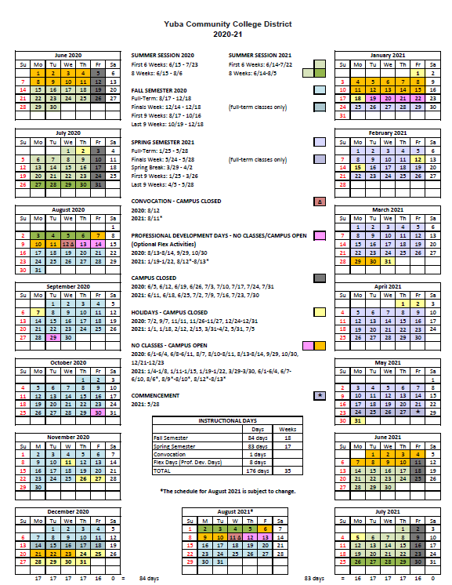

Appendix N: Map of Yuba College, 2088 North Beale Road, Marysville, California, 95901

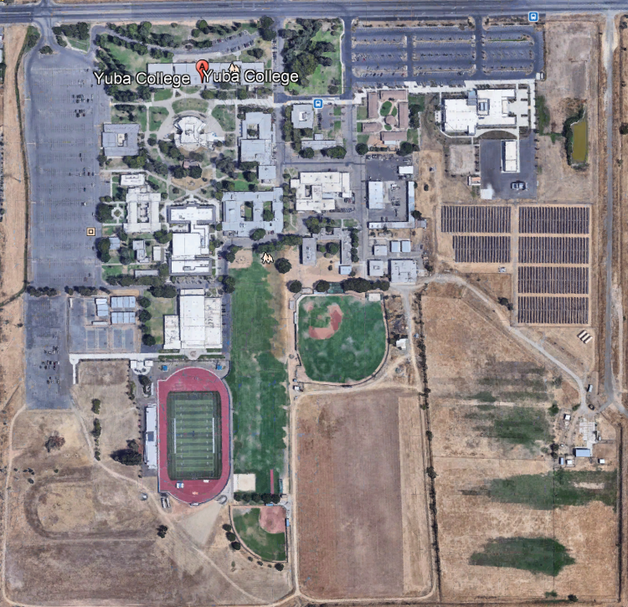
Buildings 1500 and 1300

Appendix O: N/A

The End.

