Clarifications:

Addendum No. 1

RFP 20-07 Exterior LED Lighting Upgrades
Date: 11/11/2020

Date: January 26, 2016

- Question: Is it okay to bid alternative fixtures for the top of the light poles?

Answer: Contractors are required to bid what is specified in “Request for Proposal No. 20-07” and then bid alternative fixtures as they would like as a separate Alternative. This will allow the proposal evaluation process to compare apples to apples and then consider options/alternatives separately.

- Question: Should we include photo-cells on our new LED light fixtures?

Answer: Do not include photo cells in your base bid proposal as features on the poles.

- Question: It seems that the part number on line item no. 3 in appendix D is for a new light pole?

Answer: RAB Part No. ALED5T78 is for a new light fixture per the following found at this link:

https://www.rablighting.com/product/ALED5T78

See the next page

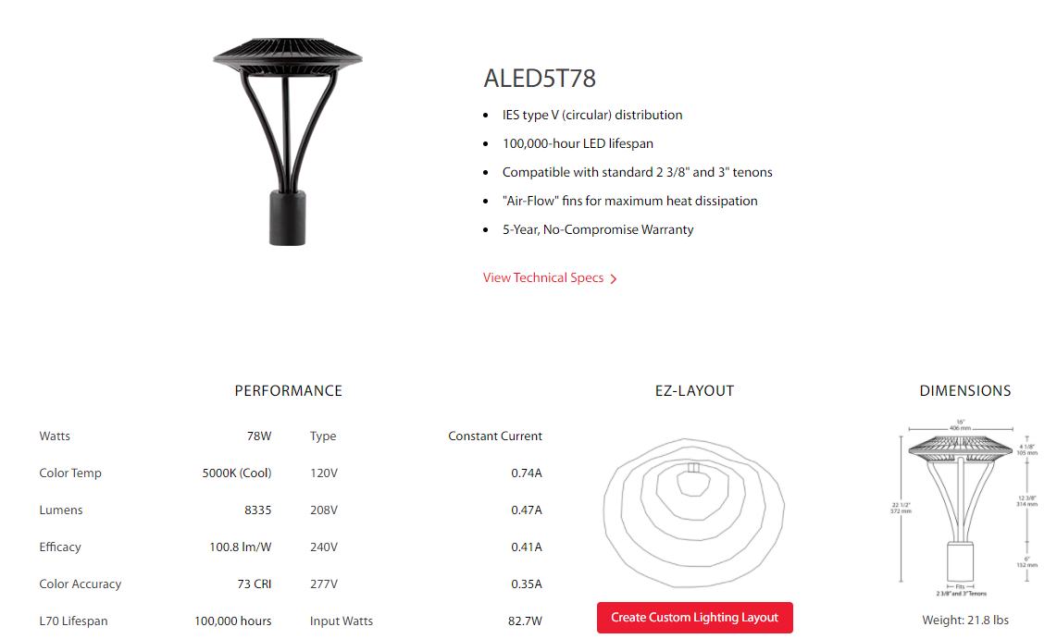

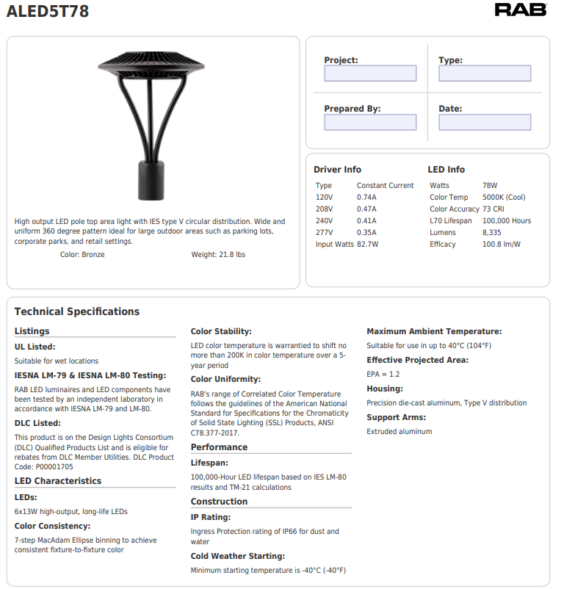

- Question: How should the new fixture be connected to the existing poles?

Answer: The new light fixtures shall use adapters to connect to the existing light poles to match existing poles and be done to provide an aesthetically pleasing appearance and a secure, long-lasting, and solidly supported final installation. Light fixtures shall not be lose, crooked, or at an angle after installation.

- Question: Some of the light poles are not straight and appear to be at an angle. Do you expect these poles to be straightened out somehow?

Answer: If there is a way to add stainless steel washers or filler plates to level the light poles, please include this work and note it in your proposal.

- Question: Do Contractors need to provide a schedule with their quotes?

Answer: Yes, please provide a preliminary schedule if the project is awarded by November 30, 2020. Please verify the lead-time of the fixtures.

- Question: Do Contractors need to fill out an Agreement for Services contract form and submit it with their proposals?

Answer: No. If you can provide it with your proposal, great.

- Question: Do Contractors need to provide cut sheets for all products used in the project?

Answer: Yes for the light fixtures, pole adapters, and bollard fixtures.

- Question: Do Contractors need to provide a photo metric study of the campus:

Answer: Yes, provide a photo-metric study before and after. Note exactly where the readings are being recorded so the values represent accurate improvements in the lighting levels.

- Question: Does the installation need to be done by a licensed Contractor?

Answer: Yes, by a licensed Contractor in the State of California. Provide a copy of the license with proposal.

- Clarification: Contractors are expected to note any exceptions, exclusions, and assumptions in their proposals.

- Question: Does the College want to keep the 5,000 Kelvin light frequency for new fixtures?

Answer: Yes

- Clarification: The Contractor is expected to provide verification of the type of sealed, weather-tight wiring connectors with product cut-sheets.

- Question: Should the Contractor replace the broken and damaged light pole base covers?

Answer: Yes, replace all light pole base covers. Field measure as needed. Match the existing light pole finish. Typical all light pole bases.

- Question: Should the bollard light lens covers be replaced?

Answer: Yes, please replace the existing lens covers with new non-yellowing, long-life, clear covers to match existing bollards lens covers.

- Question: Should the Contractor replace the wiring in the poles and bollards?

Answer: Yes, from the base to the fixture provide and install new wiring.

- What should the contractor do if the light pole base is broken or structurally compromised?

Answer: If this is the case, the contractor shall bring it to the attention of the Maintenance staff. If there is another pole at the campus, and it can be used for this location, then the contractor shall remove the old existing damage pole and replace it with the spare pole. If not, then the contractor shall purchase and install a new light pole. All of this work in this question would be covered by a change order at a later date.

- Clarification: Please see the attachment for additional information regarding the light pole adaptor connections. Please provide the appropriate adapters for each type of light pole so that each fixture will be firmly secured, straight and true, and will not wobble around. The finish of the adapter shall match the existing light poles and the new fixtures as much as possible.

- Please include all assumptions, exceptions, exclusions, and clarifications in your proposals to provide a comprehensive project approach with all scope listed and described in your proposal. Please be complete and thorough.

The end

