Request for Proposal
Yuba Community College District
Yuba College Campus
Hazardous Waste Assessment Survey
Multiple Buildings
No. RFP 20-10

Issue Date: October 19, 2020
Proposals Due: November 17, 2020

RFP Due Date: November 17, 2020, 2:00 pm Sharp, Yuba College Location Delivered To:

Yuba Community College District, District Offices
Attn.: David Willis
District Director of Facilities Planning, Maintenance & Operations
RFP No. 20-10 Yuba College Campus, Hazardous Waste Assessment Survey, Multiple Buildings
Address: 425 Plumas Blvd., Suite 200, Yuba City, California, 95991

Proposal Delivery Location, Front Counter at Second Floor
Yuba Community College District
District Offices
425 Plumas Blvd, Suite 200 (second floor)
Yuba City, California, 95991

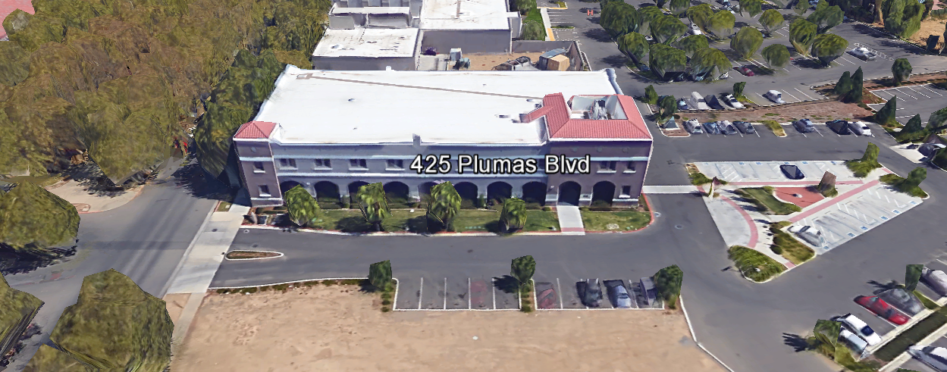
TABLE OF CONTENTS

1.0 INTRODUCTION
1.1 District Information
1.2 Yuba Community College District Background
1.3 Purpose of the Request
1.4 Applicable Codes
2.0 Scope of Work
2.1 Project Schedule
2.2 District Staff Contacts during Proposal Process
2.3 Project Safety Requirements
2.4 Demolition
3.0 Proposal Format Organization
3.1 Proposal Delivery, Contents, and Format
4.0 Selection of “Firm”
5.0 Basis of Award
6.0 Non-Discrimination
7.0 Response to Request for Proposal (RFP)
8.0 Requests for Information (RFI)
9.0 Proposal Schedule
10.0 District Parking
11.0 RFP Proposals
12.0 Award of Contract/Proposal
13.0 Reservation of Rights
14.0 Bid Bond, Performance Bond, Payment Bond Requirements: Not Applicable for Professional Services
15.0 Liquidated Damages

Appendix A, Proposal Base Bid Costs/Scope: Hazardous Materials Survey
Appendix B, Acknowledgement of Addenda Form
Appendix C, Statement of Qualifications Form
Appendix D, Yuba College Building Diagram Maps
Appendix E, N/A
Appendix F, YCCD Agreement for Services (AFS).
Appendix G, Non-Collusion Affidavit Form
Appendix H, References Form
Appendix I, Signature Proposal Form
Appendix J, FirmLicenses, Certifications, etc..
Informational Items:
Appendix K, N/A
Appendix L, Historical Hazardous Materials Assessment Surveys
Appendix M, YCCD Academic Calendar
Appendix N, Map of Yuba College Campus
Appendix O, N/A

1. INTRODUCTION

  - District Information:

The District consists of two colleges, Woodland Community College and Yuba College, with campuses located at six different locations: Yuba College in Marysville, CA; Sutter County Center in Yuba City, CA; Beale Education Center, Beale AFB, CA; Woodland Community College in Woodland, CA; Colusa County Center in Williams, CA; and Lake County Campus in Clearlake, CA.

  - Yuba Community College District

The Yuba Community College District (YCCD) was founded in 1927 and spans eight counties (Yuba, Sutter, Colusa, Yolo, Lake, Butte, Glenn and Placer) and nearly 4,200 square miles of territory in rural, north-central California. It has colleges in Marysville and Woodland, an educational center in Clearlake, an educational center in Williams, an educational center in Yuba City, and outreach operations at Beale Air Force Base.

  - Purpose Of Request

The Yuba Community College District seeks proposals from qualified Licensed/Certified Inspection and Testing Firms to properly and carefully inspect, sample, test, and generate a laboratoryreport for all hazardous materials per the defined scope of Appendix A.
Yuba College Campus Address: 2088 North Beale Road, Marysville, California 95901.

  - Applicable Codes
All work shall meet all State of California Building Codes, and Federal codes, and local ordinances.
All projects at the District/College are prevailing wage projects.
- Scope of Work
See Appendix A.

IMPORTANT SCOPE GUIDANCE:

Hazardous Materials Industry “Best Practices” shall be applied to reduce the risk of any hazardous materials from becoming airborne or spreading to the ground or surrounding area. Containment means and methods shall be applied. All required PPE shall be used.

General Comments:

The Inspection/Testing Firm is 100% responsible to coordinate and securely store materials, tools, equipment, and other items required for the project.

The District encourages a positive and open communication strategy that includes a sense of partnership and mutual success on its projects.

All sampling means and methods shall be provided in proposal and conducted to eliminate any exposure to any Students, Faculty, or Staff.

Please plan to avoid all overtime rates.

2.1 Project schedule
Start Date: December 21, 2020
Completion Dates for the Three (3) Separate Reports (One for each Group of buildings per Appendix A):
Group 1: January 29, 2021
Group 2: January 15, 2021
Group 3: January 29, 2021
Firms are required to submit a schedule with their proposals to complete each of the three written reports and submit them by the dates shown above. An earlier date for Group 2 will especially score higher.
All work shall be done when there are no College employees in the building. It is recommended that sampling be done starting at 5am and completed by 8am Monday through Friday OR during times when it can be coordinated that there are no College employees or Students in the building.

This is a prevailing wage project. The Firm is required to upload all certified payroll information to the Department of Industrial Relations web site. The Firm is also required to provide certified payroll information with progress payments.
Provide a brief project schedule with the proposal with the completion date clearly shown.
2.2 District Staff Contacts during the Proposal process:
Firms interested in submitting a Proposal are directed not to make personal contact with the Board of Trustees, District staff, or members of the evaluation committee. Any contact shall constitute grounds for disqualification from consideration.
Single Point of Contact during the Proposal Preparation Process:
David L. Willis
District Director of Maintenance, Operations, and Planning
425 Plumas Blvd., Suite 200 (Second Floor)
Yuba City, California, 95991
Cell Phone: 916-747-4262
Email: dwillis@yccd.edu

Please email Dave Willis to verify that your firm will be submitting a proposal in response to this procurement process.
On-site coordination, first contact person access and immediate contact person during inspection/sampling process:
Bryan Epp
Assistant Director of Maintenance, Operations
2088 North Beale Road
Phone: 530-740-1722
Email: bepp@yccd.edu

No changes can be made to the project scope without authorization in writing by David Willis.

2.3 Project Safety and Security Requirements
Safety is a top priority for the District. All California OSHA requirements apply. Industry best practices apply. The Firm’s employees shall wear shirts with sleeves, a hard hat, eye protection, hearing protection as needed, gloves, substantial leather footwear, long pants, a reflective safety vest, and take all needed precautions to complete the work in a safe manner. Safety shall not be compromised at all during the work.
COVID 19 BEST PRACTICES APPLY:
Firm employees are required to wear facial coverings and maintain social distancing whenever entering buildings and as much as possible when working outside. The frequent use of hand sanitizer is strongly encouraged. Firm employees shall not report to work at the campus if they are sick or have been recently exposed to anyone knowingly that has tested positive to COVID 19. If a Firm employee has been tested for COVID 19, they shall not report to work at the campus until after test results are known and after they are no longer symptomatic. If any Firm employees have been tested or have tested positive for COVID 19, this information shall be immediately shared with the District/College project Managers.
2.4 Demolition (If Applicable)
The Firm shall provide a hazardous waste manifest for all items removed from the campus. This is a requirement to be submitted with progress payment. Demolition shall be done in accordance with all State and Federal codes, laws, and ordinances. Demolition shall be coordinated to greatly reduce possible impacts with students and staff.
3.0 Proposal Format Organization
The Firm is requested to use the following proposal format:
3.1. Proposal Delivery, Contents, and Format:
Proposals should provide straightforward, concise information that satisfies the requirements noted in this RFP. Expensive binding, color displays, and the like are discouraged. Emphasis should be placed on brevity, conformity to the Districts instructions, selection criteria of this RFP, and completeness and clarity of content. Each Respondent’s proposal should clearly and accurately demonstrate specialized knowledge and experience required for consideration.
In a sealed box or envelope (clearly marked “), submit the following:
- One (1) flash memory stick containing the complete proposal and supporting documentation;
- One (1) original in paper form of the proposal, which consists of a Proposal Letter and responses to the proposal requirements of this RFP.

There is no page limit.

Firms must comply with the provisions of these instructions for completion and submission of the Proposal. The failure of a Firm to comply with the Proposal Instructions and Requirements will likely result (at the sole discretion of the District) in rejection of the Proposal for non-responsiveness.
Proposal Section | Format
- Cover Letter, Section 3.1.A | PDF
- Table of Contents, Section 3.1.B | PDF
- Identification of the Firm, Section 3.1.C | PDF
- Executive Summary, Section 3.1.D | PDF
- Staffing Resources, Section 3.1.E | PDF
- Experience, Section 3.1.F | PDF
- Project Approach, Section 3.1. G | PDF
Appendices (See Table of Contents for each one) Submit a response to each Appendix that requires Firminformation. Please submit responses to Appendices A, B, C, F, G, H, I, J. | PDF
Proposal General Information Contents:

The following is a summary of the Contents. Please address each section in a Tabbed Format.

Information requested will help the District determine if the Firm is a “Responsible Bidder”.

3.1.A. Cover Letter

The Proposal shall include a Cover Letter on Respondent’s official business letterhead, which shall be signed by an individual authorized to legally bind Respondent. The Cover Letter shall also identify the name, telephone number, and email of a person who may be contacted during the Proposal evaluation process.

3.1.B. Table of Contents

Provide a Table of Contents that outlines in sequential order the major sections and sub-sections of the Proposal. All pages in the Proposal shall be clearly and consecutively numbered and correspond to the Table of Contents. Use tabs to allow information to be more easily located.
3.1.C. Identification of the Firm
1. Legal name and address of company.
2. Legal form of company (corporation, partnership, etc.).
3. Name, address, phone number, facsimile number, email address, website address, direct email address for the following: Firm’s Principal in Charge, person(s) who will be primarily responsible for providing services for this Qualifications Package, and the contact for scheduling an in-person interview
If the Firm is selected for one.
4. California Business License Number (as applicable)
5. Other Licenses

3.1.D. Executive Summary

The Proposal shall include an Executive Summary that briefly describes the Firm, the services and types of projects that are the core business, and why this project “fits” within the business model of the Firm.

3.1.E. Staffing Resources

Firm Staffing and Key Personnel Assigned to this Project
a. Provide total number of staff currently employed by the firm.
b. Identify person/s who will be principally responsible for the work and their role.
c. Provide a list of first-tier Firms

3.1.F. Experience

- Provide a description of the Firm’s experience on these of type projects.
- State the number of years the firm has conducted business. Firm must have at least five (5) years related experience.
- Describe the experience and credentials of the staff assigned to this project. The Superintendent/Foreman shall be on site whenever work is being performed.

3.1.G. Project Approach

Describe the project approach that the Firm will take to provide a safe, efficient, cost effective, high quality project that will protect existing College property/buildings, minimize impacts to student classes, minimize the risk of hazardous materials from either spreading or being left after the sampling process, and meet all criteria outlined in this RFP. Properly fill and seal all sample locations. Describe sample location sealing means and methods.

4.0 Selection of “Firm” Services Provider

The process of “Firm” selection is based upon the complete responsiveness of the RFP and the criteria as outlined in the RFP.

The District Project Evaluation Team will read the written proposals. The District Evaluation Team will discuss the proposals and verify that the “Basis of Award” information below and information submitted in response to the RFP are complete and responsive.

The District reserves the right to reject any and all submittals, to amend the RFP process, and to discontinue or re-open the process at any time. The District reserves the right to request clarifications to RFP responses and to negotiate the terms of the agreement.

5.0 Basis of Award

This project will be awarded based on the following criteria:

- Lowest Total Cost Responsive Qualified Bidder
  - Lowest Total Cost
  - Firm Capability to do the work
  - Qualified Firm
    - Proper State of California Firm License in good standing
    - Appendix C Statement of Qualifications Information
    - Information provided as requested in the RFP.
    - All Addendums are acknowledged.
    - Firm listed any exceptions or exclusions. Firms should bid the project per the RFP and contract documents and then offer exceptions and exclusions or cost deductive or additive alternatives separately from the base bid.
    - If there is a historical context of projects with the District, they have been completed on schedule, providing high quality workmanship, minimal/reasonable change orders, and per the construction documents. Warrantees were supported professionally, timely, without impact to College/District, and per manufacturer requirements.

The Lowest Total Cost Responsive Qualified Bidder that provides the most advantageous proposal to the District as determined solely by the District.

6.0 Non-Discrimination
The District does not discriminate with regard to race, color, gender, national origin, disability, or any other protected or other classification in the awarding of contracts/agreements. The District welcomes all Qualified Firms to participate in the project Request for Qualification/Proposal process.
The District encourages firms that are women or minority owned, emerging small businesses, veteran owned firms, disabled person owned firms, and all other qualified firms to participate in the proposal process.
The District encourages the submission of proposals from all Firms that can meet the stated requirements set for this RFP.
7.0 Responses to RFP:
Sealed responses to this RFP must be clearly marked "RFP NO. 20-10 Yuba College, Hazardous Waste Assessment Survey, Multiple Buildings”.

Responses shall be mailed to or hand-delivered to the following address:

Yuba Community College District, District Offices
Attn.: David Willis
District Director of Facilities Planning, Maintenance & Operations
Envelope/Box Marked:
“RFP No. 20-10 Yuba College, Hazardous Waste Survey, Multiple Buildings”.

Address: 425 Plumas Blvd., Suite 200, Room 216, Yuba City, California, 95991

Note: Completely seal your proposals in envelope/box and make sure it gets date/time stamped when delivering proposal. Firms are each 100% responsible to make sure proposals that are mailed using a carrier such as UPS, FED Ex, etc…are received and date/time stamped by District personnel prior to the proposal due date/time. No proposals will be considered if they are late, even if it is only 5 minutes late. Please make sure your proposals are delivered and received promptly prior to the due date/time. There will be a public proposal opening at the due date/time.

Do NOT email your proposals. Emailed proposals that are not sent per the above guidance requirements will not be considered.

8.0 Requests for Information (RFI)

Requests for Information concerning the RFP must be in writing and may be submitted via email no later than the date shown below. Please direct all questions to David Willis, email: dwillis@yccd.edu.

Following the RFI deadline, all questions and answers will be summarized and posted on the District's website: https://www.yccd.edu/central-services/purchasing/ , then, click on the “Requests for Proposals / Quotes” tab on the right hand side of this web page. It is anticipated that responses to inquires received by the required time and date will be provided within 5 business days and posted on the District's website or responded to per the dates listed in the RFP for addendum publishing. Should more time be needed by the District to answer I respond to RFI’s, this information will also be posted on the above website.

- Include the following in the subject matter field on emails when requesting information: “RFP 20-10”, RFI.

9.0 Proposal Schedule:

Important Dates and Times:

October 19, 2020 Release of Request for Proposal at 4:00PM

October 28, 2020: 10:30 AM, Mandatory Pre-Bid Meeting at Yuba College Campus at Building 1400 Maintenance Conference Room: 2088 North Beale Road, Marysville, California 95901.

Prospective Firms wishing to participate in this bidding process are required to have a representative attend, sign the login sheet, and conduct a field inspection of the campus existing conditions. Firms that do not attend this mandatory pre-bid meeting are not qualified to bid this project unless they coordinate with Bryan Epp to visit the campus to review the RFP, walk the project, and sign a login sheet. Please provide at least 48 hours’ notice before coordinating a site visit. Bryan Epp’s contact information is listed below:

Bryan Epp
Assistant Director of Maintenance, Operations
2088 North Beale Road
Phone: 530-740-1722
Email: bepp@yccd.edu

November 5, 2020: 5:00 PM, All questions and requests for information must be submitted to David Willis at: dwillis@yccd.edu.

November 10, 2020: Addendum Issued if needed.

November 17, 2020: Proposals due at 2:00 PM SHARP, Yuba Community College District, District Offices Location, see page 1. There will be a public bid opening on this RFP.

December 18, 2020: Expected date of Award with Purchase Order

Completion Dates: See Appendix A.
This is a prevailing wage project.

11.0 District Parking:

-No parking in Reserved Spaces without a proper permit
-Permit Parking is enforced in all general lots between 6:00 am and 6:00 pm, Monday through Friday. All general lots require a properly displayed, valid permit during these times
-Daily Parking Permits are $2.00
-Permits are available for purchase at any of the permit machines located in the student parking lots
-All other parking regulations are enforced 24 hours a day, seven days a week. This includes designated staff spaces, handicap spaces, timed spaces, red zones, yellow zones, and areas not marked (no parking at any time)
-Once this project is awarded, temporary parking permits will be processed as requested by the successful firm for all employees associated with this project at no cost to the Firm for the duration of the project at each Campus location. These temporary permits must be displayed at all times on the dash board of employee vehicles.

10.0 RFP Proposals

Proposals received after the deadline will not be opened. Each responder shall submit one (1) signed original in separate binder. Provide one electronic format copy of the proposal using electronic media such as a flash drive, CD, etc...

All materials submitted in response to the RFP shall be on 8-1/2"x11" paper, preferably in
Portrait orientation. All submitted materials must be bound in either a three-ring binder or spiral bound notebook. Content shall be tabbed and numbered per the items included in the Submittal Requirements. All Proposals will be reviewed and evaluated by a District Selection Committee. The District at its sole discretion may interview finalists, or select a firm or firms to perform work based solely on the evaluation of the Proposal. Although there is no page limit.

All Proposals become the sole property of the District and the content will be held confidential until the selection of the firm is made and the project is awarded.

12.0 Award of Contract

- The Contract will be awarded to the lowest total cost, most responsive responsible qualified proposer whose proposal, conforming to the request for proposal and associated addendums, will be most advantageous to the District.

B. The District reserves the right to enter into an Agreement without further discussion of the proposal submitted based on the initial offers received.

C. The District reserves the right to reject any or all proposals or any part of the proposal and to waive informalities and minor irregularities in the proposals received.

D. The RFP, its addendums, any follow-up clarifying information, and the proposal of the selected Firm will become part of any contract initiated by the District.

E. A formal contract shall be signed by the successful proposer and Yuba Community College District to perform this service.

F. The District reserves the right to enter into discussions with any one or all of the Responders after Proposals have been initially reviewed. Such responses shall be subject to all provisions, terms and conditions as set forth in the RFP, unless otherwise modified.

G. The District intends to award to a single RFP Responder.

H. Failure to acknowledge all of the addendums, provide the items listed in the RFP, may render the proposal unresponsive at the discretion of the District.

J. The District reserves the right to request clarification of proposal content during the review and evaluation process.

K. The District reserves the right to negotiate the terms of the agreement to align with budgetary constraints.

L. Due to the heightened risk of illness that could then affect the performance of the Firm, Firms with multiple employee teams and the resources to adapt and complete the scope of work per the RFP, will score higher in the evaluation process.

13.0 Reservation of Rights

The District reserves the right to:

- Reject any or all submittals at its sole discretions.
- Cancel the Request for Proposal (RFP), without cause.
- Modify any requirements contained within the RFP and request a revised submission from all Providers.
- Establish other evaluation criteria determined to be in the best interest of the District.
- Contract with any of the firms responding to the RFP based solely upon its judgment of the qualifications and capabilities of the firm.
- Clarify the content of any proposal to verify that the requirements of the RFP are included.
- Waive “minor” proposal inconsistencies that do not change the scope of work as outlined in the RFP.
- Request an alternative Superintendent on the project if the initially assigned Superintendent on the project is not performing well, not meeting project requirements, not working well with College staff and students, not applying best practice safety methods, OR not following College/District guidance regarding project approach.

This RFP does not commit the District to award or negotiate a contract. The District will not be responsible for any expenses incurred by any firm in preparing and submitting a proposal or response to this RFP or in completing any of the work specified.

14. Bid Bond, Performance Bond, Payment Bond Requirements: Not Applicable

Since this is a professional services “Request for Proposal” and NOT a construction project, there are no requirements for a BID BOND, Performance Bond, or Payment Bond.

15.0 Liquidated Damages:
There are no liquidated damages on this project.

Appendix A: Proposal Base Bid Costs/Scope: Hazardous Materials Survey
Scope Guidance:
- Sample all interior floors, walls, ceilings as needed in each building (as needed)
- Sample all exterior walls, caulking and mastic around doors and windows (as needed)
- Pipe Insulation as needed
- Duct Insulation as needed
- Other surfaces as needed
This survey will be done to provide information to inform the work of the Fire Alarm System Upgrade Project in these buildings, the Building 800 Modernization Project, and the painting work of the exterior walls of the buildings. This work includes testing for Asbestos, Lead Paint, and any other known high-risk hazardous material.
Provide three separate prices for Groups 1, 2, and 3:
Group 1: Building 800 Modernization Project (Associated Project)
  - Building 800 (Orig. Construction 1965, Remodeled 2008):$ .

  - Other Costs (Please explain): $ .

  - Allowance for Unforeseen Conditions Contingency $ 1,000.00 .

Note: Each item will require approval by the District with proper documentation. Additional items will be considered on a case by case basis. It remains the Firms responsibility to do reasonable due diligence inspection and evaluation to determine and include as many items as possible during the proposal bidding process and to make all reasonable efforts to identify items before damaging them during the construction process.

  - Group 1 Total Costs: $ .

Group 2: Fire Alarm Systems Upgrade Project (Associated Project)

  - Building 100A (Original Construction 1964): $ .

  - Building 100B (Original Construction 1972): $ .

  - Building 200 (Original Construction 1964): $ .

  - Building 300 (Original Construction 1964): $ .

  - Building 400 (Original Construction 1968, Remodeled 2008): $ .

  - Building 500 (Original Construction 1966): $ .

  - Building 600 (Original Construction 1967): $ .

  - Building 900 (Original Construction 1967): $ .

  - Building 1000 (Original Construction 1968): $ .

  - Building 1100 (Original Construction 1970, Remodeled 2012): $ .

  - Building 1200 (Original Construction 1970, Remodeled 2012): $ .

  - Building 1400 (Original Construction 1965): $ .

  - Building 1400 CUP (Original Construction 2010): $ .
CUP=Central Utility Plant

  - Building 9804 (1400B Boiler Room) (Original Construction 1970): $ .

  - Building 9805 (1400C Shop Buildings) (Original Construction 1972): $ .

  - Building 1600 (Original Construction 1976): $ .

  - Police Dept. Modular Building (Original Construction 1976): $ .

  - Building 1700 A, B, C (Original Construction 1972): $ .

  - Building 1800 (Original Construction 1970, Remodeled 2010); $ .

  - Building 1900 (Original Construction 1998): $ .

  - Building 2000 (Original Construction 2010): $ .

  - Building 2100 (Original Construction 2012): $ .

  - Building 2101 (Vehicle Storage Building) (Original Construction 2012): $ .

  - Other Costs (Please explain): $ .

  - Other Costs (Please explain): $ .

  - Other Costs (Please explain): $ .

  - Allowance for Unforeseen Conditions Contingency $ 3,000.00 .

Note: Each item will require approval by the District with proper documentation. Additional items will be considered on a case by case basis. It remains the Firms responsibility to do reasonable due diligence inspection and evaluation to determine and include as many items as possible during the proposal bidding process and to make all reasonable efforts to identify items before damaging them during the construction process.

  - Group 2 Total Costs: $ .

Group 3: Other Buildings

  - Building 700 A, B, C (Original Construction 1968): $ .

  - Building 1200 Out Buildings (Original Construction 2012):$ .

  - Modular Buildings 1708, 1709 (Original Construction 2005): $ .

  - 2102 Fire Tower Building (Original Construction 2012): $ .

  - Veterans Program Modular Building (Original Construction 1999): $ .

  - 3000 Series Modular Buildings (Original Construction 2004): $ .

  - Other Costs (Please explain): $ .

  - Allowance for Unforeseen Conditions Contingency $ 1,000.00 .

Note: Each item will require approval by the District with proper documentation. Additional items will be considered on a case by case basis. It remains the Firms responsibility to do reasonable due diligence inspection and evaluation to determine and include as many items as possible during the proposal bidding process and to make all reasonable efforts to identify items before damaging them during the construction process.

  - Group 3 Total Costs: $ .

  - Total Costs (Groups 1, 2, 3): $ .

Provide all needed survey narrative to describe the findings for each building, a map of the sample locations for each building, and the lab test results. Properly patch and repair each sample location to the satisfaction of the District.

Note: In many cases, the remodels are partial and not complete remodels. Some building remodels included a building addition. All dates are estimated dates and provided to give the Firm a better understanding of the building age and risk of asbestos or lead paint.

Schedule of Services:
Start Date: December 21, 2020
Completion Dates for the Three (3) Separate Reports, 100% Completion (One for each Group of buildings per Appendix A):
Group 1: January 29, 2021
Group 2: January 15, 2021 (December 31, 2020 if possible)
Group 3: January 29, 2021
Firms are required to submit a schedule with their proposals to complete each of the three written reports and submit them by the dates shown above. An earlier date for Group 2 will especially score higher.

Appendix B: Acknowledgement of Addenda Form

The undersigned acknowledges receipt of the following addenda from the District pursuant to the Request for Proposal:
Acknowledgement: Yes or Not Applicable
Addendum No. 1: .
Addendum No. 2: .
Addendum No. 3: .
Addendum No. 4: .
Addendum No. 5: .

Firms are required to acknowledge all addenda’s within the submitted proposal at the time of submission.

Appendix C: Statement of Qualifications Form

The Respondent shall furnish the following information. Failure to comply with this requirement will render the submittal informal and may cause its rejection. Additional sheets may be attached if necessary.

- Firm name and primary address:

- Telephone: Facsimile:

- Email Address:

- Names and titles of two officers of the firm:
NAME TITLE

4.1
4.2

- Specific type of Ownership (Check one)

5.1 | Individual
5.2 | Partnership
5.3 | Corporation; If a corporation, state the following: State of incorporation:
 | Date of incorporation: President/CEO:
5.4 | Joint Venture
5.5 | Other (Specify)
- Taxpayer Identification
- Number of years Respondent has been in business:
- Number of years Respondent has conducted business under the present name:
- Number of years’ experience in California Community College, University, or Public facility projects .
- Has the Respondent been in litigation on an issue pertaining to any contract during the past five (5) years?
If yes, provide detailed information regarding the litigation, whether it was settled or not, the amount of the settlement, the liability of the claim, the circumstances and type of project, and provide case name and number.

- Has the Respondent ever failed to complete a project in the past five (5) years? If so, give owner and details:

- Safety Insurance Modifier Number: .

Appendix D: Yuba College, Building Diagram Maps

Reference Link:
https://goyccd-my.sharepoint.com/:f:/g/personal/w0398409_yccd_edu/EkdHJpKOsltEjWMOA8klMNgB3XcHuhwyrL4HpJhnw8lYFg?e=74FGW4

Appendix E: Descriptions of Past “Like” Projects:

Provide at least five (5) examples of similar projects at Community Colleges or Universities, or K-12 Schools or public agencies/institutions that your firm has completed in the past three (3) years.

Appendix F: YCCD Agreement for Services

Please refer to the following Drop Box folder link:
https://goyccd-my.sharepoint.com/:f:/g/personal/w0398409_yccd_edu/ElCviucM8PhKpfgObBGyohcB0Kk4OuxuZjEzkp4Lr8YiBA?e=Rz5vJf

Appendix G: Non-Collusion Affidavit Form

STATE OF CALIFORNIA, COUNTY OF I, being first duly sworn, deposes and says that I am the of , the party submitting the foregoing proposal (“the Proposal”). In connection with the foregoing Proposal, the undersigned declares, states and certifies that:
- The Proposal is not made in the interest of, or on behalf of, any undisclosed person, partnership, company, association, organization or corporation.
- The Proposal is genuine and not collusive or a sham.
- The Firm has not directly or indirectly induced or solicited another Firm to put in a false or sham proposal, and has not directly or indirectly colluded, conspired, connived, or agreed with any other Firm or anyone else to put in a sham proposal, or to refrain from bidding.
- The Firm has not in any manner, directly or indirectly, sought by agreement, communication, or conference with anyone to fix the proposal price, or that of any other Firm, or to fix any overhead, profit or cost element of the proposal price or that of any other Firm, or to secure any advantage against the public body awarding the contract of anyone interested in the proposed contract.
- All statements contained in the Proposal and related documents are true.
- The Firm has not, directly or indirectly, submitted the proposal price or any breakdown thereof, or the contents there of, or divulged information or data relative thereto, or paid, and will not pay any fee to any person, corporation, partnership, company, association, organization, proposal depository, or to any member or agent thereof to effectuate a collusive or sham proposal.
Executed on this date: , 2020/2021, at:

(City, County, and State)
I declare under penalty of perjury under the laws of the State of California that the foregoing is true and correct.
Signature Printed Name .
Address: .
Area Code & Phone Number: .
Note: In addition to other bid documents, bidders on public works projects are required by Public Contract Code section 7106 to submit a certification form that they have not colluded with another proposer.
Appendix “H” References Form (Example Template)

Bidder shall provide a minimum of Five (5) verifiable references with current contact information, preferably from a California public educational institution and/or California public agency, representing projects started and completed within the last 5 years. See clarification note below regarding reference requirements.
All phone numbers and emails must be current (please verify).
REFERENCE #1
NAME
ADDRESS
CITY, STATE ZIP CODE
TELEPHONE #
CONTACT
DATES OF SERVICE
REFERENCE #2
NAME
ADDRESS
CITY, STATE, ZIP CODE
TELEPHONE #
CONTACT
DATES OF SERVICE
REFERENCE #3
NAME
ADDRESS
CITY, STATE, ZIP CODE
TELEPHONE #
CONTACT
DATES OF SERVICE

You may of course use the Firm’s established reference template.

Appendix “I” Proposal Signature Form
The undersigned acknowledges the following:
- Having become familiar with the specifications and requirements of the Request for Proposal, hereby offers to provide all services in accordance with the proposal set forth herein, including all referenced material and attachments.
- By submitting a signed proposal in response to this solicitation, the Firm acknowledges that they completely understand the scope of the needed services and that the proposed services as described in the proposal will meet or exceed the needs of the District.
- Late proposals will not be accepted (even if they are only 5 minutes late).
- The District reserves the right to reject any and all proposals and that this proposal shall remain open and not be withdrawn for a minimum of 90 days.
- Cancellation Clause: The District may, without cause, terminate the contract(s) or a project under the contract(s) by giving written notice of such termination to the awarded firm. In the event of such termination the District shall reimburse the firm for services performed and reasonable expenses actually incurred by the firm in relation to the terminated project prior to the firm’s receipt of such notice of termination. The cost of proposal generation, associated travel, copies, postage, etc.., will not be reimbursed and is considered a typical and normal part of the bid process and is not reimbursed for any of the proposers.
- If the prospective Firm is a corporation, the undersigned hereby represents and warrants that the corporation is duly incorporated and is in good standing in the state of California , and that, , is authorized to act for and bind the corporation.

Entity Type (Select One):

Sole Owner: Partnership: .

Corporation: .

Other; Please specify;

- Regular monthly progress payments are made using NET 30 as a basis for payment, with Net 30 time starting after receipt of the invoice with all required support documentation, and once this information is reviewed and approved by the District.

Invoices must be emailed to the following with all support documentation:
Vendors with a first letter of A through N: rlangly@yccd.edu; rordiway@yccd.edu
Vendors with a first letter of O through Z: hgardner@yccd.edu; rordiway@yccd.edu
It is critical that invoices have all required support documentation including an updated schedule of values with 5% retainage for construction projects, updated project schedule, description of completed work, and any other information that will help to justify and support the progress payment request.

Signature_____________________________ Date: _______________________
Position: _____________________________
Print name____________________________ Title________________________

Notary Required On This Project
Notary Stamp:

Appendix J: FirmLicenses, Certifications, Lab Qualifications, Technician Qualifications, etc..

--Provided by Firm

Appendix K: N/A

Appendix L: Historical Yuba College Hazardous Materials Surveys

Information Link:
https://goyccd-my.sharepoint.com/:f:/g/personal/w0398409_yccd_edu/EtTifRu8LIVKs1TWbhcHrZkB9jvyt1PODy5-OECLqEeR7w?e=H9OehZ
Appendix M: YCCD Academic Calendars—see next page

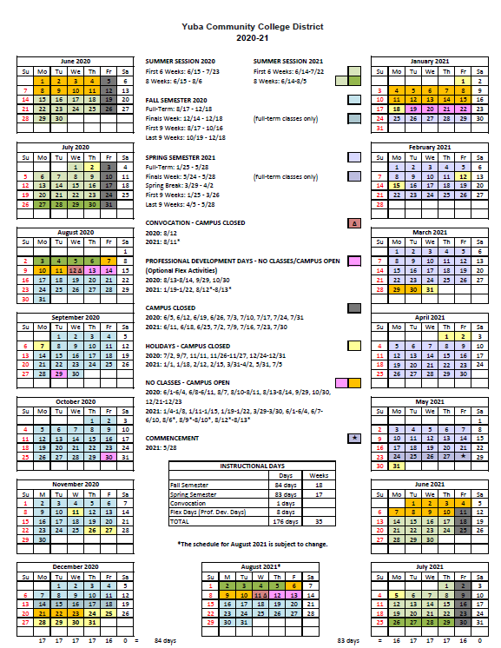

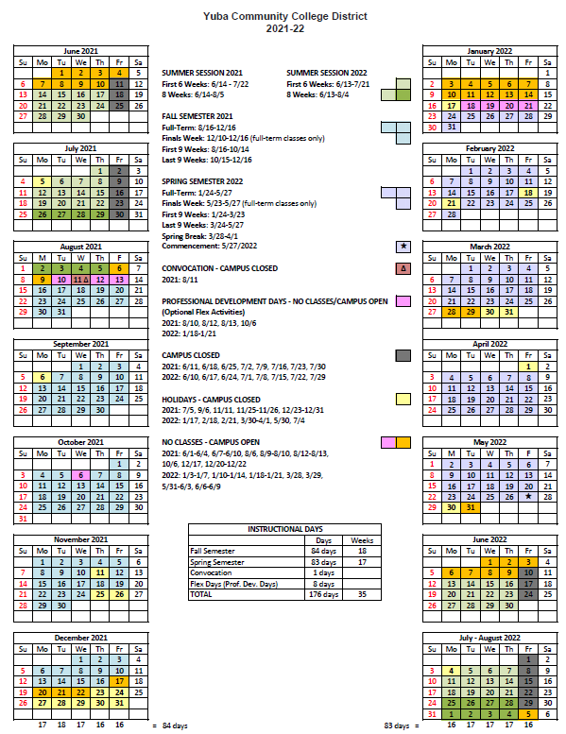
Appendix N: Map of Yuba College, 2088 North Beale Road, Marysville, California, 95901

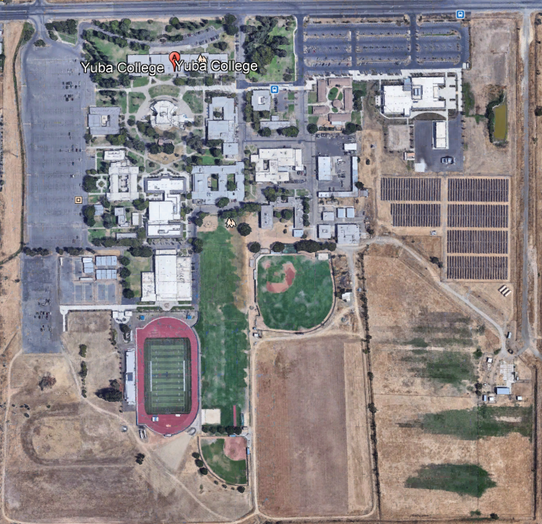

Appendix O: N/A

The End.

