Yuba Community College District

Multiple Locations: Protection Barriers
Request for Qualification /Proposal
RFQ/RFP No. 20-05

Issue Date: August 28, 2020
RFQ/RFP Proposals Due: October 13, 2020

RFQ/RFP Due Date: October 13, 2020, 1:00 pm Sharp, Yuba College Location Delivered To:

Yuba Community College District, District Offices
Attn.: David Willis
District Director of Facilities Planning, Maintenance & Operations
RFQ/RFP No. 20-05 YCCD Multiple Locations: Protective Barriers
Address: 425 Plumas Blvd., Suite 200, Yuba City, California, 95991

Proposal Delivery Location, Front Counter at Second Floor
Yuba Community College District
District Offices
425 Plumas Blvd, Suite 200 (second floor)
Yuba City, California, 95991

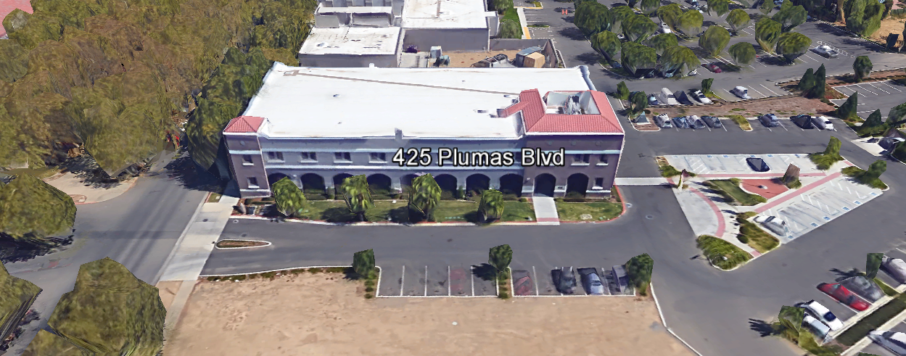
TABLE OF CONTENTS

1.0 INTRODUCTION
1.1 District Information
1.2 Yuba Community College District Background
1.3 Purpose of the Request
1.4 Applicable Codes
2.0 Scope of Work
2.1 Project Schedule
2.2 District Staff Contacts during Proposal Process
2.3 Project Safety Requirements
2.4 Demolition
3.0 Proposal Format Organization
3.1 Proposal Delivery, Contents, and Format
4.0 Selection of “Firm”
5.0 Basis of Award
5.1 Proposal Evaluation Form
6.0 Non-Discrimination
7.0 Response to Request for Proposal (RFQ/RFP)
8.0 Requests for Information (RFI)
9.0 Proposal Schedule
10.0 District Parking
11.0 RFQ/RFP Proposals
12.0 Award of Contract/Proposal
13.0 Reservation of Rights
14.0 Bid Bond, Performance Bond, Payment Bond Requirements
15.0 Liquidated Damages

Appendix A, Proposal Base Bid Costs
Appendix B, Acknowledgement of Addenda Form
Appendix C, Statement of Qualifications Form
Appendix D, Agreement for Services (AFS)
Appendix E, Descriptions of “Like” Projects
Appendix F, Protective Barrier Information Included In Proposal
Appendix G, Non-Collusion Affidavit Form
Appendix H, References Form
Appendix I, Signature Proposal Form
Appendix J, Licenses, and other qualifying information
Appendix L, YCCD Academic Calendar
Appendix M, Maps of Woodland Community College, Colusa County Center, Sutter Campus, Yuba College Campus

1. INTRODUCTION

  - District Information:

The District consists of two colleges, Woodland Community College and Yuba College, with campuses located at six different locations: Yuba College in Marysville, CA; Sutter County Center in Yuba City, CA; Beale Education Center, Beale AFB, CA; Woodland Community College in Woodland, CA; Colusa County Center in Williams, CA; and Lake County Campus in Clearlake, CA.

  - Yuba Community College District

The Yuba Community College District (YCCD) was founded in 1927 and spans eight counties (Yuba, Sutter, Colusa, Yolo, Lake, Butte, Glenn and Placer) and nearly 4,200 square miles of territory in rural, north-central California. It has colleges in Marysville and Woodland, an educational center in Clearlake, an educational center in Williams, an educational center in Yuba City, and outreach operations at Beale Air Force Base.

  - Purpose Of Request

The Yuba Community College District seeks proposals from qualified Firms to fabricate and install professional looking Protective Shields on countertops and other surfaces at the following District locations:

Woodland Community College: 2300 East Gibson Road, Woodland, California, 95776

Colusa County Center: 99 Ella Street, Williams, California 95987

Sutter Campus: 3301 East Onstott Road, Yuba City, California, 95991

Yuba College Campus: 2088 North Beale Road, Marysville, California, 95901

  - Applicable Codes
All Facilities Standards Updates shall meet all State of California Building Codes, and Federal codes, and local ordinances.
All projects at the District/College are prevailing wage projects.

2.0 Scope of Work
The scope of work will be discussed during the walk-through’s of the District locations listed above.

Although there are no drawings or specifications, the District is looking for a professional quality product without sharp edges, solid, and without cracks in the Protective Barriers.

This is a long-term solution and not a stop-gap temporary solution to the need to provide protective barriers.

All labor, materials, equipment, tools required to fully complete this project are included in the scope of work.

Plan to provide written descriptions, diagrams, graphic representations of what is included in the proposals. List options and provide pictures to illustrate solutions. Provide dimensions on renderings and graphic illustrations.

Provide example project pictures and illustrations with references for at least five (5) projects completed in the last three (3) years.

2.1 Project schedule
This project will be awarded in mid-October 2020.

The District would like to have all protective shields installed no later than December 18, 2020
This a prevailing wage project.
Provide a brief project schedule with the proposal with the completion date clearly shown.

2.2 District Staff Contacts during the Proposal process:
Firms interested in submitting a Proposal are directed not to make personal contact with the Board of Trustees, District staff, or members of the evaluation committee. Any contact shall constitute grounds for disqualification from consideration.
Single Point of Contact during the Proposal Preparation Process:
David L. Willis
District Director of Maintenance, Operations, and Planning
425 Plumas Blvd., Suite 200 (Second Floor)
Yuba City, California, 95991
Cell Phone: 916-747-4262
Email: dwillis@yccd.edu

Please email Dave Willis to verify that your firm will be submitting a proposal in response to this procurement process.

On-site coordination, first contact person (Yuba College Campus, Sutter County Campus) access and immediate contact person during construction:
Bryan Epp
Assistant Director of Maintenance, Operations
2088 North Beale Road
Phone: 530-740-1722
Email: bepp@yccd.edu

On-site coordination, first contact person (Woodland Community College, Colusa County Center):
Michael Sinn
Assistant Director of Maintenance, Operations
2300 East Gibson Road
Woodland, California, 95776
Phone: 530-668-3690
Email: msinn@yccd.edu

2.3 Project Safety and Security Requirements
Safety is a top priority for the District.
COVID 19 Corona Virus Project Requirements:
COVID 19 Best Practices and as required by the local County Department of Health shall be applied at all locations. At a minimum, all contractor personnel shall wear facial coverings at all times. Hand sanitizer shall be provided and used often during the work. All areas included in the work area shall be delineated with signs installed and thoroughly sanitized and disinfected after completing work. No employees that feel sick shall report for work. No employees that have tested positive for COVID 19 and are deemed to be sick shall report for work until at least 7 days after they have fully recovered from the illness and do not have been symptom free for at least 7 days.
All District procedures associated with COVID 19 protections and cleaning processes shall be followed.
Other Requirements:
All California OSHA requirements apply. Industry best practices apply. Contractor employees shall as required by OSHA for the project scope, wear a hard hat, eye protection, hearing protection, gloves, substantial leather footwear, long pants, a reflective safety vest, and take all needed precautions to complete the work in a safe manner. Safety shall not be compromised at all during the work.
Enhanced fall protection precautions shall be taken. During windy conditions, precautions shall be taken to ensure the safety of staff and to properly secure materials and debris.
The affected areas of construction shall be properly barricaded, have signs placed, and all reasonable precautions taken to keep staff and students out of the project boundary areas. Debris shall be removed promptly. Protection of College property shall be taken. Contractor is 100% responsible for any damage to College property and facilities.
This campus has a moderate risk of theft. It is the sole responsibility of the Contractor to secure all materials, equipment, tools, and the affected building.
2.4 Demolition
Demolition shall be done in accordance with all State and Federal codes, laws, and ordinances. Demolition shall be coordinated to greatly reduce possible impacts with students and staff.
If hazardous materials are disposed of, provide a debris waste manifest for all items removed from the campuses. If required, the Contractor shall provide large open containers.
3.0 Proposal Format Organization
The Firm is requested to use the following proposal format:
3.1. Proposal Delivery, Contents, and Format:
Proposals should provide straightforward, concise information that satisfies the requirements noted in this RFQ/RFP. Expensive binding, color displays, and the like are discouraged. Emphasis should be placed on brevity, conformity to the Districts instructions, selection criteria of this RFQ/RFP, and completeness and clarity of content. Each Respondent’s proposal should clearly and accurately demonstrate specialized knowledge and experience required for consideration.
In a sealed box or envelope (clearly marked “), submit the following:
- One (1) flash memory stick containing the complete proposal and supporting documentation;
- One (1) original signed proposal, which consists of a Proposal Letter and responses to the proposal requirements of this RFQ/RFP.

There is no page limit.

Firms must comply with the provisions of these instructions for completion and submission of the Proposal. The failure of a Firm to comply with the Proposal Instructions and Requirements will likely result (at the sole discretion of the District) in rejection of the Proposal for non-responsiveness.
Proposal Section | Format
- Cover Letter, Section 3.1.A | PDF
- Table of Contents, Section 3.1.B | PDF
- Identification of the Firm, Section 3.1.C | PDF
Appendices (See Table of Contents for each one) Submit a response to each Appendix that requires Contractor information. Please submit responses to Appendices A, B, C, D, E, F, G, H, I, J. | PDF

Proposal General Information Contents:

The following is a summary of the Contents. Please address each section in a Tabbed Format.

Information requested will help the District determine if the Firm is a “Responsible Bidder”.

3.1.A. Cover Letter

The Proposal shall include a Cover Letter on Respondent’s official business letterhead, which shall be signed by an individual authorized to legally bind Respondent. The Cover Letter shall also identify the name, telephone number, and email of a person who may be contacted during the Proposal evaluation process.

3.1.B. Table of Contents

Provide a Table of Contents that outlines in sequential order the major sections and sub-sections of the Proposal. All pages in the Proposal shall be clearly and consecutively numbered and correspond to the Table of Contents. Use tabs to allow information to be more easily located.
3.1.C. Identification of the Firm
1. Legal name and address of company.
2. Legal form of company (corporation, partnership, etc.).
3. Name, address, phone number, facsimile number, email address, website address, direct email address for the following: Firm’s Principal in Charge, person(s) who will be primarily responsible for providing services.
4. California Business License Number (as applicable)
5. Other Licenses

3.1.D. Executive Summary

The Proposal shall include an Executive Summary that briefly describes the Firm, the services and types of projects that are the core business, and why this project “fits” within the business model of the Firm.

4.0 Selection of “Firm” Services Provider

The process of “Firm” selection is based upon the complete responsiveness of the RFQ/RFP and the criteria as outlined in the RFQ/RFP.

The District Project Evaluation Team will read the written proposals. The District Evaluation Team will discuss the proposals and verify that the “Basis of Award” information below and information submitted in response to the RFQ/RFP are complete and responsive.

The District reserves the right to reject any and all submittals, to amend the RFQ/RFP process, and to discontinue or re-open the process at any time. The District reserves the right to request clarifications to RFQ/RFP responses.

5.0 Basis of Award

- Lowest Total Cost Responsive Qualified Bidder with the “Best Value” proposal as determined solely by the District.

RFQ/RFP 20-05 Multiple Locations, Protective Barrier Projects

5.1 Evaluation of Proposals Form

Firm: . Rank Order: .

This RFP will be evaluated by a District Project Evaluation Team and awarded based on a number of factors which are described below and in this RFP:

Evaluation Criteria:

- Total Cost: 50 Points
- Firm/Project Team Statement of Qualifications: 10 Points
- Project Approach, Schedule, Safety, Quality: 20 Points
- “Like” Project References: 10 Points
- Other “Areas of Concern”: 10 Points
.
Total Score: /100 Points

Comments:

Evaluator Name (Print): . Evaluator Signature: .
Date: . Recommendation to Award Yes/No: .

6.0 Non-Discrimination
The District does not discriminate with regard to race, color, gender, national origin, disability, or any other protected or other classification in the awarding of contracts/agreements. The District welcomes all Qualified Firms to participate in the project Request for Qualification/Proposal process.
The District encourages firms that are women or minority owned, emerging small businesses, veteran owned firms, disabled person owned firms, and all other qualified firms to participate in the proposal process.
The District encourages the submission of proposals from all Firms that can meet the stated requirements set for this RFQ/RFP.
7.0 Responses to RFQ/RFP:
Sealed responses to this RFQ/RFP must be clearly marked "RFQ/RFP NO. 20-05 YCCD Multiple Locations, Protective Barriers”.

Responses shall be mailed to or hand-delivered to the following address:

Yuba Community College District, District Offices
Attn.: David Willis
District Director of Facilities Planning, Maintenance & Operations
Envelope/Box Marked:
“RFQ/RFP No. 20-05 Multiple Locations, Protective Barriers”.
Address: 425 Plumas Blvd., Suite 200, Room 216, Yuba City, California, 95991

Note: Completely seal your proposals in envelope/box and make sure it gets date/time stamped when delivering proposal. Firms are each 100% responsible to make sure proposals that are mailed using a carrier such as UPS, FED Ex, etc…are received and date/time stamped by District personnel prior to the proposal due date/time. No proposals will be considered if they are late, even if it is only 5 minutes late. Please make sure your proposals are delivered and received promptly prior to the due date/time. There will be a public proposal opening at the due date/time.

Do NOT email your proposals. Emailed proposals that are not sent per the above guidance requirements will not be considered.

8.0 Requests for Information (RFI)

Requests for Information concerning the RFQ/RFP must be in writing and may be submitted via email no later than the date shown below. Please direct all questions to David Willis, email: dwillis@yccd.edu.

Following the RFI deadline, all questions and answers will be summarized and posted on the District's website: https://www.yccd.edu/central-services/purchasing/ , then, click on the “Requests for Proposals / Quotes” tab on the right hand side of this web page. It is anticipated that responses to inquires received by the required time and date will be provided within 5 business days and posted on the District's website or responded to per the dates listed in the RFQ/RFP for addendum publishing. Should more time be needed by the District to answer I respond to RFI’s, this information will also be posted on the above website.

- Include the following in the subject matter field on emails when requesting information: “RFQ/RFP 20-05”, RFI.

9.0 Proposal Schedule:

Important Dates and Times:

August 28, 2020: Release of Request for Proposal at 4:00PM

September 14, 2020: 8 AM to 5 PM, In Person Walk-through’s of the following locations starting at Woodland Community College, Building 700 at 8am:
Woodland Community College: 2300 East Gibson Road, Woodland, California, 95776 8am to 9:00 am

Colusa County Center: 99 Ella Street, Williams, California 95987 10 am to 10:30 am

Sutter Campus: 3301 East Onstott Road, Yuba City, California, 95991 11:30 am to 12:30 am.

Yuba College Campus: 2088 North Beale Road, Marysville, California, 95901
2:00 pm to 5:00 pm.
September 28, 2020: 8 AM to 5 PM, Alternative Date, ,In Person Walk-through’s of the following locations starting at Woodland Community College, Building 700 at 8am:
Same four (4) locations and estimated times per the September 14 meeting.

Note: Proposers are required to attend one of the two above mandatory walk-through’s. No exceptions. Proposers may revisit the locations after coordinating with either Michael Sinn or Bryan Epp. Times are estimated.

October 5, 2020: 1:00 PM, All questions and requests for information must be submitted to David Willis at: dwillis@yccd.edu.

October 6, 2020: Addendum Issued if needed.

October 13, 2020: Proposals due at 1:00 PM SHARP, Yuba Community College District, District Offices Location, see page 1. There will be a public bid opening on this RFQ/RFP. Contractors will be asked to use hand sanitizer and respect 6’ social distancing.

October 16, 2020 Expected date of Award with Purchase Order

December 18, 2020: STRONGLY PREFERRED COMPLETION DATE.

This is a prevailing wage project.

10.0 District Parking:

-No parking in Reserved Spaces without a proper permit
-Permit Parking is enforced in all general lots between 6:00 am and 6:00 pm, Monday through Friday. All general lots require a properly displayed, valid permit during these times
-Daily Parking Permits are $2.00
-Permits are available for purchase at any of the permit machines located in the student parking lots
-All other parking regulations are enforced 24 hours a day, seven days a week. This includes designated staff spaces, handicap spaces, timed spaces, red zones, yellow zones, and areas not marked (no parking at any time)
-Once this project is awarded, temporary parking permits will be processed as requested by the successful firm for all employees associated with this project at no cost to the Firm for the duration of the project at each Campus location. These temporary permits must be displayed at all times on the dash board of employee vehicles.

11.0 RFQ/RFP Proposals

Proposals received after the deadline will not be opened. Each responder shall submit one (1) signed original, in a binder. Provide one (1) electronic format copy of the proposal using electronic media such as a flash drive, CD, etc...

All materials submitted in response to the RFQ/RFP shall be on 8-1/2"x11" paper, preferably in
Portrait orientation. All submitted materials must be bound. Content shall be tabbed and numbered per the items included in the Submittal Requirements. All Proposals will be reviewed and evaluated by a District Selection Committee. The District at its sole discretion may interview finalists, or select a firm or firms to perform work based solely on the evaluation of the Proposal. There is no page limit.

All Proposals become the sole property of the District and the content will be held confidential until the selection of the firm is made and the project is awarded.

12.0 Award of Contract

- The Contract will be awarded to the lowest total cost, most responsive responsible qualified proposer whose proposal, conforming to the request for proposal and associated addendums, will be most advantageous to the District.

B. The District reserves the right to enter into an Agreement without further discussion of the proposal submitted based on the initial offers received.

C. The District reserves the right to reject any or all proposals or any part of the proposal and to waive informalities and minor irregularities in the proposals received.

D. The RFQ/RFP, its addendums, and the proposal of the selected Firm will become part of any contract initiated by the District.

E. A formal contract shall be signed by the successful proposer and Yuba Community College District to perform this service.

F. The District reserves the right to enter into discussions with any one or all of the Responders after Proposals have been initially reviewed. Such responses shall be subject to all provisions, terms and conditions as set forth in the RFQ/RFP, unless otherwise modified.

G. The District intends to award to a single RFQ/RFP Responder.

H. This project requires a Bid Bond. The Contractors Performance and Payment bonds are required within 7 calendar days after the award of the project with a purchase order.

I. Failure to acknowledge all of the addendums, provide the items listed in the RFQ/RFP, may render the proposal unresponsive at the discretion of the District.

J. The District reserves the right to request clarification of proposal content during the review and evaluation process.

13.0 Reservation of Rights

The District reserves the right to:

- Reject any or all submittals at its sole discretions.
- Cancel the Request for Proposal (RFQ/RFP), without cause.
- Modify any requirements contained within the RFQ/RFP and request a revised submission from all Providers.
- Establish other evaluation criteria determined to be in the best interest of the District.
- Contract with any of the firms responding to the RFQ/RFP based solely upon its judgment of the qualifications and capabilities of the firm.
- Clarify the content of any proposal to verify that the requirements of the RFQ/RFP are included.
- Waive “minor” proposal inconsistencies that do not change the scope of work as outlined in the RFQ/RFP.
- Request an alternative Superintendent on the project if the initially assigned Superintendent on the project is not performing well, not meeting project requirements, not working well with College staff and students, not applying best practice safety methods, OR not following College/District guidance regarding project approach.

This RFQ/RFP does not commit the District to negotiate a contract. The District will not be responsible for any expenses incurred by any firm in preparing and submitting a proposal or response to this RFQ/RFP or in completing any of the work specified.

14. Bid Bond, Performance Bond, Payment Bond Requirements:

Bid Bond Requirements:
Provide a Bid Bond per the following:

PUBLIC CONTRACT CODE - PCC

DIVISION 2. GENERAL PROVISIONS [1100 - 22355]

ARTICLE 4. Bids and Bidders [10160 - 10169]
( Article 4 enacted by Stats. 1981, Ch. 306. )
Section: 10167.
    - All bids shall be presented under sealed cover and accompanied by one of the following forms of bidder’s security:
      - An electronic bidder’s bond by an admitted surety insurer submitted using an electronic registry service approved by the department advertising the contract.
      - A signed bidder’s bond by an admitted surety insurer received by the department advertising the contract.
      - Cash, a cashier’s check, or certified check received by, and made payable to, the director of the department advertising the contract.
    - The required bidder’s security shall be in an amount equal to at least 10 percent of the amount bid. A bid shall not be considered unless one of the forms of bidder’s security is enclosed with it.
    - All bids submitted pursuant to this section shall also comply with the provisions of Section 1601 of the Public Contract Code.
(Amended by Stats. 2012, Ch. 290, Sec. 3. Effective January 1, 2013.)

The Bid Bond shall be provided with the Contractor’s Proposal.

Performance and Payment Bond Requirements are described in the District Agreement for Services form (Appendix D, Agreement for Services).

15.0 Liquidated Damages:
There are no liquidated damages on this project.

Appendix A: Proposal Base Bid Costs

  - Woodland Community College: $ .
  - Colusa County Center: $ .
  - Sutter Campus: $ .
  - Yuba College Campus: $ .
  - Other Costs: $ .

  - Total Costs: $ .

Appendix B: Acknowledgement of Addenda Form

The undersigned acknowledges receipt of the following addenda from the District pursuant to the Request for Proposal:
Acknowledgement: Yes or Not Applicable
Addendum No. 1: .
Addendum No. 2: .
Addendum No. 3: .
Addendum No. 4: .
Addendum No. 5: .

Firms are required to acknowledge all addenda’s within the submitted proposal at the time of submission.

Appendix C: Statement of Qualifications Form

The Respondent shall furnish the following information. Failure to comply with this requirement will render the submittal informal and may cause its rejection. Additional sheets may be attached if necessary.

- Firm name and primary address:

- Telephone: Facsimile:

- Email Address:

- Names and titles of two officers of the firm:
NAME TITLE

4.1
4.2

- Specific type of Ownership (Check one)

5.1 | Individual
5.2 | Partnership
5.3 | Corporation; If a corporation, state the following: State of incorporation:
 | Date of incorporation: President/CEO:
5.4 | Joint Venture
5.5 | Other (Specify)
- Taxpayer Identification
- Number of years Respondent has been in business:
- Number of years Respondent has conducted business under the present name:
- Number of years’ experience in California Community College, University, or Public facility projects .
- Has the Respondent been in litigation on an issue pertaining to any contract during the past five (5) years?
If yes, provide detailed information regarding the litigation, whether it was settled or not, the amount of the settlement, the liability of the claim, the circumstances and type of project, and provide case name and number.

- Has the Respondent ever failed to complete a project in the past five (5) years? If so, give owner and details:

- Safety Insurance Modifier Number: .

Appendix D: YCCD Agreement for Services Form (AFS)

Please refer to the following folder link:
https://goyccd-my.sharepoint.com/:w:/g/personal/w0398409_yccd_edu/EZgsLcjqx2hKqJBQQFhcFJwBX_OjldKlCUNfX0kceJfcmw?e=EDQqHG

It is preferred that the AFS form be filled out with the proposal. The Firm is requested to submit any exceptions or exclusions when submitting the proposal.

Appendix E: Descriptions of Past “Like” Projects:

Provide at least five (5) examples of similar projects. Provide pictures and project information.

Appendix F: Proposal Protective Barrier diagrams, illustrations, sketches, etc…

Appendix G: Non-Collusion Affidavit Form

STATE OF CALIFORNIA, COUNTY OF I, being first duly sworn, deposes and says that I am the of , the party submitting the foregoing proposal (“the Proposal”). In connection with the foregoing Proposal, the undersigned declares, states and certifies that:
- The Proposal is not made in the interest of, or on behalf of, any undisclosed person, partnership, company, association, organization or corporation.
- The Proposal is genuine and not collusive or a sham.
- The Firm has not directly or indirectly induced or solicited another Firm to put in a false or sham proposal, and has not directly or indirectly colluded, conspired, connived, or agreed with any other Firm or anyone else to put in a sham proposal, or to refrain from bidding.
- The Firm has not in any manner, directly or indirectly, sought by agreement, communication, or conference with anyone to fix the proposal price, or that of any other Firm, or to fix any overhead, profit or cost element of the proposal price or that of any other Firm, or to secure any advantage against the public body awarding the contract of anyone interested in the proposed contract.
- All statements contained in the Proposal and related documents are true.
- The Firm has not, directly or indirectly, submitted the proposal price or any breakdown thereof, or the contents there of, or divulged information or data relative thereto, or paid, and will not pay any fee to any person, corporation, partnership, company, association, organization, proposal depository, or to any member or agent thereof to effectuate a collusive or sham proposal.
Executed on this date: , 2020, at:

(City, County, and State)
I declare under penalty of perjury under the laws of the State of California that the foregoing is true and correct.
Signature Printed Name .
Address: .
Area Code & Phone Number: .
Note: In addition to other bid documents, bidders on public works projects are required by Public Contract Code section 7106 to submit a certification form that they have not colluded with another proposer.
Appendix “H” References Form (Example Template)

Bidder shall provide a minimum of Five (5) verifiable references with current contact information completed within the last 5 years. See clarification note below regarding reference requirements. All phone numbers and emails must be current (please verify).
REFERENCE #1
NAME
ADDRESS
CITY, STATE ZIP CODE
TELEPHONE #
CONTACT
DATES OF SERVICE
REFERENCE #2
NAME
ADDRESS
CITY, STATE, ZIP CODE
TELEPHONE #
CONTACT
DATES OF SERVICE
REFERENCE #3
NAME
ADDRESS
CITY, STATE, ZIP CODE
TELEPHONE #
CONTACT
DATES OF SERVICE

You may of course use the Firm’s established reference template.

Appendix “I” Proposal Signature Form
The undersigned acknowledges the following:
- Having become familiar with the specifications and requirements of the Request for Proposal, hereby offers to provide all services in accordance with the proposal set forth herein, including all referenced material and attachments.
- By submitting a signed proposal in response to this solicitation, the Firm acknowledges that they completely understand the scope of the needed services and that the proposed services as described in the proposal will meet or exceed the needs of the District.
- Late proposals will not be accepted (even if they are only 5 minutes late).
- The District reserves the right to reject any and all proposals and that this proposal shall remain open and not be withdrawn for a minimum of 90 days.
- Cancellation Clause: The District may, without cause, terminate the contract(s) or a project under the contract(s) by giving written notice of such termination to the awarded firm. In the event of such termination the District shall reimburse the firm for services performed and reasonable expenses actually incurred by the firm in relation to the terminated project prior to the firm’s receipt of such notice of termination. The cost of proposal generation, associated travel, copies, postage, etc.., will not be reimbursed and is considered a typical and normal part of the bid process and is not reimbursed for any of the proposers.
- If the prospective Firm is a corporation, the undersigned hereby represents and warrants that the corporation is duly incorporated and is in good standing in the state of California , and that, , is authorized to act for and bind the corporation.

Entity Type (Select One):

Sole Owner: Partnership: .

Corporation: .

Other; Please specify;

- Regular monthly progress payments are made using NET 30 as a basis for payment, with Net 30 time starting after receipt of the invoice with all required support documentation, and once this information is reviewed and approved by the District.

Invoices must be emailed to the following with all support documentation:
Vendors with a first letter of A through N: rlangly@yccd.edu; rordiway@yccd.edu
Vendors with a first letter of O through Z: ksiler@yccd.edu; rordiway@yccd.edu
It is critical that invoices have all required support documentation including an updated schedule of values with 5% retainage for construction projects, updated project schedule, description of completed work, and any other information that will help to justify and support the progress payment request.

Signature_____________________________ Date: _______________________
Position: _____________________________
Print name____________________________ Title________________________

Notary Required On This Project
Notary Stamp:

Appendix J: Firm Licenses and other qualifying information.

--Provided by Firm

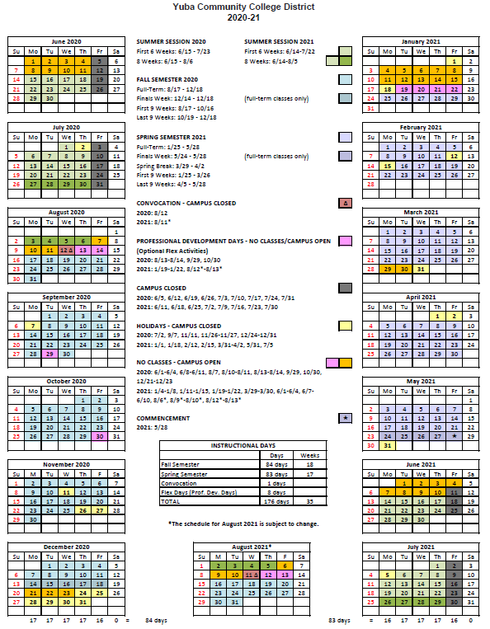
Appendix K: YCCD Academic Calendar

Appendix L: Map of Yuba College, 2088 North Beale Road, Marysville, California, 95901

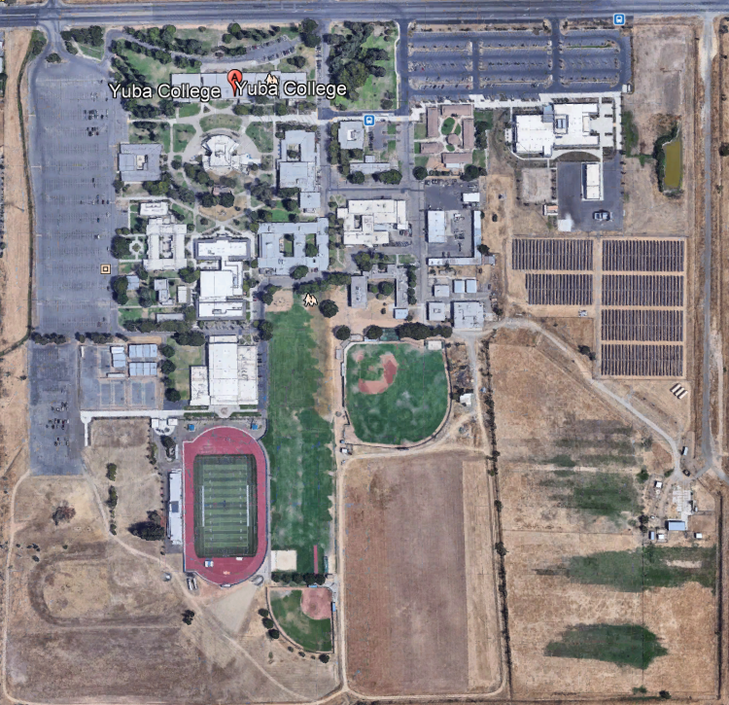

Appendix L, continued: Map of Sutter County Campus (Yuba College), 3301 East Onstott Road, Yuba City, California 95991
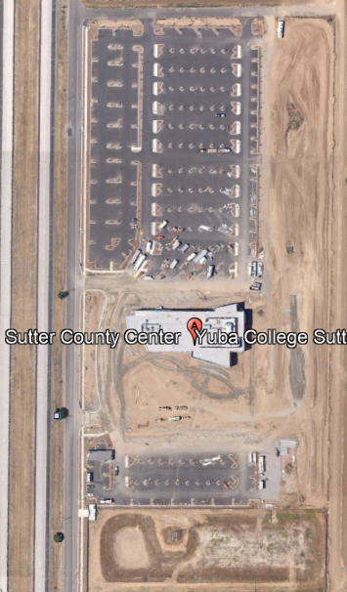
Appendix L, continued: Map of Woodland Community College, 2300 East Gibson Road, Woodland, California, 95776
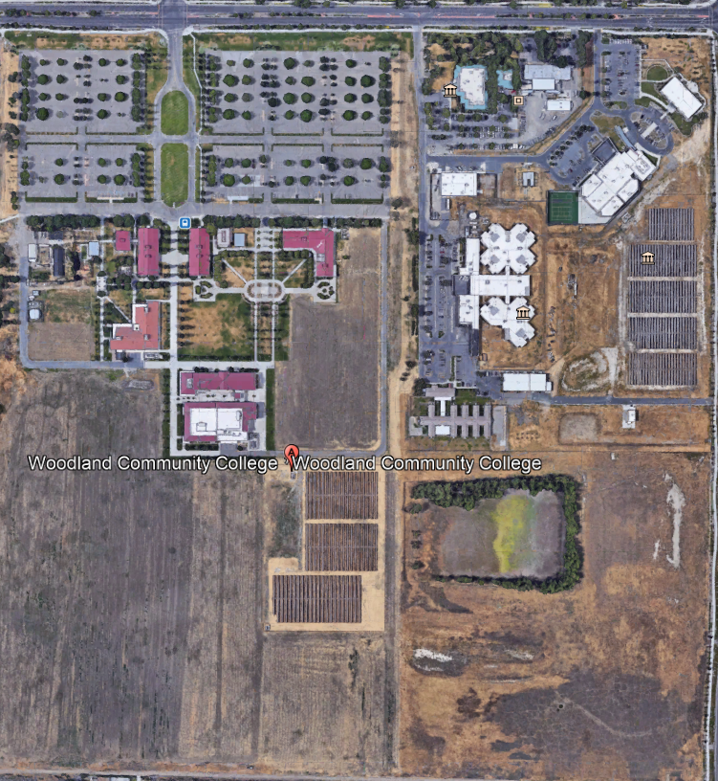
Building 700
Storm Water Pond
Solar Panel Array’s
Sherriff’s Detention Center
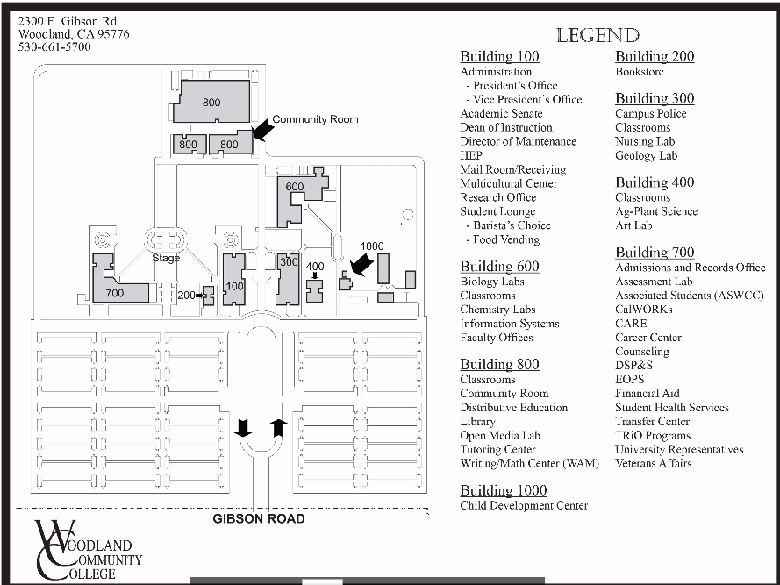

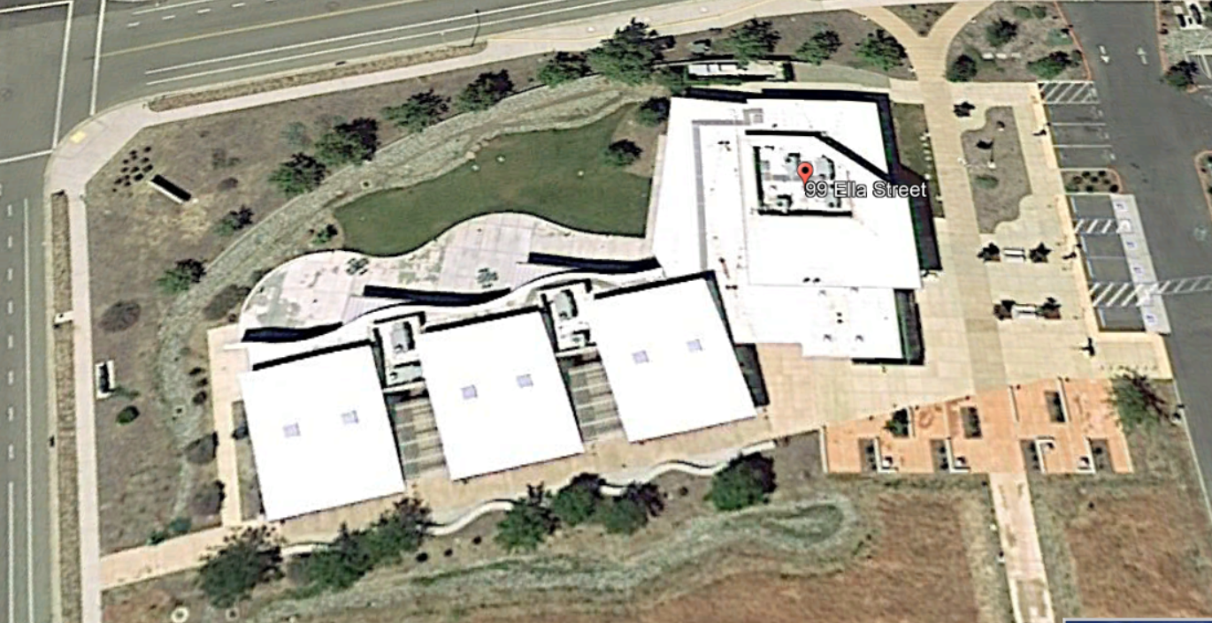
Appendix L: Colusa County Center: 99 Ella Rd, Williams, Ca.

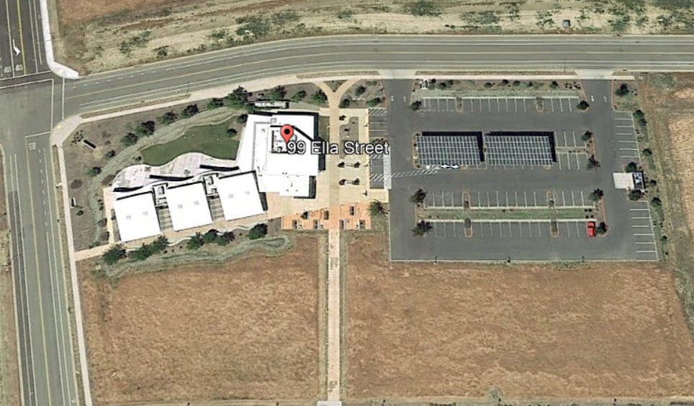

The End.

