Request for Qualification / Proposal

Architectural Services:
Yuba College Building 800 Modernization Project

Yuba Community College District

RFQ/RFP 20-04

Issue Date: August 24, 2020
RFQ/RFP Due: September 21, 2020, 1:00pm, District Office

RFQ/RFP Due Date: September 21, 2020, 1:00pm Sharp, YCCD District Offices Location- Delivered To:

Yuba Community College District, District Offices
Attn.: David Willis
District Director of Facilities Planning, Maintenance & Operations
RFQ/RFP No. 20-04, Request for Qualification/Proposal for Architectural Services: Yuba College, Building 800 Modernization
Address: 425 Plumas Blvd., Suite 200, Yuba City, California, 95991

Proposal Delivery Location, Front Counter at Second Floor
Yuba Community College District
District Offices
425 Plumas Blvd, Suite 200 (second floor)
Yuba City, California, 95991

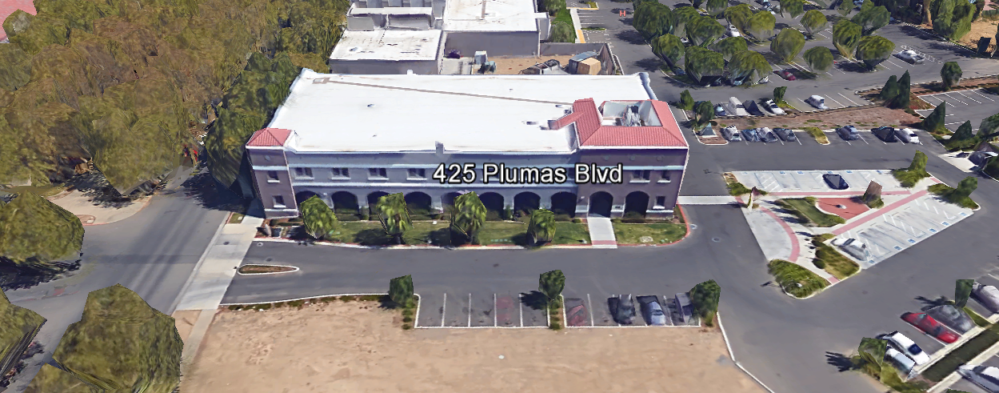
TABLE OF CONTENTS

1.0 INTRODUCTION
1.1 District Information
1.2 Yuba Community College District Background
1.3 Purpose of Request: Architectural Services, Yuba College, Building 800 Modernization
1.4 Applicable Codes
2.0 Pre-Qualification Associated with the following Professional Services Scope of Work (Describe in this Section)
2.1 District Staff Contacts during Proposal Process
3.0 Proposal Format Organization
3.1. Proposal Delivery, Contents, and Format
4.0 Statement of Qualifications
5.0 Selection of Professional Services Provider
6.0 Basis of Award-Not Applicable
7.0 Non-Discrimination
8.0 Evaluation of Proposal-Not Applicable
9.0 Responses to RFQ/RFP
10.0 Requests for Information (RFI)
11.0 Pre-Qualification Schedule
12.0 District Parking
13.0 RFQ/RFP Proposal Requirement Clarifications
14.0 Award of Contract—Not Applicable
15.0 Reservation of Rights

Appendix A, Statement of Qualifications
Appendix B Fee Proposal
Appendix C, Detailed Descriptions of Services Approach
Appendix D, Other Areas of Concern
Appendix E, Previous Project Examples of “Like” Projects-
Appendix F, Critical Project Success Criteria
Appendix G, Academic Calendars
Appendix H, Map of Yuba College Campus
Appendix I, Project Planning Documents
Appendix J, Non-Collusion Affidavit Form
Appendix K, References Form
Appendix L, Signature Proposal Form
Appendix M, Acknowledgement of Addenda Form
Appendix N, Firm W9 Form
Appendix O, Insurance Form
Appendix P, Licenses, Certifications, Documents Proving Qualifications by designated Team Members, Sub-Consultant Engineering Firms, Regionally Certified Estimating Firm.
Appendix Q, Previous Project Awards and Recognitions by various associations, peers, others.

1. INTRODUCTION

  - District Information:

The District consists of two colleges, Woodland Community College and Yuba College, with campuses located at six different locations: Yuba College in Marysville, CA; Sutter County Center in Yuba City, CA; Beale Education Center, Beale AFB, CA; Woodland Community College in Woodland, CA; Colusa County Center in Williams, CA; and Lake County Campus in Clearlake, CA.

  - Yuba Community College District

The Yuba Community College District (YCCD) was founded in 1927 and spans eight counties (Yuba, Sutter, Colusa, Yolo, Lake, Butte, Glenn and Placer) and nearly 4,200 square miles of territory in rural, north-central California. It has colleges in Marysville and Woodland, an educational center in Clearlake, an educational center in Williams, an educational center in Yuba City, and outreach operations at Beale Air Force Base.

  - Purpose of Request: Pre-Qualification of Architectural Firms

The District requests the submission of Statements of Pre-Qualifications and Proposal with support documentation to design and provide contract administration support for the Yuba College Building 800 Modernization project. The anticipated total project budget is $4,800,000.

  - Applicable Codes
All planning work shall meet all Local, State, and Federal Codes, Regulations, and Ordinances.

2.0 Pre-Qualification and Design/Contract Administration Associated with the following Professional Services Scope of Work:
This RFQ/RFQ focuses on two primary objectives:
- Pre-Qualification Information/Evaluation
- Proposal Information/Evaluation

Result: Recommendation of Top Firm for Authorization to Award to the Board of Trustees.
2.1 Pre-Qualification / Design, Contract Administration Services
The Statements of Qualifications and support information shall be associated with the following information.
The scope of work includes the full and comprehensive development of the following:
- Project Review with Staff/College and District Teams, Information Gathering Phase
- Programming/Scope Determination of District/College Requirements
- Preliminary/Schematic Design Documents
  - Drawings (Site Plan, Layouts, Elevations as needed)
  - High Level Milestone Schedule List
  - Rough Cost Estimate of Probable costs
- Design Development Documents
  - Drawings and Specifications
  - High Level Project Schedule
  - Rough Cost Estimate of Probable costs
- Construction Documents
  - Drawings and Specifications
  - Initial More Detailed Overall Project Schedule
  - Cost Estimate of Probable costs
- Division of the State Architect Submission and Coordination through Approval and Project
- Contractor Bidding
- Contract Administration
- Commissioning and Project Close-Out
Planned Service Schedule Per the JCAF 32 Form:
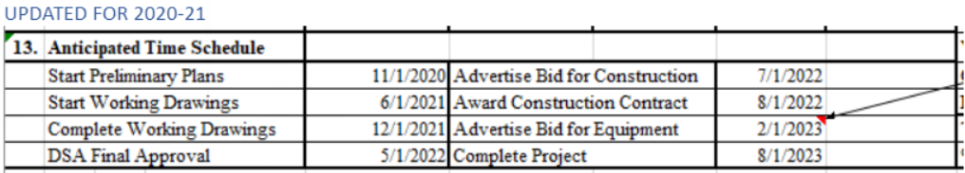

2.1 District Staff Contacts during the Proposal process:
Firms interested in submitting a Proposal are directed not to make personal contact with the Board of Trustees, District staff, or members of the evaluation committee. Any contact shall constitute grounds for disqualification from consideration.
Single Point of Contact during the Request for Qualifications Preparation Process:
David L. Willis
District Director of Maintenance, Operations, and Planning
425 Plumas Blvd., Suite 200 (Second Floor)
Yuba City, California, 95991
Cell Phone: 916-747-4262
Email: dwillis@yccd.edu

3.0 Proposal Format Organization
The Firm is requested to use the following proposal format:
3.1. Proposal Delivery, Contents, and Format:
Proposals should provide straightforward, concise information that satisfies the requirements noted in this RFQ/RFP. Expensive binding, color displays, and the like are discouraged. Emphasis should be placed on brevity, conformity to the Districts instructions, selection criteria of this RFQ/RFP, and completeness and clarity of content. Each Respondent’s proposal should clearly and accurately demonstrate specialized knowledge and experience required for consideration.
In a sealed box or envelope (clearly marked “), submit the following:
- One (1) flash memory stick containing the complete proposal and supporting documentation;
- One (1) original and two (2) copies in paper form of the proposal, which consists of a Proposal Letter and responses to the proposal requirements listed in Section 2.3

Proposals shall adhere to the following requirements for contents and format, should be as concise as possible and should not include more than 50 pages of promotional or marketing materials. There is no page limit overall but each proposal is requested to be no more than 150 physical pages (printing on both sides of each page) in total length.
Firms must comply with the provisions of these instructions for completion and submission of the Proposal. The failure of a Firm to comply with the Proposal Instructions and Requirements will result in rejection of the Proposal for non-responsiveness.

Proposal Section | Format
- Cover Letter | PDF
- Table of Contents | PDF
- Identification of the Firm | PDF
- Executive Summary | PDF
- Staffing Resources | PDF
- Experience
- Proposed Project Team--“Like Projects” Experience of Team Members and Firm | PDF
- Proposed Project Approach | PDF
- Technical Competence | PDF
- Fiscal Stability of Firm | PDF
- Statement of Minimum Qualifications | PDF
- Firm W9 Form | PDF
- Licenses, Certifications, Documents Proving Qualifications by Team Members | PDF
Appendices (See Appendix)
- Statement of Qualifications | PDF
- Fee Proposal | PDF
- Detailed Description of Services Approach—By Proposer | PDF
- Other Areas of Concern | PDF
- Examples of Previous “Like Projects” | PDF
- Critical Project Success Criteria | PDF
- Academic Calendar | PDF
- Map of Yuba College Campus | PDF
- Final Project Proposal (FPP) Documents | PDF
- Non-Collusion Affidavit Form | PDF
- References Form | PDF
- Proposal Signature Form | PDF
- Acknowledgement of Addendum Form | PDF
- Firm W9 Form | PDF
- Insurance Form | PDF
- Licenses, Certifications, Documents Proving Qualifications by designated Team Members, Sub-Consultant Engineering Firms, Regionally Certified Estimating Firm. | PDF
- Previous Project Awards and Recognitions by various associations, peers, others. | PDF

INCLUDE THE FOLLOWING CONTENTS IN THE PROPOSAL PACKAGE:

The following is a summary of the Contents. Please address each section in a Tabbed Format.

A. Cover Letter

The Proposal shall include a Cover Letter on Respondent’s official business letterhead, which shall be signed by an individual authorized to legally bind Respondent. The Cover Letter shall also identify the name and telephone number of a person who may be contacted during the Proposal evaluation process.

B. Table of Contents

Provide a Table of Contents that outlines in sequential order the major sections and sub-sections of the Proposal. All pages in the Proposal shall be clearly and consecutively numbered and correspond to the Table of Contents. Use tabs to allow information to be more easily located. Follow the table in section 3.1 for tab numbers and descriptions.
C. Identification of the Firm
1. Legal name and address of company.
2. Legal form of company (corporation, partnership, etc.).
3. Name, address, phone number, facsimile number, email address, website address, direct email address for the following: Firm’s Principal in Charge, person(s) who will be primarily responsible for providing services for this Proposal Package, and the contact for scheduling an in-person interview if the Firm is selected for one.
4. California Business License Number

D. Executive Summary

The Proposal shall include an Executive Summary that briefly describes the Proposal, the Team, and the approach to meet the District’s goals. The Executive Summary shall describe the approach that will be used to keep costs as low as possible yet provide the services required as described in this RFP and by California State regulations and codes.

E. Staffing Resources

1. Firm Staffing and Key Personnel
a. Provide total number of professional staff currently employed by the firm. Identify person/s who will be principally responsible for working with the District. Indicate the role and responsibility of each person/s, and how many years they have been with the company. Include a brief description of the project team members experience, certifications, licenses, past projects, role on the projects, availability, and capacity to support the project.
If the Firm is chosen as a finalist, the proposed individual/s are strongly encouraged to attend the interview and in-person presentation. First tier sub-consultants are strongly encouraged to attend and participate in the interview process.
c. Provide brief biographies and work experience history of individual/s that will be working directly with the District, highlighting the skills identified with their tasks.
d. Link each named person with the specific tasks, responsibilities, and deliverables.
e. If more than one person is named as a candidate for a specific role, include above information for all listed persons.
f. List all Subcontracted Professional Consulting Firms and provide information regarding the above items 1a, 1b, 1c, 1d, 1e.
2. Interviews: The District does wish to interview the top scoring Firms. The exact number of those firms will likely be at least 2 and as many as 4 firms.

3. Subcontracted Professional Consulting Firms: Firms are encouraged to bring strategic main subcontracting consultant representatives such as the Regional Cost Estimating Firm to the Finalist Interviews.

G. Experience (Firm, Team Members, Professional Sub-Consultants)

- Provide a description of how the Firm’s experience, technical, and professional skills will meet the goals and fulfill the general functions identified in this RFP.

- State the number of years the firm has conducted business. Firm must have at least five (5) years’ experience in providing the outlined scope of required professional services for public clients, preferably community college districts.

- Describe in detail, the depth and extent of design experience in providing large science building or technology building project design and contract administration services for California Community Colleges, Universities or other large public institutions.

- Experience (References)
Provide a description of at least Five (5) most relevant “Like” project services contracts preferably for projects of similar type science OR technology buildings or large renovation projects for California community colleges or four-year colleges and universities, within the last ten (10) years, to include:

  - Role of the firm and relationship to client
  - Planning budget estimate
  - Dollar value of the Firm fee
  - Project Estimate Amount
  - Contractor Bid Amount
  - Change Order Amount and Percentage of Contractor Bid
  - Delivery Method
  - Year Completed
  - Location and Name of Owner/Community College District/University/Other
  - Planning scope description
  - Key Features of the Project
  - Challenges overcome during the project
  - Staffing and major sub-consultants used
  - Project Schedule, Planned Completion Date vs. Final Completion Date
  - Duration of Project Detailed Project Description
- How the project best met the Owners Requirements
  - Contact name, position, entity name, telephone number, facsimile number and email

H. Proposed Project Approach

Describe the conceptual overall project approach that would be taken to complete the proposed project. Describe means and methods, processes and strategies that the Firm has used in the past to generate the types of information and plans that are requested.

Provide examples describing how the Architect’s Team Representative has worked with other diverse higher education teams to minimize student and staff impacts and to possibly phase in the project in a way that best maintains operational life safety capacities of the Science Buildings or Technology Buildings at Yuba College.

Describe overall approach to aligning the scope of the project with both the strategic deliverable criteria by the Owner and the cost of the project without compromising quality and performance and features.

Describe objective examples of how the firm will maximize value, provide lowest “Total Cost of Ownership” using innovative design and construction best practices.

Describe how ethnic cultural diversity of both the students and communities served will be incorporated and encouraged in the design and features of the project.

I. Technical Competence
1. Description of “in-house” resources.
2. Description of “contracted-in” resources. Note: Both Architectural and Architectural Engineering Firms are expected to act as the Lead Professional for the project.
3. Ability to draw upon qualified design staff (in house or contracted) to address the services requested in this RFP.

J. Fiscal Stability:

The Firm should provide evidence of Firm stability including:

1. A current report from any commercial credit rating service such as Dun and
Bradstreet or Experian; OR
2. A letter from a financial institution stating a current line of credit; OR
3. Latest audited financial statement and/or annual report that has been certified by a CPA.

Note: If the Firm would like this information to be “Confidential”, please place this information in a sealed envelope and mark it “Confidential”. The District will not publish or share this information. Please keep this information as a separate electronic document from the proposal on the flash drive.

- Fee Proposal – A fee proposal is requested as part of the RFP process.

A fee proposal is requested as part of this RFP. Submit both a fixed price with a list of anticipated reimbursable expenses and a list of professional position hourly rates:

            - Provide a list of hourly rates for anticipated positions within the Architect’s organizational structure. Additional services shall be billed to the District at the Architect’s contracted hourly rates. Such rates shall include all labor, materials, overhead and profit (OH&P), and other direct and indirect costs.
            - Fees shall be based on an estimated project contractor bid construction cost and not to exceed the amounts listed per the JCAF 32 form for the project. If travel expenses are to be included as part of the reimbursable fee structure, describe in detail the rate charges for specific items and the context in which these fees would be applied. Travel expenses shall be kept to an absolute minimum. Please provide detailed information regarding the breakdown of the fee structure in alignment with the JCAF-32 form.
            - The delivery method for these projects will be the traditional design, bid, build approach. This RFP scope is only associated with and to only include the services described in this RFP, which include the design and project contract administration services, and all other services that are required from the Preliminary Plans and Owners Project Requirements documents through the Final Project Close-out process through DSA project certification.
            - Provide a schedule of values with each item listed separately and to serve as a basis for future progress payments calculations/documentation.

Fee Proposal: See Appendix B

4.0 Statement of Qualifications: See Appendix A

5.0 Selection of Professional Services Provider

The process of Firm selection is based upon the complete responsiveness of the RFQ/RFP and the criteria as outlined below.

Subject to the District’s express reservation of rights to modify the selection process, the selection process anticipated by the District will consist of the following:

  - Information received will be reviewed, scored, evaluated, and discussed, for responsiveness and completeness.
  - Firms will be “Prequalified” with a scoring matrix as outlined in Appendix A. Firms that score higher in the pre-qualification process will also be given additional points and consideration regarding the review and evaluation of the proposal. Firms that do not meet minimum pre-qualification scores/criteria will not be considered during the proposal evaluation process.
  - References will be checked for the top firms.
  - Proposals will be evaluated and scored per the criteria in the RFQ/RFP.
  - In person interviews for the top 2 to 4 Firms require presentations that address the following:, Team members experience working together, experience of other State Matching Funding projects, experience of similar projects, other pre-qualification criteria, project approach, schedule, and answers to follow-up questions regarding the proposal by the District Project Team.

The District Project Proposal Review/Evaluation Team will then select and recommend the top Firm to the Board of Trustees for authorization to award.

Formal award of any Agreement will only be affected after the District’s Board of Trustees have formally approved of such award. The District reserves the right to waive minor irregularities in the solicitation process. The District may award one or more agreements, or no agreements, as a result of this Request for Proposal (RFP) process.

The District reserves the right to reject any and all submittals, to amend the RFP process, and to discontinue or re-open the process at any time. The submittals will be evaluated based on each respondent’s qualifications, proposal criteria, service approach, schedule, and relevant experience.

6.0 Basis of Award

The “Successful” Architectural or Architectural/Engineering Firm will be awarded as providing “Best Value” AND “Best Qualified” Firm for the scope of work as described in this RFP as determined solely by the District. The “Successful” Firm may not be the “Lowest Fee Cost” Firm per the RFP. “Best Qualified” is defined per RFQ/RFP 20-04, entitled,” Yuba College, Architectural Services: Building 800 Modernization Project”.

There is no guarantee expressed or implied that the District will provide work to all or any of the Respondents that submit a response to this RFQ/RFP. It is the intent of the District to award the scope of work described in this RFQ/RFP to a single proposer.

7.0 Non-Discrimination
The District does not discriminate with regard to race, color, gender, national origin, disability, or any other protected or other classification in the awarding of contracts/agreements. The District welcomes all Qualified Firms to participate in the project Request for Proposal process.
The District encourages firms that are women or minority owned, emerging small businesses, veteran owned firms, disabled person owned firms, and all other qualified firms to participate in the qualification process.
The District encourages the submission of proposals from all Firms that can meet the stated requirements set for this RFQ/RFP.

8.0 Evaluation of Proposals Form

Firm: .

Proposals will be evaluated and include a careful review of the proposals and the ability of the firm to perform cost effective solutions as described in this request, including reference checks of the firm doing the work. This RFQ will be evaluated by a District Facilities Management Team and awarded based on a number of factors which are described below:

Evaluation Criteria:

- Firm/Project Team Qualifications, Roles, Experience: 30 Points
- Fee Proposal: 30 Points
- “Like” Science Buildings or Technology Buildings Projects: 20 Points
- Project Approach: 10 Points
- “Other Factors” Described in the RFP: 10 Points
.
.
Total Score: /100 Points

Comments:

Evaluator Name (Print): . Evaluator Signature: .
Date: . Recommendation to Interview/ or Award: Yes/No: .

9.0 Responses to RFP:
Sealed responses to this RFP must be clearly marked "RFQ/RFP NO. 20-04, Architectural Services: Yuba College Building 800 Modernization Project”.

Responses shall be mailed to or hand-delivered to the following address:

Yuba Community College District, District Offices
Attn.: David Willis
District Director of Facilities Planning, Maintenance & Operations
Envelope/Box Marked:
“RFQ/RFP No. 20-04 Architectural Services: Yuba College, Building 800 Modernization Project”.

Address: 425 Plumas Blvd., Suite 200, Room 216, Yuba City, California, 95991

Note: Completely seal your proposals in envelop/box and make sure it gets date/time stamped when delivering proposal. Firms are each 100% responsible to make sure proposals that are mailed using a carrier such as UPS, FED Ex, etc…are received and date/time stamped by District personnel prior to the proposal due date/time. No proposals will be considered if they are late, even if it is only 5 minutes late. Please make sure your proposals are delivered and received promptly prior to the due date/time. There will be a public proposal opening at the due date/time.

Do NOT email your proposals. Proposals that are not sent per the above guidance requirements will not be considered.

10.0 Requests for Information (RFI)

Requests for Information concerning the RFQ/RFP must be in writing and may be submitted via email no later than the date shown below. Please direct all questions to David Willis, email: dwillis@yccd.edu.

Following the RFI deadline, all questions and answers will be summarized and posted on the District's website: https://www.yccd.edu/central-services/purchasing/ , then, click on the “Requests for Proposals / Quotes” tab on the right hand side of this web page. It is anticipated that responses to inquiries received by the required time and date will be provided within 3 business days and posted on the District's website. Should more time be needed by the District to answer I respond to RFI’s, this information will also be posted on the above website.

The District has developed Procurement Milestones, shown below, with dates showing the key events in this solicitation process. This RFQ/RFP and schedule is subject to change, and the Director will notify Respondents of any changes via email to the contact designated by each Respondent. Respondents must take the following actions according to the specified timelines in order to participate in this process.

11.0 Proposal Schedule:

Important Dates and Times:

August 24, 2020: Release of Request for Proposal at 4:00PM

September 2, 2020: 1:30PM Pre-RFQ/RFP Meeting, Yuba College, Building 1400, Maintenance Conference Room, 2088 North Beale Road, Marysville, California, 95901.

Note: Firms are NOT required but strongly encouraged to attend the Pre-Proposal meeting listed above or make arrangements to meet with Dave Willis at the College at another time and date, A sign-in log sheet with contact information shared will be used to provide Addendum’s and any other procurement information in addition to the YCCD Purchasing web page where all procurement information is posted.

September 10, 2020: All questions and requests for information must be submitted to David Willis at: dwillis@yccd.edu by 3pm.

September 14, 2020: Addendum Issued if needed.

September 21, 2020: Proposals due at 1:00 PM SHARP, Yuba Community College District, District Offices Location, Suite 200 (Second Floor), Board Room, 425 Plumas Blvd., Yuba City, California 95991. There will be a public bid opening on this RFQ/RFP.

It is the intention to award this work in mid-October, 2020, after the regularly scheduled Board meeting on October 8, 2020.

The District reserves the right to alter or amend the above timetable as required to conclude the process to the District's satisfaction.

All questions associated with the procurement process shall be addressed to David Willis, District Director of Facilities Planning, Maintenance, and Operations at email: dwillis@yccd.edu or cell phone: 916-747-4262.

12.0 District Parking:

-No parking in Reserved Spaces without a proper permit
-Permit Parking is enforced in all general lots between 6:00 am and 6:00 pm, Monday through Friday. All general lots require a properly displayed, valid permit during these times
-Daily Parking Permits are $2.00
-Permits are available for purchase at any of the permit machines located in the student parking lots
-Failure to get a $2 parking permit whenever parking at any location at the District could result in a parking ticket. Parking tickets can cost $25 each or more per event.
-All other parking regulations are enforced 24 hours a day, seven days a week. This includes designated staff spaces, handicap spaces, timed spaces, red zones, yellow zones, and areas not marked (no parking at any time)
-Once this project is awarded, temporary parking permits will be processed as requested by the successful firm for all service Professional Consulting Firm employees associated with this project at no cost to the Professional Consulting Firm for the duration of the project at each Campus location. These temporary permits must be displayed at all times on the dash board of service Professional Consulting Firm vehicles.

13.0 RFP Proposal Requirement Clarification: Prompt and Complete Proposals

Proposals received after the deadline will not be opened. Each responder shall submit one (1) signed original, three (3) additional hard paper copies, all in separate binders. Provide one electronic format copy of the proposal using electronic media such as a flash drive, CD, etc..

All materials submitted in response to the RFP shall be on 8-1/2"x11" paper, preferably in
Portrait orientation. All submitted materials must be bound in either a three-ring binder or spiral bound notebook. Content shall be tabbed and numbered per the items included in the Submittal Requirements. All Proposals will be reviewed and evaluated by a District Selection Committee. The District at its sole discretion may interview finalists, or select a firm or firms to perform work based solely on the evaluation of the Proposal. There is no page limit. Please be succinct.

All Proposals become the sole property of the District and the content will be held confidential and used for internal District purposes until the selection of the firm is made and the project is awarded. Items stamped or clearly noted “Confidential” by the Proposer will remain confidential and not distributed or published. If the financial information of the Firm is “Confidential” please list it separately and as a separate electronic document from the proposal.

14.0 Award of Contract

- The Contract will be awarded to the most responsible and responsive proposer whose proposal, conforming to the request, will be most advantageous to the District. An Interview process of the top 2 to 4 proposer firms will be included per this RFQ/RFP to allow the District to meet the District and Project Team members of the proposer to further discuss the project approach, schedule, capacities of the proposer to deliver, and any other considerations that warrant further discussion and evaluation.

B. The District reserves the right to enter into an Agreement without further discussion of the proposal submitted based on the initial offers received.

C. The District reserves the right to reject any or all proposals or any part of the proposal and to waive informalities and minor irregularities in the proposals received.

D. The RFQ/RFP, its addendums, and the proposal of the selected Firm will become part of any contract initiated by the District.

F. In no event shall a proposer submit its own standard contract terms and conditions as a response to this RFQ/RFP. The terms of any contract may be negotiated as part of the negotiation process with the exception of contract provisions that are nonnegotiable.

G. A formal contract shall be signed by the successful proposer and Yuba Community College District to perform this service.

H. The District reserves the right to enter into discussions with any one or all of the Responders after Proposals have been initially reviewed. Such responses shall be subject to all provisions, terms and conditions as set forth in the RFQ/RFP, unless otherwise modified.

I. Award shall be made to the Responder whose submittal, conforming to the RFQ/RFP, will be the most advantageous to the District after consideration of the defined evaluation criteria.

J. The District intends to award to a single RFQ/RFP Responder.

K. The “Successful” Architectural Firm will be awarded as providing “Best Value” AND “Best Qualified” Firm for the scope of work as described in this RFQ/RFP as determined solely by the District.

- The “Successful” Firm may not be the “Lowest Fee Cost” Firm per the RFQ/RFP. “Best Qualified” is defined per RFQ 20-04, entitled, “Architectural Services, Yuba College, Building 800 Modernization Project”.

There is no guarantee expressed or implied that the District will provide work to all or any of the Respondents that submit a response to this RFQ/RFP.

15.0 Reservation of Rights

The District reserves the right to:

• Reject any or all submittals at its sole discretions.
• Cancel the Request for Qualifications/Proposal (RFQ/RFP), without cause.
• Modify any requirements contained within the RFQ/RFP and request a revised submission from all Providers.
• Establish other evaluation criteria determined to be in the best interest of the District.
• Contract with any of the firms responding to the RFQ/RFP based solely upon its judgment of the qualifications and capabilities of the firm.

The District reserves the right to cancel the contract any time during the contract period after providing at least a written 14-day notice to the Firm. The District would consider cancellation of the contract if the Firm does not fulfill the contracted requirements of this RFQ/RFP in a timely and professional fashion. This action would be at the full discretion of the District. Termination of the agreement could also occur if for some reason, the performance of the Firm or quality of the work adversely impacts the mission of the District in serving Students or Staff; or, if available funding resources to implement the service contract were no longer available.

This RFQ/RFP does not commit the District to negotiate a contract. The District will not be responsible for any expenses incurred by any firm in preparing and submitting a proposal or response to this RFQ/RFP.

Appendix A: Statement of Qualifications Form

The Respondent shall furnish the following information. Failure to comply with this requirement will render the submittal informal and may cause its rejection. Additional sheets may be attached if necessary.
Basic Requirements: Questions 1 through 16

- Firm name and primary address:

- Telephone: Facsimile:

- Email Address:

- Names and titles of two officers of the firm:
NAME TITLE

4.1
4.2

- Specific type of Ownership (Check one)

5.1 | Individual
5.2 | Partnership
5.3 | Corporation; If a corporation, state the following: State of incorporation:
 | Date of incorporation: President/CEO:
5.4 | Joint Venture
5.5 | Other (Specify)

- Taxpayer Identification
- Number of years Respondent has been in business:
- Number of years Respondent has conducted business under the present name:
- Has the Respondent ever been licensed under a different name or different license number? ? If Yes, give name and license number:
- Number of years’ experience in California Community College, University or educational facility projects .

- Has the Respondent or any of its principals defaulted to as to cause a loss to a surety on a payment or performance bond?

If yes, give dates, name and address of surety, and details:

- Has the Respondent been assessed liquidated damages for any project in the past three years? If so, give owner and details:

- Has the Respondent been in litigation on an issue pertaining to any contract during the past three years?
If yes, explain and provide case name and number.

- Has the Respondent ever failed to complete a project in the past three years? If so, give owner and details:

- Do you now or have you ever had any direct or indirect business, financial or other connection with any official, employee or consultant of the District?
If so, please elaborate.

- Has the Respondent ever completed any work at the Yuba Community College District? If so, please elaborate.

Qualification Criteria:

Questions 17 through 33 Worth 10 Points with Question No. 22 Worth 40 Points= 200 points Total. To be determined as a qualified firm, each firm must score at least 160 points and meet/provide proper information on questions 1 through 16 and other information as described in the RFQ. Scoring is determined through a collaborative internal District process. Firms that do not meet minimum pre-qualification thresholds will not be considered when evaluating proposals. Question 22 must be answered YES to be considered as a qualified proposer.

State matching funding is expected to be released for the Preliminary Planning Phase of the project prior to 11/01/2020.

- Has the Respondent worked with a Community College District with limited financial project resources yet with high expectations to provide high quality learning environments? If so, please elaborate:

- Does the Respondent have any cost-effective ideas to help deliver the scope of work described in this RFQ that would complete the work as described using an alternative approach or utilizing other options? If so, please describe:

- Has the Respondent completed at least five (5) projects of similar scope or new science lab buildings at Colleges/Universities or new science lab buildings for a public entity, or large science lab buildings for a commercial business in the past 10 years? (Please note that at least 3 projects need to have been completed in the past 5 years.) Yes/No If No, please describe why you feel that your firm still qualifies for this project:
If yes, please describe in detail the design/contract administration on projects were completed:

- Has the Respondent completed similar College/University extensive science building lab renovations that required a high level of coordination and planning to phase-in the construction while maintaining at least half of the building to be in operational status during construction in the past 10 years? Yes/No. If No, please describe why you feel that your firm still qualifies for this project:
If yes, please describe the approach that was taken to make this project a success and mitigate any impacts to student/staff/faculty:

- Has the Respondent ever designed and provided contract administration on a California Community College Science Lab Building renovation or new building project? Yes/No If No, please describe why you feel that your firm still qualifies for this project:
If yes, please describe the project team members that worked on that project and if they would be working on this project as well. Describe how this experience helps to qualify your firm for this project.

- Does the Respondent have experience working with the State Chancellors Office and Department of Finance on State Matching Funding projects? If so, please describe at least five (5) similar renovation or new building projects that had State Funding Match that your firm has completed in the past ten (10 years. Projects must be have a total project budget of at least $4,000,000. Yes/No

If No, this will disqualify the Firm from consideration.

If yes, please list the State matching projects completed in the past Five (5) years and describe in detail the design/contract administration on projects were completed and verify that the schedule and all funding requirements were fulfilled with the State Chancellors Office and Department of Finance:

- Please describe some of the ideas that your Firm may have in creating a value enhanced science lab renovation project:

- Please describe how quality assurance will be verified and tracked during the contract administration period of construction. Describe the extent your firm will take to provide project progress reports, documentation, and verification of construction means and methods in alignment with RFI’s, Submittals, and change orders.

- Please describe the level of accuracy percentage your Firm has in providing accurate cost estimates to the District/College prior to receiving the proposals from the contractors. Does your firm have a cost estimating consultant or the capability to perform detailed accurate cost estimates and constructability reviews prior to the submission of the Contract Documents to the Division of the State Architect? Please describe. The District strongly encourages the use of a local certified Cost Estimator to generate the needed cost estimates for the project.

- Please provide several recent examples of the accuracy of your Firm’ cost estimating work on recent (past 5 years) similarly sized ($4 million or greater) Science Building projects in California:

Please provide at least five (5) recent project examples of the Constructability Review process that your Firm’ has used to identify potential gaps in the specifications and drawings and the use of best practices means and methods in the recent past 5 years on similarly sized projects in California: How effective were these reviews? What was the Change order percentage of total construction cost on each of these projects?

- Please describe some of the “diversity” elements/features that your Firm would propose be included into this project. For example, each College serves a diverse demography of students and has a campus “culture”. How does your firm meet these challenges to design welcoming, friendly, bright, safe, healthy environments for all students and faculty.

- Please describe how your Firm would analyze the project to provide “Maximum Value” and Lowest “Total Cost of Ownership” for the life of the upgraded science building spaces. Provide examples of past projects.

- Demonstrated performance of Professional Services on Science Buildings or Technology Building projects with similar or larger scope for higher education OR Public OR Commercial clients. Firm must have completed at least FIVE (5) similar projects in the past 10 years.

Please list and describe the projects. Provide the project budgets, the total amount and percentage of the change orders, if the schedule was completed on schedule, and a description of which team members, sub-consultant team members worked on each project.

- Clearly Describe the Architects Proposed Project Team, the projects that the team has worked together on recently and over the past 5 years, time commitment to the project for each team member, role of each team member, how the proposed Project Team provides maximum value and benefit to the District for this Project.

- At least Five (5) years’ experience as a licensed Architectural or Architectural/Engineering Firm with licensed Science Buildings or Technology Buildings design professionals/Firm in the State of California.

- Established Firm presence in California, including familiarity with the California Community Colleges and Universities. Please list projects completed for Community College Districts in the past Ten (10) years, provide the amount of the project budget, important features of the projects, team members, accuracy of the cost estimates to actual project costs, change order percentage, and ability to complete projects on schedule.

- Appropriate professional California licensing and certifications of key Team Members assigned to work in response to this Request for Proposal and to complete scope of work in fulfillment of all requirements therein. Please list credentials.

Appendix B: Fee Proposal:

A fee proposal is requested as part of this RFQ/RFP. Submit both a fixed price with a list of anticipated reimbursable expenses AND a list of professional position hourly rates:

            - Provide a list of hourly rates for anticipated positions within the Architect’s organization structure. Additional services shall be billed to the District at the Architect’s contracted hourly rates. Such rates shall include all labor, materials, overhead and profit (OH&P), and other direct and indirect costs. Please include hourly rates for first tier design consultants positions that will be required to support this project.

            - Fees shall be based on an estimated project contractor bid construction cost and not to exceed the values in the JCAF 32 form for the project. The Architectural fees shown in the JCAF 32 include reimbursable expenses. The District will directly pay DSA Fees. Do not include DSA Fees in your proposal. Changes required to the design as a result of the DSA review process shall be covered by the base Architectural Firm proposal per this RFQ/RFP. If travel expenses are to be included as part of the reimbursable fee structure, describe in detail the rate charges for specific items and the context in which these fees would be applied. Travel expenses shall be kept to an absolute minimum.

            - The delivery method for this project will be the traditional design, bid, build approach. This RFQ/RFP scope is only associated with and to only include the services described in this RFQ/RFP, which include the design and project administration services, and all other services that are required from the Preliminary Plans, Working Drawings, Coordination with DSA, Review of Contractor Proposals, Contract Administration, through the Final Project Close-out process.

            - Provide a schedule of values aligning with the JCAF 32 Form categories which will serve as a basis for future progress payments calculations/documentation.

              - List Sub-Consulting Fees Separately in the Schedule of Values for each phase of the project.
              - Describe and list each item in the “Other Fees” section.

  - Lower cost fees do score higher during the review and evaluation process. Firms with lower fees below that of the JCAF 32 must provide comprehensive and detailed explanations and reasoning why their fees are lower and how they can still complete all of the scope of work of the project including a thorough review of existing conditions. The District does not have accurate as-built drawings of building 800.

  - The “Best Value” proposal considering “Best Qualified” and “Most Advantageous” Proposal, as determined solely by the District will be recommended to the Board of Trustees for approval to award. The Lowest Cost Proposer may not be the “Best Qualified” or “Most Advantageous” and may (solely at the discretion of the District) not be awarded the project professional services contract as described in this RFQ/RFP. Many factors, as described in this RFQ/RFP, are considered prior to selecting the Firm to be recommended to the Board of Trustees for this Professional Services Contract.
Provide Description of Fees as needed of the items below:

- Preliminary Plans:
$ .

- Working Drawings (Design Development, Contract Documents) :
$ .

- Division of the State Architect Submission, Fees:
$ .

- Contract Administration:
$ .

- Project Close-Out:
$ .

- Other Fees:
$ .

- Total Fees:
$ .

Align all fees with the JCAF 32 form which shows the approved project budget.

Appendix C: Detailed Descriptions of Services Approach

--Provided by the Firm.
Appendix D: Other Areas of Concern:

If any of the following has occurred, please describe in detail:

- Termination or failure to complete a contract.
- Termination by any municipal, county, state, federal or local agency.
- Involvement in litigation, arbitration or mediation.
- Provide litigation history for any claims filed by your firm or against your firm related to the provision of Professional Consulting services in the last five (5) years.

- Conviction of the firm or its principals for violating a state or federal antitrust law by bid or proposal rigging, collusion, or restrictive competition between bidders or proposers, or conviction of violating any other federal or state law related to bidding or performance of Professional Consulting services.

- Conviction of a Felony of any of the members of the project team.
- Knowing concealment of any deficiency in the performance of a prior contract.
- Falsification of information or submission of deceptive or fraudulent statements in connection with a contract.

- Willful disregard for applicable rules, laws or regulations.

- Loss of State mating funding or significant delays as a result of the Architectural Firms services with greater than 6 months on a California State matching funds project.

Firms are required to respond with a “Yes” or “No” to the above listed items and to describe with detail any of the above items that have a Yes answer.

Information regarding any of the above may, at the sole discretion of the District, be deemed to indicate an unsatisfactory record of performance. Failure to disclose any of the above may, at the sole discretion of the District, be deemed to indicate an unsatisfactory record of performance.

Appendix E: Previous Project Examples of “Like” Projects

Examples of Previous “Like Projects” and associated Architectural and Engineering Professional Services Work. Description of and examples of cost control, constructability, minimization of change order, traditional Design/Bid/Build deliverable method, California Community College Districts projects, and more information scores higher.

Clarification: Requesting projects with Science Building renovations within the past 10 years. Other major Science Building projects with a construction value of over $4,000,000 may also be used as a reference. Describe how each project was successful in meeting the owner’s requirements. Describe the team members and sub-consultants roles. Describe how this experience adds value to this project.

Appendix F: Critical Project Success Criteria:

Specifically, what can the District/College expect regarding the following criteria:

            - Project Cost: +/- % Within Budget
            - Change Orders: +/- % After Award
            - Schedule: Compared to State Milestone Dates in JCAF 32 Form.

Appendix G: YCCD Academic Calendars

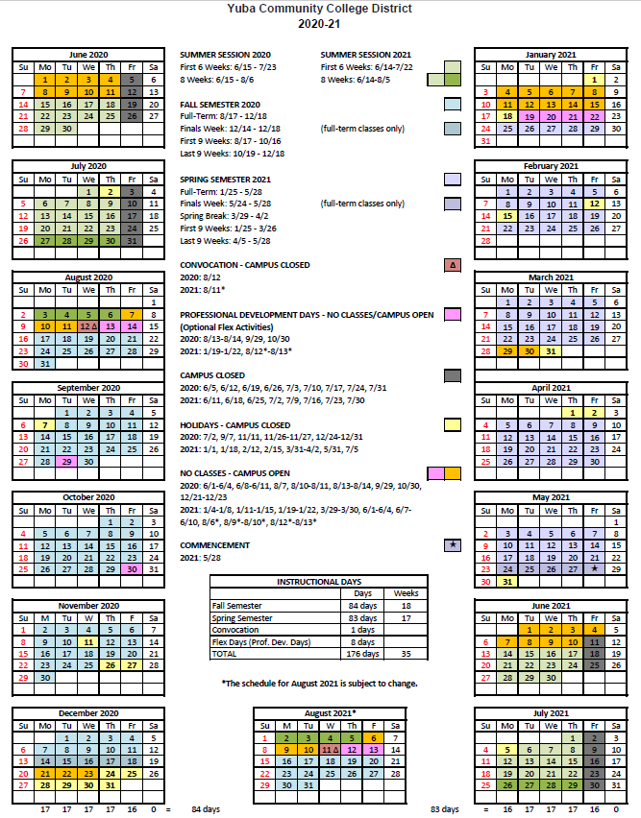

Appendix H Map of Yuba College, 2088 North Beale Road, Marysville, California, 95901

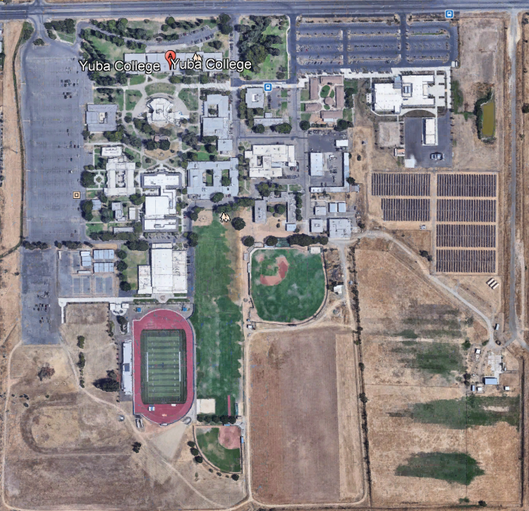
Building 800

Appendix I: Project Planning Documents:

Final Project Proposal Documents:
https://goyccd-my.sharepoint.com/:f:/g/personal/w0398409_yccd_edu/EvZOg9TprS9EsJBEqGlfqT0BySRmD9WpADOVxCfFe1j3fQ?e=7RZ8fc

Referenced Existing Building 800 Drawings:
https://goyccd-my.sharepoint.com/:f:/g/personal/w0398409_yccd_edu/Ev_WVNyZJbRFkzu6v8FwZ1QBVssferxNMGF8IA3AHTsQyg?e=Vaz6D1

See next page for JCAF 32. Note: The State Chancellors Office will be issuing a revised JCAF 32 form to reflect the change in funding year. When it is issued, it will be shared. If it is issued during the proposal process, it will become part of a future Addendum that will be published and posted online in the District’s Purchasing web page. Please align your Firm’s fees with the latest JCAF 32 form that is available and shared.

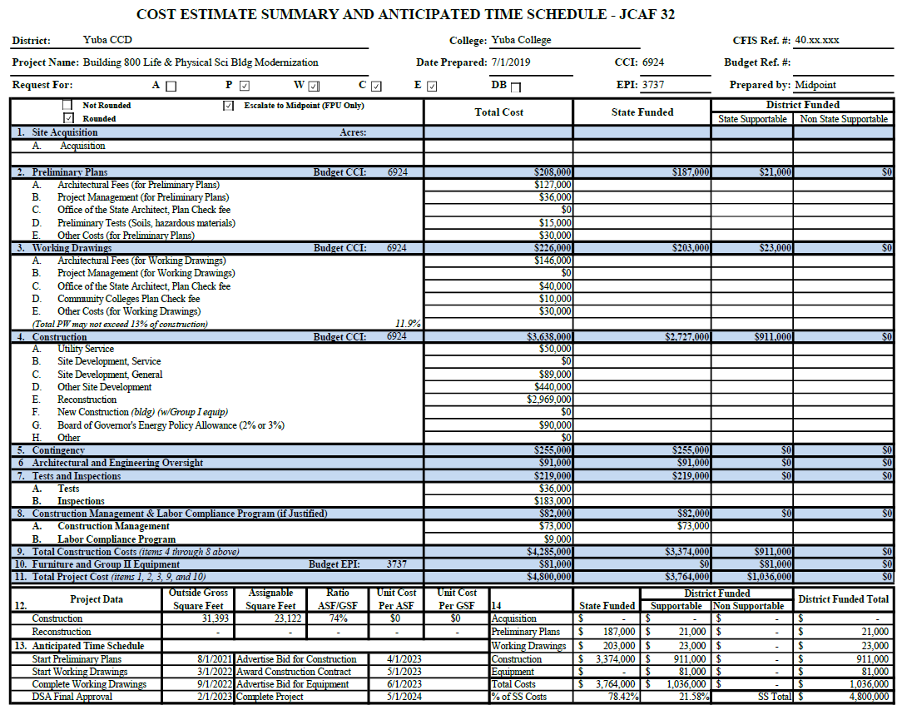

Appendix “J” Non-Collusion Affidavit Form
STATE OF CALIFORNIA, COUNTY OF I, being first duly sworn, deposes and says that I am the of , the party submitting the foregoing proposal (“the Proposal”). In connection with the foregoing Proposal, the undersigned declares, states and certifies that:
- The Proposal is not made in the interest of, or on behalf of, any undisclosed person, partnership, company, association, organization or corporation.
- The Proposal is genuine and not collusive or a sham.
- The Firm has not directly or indirectly induced or solicited another Firm to put in a false or sham proposal, and has not directly or indirectly colluded, conspired, connived, or agreed with any other Firm or anyone else to put in a sham proposal, or to refrain from bidding.
- The Firm has not in any manner, directly or indirectly, sought by agreement, communication, or conference with anyone to fix the proposal price, or that of any other Firm, or to fix any overhead, profit or cost element of the proposal price or that of any other Firm, or to secure any advantage against the public body awarding the contract of anyone interested in the proposed contract.
- All statements contained in the Proposal and related documents are true.
- The Firm has not, directly or indirectly, submitted the proposal price or any breakdown thereof, or the contents there of, or divulged information or data relative thereto, or paid, and will not pay any fee to any person, corporation, partnership, company, association, organization, proposal depository, or to any member or agent thereof to effectuate a collusive or sham proposal.
Executed on this date: 2020, at:

(City, County, and State)
I declare under penalty of perjury under the laws of the State of California that the foregoing is true and correct.
Signature Printed Name .
Address:
Area Code & Phone Number: .
Note: In addition to other bid documents, bidders on public works projects are required by Public Contract Code section 7106 to submit a certification form that they have not colluded with another proposer.

Appendix “K” References Form (Example Template)

Bidder shall provide a minimum of Five (5) verifiable references with current contact information, preferably from a California public educational institution and/or California public agency, within the last 5 years. See clarification note below regarding reference requirements. All phone numbers and emails must be current (please verify).
REFERENCE #1
NAME
ADDRESS
CITY, STATE ZIP CODE
TELEPHONE #
CONTACT
DATES OF SERVICE
REFERENCE #2
NAME
ADDRESS
CITY, STATE, ZIP CODE
TELEPHONE #
CONTACT
DATES OF SERVICE
REFERENCE #3
NAME
ADDRESS
CITY, STATE, ZIP CODE
TELEPHONE #
CONTACT
DATES OF SERVICE

You may of course use the Firm’s established reference template.

Appendix “L” Proposal Signature Form
The undersigned acknowledges the following:
- Having become familiar with the specifications and requirements of the Request for Proposal, hereby offers to provide all services in accordance with the proposal set forth herein, including all referenced material and attachments.
- By submitting a signed proposal in response to this solicitation, the Firm acknowledges that they completely understand the scope of the needed services and that the proposed services as described in the proposal will meet or exceed the needs of the District.
- Late proposals will not be accepted (even if they are only 5 minutes late).
- The District reserves the right to reject any and all proposals and that this proposal shall remain open and not be withdrawn for a minimum of 90 days.
- Cancellation Clause: The District may, without cause, terminate the contract(s) or a project under the contract(s) by giving written notice of such termination to the awarded firm. In the event of such termination the District shall reimburse the firm for services performed and reasonable expenses actually incurred by the firm in relation to the terminated project prior to the firm’s receipt of such notice of termination. The cost of proposal generation, associated travel, copies, postage, etc.., will not be reimbursed and is considered a typical and normal part of the bid process and is not reimbursed for any of the proposers.
- If the prospective Firm is a corporation, the undersigned hereby represents and warrants that the corporation is duly incorporated and is in good standing in the state of California , and that, , is authorized to act for and bind the corporation.

Entity Type (Select One):

Sole Owner: Partnership: .

Corporation: .

Other; Please specify;

Regular monthly progress payments are made using NET 30 as a basis for payment, with Net 30 time starting after receipt of the invoice with all required support documentation, and once this information is reviewed and approved by the District.
Signature_____________________________ Date: _______________________
Position: _____________________________
Print name____________________________ Title________________________

Notary Required On This Project
Notary Stamp:

Appendix M: Acknowledgement of Addenda Form

The undersigned acknowledges receipt of the following addenda from the District pursuant to the Request for Proposal:
Acknowledgement: Yes or Not Applicable
Addendum No. 1: .
Addendum No. 2: .
Addendum No. 3: .
Addendum No. 4: .
Addendum No. 5: .

Appendix N: Firm W9 Form

--Provided by Firm

Appendix O: Insurance Form

--Provided by Firm

Appendix P: Licenses, Certifications, Documents Proving Qualifications by designated Team Members, Sub-Consultant Engineering Firms, Regionally Certified Estimating Firm.

--Provided by Firm

Appendix Q: Previous Project Awards and Recognitions by various associations, peers, others.

--Provided by Firm.

The End.

