Request for Proposal
Yuba Community College District
Yuba College, Cell Tower Land Lease

No. RFP 20-03

Issue Date: August 14, 2020
RFP Due: September 10, 2020

RFP Due Date: September 10, 2020; 1:00pm Sharp, Yuba College Location Delivered To:

Yuba Community College District, District Offices
Attn.: David Willis
District Director of Facilities Planning, Maintenance & Operations
RFP No. 20-03 YCCD Yuba College Cell Tower Land Lease
Address: 425 Plumas Blvd., Suite 200, Yuba City, California, 95991

Proposal Delivery Location, Front Counter at Second Floor
Yuba Community College District
District Offices
425 Plumas Blvd, Suite 200 (second floor)
Yuba City, California, 95991

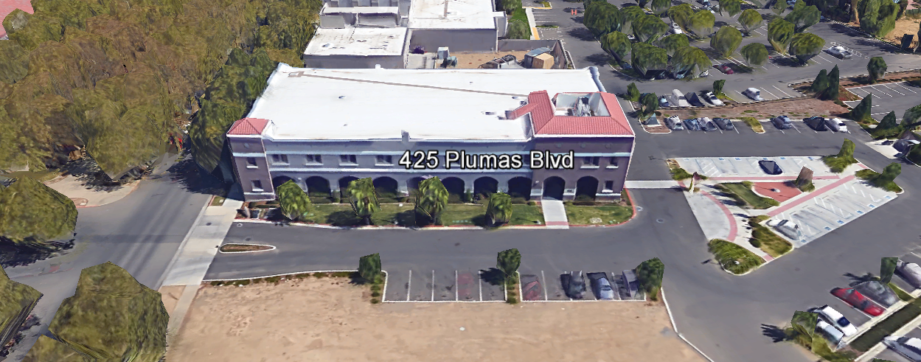
TABLE OF CONTENTS

1.0 INTRODUCTION
1.1 District Information
1.2 Yuba Community College District Background
1.3 Purpose of the Request
1.4 Applicable Codes
2.0 Projects Summary
2.1 District Staff Contacts during Proposal Process
3.0 Proposal Format Organization
3.1. Proposal Delivery, Contents, and Format
4.0 Selection of New Cell Phone Tower Proposer
5.0 Basis of Award
6.0 Non-Discrimination
7.0 Evaluation of Proposals
8.0 Responses to RFP
9.0 Requests for Information (RFI)
10.0 Proposal Schedule
11.0 District Parking
12.0 RFP Proposals
13.0 Award of Contract/Proposal
14.0 Reservation of Rights
15.0 Bid Bond, Insurance, Payment Bond, Performance Bond Requirements (unless exempted per Public Contract Code)

Appendix A, Land Lease Payment Proposal Information
Appendix B, Acknowledgement of Addenda Form
Appendix C, Statement of Qualifications Form
Appendix D, Proposed Land Lease Agreement
Appendix E, Site Map locating the proposed tower, picture of “like” tower, suggest using a Google Earth Satellite Picture with location of tower clearly shown.
Appendix F, New Cell Phone Tower Overall Process Description
Appendix G, Other Areas of Concern
Appendix H, Examples of Previous “Like Projects”
Appendix I, Academic Calendar
Appendix J, Map of Yuba College Campus
Appendix K, Non-Collusion Affidavit Form
Appendix L, References Form
Appendix M, Signature Proposal Form
Appendix N, Firm W9 Form
Appendix O, Insurance Form
Appendix P, Licenses, Certifications, Documents Proving Qualifications
Appendix Q, Example drawings/elevation of proposed 100’ artificial tree cell tower. Pictures of previous similar tower projects.

1. INTRODUCTION

  - District Information:

The District consists of two colleges, Woodland Community College and Yuba College, with campuses located at six different locations: Yuba College in Marysville, CA; Sutter County Center in Yuba City, CA; Beale Education Center, Beale AFB, CA; Woodland Community College in Woodland, CA; Colusa County Center in Williams, CA; and Lake County Campus in Clearlake, CA.

  - Yuba Community College District

The Yuba Community College District (YCCD) was founded in 1927 and spans eight counties (Yuba, Sutter, Colusa, Yolo, Lake, Butte, Glenn and Placer) and nearly 4,200 square miles of territory in rural, north-central California. It has colleges in Marysville and Woodland, an educational center in Clearlake, an educational center in Williams, an educational center in Yuba City, and outreach operations at Beale Air Force Base.

  - Purpose Of Request

The Yuba Community College District seeks to lease space to a qualified firm to own, operate and develop wireless communications facilities for the installation of telecommunications equipment upon property owned by the District and located at Yuba College. Respondents shall primarily focus on analyzing the potential of the Yuba College Campus location and submit a proposal.

All proposals must include all costs such as site investigation, surveys, electrical utilities infrastructure and locations for tie-in and new services, separate PG&E meter, fencing, generator, power conditioning, and the cell phone tower itself, all permits and local city/county approvals, design construction documents and specifications, all construction, all monitoring tie-in such as cell phone transmitter or other means, security camera, exterior lighting, emergency power generator (if required), roadway access, and other site improvements required for the installation of specific cell phone towers.

Example pictures of other similar Cell Phone Towers similar to that which is included in this RFP shall be provided in this proposal. The height of the tower shall be described. The frequency and strength of the signals on the tower and if there are any possible adverse effects to Campus WIFI signals and Police/Maintenance radio signals shall be noted in this proposal. Provide safety data that assures that the new cell phone tower will not pose any safety issues to the Students, Faculty, and Staff of the College.

The new Cell Tower shall support up to at least four cell phone service carriers.

The Lessee shall be fully responsible for obtaining all permits in accordance with all applicable federal, state, and local laws, regulations and codes; shall bear all costs of construction and maintenance of its facilities; and shall install all equipment and facilities in such manner as will minimize any impact upon the operation or use of the property by the District. Any damages to the property that occur as a consequence of the installation of equipment and facilities by the Lessee apparatus will be repaired to the satisfaction of the District by the Lessee.

All required permits and ongoing expenses with PG&E (including utilities, testing, metering, monitoring, etc..) shall be processed, coordinated, and paid for by the Cell Phone Tower provider.

All required permits, code compliance coordination, local ordinances, and meetings with local Planning Commissions and City/County regulators and councils shall be provided and supported including all costs by the Cell Phone Tower providers as part of this proposal.

Cell phone signal strength studies shall be made as required and all costs provided by the Cell Phone Tower provider.

All FCC and other Federal and State licenses shall be provided and included with all costs and coordination shall be included in this proposal process.

All utilities costs, maintenance, testing, permitting, reporting, and other operational requirements and all costs associated with the ongoing operations of the cell phone towers shall be borne by the cell phone tower provider, and included in this proposal.

A DRAFT Agreement shall be developed and included in the RFP response. Monthly or Quarterly compensation to the District shall be included in the agreement to lease the land for a determined number of years with a percentage increase per year.

The District is suggesting the following minimum compensation levels in the agreement:

  - The term of the lease is for up to ten years, and will include up to five automatic renewal periods of up to five years each, up to a total of not more than 50 years, as agreed between the Yuba Community College District (“District”) and the successful bidder.
  - The minimum rental amount for the lease of the Property will be a payment of at least $1,350 to $2,500 each month, with an increase in the rental amount of at least 7.5% every five years.
  - The successful bidder shall construct a cell phone tower on the Property, the exact location of which will be approved by the District. The cell phone tower shall be a 100-foot-high artificial coniferous tree structure with capacity of at least four cell phone carriers, unless otherwise agreed to by the District.
  - All construction costs for the cell phone tower, the utilities, connections, fencing, permits, fees, inspections, approvals, and all other items or costs related to the construction, installation, or maintenance of a cell phone tower shall be the sole responsibility of the successful bidder.
  - The District and the successful bidder shall negotiate and include a revenue sharing amount for each cell phone carrier.
  - The District must approve the successful bidder’s proposed cell phone tower construction documents.
  - The successful bidder shall submit the cell phone tower construction documents to the Division of the State Architect (DSA) for review and approval prior to construction.

A description of all proposed cell phone service providers shall be listed and described as part of this agreement. If additional providers are added to the tower later after the initial contract is processed, then additional compensation to the District is encouraged as part of this proposal process.

The District would like three (3) half-sized 24” x 30” drawings and specifications of the design construction drawings at the 50%, 75%, 95%, and 100% phases of the process for review and approval by the District/College teams. Electronic digital copies of the drawings and specifications are also required. Elevations of the towers must be included in the drawings. A site drawing showing the exact location and all underground utilities must be included. All designs must be stamped and signed by a licensed engineer in the State of California. Structural calculations must be included.

The design construction drawings for the New Wireless Communications/Cell Phone Towers must be approved, signed and stamped Division of the State Architect (DSA) prior to bidding the construction work. All fees must be paid by the proposer.

The District will hire a DSA, Inspector of Record (IOR) to inspect the work of the Proposer in constructing the tower and footing, underground utilities, etc..

Sample drawings/sketches of the proposed location of the Cell Phone Towers with height of the tower shall be submitted with the proposals.

Yuba College Address: Yuba College Campus
2088 North Beale Road, Marysville, California 95901

Other District/College optional/potential land-lease locations may also be considered at these locations:
  - Yuba College (Sutter Campus)
3301 East Onstott Road, Yuba City, California 95991
  - Woodland Community College
2300 East Gibson Road, Woodland, California 95776
  - Woodland Community College (Lake County Campus)
15880 Dam Road Extension, Clear Lake, California 95422
  - Woodland Community College (Colusa County Center)
99 Ellis Street, Williams, California 95987

This RFP proposal process primarily focuses on the Yuba College Campus Location. If the other listed locations are of interest to the Firm to propose on in the future, simply express an interest in these locations and the District will initiate a similar process for any one or more of these locations. Please do not however submit a proposal for these locations at this time. Per Ed Code, the District will be required to get a District Governance Board Authorized Resolution to seek Land Lease agreements before initiating an RFP process.

  - Applicable Codes
All Facilities Standards Updates shall meet all State of California Building Codes, and Federal codes, and local ordinances.
2.0 Projects Summary
The District is seeking proposals from qualified Firms regarding a Land Lease Agreement for a Firm to construct, maintain, and operate a New Cell Phone Tower at the Yuba College Campus location.
2.1 District Staff Contacts during the Proposal process:
Firms interested in submitting a Proposal are directed not to make personal contact with the Board of Trustees, District staff, or members of the evaluation committee. Any contact shall constitute grounds for disqualification from consideration.
Single Point of Contact during the Proposal Preparation Process:
David L. Willis
District Director of Maintenance, Operations, and Planning
425 Plumas Blvd., Suite 200 (Second Floor)
Yuba City, California, 95991
Cell Phone: 916-747-4262
Email: dwillis@yccd.edu

Please email Dave Willis to verify that your firm will be submitting a proposal in response to this procurement process.

On-site coordination, first contact person (Yuba College, Sutter Campus Locations):
Bryan Epp
Assistant Director of Maintenance, Operations
2088 North Beale Road
Marysville, California, 95901
Cell Phone: 530-701-9202
Email: bepp@yccd.edu

On-site coordination, first contact person (Woodland Community College, Lake County Campus, Colusa County Center Locations):
Michael Sinn
Assistant Director of Maintenance, Operations
2300 East Gibson Road
Woodland, California, 95776
Cell Phone: 530-575-0206
Email: msinn@yccd.edu

3.0 Proposal Format Organization
The Firm is requested to use the following proposal format:
3.1. Proposal Delivery, Contents, and Format:
Proposals should provide straightforward, concise information that satisfies the requirements noted in this RFP. Expensive binding, color displays, and the like are discouraged. Emphasis should be placed on brevity, conformity to the Districts instructions, selection criteria of this RFP, and completeness and clarity of content. Each Respondent’s proposal should clearly and accurately demonstrate specialized knowledge and experience required for consideration.
In a sealed box or envelope (clearly marked “), submit the following:
- One (1) flash memory stick containing the complete proposal and supporting documentation;
- One (1) original and two (2) copies in paper form of the proposal, which consists of a Proposal Letter and responses to the proposal requirements listed in Section 2.3

Proposals shall adhere to the following requirements for contents and format, should be as concise as possible and should not include more than 30 pages of promotional or marketing materials. There is no page limit overall but each proposal is requested to be no more than 100 physical pages (printing on both sides of each page) in total length.
Firms must comply with the provisions of these instructions for completion and submission of the Proposal. The failure of a Firm to comply with the Proposal Instructions and Requirements will result in rejection of the Proposal for non-responsiveness.
Proposal Section |  | Format
- Cover Letter |  | PDF
- Table of Contents |  | PDF
- Identification of the Firm |  | PDF
- Executive Summary |  | PDF
- Staffing Resources |  | PDF
- Experience |  | PDF
- Technical Competence |  | PDF
- Fiscal Stability |  | PDF
- Land Lease Proposal: See Appendix A, D |  | PDF
- Cell Phone Tower Provider/Firm Licenses, Certifications, Documents Proving Qualifications |  | PDF
Appendices
- Land Lease Payment Proposal Information  - Initial Monthly Land Lease Payment with Single Carrier:$ .  - Revenue Sharing Per Additional Carrier: $ .  - Initial Term (Years): .  - Percentage Increase Every Renewal Period: .  - Number of Renewing (5) Year Terms: .  - Total Length of Land Lease Terms: .  - Other:  Refer to section 1.3 for minimum requirements. |  | PDF
- Acknowledgement of Addendum Form | PDF
- Statement of Qualifications
- Proposed “Land-Lease Agreement” | PDF
- Site Map locating the proposed tower, picture of “like” tower, suggest using a Google Earth Satellite Picture with location of tower clearly shown. | PDF
- New Cell Phone Tower Overall Process Description | PDF
- Other Areas of Concern | PDF
- Examples of Previous “Like Projects” | PDF
- Academic Calendar | PDF
- Map of Yuba College Campus | PDF
- Non-Collusion Affidavit Form | PDF
- References Form | PDF
- Proposal Signature Form | PDF
- Firm W9 Form | PDF
- Insurance Form | PDF
- Licenses, Certifications, Licenses, Documents Proving Qualifications | PDF

CONTENTS OF PROPOSAL PACKAGE

The following is a summary of the Contents. Please address each section in a Tabbed Format.

A. Cover Letter

The Proposal shall include a Cover Letter on Respondent’s official business letterhead, which shall be signed by an individual authorized to legally bind Respondent. The Cover Letter shall also identify the name and telephone number of a person who may be contacted during the Proposal evaluation process.

Executive Summary: Provide an overview of the entire proposal package and a summary of the approach.

B. Table of Contents

Provide a Table of Contents that outlines in sequential order the major sections and sub-sections of the Proposal. All pages in the Proposal shall be clearly and consecutively numbered and correspond to the Table of Contents. Use tabs to allow information to be more easily located.
C. Identification of the Firm
1. Legal name and address of company.
2. Legal form of company (corporation, partnership, etc.).
3. Name, address, phone number, facsimile number, email address, website address, direct email address for the following: Firm’s Principal in Charge, person(s) who will be primarily responsible for providing services for this Proposal Package, and the contact for scheduling an in-person interview
if the Firm is selected for one.
4. California Business License Number (as applicable)
5. Other Licenses

D. Executive Summary

The Proposal shall include an Executive Summary that briefly describes the Proposal, the Team, and the approach to meet the project requirements.

E. Staffing Resources

1. Firm Staffing and Key Personnel
a. Identify person/s who will be principally responsible for working with the District. Indicate the role and responsibility of each person/s, and how many years they have been with the company. If the Firm is chosen as a finalist, the proposed individual/s must attend the interview and in-person presentation.
b. Provide brief biographies and work experience history of individual/s that will be working directly with the District, highlighting the skills identified with their tasks.
c. Link each named person with the specific tasks, responsibilities, and deliverables.
d. If more than one person is named as a candidate for a specific role, include above information for all listed persons.
F. Experience

- Provide a description of how the Firm’s experience, technical, and professional skills will meet the goals and fulfill the general functions identified in this RFP.

- State the number of years the firm has conducted business. Firm must have at least five (5) years’ experience in providing the outlined scope of required services in California.

- Describe experience designing and delivering projects under the oversight of the Division of State Architect (DSA). If the Firm does not have experience working with DSA, the Firm is required to hire a Consulting Architectural Firm or other Qualified Consultant to guide and facilitate the process.

- Cell Tower Provider Projects Experience (References)
Provide a description of at least five (5) most relevant similar projects with cell phone towers contracts held by the firm, preferably involving projects for California community colleges or four-year colleges and universities, no more than one page per project, to include:

• Role of the firm and relationship to client
• Project Scope description
• Staffing and major sub-consultants used
• Duration of project
• Planning work through DSA/agency approval? Yes/No
• Contact name, position, entity name, telephone number, facsimile number and email

G. Proposed Project Team

The Proposal shall include a brief description of the project team members that will be assigned to work on the projects in this RFP.
H. Technical Competence
1. Description of in-house resources.
2. Ability to draw upon multi-disciplinary staff (in house or contracted) to address the services requested in this RFP.

I. Fiscal Stability: The Firm should provide evidence of Corporate/Firm stability including:

1. A current report from any commercial credit rating service such as Dun and
Bradstreet or Experian; or
2. A letter from a financial institution stating a current line of credit; and
3. Latest audited financial statement and/or annual report that has been certified by a CPA.

4.0 Selection of “Firm” Services Provider

The process of “Firm” selection is based upon the complete responsiveness of the RFP and the criteria as outlined below.

Subject to the District’s express reservation of rights to modify the selection process, the selection process anticipated by the District will consist of the following:

  - Qualifications of the Firm.
  - The Proposal as outlined in this RFP.
  - Interviews

The Review Committee will then recommend the highest ranked firm and “Best Value” projects to the Board of Trustees for approval.

The District reserves the right to reject any and all submittals, to amend the RFP process, and to discontinue or re-open the process at any time.

5.0 Basis of Award

As the basis of award the District intends to utilize the determination of “Best Value” in providing the stated services to the District. There is no guarantee expressed or implied that the District will award all or any of the projects stated in the RFP.

6.0 Non-Discrimination
The District does not discriminate with regard to race, color, gender, national origin, disability, or any other protected or other classification in the awarding of contracts/agreements. The District welcomes all Qualified Firms to participate in the project Request for Proposal process.
The District encourages firms that are women or minority owned, emerging small businesses, veteran owned firms, disabled person owned firms, and all other qualified firms to participate in the proposal process.
The District encourages the submission of proposals from all Firms that can meet the stated requirements set for this RFP.
7.0 Evaluation of Proposals

All proposals will be reviewed and evaluated by the District. An award will be made, if at all, to the responsive and responsible respondent offering the most advantageous “Best Value” proposal taking into consideration all evaluation criteria provided herein, as well as price.
Evaluation of Proposals Form

Firm: .

Proposals will be evaluated by a District Facilities Management Team and awarded based on a number of factors which are described below:

Evaluation Criteria:

- Firm/Project Team Qualifications: 20 Points
- Proposed Land-Lease Terms: 60 Points
- “Like” Projects and References: 10 Points
- Division of the State Architect (DSA) Experience: 10 Points
Total Score: /100 Points

Comments:

Evaluator Name (Print): . Evaluator Signature: .
Date: . Recommendation to Award Yes/No: .
8.0 Responses to RFP:
Sealed responses to this RFP must be clearly marked RFP NO. 20-03, YCCD Yuba College, Cell Tower Land Lease”.

Responses shall be mailed to or hand-delivered to the following address:

Yuba Community College District, District Offices
Attn.: David Willis
District Director of Facilities Planning, Maintenance & Operations
Envelope/Box Marked:
“RFP No. 20-03 YCCD Yuba College, Cell Tower Land Lease”.
Address: 425 Plumas Blvd., Suite 200, Room 216, Yuba City, California, 95991

Note: Completely seal your proposals in envelop/box and make sure it gets date/time stamped when delivering proposal. Firms are each 100% responsible to make sure proposals that are mailed using a carrier such as UPS, FED Ex, etc…are received and date/time stamped by District personnel prior to the proposal due date/time. No proposals will be considered if they are late, even if it is only 5 minutes late. Please make sure your proposals are delivered and received promptly prior to the due date/time. There will be a public proposal opening at the due date/time.

Do NOT email your proposals. Emailed proposals that are not sent per the above guidance requirements will not be considered.

9.0 Requests for Information (RFI)

Requests for Information concerning the RFP must be in writing and may be submitted via email no later than the date shown below. Please direct all questions to David Willis, email: dwillis@yccd.edu.

Following the RFI deadline, all questions and answers will be summarized and posted on the District's website: https://www.yccd.edu/central-services/purchasing/ , then, click on the “Requests for Proposals” tab on the right hand side of this web page. It is anticipated that responses to inquires received by the required time and date will be provided within 5 business days and posted on the District's website or responded to per the dates listed in the RFP for addendum publishing. Should more time be needed by the District to answer I respond to RFI’s, this information will also be posted on the above website. Include the following in the subject matter field on emails when requesting information: “RFP 20-03”, RFI.

The District has developed Procurement Milestones, shown below, with dates showing the key events in this solicitation process. This RFP and schedule are subject to change, and the Director will notify Respondents of any changes via email to the contact designated by each Respondent. Respondents must take the following actions according to the specified timelines in order to participate in this process.

10.0 Proposal Schedule:

Important Dates and Times:

August 14, 2020: Release of Request for Proposal at 4:00PM

August 25, 2020: 1:00pm, Pre-Bid Meeting at Yuba College, Building 1400, Maintenance Conference Room, 2088 North Beale Road, Marysville, California 95901.

Note: Although the Pre-Bid meeting is not mandatory, it is strongly recommended that interested qualified firms attend the pre-bid meeting and walk the campus. Firms may make arrangements to visit at other times and dates by contacting Bryan Epp, Assistant Director, Yuba College.

September 2, 2020: All questions and requests for information must be submitted to David Willis at: dwillis@yccd.edu by 4pm.

September 3, 2020: Addendum Issued if needed.

September 10, 2020: Proposals due at 1:00 PM SHARP, Yuba Community College District, District Offices Location, see page 1. There will be a public bid opening on this RFP.

The District reserves the right to alter or amend the above timetable as required to conclude the process to the District's satisfaction.

All questions associated with the procurement process shall be addressed to David Willis, District Director of Facilities Planning, Maintenance, and Operations at email: dwillis@yccd.edu or cell phone: 916-747-4262.

11.0 District Parking:

-No parking in Reserved Spaces without a proper permit
-Permit Parking is enforced in all general lots between 6:00 am and 6:00 pm, Monday through Friday. All general lots require a properly displayed, valid permit during these times
-Daily Parking Permits are $2.00
-Permits are available for purchase at any of the permit machines located in the student parking lots
-All other parking regulations are enforced 24 hours a day, seven days a week. This includes designated staff spaces, handicap spaces, timed spaces, red zones, yellow zones, and areas not marked (no parking at any time)
-Once this project is awarded, temporary parking permits will be processed as requested by the successful firm for all employees associated with this project at no cost to the Firm for the duration of the project at each Campus location. These temporary permits must be displayed at all times on the dash board of employee vehicles.

12.0 RFP Proposals

Proposals received after the deadline will not be opened. Each responder shall submit one (1) signed original, two (2) additional hard paper copies, all in separate binders. Provide one electronic format copy of the proposal using electronic media such as a flash drive, CD, etc..

All materials submitted in response to the RFP shall be on 8-1/2"x11" paper, preferably in
Portrait orientation. All submitted materials must be bound in either a three-ring binder or spiral bound notebook. Content shall be tabbed and numbered per the items included in the Submittal Requirements. All Proposals will be reviewed and evaluated by a District Selection Committee. The District at its sole discretion may interview finalists, or select a firm or firms to perform work based solely on the evaluation of the Proposal.

All Proposals become the sole property of the District and the content will be held confidential until the selection of the firm is made and the project is awarded.

13.0 Award of Contract

- The Contract will be awarded to the most responsive proposer whose proposal, conforming to the request for proposal and associated addendums, will be most advantageous to the District. An Interview process of the top 2 or 3 proposer firms may be included per this RFP to allow the District to meet the District and Project Team members of the proposer to further discuss the project approach, schedule, capacities of the proposer to deliver, and any other considerations that warrant further discussion and evaluation.

B. The District reserves the right to enter into an Agreement without further discussion of the proposal submitted based on the initial offers received.

C. The District reserves the right to reject any or all proposals or any part of the proposal and to waive informalities and minor irregularities in the proposals received.

D. The RFP, its addendums, and the proposal of the selected Firm will become part of any contract initiated by the District.

E. A formal contract shall be signed by the successful proposer and Yuba Community College District to perform this service.

F. The District reserves the right to enter into discussions with any one or all of the Responders after Proposals have been initially reviewed. Such responses shall be subject to all provisions, terms and conditions as set forth in the RFP, unless otherwise modified.

G. Award shall be made to the Responder whose submittal, conforming to the RFP, will be the most advantageous to the District after consideration of the defined evaluation criteria.

H. The District intends to award to a single RFP Responder.

I. Due to the nature of this RFP process, the proposed Land Lease Agreement and other proposal documents will be thoroughly reviewed and discussed by the District/College Leadership and the Board of Trustees prior to agreeing to any terms of service. Legal counsel will likely review the agreements. There will be a period of contract negotiation prior to agreeing to terms and conditions. The Best Value proposal will be awarded if it is deemed to be in the best interests of the District/College to do so.

14.0 Reservation of Rights

The District reserves the right to:

• Reject any or all submittals at its sole discretions.
• Cancel the Request for Proposal (RFP), without cause.
• Modify any requirements contained within the RFP and request a revised submission from all Providers.
• Establish other evaluation criteria determined to be in the best interest of the District.
• Contract with any of the firms responding to the RFP based solely upon its judgment of the qualifications and capabilities of the firm.

The District reserves the right to cancel the contract any time during the contract period after providing at least a written 14-day notice to the Firm. The District would consider cancellation of the contract if the Firm does not fulfill the contracted requirements of this RFP in a timely and professional fashion); or, if for some reason the performance of the Firm or quality of the work adversely impacts the mission of the District in serving Students or Staff; or, if it is determined to be in the best interest of the District/College to do so.

This RFP does not commit the District to negotiate a contract. The District will not be responsible for any expenses incurred by any firm in preparing and submitting a proposal or response to this RFP or in completing any of the work specified.

15. Bid Bond, Insurance, Payment Bond, Performance Bond Requirements: A bid bond, Insurance, payment bond, and performance bond are required on this project in alignment with the Public Contract Code. If however an exception is requested, since this is a no-cost (to the District) request for proposal, please reference the section of the Public Contract Code that allows for this exception. Otherwise the following would apply:

15.1 Bid Bond Requirements
- A Bid Bond is required on the project per Public Contract Code
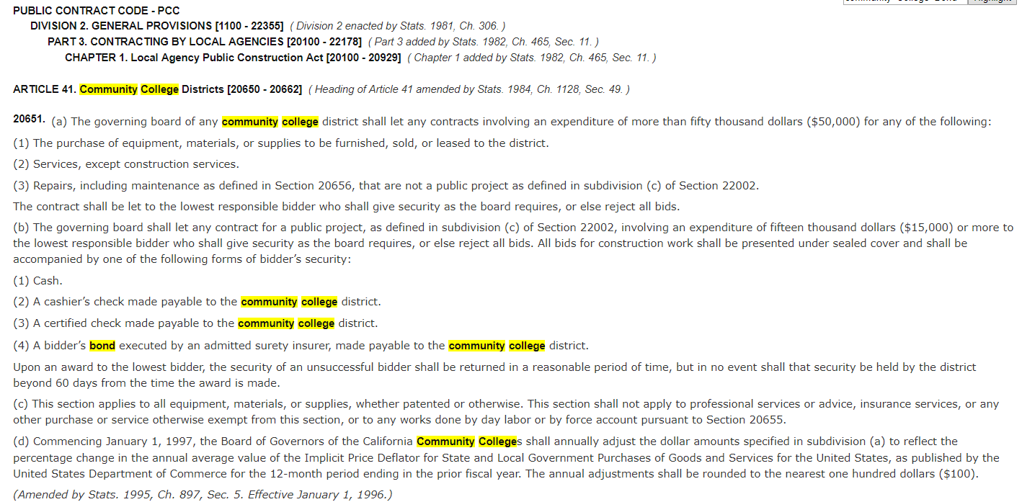

15.2 Insurance Requirements

Consultant’s Duty to Show Proof of Insurance Prior to the execution of this Agreement, Consultant shall furnish to District Certificates of Insurance showing satisfactory insurance coverage:

Commercial General Liability Insurance

Commercial general liability insurance, written on an “occurrence” basis, which shall provide coverage for bodily injury, death and property damage resulting from operations, products liability, liability for slander, false arrest and invasion of privacy arising out of professional services rendered hereunder, blanket contractual liability, broad form endorsement, products and completed operations, personal and advertising liability, with per limits of not less than $2,000,000 annual general aggregate and $1,000,000 each occurrence.

Excess Liability Insurance

Excess liability insurance, on an “Occurrence” form, coverage should apply and follow form over primary coverages shown above. Limits must apply per any one occurrence and general aggregate annually; and Annual Aggregate Products and Completed Operations. The following are required excess limits of liability: $2,000,000 Bodily Injury and Property Damage Liability, $2,000,000 General Aggregate, $2,000,000 Products and Completed Operations.

Business Automobile Liability Insurance

Business automobile liability insurance with limits not less than $1,000,000 each occurrence including coverage for owned, non-owned and hired vehicles.

Workers’ Compensation Insurance

Workers’ Compensation Employers’ Liability limits required by the laws of the State of California. Consultant’s Worker’s Compensation Insurance policy shall contain a Waiver of Subrogation. In the event Consultant is self-insured, it shall furnish Certificate of Permission to Self-Insure signed by Department of Industrial Relations Administration of Self-Insurance, State of California.

Professional Liability Insurance
Professional Liability Insurance satisfying either of the two following requirements: (a) specific to this Project only, with limits not less than $1,000,000 each claim, or (b) limits of not less than $2,000,000 each claim and aggregate. Such Professional Liability Insurance shall apply to and insure against Consultant’s negligent acts, errors or omissions in connection with services to be provided under this Agreement, and shall contain no exclusion for claims of one insured against another insured. Such Professional Liability Insurance policy shall be maintained for a period of five years after the Completion of the Services.

15.3 Payment Bond Requirements

CONSTRUCTION LABOR AND MATERIAL PAYMENT BOND

KNOW ALL PERSONS BY THESE PRESENTS:
- THAT WHEREAS, the YUBA COMMUNITY COLLEGE DISTRICT, a California community college district (Owner) has awarded to (Name of Contractor) _________________ as Principal a Firms Agreement For Services, dated the ___________ day of ______________, 20 ____, together with Work Order No. _____ (Order, and together with the Firms Agreement For Services, the CAFS Agreement), in the amount of $_____________________________ (Contract Sum), which Agreement is by this reference made a part hereof, for the work described as follows:

(Describe Agreement Work) .
- AND WHEREAS, Principal is required to furnish a bond in connection with the Agreement to secure the payment of claims of laborers, mechanics, material suppliers, and other persons as provided by law;

- NOW, THEREFORE, we, the undersigned Principal and ______________________________ as Surety, are held and firmly bound unto Owner in the sum of 100% OF THE CONTRACT SUM ($_________________), for which payment well and truly to be made we bind ourselves, our heirs, executors, administrators, successors, and assigns, jointly and severally, firmly by these presents.

- THE CONDITION OF THIS OBLIGATION IS SUCH, that if Principal, or its heirs, executors, administrators, successors, or assigns approved by Owner, or its sub Firms shall fail to pay any of the persons named in California Civil Code Section 9100, or amounts due under the State of California Unemployment Insurance Code with respect to work or labor performed under the Agreement, or for any amounts required to be deducted, withheld, and paid over to the State of California Employment Development Department from the wages of employees of Principal and sub Firms pursuant to California Unemployment Insurance Code Section 13020 with respect to such work and labor, that Surety will pay for the same in an amount not exceeding the sum specified in this bond, plus reasonable attorneys’ fees, otherwise the above obligation shall become and be null and void.

- This bond shall inure to the benefit of any of the persons named in California Civil Code Section 9100, as to give a right of action to such persons or their assigns in any suit brought upon this bond. The intent of this bond is to comply with the California Mechanic’s Lien Law.

- Surety, for value received, hereby expressly agrees that no extension of time, change, modification, alteration, or addition to the undertakings, covenants, terms, conditions, and agreements of the Agreement, or to the work to be performed thereunder, shall in any way affect the obligation of this bond; and it does hereby waive notice of any such extension of time, change, modification, alteration, or addition to the undertakings, covenants, terms, conditions, and agreements of the Agreement, or to the work to be performed thereunder.

- Surety’s obligations hereunder are independent of the obligations of any other surety for the payment of claims of laborers, mechanics, material suppliers, and other persons in connection with Agreement; and suit may be brought against Surety and such other sureties, jointly and severally, or against any one or more of them, or against less than all of them without impairing Owner’s rights against the other.

- Correspondence or claims relating to this bond shall be sent to Surety at the address set forth below.

IN WITNESS WHEREOF, we have hereunto set our hands this __________ day of ____________________, 20___.

CONTRACTOR AS PRINCIPAL SURETY
Company: (Corp. Seal) Company: (Corp. Seal)

Signature Signature

Name Name

Title Title

Street Address Street Address

City, State, Zip Code City, State, Zip Code

(End of Appendix C) in the CAFS
15.4 Performance Bond Requirements

CONSTRUCTION PERFORMANCE BOND

KNOW ALL PERSONS BY THESE PRESENTS:
- THAT WHEREAS, YUBA COMMUNITY COLLEGE DISTRICT, a California community college district (Owner) has awarded to (Name of Contractor)____________________________ as Principal a Firms Agreement For Services, dated the ___________ day of ___________, 20___, together with Work Order No. _____ (Order, and together with the Firms Agreement For Services, the CAFS Agreement), in the amount of $______________ (Contract Sum), which Agreement is by this reference made a part hereof, for the work described as follows:
(Describe Agreement Work) .
- AND WHEREAS, Principal is required to furnish a bond in connection with the Agreement, guaranteeing the faithful performance thereof;
- NOW, THEREFORE, we, the undersigned Principal and _________________________ as Surety are held and firmly bound unto Owner in the sum of 100% OF THE CONTRACT SUM to be paid to Owner or its successors and assigns; for which payment, well and truly to be made, we bind ourselves, our heirs, executors, administrators, successors, and assigns, jointly and severally, firmly by these presents.
- THE CONDITION OF THIS OBLIGATION IS SUCH, that if Principal, or its heirs, executors, administrators, successors, or assigns approved by Owner, shall promptly and faithfully perform the covenants, conditions, and agreements of the Agreement during the original term and any extensions thereof as may be granted by Owner, with or without notice to Surety, and during the period of any guarantees or warranties required under the Agreement, and shall also promptly and faithfully perform all the covenants, conditions, and agreements of any alteration of the Agreement made as therein provided, notice of which alterations to Surety being hereby waived, on Principal’s part to be kept and performed at the time and in the manner therein specified, and in all respects according to their true intent and meaning, and shall indemnify, defend, protect, and hold harmless Owner as stipulated in the Agreement, then this obligation shall become and be null and void; otherwise it shall be and remain in full force and effect.
- No extension of time, change, alteration, modification, or addition to the Agreement, or of the work required thereunder, shall release or exonerate Surety on this bond or in any way affect the obligation of this bond; and Surety does hereby waive notice of any such extension of time, change, alteration, modification, or addition.
- Whenever Principal shall be and declared by Owner in default under the Agreement, Surety shall promptly remedy the default, or shall promptly:
  - Undertake through its agents or independent Firms, reasonably acceptable to Owner, to complete the Agreement in accordance with its terms and conditions and to pay and perform all obligations of Principal under the Agreement including, without limitation, all obligations with respect to warranties, guarantees, indemnities, and the payment of liquidated damages; or

  - Obtain a bid or bids for completing the Agreement in accordance with its terms and conditions, and, upon determination by Owner of the lowest responsible bidder, reasonably acceptable to Owner, arrange for a contract between such bidder and Owner and make available as work progresses (even though there should be a default or a succession of defaults under the contract or contracts of completion arranged under this paragraph) sufficient funds to pay the cost of completion less the balance of the Contract Sum, and to pay and perform all obligations of Principal under the Agreement including, without limitation, all obligations with respect to warranties, guarantees, and the payment of liquidated damages; but, in any event, Surety’s total obligations hereunder shall not exceed the amount set forth in the third paragraph hereof. The term “balance of the Contract Sum,” as used in this paragraph, shall mean the total amount payable by Owner to the Principal under the Agreement and any amendments thereto, less the amount Owner paid to Principal.
- Surety’s obligations hereunder are independent of the obligations of any other surety for the performance of the Agreement, and suit may be brought against Surety and such other sureties, jointly and severally, or against any one or more of them, or against less than all of them without impairing Owner’s rights against the others. Surety may not use Contractor to complete the Agreement absent Owner’s written consent.

- No right of action shall accrue on this bond to or for the use of any person or corporation other than Owner or its successors or assigns.
- Surety may join in any proceedings brought under the Agreement and shall be bound by any judgment.
- Correspondence or claims relating to this bond shall be sent to Surety at the address set forth below.
IN WITNESS WHEREOF, we have hereunto set our hands this _________ day of ________________, 20___.
CONTRACTOR AS PRINCIPAL SURETY
Company: (Corp. Seal) Company: (Corp. Seal)

Signature Signature

Name Name

Title Title

Street Address Street Address

City, State, Zip Code City, State, Zip Code

Appendix A: Land Lease Payment Proposal Information
- Initial Monthly Land Lease Payment with Single Carrier: $ .

- Revenue Sharing Per Additional Carrier: $ .

- Initial Term (Years): .

- Percentage Increase Every Renewal Period: .

- Number of Renewing (5) Year Terms: .

- Total Length of Land Lease Terms: .

- Other:

Refer to section 1.3 for minimum requirements.
Describe any other terms.

Appendix B: Acknowledgement of Addenda Form

The undersigned acknowledges receipt of the following addenda from the District pursuant to the Request for Proposal:
Acknowledgement: Yes or Not Applicable
Addendum No. 1: .
Addendum No. 2: .
Addendum No. 3: .
Addendum No. 4: .
Addendum No. 5: .

Failure to acknowledge the Addenda’s may, at the Descretion of the District, determine the Proposal to be incomplete and unresponsive. Firms are required to acknowledge all addenda’s within the submitted proposal at the time of submission.

Appendix C: Statement of Qualifications Form

The Respondent shall furnish the following information. Failure to comply with this requirement will render the submittal informal and may cause its rejection. Additional sheets may be attached if necessary.

- Firm name and primary address:

- Telephone: Facsimile:

- Email Address:

- Names and titles of two officers of the firm:
NAME TITLE

4.1
4.2

- Specific type of Ownership (Check one)

5.1 | Individual
5.2 | Partnership
5.3 | Corporation; If a corporation, state the following: State of incorporation:
 | Date of incorporation: President/CEO:
5.4 | Joint Venture
5.5 | Other (Specify)

Statement of Qualifications, continued:

- Taxpayer Identification
- Number of years Respondent has been in business:
- Number of years Respondent has conducted business under the present name:
- Has the Respondent ever been licensed under a different name or different license number? ? If Yes, give name and license number:

- Number of years’ experience in California doing various cell tower projects .

- Has the Respondent or any of its principals defaulted to as to cause a loss to a surety on a payment or performance bond?

If yes, give dates, name and address of surety, and details:

- Has the Respondent been assessed liquidated damages for any project in the past three years? If so, give owner and details:

- Has the Respondent been in litigation on an issue pertaining to any contract during the past three years?
If yes, explain and provide case name and number.

- Has the Respondent ever failed to complete a project in the past three years? If so, give owner and details:

- Do you now or have you ever had any direct or indirect business, financial or other connection with any official, employee or consultant of the District?
If so, please elaborate.

Statement of Qualifications, continued:

- Has the Respondent ever completed work for the Yuba Community College District in the past? If so, please elaborate:

- Has the Respondent Firm Leased Land and installed New Wireless Communications/Cell Phone Towers on Community College campus locations or any University or Public Project locations in California? If so, please list. Please describe the projects and provide contact information.

- Has the Respondent ever removed a cell tower after a few years in service? If so, please describe the reasoning for the tower removal and the criteria that is used in making decisions to remove towers from sites.

- Will this new tower support ongoing improvements in technology? For example, if designed around 5G technology, will it be improved in the future for 6G or 7G or 10G and how will that look?

Appendix D: Proposed Land Lease Agreement (By Firm)

Appendix E: Site Map locating the proposed tower, picture of “like” tower, suggest using a Google Earth Satellite Picture with location of tower clearly shown. (By Firm)

Appendix F: New Cell Phone Tower Overall Process Description (By Firm)

Appendix G: Other Areas of Concern:

If any of the following has occurred, please describe in detail:

- Termination or failure to complete a contract.
- Termination by any municipal, county, state, federal or local agency.
- Involvement in litigation, arbitration or mediation.
- Provide litigation history for any claims filed by your firm or against your firm related to cell tower projects or related services in the last five (5) years.

- Conviction of the firm or its principals for violating a state or federal antitrust law by bid or proposal rigging, collusion, or restrictive competition between bidders or proposers, or conviction of violating any other federal or state law related to bidding or performance of Professional Consulting services.

- Conviction of a Felony of any of the members of the project team.
- Knowing concealment of any deficiency in the performance of a prior contract.
- Falsification of information or submission of deceptive or fraudulent statements in connection with a contract.

- Willful disregard for applicable rules, laws or regulations.

Firms are required to respond with a “Yes” or “No” to the above listed items and to describe with detail any of the above items that have a Yes answer.

Information regarding any of the above may, at the sole discretion of the District, be deemed to indicate an unsatisfactory record of performance. Failure to disclose any of the above may, at the sole discretion of the District, be deemed to indicate an unsatisfactory record of performance.

Appendix H: Examples of Previous “Like Projects” in California. (By Firm)
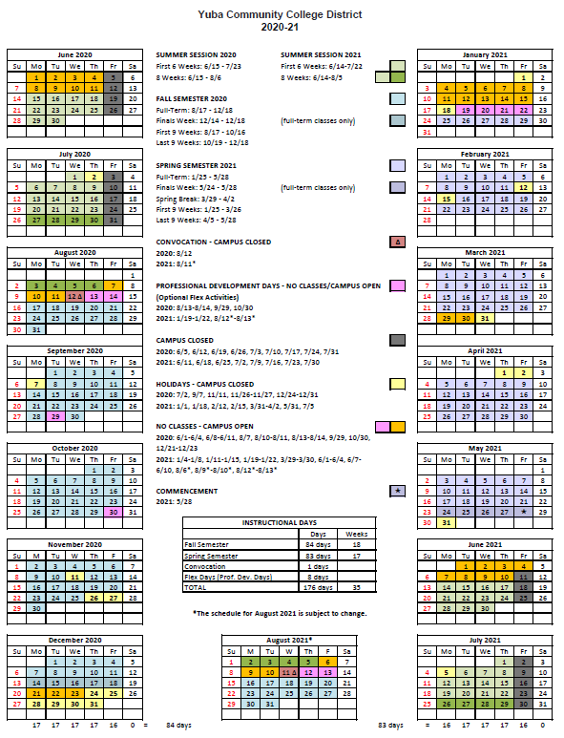
Appendix I: YCCD Academic Calendar 2020/2021

Appendix J: Map of Yuba College, 2088 North Beale Road, Marysville, California, 95901

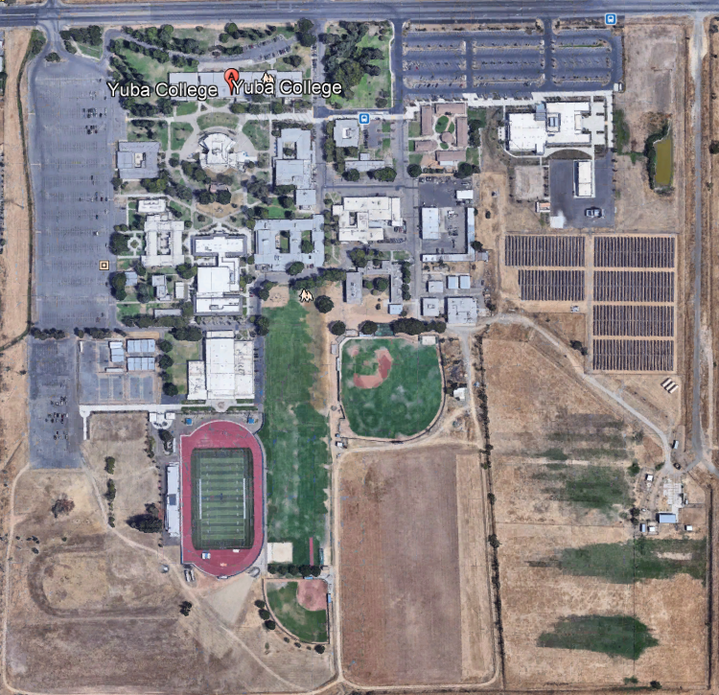
Possible Cell Phone Tower Location

Appendix “K” Non-Collusion Affidavit Form
STATE OF CALIFORNIA, COUNTY OF I, being first duly sworn, deposes and says that I am the of , the party submitting the foregoing proposal (“the Proposal”). In connection with the foregoing Proposal, the undersigned declares, states and certifies that:
- The Proposal is not made in the interest of, or on behalf of, any undisclosed person, partnership, company, association, organization or corporation.
- The Proposal is genuine and not collusive or a sham.
- The Firm has not directly or indirectly induced or solicited another Firm to put in a false or sham proposal, and has not directly or indirectly colluded, conspired, connived, or agreed with any other Firm or anyone else to put in a sham proposal, or to refrain from bidding.
- The Firm has not in any manner, directly or indirectly, sought by agreement, communication, or conference with anyone to fix the proposal price, or that of any other Firm, or to fix any overhead, profit or cost element of the proposal price or that of any other Firm, or to secure any advantage against the public body awarding the contract of anyone interested in the proposed contract.
- All statements contained in the Proposal and related documents are true.
- The Firm has not, directly or indirectly, submitted the proposal price or any breakdown thereof, or the contents there of, or divulged information or data relative thereto, or paid, and will not pay any fee to any person, corporation, partnership, company, association, organization, proposal depository, or to any member or agent thereof to effectuate a collusive or sham proposal.
Executed on this date: , 2019, at:

(City, County, and State)
I declare under penalty of perjury under the laws of the State of California that the foregoing is true and correct.
Signature Printed Name .
Address: .
Area Code & Phone Number: .
Note: In addition to other bid documents, bidders on public works projects are required by Public Contract Code section 7106 to submit a certification form that they have not colluded with another proposer.

Appendix “L” References Form (Example Template)

Bidder shall provide a minimum of Five (5) verifiable references with current contact information, preferably from a California public educational institution and/or California public agency, within the last 5 years. See clarification note below regarding reference requirements. All phone numbers and emails must be current (please verify).
REFERENCE #1
NAME
ADDRESS
CITY, STATE ZIP CODE
TELEPHONE #
CONTACT
DATES OF SERVICE
REFERENCE #2
NAME
ADDRESS
CITY, STATE, ZIP CODE
TELEPHONE #
CONTACT
DATES OF SERVICE
REFERENCE #3
NAME
ADDRESS
CITY, STATE, ZIP CODE
TELEPHONE #
CONTACT
DATES OF SERVICE

You may of course use the Firm’s established reference template.

Appendix “M” Proposal Signature Form
The undersigned acknowledges the following:
- Having become familiar with the specifications and requirements of the Request for Proposal, hereby offers to provide all services in accordance with the proposal set forth herein, including all referenced material and attachments.
- By submitting a signed proposal in response to this solicitation, the Firm acknowledges that they completely understand the scope of the needed services and that the proposed services as described in the proposal will meet or exceed the needs of the District.
- Late proposals will not be accepted (even if they are only 5 minutes late).
- The District reserves the right to reject any and all proposals and that this proposal shall remain open and not be withdrawn for a minimum of 90 days.
- Cancellation Clause: The District may, without cause, terminate the contract(s) or a project under the contract(s) by giving written notice of such termination to the awarded firm. In the event of such termination the District shall reimburse the firm for services performed and reasonable expenses actually incurred by the firm in relation to the terminated project prior to the firm’s receipt of such notice of termination. The cost of proposal generation, associated travel, copies, postage, etc.., will not be reimbursed and is considered a typical and normal part of the bid process and is not reimbursed for any of the proposers.
- If the prospective Firm is a corporation, the undersigned hereby represents and warrants that the corporation is duly incorporated and is in good standing in the state of California , and that, , is authorized to act for and bind the corporation.

Entity Type (Select One):

Sole Owner: Partnership: .

Corporation: .

Other; Please specify;

Regular monthly progress payments are made using NET 30 as a basis for payment, with Net 30 time starting after receipt of the invoice with all required support documentation, and once this information is reviewed and approved by the District.
Signature_____________________________ Date: _______________________
Position: _____________________________
Print name____________________________ Title________________________

Notary Required On This Project
Notary Stamp:

Appendix “N”: Firm W9 Form

Appendix “O”: Insurance Form

Appendix “P”: Licenses, Certifications, Licenses, Documents Proving Qualifications (By Firm)

Appendix Q, Example drawings/elevation of proposed 100’ artificial tree cell tower. Pictures of previous similar tower projects.

The End.

