Clarifications:

Addendum No. 2

RFP 20-02 YCCD, Yuba College: Architectural Services: Fire Alarm Systems Project
Date: 07/18/2020

Date: January 26, 2016

- Question: Could you please clarify additional information in regard to the RFP for us:

- On Page 12 of the RFP Section K. Fee Proposal on number 2 it says “..not to exceed 8% of the total construction costs..”
Answer: The fee percentage for Architectural Services is limited to that shown on the JCAF 32 Form, which is 8% of the construction costs of the project.
- However, on Page 21 of the RFP under Appendix A. Fee Proposal on number 2 it says “..not to exceed 11% of the total construction costs..”
Answer: The 11% fee percentage is an error. The funding for Architectural Services is limited to that shown on the JCAF 32 Form.
- Could you please clarify whether it’s 11% or 8%?
Answer: Architectural Services Fees in JCAF 32 (If other fees in the JCAF 32 apply add them in your proposal. Architectural Fees must align with the JCAF 32 form for the project)
Summary:
- Preliminary Planning Phase: $114,000
- Working Drawing Phase: $130,000
- Construction Phase: $ 82,000
Total Architectural Services Fee: $326,000, which is equal to 8% of the construction costs.
- Please refer to the JCAF 32 Form on the next page for more details.

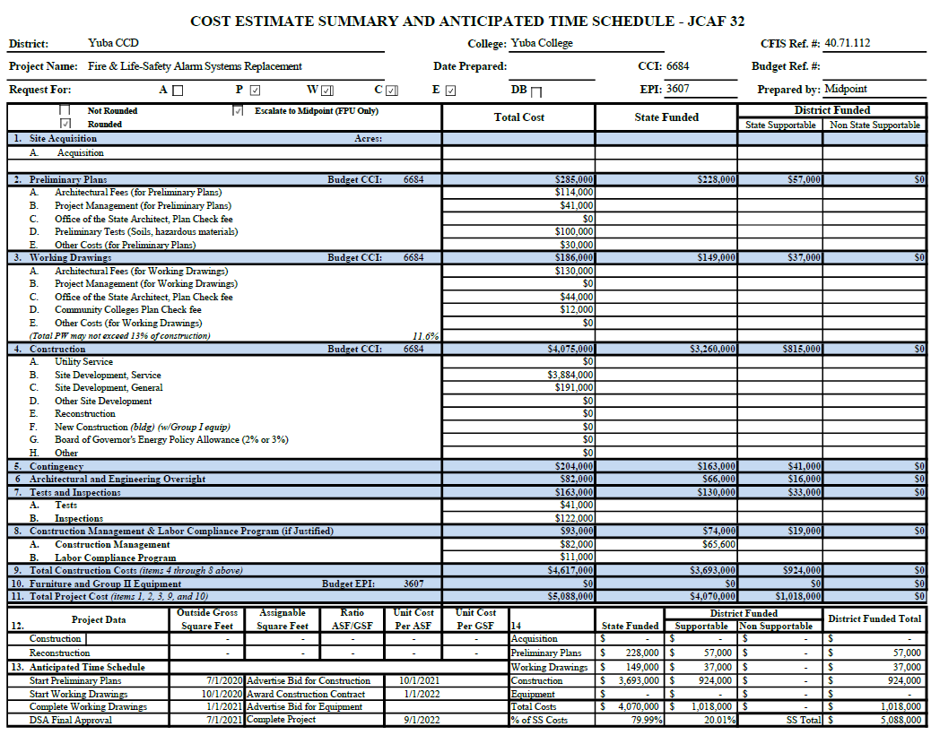

Thank you for your participation in the procurement process at Yuba Community College District.

The End.

