Request for Qualification

Architectural / Engineering Services:
Yuba College Fire Alarm Systems Upgrade Project

Yuba Community College District

RFQ 20-01

Issue Date: June 4, 2020
RFQ Due: June 30, 2020, 1:00pm, District Office

RFQ Due Date: June 30, 2020, 1:00pm Sharp, YCCD District Offices Location- Delivered To:

Yuba Community College District, District Offices
Attn.: David Willis
District Director of Facilities Planning, Maintenance & Operations
RFQ No. 20-01, Request for Qualification for Architectural/Engineering Services: Yuba College, Fire Alarm Systems Upgrade
Address: 425 Plumas Blvd., Suite 200, Yuba City, California, 95991

Proposal Delivery Location, Front Counter at Second Floor
Yuba Community College District
District Offices
425 Plumas Blvd, Suite 200 (second floor)
Yuba City, California, 95991

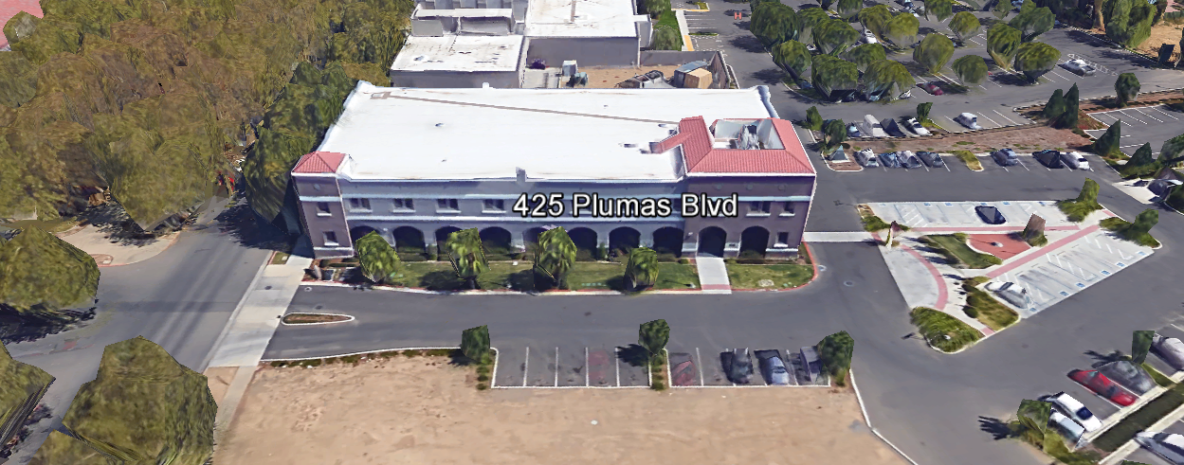
TABLE OF CONTENTS

1.0 INTRODUCTION
1.1 District Information
1.2 Yuba Community College District Background
1.3 Purpose of Request: Development of a District-Wide Long-Range Facilities Master Plan
1.4 Applicable Codes
2.0 Pre-Qualification Associated with the following Professional Services Scope of Work (Describe in this Section)
2.1 District Staff Contacts during Proposal Process
3.0 Proposal Format Organization
3.1. Proposal Delivery, Contents, and Format
4.0 Statement of Qualifications
5.0 Selection of Professional Services Provider
6.0 Basis of Award-Not Applicable
7.0 Non-Discrimination
8.0 Evaluation of Proposal-Not Applicable
9.0 Responses to RFQ
10.0 Requests for Information (RFI)
11.0 Pre-Qualification Schedule
12.0 District Parking
13.0 RFQ Proposal Requirement Clarifications
14.0 Award of Contract—Not Applicable
15.0 Reservation of Rights
Appendix A, Statement of Qualifications Form
Appendix B, Academic Calendars
Appendix C, Map of Woodland Community College
Appendix D, Performing Arts / Culinary Services Facility, Preliminary Planning Documents
Appendix E, Open
Appendix F, Non-Collusion Affidavit Form
Appendix G, References Form
Appendix H, Signature Form
Appendix I, Acknowledgement of Addenda Form

1. INTRODUCTION

  - District Information:

The District consists of two colleges, Woodland Community College and Yuba College, with campuses located at six different locations: Yuba College in Marysville, CA; Sutter County Center in Yuba City, CA; Beale Education Center, Beale AFB, CA; Woodland Community College in Woodland, CA; Colusa County Center in Williams, CA; and Lake County Campus in Clearlake, CA.

  - Yuba Community College District

The Yuba Community College District (YCCD) was founded in 1927 and spans eight counties (Yuba, Sutter, Colusa, Yolo, Lake, Butte, Glenn and Placer) and nearly 4,200 square miles of territory in rural, north-central California. It has colleges in Marysville and Woodland, an educational center in Clearlake, an educational center in Williams, an educational center in Yuba City, and outreach operations at Beale Air Force Base.

  - Purpose of Request: Pre-Qualification of Architectural Firms

The District requests the submission of Statements of Pre-Qualifications with support documentation to design and provide contract administration support for a comprehensive Yuba College campus-wide Fire Alarm Systems Upgrade project. The anticipated total project budget is $5,088,000.
  - Applicable Codes
All planning work shall meet all Local, State, and Federal Codes, Regulations, and Ordinances.

2.0 Pre-Qualification Associated with the following Professional Services Scope of Work:
Since this is a Pre-Qualification document, statements regarding the scope of work are associated with the Fire Alarm Systems Upgrade Project at Yuba College located at 2088 North Beale Road, Marysville, California, 95901.
The scope of work includes the full and comprehensive development of the following:
- Project Review with Staff/College and District Teams, Information Gathering Phase
- Programming/Scope Determination of District/College Requirements
- Preliminary/Schematic Design Documents
  - Drawings (Site Plan, Layouts, Elevations as needed)
  - High Level Milestone Schedule List
  - Rough Cost Estimate of Probable costs
- Design Development Documents
  - Drawings and Specifications
  - High Level Project Schedule
  - Rough Cost Estimate of Probable costs
- Construction Documents
  - Drawings and Specifications
  - Initial More Detailed Overall Project Schedule
  - Cost Estimate of Probable costs
- Division of the State Architect Submission and Coordination through Approval and Project
- Contractor Bidding
- Contract Administration
- Commissioning and Project Close-Out
Planned Service Schedule Per the JCAF 32 Form:
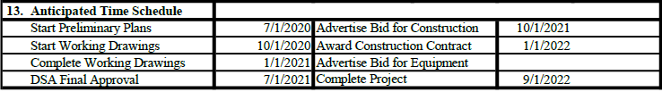

2.1 District Staff Contacts during the Proposal process:
Firms interested in submitting a Proposal are directed not to make personal contact with the Board of Trustees, District staff, or members of the evaluation committee. Any contact shall constitute grounds for disqualification from consideration.
Single Point of Contact during the Request for Qualifications Preparation Process:
David L. Willis
District Director of Maintenance, Operations, and Planning
425 Plumas Blvd., Suite 200 (Second Floor)
Yuba City, California, 95991
Cell Phone: 916-747-4262
Email: dwillis@yccd.edu

3.0 Proposal Format Organization
The Firm is requested to use the following proposal format:
3.1. Proposal Delivery, Contents, and Format:
Proposals should provide straightforward, concise information that satisfies the requirements noted in this RFQ. Expensive binding, color displays, and the like are discouraged. Emphasis should be placed on brevity, conformity to the Districts instructions, selection criteria of this RFQ, and completeness and clarity of content. Each Respondent’s proposal should clearly and accurately demonstrate specialized knowledge and experience required for consideration.
In a sealed box or envelope (clearly marked “), submit the following:
- One (1) flash memory stick containing the complete proposal and supporting documentation;
- One (1) original and two (2) copies in paper form of the proposal, which consists of a Proposal Letter and responses to the proposal requirements listed in Section 2.3

Proposals shall adhere to the following requirements for contents and format, should be as concise as possible and should not include more than 50 pages of promotional or marketing materials. There is no page limit overall but each proposal is requested to be no more than 150 physical pages (printing on both sides of each page) in total length.
Firms must comply with the provisions of these instructions for completion and submission of the Proposal. The failure of a Firm to comply with the Proposal Instructions and Requirements will result in rejection of the Proposal for non-responsiveness.

Proposal Section | Format
- Cover Letter | PDF
- Table of Contents | PDF
- Identification of the Firm | PDF
- Executive Summary | PDF
- Staffing Resources | PDF
- Experiance
- Proposed Project Team--“Like Projects” Experience of Team Members and Firm | PDF
- Proposed Project Approach | PDF
- Technical Competence | PDF
- Fiscal Stability of Firm | PDF
- Fee Proposal: All Costs for the “Request for Qualifications” Documents/Statement of Qualifications Information shall be borne by the Architectural/Engineering Firm. A second document “Request for Proposals” will be issued following the Pre-Qualification process. | PDF
- Statement of Minimum Qualifications | PDF
- Firm W9 Form | PDF
- Licenses, Certifications, Documents Proving Qualifications by Team Members | PDF
Appendices
- Statement of Qualifications | PDF
- YCCD Academic Calendar | PDF
- Yuba College Map | PDF
- Project Planning Documents | PDF
- References Form | PDF
- Signature Form | PDF
- Acknowledgement of Addendum Form | PDF

CONTENTS OF QUALIFICATIONS PACKAGE

(Include the below information and the Statement of Qualification in Appendix A)

The following is a summary of the Contents. Please address each section in a Tabbed Format.

A. Cover Letter

The Proposal shall include a Cover Letter on Respondent’s official business letterhead, which shall be signed by an individual authorized to legally bind Respondent. The Cover Letter shall also identify the name and telephone number of a person who may be contacted during the Proposal evaluation process.

Executive Summary: Provide an overview of the entire Qualifications Package describing the general approach to building design that Firm will use to meet the goals and fulfill the general functions required in this RFQ.

B. Table of Contents

Provide a Table of Contents that outlines in sequential order the major sections and sub-sections of the Proposal. All pages in the Proposal shall be clearly and consecutively numbered and correspond to the Table of Contents. Use tabs to allow information to be more easily located.
C. Identification of the Firm
1. Legal name and address of company.
2. Legal form of company (corporation, partnership, etc.).
3. Name, address, phone number, facsimile number, email address, website address, direct email address for the following: Firm’s Principal in Charge, person(s) who will be primarily responsible for providing services for this Qualifications Package.
4. California Business License Number

D. Executive Summary

The Proposal shall include an Executive Summary that briefly describes the Proposal, the Team, and the approach to meet the District’s goals. The Executive Summary shall describe the approach that will be used to keep costs as low as possible yet provide the minimal services required by California State regulations and codes.

E. Staffing Resources

1. Firm Staffing and Key Personnel (Both the A/E Firm and the Primary Fire Alarm System Sub-Consulting Firm)
a. Provide total number of professional staff currently employed by the firm.
b. Identify person/s who will be principally responsible for working with the District. Indicate the role and responsibility of each person/s, and how many years they have been with the company. If the Firm is chosen as a finalist, the proposed individual/s must attend the interview and in-person presentation.
c. Provide brief biographies and work experience history of individual/s that will be working directly with the District, highlighting the skills identified with their tasks.
d. Link each named person with the specific tasks, responsibilities, and deliverables.
e. If more than one person is named as a candidate for a specific role, include above information for all listed persons.
2. Consultants: The District may choose to interview the top scoring Firms. The exact number of those firms will likely be at least 4 firms and as many as 8 firms.

F. Experience (Include the Fire Alarm Sub-Design Firm Information as a sub-set of each of the items)

- Provide a description of how the Firm’s experience, technical, and professional skills will meet the goals and fulfill the general functions identified in this RFQ.

- State the number of years the firm has conducted business. Firm must have at least ten (10) years’ experience in providing the outlined scope of required professional services for public clients, preferably community college districts.

- Describe in detail, the depth and extent of design experience in providing Performing Arts or Culinary Services design and planning services for California Community Colleges, Universities or other large public institutions.

- Experience (References)
Provide a description of at least Five (5) most relevant “Like” project services contracts held by the firm, preferably involving projects for California community colleges or four-year colleges and universities, within the last ten (10) years, to include:

  - Role of the firm and relationship to client
  - Planning budget estimate
  - Dollar value of the Firm fee
  - Planning scope description
  - Staffing and major sub-consultants used
  - Duration of Project Detailed Project Description
- How the project best met the Owners Requirements
  - Contact name, position, entity name, telephone number, facsimile number and email

G. Proposed Project Team

The Proposal shall include a brief description of the project team members experience, certifications, licenses, past projects, role on the projects, availability, and capacity to support the project.

H. Proposed Project Approach

Describe the conceptual overall project approach that would be taken to completing the proposed project. Describe means and methods, processes and strategies that the Firm has used in the past to generate the types of information and plans that are requested.

I. Technical Competence
1. Description of “in-house” resources.
2. List of ALL Sub-Design Firms, Cost Estimating Firm.

J. Fiscal Stability (Submitted Separately from the RFQ Package and Kept Confidential by the District): The Firm should provide evidence of Firm stability including:

1. A current report from any commercial credit rating service such as Dun and
Bradstreet or Experian; OR
2. A letter from a financial institution stating a current line of credit; OR
3. Latest audited financial statement and/or annual report that has been certified by a CPA.

- Fee Proposal – A fee proposal is NOT requested as part of the RFQ process.

4.0 Statement of Minimum Qualifications

In addition to the above required qualification information, consider the following:

The District is interested in considering Qualifications from firms that meet or exceed the following minimum acceptable qualifications:

A. Demonstrated performance of Professional Services on projects of the same size and similar scope for higher education clients.

B. Ten (10) years’ experience as a licensed Firm in the State of California.

C. Established firm presence in California, including familiarity with the California Community Colleges and Universities.

- Appropriate professional California licensing and certifications of key Team Members assigned to work in response to this Request for Proposal and to complete scope of work in fulfillment of all requirements therein.

- Vast Depth and broad experience/understanding of various Fire Alarm Systems on the market.

5.0 Selection of Professional Services Provider

The process of Firm selection is based upon the complete responsiveness of the RFQ and the criteria as outlined below.

Subject to the District’s express reservation of rights to modify the selection process, the selection process anticipated by the District will consist of the following:

  - Qualifications received will be reviewed for responsiveness.
  - Oral presentations of the firm’s qualifications, approach, and schedule for the specific professional services requested.

The Review Committee will then share the list of Pre-Qualified Firms that are the highest ranked with the Board of Trustees for consideration when developing and publishing a future Request for Proposals for the work outlined and described in this RFQ.

Recommendations by the Review Committee for the selection of Professional Services providers will be based upon the ability of the provider to achieve the District’s objectives and demonstrated competence and qualifications to perform the basic services at a fair and reasonable price to the District. The recommendation of the list of pre-qualified Firms by the Review Committee is not binding on the District. Formal award of any Agreement will only be affected after the District’s Board of Trustees has formally approved of such award. The District reserves the right to waive minor irregularities in the solicitation process. The District may award one or more agreements, or no agreements, as a result of this Request for Qualifications (RFQ) process.

The District reserves the right to reject any and all submittals, to amend the RFQ process, and to discontinue or re-open the process at any time. The submittals will be evaluated based on each respondent’s qualifications, proposal criteria, service approach, schedule, and relevant experience.

6.0 Basis of Award

Not applicable.

7.0 Non-Discrimination
The District does not discriminate with regard to race, color, gender, national origin, disability, or any other protected or other classification in the awarding of contracts/agreements. The District welcomes all Qualified Firms to participate in the project Request for Qualification/Proposal process.
The District encourages firms that are women or minority owned, emerging small businesses, veteran owned firms, disabled person owned firms, and all other qualified firms to participate in the qualification process.
The District encourages the submission of proposals from all Architectural Engineering Firms that can meet the stated requirements set for this RFQ.

8.0 Evaluation of Proposals Form (Not Applicable)

9.0 Responses to RFQ:
Sealed responses to this RFQ must be clearly marked "RFQ NO. 20-01, Request for Qualification for Architectural / Engineering Services: Yuba College Fire Alarm Systems Upgrade Project”.

Responses shall be mailed to or hand-delivered to the following address:

Yuba Community College District, District Offices
Attn.: David Willis
District Director of Facilities Planning, Maintenance & Operations
Envelope/Box Marked:
"RFQ NO. 20-01, Request for Qualification for Architectural / Engineering Services: Yuba College Fire Alarm Systems Upgrade Project”.
Address: 425 Plumas Blvd., Suite 200, Room 216, Yuba City, California, 95991

Note: Completely seal your proposals in envelop/box and make sure it gets date/time stamped when delivering proposal. Firms are each 100% responsible to make sure proposals that are mailed using a carrier such as UPS, FED Ex, etc…are received and date/time stamped by District personnel prior to the proposal due date/time. No proposals will be considered if they are late, even if it is only 5 minutes late. Please make sure your proposals are delivered and received promptly prior to the due date/time. There will be a public proposal opening at the due date/time.

Do NOT email your proposals. Emailed proposals that are not sent per the above guidance requirements will not be considered.

10.0 Requests for Information (RFI)

Requests for Information concerning the RFQ must be in writing and may be submitted via email no later than the date shown below. Please direct all questions to David Willis, email: dwillis@yccd.edu.

Following the RFI deadline, all questions and answers will be summarized and posted on the District's website: https://www.yccd.edu/central-services/purchasing/ , then, click on the “Requests for Proposals / Quotes” tab on the right hand side of this web page. It is anticipated that responses to inquires received by the required time and date will be provided within 3 business days and posted on the District's website. Should more time be needed by the District to answer I respond to RFI’s, this information will also be posted on the above website.

The District has developed Procurement Milestones, shown below, with dates showing the key events in this solicitation process. This RFQ and schedule are subject to change, and the Director will notify Respondents of any changes via email to the contact designated by each Respondent. Respondents must take the following actions according to the specified timelines in order to participate in this process.

11.0 Pre-Qualification Schedule:

Important Dates and Times:

June 4, 2020: Release of Request for Qualifications

June 15, 2020: 1:00PM Pre-RFQ Meeting, Yuba Community College District, District Offices, Second Floor, Board Room, 425 Plumas Blvd., Yuba City, California, 95991.

June 17, 2020: 1:00PM Pre-RFQ Meeting, Yuba Community College District, District Offices, Second Floor, Board Room, 425 Plumas Blvd., Yuba City, California, 95991.

Note: Firms are REQUIRED to attend a Pre-Qualification meeting listed above or make arrangements to meet with Dave Willis at the District Office location to review the RFQ requirements, Sign a log-in form, to be considered a qualifying proposer for the purposes of the procurement process.

June 19, 2020: All questions and requests for information must be submitted to David Willis at: dwillis@yccd.edu by 1pm.

June 20, 2020: Addendum Issued if needed.

June 30, 2020: Pre-Qualification Packages due at 1:00 PM SHARP, Yuba Community College District, District Offices Location. There will be a public bid opening on this RFQ.

A list of pre-qualified Firms will likely be determined by July 1, 2020. A Request for Proposal will be published shortly thereafter.

The District reserves the right to alter or amend the above timetable as required to conclude the process to the District's satisfaction.

All questions associated with the procurement process shall be addressed to David Willis, District Director of Facilities Planning, Maintenance, and Operations at email: dwillis@yccd.edu or cell phone: 916-747-4262.

12.0 District Parking:

-No parking in Reserved Spaces without a proper permit
-Permit Parking is enforced in all general lots between 6:00 am and 6:00 pm, Monday through Friday. All general lots require a properly displayed, valid permit during these times
-Daily Parking Permits are $2.00
-Permits are available for purchase at any of the permit machines located in the student parking lots
-All other parking regulations are enforced 24 hours a day, seven days a week. This includes designated staff spaces, handicap spaces, timed spaces, red zones, yellow zones, and areas not marked (no parking at any time)
-Once this project is awarded, temporary parking permits will be processed as requested by the successful firm for all service Professional Consulting Firm employees associated with this project at no cost to the Professional Consulting Firm for the duration of the project at each Campus location. These temporary permits must be displayed at all times on the dash board of service Professional Consulting Firm vehicles.

13.0 RFQ Proposal Requirement Clarification

Proposals received after the deadline will not be opened. Each responder shall submit one (1) signed original, six (6) additional hard paper copies, all in separate binders. Provide one electronic format copy of the proposal using electronic media such as a flash drive, CD, etc...

All materials submitted in response to the RFQ shall be on 8-1/2"x11" paper, preferably in
Portrait orientation. All submitted materials must be bound in either a three-ring binder or spiral bound notebook. Content shall be tabbed and numbered per the items included in the Submittal Requirements. All Proposals will be reviewed and evaluated by a District Selection Committee. The District at its sole discretion may interview finalists, or select a firm or firms to perform work based solely on the evaluation of the Proposal. Page limit of 50 pages of marketing materials plus 200 paper pages, double sided print (400 pages total) regarding the proposal. Fewer pages is better and encouraged with tab references.

All Proposals become the sole property of the District and the content will be held confidential until the selection of the firm is made and the project is awarded.

14.0 Award of Contract (Not Applicable)

15.0 Reservation of Rights

The District reserves the right to:

• Reject any or all submittals at its sole discretions.
• Cancel the Request for Qualifications/Proposal (RFQ), without cause.
• Modify any requirements contained within the RFQ and request a revised submission from all Providers.
• Establish other evaluation criteria determined to be in the best interest of the District.
• Contract with any of the firms responding to the RFQ based solely upon its judgment of the qualifications and capabilities of the firm.

The District reserves the right to cancel the contract any time during the contract period after providing at least a written 14-day notice to the Firm. The District would consider cancellation of the contract if the Firm does not fulfill the contracted requirements of this RFQ in a timely and professional fashion at the full discretion of the District); or, if for some reason the performance of the Firm or quality of the work adversely impacts the mission of the District in serving Students or Staff; or, if available funding resources to implement the service contract were no longer available.

This RFQ does not commit the District to negotiate a contract. The District will not be responsible for any expenses incurred by any firm in preparing and submitting a proposal or response to this RFQ.

Appendix A: Statement of Qualifications Form

The Respondent shall furnish the following information. Failure to comply with this requirement will render the submittal informal and may cause its rejection. Additional sheets may be attached if necessary.
Basic Requirements: Questions 1 through 16

- Firm name and primary address:

- Telephone: Facsimile:

- Email Address:

- Names and titles of two officers of the firm:
NAME TITLE

4.1
4.2

- Specific type of Ownership (Check one)

5.1 | Individual
5.2 | Partnership
5.3 | Corporation; If a corporation, state the following: State of incorporation:
 | Date of incorporation: President/CEO:
5.4 | Joint Venture
5.5 | Other (Specify)

- Taxpayer Identification
- Number of years Respondent has been in business:
- Number of years Respondent has conducted business under the present name:
- Has the Respondent ever been licensed under a different name or different license number? ? If Yes, give name and license number:
- Number of years’ experience in California Community College, University or educational facility projects .

- Has the Respondent or any of its principals defaulted to as to cause a loss to a surety on a payment or performance bond?

If yes, give dates, name and address of surety, and details:

- Has the Respondent been assessed liquidated damages for any project in the past three years? If so, give owner and details:

- Has the Respondent been in litigation on an issue pertaining to any contract during the past three years?
If yes, explain and provide case name and number.

- Has the Respondent ever failed to complete a project in the past three years? If so, give owner and details:

- Do you now or have you ever had any direct or indirect business, financial or other connection with any official, employee or consultant of the District?
If so, please elaborate.

- Has the Respondent ever completed any work at the Yuba Community College District? If so, please elaborate.

Qualification Criteria:

Questions 17 through 27 Worth 10 Points with Question No. 22 Worth 20 Points= 120 points Total. To be determined as a qualified firm, each firm must score at least 90 points and meet/provide proper information on questions 1 through 16 and other information as described in the RFQ. Scoring is determined through a collaborative internal District process. Firms will be notified if they are determined meet minimum qualification criteria.

It is the intent of the District, if State matching funding becomes available (likely in July, 2020), to publish a Request for Proposals document to solicit proposals to provide needed Architectural / Engineering Firm Services to pre-qualified firms, closely following the completion of the pre-qualification process.

- Has the Respondent worked with a Community College District with limited financial project resources yet with high expectations to provide high quality learning environments? If so, please elaborate:

- Does the Respondent have any cost effective ideas to help deliver the scope of work described in this RFQ that would complete the work as described using an alternative approach or utilizing other options? If so, please describe:

- Has the Respondent completed at least five (5) projects of similar scope or a large fire alarm systems upgrade project with multiple buildings and different alarm system manufacturer components/systems OR a large Fire Alarm System Upgrade of an Existing System in the past 10 years? Yes/No If No, please describe why you feel that your firm still qualifies for this project:
If yes, please describe in detail the design/contract administration on projects were completed:
- Has the Respondent completed similar Fire Alarm Systems scope of work as the primary design firm/primary sub-design firm for an A/E Firm on at least five (5) projects that have a construction contractor value of at least $1.0 million in the past ten (10) years? Yes/No. If No, please describe why you feel that your firm still qualifies for this project:
If yes, please describe in detail the design/contract administration on projects were completed:

- Has the Respondent ever designed and provided contract administration on a Fire Alarm Systems Project or a project with significant Fire Alarm Systems scope in California? Yes/No If No, please describe why you feel that your firm still qualifies for this project:
If yes, please describe in detail the design/contract administration on projects were completed:

- Does the Respondent have experience designing comprehensive building to building networked Fire Alarm Systems that provide emergency communication messaging (including pre-recorded messages) from a central location? ; Yes/No If No, please describe why you feel that your firm still qualifies for this project:
If yes, please describe in detail the design/contract administration on projects were completed:
- Please describe some of the ideas that your Firm may have in creating a value enhanced comprehensive campus-wide integrated Fire Alarm Systems project that supports a central monitoring service, a central emergency messaging location, either for one, a group of, or all buildings on a campus:

- Please describe how quality assurance will be verified and tracked during the contract administration period of construction to verify that systems have proper testing, commissioning, labeling, and performance testing:

- Please describe the level of confidence/accuracy percentage your Firm has in providing accurate cost estimates to the District/College prior to receiving the proposals from the contractors. Does your firm have a cost estimating consultant or the capability to perform detailed accurate cost estimates and constructability reviews prior to the submission of the Contract Documents to the Division of the State Architect? Please describe. The District strongly encourages the use of a local certified Cost Estimator to generate the needed cost estimates for the project.

Please provide several recent examples of the accuracy of your Firm’ cost estimating work on recent (past 5 years) similarly sized ($1 million or greater) Fire Alarm Systems projects in California:

Please provide at least five (5) recent project examples of the Constructability Review process that your Firm’ has used to identify potential gaps in the specifications and drawings and the use of best practices means and methods in the recent past 5 years on similarly sized projects in California: How effective were these reviews? What was the Change order percentage of total construction cost on each of these projects?

- Please describe some of the “diversity” elements/features that your Firm would propose be included into this project. For example, the use of multiple language emergency messages, signs, etc.. that reflect the diverse culture that the Yuba College campus serves:

- Please describe how your Firm would analyze the project to provide “Maximum Value” and Lowest “Total Cost of Ownership” for the life of the upgraded Fire Alarm Systems. Please consider local technician service and spare parts support, reliability and proven technologies, system support longevity of the manufacturer, etc.. Provide examples of past projects.

Appendix B: YCCD Academic Calendars
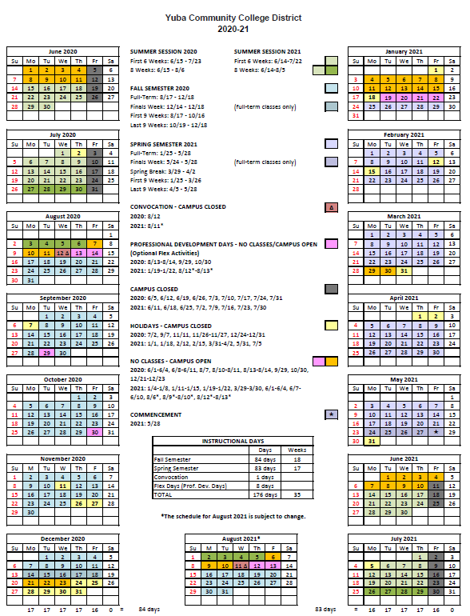

Appendix C: Yuba College Map

Appendix D: Project Planning Documents

Shared Folder Link:
https://goyccd-my.sharepoint.com/:f:/g/personal/w0398409_yccd_edu/EnJ-LSFqbclDl0GlwzXN4awBZc7tlR1XU7xY2M2BnIKmBA?e=TVAhEC

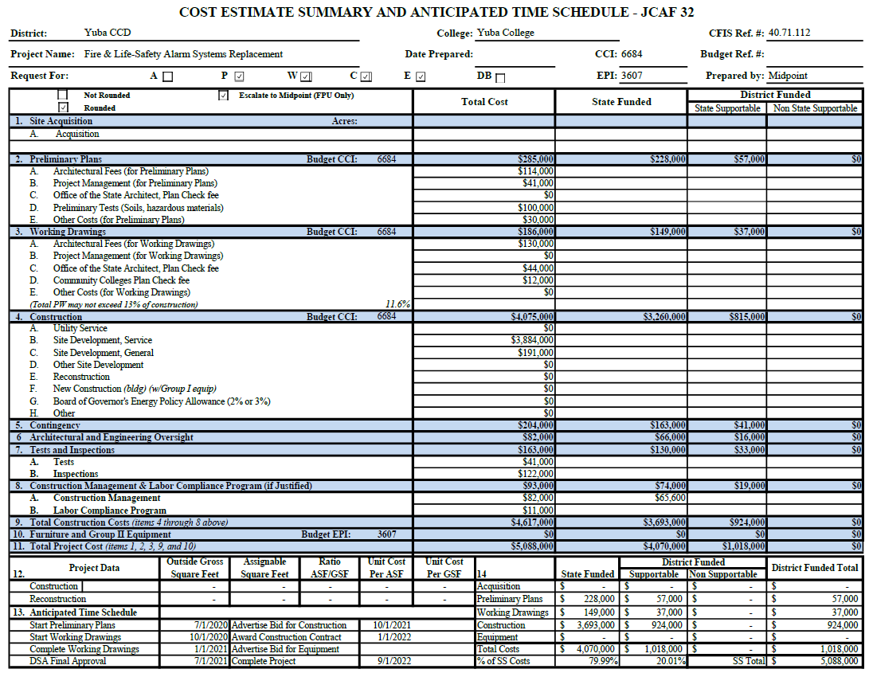

Appendix “E” References Form (Example Template)

(Include at least 5 recent references for both the A/E Firm and the Fire Alarm Sub Consultant Design Firm in California) All phone numbers and emails must be current (please verify).
REFERENCE #1
NAME
ADDRESS
CITY, STATE ZIP CODE
TELEPHONE #
CONTACT
DATES OF SERVICE
REFERENCE #2
NAME
ADDRESS
CITY, STATE, ZIP CODE
TELEPHONE #
CONTACT
DATES OF SERVICE
REFERENCE #3
NAME
ADDRESS
CITY, STATE, ZIP CODE
TELEPHONE #
CONTACT
DATES OF SERVICE

You may of course use the Firm’s established reference template.

Appendix “F”, Signature Form
The undersigned acknowledges the following:
- Having become familiar with the specifications and requirements of the Request for Proposal, hereby offers to provide all services in accordance with the proposal set forth herein, including all referenced material and attachments.
- By submitting a signed proposal in response to this solicitation, the Firm acknowledges that they completely understand the scope of the needed services and that the proposed services as described in the proposal will meet or exceed the needs of the District.
- Late proposals will not be accepted (even if they are only 5 minutes late).
- The District reserves the right to reject any and all proposals and that this proposal shall remain open and not be withdrawn for a minimum of 90 days.
- Cancellation Clause: The District may, without cause, terminate the contract(s) or a project under the contract(s) by giving written notice of such termination to the awarded firm. In the event of such termination the District shall reimburse the firm for services performed and reasonable expenses actually incurred by the firm in relation to the terminated project prior to the firm’s receipt of such notice of termination. The cost of proposal generation, associated travel, copies, postage, etc.., will not be reimbursed and is considered a typical and normal part of the bid process and is not reimbursed for any of the proposers.
- If the prospective Firm is a corporation, the undersigned hereby represents and warrants that the corporation is duly incorporated and is in good standing in the state of California , and that, , is authorized to act for and bind the corporation.

Entity Type (Select One):

Sole Owner: Partnership: .

Corporation: .

Other; Please specify;

Regular monthly progress payments are made using NET 30 as a basis for payment, with Net 30 time starting after receipt of the invoice with all required support documentation, and once this information is reviewed and approved by the District.
Signature_____________________________ Date: _______________________
Position: _____________________________
Print name____________________________ Title________________________

Notary Required On This Project
Notary Stamp:

Appendix G: Acknowledgement of Addenda Form

The undersigned acknowledges receipt of the following addenda from the District pursuant to the Request for Proposal:
Acknowledgement: Yes or Not Applicable
Addendum No. 1: .
Addendum No. 2: .
Addendum No. 3: .
Addendum No. 4: .
Addendum No. 5: .

The End.

