Yuba Community College District
Woodland Community College
Lake County Campus
Building 400 Roof and Retaining Wall Replacement Project
Request for Proposal No. RFP 19-11

Issue Date: April 7, 2020
RFP Due: May 12, 2020

RFP Due Date: May 12, 2020, 1:00 pm Sharp, Yuba College Location Delivered To:

Yuba Community College District, District Offices
Attn.: David Willis
District Director of Facilities Planning, Maintenance & Operations
RFP No. 19-11 Woodland Community College, Lake County Campus, Building 400 Roof and Retaining Wall Replacement
Address: 425 Plumas Blvd., Suite 200, Yuba City, California, 95991

Proposal Delivery Location, Front Counter at Second Floor
Yuba Community College District
District Offices
425 Plumas Blvd, Suite 200 (second floor)
Yuba City, California, 95991

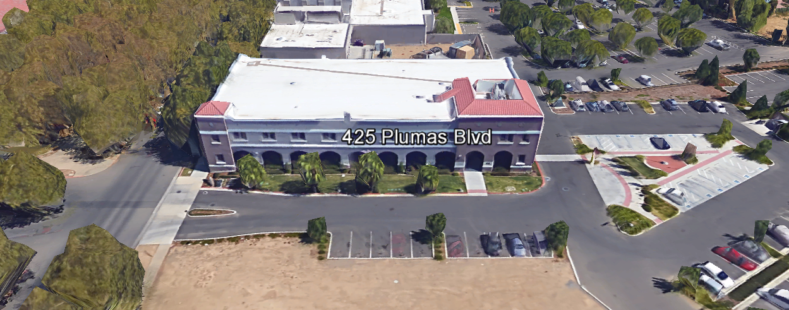
TABLE OF CONTENTS

1.0 INTRODUCTION
1.1 District Information
1.2 Yuba Community College District Background
1.3 Purpose of the Request
1.4 Applicable Codes
2.0 Scope of Work
2.1 Project Schedule
2.2 District Staff Contacts during Proposal Process
2.3 Project Safety Requirements
2.4 Demolition
3.0 Proposal Format Organization
3.1 Proposal Delivery, Contents, and Format
4.0 Selection of “Firm”
5.0 Basis of Award
6.0 Non-Discrimination
7.0 Response to Request for Proposal (RFP)
8.0 Requests for Information (RFI)
9.0 Proposal Schedule
10.0 District Parking
11.0 RFP Proposals
12.0 Award of Contract/Proposal
13.0 Reservation of Rights
14.0 Bid Bond, Performance Bond, Payment Bond Requirements
15.0 Liquidated Damages

Appendix A, Proposal Base Bid Costs
Appendix B, Acknowledgement of Addenda Form
Appendix C, Statement of Qualifications Form
Appendix D, Agreement for Services (AFS)
Appendix E, Descriptions of “Like” Projects
Appendix F, Roof System Information Included In Proposal
Appendix G, Non-Collusion Affidavit Form
Appendix H, References Form
Appendix I, Signature Proposal Form
Appendix J, Contractor Licenses, Roofing Manufacturer Certifications, etc..
Appendix K, DSA Approved Project Drawings and Specifications Package’s
Appendix L, Existing Building Drawings for Reference
Appendix M, YCCD Academic Calendar
Appendix N, Map of Lake County Campus
Appendix O, Limited Pre-Renovation Asbestos & Lead Survey

1. INTRODUCTION

  - District Information:

The District consists of two colleges, Woodland Community College and Yuba College, with campuses located at six different locations: Yuba College in Marysville, CA; Sutter County Center in Yuba City, CA; Beale Education Center, Beale AFB, CA; Woodland Community College in Woodland, CA; Colusa County Center in Williams, CA; and Lake County Campus in Clearlake, CA.

  - Yuba Community College District

The Yuba Community College District (YCCD) was founded in 1927 and spans eight counties (Yuba, Sutter, Colusa, Yolo, Lake, Butte, Glenn and Placer) and nearly 4,200 square miles of territory in rural, north-central California. It has colleges in Marysville and Woodland, an educational center in Clearlake, an educational center in Williams, an educational center in Yuba City, and outreach operations at Beale Air Force Base.

  - Purpose Of Request

The Yuba Community College District seeks proposals from qualified General Contractors to replace the Building 400 roof and retaining wall at the Lake County Campus. This is a multi-trade project with roof work, carpentry, electrical, and concrete work.

This Request for Proposal is a re-bidding and extension of a previous procurement process numbered RFP Lake County Campus Building 400 Roof and Retaining Wall Replacement as a separate stand-alone project.

Lake County Campus Address: 15880 Dam Road Extension, Clear Lake, California 95422.

  - Applicable Codes
All Facilities Standards Updates shall meet all State of California Building Codes, and Federal codes, and local ordinances.
All projects at the District/College are prevailing wage projects.

2.0 Scope of Work
The scope of work includes the following:

Lake County Campus of Woodland Community College:

- Remove and replace the existing building 400 roof system. Relocate lighting fixtures.
- Remove and replace the retaining wall. Re-grade ground areas to slope. Add drain piping. Add concrete sidewalks.
- Remove/trim trees back at least 15’ from the roof line of building 400 so that no branches are within 15’ of the roof line. Trim oak trees to provide a balanced appearance. This may require that tree branches be trimmed all around the tree on all sides. Bushes shall be removed within 20’ of the building.

This project is a multi-trades project.
The Contractor is 100% responsible to coordinate and securely store materials, tools, equipment, and other items required for the project. The Contractor must receive, inspect, unload, move, properly store, and sign for all materials. All materials need to be locked up and stored properly. The construction area must be cleaned up and organized each night to reduce trip hazards and the risk of a fire. Deliveries that arrive without a Contractor representative on site will not likely be received. All materials must be as specified and pre-approved by the Architect and the District before orders are placed. The District cannot pay for materials until they arrive on site.

The contractor shall provide quality work or it will not be acceptable to the District/College.

The Contractor shall provide their own waste container and have it emptied as needed.

The Contractor shall use and maintain barricades and barricade tape, and signs to delineate all project boundary areas.

The Contractor shall provide temporary lighting as needed to work safely.

The Contractor should provide “port-a-jons”.

The Contractor shall protect all landscape areas, windows & doors, interior building space, and all other College property from damage.

The Contractor is expected to meet briefly each weekly at the construction site, during the busy month or two of the project, with District/College staff at the project site to review progress, discuss issues, and provide a brief update on what is expected to occur during the next week.

The District encourages a positive and open communication strategy that includes a sense of partnership and mutual success on its projects.

NOTE: Both TREMCO and GARLAND are approved roof system manufacturers. Refer to project contract documents for more information.

2.1 Project schedule
Start Date: June 15, 2020
Strongly Preferred 100% Completion Date: August 31, 2020.
June 8 through August 11, 2020, Contractor work schedule: Any work hours and days.
August 19th, 2020 through August 31, 2020: Normal working hours can be anytime. It is however important that noisy activities that could disturb classes in the building be coordinated to reduce impacts.
If additional time is needed after August 31, 2020: Contractor to coordinate with the College/District. It is the intention of the College/District to complete the work without overtime yet within a reasonable period of time.
The Contractor shall not leave the underlayment on the roof longer than is absolutely necessary and no longer than 45 days without the installation of the new roofing system. The underlayment shall be high temperature and UV rated.
This a prevailing wage project.
Provide a brief project schedule with the proposal with the completion date clearly shown.

2.2 District Staff Contacts during the Proposal process:
Firms interested in submitting a Proposal are directed not to make personal contact with the Board of Trustees, District staff, or members of the evaluation committee. Any contact shall constitute grounds for disqualification from consideration.
Single Point of Contact during the Proposal Preparation Process:
David L. Willis
District Director of Maintenance, Operations, and Planning
425 Plumas Blvd., Suite 200 (Second Floor)
Yuba City, California, 95991
Cell Phone: 916-747-4262
Email: dwillis@yccd.edu

Please email Dave Willis to verify that your firm will be submitting a proposal in response to this procurement process.
On-site coordination, first contact person:
Michael Sinn
Assistant Director of Maintenance, Operations
2300 East Gibson Road
Woodland, California, 95776
Phone: 530-668-3690
Email: msinn@yccd.edu

2.3 Project Safety and Security Requirements
Safety is a top priority for the District. All California OSHA requirements apply. Industry best practices apply. Contractor employees shall wear a hard hat, eye protection, hearing protection, gloves, substantial leather footwear, long pants, a reflective safety vest, and take all needed precautions to complete the work in a safe manner. Safety shall not be compromised at all during the work.
Enhanced fall protection precautions shall be taken. During windy conditions, precautions shall be taken to ensure the safety of staff and to properly secure materials and debris.
The affected areas of construction shall be properly barricaded, have signs placed, and all reasonable precautions taken to keep staff and students out of the project boundary areas. Debris shall be removed promptly. Protection of College property shall be taken. Contractor is 100% responsible for any damage to College property and facilities.
This campus has a moderate risk of theft. It is the sole responsibility of the Contractor to secure all materials, equipment, tools, and the affected building.

2.4 Demolition
The contractor shall provide a debris waste manifest for all items removed from the campuses. Demolition shall be done in accordance with all State and Federal codes, laws, and ordinances. Demolition shall be coordinated to greatly reduce possible impacts with students and staff.
If required, the Contractor shall provide large open containers. Fire hazards shall be minimized. Minimize debris in parking lots and asphalt areas. Debris shall be completely removed out of all landscape areas and other areas affected by the project after the project is completed. All roofs and rain-gutters shall be clean of all construction debris.
3.0 Proposal Format Organization
The Firm is requested to use the following proposal format:
3.1. Proposal Delivery, Contents, and Format:
Proposals should provide straightforward, concise information that satisfies the requirements noted in this RFP. Expensive binding, color displays, and the like are discouraged. Emphasis should be placed on brevity, conformity to the Districts instructions, selection criteria of this RFP, and completeness and clarity of content. Each Respondent’s proposal should clearly and accurately demonstrate specialized knowledge and experience required for consideration.
In a sealed box or envelope (clearly marked “), submit the following:
- One (1) flash memory stick containing the complete proposal and supporting documentation;
- One (1) original signed proposal, which consists of a Proposal Letter and responses to the proposal requirements of this RFP.

There is no page limit.

Firms must comply with the provisions of these instructions for completion and submission of the Proposal. The failure of a Firm to comply with the Proposal Instructions and Requirements will likely result (at the sole discretion of the District) in rejection of the Proposal for non-responsiveness.
Proposal Section | Format
- Cover Letter, Section 3.1.A | PDF
- Table of Contents, Section 3.1.B | PDF
- Identification of the Firm, Section 3.1.C | PDF
- Executive Summary, Section 3.1.D | PDF
- Staffing Resources, Section 3.1.E | PDF
- Experience, Section 3.1.F | PDF
- Project Approach, Section 3.1. G | PDF
- Roofing System Warrantee 3.1.H | PDF
- Roofing System Quality 3.1.I | PDF
- Manufacturers Certification Letter for the project in the year to be completed. | PDF
Appendices (See Table of Contents for each one) Submit a response to each Appendix that requires Contractor information. Please submit responses to Appendices A, B, C, D, E, F, G, H, I, J. | PDF

Proposal General Information Contents:

The following is a summary of the Contents. Please address each section in a Tabbed Format.

Information requested will help the District determine if the Firm is a “Responsible Bidder”.

3.1.A. Cover Letter

The Proposal shall include a Cover Letter on Respondent’s official business letterhead, which shall be signed by an individual authorized to legally bind Respondent. The Cover Letter shall also identify the name, telephone number, and email of a person who may be contacted during the Proposal evaluation process.

3.1.B. Table of Contents

Provide a Table of Contents that outlines in sequential order the major sections and sub-sections of the Proposal. All pages in the Proposal shall be clearly and consecutively numbered and correspond to the Table of Contents. Use tabs to allow information to be more easily located.
3.1.C. Identification of the Firm
1. Legal name and address of company.
2. Legal form of company (corporation, partnership, etc.).
3. Name, address, phone number, facsimile number, email address, website address, direct email address for the following: Firm’s Principal in Charge, person(s) who will be primarily responsible for providing services for this Qualifications Package, and the contact for scheduling an in-person interview
If the Firm is selected for one.
4. California Business License Number (as applicable)
5. Other Licenses

3.1.D. Executive Summary

The Proposal shall include an Executive Summary that briefly describes the Firm, the services and types of projects that are the core business, and why this project “fits” within the business model of the Firm.

3.1.E. Staffing Resources

Firm Staffing and Key Personnel Assigned to this Project
a. Provide total number of staff currently employed by the firm.
b. Identify person/s who will be principally responsible for the work and their role.
c. Provide a list of first tier sub-contractors

3.1.F. Experience

- Provide a description of the Firm’s experience on these type projects.
- State the number of years the firm has conducted business. Firm must have at least five (5) years’ related experience.
- Describe the experience and credentials of the staff assigned to this project. The Superintendent/Foreman shall be on site whenever work is being performed.

3.1.G. Project Approach

Describe the project approach that the contractor will take to provide a safe, efficient, cost effective, high quality project that will protect existing College property/buildings, minimize impacts to student classes, and meet all criteria outlined in this RFP. Describe the site preparations including setting up the project boundaries, if an office trailer will be set on site, if a generator will be on site, where open waste containers and “port-a-jons” will be set up, traffic flow, signs and delineators, safety plan to complete the project without incidents, security of materials and equipment, working hours and days, overall schedule and having a Superintendent on site whenever work is done, receiving deliveries, and maintaining weather-tight buildings at all times during the project construction. Describe the commitment to having weekly construction meetings with the District/College, working with the DSA inspector, communication methods, timely processing of any potential change orders, definition of what constitutes a change order and if there are any items that need to be addressed now, and the importance of maintaining positive respectful relationships throughout the project.

The District would like to have weekly project team meetings (once the projects are in full construction mode) to review the project progress, review the work of the contractor, and discuss issues. The District Project Manager and associated District staff, the Architect of Record, and the DSA Inspector will also attend the project team meetings. In some cases, due to weather or other factors, there may not be a need for the weekly meeting.

3.1.H. Roof System Warrantee

Specifications require 30-year labor and material warranty, a two-year installer bond and a 5-year installer guarantee for Modified bitumen roof w/Thermoplastic cap; and for the standing seam, a 30-year including trim, flashing etc., a 20-year for material and finish. Please refer to Division 7, Specification sections 074100 and 075550

3.1.I. Roof System Quality

The quality of the roofing systems shall be consistent and very high. All work and materials used shall be approved by the District and the Roofing System Manufacturer. NO substitute “value engineered” products shall be used that compromise the long-term performance or aesthetics of the Roofing System. The Roof System shall be installed using best practices established in the roofing industry and consistent with the requirements of the Roofing Manufacturer, all codes and regulations, and to provide a comprehensive and complete weather-tight roofing system that will provide long-term performance and extremely low maintenance requirements. The roofing system shall perform under extremely high winds, solar UV exposure, and temperature changes from below freezing to over 120 degrees F on the roof. Only qualified roofing manufacturer approved roofing technicians with previous extensive roofing experience with this type of roofing system shall install these roofing systems. The completed roofing system shall have a vigorous weekly punch lists and final warrantee inspection process to ensure that all connections, fasteners, and seals are made to the satisfaction of the Architect of Record, the DSA inspector, and the District representatives. A 5% retainage will be held on all requests for payment and released once all punch list work and all work is 100% completed to the satisfaction of the District.

No damaged, used, or compromised materials shall be used on the projects. Any damaged, stolen, or vandalized materials are the sole responsibility of the Contractor. The Contractor shall provide adequate secure storage for all materials, tools, and equipment.

Quality of workmanship and materials is critical to the District as a top priority.

CONTRACTORS ARE REQUIRED TO LIST AND DESCRIBE ALL ROOF SYSTEM MATERIALS AND SYSTEMS, MANUFACTURER, AND PERFORMANCE FEATURES WITH THE PROPOSAL.

NOTE: Both TREMCO and GARLAND are approved roof system manufacturers. Refer to project contract documents for more information.

4.0 Selection of “Firm” Services Provider

The process of “Firm” selection is based upon the complete responsiveness of the RFP and the criteria as outlined in the RFP.

The District Project Evaluation Team will read the written proposals. The District Evaluation Team will discuss the proposals and verify that the “Basis of Award” information below and information submitted in response to the RFP are complete and responsive.

The District reserves the right to reject any and all submittals, to amend the RFP process, and to discontinue or re-open the process at any time. The District reserves the right to request clarifications to RFP responses.

5.0 Basis of Award

This roof and retaining wall replacement project will be awarded based on the following criteria:

- Lowest Total Cost Responsive Qualified Bidder
  - Lowest Total Cost
  - Contractor Capability to do the work
  - Qualified General Contractor
    - Proper State of California General Contractor License in good standing
    - Roofing System Manufacturer Certified Installer
    - Appendix C Statement of Qualifications Information
    - Information provided as requested in the RFP.
    - All Addendums are acknowledged.
    - If there is a historical context of projects with the District:
      - Have these projects been completed on schedule?
      - Where there minimal/reasonable change orders?
      - Whether the Warrantees were supported professionally, timely, without impact to College/District, and per manufacturer requirements.

The Lowest Total Cost Responsive Qualified (General Contractor) Bidder that provides the most advantageous proposal to the District as defined by the District. The design of the specified roofing system will provide the best value. The low bid will be the competitive labor installation price of the designed system.

6.0 Non-Discrimination
The District does not discriminate with regard to race, color, gender, national origin, disability, or any other protected or other classification in the awarding of contracts/agreements. The District welcomes all Qualified Firms to participate in the project Request for Qualification/Proposal process.
The District encourages firms that are women or minority owned, emerging small businesses, veteran owned firms, disabled person owned firms, and all other qualified firms to participate in the proposal process.
The District encourages the submission of proposals from all Firms that can meet the stated requirements set for this RFP.

7.0 Responses to RFP:
Sealed responses to this RFP must be clearly marked "RFP NO. 19-11 Woodland Community College, Lake County Campus, Building 400 Roof and Retaining Wall Replacement Project”.

Responses shall be mailed to or hand-delivered to the following address:

Yuba Community College District, District Offices
Attn.: David Willis
District Director of Facilities Planning, Maintenance & Operations
Envelope/Box Marked:
“RFP No. 19-11 Woodland Community College, Lake County Campus, Building 400 Roof and Retaining Wall Replacement Project”.
Address: 425 Plumas Blvd., Suite 200, Room 216, Yuba City, California, 95991

Note: Completely seal your proposals in envelope/box and make sure it gets date/time stamped when delivering proposal. Firms are each 100% responsible to make sure proposals that are mailed using a carrier such as UPS, FED Ex, etc…are received and date/time stamped by District personnel prior to the proposal due date/time. No proposals will be considered if they are late, even if it is only 5 minutes late. Please make sure your proposals are delivered and received promptly prior to the due date/time. There will be a public proposal opening at the due date/time.

Do NOT email your proposals. Emailed proposals that are not sent per the above guidance requirements will not be considered.

8.0 Requests for Information (RFI)

Requests for Information concerning the RFP must be in writing and may be submitted via email no later than the date shown below. Please direct all questions to David Willis, email: dwillis@yccd.edu.

Following the RFI deadline, all questions and answers will be summarized and posted on the District's website: https://www.yccd.edu/central-services/purchasing/ , then, click on the “Requests for Proposals / Quotes” tab on the right hand side of this web page. It is anticipated that responses to inquires received by the required time and date will be provided within 5 business days and posted on the District's website or responded to per the dates listed in the RFP for addendum publishing. Should more time be needed by the District to answer I respond to RFI’s, this information will also be posted on the above website.

- Include the following in the subject matter field on emails when requesting information: “RFP 19-11”, RFI.

9.0 Proposal Schedule:

Important Dates and Times:

April 7, 2020: Release of Request for Proposal at 4:00PM

April 16, 2020: 11:00 AM, Contractor Pre-Bid ZOOM Meeting ONLINE.
ZOOM Meeting Invitation:
Time: Apr 16, 2020 11:00 AM Pacific Time (US and Canada)
Join from PC, Mac, Linux, iOS or Android: https://cccconfer.zoom.us/j/975671284

Or iPhone one-tap (US Toll): +16699006833,975671284# or +13462487799,975671284#

Or Telephone:
Dial:
+1 669 900 6833 (US Toll)
+1 346 248 7799 (US Toll)
+1 253 215 8782 (US Toll)
+1 301 715 8592 (US Toll)
+1 312 626 6799 (US Toll)
+1 646 876 9923 (US Toll)
Meeting ID: 975 671 284
International numbers available: https://cccconfer.zoom.us/u/abPebIzepj

NOTE: THIS ZOOM MEETING WILL BE RECORDED AND POSTED ONLINE ON THE YCCD PURCHASING WEB PAGE LINK TO ALLOW CONTRCTORS TO VIEW IT LATER AS NEEDED.

Lake County Campus, Building 200, Room 211, 15880 Dam Road Extension, Clear Lake, California 95422.
. Contractors are requested to review or participate in the ZOOM meeting and visit the Lake County Campus to view the project, inspect the roof, and investigate the site conditions. On-site visits are not required. First tier sub-contractors are encouraged to view the site conditions and the roof condition. Please note in your proposal which firms have visited the site. Contact Michael Sinn at: msinn@yccd.edu (see page 6) to schedule a site visit at the LCC campus. Please schedule site visits before April 27th.

May 4, 2020: 1:00 PM, All questions and requests for information must be submitted to David Willis at: dwillis@yccd.edu.

May 5, 2020: Addendum Issued if needed.

May 12, 2020: Proposals due at 1:00 PM SHARP, Yuba Community College District, District Offices Location, see page 1. There will be a public bid opening on this RFP. Contractors will be asked to use hand sanitizer and respect 6’ social distancing.

June 15, 2020: Expected date of Award with Purchase Order, if the Agreement for Services is filled out and submitted with the proposal.

*August 31, 2020: STRONGLY PREFERRED COMPLETION DATE.

*The contractor shall review the Academic Calendar closely and work to minimize loud noisy work that could disrupt classes during days that instruction is occurring.

This is a prevailing wage project.

10.0 District Parking:

-No parking in Reserved Spaces without a proper permit
-Permit Parking is enforced in all general lots between 6:00 am and 6:00 pm, Monday through Friday. All general lots require a properly displayed, valid permit during these times
-Daily Parking Permits are $2.00
-Permits are available for purchase at any of the permit machines located in the student parking lots
-All other parking regulations are enforced 24 hours a day, seven days a week. This includes designated staff spaces, handicap spaces, timed spaces, red zones, yellow zones, and areas not marked (no parking at any time)
-Once this project is awarded, temporary parking permits will be processed as requested by the successful firm for all employees associated with this project at no cost to the Firm for the duration of the project at each Campus location. These temporary permits must be displayed at all times on the dash board of employee vehicles.

11.0 RFP Proposals

Proposals received after the deadline will not be opened. Each responder shall submit one (1) signed original, in a binder. Provide one electronic format copy of the proposal using electronic media such as a flash drive, CD, etc...

All materials submitted in response to the RFP shall be on 8-1/2"x11" paper, preferably in
Portrait orientation. All submitted materials must be bound. Content shall be tabbed and numbered per the items included in the Submittal Requirements. All Proposals will be reviewed and evaluated by a District Selection Committee. The District at its sole discretion may interview finalists, or select a firm or firms to perform work based solely on the evaluation of the Proposal. There is no page limit.

All Proposals become the sole property of the District and the content will be held confidential until the selection of the firm is made and the project is awarded.

12.0 Award of Contract

- The Contract will be awarded to the lowest total cost, most responsive responsible qualified proposer whose proposal, conforming to the request for proposal and associated addendums, will be most advantageous to the District.

B. The District reserves the right to enter into an Agreement without further discussion of the proposal submitted based on the initial offers received.

C. The District reserves the right to reject any or all proposals or any part of the proposal and to waive informalities and minor irregularities in the proposals received.

D. The RFP, its addendums, and the proposal of the selected Firm will become part of any contract initiated by the District.

E. A formal contract shall be signed by the successful proposer and Yuba Community College District to perform this service.

F. The District reserves the right to enter into discussions with any one or all of the Responders after Proposals have been initially reviewed. Such responses shall be subject to all provisions, terms and conditions as set forth in the RFP, unless otherwise modified.

G. The District intends to award to a single RFP Responder.

H. The Contractors Performance and Payment bonds are required within 7 calendar days after the award of the project with a purchase order. Refer to the Agreement for Services for more information.

I. Failure to acknowledge all of the addendums, provide the items listed in the RFP, may render the proposal unresponsive at the discretion of the District.

J. The District reserves the right to request clarification of proposal content during the review and evaluation process.

13.0 Reservation of Rights

The District reserves the right to:

- Reject any or all submittals at its sole discretions.
- Cancel the Request for Proposal (RFP), without cause.
- Modify any requirements contained within the RFP and request a revised submission from all Providers.
- Establish other evaluation criteria determined to be in the best interest of the District.
- Contract with any of the firms responding to the RFP based solely upon its judgment of the qualifications and capabilities of the firm.
- Clarify the content of any proposal to verify that the requirements of the RFP are included.
- Waive “minor” proposal inconsistencies that do not change the scope of work as outlined in the RFP.
- Request an alternative Superintendent on the project if the initially assigned Superintendent on the project is not performing well, not meeting project requirements, not working well with College staff and students, not applying best practice safety methods, OR not following College/District guidance regarding project approach.

This RFP does not commit the District to negotiate a contract. The District will not be responsible for any expenses incurred by any firm in preparing and submitting a proposal or response to this RFP or in completing any of the work specified.

14. Bid Bond, Performance Bond, Payment Bond Requirements:

Bid Bond Requirements:
Provide a Bid Bond per the following:

PUBLIC CONTRACT CODE - PCC

DIVISION 2. GENERAL PROVISIONS [1100 - 22355]

ARTICLE 4. Bids and Bidders [10160 - 10169]
( Article 4 enacted by Stats. 1981, Ch. 306. )
Section: 10167.
    - All bids shall be presented under sealed cover and accompanied by one of the following forms of bidder’s security:
      - An electronic bidder’s bond by an admitted surety insurer submitted using an electronic registry service approved by the department advertising the contract.
      - A signed bidder’s bond by an admitted surety insurer received by the department advertising the contract.
      - Cash, a cashier’s check, or certified check received by, and made payable to, the director of the department advertising the contract.
    - The required bidder’s security shall be in an amount equal to at least 10 percent of the amount bid. A bid shall not be considered unless one of the forms of bidder’s security is enclosed with it.
    - All bids submitted pursuant to this section shall also comply with the provisions of Section 1601 of the Public Contract Code.
(Amended by Stats. 2012, Ch. 290, Sec. 3. Effective January 1, 2013.)

The Bid Bond shall be provided with the Contractor’s Proposal.

Performance and Payment Bond Requirements are described in the District Agreement for Services form (Appendix D, Agreement for Services).

15.0 Liquidated Damages:
There are no liquidated damages on this project.

Appendix A: Proposal Base Bid Costs

  - LCC Building 400 Roof $ .
  - LCC Building 400 Retaining Wall Replacement $ .
  - LCC: Other Costs: $ .
  - Total LCC Costs: $ .

  - Allowance for Unforeseen Conditions: $ 20,000.00 .

Note: Each item will require approval by the District with proper documentation. Additional items will be considered on a case by case basis. It remains the contractors responsibility to do reasonable due diligence inspection and evaluation to determine and include as many items as possible during the proposal bidding process and to make all reasonable efforts to identify items before damaging them during the construction process.

  - Total LCC Bld. 400 Base Bid: $ .

Appendix B: Acknowledgement of Addenda Form

The undersigned acknowledges receipt of the following addenda from the District pursuant to the Request for Proposal:
Acknowledgement: Yes or Not Applicable
Addendum No. 1: .
Addendum No. 2: .
Addendum No. 3: .
Addendum No. 4: .
Addendum No. 5: .

Firms are required to acknowledge all addenda’s within the submitted proposal at the time of submission.

Appendix C: Statement of Qualifications Form

The Respondent shall furnish the following information. Failure to comply with this requirement will render the submittal informal and may cause its rejection. Additional sheets may be attached if necessary.

- Firm name and primary address:

- Telephone: Facsimile:

- Email Address:

- Names and titles of two officers of the firm:
NAME TITLE

4.1
4.2

- Specific type of Ownership (Check one)

5.1 | Individual
5.2 | Partnership
5.3 | Corporation; If a corporation, state the following: State of incorporation:
 | Date of incorporation: President/CEO:
5.4 | Joint Venture
5.5 | Other (Specify)
- Taxpayer Identification
- Number of years Respondent has been in business:
- Number of years Respondent has conducted business under the present name:
- Number of years’ experience in California Community College, University, or Public facility projects .
- Has the Respondent been in litigation on an issue pertaining to any contract during the past five (5) years?
If yes, provide detailed information regarding the litigation, whether it was settled or not, the amount of the settlement, the liability of the claim, the circumstances and type of project, and provide case name and number.

- Has the Respondent ever failed to complete a project in the past five (5) years? If so, give owner and details:

- Safety Insurance Modifier Number: .

Appendix D: YCCD Agreement for Services Form (AFS)

Please refer to the following folder link:
https://goyccd-my.sharepoint.com/:w:/g/personal/w0398409_yccd_edu/EZgsLcjqx2hKqJBQQFhcFJwBX_OjldKlCUNfX0kceJfcmw?e=EDQqHG

Not filling out the AFS form and submitting it with the proposal will not render the proposal unresponsive. It is however requested to be submitted at the time of the proposal. The contractor is requested to submit any exceptions or exclusions when submitting the proposal.

Appendix E: Descriptions of Past “Like” Projects:

Provide at least five (5) examples of similar projects at Community Colleges or Universities, or K-12 Schools or public agencies/institutions that your firm has completed in the past three (3) years. Projects must be at least $500,000 in contract value. Include the year completed, base bid costs, change order total costs, if the project was completed on schedule, if the project was a Division of the State Architect project, and the owners contact information. Please include the contact information for the project location.

Appendix F: Roof System Information Included In Proposal
CONTRACTORS ARE REQUIRED TO LIST AND DESCRIBE ALL ROOF SYSTEM MATERIALS AND SYSTEMS, MANUFACTURER, AND PERFORMANCE FEATURES WITH THE PROPOSAL.

Appendix G: Non-Collusion Affidavit Form

STATE OF CALIFORNIA, COUNTY OF I, being first duly sworn, deposes and says that I am the of , the party submitting the foregoing proposal (“the Proposal”). In connection with the foregoing Proposal, the undersigned declares, states and certifies that:
- The Proposal is not made in the interest of, or on behalf of, any undisclosed person, partnership, company, association, organization or corporation.
- The Proposal is genuine and not collusive or a sham.
- The Firm has not directly or indirectly induced or solicited another Firm to put in a false or sham proposal, and has not directly or indirectly colluded, conspired, connived, or agreed with any other Firm or anyone else to put in a sham proposal, or to refrain from bidding.
- The Firm has not in any manner, directly or indirectly, sought by agreement, communication, or conference with anyone to fix the proposal price, or that of any other Firm, or to fix any overhead, profit or cost element of the proposal price or that of any other Firm, or to secure any advantage against the public body awarding the contract of anyone interested in the proposed contract.
- All statements contained in the Proposal and related documents are true.
- The Firm has not, directly or indirectly, submitted the proposal price or any breakdown thereof, or the contents there of, or divulged information or data relative thereto, or paid, and will not pay any fee to any person, corporation, partnership, company, association, organization, proposal depository, or to any member or agent thereof to effectuate a collusive or sham proposal.
Executed on this date: , 2020, at:

(City, County, and State)
I declare under penalty of perjury under the laws of the State of California that the foregoing is true and correct.
Signature Printed Name .
Address: .
Area Code & Phone Number: .
Note: In addition to other bid documents, bidders on public works projects are required by Public Contract Code section 7106 to submit a certification form that they have not colluded with another proposer.
Appendix “H” References Form (Example Template)

Bidder shall provide a minimum of Five (5) verifiable references with current contact information, preferably from a California public educational institution and/or California public agency, within the last 5 years. See clarification note below regarding reference requirements. All phone numbers and emails must be current (please verify).
REFERENCE #1
NAME
ADDRESS
CITY, STATE ZIP CODE
TELEPHONE #
CONTACT
DATES OF SERVICE
REFERENCE #2
NAME
ADDRESS
CITY, STATE, ZIP CODE
TELEPHONE #
CONTACT
DATES OF SERVICE
REFERENCE #3
NAME
ADDRESS
CITY, STATE, ZIP CODE
TELEPHONE #
CONTACT
DATES OF SERVICE

You may of course use the Firm’s established reference template.

Appendix “I” Proposal Signature Form
The undersigned acknowledges the following:
- Having become familiar with the specifications and requirements of the Request for Proposal, hereby offers to provide all services in accordance with the proposal set forth herein, including all referenced material and attachments.
- By submitting a signed proposal in response to this solicitation, the Firm acknowledges that they completely understand the scope of the needed services and that the proposed services as described in the proposal will meet or exceed the needs of the District.
- Late proposals will not be accepted (even if they are only 5 minutes late).
- The District reserves the right to reject any and all proposals and that this proposal shall remain open and not be withdrawn for a minimum of 90 days.
- Cancellation Clause: The District may, without cause, terminate the contract(s) or a project under the contract(s) by giving written notice of such termination to the awarded firm. In the event of such termination the District shall reimburse the firm for services performed and reasonable expenses actually incurred by the firm in relation to the terminated project prior to the firm’s receipt of such notice of termination. The cost of proposal generation, associated travel, copies, postage, etc.., will not be reimbursed and is considered a typical and normal part of the bid process and is not reimbursed for any of the proposers.
- If the prospective Firm is a corporation, the undersigned hereby represents and warrants that the corporation is duly incorporated and is in good standing in the state of California , and that, , is authorized to act for and bind the corporation.

Entity Type (Select One):

Sole Owner: Partnership: .

Corporation: .

Other; Please specify;

- Regular monthly progress payments are made using NET 30 as a basis for payment, with Net 30 time starting after receipt of the invoice with all required support documentation, and once this information is reviewed and approved by the District.

Invoices must be emailed to the following with all support documentation:
Vendors with a first letter of A through N: rlangly@yccd.edu; rordiway@yccd.edu
Vendors with a first letter of O through Z: ksiler@yccd.edu; rordiway@yccd.edu
It is critical that invoices have all required support documentation including an updated schedule of values with 5% retainage for construction projects, updated project schedule, description of completed work, and any other information that will help to justify and support the progress payment request.

Signature_____________________________ Date: _______________________
Position: _____________________________
Print name____________________________ Title________________________

Notary Required On This Project
Notary Stamp:

Appendix J: Contractor Licenses, Roof Manufacturer Certifications, etc..

--Provided by Firm

Appendix K: DSA Approved Drawings and Specifications Package

See Folder Link:
https://goyccd-my.sharepoint.com/:f:/g/personal/w0398409_yccd_edu/EkEN9U3r0vVIkGxI4-OXK0kBIrjTkha6wHLcEHpDY8RqWg?e=gfQqlQ

Appendix L: Existing Building 400 Reference Drawings:
See Folder Link:
https://goyccd-my.sharepoint.com/:f:/g/personal/w0398409_yccd_edu/EuFvw2qMz7dKrJcMTqr4yeEBkrjXDGGoGYN80bnrbdu1Zw?e=yJAgpJ

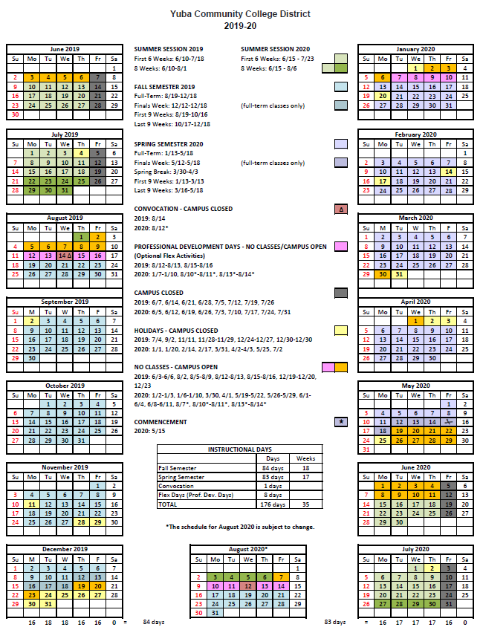
Appendix M: YCCD Academic Calendars

Appendix N: Map of Lake County Campus

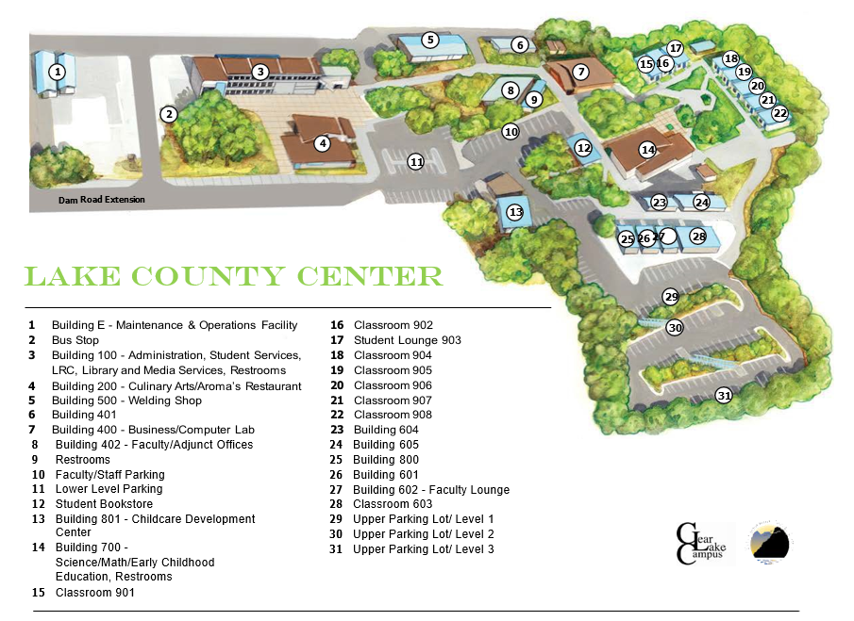

Appendix O: Limited Pre-Renovation Asbestos & Lead Survey
Please refer to this link:
https://goyccd-my.sharepoint.com/:f:/g/personal/w0398409_yccd_edu/ElnxeH2duBRCjUdAlF-NIq0BDjR6EVe5e0-R74y7K2EEeg?e=ipcEpb

The End.

