Addendum No. 1

RFP 19-11 WCC Lake County Campus, Building 400 Roof and Retaining Wall Replacement Project
Date: 04/21/2020

Date: January 26, 2016

- ZOOM Pre-Bid Meeting Recording Link:
https://cccconfer.zoom.us/rec/share/5uNSJuzd6GpJYNLD037PB_QLAtXAT6a8gXVP8qYMxR5s52c0MzYOxbzT0E3CKCzM?startTime=1587059240000

- Reminder: Please schedule a time to visit the project site at the Lake County Campus by contacting Michael Sinn:
Michael Sinn
Assistant Director of Maintenance, Operations
2300 East Gibson Road
Woodland, California, 95776
Phone: 530-668-3690
Email: msinn@yccd.edu

- Roof Deck Plywood Roof Replacement/Repairs:
  - Roof Deck Replacement Cost (96 square feet): $ .
--Provide a cost to remove damaged roof deck and replace with “like” roof deck material. For bidding purposes, provide a cost to remove and replace three (3) 4’ x 8’ wood deck panels. Include all labor and materials in the cost per square foot. See revised bid form sheets above.

If “soft” areas of the roof are “discovered”, further investigation work is required to determine if the roof deck is compromised due to wood rot or other factors. Compromised roof deck shall be replaced “like for like” on a per unit price established in the proposal before commencing with the new roof work. Additional “discovered” areas shall be replaced at the same cost per 4’ x 8’ wood roof deck panel as that noted above. If however, there are damaged roof framing members encountered, the repair costs shall be proposed as a change order after the extent of the damage is determined.

  - Updated Appendix A Proposal Bid Costs Format to Include the Plywood Deck Replacements:

Appendix A: Proposal Base Bid Costs

  - LCC Building 400 Roof $ .
  - LCC Building 400 Retaining Wall Replacement $ .
  - LCC: Other Costs: $ .
  - Total LCC Costs: $ .

  - Allowance for Unforeseen Conditions: $ 20,000.00 .

  - Roof Deck Replacement Cost (96 square feet): $ .
--Provide a cost to remove damaged roof deck and replace with “like” roof deck material. For bidding purposes, provide a cost to remove and replace three (3) 4’ x 8’ wood deck panels. Include all labor and materials in the cost per square foot. See revised bid form sheets above.

If “soft” areas of the roof are “discovered”, further investigation work is required to determine if the roof deck is compromised due to wood rot or other factors. Compromised roof deck shall be replaced “like for like” on a per unit price established in the proposal before commencing with the new roof work. Additional “discovered” areas shall be replaced at the same cost per 4’ x 8’ wood roof deck panel as that noted above. If however, there are damaged roof framing members encountered, the repair costs shall be proposed as a change order after the extent of the damage is determined.

Note: Each item will require approval by the District with proper documentation. Additional items will be considered on a case by case basis. It remains the contractors responsibility to do reasonable due diligence inspection and evaluation to determine and include as many items as possible during the proposal bidding process and to make all reasonable efforts to identify items before damaging them during the construction process.

  - Total LCC Bld. 400 Base Bid: $ .

- General Pictures of Building 400 at the Lake County Campus:

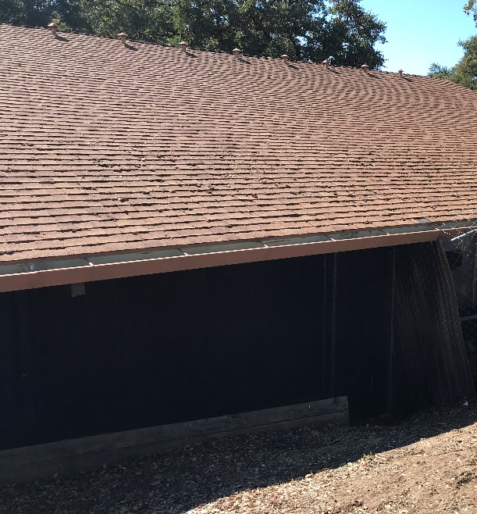
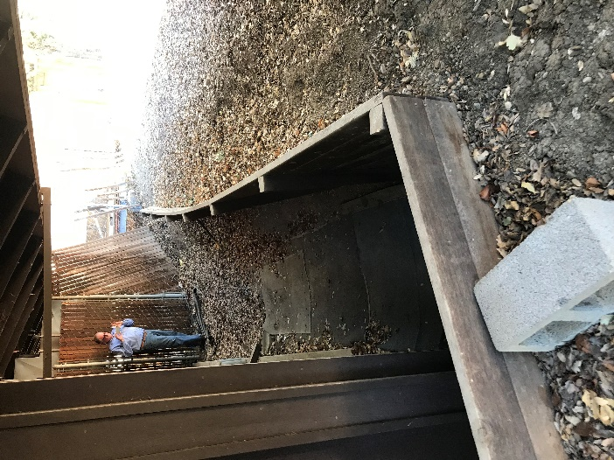

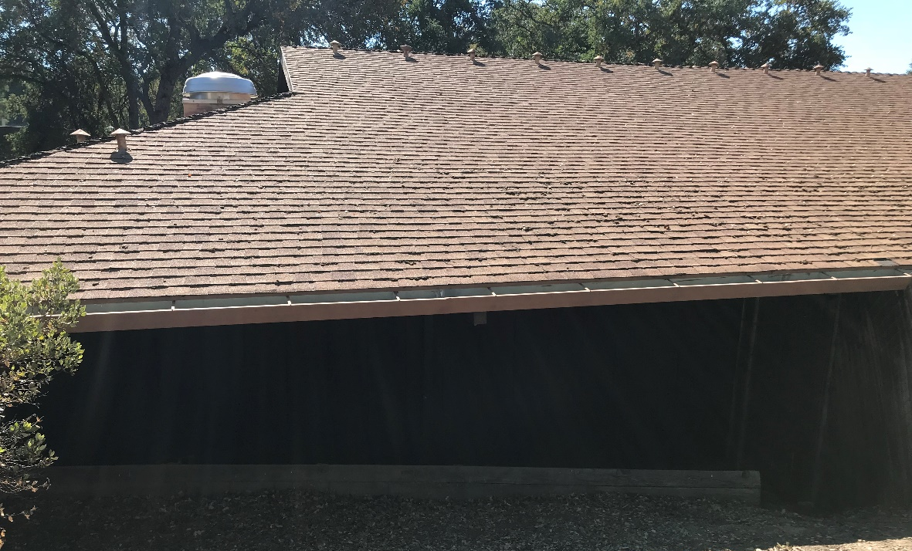

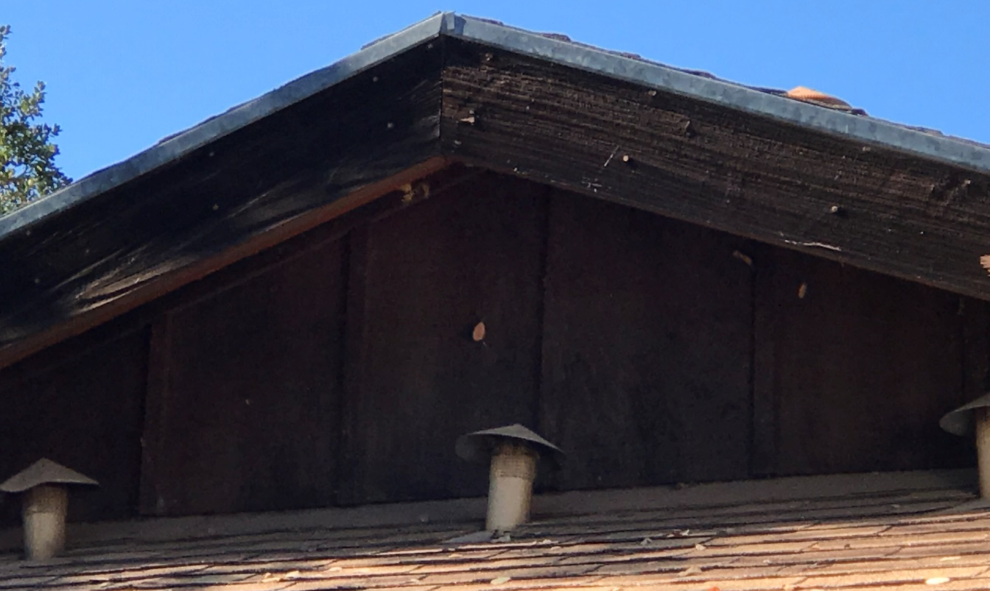

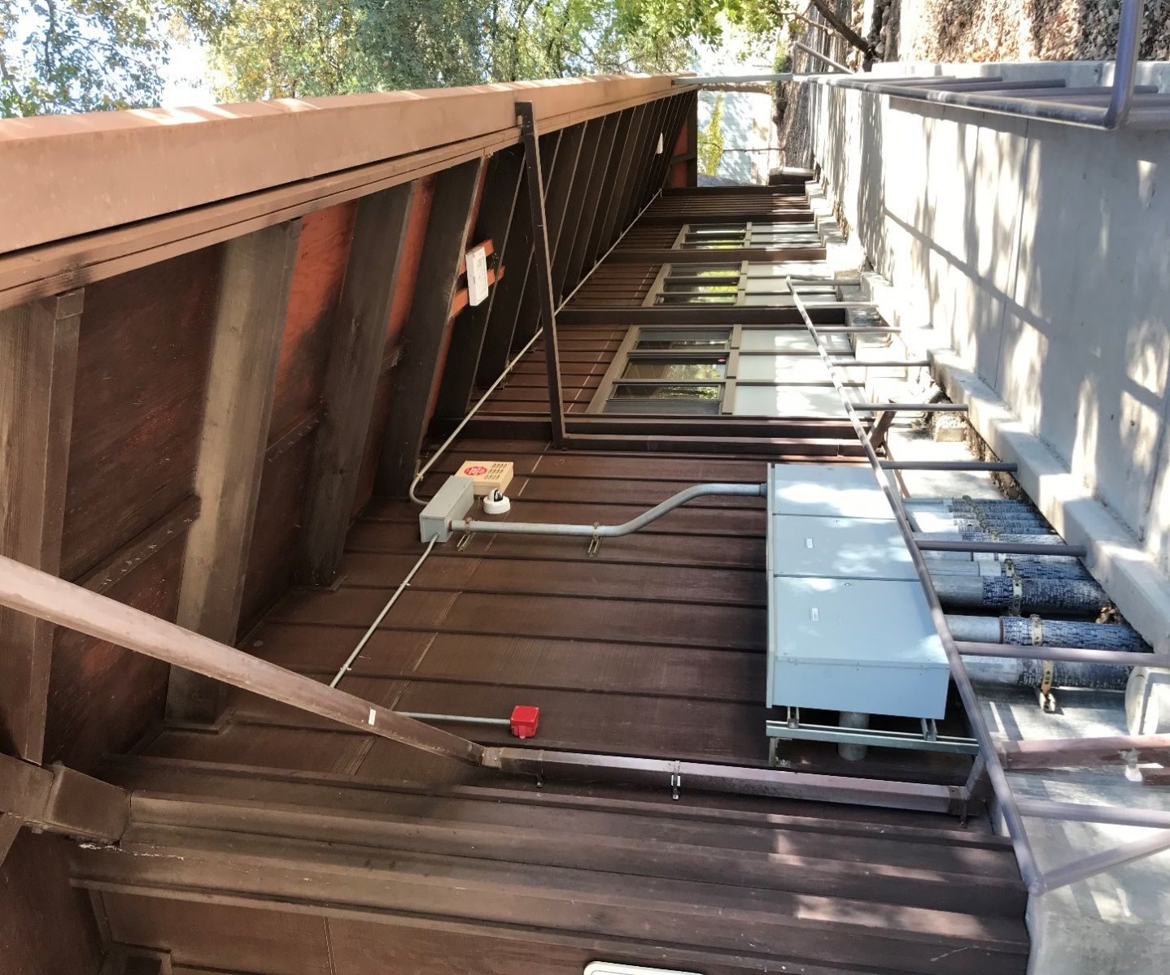

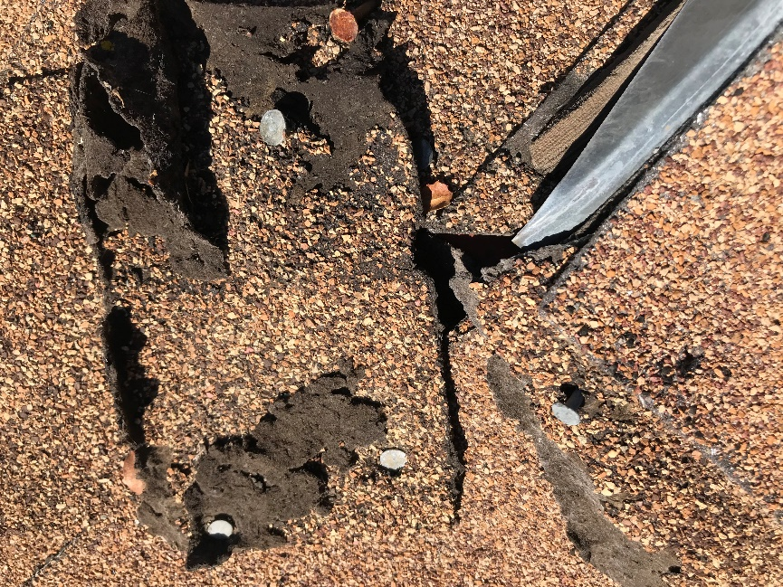

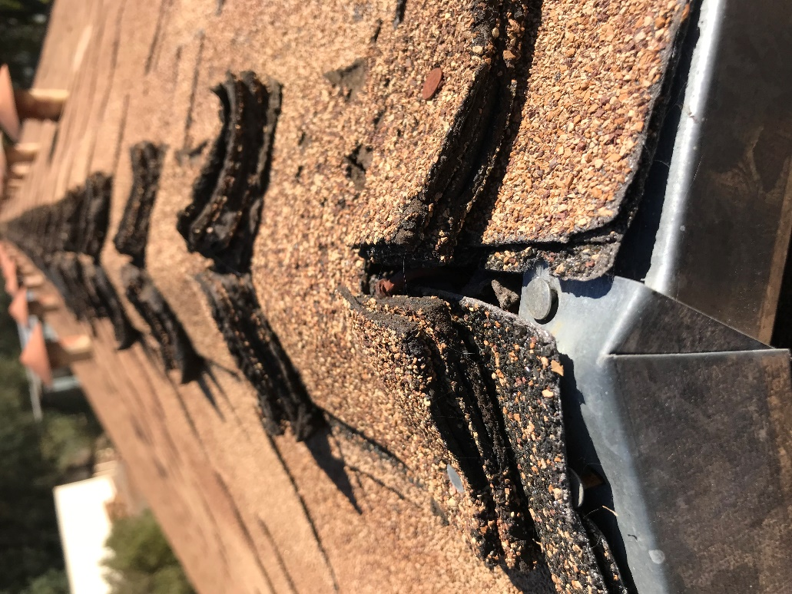

Thank you for your participation in the procurement process at Yuba Community College District.

The End.

