Request for Proposal
Yuba Community College District
Woodland Community College
Building 800 Corridor Remodel
No. RFP 19-05

Issue Date: October 31, 2019
RFP Due: December 10, 2019

RFQ/RFP Due Date: December 10, 2019, 1:00pm Sharp, Yuba College Location Delivered To:

Yuba Community College District, District Offices
Attn.: David Willis
District Director of Facilities Planning, Maintenance & Operations
RFQ No. 19-05 WCC Building 800 Corridor Remodel
Address: 425 Plumas Blvd., Suite 200, Yuba City, California, 95991

Proposal Delivery Location, Front Counter at Second Floor
Yuba Community College District
District Offices
425 Plumas Blvd, Suite 200 (second floor)
Yuba City, California, 95991

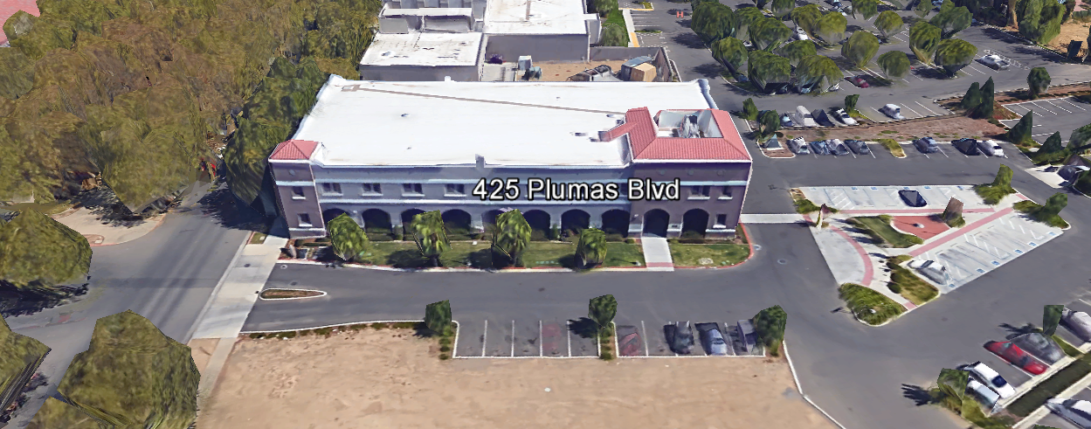
TABLE OF CONTENTS

1.0 INTRODUCTION
1.1 District Information
1.2 Yuba Community College District Background
1.3 Purpose of the Request
1.4 Applicable Codes
2.0 Scope of Work
2.1 Project Schedule
2.2 District Staff Contacts during Proposal Process
2.3 Project Safety Requirements
2.4 Demolition
3.0 Proposal Format Organization
3.1 Proposal Delivery, Contents, and Format
4.0 Selection of “Firm”
5.0 Basis of Award
6.0 Non-Discrimination
7.0 Evaluation of Proposals
8.0 Response to Request for Proposal (RFP)
9.0 Requests for Information (RFI)
10.0 Proposal Schedule
11.0 District Parking
12.0 RFP Proposals
13.0 Award of Contract/Proposal
14.0 Reservation of Rights

Appendix A, Statement of Qualifications Form
Appendix B, Financial Stability of Firm
Appendix C, Descriptions of “Like” Projects
Appendix D, YCCD Academic Calendar 2019/2020.
Appendix E, YCCD Agreement for Services (AFS).
Appendix F, Other Areas of Concern
Appendix G, Map of Woodland Community College Campus
Appendix H, Utilities Clarifications and Contractor Responsibilities
Appendix I, Non-Collusion Affidavit Form
Appendix J, References Form
Appendix K, Signature Proposal Form
Appendix L, Certification of Non-Discrimination
Appendix M, Acknowledgement of Addenda Form
Appendix N, Firm’s W4 Form
Appendix O, Insurance Form
Appendix P, Licenses, Certificates, Documents that prove qualifications by team members and Firm.
Appendix Q, DSA Approved Project Drawings and Specifications Package

Note: If Contractor Firm is “Pre-Qualified” in the District, then Appendix A, B, F, P do not apply and are not required to be filled out again by the Firm.

1. INTRODUCTION

  - District Information:

The District consists of two colleges, Woodland Community College and Yuba College, with campuses located at six different locations: Yuba College in Marysville, CA; Sutter County Center in Yuba City, CA; Beale Education Center, Beale AFB, CA; Woodland Community College in Woodland, CA; Colusa County Center in Williams, CA; and Lake County Campus in Clearlake, CA.

  - Yuba Community College District

The Yuba Community College District (YCCD) was founded in 1927 and spans eight counties (Yuba, Sutter, Colusa, Yolo, Lake, Butte, Glenn and Placer) and nearly 4,200 square miles of territory in rural, north-central California. It has colleges in Marysville and Woodland, an educational center in Clearlake, an educational center in Williams, an educational center in Yuba City, and outreach operations at Beale Air Force Base.

  - Purpose Of Request

The Yuba Community College District seeks proposals from qualified Contractors to remodel a section of corridor in building 800 at the Woodland Community College
Woodland Community College Campus Address: 2300 East Gibson Road, Woodland, California 95776
  - Applicable Codes
All Facilities Standards Updates shall meet all State of California Building Codes, and Federal codes, and local ordinances.
All projects at the District/College are prevailing wage projects.
2.0 Scope of Work
The scope of work includes the following:

- Wall and miscellaneous demolition.
- Relocation of existing electrical wiring and any other utilities in the walls
- Wall framing, drywall, and finish work
- Painting
- Ceiling re-work
- Replacement/Upgrading of Corridor Lighting Fixtures to LED Fixtures
- Replacement of Doors and Door Hardware
- Clean-up.
- Other work as described on drawings.

Note: Unforeseen conditions are not grounds for a contractor change order. The Contractor must do all required research in advance to identify all hazards, utilities, and items that would impact the project. Changes in scope of work previously approved by the District/College would be considered as a basis for future change orders. Working hours shall be straight time Monday through Friday in May, 2020 and Monday through Thursday in June, 2020. Normal working hours are 7AM to 4:00PM. Other working hours may be submitted for consideration by the District/College.

The Contractor is 100% responsible to coordinate and securely store materials, tools, equipment, and other items required for the project. The Contractor must receive, inspect, unload, move, properly store, and sign for all materials, windows, doors, door hardware, lighting fixtures, and other items. It is recommended that all tools be locked up each night in a lock box. All materials need to be locked up and stored properly. The construction area must be cleaned up and organized each night to reduce trip hazards and the risk of a fire. Deliveries that arrive without a Contractor representative on site will not likely be received. All materials must be as specified and pre-approved by the Architect and the District before orders are placed. The District cannot pay for materials until they arrive on site.

All wall finishes shall be smooth, level, and true to match existing walls. All paint shall arrive on site in sealed containers and not pre-mixed at the shop before delivering at the site. The contractor must use primer for walls and not “flat” paint to seal walls. The contractor shall provide quality work or it will not be acceptable to the District/College.

The Contractor shall provide their own waste container and have it emptied as needed.

The Contractor shall use barricades and barricade tape, and signs to delineate all project boundary areas.

The Contractor shall provide temporary lighting as needed to work safely.

The Contractor shall de-energize and perform Lock-out/Tag-out on all electrical wiring circuits known to be in the affected project boundary and in demolition areas before demolition activities commence.

The Contractor may use the College restrooms if dirt and debris are not tracked into the restrooms.

The Contractor is expected to meet weekly with District/College staff at the project site to review progress, discuss issues, and provide an updated schedule for the next week.

2.1 Project schedule
This work shall be done May 20, 2020 through June 6, 2020. All work shall be completed 100% by June 13th. All remaining punch list items shall be completed by June 13th.
If this schedule is too tight and requires overtime, suggest an alternative work schedule. Please note that the College is closed on Friday’s in June so please do not schedule work on Friday’s. It is the intent of the College/District to avoid overtime.

2.2 District Staff Contacts during the Proposal process:
Firms interested in submitting a Proposal are directed not to make personal contact with the Board of Trustees, District staff, or members of the evaluation committee. Any contact shall constitute grounds for disqualification from consideration.
Single Point of Contact during the Proposal Preparation Process:
David L. Willis
District Director of Maintenance, Operations, and Planning
425 Plumas Blvd., Suite 200 (Second Floor)
Yuba City, California, 95991
Cell Phone: 916-747-4262
Email: dwillis@yccd.edu

Please email Dave Willis to verify that your firm will be submitting a proposal in response to this procurement process.
On-site coordination, first contact person (Woodland Community College Location):
Michael Sinn
Assistant Director of Maintenance, Operations
2300 East Gibson Road
Woodland, California, 95776
Cell Phone: 530-575-0206
Email: msinn@yccd.edu

2.3 Project Safety Requirements
Safety is a top priority for the District. All California OSHA requirements apply. Industry best practices apply. Contractor employees shall wear a hard hat, eye protection, hearing protection, gloves, substantial leather footwear, long pants, a reflective safety vest, and take all needed precautions to complete the work in a safe manner. Safety shall not be compromised at all during the work.
The affected areas of construction shall be properly barricaded, have signs placed, and all reasonable precautions taken to keep staff and students out of the project boundary areas. Debris shall be removed daily. Protection of existing doors and other College property shall be taken. Contractor is 100% responsible for any damage to College property and facilities.
2.4 Demolition
The contractor shall provide a debris waste manifest for all items removed from the campus. Demolition shall be done in accordance with all State and Federal codes, laws, and ordinances. Demolition shall be coordinated to greatly reduce possible impacts with students and staff.
The contractor shall return all existing doors and hardware that are removed, to the College.

3.0 Proposal Format Organization
The Firm is requested to use the following proposal format:
3.1. Proposal Delivery, Contents, and Format:
Proposals should provide straightforward, concise information that satisfies the requirements noted in this RFP. Expensive binding, color displays, and the like are discouraged. Emphasis should be placed on brevity, conformity to the Districts instructions, selection criteria of this RFP, and completeness and clarity of content. Each Respondent’s proposal should clearly and accurately demonstrate specialized knowledge and experience required for consideration.
In a sealed box or envelope (clearly marked “), submit the following:
- One (1) flash memory stick containing the complete proposal and supporting documentation;
- One (1) original and two (2) copies in paper form of the proposal, which consists of a Proposal Letter and responses to the proposal requirements of this RFP.

Proposals shall adhere to the following requirements for contents and format, should be as concise as possible and should not include more than 25 pages of promotional or marketing materials. There is no page limit overall but each proposal is requested to be no more than 50 physical pages (printing on both sides of each page) in total length.
Firms must comply with the provisions of these instructions for completion and submission of the Proposal. The failure of a Firm to comply with the Proposal Instructions and Requirements will result in rejection of the Proposal for non-responsiveness.

Proposal Section | Format
- Cover Letter, Section 3.1.A | PDF
- Table of Contents, Section 3.1.B | PDF
- Identification of the Firm, Section 3.1.C | PDF
- Executive Summary, Section 3.1.D | PDF
- Staffing Resources, Section 3.1.E | PDF
- Assigned Staffing Experience, Education, Credentials, Section 3.1.F | PDF
- Fiscal Stability, Section 3.1. G | PDF
- Base Fee Proposal, Section 3.1. I:  - Demolition: $ .  - Utilities Work/Relocations: $ .  - Wall Re-Construction $ .  - Hallway Windows (classrooms only): $ .  - Accessibility Signs: $ .  - Ceiling Work: $ .  - Other: $ .  - Total Base Bid: $ . | PDF
- Additive Alternates:  - Hallway Windows & Assoc. Work (4 Offices) $ .  (Rooms 820, 821, 822, 824.)  - Replace Existing Light Fixtures with LED Fixtures in Hallway “Area of Work” shown on Drawing A-201/ Use RAB EZPAN 5,000 Kelvin, 50 Watt 2’x4’ Fixtures. Existing light fixtures to be returned to the College: $ .  - Replace Existing Hallway Doors and Hardware on 6 Classrooms (rooms 139, 814, 815, 816, 817, 819) with full height glass glazing doors. Match existing door and hardware finishes, door hardware brand. Existing doors and hardware to be returned to the College: $ . | PDF
Appendices (See Table of Contents for each one) Submit a response to each Appendix that requires Contractor information. | PDF

Proposal General Information Contents:

The following is a summary of the Contents. Please address each section in a Tabbed Format.

3.1.A. Cover Letter

The Proposal shall include a Cover Letter on Respondent’s official business letterhead, which shall be signed by an individual authorized to legally bind Respondent. The Cover Letter shall also identify the name and telephone number of a person who may be contacted during the Proposal evaluation process.

3.1.B. Table of Contents

Provide a Table of Contents that outlines in sequential order the major sections and sub-sections of the Proposal. All pages in the Proposal shall be clearly and consecutively numbered and correspond to the Table of Contents. Use tabs to allow information to be more easily located.
3.1.C. Identification of the Firm
1. Legal name and address of company.
2. Legal form of company (corporation, partnership, etc.).
3. Name, address, phone number, facsimile number, email address, website address, direct email address for the following: Firm’s Principal in Charge, person(s) who will be primarily responsible for providing services for this Qualifications Package, and the contact for scheduling an in-person interview
If the Firm is selected for one.
4. California Business License Number (as applicable)
5. Other Licenses

3.1.D. Executive Summary

The Proposal shall include an Executive Summary that briefly describes the Firm, the services and types of projects that are the core business, and why this project “fits” within the business model of the Firm.

3.1.E. Staffing Resources

Firm Staffing and Key Personnel Assigned to this Project
a. Provide total number of staff currently employed by the firm.
b. Identify person/s who will be principally responsible for the work and their role.

3.1.F. Experience

- Provide a description of how the Firm’s experience on these type projects.
- State the number of years the firm has conducted business. Firm must have at least five (5) years’ related experience.
- Describe the experience and credentials of the staff assigned to this project. Will the Superintendent be on site whenever work is being performed?

4.0 Selection of “Firm” Services Provider

The process of “Firm” selection is based upon the complete responsiveness of the RFQ/RFP and the criteria as outlined below.

Subject to the District’s express reservation of rights to modify the selection process, the selection process anticipated by the District will consist of the following:

  - Qualifications received will be reviewed for responsiveness.
  - The Proposal as outlined in this RFP.
  - Other criteria listed in the RFP.

The Review Committee will then recommend the highest ranked firm and “Best Value” projects to the Board of Trustees for approval.

The District reserves the right to reject any and all submittals, to amend the RFQ/RFP process, and to discontinue or re-open the process at any time. The submittals will be evaluated based on each respondent’s qualifications, proposal criteria, service fees, and relevant experience.

5.0 Basis of Award

As the basis of award the District intends to utilize the determination of “Best Value” in providing the stated services to the District. There is no guarantee expressed or implied that the District will award all or any of the projects stated in the RFP.

6.0 Non-Discrimination
The District does not discriminate with regard to race, color, gender, national origin, disability, or any other protected or other classification in the awarding of contracts/agreements. The District welcomes all Qualified Firms to participate in the project Request for Qualification/Proposal process.
The District encourages firms that are women or minority owned, emerging small businesses, veteran owned firms, disabled person owned firms, and all other qualified firms to participate in the proposal process.
The District encourages the submission of proposals from all Firms that can meet the stated requirements set for this RFP.

RFP 19-05 WCC Building 800 Corridor Remodel

7.0 Evaluation of Proposals Form

Firm: . Rank Order: .

Proposals will be evaluated and include a careful review of the proposals and the ability of the firm to perform cost effective solutions as described in this request, including reference checks of the firm doing the work. This RFP will be evaluated by a District Facilities Management Team and awarded based on a number of factors which are described below:

Evaluation Criteria:

- Total Cost: 40 Points
- Firm/Project Team Statement of Qualifications: 20 Points
- Project Approach, Schedule, Safety: 20 Points
- “Like” Project References: 10 Points
- Other “Areas of Concern”: 10 Points
.
Total Score: /100 Points

Comments:

Evaluator Name (Print): . Evaluator Signature: .
Date: . Recommendation to Award Yes/No: .
8.0 Responses to RFP:
Sealed responses to this RFP must be clearly marked "RFP NO. 19-05 WCC Building 800 Corridor Remodel”.

Responses shall be mailed to or hand-delivered to the following address:

Yuba Community College District, District Offices
Attn.: David Willis
District Director of Facilities Planning, Maintenance & Operations
Envelope/Box Marked:
“RFP No. 19-05 WCC Building 800 Corridor Remodel”.
Address: 425 Plumas Blvd., Suite 200, Room 216, Yuba City, California, 95991

Note: Completely seal your proposals in envelope/box and make sure it gets date/time stamped when delivering proposal. Firms are each 100% responsible to make sure proposals that are mailed using a carrier such as UPS, FED Ex, etc…are received and date/time stamped by District personnel prior to the proposal due date/time. No proposals will be considered if they are late, even if it is only 5 minutes late. Please make sure your proposals are delivered and received promptly prior to the due date/time. There will be a public proposal opening at the due date/time.

Do NOT email your proposals. Emailed proposals that are not sent per the above guidance requirements will not be considered.

9.0 Requests for Information (RFI)

Requests for Information concerning the RFP must be in writing and may be submitted via email no later than the date shown below. Please direct all questions to David Willis, email: dwillis@yccd.edu.

Following the RFI deadline, all questions and answers will be summarized and posted on the District's website: https://www.yccd.edu/central-services/purchasing/ , then, click on the “Requests for Proposals / Quotes” tab on the right hand side of this web page. It is anticipated that responses to inquires received by the required time and date will be provided within 5 business days and posted on the District's website or responded to per the dates listed in the RFP for addendum publishing. Should more time be needed by the District to answer I respond to RFI’s, this information will also be posted on the above website.

Include the following in the subject matter field on emails when requesting information: “RFP 19-05”, RFI.

The District has developed Procurement Milestones, shown below, with dates showing the key events in this solicitation process. This RFP and schedule are subject to change, and the Director will notify Respondents of any changes via email to the contact designated by each Respondent. Respondents must take the following actions according to the specified timelines in order to participate in this process.

10.0 Proposal Schedule:

Important Dates and Times:

October 31, 2019: Release of Request for Proposal at 4:00PM

November 18, 2019: 1:00pm, Mandatory Pre-Bid Meeting at Yuba College, Building 1400, Maintenance Conference Room, 2088 North Beale Road, Marysville, California 95901.

Note: Firms may make arrangements to visit at other times and dates by contacting staff listed in the RFP. Meeting Log Sheets must be signed by Firm representatives at the Mandatory Meeting or a subsequent meeting to become a qualified Firm. Alternative meeting times and dates (coordinated by the Firm at an alternative date and time) at the Woodland Community College will replace the noted mandatory meeting scheduled above. Firms must attend one meeting at Woodland Community College Campus to be determined to qualify to bid this project.

December 2, 2019 All questions and requests for information must be submitted to David Willis at: dwillis@yccd.edu by 4pm.

December 3, 2019: Addendum Issued if needed.

December 10, 2019: Proposals due at 1:00 PM SHARP, Yuba Community College District, District Offices Location, see page 1. There will be a public bid opening on this RFP.

January 24, 2020: Proposed date of Award with Purchase Order

June 13, 2020: ALL WORK COMPLETED 100%. See section 2.1, Project Schedule.

The District reserves the right to alter or amend the above timetable as required to conclude the process to the District's satisfaction.

All questions associated with the procurement process shall be addressed to David Willis, District Director of Facilities Planning, Maintenance, and Operations at email: dwillis@yccd.edu or cell phone: 916-747-4262.

11.0 District Parking:

-No parking in Reserved Spaces without a proper permit
-Permit Parking is enforced in all general lots between 6:00 am and 6:00 pm, Monday through Friday. All general lots require a properly displayed, valid permit during these times
-Daily Parking Permits are $2.00
-Permits are available for purchase at any of the permit machines located in the student parking lots
-All other parking regulations are enforced 24 hours a day, seven days a week. This includes designated staff spaces, handicap spaces, timed spaces, red zones, yellow zones, and areas not marked (no parking at any time)
-Once this project is awarded, temporary parking permits will be processed as requested by the successful firm for all employees associated with this project at no cost to the Firm for the duration of the project at each Campus location. These temporary permits must be displayed at all times on the dash board of employee vehicles.

12.0 RFQ Proposals

Proposals received after the deadline will not be opened. Each responder shall submit one (1) signed original, two (2) additional hard paper copies, all in separate binders. Provide one electronic format copy of the proposal using electronic media such as a flash drive, CD, etc...

All materials submitted in response to the RFQ/RFP shall be on 8-1/2"x11" paper, preferably in
Portrait orientation. All submitted materials must be bound in either a three-ring binder or spiral bound notebook. Content shall be tabbed and numbered per the items included in the Submittal Requirements. All Proposals will be reviewed and evaluated by a District Selection Committee. The District at its sole discretion may interview finalists, or select a firm or firms to perform work based solely on the evaluation of the Proposal. Page limit of 25 pages of marketing materials plus 50 paper pages, double sided print (100 pages total) regarding the proposal. Fewer pages is better and encouraged with tab references.

All Proposals become the sole property of the District and the content will be held confidential until the selection of the firm is made and the project is awarded.

13.0 Award of Contract

- The Contract will be awarded to the most responsive proposer whose proposal, conforming to the request for proposal and associated addendums, will be most advantageous to the District.

B. The District reserves the right to enter into an Agreement without further discussion of the proposal submitted based on the initial offers received.

C. The District reserves the right to reject any or all proposals or any part of the proposal and to waive informalities and minor irregularities in the proposals received.

D. The RFP, its addendums, and the proposal of the selected Firm will become part of any contract initiated by the District.

- In no event shall a proposer submit its own standard contract terms and conditions as a response to this RFP. The terms of any contract may be negotiated as part of the negotiation process with the exception of contract provisions that are nonnegotiable.

G. A formal contract shall be signed by the successful proposer and Yuba Community College District to perform this service.

H. The District reserves the right to enter into discussions with any one or all of the Responders after Proposals have been initially reviewed. Such responses shall be subject to all provisions, terms and conditions as set forth in the RFP, unless otherwise modified.

J. Award shall be made to the Responder whose submittal, conforming to the RFP, will be the most advantageous to the District after consideration of the defined evaluation criteria.

K. The District intends to award to a single RFP Responder.

L. The Contractors Performance and Payment bonds are required within 7 calendar days after the award of the project with a purchase order.

14.0 Reservation of Rights

The District reserves the right to:

- Reject any or all submittals at its sole discretions.
- Cancel the Request for Proposal (RFP), without cause.
- Modify any requirements contained within the RFP and request a revised submission from all Providers.
- Establish other evaluation criteria determined to be in the best interest of the District.
- Contract with any of the firms responding to the RFP based solely upon its judgment of the qualifications and capabilities of the firm.
- Clarify the content of any proposal to verify that the requirements of the RFP are included.
- Waive “minor” proposal inconsistencies that do not change the scope of work as outlined in the RFP.
- Request an alternative Superintendent on the project if the initially assigned Superintendent on the project is not performing well, not meeting project requirements, not working well with College staff and students, not applying best practice safety methods, OR not following College/District guidance regarding project approach.

The District reserves the right to cancel the contract any time during the contract period after providing at least a written 14-day notice to the Firm. The District would first provide a 7 day notice to correct deficiencies and provide a written plan to address project identified issues. If a written corrective action plan is not received OR it is not complete OR if it does not address known issues, then, at the sole discretion of the District, the District would consider termination of the contract. The District would consider cancellation of the contract if the Firm does not fulfill the contracted requirements of this RFP in a timely and professional fashion); or, if for some reason the performance of the Firm or quality of the work adversely impacts the mission of the District in serving Students or Staff; or, if it is determined to be in the best interest of the District/College to do so. Termination of the contract due to poor performance, would likely result in a claim on the Contractors Performance Bond by the District.

This RFP does not commit the District to negotiate a contract. The District will not be responsible for any expenses incurred by any firm in preparing and submitting a proposal or response to this RFP or in completing any of the work specified.

Appendix A: Statement of Qualifications Form

The Respondent shall furnish the following information. Failure to comply with this requirement will render the submittal informal and may cause its rejection. Additional sheets may be attached if necessary.

- Firm name and primary address:

- Telephone: Facsimile:

- Email Address:

- Names and titles of two officers of the firm:
NAME TITLE

4.1
4.2

- Specific type of Ownership (Check one)

5.1 | Individual
5.2 | Partnership
5.3 | Corporation; If a corporation, state the following: State of incorporation:
 | Date of incorporation: President/CEO:
5.4 | Joint Venture
5.5 | Other (Specify)

STATEMENT OF QUALIFICATIONS

- Taxpayer Identification
- Number of years Respondent has been in business:
- Number of years Respondent has conducted business under the present name:
- Has the Respondent ever been licensed under a different name or different license number? ? If Yes, give name and license number:

- Number of years’ experience in California Community College, University, or Public facility projects .

- Has the Respondent been in litigation on an issue pertaining to any contract during the past five (5) years?
If yes, provide detailed information regarding the litigation, whether it was settled or not, the amount of the settlement, the liability of the claim, the circumstances and type of project, and provide case name and number.

- Has the Respondent ever failed to complete a project in the past five (5) years? If so, give owner and details:

- Do you now or have you ever had any direct or indirect business, financial or other connection with any official, employee or consultant of the District?
If so, please elaborate.

- Has the Respondent ever completed work for the Yuba Community College District in the past? If so, please elaborate:
- Please describe the extend, depth, and number of “like” projects that have been completed by the Respondent in the past five (5) years:
.
Appendix B: Financial Stability of “Firm”:

The Firm should provide evidence of Corporate/Firm stability including:

1. Latest audited financial statement and/or annual report that has been certified by a CPA.
2. If this information is not available, provide what is available that documents solid financial status.

Appendix C: Descriptions of Past “Like” Projects:

Provide at least five (5) examples of small interior remodel projects at Community Colleges or Universities, or K-12 Schools that your firm has completed in the past three (3) years.

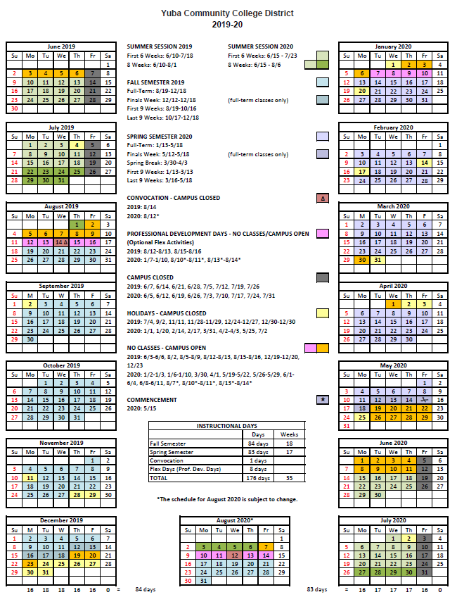
Appendix D: YCCD Academic Calendar 2019/2020

Appendix E: YCCD Agreement for Services

Please refer to the following Drop Box folder link:
https://goyccd-my.sharepoint.com/:f:/g/personal/w0398409_yccd_edu/EjuUlOk2YnZHk56ByEIcqa8B7UGX3KfWiKA8k9aCy08N3w?e=YyB8V3

Appendix F: Other Areas of Concern:

If any of the following has occurred, please describe in detail:

- Termination or failure to complete a contract.
- Termination by any municipal, county, state, federal or local agency.
- Involvement in litigation, arbitration or mediation.
- Provide litigation history for any claims filed by your firm or against your firm related to the provision of services in the last five (5) years.
- Conviction of the firm or its principals for violating a state or federal antitrust law by bid or proposal rigging, collusion, or restrictive competition between bidders or proposers, or conviction of violating any other federal or state law related to bidding or performance of services.
- Conviction of a Felony of any of the members of the project team.
- Knowing concealment of any deficiency in the performance of a prior contract.
- Falsification of information or submission of deceptive or fraudulent statements in connection with a contract.
- Willful disregard for applicable rules, laws or regulations.

Firms are required to respond with a “Yes” or “No” to the above listed items and to describe with detail any of the above items that have a Yes answer.

Information regarding any of the above may, at the sole discretion of the District, be deemed to indicate an unsatisfactory record of performance. Failure to disclose any of the above may, at the sole discretion of the District, be deemed to indicate an unsatisfactory record of performance.

Appendix G: Map of Woodland Community College, 2300 East Gibson Road, Woodland, California, 95776

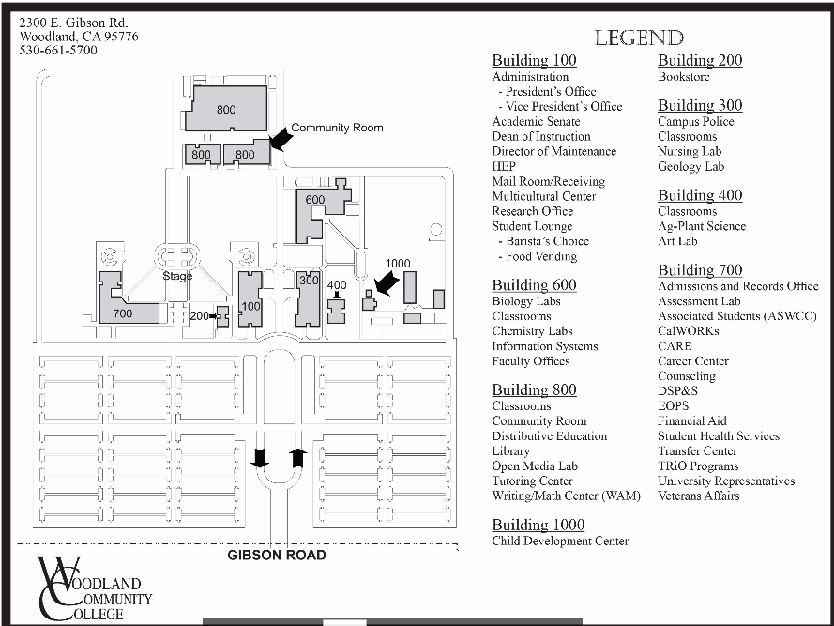

Appendix G: Map of Woodland Community College, 2300 East Gibson Road, Woodland, California 95776
East Gibson Road
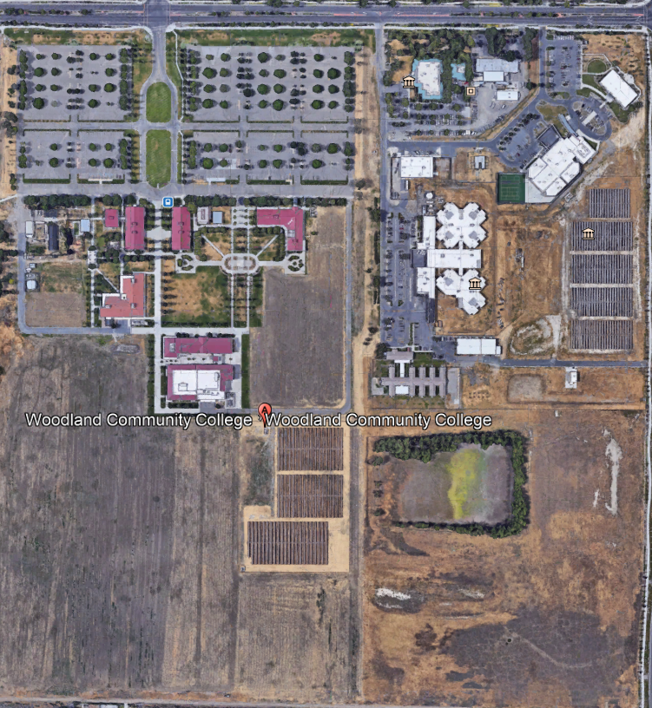
Building 800 Project

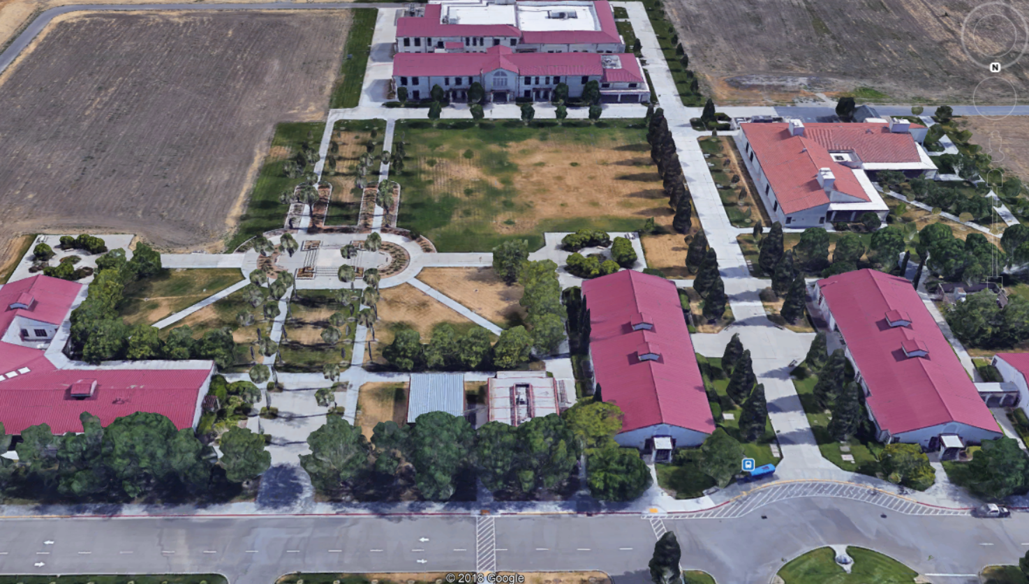
Building 800

Woodland Community College Campus- Facing South
Building 600
Building 600
Building 100
Building 700
Appendix “H” Utilities Clarifications and Contractor Responsibilities
Note: It will be necessary that the contractor visit the campus and thoroughly investigate the locations of all in-wall and above ceiling utilities. The Contractor is required to locate and perform a careful and thorough location analysis prior to any demolition or construction work.
Contractors are required to make and pay for all repairs to all damage to utilities. Any damage to existing utilities that occurs as a result of the work of this project, including electrical, natural gas, domestic water, landscape irrigation piping, storm water drain piping, and low voltage wiring that are in existing walls, above ceilings, buried in concrete floors or under concrete floors are not grounds for change orders associated with “unforeseen conditions”. All existing utilities damage resulting from the work of the Contractor on this project shall be repaired to the satisfaction of the College/District and at no expense to the College/District. Repairs shall be done expeditiously to avoid any impacts to the continued operations of the College/District.
Incomplete or inaccurate drawings showing any existing utilities does not constitute grounds for a change order. It is solely the Contractors responsibility to investigate the existing utilities prior to bidding the work to ensure the bid proposal is complete and includes all required work and costs.
All electrical work shall be included in the respective base bid and respective additive and deductive alternates.
All utilities work shall be coordinated closely with the College/District to avoid any unexpected and unplanned outages and impacts to continued College/District operations and student classes.
All required inspections shall be closely coordinated with the College/District to allow the DSA Inspector of Record to fully inspect the work before any of the work is “closed up” in walls or places that are inaccessible. At least a 72 hour notice is required for these inspections.

Appendix “I” Non-Collusion Affidavit Form
STATE OF CALIFORNIA, COUNTY OF I, being first duly sworn, deposes and says that I am the of , the party submitting the foregoing proposal (“the Proposal”). In connection with the foregoing Proposal, the undersigned declares, states and certifies that:
- The Proposal is not made in the interest of, or on behalf of, any undisclosed person, partnership, company, association, organization or corporation.
- The Proposal is genuine and not collusive or a sham.
- The Firm has not directly or indirectly induced or solicited another Firm to put in a false or sham proposal, and has not directly or indirectly colluded, conspired, connived, or agreed with any other Firm or anyone else to put in a sham proposal, or to refrain from bidding.
- The Firm has not in any manner, directly or indirectly, sought by agreement, communication, or conference with anyone to fix the proposal price, or that of any other Firm, or to fix any overhead, profit or cost element of the proposal price or that of any other Firm, or to secure any advantage against the public body awarding the contract of anyone interested in the proposed contract.
- All statements contained in the Proposal and related documents are true.
- The Firm has not, directly or indirectly, submitted the proposal price or any breakdown thereof, or the contents there of, or divulged information or data relative thereto, or paid, and will not pay any fee to any person, corporation, partnership, company, association, organization, proposal depository, or to any member or agent thereof to effectuate a collusive or sham proposal.
Executed on this date: , 2019/2020, at:

(City, County, and State)
I declare under penalty of perjury under the laws of the State of California that the foregoing is true and correct.
Signature Printed Name .
Address: .
Area Code & Phone Number: .
Note: In addition to other bid documents, bidders on public works projects are required by Public Contract Code section 7106 to submit a certification form that they have not colluded with another proposer.
Appendix “J” References Form (Example Template)

Bidder shall provide a minimum of Ten (10) verifiable references preferably from a California public or private educational institution and/or California public agency, within the last 5 years. All phone numbers must be current (please verify).
REFERENCE #1
NAME
ADDRESS
CITY, STATE ZIP CODE
TELEPHONE #
CONTACT
DATES OF SERVICE
REFERENCE #2
NAME
ADDRESS
CITY, STATE, ZIP CODE
TELEPHONE #
CONTACT
DATES OF SERVICE
REFERENCE #3
NAME
ADDRESS
CITY, STATE, ZIP CODE
TELEPHONE #
CONTACT
DATES OF SERVICE

You may of course use the Firm’s established reference template.

Appendix “K” Proposal Signature Form
The undersigned acknowledges the following:
- Having become familiar with the specifications and requirements of the Request for Proposal, hereby offers to provide all services in accordance with the proposal set forth herein, including all referenced material and attachments.
- By submitting a signed proposal in response to this solicitation, the Firm acknowledges that they completely understand the scope of the needed services and that the proposed services as described in the proposal will meet or exceed the needs of the District.
- Late proposals will not be accepted (even if they are only 5 minutes late).
- The District reserves the right to reject any and all proposals and that this proposal shall remain open and not be withdrawn for a minimum of 90 days.
- Cancellation Clause: The District may, without cause, terminate the contract(s) or a project under the contract(s) by giving written notice of such termination to the awarded firm. In the event of such termination the District shall reimburse the firm for services performed and reasonable expenses actually incurred by the firm in relation to the terminated project prior to the firm’s receipt of such notice of termination. The cost of proposal generation, associated travel, copies, postage, etc.., will not be reimbursed and is considered a typical and normal part of the bid process and is not reimbursed for any of the proposers.
- If the prospective Firm is a corporation, the undersigned hereby represents and warrants that the corporation is duly incorporated and is in good standing in the state of California , and that, , is authorized to act for and bind the corporation.

Entity Type (Select One):

Sole Owner: Partnership: .

Corporation: .

Other; Please specify;

Regular monthly progress payments are made using NET 30 as a basis for payment, with Net 30 time starting after receipt of the invoice with all required support documentation, and once this information is reviewed and approved by the District.
Signature_____________________________ Date: _______________________
Position: _____________________________
Print name____________________________ Title________________________

Notary Required On This Project
Notary Stamp:

Appendix L: CERTIFICATION OF NON-DESCRIMINATION
TO BE EXECUTED BY BIDDER AND SUBMITTED WITH PROPOSAL

Proposer hereby certifies in performing work or providing services for the District, there shall be no discrimination in its hiring or employment practices because of age, sex, race, color, ancestry, national origin, religious creed, physical or mental disability, medical condition, marital status, or sexual orientation, except as provided for in Section 12940 of the California Government Code. Proposer shall comply with applicable federal and California anti-discrimination laws, including but not limited to the California Fair Employment and Housing Act, beginning with Section 12900 of the California Government Code.

IN WITNESS WHEREOF, the undersigned has executed this Certificate of Non-Discrimination this
day of , .

Proposer
(Type or print complete legal name of Proposer)
BY
(Signature)
Name
(Type or print)
Title

Appendix M: Acknowledgement of Addenda Form

The undersigned acknowledges receipt of the following addenda from the District pursuant to the Request for Proposal:
Acknowledgement: Yes or Not Applicable
Addendum No. 1: .
Addendum No. 2: .
Addendum No. 3: .
Addendum No. 4: .
Addendum No. 5: .

Failure to acknowledge the Addenda’s may, at the Descretion of the District, determine the Proposal to be incomplete and unresponsive. Firms are required to acknowledge all addenda’s within the submitted proposal at the time of submission.

Appendix N: Firm W9 Form

--Provided by Firm

Appendix O: Insurance Form

--Provided by Firm

Appendix P: Licenses, Certifications, Documents Proving Qualifications by Team Members

--Provided by Firm

Appendix Q: DSA Approved Drawings and Specifications Package

See Folder Link:
https://goyccd-my.sharepoint.com/:f:/g/personal/w0398409_yccd_edu/ErJzT3iS3HBAmQzGSttnWdUBLAXDa4keobn6xuzojowBFA?e=QTQZKD

The End.

